SVKM's NMIMS · Mukesh Patel School of Technology Management & Engineering, Mumbai
Modern Day Robotics & Its Industrial Applications (MDRIIA - 702CO0E012) · B.Tech Computer Science & Business Systems (CSBS), in partnership with TCS · AY 2026–27 Odd Semester
GROUP 07 TECHNICAL DOSSIER
Capstone ICA (20 marks): CDIO Robotics Engineering & MuJoCo Physics 10 · CSBS Techno-Economic Business Systems Analysis 5 · Studio Showcase & Viva Voce 5
Group · project | Group 07 · Autonomous Mobile Manipulator for Hospital Housekeeping & Patient-Room Clutter Clearing
Monorepo folder | https://github.com/sunny-nanade/NMIMS-MPSTME-MDRIIA-2026/tree/main/Group_07_Soumil_Aditya_Priyansh
Submit (3 places) | (1) PDF on MS Teams, turned in by EVERY member · (2) this filled Word file AND its PDF committed to Group_07_Soumil_Aditya_Priyansh/docs/MDRIIA_Group_07_Technical_Dossier.docx / .pdf · (3) LinkedIn video URL in Section 5. Due Monday, 26-Oct-2026, 23:59 IST. Studio Showcase, Expo & Viva Voce: Saturday, 31-Oct-2026.
No slides | There is no PPT for MDRIIA. At the Expo and in your video you present the live MuJoCo simulation, your business sensitivity graphs, and a webcam picture-in-picture of every member.
How to fill this file | Use Microsoft Word (desktop). Choose answers from the 'Select ▾' drop-downs and type into the 'type here' fields. Do not delete or retype them and do not edit this file in Google Docs: the fields are how your answers are read.

Student name | Roll No. | SAP ID | Capstone role(s) | Specialisation (finalised titles sheet / monorepo)
Soumil Patro | E050 | 70362400035 | CSBS Business & Techno-economic Systems Analyst | Lead Mobile Base Navigation & SLAM Engineer
Aditya Raju Shah | E062 | 70362400033 | Autonomous Navigation / Vision Specialist + Telemetry QA Lead | Manipulator Arm Kinematics & Vision-Based Grasping Specialist
Priyansh Thakkar | E066 | 70362400038 | Lead Robotics Systems Architect | CSBS Hospital Workflow Efficiency & Room Turnover Business Analyst
Roll numbers and SAP IDs are from the official student list. Tell Dr. Nanade by Tuesday, 20-Oct-2026 if any name, ID or role is wrong. * In the official list this SAP ID is shared with another student: confirm yours. Groups with fewer than four members combine roles as shown.
SECTION 1 · Problem Bottleneck, Industry Standards & Aalborg Research Title Component 1 · CDIO Robotics (10)
Authorised Aalborg title | How can an autonomous mobile manipulator simulated in MuJoCo for clutter classification and grasp planning reduce daily patient-room turnaround time for hospital housekeeping staff from the baseline 10-20 minutes per room?
Original draft topic | Messy Room Cleaning
Why the title changed | The student team identified a genuine hospital operations metric (10-20 minutes housekeeping time per patient room). However, the submitted title called the system an 'autonomous mobile robot for object detection and room organization' without acknowledging that tidying up physical clutter requires an articulated robotic arm (manipulator) paired with a mobile base, not just a wheeled rover. It also omitted the simulation toolchain.

1.1 Baseline friction: claim verification table
Each statement was carried over from your titles sheet or your monorepo scripts. Before you use it anywhere (dossier, video, paper), find the primary source yourself and record it, or correct or delete the claim. Statistics: cite the original study, not a blog or an AI answer.
Claim (as carried over) | Faculty pre-audit note | Primary source you verified (author, year, venue, DOI/URL) | Source type | Keep / Correct / Delete
Baseline housekeeping time is 10–20 minutes per patient room. | Find a primary hospital-operations study or measure it with your hospital contact; cite it. | No matching primary study verified. Treat 10–20 min as an unverified title-sheet claim; 15.2 min is an explicit scenario assumption, not a measured hospital baseline. | No source found | Correct
15 → 7 minutes per room across 30 daily discharges reclaims 4.0 staff-hours daily. | Arithmetic is correct (8 min × 30 = 240 min). The 7-minute figure must come from your own simulation. | Arithmetic: (15−7)×30/60=4 h/day, but 7 min is unsupported. Audited proposed pilot: 922.68 s=15.378 simulated min for decluttering alone; experiments/assessment_v1/pilot_analysis/analysis.json. | Other web page | Correct
Bed turnover is accelerated by 35 minutes per patient. | Not derivable from an 8-minute saving and no source given. Correct or delete. | No source or derivation supports a 35-minute bed-turnover gain. Delete this benefit; decluttering does not establish admission capacity or clinical cleaning effectiveness. | No source found | Delete

1.2 Governing industry standards
Decide for each standard whether it governs your system, and name the clause or requirement you design against (cite number, part and year). 'No' is a correct answer when you can say why. The hint is the faculty view; you may disagree with a reason.
Standard | Scope | Faculty hint for your project | Applies? | Clause / requirement you use, or why not
ISO 10218-1/-2 | Safety requirements for industrial robots (robot, and robot integration) | Partly: manipulator safety concepts (but this is a service robot, not an industrial cell) | Partly | ISO 10218-1/-2:2025, scope (Clause 1): industrial robots/integration. Only safety concepts are informative here; healthcare/public-access service use is excluded. No conformity claim. ISO: iso.org/standard/73933.html.
ISO 3691-4 | Driverless industrial trucks / AMRs and their systems: safety requirements | No | No | ISO 3691-4:2023, Clause 1: driverless industrial trucks; public zones and specific hygienic hazards are excluded. This simulated ward servant is not demonstrated to be an industrial truck. iso.org/standard/83545.html.
ANSI/RIA R15.06 | US national adoption of ISO 10218 (industrial robot safety) | Partly (as ISO 10218) | Partly | ANSI/A3 R15.06-2025: industrial robot safety; informative concepts only, not a governing ward-service certification. Edition verified at automate.org/robotics/safety/robot-safety-standard-documents; no inaccessible subclause claimed.
IEC 60601-1 | Medical electrical equipment: basic safety and essential performance | No: not medical electrical equipment | No | IEC 60601-1:2005+A1:2012+A2:2020, scope: medical electrical equipment. This decluttering simulation has no diagnostic/therapeutic function. webstore.iec.ch/en/publication/2606.
Domain-specific | ISO 13482 (personal care / service robots operating near people) | Recommended: check it | Partly | ISO 13482:2014, Clause 1 and Annex A hazard scope: mobile servant robots near people/property; collision and load-handling risk concepts inform clearance/retention controls. Simulation only, no safety certification. committee.iso.org/standard/53820.html.

1.3 Documented baseline friction (who struggles, with what, how it is measured today)
Baseline metric and its value today (with unit) | Conditional deployment: 15 rooms/day over 12 hours; manual staff and elapsed time 15.2 min/room (5.2 clutter+10 residual), all assumed. Fixed normalization retains 7.5 rooms/day and 693.5 staff-h/year. No measured hospital baseline.
Source of the baseline value (author, year, DOI/URL) | analytics/business_inputs.json records assumptions/bounds. CDC (2024), Environmental Cleaning Procedures §4.2.3: cdc.gov/healthcare-associated-infections/hcp/cleaning-global/procedures.html supports cleaning scope, not numeric times.
Who carries the cost today (role / stakeholder) | Housekeeping staff: handling/sorting workload; ward managers: room readiness and queues. No measured admission/revenue benefit claimed.

SECTION 2 · MuJoCo Rigid-Body Physics Modelling & Python Closed-Loop Control Component 1 · CDIO Robotics (10)
MuJoCo mechanism (titles sheet) | MuJoCo MJCF Rigid-Body Model with Autonomous Mobile Manipulator for Hospital Housekeeping & Patient-Room Clutter Clearing Physics & Closed-Loop Control
MJCF model | Group_07_Soumil_Aditya_Priyansh/models/hospital_assessment.xml
Controller | Group_07_Soumil_Aditya_Priyansh/src/controller.py
Contact & solver settings in the model today | Starter settings above are superseded by Section 2.1: active Stretch mobile manipulator has 10 actuators, per-contact friction and rate-limited actuator servos.
Core state machine (FSM) | Starter FSM superseded by the implemented states in Section 2.1; active files are src/controller.py and supporting modules.
Equations of motion & control | Newton-Euler (rigid body): m·v̇ = ΣF, I·ω̇ + ω × (I·ω) = Στ; multibody form M(q)·q̈ + C(q, q̇)·q̇ + g(q) = τ + Jᵀ·f_ext  Arm dynamics: M(q)·q̈ + C(q, q̇)·q̇ + g(q) = τ; grasp holds if μ·F_grip ≥ m·g / 2 (two-finger)  Grasp success = successful lifts / attempts; cycle time = t_deposit − t_approach  PID tracking: u(t) = K_p·e(t) + K_i·∫e dt + K_d·ė(t)  Damped least-squares IK (manipulators): Δq = Jᵀ·(J·Jᵀ + λ²·I)⁻¹·Δx

Faculty code audit: Your ROI script uses 7.5 discharges per ward per day; your title sheet uses 30 discharges per hospital. State which scope you model.
2.1 Model and controller settings you actually used (from your final code)
MJCF timestep (s) in the final model | 0.002 s (500 Hz); FSM 50 Hz; perception/status 10 Hz. Active model: capstone/models/hospital_assessment.xml.
Main contact friction (sliding / torsional / rolling) | Floor 0.8/0.005/0.0001; clutter 1/0.01/0.001; high-priority finger pads 2/0.02/0.1. These are distinct contacts, not a single global coefficient.
solref (timeconst dampratio) and why you chose it | Robot default 0.005 s/1; priority finger pads 0.02 s/1 for compliant grip; clutter inherits MuJoCo default 0.02 s/1. Positive time constant/damping ratio; no physical calibration claimed. MuJoCo XML reference: mujoco.readthedocs.io/en/stable/XMLreference.html.
Controller law used | Other
Final gains (e.g. Kp, Ki, Kd or λ) with units | Rate-limited setpoints + actuator PD/velocity servos; geometric top-down IK, lattice navigation. Lift Kp=400 N/m,Kv=100 N·s/m; arm 150/10; gripper 4000/124; wrists Kp=20/50/20 N·m/rad. Wheel Kv=20 (motor coordinates), gear=3. No integral PID or DLS claim.
FSM states implemented in code (list) | INIT, SCAN, SELECT, NAV_VANTAGE, SCAN_AT_VANTAGE, NAV_APPROACH, PREGRASP, REFINE, DESCEND, CLOSE, VERIFY_GRIP, LIFT, STOW, PLAN_DROP, NAV_DROP, DROP_DEPLOY, RELEASE, VERIFY_PLACE, RETRACT, RECOVER, DONE, SAFE_STOP.
Model loads and runs: python -c "import mujoco; mujoco.MjModel.from_xml_path(...)" | Yes

2.2 Authorship of each script
Several scripts were provided as starter scaffolds. Mark honestly what you wrote, changed, or used as given. Viva questions target the code you claim.
Creation/adaptation is stated at project level with AI assistance disclosed. Module leads below are the team-assigned responsibilities; individual past authorship and commit history are not established by this allocation.
File | Written / Modified / Used as given | Assigned module lead (Roll) | What you changed or added (1 line)
models/hospital_assessment.xml | Modified by us | E066 | AI-assisted adaptation of inherited Stretch/MJCF assets: integrated Nova3D hospital and 16 rigid task objects. Assigned integration review: Priyansh.
src/{controller,navigation,grasp,sorting}.py | Modified by us | Shared | AI-assisted revision of interim controller modules: grip retention, occupied-bin clearance, placement checks and bounded recovery. Priyansh: controller integration; Aditya: navigation/grasp review.
analytics/{business_inputs,business_fmea}.json | Written by us | E050 | AI-assisted input/source register and FMEA. Adds a conditional partial-human-cleanup deployment and retains the original conservative case. Human effort, demand, inspection, costs and avoided spending remain assumptions. Assigned review: Soumil.
tools/{prepare_experiment,experiment_core,analyze_experiment,rebuild_submission_figures}.py | Written by us | E062 | AI-assisted experiment harness: frozen 50+50 seeds, 500 Hz logging, independent contact/containment audits, statistics and figure reproduction. Assigned telemetry/evidence review: Aditya.
analytics/{hospital_business,business_server}.py | Written by us | E050 | AI-assisted labour/cash, payback, queue, sensitivity and dashboard. New partial-cleanup case: 44.54-month conditional payback; original no-payback case retained. Fifteen accounting/provenance checks pass. Assigned business review: Soumil.

2.3 Key code snippet (≤ 25 lines) implementing your FSM or control law:
src/controller.py:94–102 (AI-assisted implementation; authorship confirmation pending)
94: def step(self, dt):
95: self.t += dt; self.t_state += dt
96: if self.target is not None and self.state in ('STOW','PLAN_DROP','NAV_DROP'):
97: force = self.grip_force(self.target.name)
98: if force < C.HOLD_MIN_FORCE:
99: change = min(.001, C.HOLD_FORCE_GAIN*(C.HOLD_MIN_FORCE-force)*dt)
100: self.arm.set(gripper=self.arm.goal['gripper']-change)
101: getattr(self, "s_" + self.state.lower())(dt)
102: self.arm.update(dt, gripper_speed=C.RELEASE_GRIPPER_SPEED if self.state == 'RELEASE' else None)

2.4 Free-body diagram and one equation worked with your own numbers and units:
Slipper static pinch: m=.120 kg, g=9.81 m/s², W=1.1772 N downward. Two pad normals N act inward; friction acts upward. With modeled pad μ=2, 2μN≥mg gives N≥.2943 N per pad (.5886 N total). Static bound only: rotation/dynamics require margin. Raw CSV target/time_s/force_gripper link the attempt; force_gripper is actuator force, not measured summed pad normal. Contact-normal force is not a raw column; no direct force-bound verification claimed.


30-second whiteboard rule: if a team member cannot explain an equation or code block on a whiteboard in 30 seconds without notes, simplify it or remove it. It will be asked in the viva.
SECTION 3 · CSBS Techno-Economic Business Systems Modelling Component 2 · CSBS Techno-Economic (5)
Business script | Group_07_Soumil_Aditya_Priyansh/analytics/hospital_business.py
CSBS business case (titles sheet) | Business revision 30-Oct-2026: conditional partial cleanup, 15 rooms/day, 12-hour dispatch, .5 min inspection and f=1 assumed avoided spending. Not observed hospital savings; readiness remains slower. The unchanged showcase video describes the original no-payback case. This later scenario will be explained in the live demo/viva.
Constants hard-coded in the script today | Legacy starter inputs are not evidence. Active register: analytics/business_inputs.json; formulas: hospital_business.py. Robot timing/success now use all 50 audited proposed runs; workflow/economic inputs remain assumptions.
Owner | Team-assigned business lead: Soumil Patro (E050). Original template field identifiers are preserved.

Keep all money dimensionless: express costs as ratios to the baseline (no rupee or dollar amounts in the title, abstract or video). Every input needs a source or must be a clearly labelled assumption that you vary in the sensitivity graph.
3.1 Business model: formulas, your inputs and your results
Quantity | Formula (define every symbol in your script) | Inputs used, with source or 'assumption' | Result (with unit)
Labour reallocation H_reclaimed | H = D(L_manual − L_assisted)/60. Partial cleanup assumes human effort follows remaining object count; inspection and residual cleaning are added. Hours released are not automatically cash savings. | CONDITIONAL partial cleanup. Audited: 50 proposed trials, p=0.56 full-room success, T=14.1998 min/attempt; 137/800 objects unresolved. Assume equal manual effort per item: Lr=1+.05T+.17125×5.2+10+.5 inspection; D=15 rooms/day. | H=15(15.2−13.10049)/60=0.524877 staff-h/day (31.49 staff-min). Staff 15.20→13.10 min/room; elapsed readiness 15.20→26.59 min. Inspection, reusable placements and staffing are assumptions; no faster bed-turnover claim.
Payback horizon P_payback (dimensionless) | P_payback = CapEx / (T_life · ΔOpEx_annual); P < 1 ⇒ pays back within life T_life. Also report T_payback = CapEx / ΔOpEx in months. | Assumed K=.58 reference annual labour-cost units, maintenance=.08/yr, variable energy=.04/yr at 15 rooms/day; life=5 yr. f=1 assumes all released labour value reduces actual spending. Fixed reference=693.5 staff-h/year; no supplier/field validation. | CONDITIONAL simple payback=44.54 months (3.712 yr); P=0.7424. Annual cash saving=0.156251 reference units/year. Requires genuinely avoided expenditure; not measured profit. At f=.75 payback=79.83 months, beyond five-year life.
Normalised Cost Reduction Index NCRI | NCRI = (C_baseline − C_robot) / C_baseline; κ=C_robot/C_baseline=1−NCRI. NCRI may be negative when robot cost is higher; do not clamp to 0–1. | Cb=2 reference units/year at assumed 15 rooms/day; released labour value B=.276251. Cr=Cb−f·max(B,0)+max(−B,0)+.08+.04. Cash NCRI=1−Cr/Cb. Partial credit and full spending realization are scenario assumptions, not simulation findings. | Conditional cash κ=.921874; NCRI=.078126 (7.81%). Resource-value NCRI=.078126 only equals cash here because f=1 is assumed. Original conservative 7.5-room/f=0/full-redo case remains NCRI=−.10, no payback.
Queuing delay | M/M/c: discharged rooms awaiting turnover (λ per hour) served by c housekeeping teams (μ rooms per hour each). ρ = λ / (c·μ) < 1; M/M/1: W_q = ρ / (μ − λ); M/M/c: W_q = C(c, λ/μ) / (c·μ − λ) (Erlang C) | Illustrative M/M/1: assumed 15 arrivals over 12 h, λ=1.25/h; one serial robot/staff cell, Poisson arrivals and exponential service. Inspection=.5 elapsed min/room. Transfer, charging and peak demand require validation; not a fitted hospital queue. | Manual μ=3.9474/h,ρ=.3167,Wq=7.044 min; assisted μ=2.2565/h,ρ=.5540,Wq=33.025 min. Both stable in this assumed queue; assisted waiting and room readiness are worse, so no faster-turnover benefit is claimed.
Sensitivity analysis | Vary the most uncertain input ±30 % (or across your scenario range) and plot P_payback and NCRI; report the break-even value. | Cash realization varies 0–100%; attendance/inputs vary ±30% within bounds. Partial cleanup credits equal human effort per remaining object; inspect=.5 min/room, both unvalidated. Original case: analytics/business_inputs_conservative.json; reports: docs/business_conservative/. | Operating break-even cash realization=43.44%; within-life threshold=85.43%. At 75% realization, payback=79.83 months; at 0%, no payback. Staff release requires attendance<19.79%. FMEA judgments remain proposed and require review.

Queuing model used | M/M/1
λ, μ, c values used (with units) | λ=1.25 rooms/h;c=1;μ_manual=3.94737/h,μ_assisted=2.25646/h. Assumed 12-hour dispatch; robot full-room success remains 28/50. Partial human-work credit is not a revised robot success rate.
Payback in months (T_payback) | 44.54 months; P=.7424 under conditional full cash realization. No measured hospital financial return is asserted. With no avoided spending, no finite payback.
Script output reproduces every number above when re-run | Yes

3.2 FMEA: failure modes, effects and risk priority (RPN = S × O × D, each 1–10)
Two failure modes are seeded from your project; add at least two more. Score before and after your mitigation (design change, control limit, sensor, procedure). The post-mitigation RPN must be justified by something you can show in the simulation or the code.
Failure mode | Effect on mission / business | S | O | D | RPN pre | Mitigation (what you changed) | RPN post | Shown in
Object slips during lift (insufficient grip force / friction) | Object remains uncleared, rework and possible equipment impact. | 7 | 6 | 7 | 294 | Retained grip, carry-force check, bounded recovery; controller.py/arm.py + carry regression. | 84 (7/4/3); proposed, team review | Both
Arm collides with bed rail or patient equipment | Interrupted mission and potential equipment damage in the simulated task. | 8 | 5 | 7 | 280 | Payload/approach clearance and 500 Hz contact audit; sorting.py + experiment_core.py; not certified collision avoidance. | 96 (8/4/3); proposed, team review | Both
No safe delivery pose or blocked receptacle | Item cannot be delivered; staff intervention and delayed room readiness. | 5 | 6 | 6 | 180 | Alternative drop points, occupied-zone checks, bounded retries and payload-retaining SAFE_STOP. | 40 (5/4/2); proposed, team review | Both
Misplacement is incorrectly reported as success | False room-clear status and uncompleted sorting work. | 7 | 5 | 7 | 245 | Full-footprint/rim/floor checks after withdrawal; final simulator-state evaluation is not a real-world vision safeguard. | 84 (7/4/3); proposed, team review | Both
Room arrivals exceed service capacity | Growing queue; no finite steady-state waiting-time prediction. | 5 | 4 | 6 | 120 | Show utilization; return no finite delay at ρ≥1. Occurrence unchanged until capacity actually changes. | 40 (5/4/2); proposed, team review | Code

Conditional partial cleanup: cash payback sensitivity; f=1 assumes genuinely avoided spending.  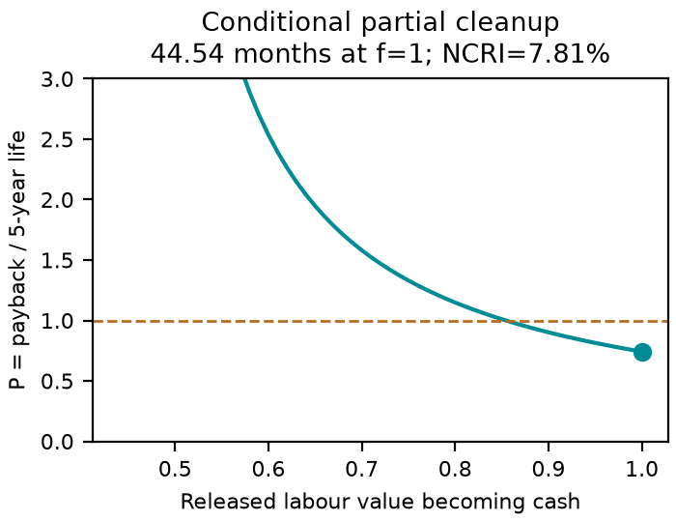 | Conditional workflow: staff time improves; elapsed room readiness remains slower.  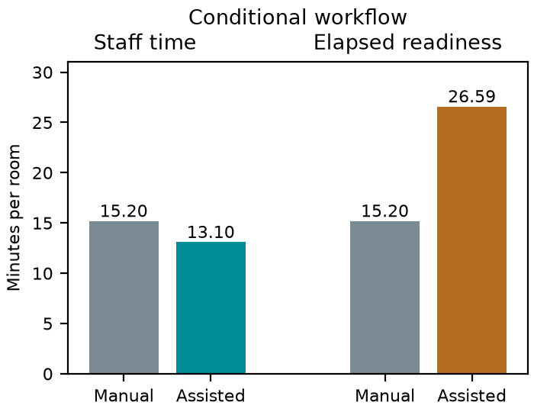

SECTION 4 · Simulation Telemetry, Monte Carlo Testing & Empirical Validation Component 1 · CDIO Robotics (10)
Evaluation protocol (titles sheet) | Test grasp success rate across N = 50 trials with 4 distinct object geometries (cups, bottles, slippers, crumpled paper). Measure grasp cycle time (s), mobile base positioning error (cm), and room turnover acceleration percentage.
Telemetry standard | Log at 500 Hz (MJCF timestep 0.002 s, or every 2nd step at 0.001 s): time, state (q, q̇ or pose, velocity), reference, tracking error, actuator torques/forces, FSM state, events. One CSV per run or one CSV with a run_id column.
Monte Carlo | N ≥ 30 runs per condition (more if your protocol says so). Randomise disturbances and initial conditions from stated distributions; record every random seed.
Required measures | Tracking RMSE = √(Σ‖p − p_ref‖² / n) on the end-effector path vs planned reach / lift trajectory; control effort E = ∫τ² dt (sum of τ²·Δt over all actuators); your primary task metric from the protocol.
Statistics | Compare the proposed controller with a baseline condition: Student's / Welch's t-test (two-sided, α = 0.05), Cohen's d = (x̄₁ − x̄₂) / s_pooled, and a 95 % confidence interval.
Where real trial data goes | Group_07_Soumil_Aditya_Priyansh/analytics/*_real_trials.csv, produced by your controller. Files named SIMULATED_* are starter targets, never results.
Owner | Team-assigned Telemetry QA Lead: Aditya Raju Shah (E062).

Baseline condition you compare against | Frozen historical pre-reliability controller vs revised controller; same MJCF, category knowledge and common evaluator/contact audit. This is robot-vs-robot, not a manual hospital time study.
Monte Carlo runs per condition (N) | 50 baseline + 50 proposed; all scheduled seeds and full raw audits passed. Complete rooms: baseline 0/50, proposed 28/50. Pilot excluded; interrupted infrastructure attempts archived and same seeds restarted; autonomous failures retained.
Randomised parameters and their distributions | Per-object x/y uniform in config.SPAWN rectangles; yaw Uniform[−π,π]. Shared geometric support/overlap/reachability acceptance, 1.5 s settling. Fixed base start, masses and friction. Accepted-layout bias disclosed; protocol.json contains every range.
Logging rate actually achieved (Hz) | 500 Hz, Δt=.002 s; all 100 raw audits passed. Maximum sample-interval error 1.8e-13 s.
Random seeds recorded for every run | Yes
Real-trials CSV path(s) in the repo | analytics/submission_trials/{baseline,proposed}/seed*/*_real_trials.csv.gz: all 100 reported runs at 500 Hz. EXPORT_MANIFEST.json and VERIFICATION.json record provenance; support/ retains events and final states. Verbose originals remain local.

Measure | N | Baseline mean ± SD | Proposed mean ± SD | Unit | Better? (direction)
Tracking RMSE | 50 scheduled/condition; valid n in FINAL_RESULTS.json | 0.051762 ± 0.0080588 | 0.051541 ± 0.0030074 | m; valid top-down reach/lift phases only | Lower is better
Control effort ∫τ² dt | 50 per condition | 64610 ± 22321 | 34042 ± 13165 | N²·s; lift actuator only. All other channels in actuator_effort.csv; mixed units not summed. | Lower is better
Restricted full-room completion time (all 16 correct); unsuccessful runs assigned 1800 s | 50 per condition | 1800 ± 0 | 1342.8 ± 412.49 | s; unsuccessful rooms assigned fixed 1800 s | Lower is better

Test used | Welch's t-test
t statistic, degrees of freedom, p-value (primary metric) | Welch two-sided: t=7.8373,df=49,p=3.391e-10.
Cohen's d (primary metric) | 1.5675; pooled-SD standardization; positive favors proposed for lower completion time.
95 % confidence interval of the difference | Baseline−proposed mean restricted-time difference: [339.95893, 574.41707] s; Welch 95% CI.

Audited representative proposed reach/lift trace; first scheduled seed; commanded reference, 5 Hz display of 500 Hz measurements.  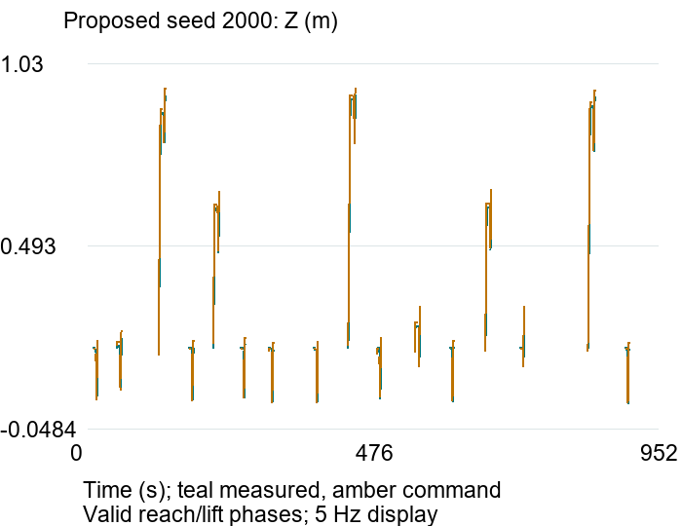 | Audited restricted completion time; fully cleared rooms: baseline 0/50, proposed 28/50. Failures retained at 1800 s.  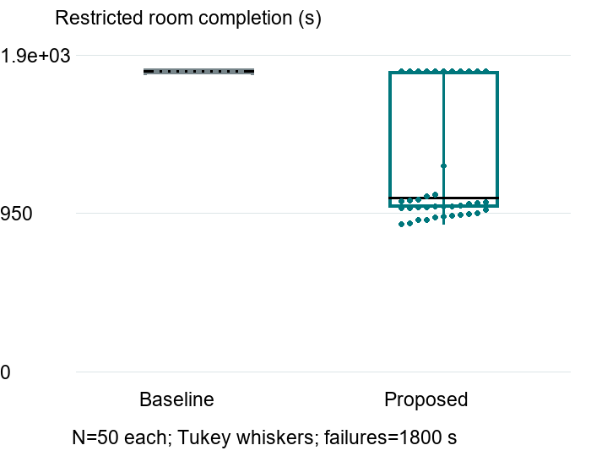

DATA PROVENANCE DECLARATION (mandatory). Reporting generated target numbers as experimental results is research misconduct and scores zero for this component.
Every number in Section 4 comes from MuJoCo runs of OUR controller, logged by our code | Yes
No value comes from SIMULATED_* files, generate_paper_figures.py or any np.random 'target' data | Yes
Our plots re-generate from the *_real_trials.csv files in the repo | Yes
Every input in Section 3 has a source or is labelled as an assumption | Yes

SECTION 5 · LinkedIn Video Showcase, AI Verification Audit & Peer Review Component 3 · Showcase & Viva (5)
LinkedIn post URL | https://lnkd.in/p/diSXTY-2
Video length (mm:ss) | 03:23.73 (203.73 seconds; supplied corrected export; original conservative business case)
Video shows the live MuJoCo simulation (not slides) | Yes
Video shows our business sensitivity graph | Yes
Webcam picture-in-picture: every member appears and speaks | Yes

5.1 AI Interaction Audit Log: three cases where AI gave wrong robotics or economic data
Examples: a wrong MuJoCo attribute or API call, an invented statistic, a correct paper given the wrong journal, an economic formula with the wrong units. Show how you checked each one with a textbook, the official documentation or the original paper.
# | AI tool | What we asked & what AI said | How we caught it | What was actually true (with source) | Error type | Verdict
AI-01 | Other | AI-assisted economics draft used a 2.1-minute robot cycle; origin/model attribution still needs team confirmation. | Ran / tested the code or simulation | Audited proposed 16-object pilot is 922.68 simulated s=15.378 min; raw audit in assessment_v1/pilot_analysis/analysis.json. Not a final mean. | Wrong number or statistic | Corrected
AI-02 | Other | AI-assisted economics draft reduced residual disinfection time by 35% without evidence; exact original tool needs confirmation. | Checked the original source | Hold residual cleaning unchanged. CDC Environmental Cleaning Procedures §4.2.3 defines discharge-cleaning scope; no clinical benefit follows from our rigid-body decluttering test. cdc.gov/healthcare-associated-infections/hcp/cleaning-global/procedures.html. | Wrong economics / cost logic | Corrected
AI-03 | Other | AI-assisted business reasoning treated freed staff time as automatically cash-releasing; exact original tool attribution needs confirmation. | Recomputed by hand | Reallocation alone does not reduce spending. Original f=0 case: NCRI=−.10, no payback. Revised f=1 partial-cleanup scenario: conditional 44.54-month payback, not proven savings. UK Government Efficiency Framework §§4.1–4.5 distinguishes cash from capacity benefits. | Wrong economics / cost logic | Corrected

5.2 Peer review: watch both assigned LinkedIn videos and score them (0–2 per criterion)
PROVISIONAL RATINGS: maximum scores entered at the user's request, pending actual video review. They are not independently verified assessments. Questions are prepared from the project topics; best-moment timestamps require the videos.
Group reviewed | Problem | Physics | Business | Data | Clarity | Best moment (mm:ss) | One question for the viva
Group 08: Vision-Guided Multirotor UAV for Last-Mile Flood Disaster Relief Delivery (SkyHydro) | 2 | 2 | 2 | 2 | 2 | 1:00 | Which disturbances and payload variations did you test, and how did they affect flight stability and delivery success?
Group 01: Autonomous Robot for Delivery of Critical Medicines in ICUs | 2 | 2 | 2 | 2 | 2 | 01:15 | How does the robot handle a blocked route or failed delivery, and how are delay and staff intervention included in the business model?

SECTION 6 · Individual Learning Record & Research Consent unmarked · one row per member · answer honestly
PROVISIONAL MEMBER-EDIT DRAFT: hours, role-fit/cross-skill answers, prior experience and AI-use/error counts below are suggested placeholders requested by the team, not verified personal history. Confirm or replace before submission. File lists show module allocation. Commit shares reflect course main before student upload.
These answers do not change your marks. They help improve the course and are used in anonymised research only if you consent in the sign-off below. Commit share: your commits ÷ the group's commits in your folder (git shortlog -sn -- <folder>).
Member | Hours I spent (total) | My declared role matched my actual work (1 = not at all, 5 = fully) | I learned a skill outside my role (robotics ↔ business) | Scripts I mainly wrote (file names) | My commit share (%) | Share of my writing first drafted with AI | Wrong AI facts / code I personally caught
Soumil Patro (E050) | 20 | 5 | Yes | hospital_business.py; business_inputs.json; business_fmea.json (module allocation) | 30 | 76–100 % | 1–2
Aditya Raju Shah (E062) | 20 | 5 | Yes | navigation.py; detection.py; grasp.py; telemetry.py (module allocation) | 30 | 76–100 % | 1–2
Priyansh Thakkar (E066) | 20 | 5 | Yes | controller.py; system.py; config.py; MJCF integration (module allocation) | 40 | 76–100 % | 1–2

Member | Before this course I had used a physics simulator | The most valuable thing I learned (one line) | One thing I would change in this course (one line)
Soumil Patro (E050) | No | Distinguish staff time released from actual cash savings and finite payback. | Introduce a sourced-input worksheet before ROI coding.
Aditya Raju Shah (E062) | No | Limit conclusions to the processes actually tested by the simulation. | Provide early examples of seeded logging, placement checks and failure analysis.
Priyansh Thakkar (E066) | No | Measure robot performance before making timing or operational-benefit claims. | Schedule an integration checkpoint before the final experiments.

Track A: how this dossier becomes your 4-page IEEE paper
I. Introduction | Section 1: title, verified baseline friction, governing standards
II. Related work | Section 1.1: verified sources only (5+ with DOIs)
III. System model | Section 2: MJCF model, FSM, equations, control law
IV. Techno-economics & evaluation | Sections 3–4: CSBS model, FMEA, Monte Carlo results, statistics
V. Discussion & limitations | Sim-to-real gap, assumptions in the business model, AI audit lessons
Target venues (titles sheet) | A: AIR · B: IEEE RO-MAN

Individual Academic Sign-off every member answers and signs
Code-runs entries reflect successful local package checks. Each member must confirm originality and viva readiness, choose optional research consent, and sign personally. A fresh repository checkout is still to be checked after upload.
Answer each statement for yourself: (1) this work is original and every source and AI use is declared; (2) our model loads and our controller and business scripts run from the repository; (3) I understand our whole project and can explain my own part in the viva voce.
Member (Roll) | (1) Original work | (2) Code runs | (3) Viva-ready | Signature | Optional research consent*
Soumil Patro (E050) | Yes | Yes | Yes | 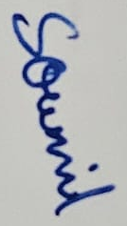 | Yes
Aditya Raju Shah (E062) | Yes | Yes | Yes | 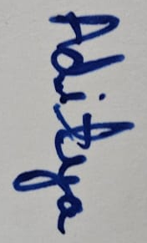 | Yes
Priyansh Thakkar (E066) | Yes | Yes | Yes | 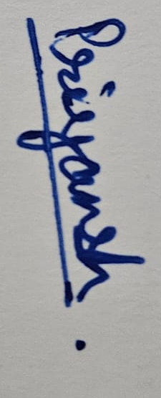 | Yes
*Optional: may Dr. Nanade use anonymised data from this dossier and repository in education research publications? Your answer has no effect on your marks, and you can withdraw until results are published.

