Scenarios(adding complexity):   
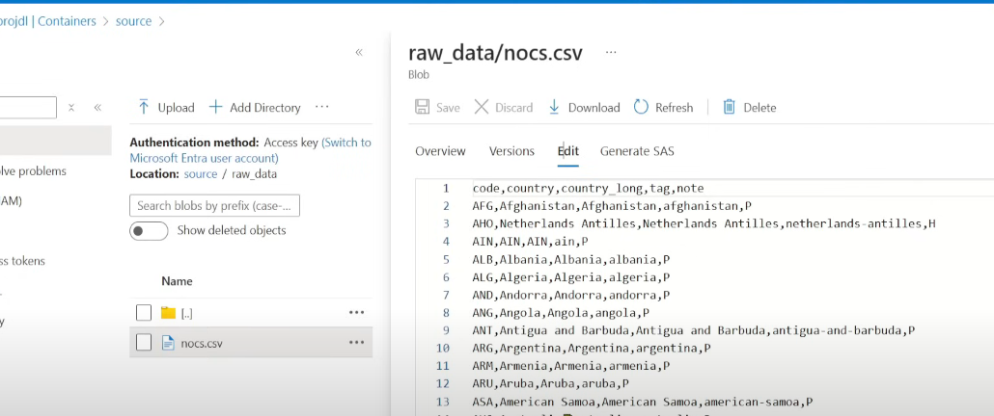  
1) Make sure that the file has 5 columns  
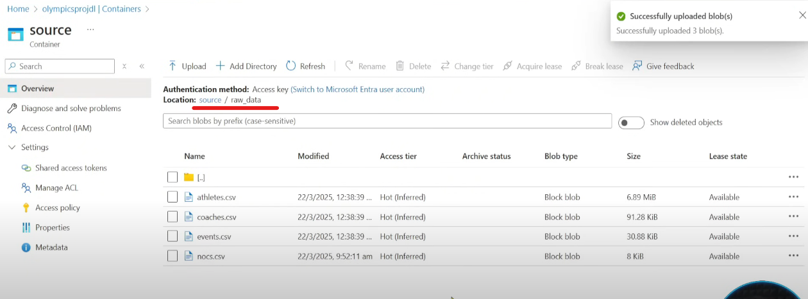  
2) We have to process only the nocs file but I want the count of other files also  
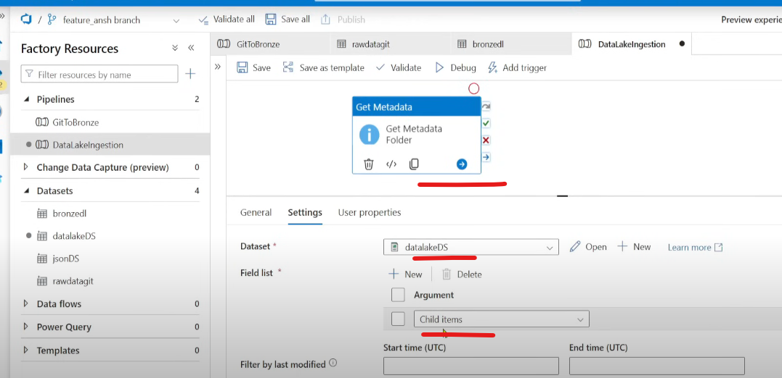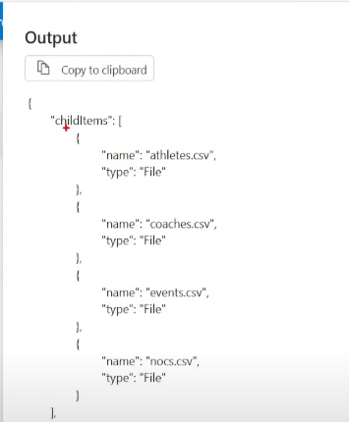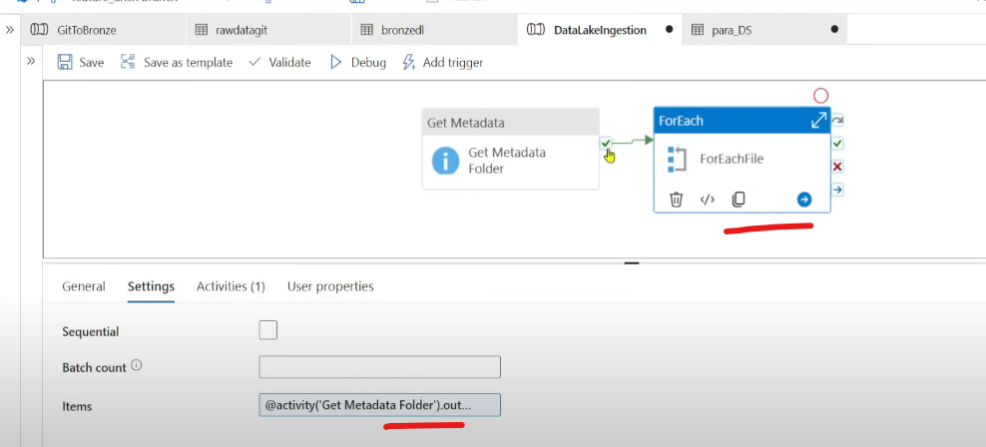  
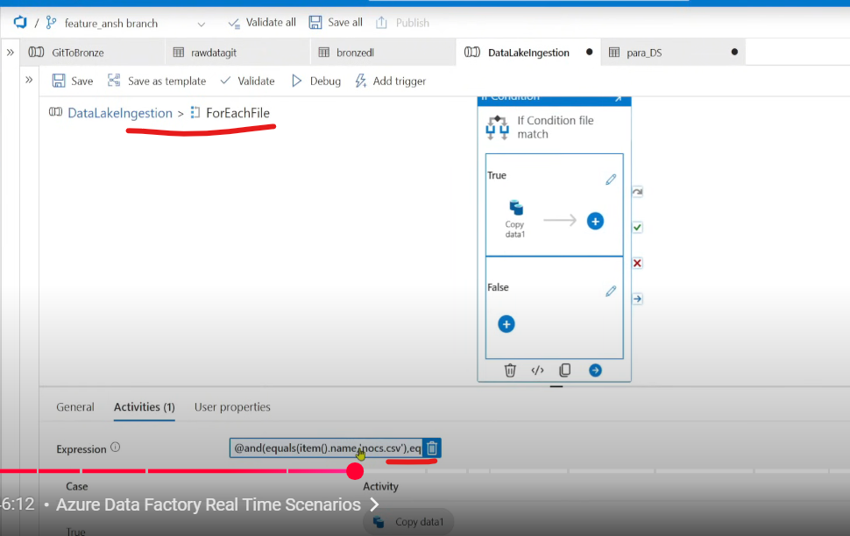  
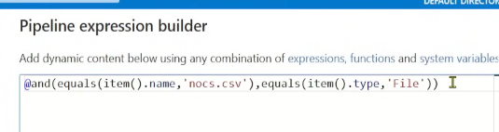  
True 🡪 Copy  
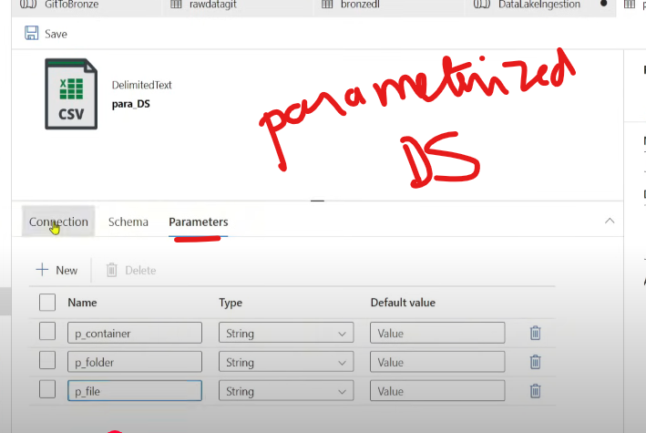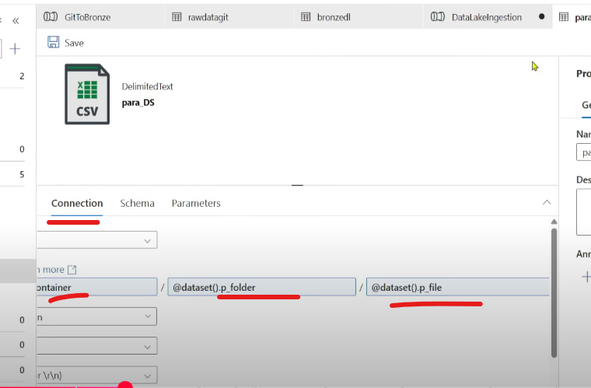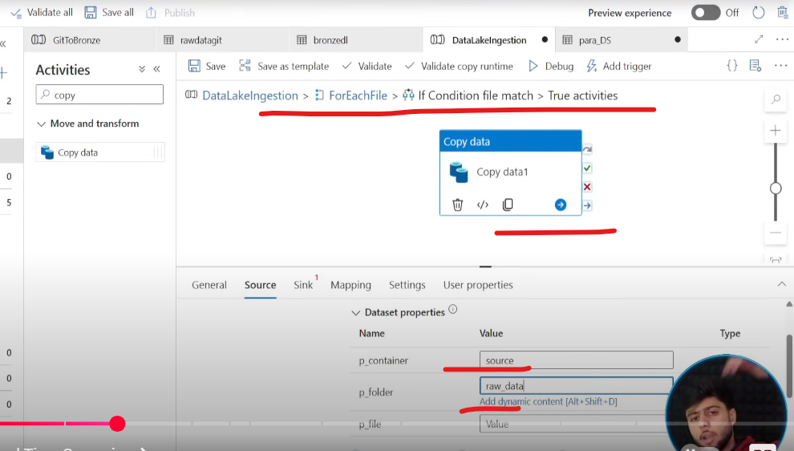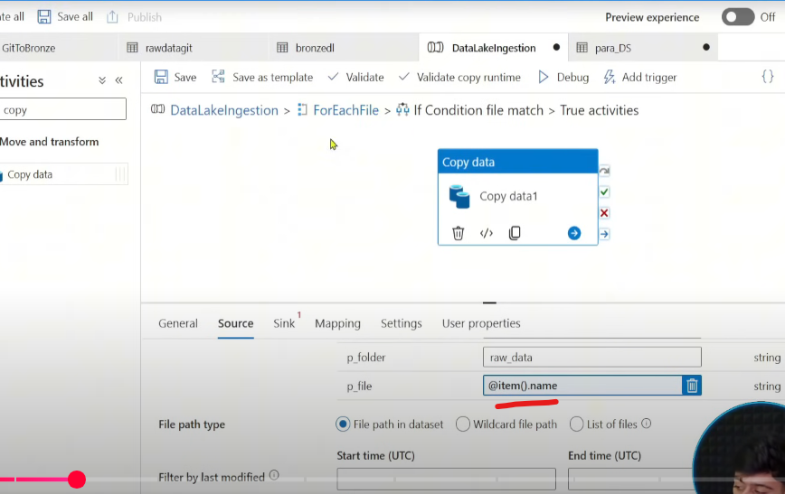

Lets create 3 variables 🡪 one to hold the names of the files apart from nocs, one to hole the count of items in the previous variable/array, one to convert the list of names in the array to string  
 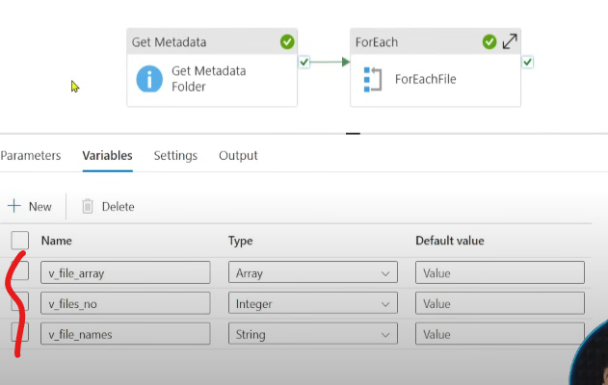  
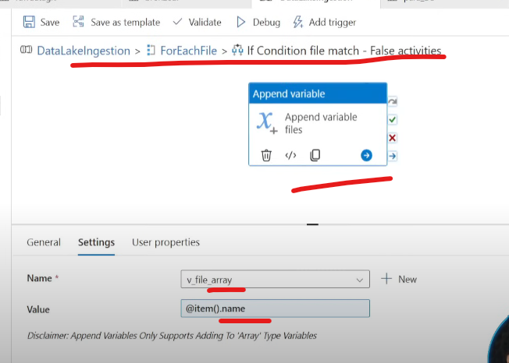  
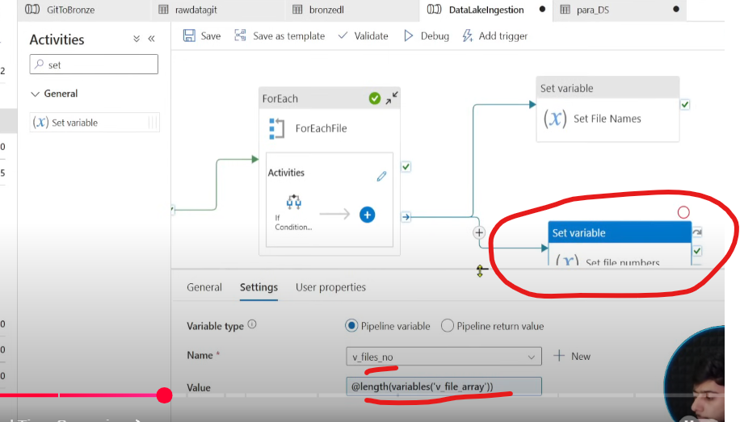  
Note both the set variable activities are connected with on completion of ForEach activity  
Run the pipeline  
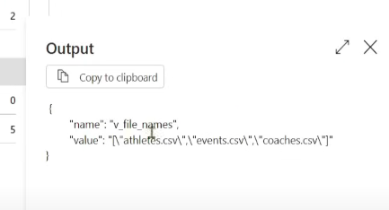  
Save all the changes in the FR  
Create a PR and complete and merge the FR with main branch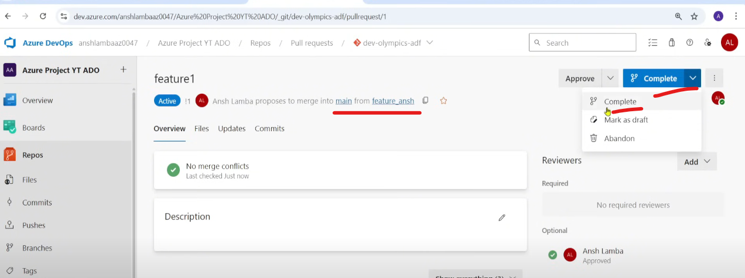  
post merge the main branch will be updated with the new changes, then publish to ADF Live mode, ADF bts will create ARM templates in adf_publish branch  
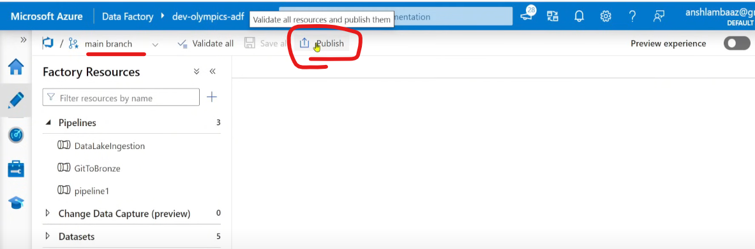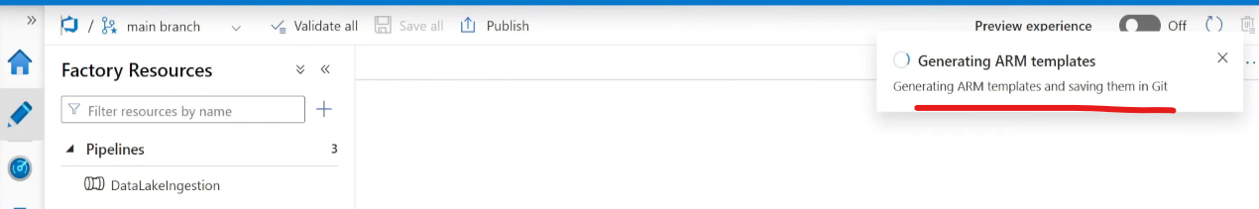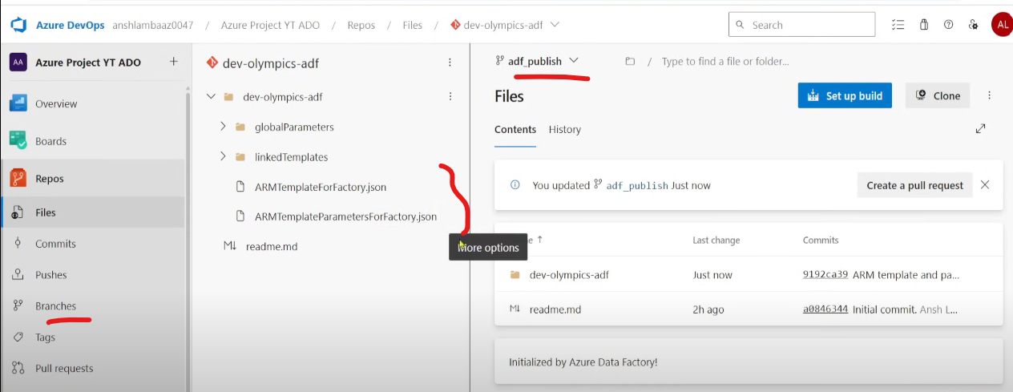  
This is the crux of ADF artifacts & also help us in the deployment  
  
Additional : You can see the changes done on FR with the main branch using Compare option  
