In Databricks Serverless, we cant see the Spark UI, we can only see the performance.  
  
Q1) Read data from ADLS in parquet and write in delta format along with table  
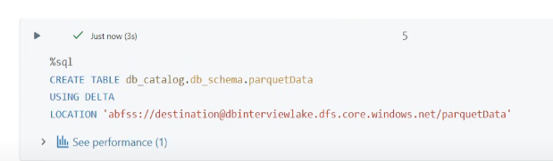Ensure to give same path  
You can also write saveAsTable instead of save to do in a single step

Q2) Incremental Data Loading 🡪 use Autoloader 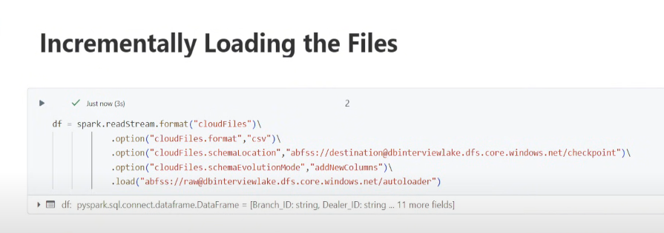  
Schema Evolution happens in Autoloader by default, schemaEvolutionMode happens in Autoloader by default no need of explicitly mentioning it.  
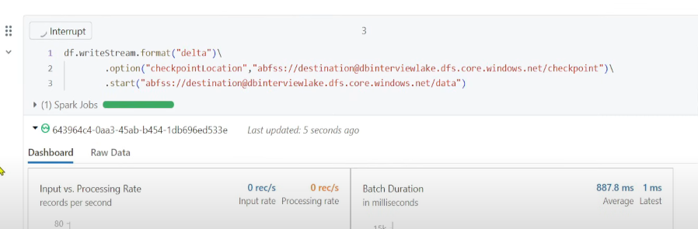  
Schema is present in this location 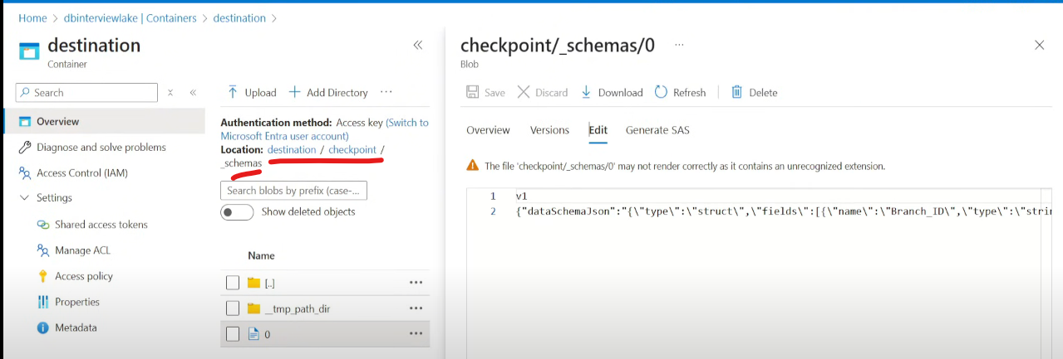

Now lets say there is schema change,and you want to rescue those columns, in destination I don’t want to add any further columns but I want to store those columns 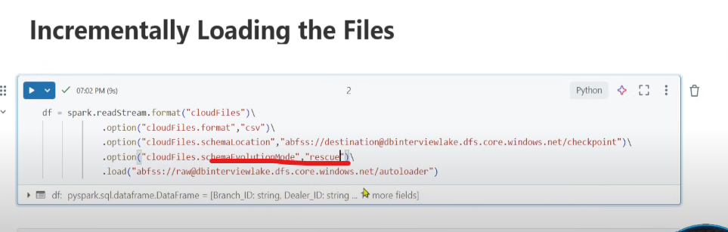  
All the new columns can be found in rescued_data column 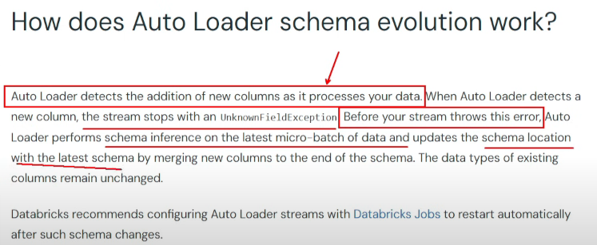 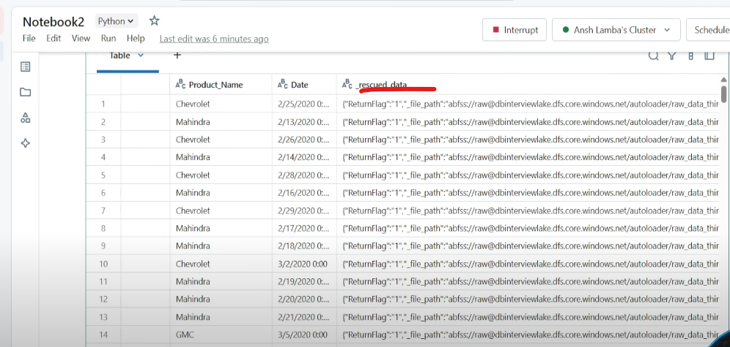 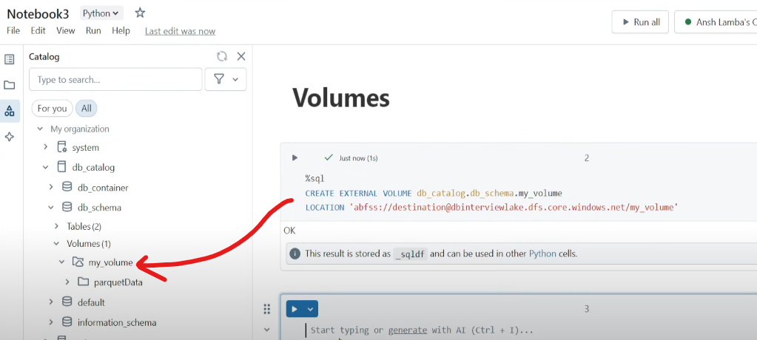  
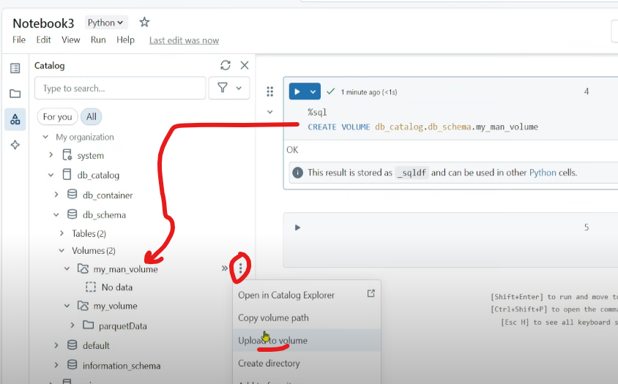  
To insert data 🡪 Upload to Volume

**Liquid Clustering**  
Liquid Clustering creates dynamic clusters on top of data, dynamic query behaviour  
 