Memorandum
To: Andres Fergadiotti, SCE
From: Yizhi Yang, Justin DeBlois, TRC
Date: May 6, 2026
Re: Technical memo for DEER Nonresidential Prototype Scorecards

DEER Prototype Scorecard Automated Generation Workflow

Purpose and Scope
The CPUC established the DEER nonresidential prototype building energy models in a newly adopted EnergyPlus modeling framework in 2023. While this effort completely revamped the energy models, no documentation of the model development process or the model inputs and assumptions exists. The CPUC, SCE and other stakeholders noted that this lack of documentation has made measure development and measure review more difficult. In addition, while several stakeholders noted differences in EUI and savings between the EnergyPlus prototypes, the previous generation of DOE-2 prototypes and other prototypes such as the CalBEM prototype models, there is no readily available reference documentation on the DEER prototypes. Establishing this documentation is seen as a key step in evaluating the DEER prototype models and comparing against recent efforts to characterize the building stock such as the CalBEM prototypes.
The purpose of this work is to document the DEER nonresidential prototype inputs by developing an automated process to create prototype scorecards. A scorecard is a structured summary of a prototype model that captures the key input parameters and outputs needed to understand and evaluate the prototype. These scorecards are expected to include geometry, envelope properties, thermostat settings, HVAC systems, ventilation, lighting, equipment, schedules, and energy usage results. By organizing this information in a standardized format, scorecards improve transparency of model inputs and outputs and provide a consistent basis for reviewing measure impacts. This work was requested by the CPUC and measure developers to support measure review and development and is timed to align with PY28 and the release of the CalBEM scorecards (NOR-Codes-Stds/CalBEM-Prototypes: California Prototypes Project). Parallel release of the DEER scorecards will enable easy comparison between the DEER and CalBEM two sets, as well as other prototypes such as the DOE prototypes. Developing and releasing an automated process for generating scorecards will allow stakeholders to update the scorecards in the future as the DEER repository continues to evolve with new measures, bug fixes and improvements.
The scorecard project includes the 26 nonresidential DEER prototype models as shown by Figure 3. The project team ran each building type for two vintages, 16 climate zones and five main HVAC systems (Table A1). The prototype version is the DEER repository as of 2/19/2026 and the prototypes are built for EnergyPlus v22.2.0. The scorecard format and the data fields included in the scorecards are based on feedback from the eTRM Modeled Measures SME meeting held on 12/9/2025 and sample CalBEM prototypes provided on 12/9/2025. The project team made additional adjustments to the format and data fields to improve clarity and automation.

Methodology

Overview of Scorecard Automated Generation Workflow
The team proposes a workflow to enable automated generation of DEER prototype scorecards, as shown in Figure 1. The workflow can be divided into four main steps:
- DEER prototype model generation and simulation, which produces EnergyPlus (EP) input and output files (e.g., idf, eio, html)
- Data extraction automation using Python to obtain values
- Post-processing with rule-based methods to transform and standardize the extracted data such as zone type categorization
- Scorecard generation, in which raw data is organized, additional values are computed using predefined equations in the spreadsheet, and the finalized results are populated across Excel tabs to produce the complete scorecard.

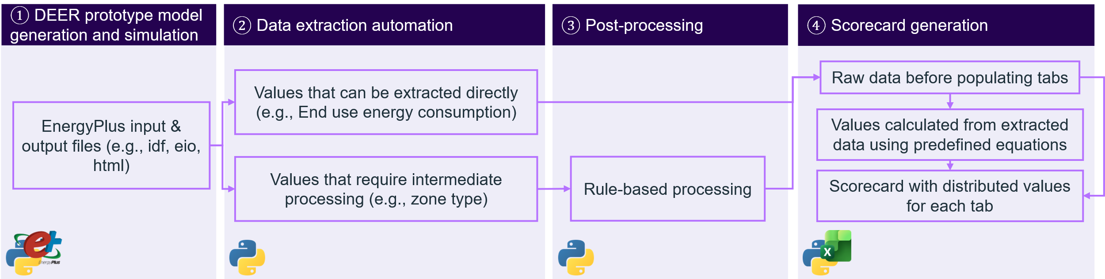
Figure 1. Workflow of scorecard automated generation

DEER Prototype Model Generation and Simulation
The DEER nonresidential prototype models use the Modelkit framework and draw from the DEER repository as of 2/19/2026. Modelkit, formerly called Params, is a free, open-source, cross-platform framework for parametric building energy modeling. It integrates templates and scripting: templates combine static content with dynamic inputs, while scripting automates the modeling process. In this workflow, Modelkit creates DEER prototype variants across building types, vintages, climate zones, and main HVAC systems in a scalable modeling environment. A Python workflow then automatically extracts and sorts the generated models and runs EnergyPlus (v22.2.0) to produce the required outputs. For example, the .eio file includes both standard and optional reports that can be easily imported into spreadsheet programs for further analysis. The weather file dictionary is hard-coded in the Python script to link the corresponding CZ2022 weather file to each climate zone (CZ) number for EnergyPlus simulations, as shown in Figure 2.
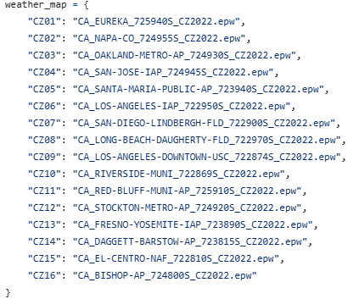
Figure 2. Hard-coded weather file dictionary in the Python script for EP simulation

Data Extraction Automation
Python-based automated scripts extract the data. A separate extraction function is used for each building attribute, such as zone summary, and HVAC system, to account for differences in building energy model data formats. The team organizes these extraction functions by data category and stores them in a Python script library to support modular data extraction and easier code management. These functions automatically parse EnergyPlus input (.idf) and output (.htm and .eio) files and export raw tables for downstream processing. Prototype names are hard coded in the Python script by linking each prototype to its abbreviation, as shown in Figure 3.
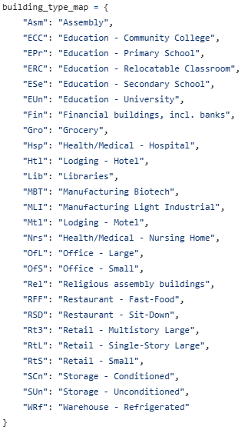
Figure 3. Hard-coded prototype full name dictionary in the Python script in raw data extraction

Data Post-processing
The team groups internal EnergyPlus model zones into defined zone type categories based on the original DEER prototype root files. The team uses natural language zone type names to improve readability. Python rule-based post-processing scripts automate this classification and aggregation step. After the team assigns zone types, the team aggregates key parameters by zone type. These parameters include outdoor air flow rate, lighting power density, plug load density, and gas power density. This supports consistent comparisons across zone types. The team also uses schedule identifier labels to group zone-level schedules. This makes schedule types easier to interpret. Some buildings include HVAC systems beyond the main configuration. For example, for the secondary school with HVAC name cAVVG, the boiler and chiller system is the main heating and cooling system, but it also has a furnace and direct expansion air conditioning systems serving the computer room and dining room. The team adds these systems to ensure the HVAC system information is complete. Dictionary-based rules identify and include these supplemental HVAC systems automatically.
All classifications and supplements rely on a dictionary that the team creates from the original DEER prototype root files. The dictionary uses a .json file format. The workflow uses the dictionary to identify additional HVAC systems, assign zone categories, and label the schedule identifier for each zone in the EP model. The Python workflow automatically reads and applies this .json dictionary during post-processing. The team can also edit the .json file to customize zone type names.

Spreadsheet Scorecard Generation
The team creates a spreadsheet template with predefined formulas but without any DEER prototype data in presenting Tab. The template includes a Geometry Summary tab to store the prototype shape image, aspect ratio, number of floors, floor-to-floor height, and floor-to-ceiling height. It also includes tabs for storing data extracted from EnergyPlus and tabs for presenting the scorecard results.
Python scripts populate the template by mapping the processed datasets into the appropriate tabs. The extracted data populates the designated tabs. The team then hides these tabs and uses them as source data for the scorecard presentation tabs. However, the tabs can be unhidden for review or exploratory purposes as needed. The workflow automatically generates the final scorecard files for each prototype without manual copy/paste.

Instructions for Using the Script
A Python-based script execution workflow was developed to automate the generation of DEER nonresidential prototype scorecards. The process is organized into three sequential runs:
- Prepare & Simulate, which sorts inputs and executes EnergyPlus models. Run 1 implements Step 1 of the methodology.
- Extract & Process, which extracts relevant results using a function library, applies rule-based intermediate processing, and compiles outputs into structured datasets. Run 2 implements Steps 2 and 3 of the methodology.
- Generate Scorecard, which converts the processed data into Excel tabs and populates a predefined scorecard template with built-in equations. Run 3 implements Step 4 of the methodology.
These three stages form an end-to-end automation pipeline that streamlines simulation and post-processing and ensures consistent, reproducible scorecard production across prototypes.
The user will start in the DEER-Prototypes-EnergyPlus-Working/ScorecardAutomation folder. After generating the DEER prototypes using the ModelKit workflow, the user will go to the ScorecardAutomation folder and run three Python scripts: Run1_Pre_Data_Extraction.py, Run2_Data_Extraction_Processing.py, and Run3_Scorecard_Generation.py. Before running the scripts, the user must update the required paths, including the DEER prototype folder path, the EP installation path, and the weather file path. Then the user runs the scripts in order: Run1, Run2, and Run3. Run1 will take the longest because it includes the EnergyPlus simulations. The supporting modules are located in DEER-Prototypes-EnergyPlus-Working /ScorecardAutomation/src. Figure 4 shows how the run scripts relate to the supporting scripts and templates. The expected outputs for each step are described in the following subsections, and the source files for extracted data are summarized in Table A. 1.
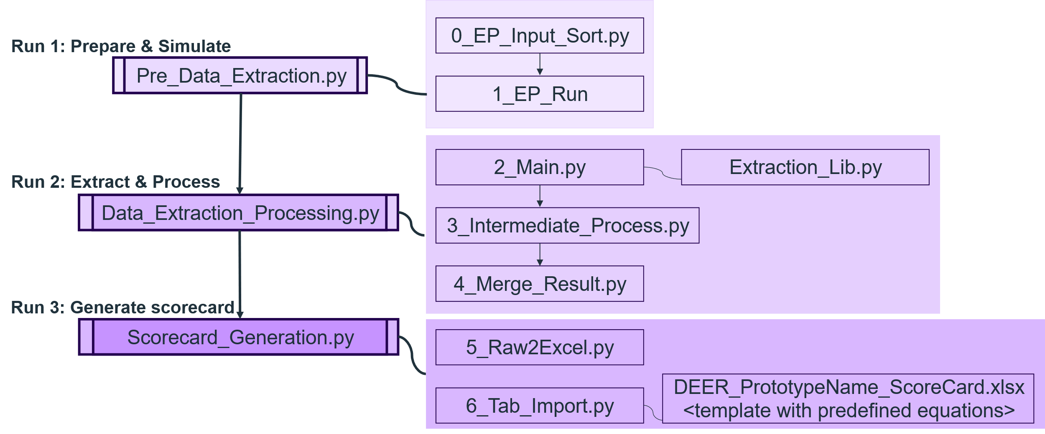
Figure 4. Python-based script execution workflow

Environment Setup Requirements
Before running the three scripts in order Run1_Pre_Data_Extraction.py, Run2_Data_Extraction_Processing.py, Run3_Scorecard_Generation.py. Two tables are provided for users to review the suggested system and software requirements and to complete the pre-run checklist. Table 1 summarizes the recommended setup and Table 2 presents the pre-run checklist.
Table 1. Recommendation for system and software requirements
Name | Recommendation
Operating System | Windows 11 (recommended)
Software | - Python 3 (recommended 3.10+)  - EnergyPlus installed (recommended EnergyPlusV22-2-0 given DEER prototype version)  - Microsoft Excel Desktop
Table 2. Pre-run checklist
Number | Checklist
1 | Python runs and points to intended environment
2 | EnergyPlus folder exists and contains energyplus.exe
3 | Weather folder contains required .epw files
4 | ScorecardAutomation/src exists and contains scripts 0–6
5 | Run1/Run2/Run3 “ONLY EDIT PATHS HERE” blocks updated
6 | Scorecard template file path is correct and Excel desktop works

Preparation and Simulation
After running Pre_Data_Extraction.py, the workflow executes two scripts in sequence: 0_EP_Input_Sort.py followed by 1_EP_Run.py. 0_EP_Input_Sort.py collects the EP input files from the Modelkit runs directories and reorganizes them into a clean folder structure under DEER-Prototypes-EnergyPlus-Working\ScorecardAutomation\EP_File by building type, vintage category, and California Energy Commission (CEC) climate zone. DEER-Prototypes-EnergyPlus-Working is the folder used for DEER prototype generation, and ScorecardAutomation is a subdirectory within the DEER-Prototypes-EnergyPlus-Working repository. The automation scripts use the ScorecardAutomation folder as the working module and reference shared repository resources (e.g., weather/, commercial measures/) via paths relative to the repository root. Next, 1_EP_Run.py iterates through the organized IDF folders, selects the appropriate EPW weather file based on the climate-zone folder name (CZ01–CZ16) and the weather-file dictionary in 1_EP_Run.py. It then programmatically updates each IDF to enforce the Inch-Pound table style and runs EP from the command line. The script saves outputs back to the same folder with a consistent prefix for later extraction and scorecard population. The resulting file and folder structure that organizes IDF files by climate zone, vintage, and prototype is shown in Figure 5.
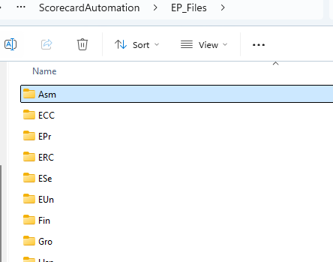 | 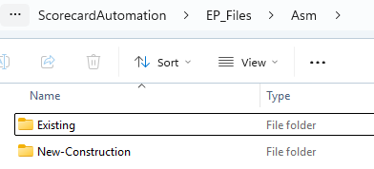
a. Folder path: EP_File | b. Folder path: EP_File/Asm
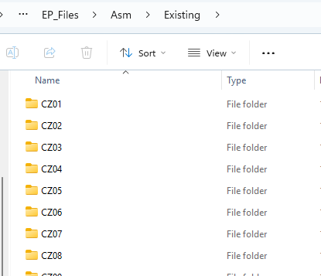 | 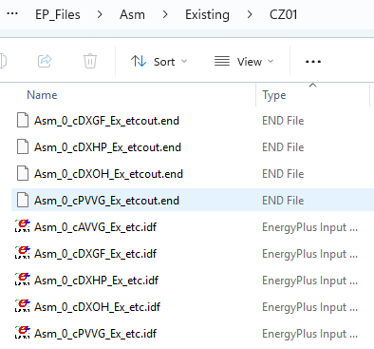
c. Folder path: EP_File/Asm/Existing | d. Folder path: EP_File/Asm/Existing/CZ01
Figure 5. Folder structure for the assembly prototype after running the pre-data processing scripts

Data Extraction and Processing
After running Data_Extraction_Processing.py, the workflow runs 2_Main.py, 3_Intermediate_Process.py, and 4_Merge_Result.py in sequence, and the workflow creates one final compiled data folder (Compiled_Data) and two intermediate data folders (Extracted_Data_Raw and Extracted_Data_Intermediate_Processed) under the EP_Files folder. The source-file mapping used for building attributes is documented in Appendix A Table A. 1, and the unit conversion rules applied during data extraction and processing are documented in Appendix A Table A. 2.
The script 2_Main.py acts as the primary extraction executor. It imports parsing functions from Extraction_Lib.py, walks through the organized EP_Files folder by building type and vintage, and reads the EP result files (.idf, .htm, and .eio) to extract key tables such as building metadata, window dimensions and sill height, shading geometry, zone summary, envelope, infiltration, water heater, OA controller, DHW peak flow, annual end uses, end-use breakdown, HVAC, fan, refrigeration, thermostat setpoints, schedules, and gas equipment.
During this extraction stage, Extraction_Lib.py performs required unit conversions to standardize values to Inch-Pound (IP) units where EP input (.idf) and output (.eio) remain in SI units (for example, converting geometry from meters to feet, airflow from m³/s to cfm, infiltration from m³/s·m² to cfm/ft², equipment intensity from W/m² to Btu/h-ft², fan pressure from Pa to inches water column, envelope U-values from W/m²·K to Btu/h-ft²·°F and hot water volume flow rate from m³/s to gal/hr). It then writes them into a structured multi-section CSV in Extracted_Data_Raw. The generated folder and datasets are shown in Figure 6.
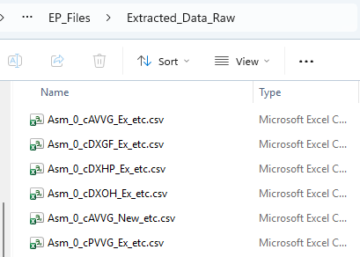
Figure 6. Folder of Extracted_Data_Raw
Next, the script 3_Intermediate_Process.py applies rule-based post-processing to these raw extracted tables. It generates and uses a zone-type and HVAC-identifier mapping from the prototype root.pxt files, applies aggregation rules (for example, area-weighted summaries using zone multipliers), and standardizes or enriches tables (such as adding HVAC and schedule identifiers to summary tables) to produce cleaner intermediate CSVs in Extracted_Data_Intermediate_Processed. This step also performs key unit conversions for downstream aggregation and scorecard calculations, including converting thermostat setpoints and temperature schedules from °C to °F and converting lighting and plug intensities from Btu/h to Watts where required. The generated folder and datasets are shown in Figure 7.
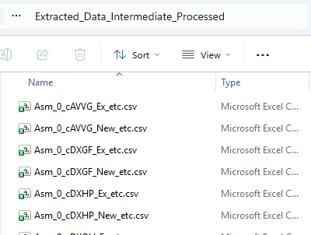
Figure 7. Folder of Extracted_Data_Intermediate_Processed.
Next, the script 4_Merge_Result.py compiles the processed outputs by integrating results across the five HVAC configurations and two vintages into a consolidated dataset for each prototype. It merges and de-duplicates the intermediate CSV sections, appends vintage and HVAC configuration tags, and writes a single compiled output file named by prototype to the Compiled_Data folder.The generated folder and datasets are shown in Figure 8.
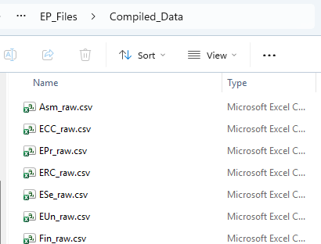
Figure 8. Folder of Compiled_Data

Automated Scorecard Generation
After running the Scorecard_Generation.py, 0_Raw2Excel.py converts each compiled .csv file in EP_Files\Compiled_Data into an Excel workbook saved under Tab_from_Raw, as shown in Figure 9. Each table section in the CSV becomes a separate worksheet with a Raw_ prefix and a corresponding sheet name, as shown in Figure 10.
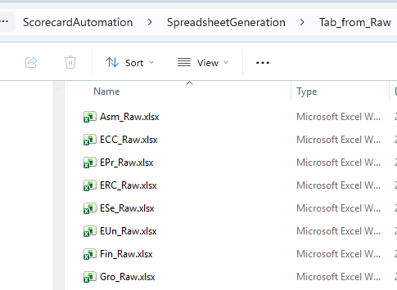
Figure 9. Folder of excel workbook that extract data from run 2
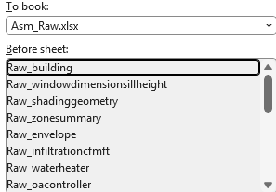
Figure 10. Sheet name inside each Excel workbook
Next, the script 1_Tab_Import.py opens the scorecard template (DEER_PrototypeName_ScoreCard.xlsx) which includes predefined formulas, and the corresponding raw tab workbook. It copies each raw sheet into the matching template tab and hides the Raw_ tabs. It removes trailing placeholder rows in selected tabs. It generates the Schedule figures and keeps the charts linked to the Schedules tab. Finally, it saves a finalized scorecard workbook for each prototype, as shown in Figure 11.
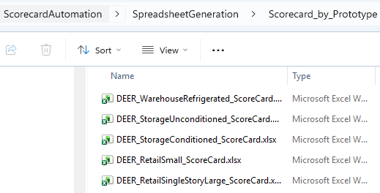
Figure 11. Folder of final prototype scorecards

Next Steps
The team recommended next steps that build on the DEER scorecards to identify specific changes that will improve the accuracy and reliability of the DEER prototypes and establish a pathway towards implementing these changes.
- Compare the DEER scorecards to the CalBEM scorecards and document the ways that they differ structurally (e.g. building type, HVAC type and vintage selection), by model assumptions (e.g. gains and schedules), and by model results. Document any deficiencies found in the DEER prototypes and identify the impact on results.
- Compare DEER measure savings against savings calculated with the CalBEM models, for sample measures.
- Review the possible pathways towards implementing technical improvements to the DEER prototypes to address structure, inputs and assumptions, and functionality of the modeling framework. Identify the challenges and limitations for each pathway.
- Appendix A
Table A. 1. Source file mapping for building attributes in Run 2
Building Attribute | Source File
Building Type | DEER prototype name
Building Category | DEER prototype name
Roof Type | Idf¹
Window-Wall Ratio | Html²
Window Dimensions | Eio³
Window Sill Height | Idf
Shading Geometry | Idf
Run Begin Day | Idf
Special Days | Idf
Zone Area / Volume | Html
Zone Multipliers | Html
Lighting Density | Html
Plug Load Density | Html
People Density | Html
Outdoor Air (per area/person) | Idf
Zone Type Mapping | Pxt⁴
HVAC Identifier | Pxt
Construction Layers | Idf
Roof/Wall U-Value | Html
Window U-Value / SHGC / VT | Idf
HVAC Parameters (including system type, air distribution system type, cooling efficiency and heating efficiency) | Idf
Fan Parameters | idf + html
Gas Equipment | Idf
Refrigeration System | Idf
Thermostat Setpoints | Idf
Water Heater Properties (including fuel type, system efficiency, capacity, tank volume and tank losses) | idf + html
DHW Peak Flow by Zone | Idf
Total End Uses | Html
End Use Breakdown | Html
Annual Electricity / Gas | Html
Schedule Profiles | eio + idf
¹Idf: EnergyPlus Input Data File for DEER nonresidential prototypes
²Html: result file produced by EnergyPlus simulation
³Eio: EnergyPlus Invariant Output file generated after EnergyPlus simulation
⁴Pxt: prototype root template in the DEER-Prototypes-EnergyPlus repository, located at DEER-Prototypes-EnergyPlus/prototypes/<DEER non residential prototype abbreviation>/templates/root.pxt

Table A. 2. Unit conversion of building attributes during Run 2
Building Attribute | Start unit | Converted unit (output after Run 2) | Processed scripts
Window width / height | m | ft | Extraction_Lib.py (during 2_Main.py)
Window sill height | m | ft
People density | ft² per person | persons/1000 ft²
OA flow per person | m³/s-person | cfm/person
OA flow per floor area | m³/s·m² | cfm/ft²
Infiltration rate | m³/s·m² | cfm/ft²
Gas equipment power density | W/m² | Btu/h-ft²
Fan static pressure | Pa | in. w.c.
Window U-value | W/m²·K | Btu/h-ft²-°F
DHW peak flow | m³/s | gal/hr
Thermostat setpoints | °C | °F | 3_Intermediate_Process.py
Temperature setpoint schedules | °C | °F
Lighting / plug intensity | Btu/h-ft² | W/ft²

CalBEM is the California Building Energy Modeling stakeholder collective and annual statewide event hosted by SCE on behalf of the California Investor-Owned Utilities (https://calbem.ibpsa.us/)
https://www.energycodes.gov/prototype-building-models
https://github.com/sound-data/DEER-Prototypes-EnergyPlus
https://bigladdersoftware.com/projects/modelkit/

