**Naan Mudhalvan Phase 4 Assessment**

**Course Name :** Internet of Things

**Project Title :** Smart Water Management

**Team Name :**  Tech Enthusiast

**Github link** : https://github.com/soundar98/IoT

**Team Members :**

|  |  |  |
| --- | --- | --- |
| **Name** | **Register number** | **Naan Mudhalvan**  **ID** |
| Senthilnathan J R | 721221106093 | au721221106093 |
| Vimal N | 721221106119 | au721221106119 |
| Soundar S | 721221106098 | au721221106098 |

**Project Objectives:**

The main objective of this project is to develop a real-time water consumption monitoring system using IoT sensors, Raspberry Pi, and a mobile app. The system will enable users to track their water usage in real time, identify leaks and excessive water consumption, and set water conservation goals.

**Software used :** Visual Studio

**Technological Stack:**

* HTML
* CSS
* JAVASCRIPT

**Web page:**

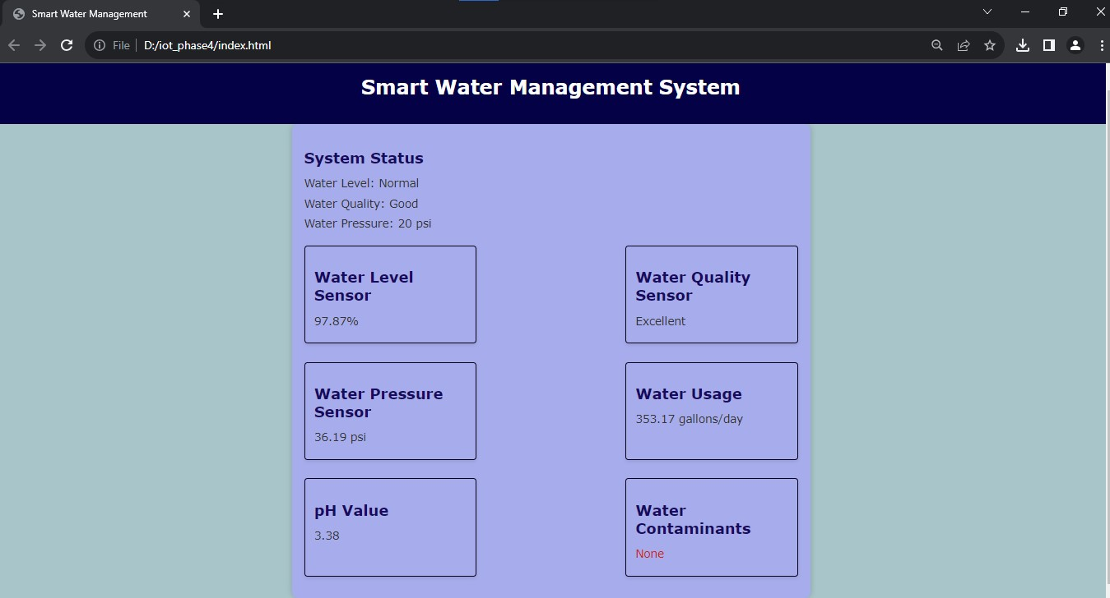

**Web development:**

The Smart Water Management webpage utilizes HTML for structure, CSS for styling, and JavaScript for real-time data updates. It features user-friendly design, data visualization, and simulated sensor data, making it a visually appealing platform for water resource monitoring**.**

**HTML:**

We have a simple interface for viewing real-time Smart Water Management.

<!DOCTYPE html>

<html>

<head>

<meta charset="UTF-8">

<title>Smart Water Management</title>

<link rel="stylesheet" type="text/css" href="style.css">

</head>

<body>

<div id="header">

<h1>Smart Water Management System</h1>

</div>

<div id="container">

<div id="status">

<h2>System Status</h2>

<p>Water Level: <span id="waterLevel">Normal</span></p>

<p>Water Quality: <span id="waterQuality">Good</span></p>

<p>Water Pressure: <span id="waterPressure">20 psi</span></p>

</div>

<div id="sensors">

<div class="sensor-reading">

<h2>Water Level Sensor</h2>

<p><span id="waterLevelSensor">75%</span></p>

</div>

<div class="sensor-reading">

<h2>Water Quality Sensor</h2>

<p><span id="waterQualitySensor">Excellent</span></p>

</div>

<div class="sensor-reading">

<h2>Water Pressure Sensor</h2>

<p><span id="waterPressureSensor">20 psi</span></p>

</div>

<div class="sensor-reading">

<h2>Water Usage</h2>

<p><span id="waterUsage">500 gallons/day</span></p>

</div>

<div class="sensor-reading">

<h2>pH Value</h2>

<p><span id="pHValue">7.0</span></p>

</div>

<div class="sensor-reading">

<h2>Water Contaminants</h2>

<p><span id="waterContaminants">None</span></p>

</div>

</div>

</div>

<div id="graphic-picture">

</div>

<script src="script.js"></script>

</body>

</html>

**CSS:**

Create a stylesheet (styles.css) to define the layout and styling of your webpage.

body {

font-family: 'Verdana', sans-serif;

background-color: #ffffff;

color: #333;

margin: 0;

padding: 0;

}

#header {

background-color: #050146;

color: #fffefe;

text-align: center;

padding: 20px;

}

#container {

max-width: 800px;

margin: 0 auto;

background-color: #a7acec;

box-shadow: 0px 0px 10px rgba(0, 0, 0, 0.2);

padding: 20px;

border-radius: 10px;

}

#status, #sensors {

font-size: 18px;

}

#sensors {

display: flex;

flex-wrap: wrap;

justify-content: space-between;

}

.sensor-reading {

flex: 0 0 calc(33.333% - 20px);

padding: 15px;

margin: 15px 0;

background-color: #a7acec;

border: 1px solid #09021d;

border-radius: 5px;

box-shadow: 0 3px 6px rgba(0, 0, 0, 0.1);

}

h2 {

font-size: 24px;

color: #170a61;

margin-bottom: 15px;

}

p {

font-size: 18px;

margin: 10px 0;

color: #333;

}

#waterContaminants {

color: #c72512;

}

#graphic-picture {

text-align: center;

}

img {

max-width: 100%;

height: auto;

}

**JAVASCRIPT:**

Use JavaScript (app.js) to simulate real-time Smart Water Management updates.

const simulatedData = {

waterLevel: "Normal",

waterQuality: "Good",

waterPressure: "20 psi",

waterLevelSensor: "75%",

waterQualitySensor: "Excellent",

waterPressureSensor: "20 psi",

waterUsage: "500 gallons/day",

pHValue: "7.0",

waterContaminants: "None",

};

function updateSensorData() {

document.getElementById("waterLevel").textContent = simulatedData.waterLevel;

document.getElementById("waterQuality").textContent = simulatedData.waterQuality;

document.getElementById("waterPressure").textContent = simulatedData.waterPressure;

document.getElementById("waterLevelSensor").textContent = simulatedData.waterLevelSensor;

document.getElementById("waterQualitySensor").textContent = simulatedData.waterQualitySensor;

document.getElementById("waterPressureSensor").textContent = simulatedData.waterPressureSensor;

document.getElementById("waterUsage").textContent = simulatedData.waterUsage;

document.getElementById("pHValue").textContent = simulatedData.pHValue;

document.getElementById("waterContaminants").textContent = simulatedData.waterContaminants;

}

updateSensorData();

setInterval(() => {simulatedData.waterLevelSensor = (Math.random() * 100).toFixed(2) + "%";

simulatedData.waterQualitySensor = ["Excellent", "Good", "Fair", "Poor"][Math.floor(Math.random() * 4)];

simulatedData.waterPressureSensor = (Math.random() * 50 + 10).toFixed(2) + " psi";

simulatedData.waterUsage = (Math.random() * 1000).toFixed(2) + " gallons/day";

simulatedData.pHValue = (Math.random() * 14).toFixed(2);

simulatedData.waterContaminants = ["None", "Chlorine", "Lead", "Bacteria"][Math.floor(Math.random() * 4)];

updateSensorData();

}, 5000);

**Water Data Collection:**  
**Data Sources:**  
Gather real-time water-related data from diverse sources, including sensors, water quality monitoring equipment, usage meters, and government databases. This data provides a comprehensive view of water resources.  
  
**Data Processing and Analysis:**  
 Process and analyze the collected data to gain valuable insights into water levels, quality, pressure, and potential contaminants. Leverage data analytics and machine learning to predict water patterns and offer proactive water management recommendations.  
  
**Data Storage:** Establish a secure and robust database to store both historical and real-time water data. Ensure that data security and privacy compliance standards are met to safeguard sensitive information.  
  
**API Development:**  
Create APIs that enable data access for various components, including the web interface.  
  
**Web Interface:**  
  
**User Types:**  
Identify different user categories such as consumers, water utility managers, and environmental agencies. Tailor features to address the specific needs of each group.  
 **Real-Time Water Updates:**  
Provide users with real-time information on water resources, including water level, quality, pressure, and water usage statistics.  
  
**Consumption Tracking:**  
 Enable users to monitor their water consumption, set goals, and receive notifications about excessive or unusual usage.  
  
**Water Quality Alerts:**  
Send timely alerts to users regarding changes in water quality, such as potential contaminants, pH level fluctuations, or other critical events.  
  
**Community Interaction:**  
Allow users to report water-related issues or concerns, share experiences, and engage with the community. Implement a user rating system to validate reported incidents for accuracy.  
 **User Profile and Preferences:**  
Give users the ability to customize their profiles, set preferences, and receive personalized recommendations.  
  
**Data Visualization:**  
 Use interactive maps and charts to present water-related data in a user-friendly manner, making it easy for users to grasp complex information at a glance.  
  
**Data Security and Privacy:**  
Implement stringent security measures to protect user data and ensure the system's integrity.  
Adhere to data protection regulations, such as GDPR or CCPA, as applicable, to maintain user privacy and compliance.

**Deployment:**Deploy the web platform on reliable servers and cloud infrastructure to ensure scalability and accessibility.

**Conclusion:**

In summary, this code is designed to monitor the water level in a container, display it on an LCD screen, and provide visual and audible alerts based on the water level. It uses an ultrasonic sensor to measure the distance to the water surface, calculates the percentage fullness, and provides feedback through LEDs and a piezo buzzer.