# Hyland-OnBase

# Application Migration Assessment

# Discovery and Design

**Overview**

[**Hyland OnBase**](https://chatgpt.com?q=Hyland%20OnBase) is an **enterprise content management (ECM) and workflow automation platform** that helps organizations capture, manage, store, and distribute digital content. It is widely used in industries like **healthcare, finance, government, and higher education** for document management, case management, and business process automation.

**Application Profile**

OnBase is a **modular platform** consisting of the following key components:

* **Document Repository**: Secure centralized storage for documents, images, and records.
* **Workflow Engine**: Automates business processes using rules-based routing and task management.
* **Capture & Scanning**: Supports OCR (Optical Character Recognition), ICR (Intelligent Character Recognition), and barcode recognition.
* **Integration Services**:Connects with third-party applications like **SAP, Salesforce, Epic (for healthcare), and Microsoft 365**.

**Methodlogy**

**Hyland OnBase** follows a structured methodology to ensure **successful implementation, optimization, and migration** across different environments (on-premises, cloud, or hybrid). This methodology includes **discovery, design, deployment, and ongoing support**, aligned with **enterprise content management (ECM) best practices**.

Enterprise Content Management (**ECM**) is essential for **organizing, storing, and managing digital content** efficiently. Proper **ECM implementation** ensures **compliance, security, automation, and seamless integration** across an organization. Below are industry **best practices** for deploying and optimizing ECM systems like **Hyland OnBase, OpenText, SharePoint, and IBM FileNet**.

**Architecture and Platform(Current)**

**Current-Logical View**

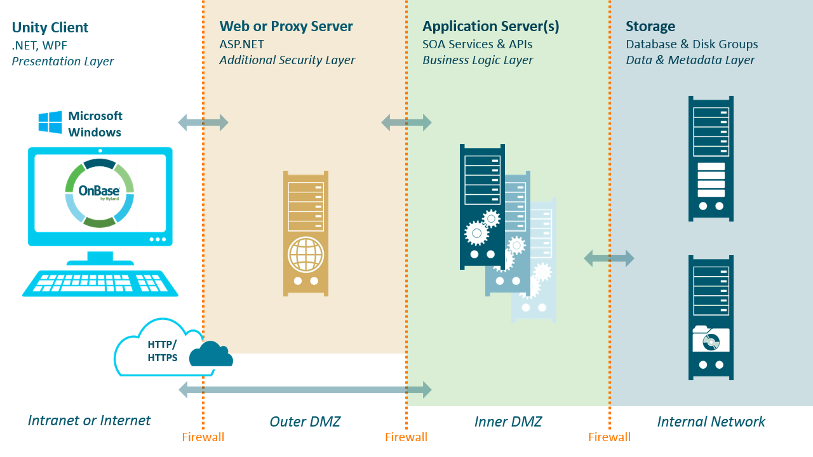

**Current -Physical view**

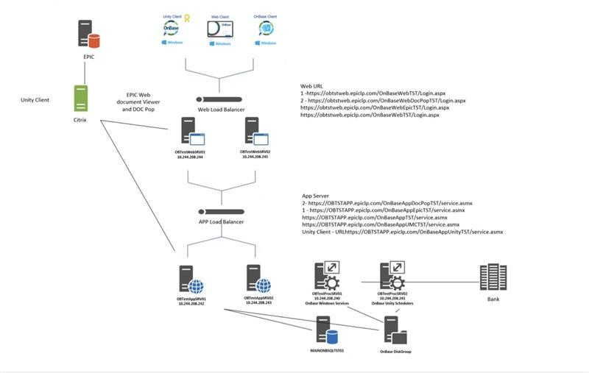

**Users → Web Client / Unity Client / Mobile App**

**→ Load Balancer (NGINX, F5)**

**→ OnBase Application Server (Windows Server, IIS)**

**→ SQL Database Server (SQL Server / Oracle)**

**→ Document Storage (SAN/NAS)**

**→ Integration Layer (SAP, Epic, Microsoft 365)**

**Findings and Recommendations**

**Infrastructure**

**Scalability Limitations:**On-premises deployments can be less scalable than cloud solutions, potentially leading to bottlenecks and performance issues as your business grows.

**Dependency on Infrastructure:**You're reliant on your own IT infrastructure, which can be prone to outages, failures, or security breaches.

**Complexity of Management:**Managing and maintaining an on-premises OnBase environment can be complex, requiring specialized expertise.

**Integration Challenges:**Integrating OnBase with other on-premises systems can be complex and time-consuming.

**Limited Mobility:**On-premises deployments can limit user access to OnBase from outside your physical network.

**Resource Strain:**On-premises deployments can strain your IT resources, potentially diverting them from other critical tasks.

**Recommendations**

### ****Compute – Application & Web Servers****

| **On-Premises** | **Azure Cloud Equivalent** | **Recommendation** |
| --- | --- | --- |
| Physical/VM Windows Servers for **OnBase Application Server** | **Azure Virtual Machines (VMs) – Windows Server 2019/2022** | Use **D-Series or E-Series VMs** with **autoscaling** enabled. |
| IIS Web Server for **OnBase Web Client** | **Azure App Service (PaaS) or Azure VM (IIS-based)** | Azure **App Service** is preferred for **managed hosting**. |

### ****Database – Metadata & Workflow Storage****

| **On-Premises** | **Azure Cloud Equivalent** | **Recommendation** |
| --- | --- | --- |
| **SQL Server or Oracle Database** | **Azure SQL Managed Instance or SQL Server on Azure VM** | Use **Azure SQL Managed Instance** for **lower maintenance & auto-scaling**. |

### ****Storage – Document Repository****

| **On-Premises** | **Azure Cloud Equivalent** | **Recommendation** |
| --- | --- | --- |
| **SAN/NAS File Storage** | **Azure Blob Storage (Hot & Cold Tiers)** | Store documents in **Azure Blob Storage** for **scalability & cost optimization**. |
| **Local File System for Document Caching** | **Azure Files (SMB/NFS Storage)** | Azure Files allows **SMB-based access** for legacy integrations. |

### ****Networking & Security****

| **On-Premises** | **Azure Cloud Equivalent** | **Recommendation** |
| --- | --- | --- |
| **Local LAN for Internal Users** | **Azure Virtual Network (VNet) + ExpressRoute** | Use **ExpressRoute** for **low-latency hybrid connectivity**. |
| **Active Directory Authentication (AD)** | **Azure AD with Hybrid Sync** | Sync with **Azure AD Connect** for **SSO & MFA security**. |

**Lower Infrastructure Costs –** No need for on-prem hardware & maintenance.

**Pay-as-you-go pricing – Scale resources up/down as needed.**

**Azure Reserved Instances (RI) – Save up to 72% on VM costs.**

**Security and Compliance**

**Increased Security Burden:**You're responsible for securing your own infrastructure and data, which can be a significant burden.

**Vulnerability to Cyberattacks:**On-premises systems are vulnerable to various cyberattacks, including ransomware and data breaches.

**Compliance Challenges:**Ensuring compliance with industry regulations and standards can be challenging.

**Recommendations**

**To protect data, ensure compliance, and prevent unauthorized access, follow these best practices when migrating Hyland OnBase to Azure:**

**Identity & Access Management (IAM)  
 Azure Active Directory (Azure AD) Integration** Use Azure AD Single Sign-On (SSO) for seamless authentication.  
 Enforce Multi-Factor Authentication (MFA) to secure user logins.  
 Enable Conditional Access Policies (e.g., restrict access based on device/location).Assign least privilege access using RBAC on Azure resources.  
 Configure Hyland OnBase user roles based on business functions.

**Data Protection & Encryption  
 Encryption at Rest & In-Transit** Use Azure Storage Encryption (AES-256) for document repository.  
 Enable Transparent Data Encryption (TDE) for Azure SQL Managed Instance.  
 Use TLS 1.2+ for secure communication between OnBase servers and clients.

**Azure Key Vault for Secrets Management** Store encryption keys, passwords, and API tokens securely.  
 Use Hardware Security Module (HSM)-backed keys for compliance.

**Compliance & Audit Controls** Enable Azure Policy & Compliance Monitoring  
 Use Azure Policy to enforce compliance with GDPR, HIPAA, and SOX.Enable Azure Security Center & Microsoft Defender for Cloud to monitor threats.

**Audit Logging & Monitoring** Enable Azure Monitor & Log Analytics for real-time event tracking.  
 Use Azure Sentinel (SIEM) for threat detection & response.

**TCO Assessment and Management**

**Financial Risks:**High Initial Investment:On-premises deployments require significant upfront costs for hardware, software licenses, and implementation.

**Ongoing Maintenance Costs:**You'll need to budget for ongoing maintenance, upgrades, and support for the hardware and software infrastructure.

**Hidden Costs:**Don't forget to factor in costs for IT staff, security personnel, and potential downtime.

**Recommendations**

When assessing **TCO for OnBase migration**, consider the following cost factors:

| **Category** | **On-Premises Costs** | **Azure Cloud Costs** |
| --- | --- | --- |
| **Infrastructure (CapEx vs. OpEx)** | High upfront hardware costs (CapEx) | Pay-as-you-go (OpEx), no upfront investment |
| **Compute (Application Server)** | Windows Server license, physical/VM infrastructure | **Azure Virtual Machines (VMs)** or **Azure App Service** |
| **Database (SQL Server)** | SQL Server license, backup storage | **Azure SQL Managed Instance** (fully managed) |
| **Storage (Document Repository)** | SAN/NAS storage, data replication | **Azure Blob Storage (Hot/Cold Tiers)** |
| **Networking & Security** | Firewalls, VPNs, data center maintenance | **Azure VNet, Private Link, WAF, ExpressRoute** |
| **Backup & Disaster Recovery** | Manual setup, secondary DR site | **Azure Backup, Azure Site Recovery (ASR)** |
| **Software Maintenance & Support** | IT staff, manual patching & upgrades | Azure handles **OS updates & security patches** |
| **Scaling Costs** | Additional hardware needed for growth | **Auto-scaling VMs, storage, and databases** |
| **Compliance & Security** | Internal audits, security solutions | **Azure Security Center, Defender for Cloud** |

To **reduce costs and optimize TCO**, follow these **best practices** when migrating OnBase to Azure:

### ****Compute Cost Optimization (Application & Web Servers)****

* **Choose Right-Sized Azure VMs**: Avoid over-provisioning; use **D-Series or E-Series VMs** for OnBase workloads.
* **Use Azure Reserved Instances (RIs)**: Save **up to 72%** on long-term VM costs (1-year or 3-year RI).
* **Leverage Azure Hybrid Benefit (AHB)**: Use **existing Windows Server & SQL Server licenses** for cost savings.
* **Consider Azure App Service (PaaS)**: Reduces server management overhead compared to VMs.

### ****Database Cost Optimization (SQL Server)****

* **Migrate to Azure SQL Managed Instance** instead of running SQL on a VM (**no manual maintenance**).
* **Scale Database Resources Dynamically**: Use **auto-scaling & elastic pools** to optimize performance vs. cost.
* **Use SQL Server Licensing in Azure Hybrid Benefit** to **reuse on-prem SQL licenses** and reduce licensing fees.

### ****Storage Cost Optimization (Document Repository)****

* **Use Azure Blob Storage Instead of Premium Disk Storage**:
  + **Hot Tier** for frequently accessed files.
  + **Cold Tier** for infrequent document access (**50%+ cost savings**).
  + **Archive Tier** for long-term storage (**up to 80% cheaper than on-prem storage**).
* **Implement Automated Storage Lifecycle Policies** to move **unused documents to cheaper storage tiers**.
* **Use Azure Files (SMB/NFS) if OnBase Requires Legacy File Access**.

**Bussiness continuity and Disastery Recovery**

**Disaster Recovery Challenges:**Planning for and implementing robust disaster recovery measures can be complex and costly.

**Recommendations**

Data Loss Prevention (DLP) & Backup  
Use Azure Backup & Azure Site Recovery (ASR) for disaster recovery.  
Set up immutable storage & retention policies for legal compliance.

Migrating **Hyland OnBase** from an **on-premises** environment to **Microsoft Azure** enhances **Business Continuity and Disaster Recovery (BCDR)** by leveraging **Azure’s built-in redundancy, backup automation, and failover capabilities**. Below is a **detailed guide** outlining best practices, recommendations, and benefits of an **Azure-based BCDR strategy for OnBase**.

## ****Key Business Continuity & Disaster Recovery (BCDR) Goals for OnBase****

When planning a **BCDR strategy for OnBase in Azure**, focus on:

**Minimizing Downtime (High Availability & Failover).**  
 **Ensuring Data Integrity & Compliance (Automated Backups, Encryption).**  
 **Reducing Recovery Time Objective (RTO) & Recovery Point Objective (RPO).**  
 **Implementing Scalable, Cost-Effective DR Solutions.**  
 **Protecting Against Cyber Threats & Ransomware (Immutable Backups, Multi-Factor Authentication).**

## ****Business Continuity & Disaster Recovery Architecture for OnBase in Azure****

### ****📌 Primary OnBase Components for BCDR****

| **OnBase Component** | **BCDR Strategy in Azure** |
| --- | --- |
| **OnBase Application Server (IIS, Workflow, API Services)** | **Azure Virtual Machines (VMs) with Auto-Scaling & Load Balancing** |
| **OnBase Web Client & Mobile Access** | **Azure App Service for Web Hosting (PaaS) or Load-Balanced VMs** |
| **Database (SQL Server / Oracle)** | **Azure SQL Managed Instance with Geo-Replication** |
| **Document Repository (File System, SAN/NAS Storage)** | **Azure Blob Storage with Geo-Redundancy** |
| **Authentication & Access (Active Directory, SSO)** | **Azure AD with Hybrid Sync & Conditional Access** |
| **Backup & Recovery** | **Azure Backup & Azure Site Recovery (ASR)** |