We have totally 3 modules

* ALB
* Network
* Security Group

Using Network Module we create 4 subnets where 2 private subnet and 2 public subnet with internet gateway and nat gateway

VPC

Private Subnet

Private Subnet_2

Public Subnet

Public Subnet_2

Private Subnets are used for servers and Public Subnets are used for load balancers

**Subnets**

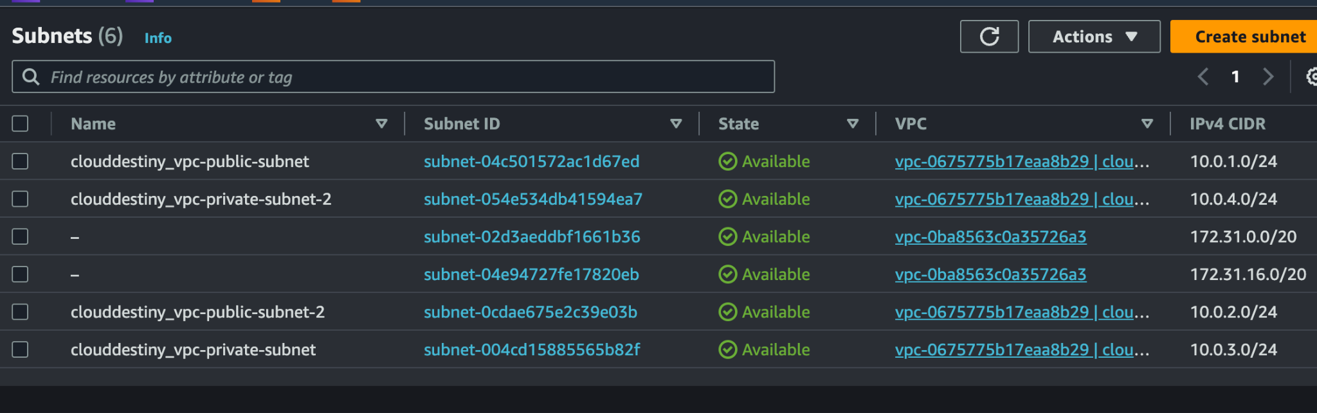

VPC

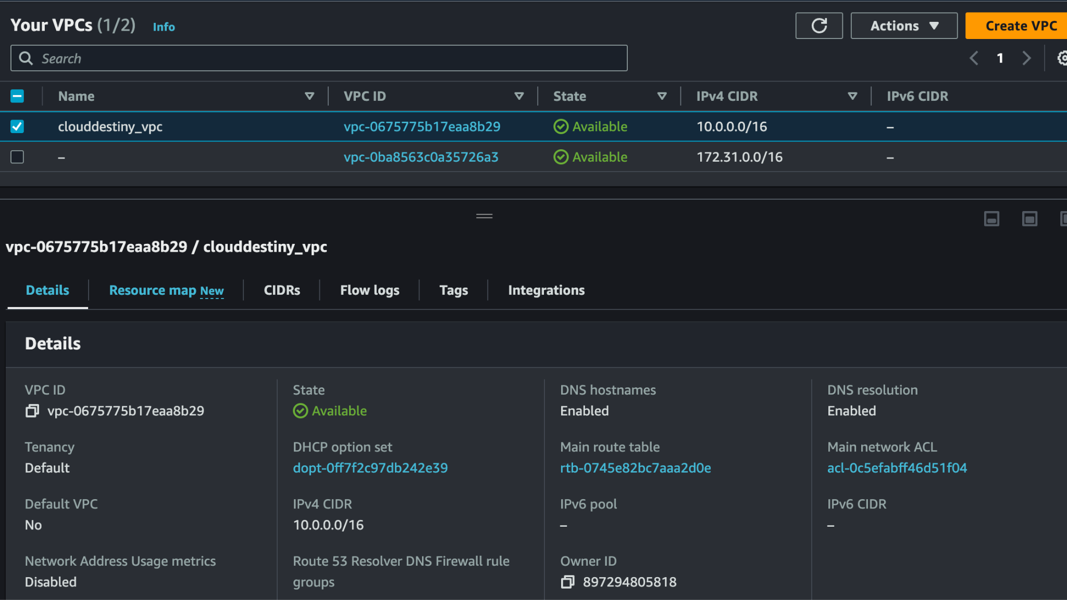

Routing tables

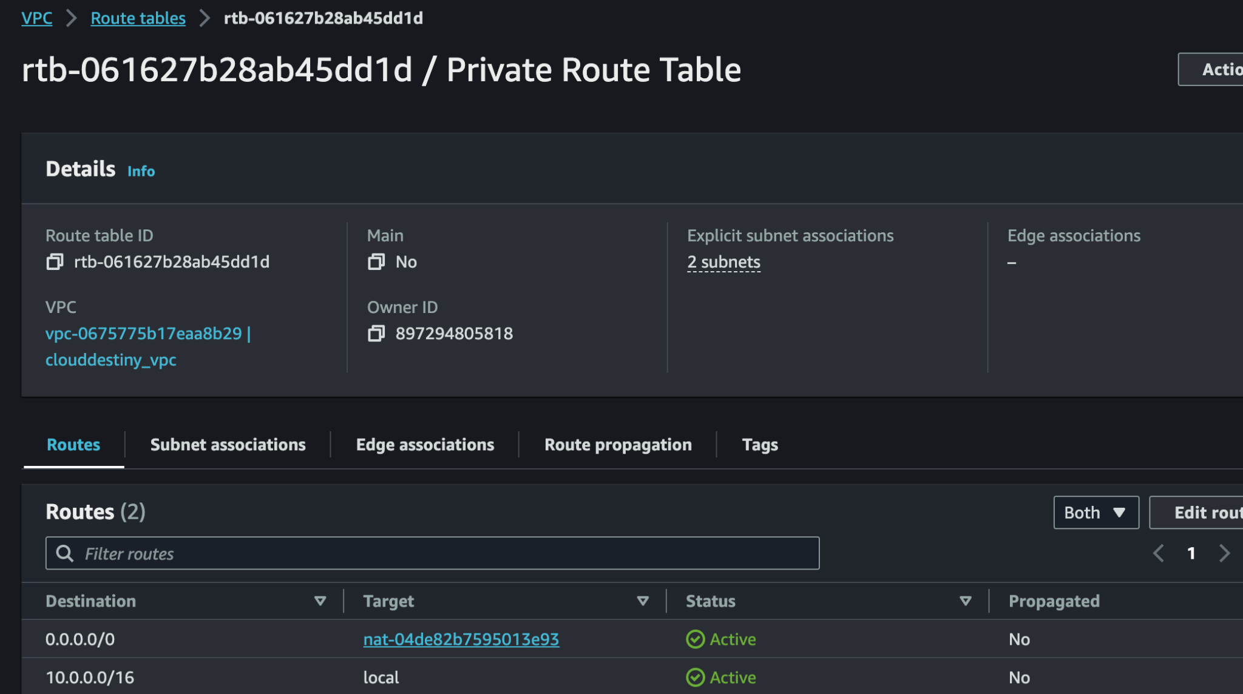

With Security Group module we create security group for application load balancer and Autoscaling

We have used only 80 and 443 port for load balancers

We have used 3000 port for servers and only that port is opened

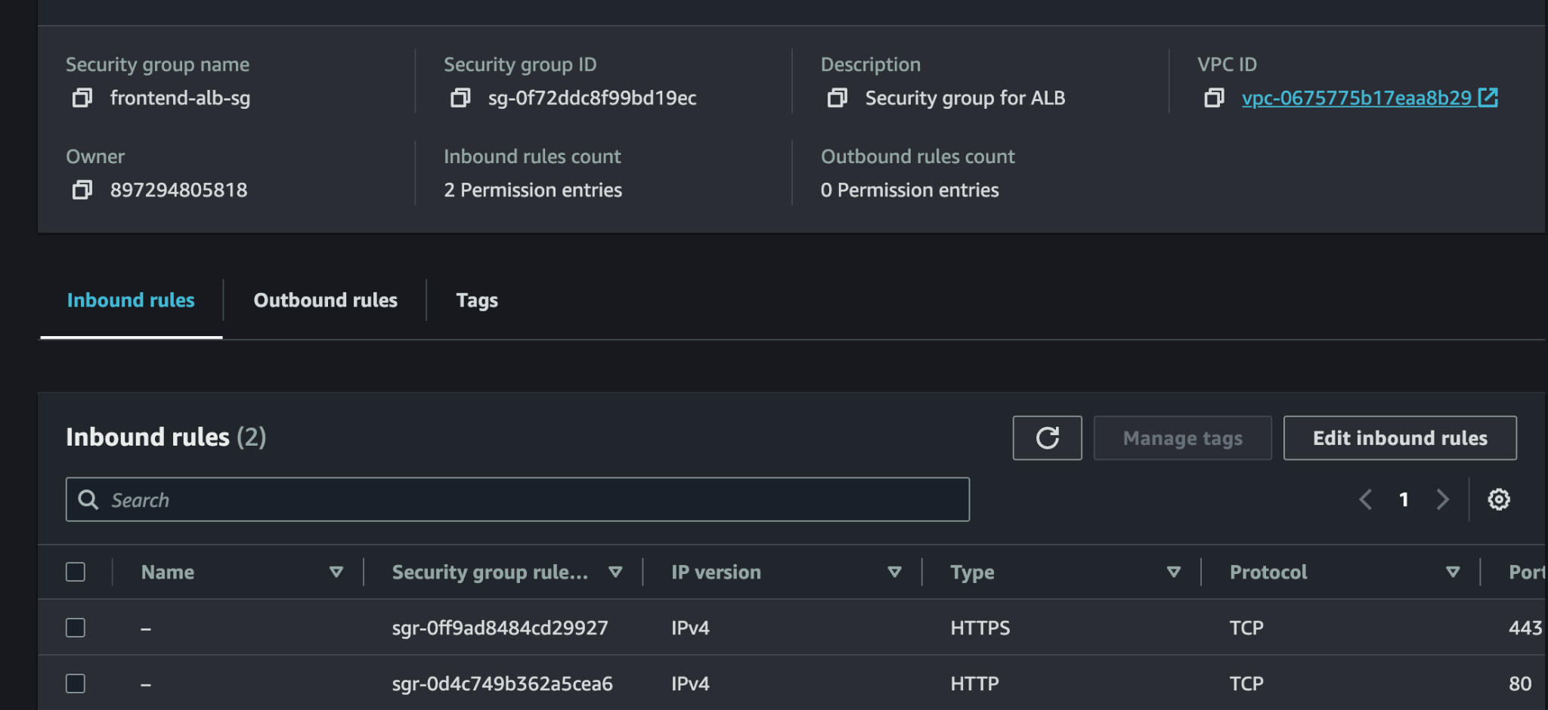

With Alb module we create the load balancer target group and also the launching configuration with autoscaling of 2 minimal server , in this part of the code we have the user data which will install the required packages

* Application load balancer
* Listeners
* Target group
* Security group for launching config
* Launching configuration and Auto Scaling

Launching configuration will have the number of servers and scaling threshold

Autoscaling will trigger 2 servers minimal and in different private subnets

**Loadbalancer**

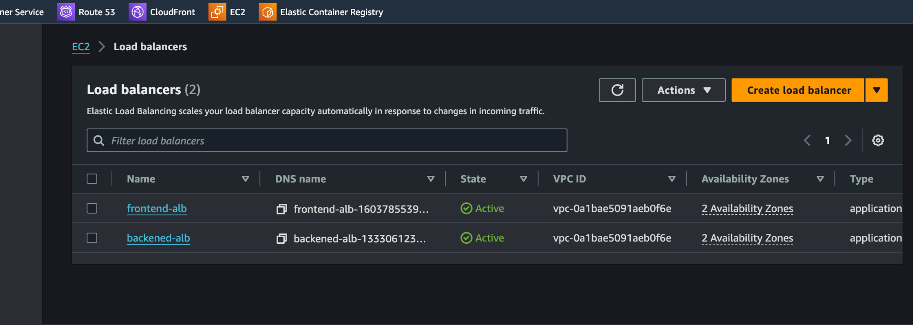

Listeners

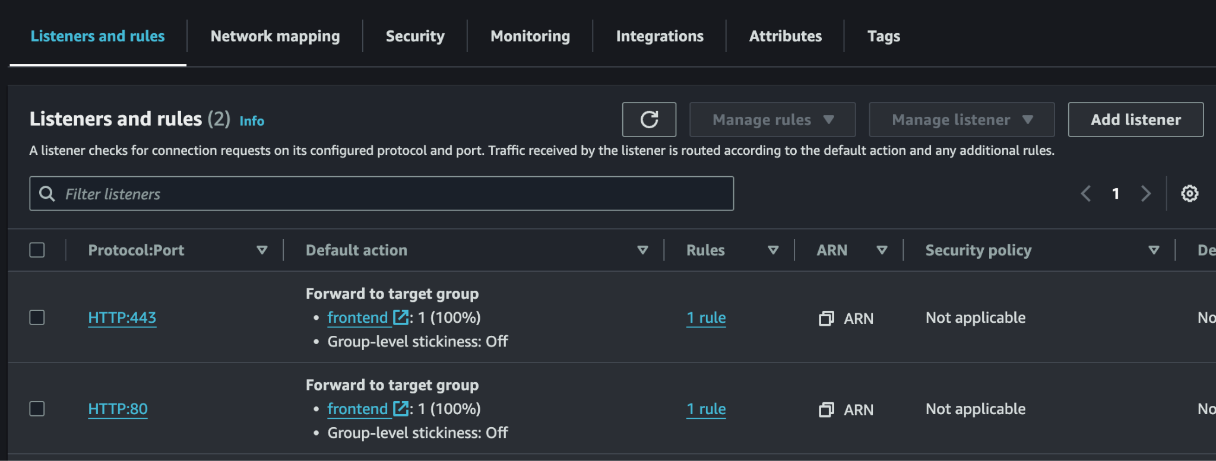

Autoscaling groups

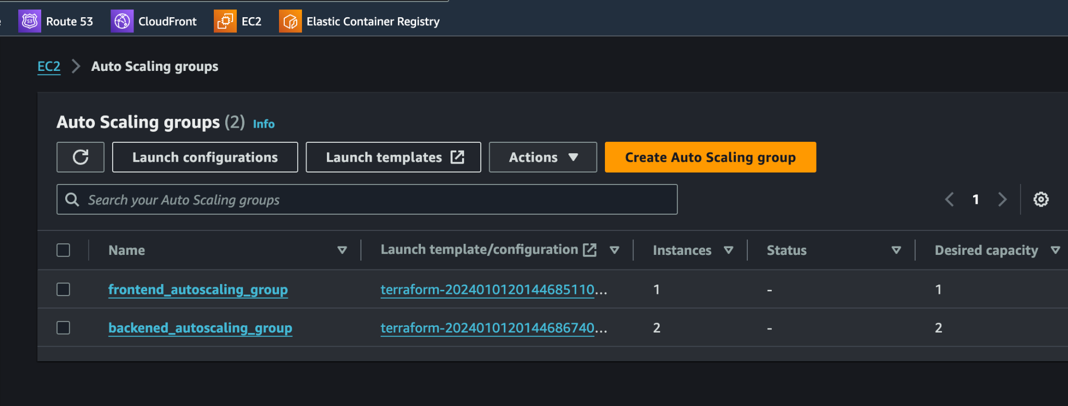

We have all the variables in variable file

Pipeline

Jenkins file is attached which will be used for deploying on the servers

Jenkins file is attached which will take the ami and will update the launching config ami

It has basic steps which will be replicated for all the stages

* Github pull
* Build
* Deploy

Pipeline code is added which will trigger the Jenkins job in stage wise based on the success and failure of the respective stages