Step 1: Create the Windows EC2 Instance with HTTP port open.

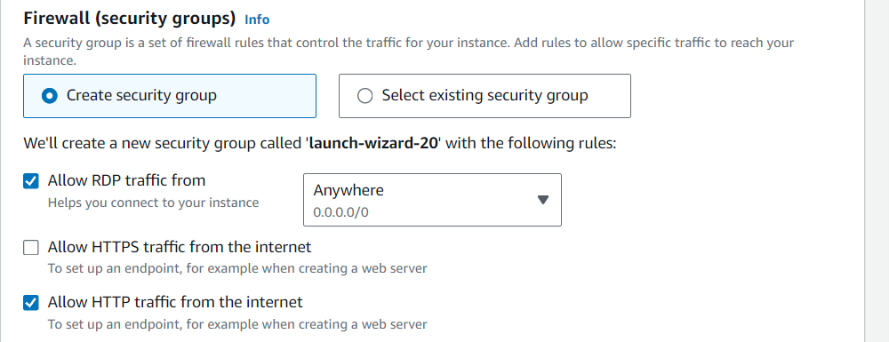

Step 2: Connect the Instance.

Step 3: Right Click on Windows button select the Server Manager

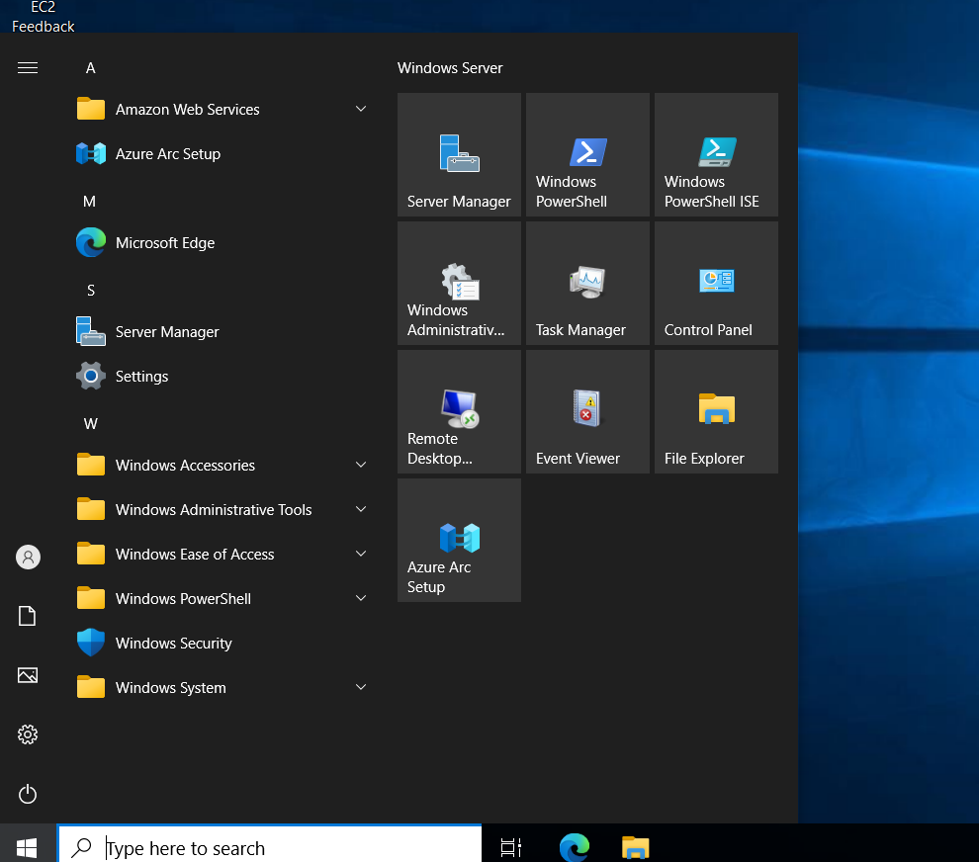

Step 4: Click the add roles and features.

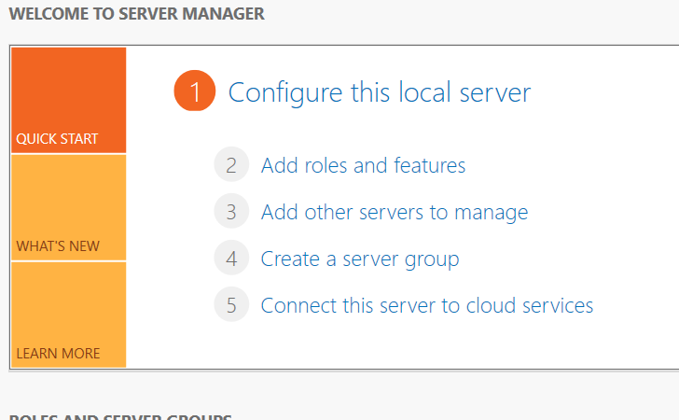

Step 5: Click next.. next until Server role. Enable the “Web Server (IIS)”

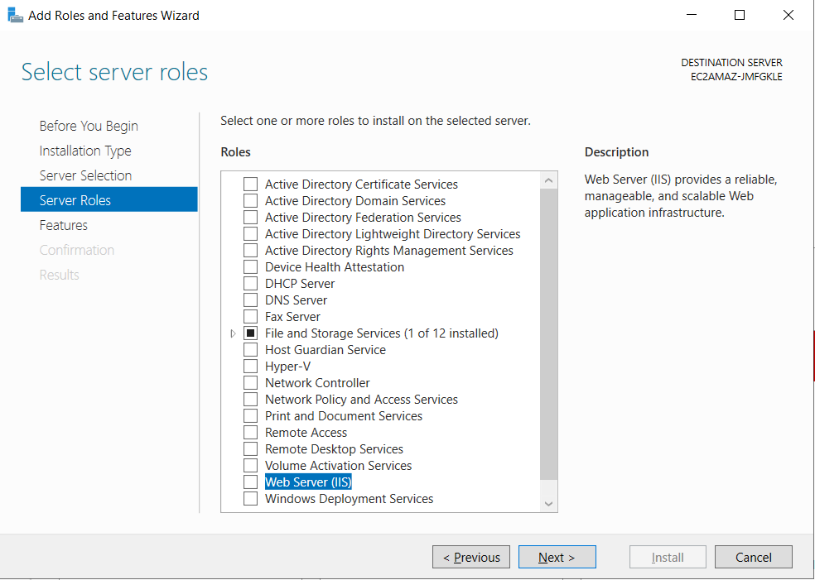

Step 6: Click the add feature then give next and Install

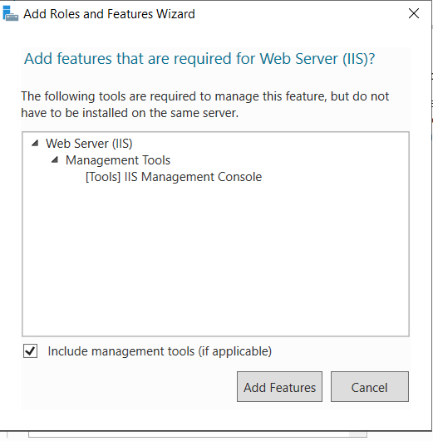

Step 7: Installation done then Copy your public ip and hit in browser

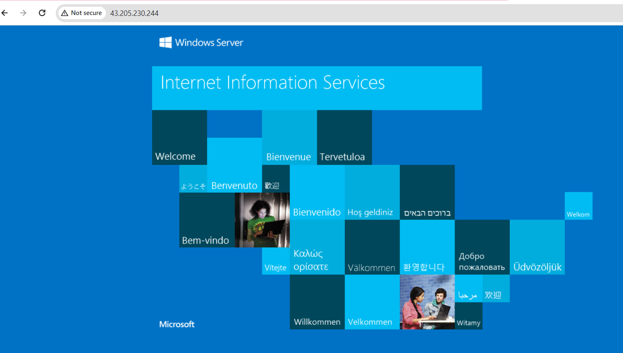

Step 8: Go to Middleware folder in your remote machine “C:\inetpub\wwwroot” and remove the files in this folder

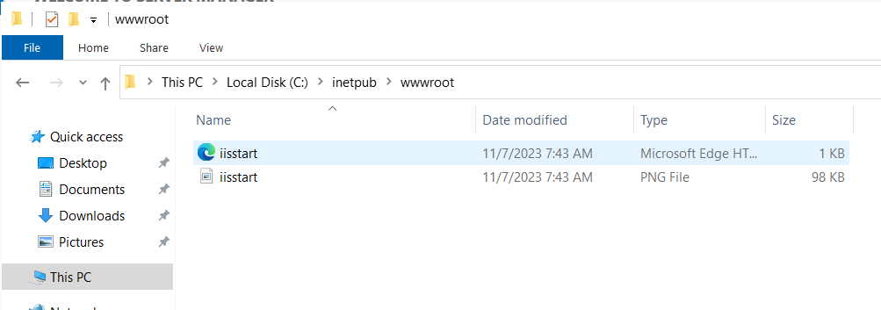

Step 9: Copy the downloaded static website and past it in “C:\inetpub\wwwroot”

