**CDN - CONTENT DELIVERY NETWORK:**

IT IS A SYSTEM OF DISTRIBUTED SERVERS THAT DELIVER WEBPAGES AND OTHER WEB CONTENTS TO THE USER BASED ON THE **GEOGRAPHIC LOCATIONS** OF THE USER, THE **ORIGIN** OF THE WEBPAGE & A **CONTENT DELIVERY SERVER**.

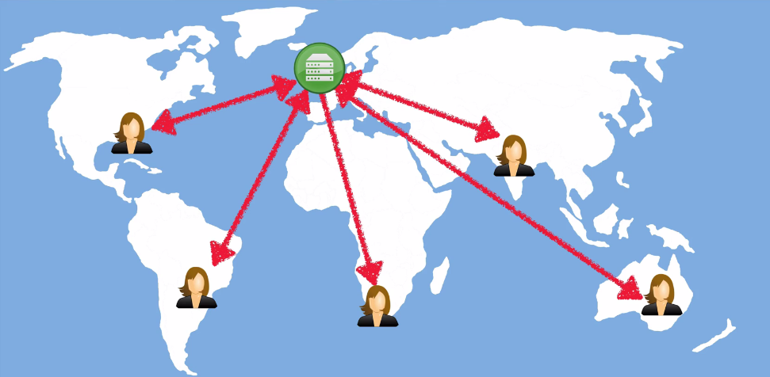

SERVER IS IN UK => THE USERS, ALL OVER THE WORLD ARE ACCESSING THEIR WEBPAGES IN UK SERVER

THEY CAN ACCESS,

* A WEBPAGE – STATIC/ DYNAMIC
* MOVIE FILE
* STREAMING FILE, ETC

**KEY TERMS IN CLOUDFRONT**:

**EDGE LOCATION**: THIS IS THE LOCATION WHERE CONTENT WILL BE CACHED. THIS IS SEPARATE TO AN AWS REGION / AZ [AVAILABLE ZONES]. THERE ARE AROUND 50 EDGE LOCATIONS IN AWS CURRENTLY [2016].

**ORIGIN**: THIS IS THE ORIGIN OF ALL THE FILES THAT THE CDN WILL DISTRIBUTE. THIS CAN BE EITHER AN S3 BUCKET, AN EC2 INSTANCE, ELASTIC LB OR ROUTE 53. EVEN IT CAN BE A NON-AWS RESOURCE.

**DISTRIBUTION**: THIS IS THE NAME GIVEN TO THE CDN WHICH CONSIST S OF A COLLECTION OF EDGE LOCATIONS. TWO TYPES => 1. **WEB DISTRIBUTION**. 2. **RTMP** [FOR MEDIA STREAMING]

**MULTIPLE USERS IN MULTIPLE PART OF THE WORLD**:

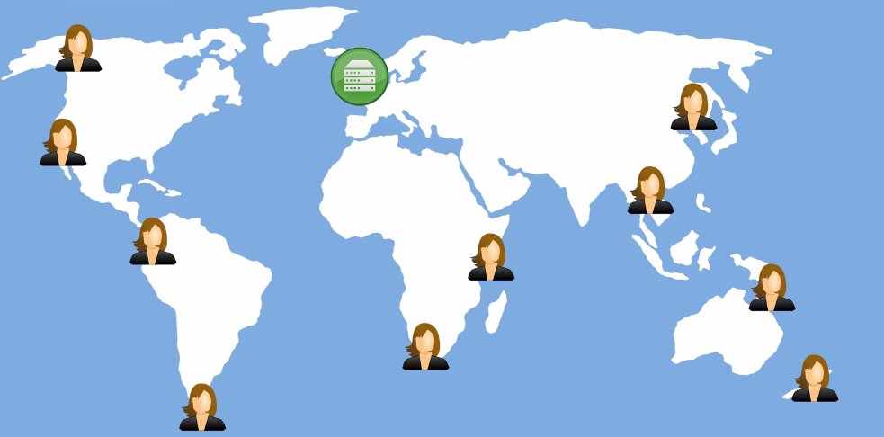

**EDGE LOCATIONS SPREADS ALL ACROSS THE WORLD**:

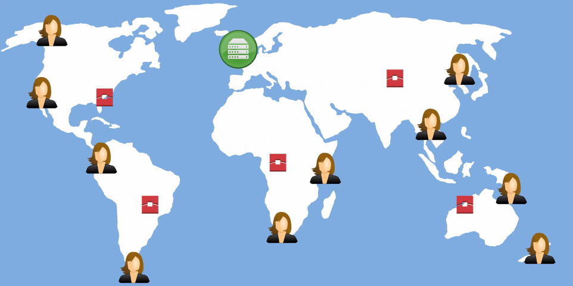

**WHEN THE FIRST USER ACCESS TO THE CONTENT & THAT GOES TO THE E.L**:

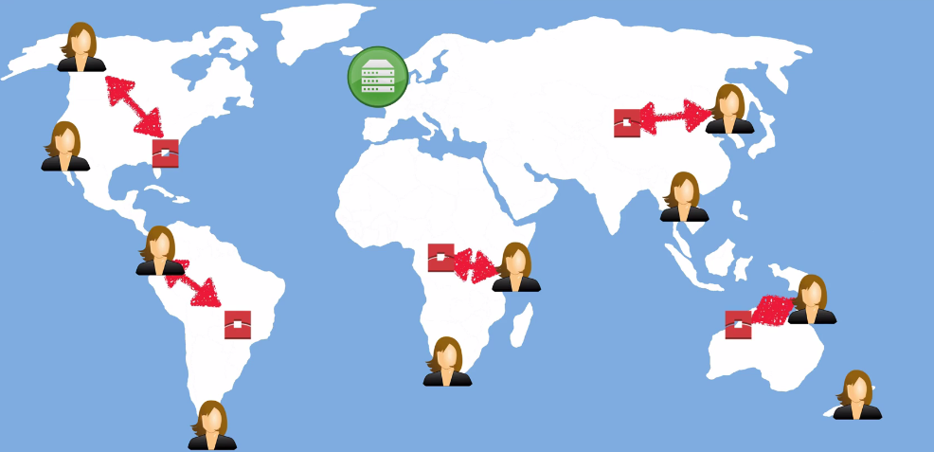

**IF IT NOT CACHED IN THE EDGE LOC => THEN AS PER DISTRIBUTION, IT ROUTES TO THE CDN SERVER**:

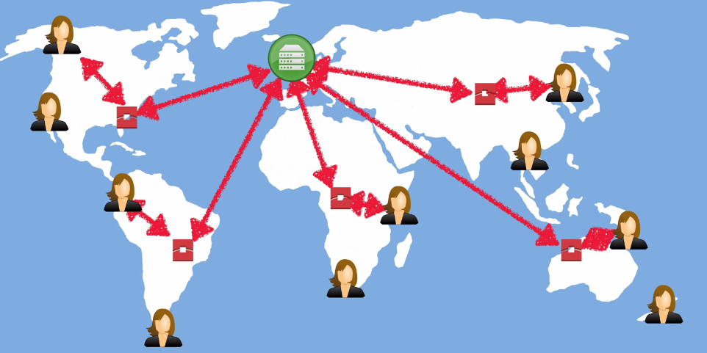

THUS THE FIRST USER ACCESSES THE CONTENT WITH NO SPEACILITY, RATHER THAN A NORMALE CASE.

**USER TO E.L => E.L TO ORIGIN [S3] => ORIGIN TO E.L => CACHES THE CONENT => SERVES THE USER.**

**BUT WHEN THEN SECOND USER ACCESSES THE SAME DATA, IT RETRIVES FROM THE CACHED**:

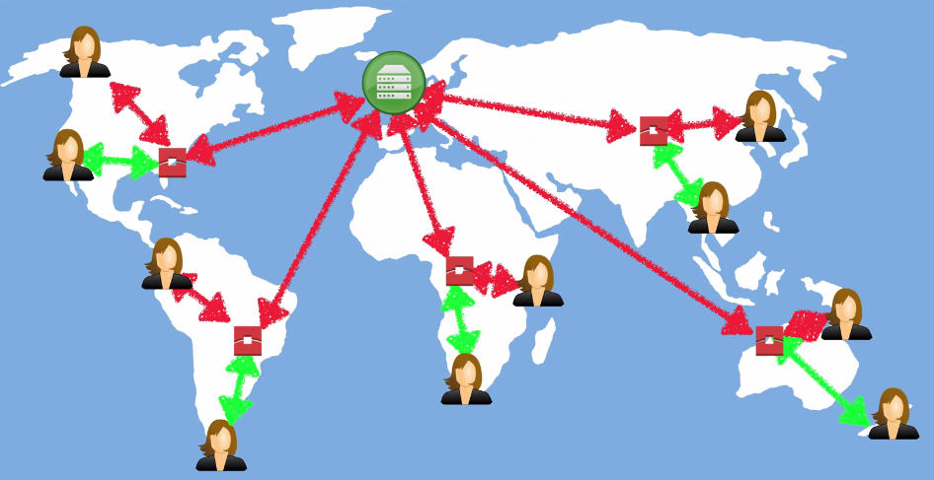

**IMPORTANT THINGS ABOUT CDN**:

1. EDGE LOCATIONS ARE NOT JUST READ ONLY, YOU **CAN WRITE** NEW FILES TOO TO THE E.L.
2. OBJECTS ARE CACHED FOR THE LIFE OF THE TTL [**TIME TO LIVE**]
3. YOU **CAN CLEAR THE CACHED OBJECTS** FROM THE EDEGE LOCATION, BUT IT WILL BE CHARGED.