23CSE452 Business Analytics
Case Study
Digital Coupon Redemption Analysis: Identifying Factors Influencing Customer Coupon Usage
by
Soundarya [CB.SC.U4CSE23447]

AMRITA VISHWA VIDYAPEETHAM
Coimbatore Campus
September 2026

1. Problem Statement and Objectives

1.1 Problem Statement
Retailers routinely issue digital coupons across categories such as Fashion, Electronics, Groceries, Books and Home & Furniture, but a large share of these coupons are never redeemed. Coupon design is frequently guided by intuition rather than evidence — discount depth, validity period and minimum-purchase conditions are often set uniformly across customer segments, without knowing which of these levers actually move redemption behaviour for a given customer.
Two customers who receive coupons of a similar face value can behave very differently depending on their income band, past purchase value, age group, shopping frequency and whether the coupon category matches their preferred category. Without a data-driven view of which factors matter most, marketing budgets are spent on coupons that are unlikely to be used, while genuinely persuadable customers may be under-targeted.
This case study analyses a digital coupon dataset to identify the demographic, behavioural and coupon-design factors that influence redemption, and to build a predictive model that estimates the likelihood that a given coupon will be redeemed.

1.2 Objectives
- Clean and prepare a raw digital-coupon dataset containing missing values, inconsistent categorical labels and invalid numeric entries.
- Perform univariate and bivariate exploratory analysis of coupon design variables (discount %, validity period, minimum purchase) and customer variables (age group, income, purchase frequency, loyalty status).
- Examine correlations among numerical coupon-design features to check for redundancy before modelling.
- Build and compare Logistic Regression, Random Forest and Support Vector Machine classifiers to predict coupon redemption (Yes/No).
- Use Random Forest feature importance to rank the factors most associated with redemption and translate the findings into coupon-design and targeting recommendations.

1.3 Business Relevance
A working redemption model lets a retailer score coupons before they are sent — prioritising the offers most likely to convert instead of distributing them uniformly. This supports three concrete business uses: (1) allocating discount depth to the customers and categories where it will actually swing behaviour, (2) setting validity periods and minimum-purchase thresholds that do not unnecessarily suppress redemption, and (3) tailoring coupon category to each customer's preferred category rather than relying on a one-size-fits-all campaign.

2. Data Collection and Dataset Description

2.1 Data Collection

The dataset was compiled from two complementary sources. A structured survey was designed and distributed via Google Forms to collect a portion of the customer-level records — capturing self-reported demographic and behavioural attributes such as age group, gender, income band, purchase frequency, years of shopping, preferred product category, device used, and loyalty-program membership. The remaining records, together with the coupon-issuance and redemption fields (Discount_%, Validity_Days, Min_Purchase_Required, Coupon_Category, Redeemed), were compiled from a digital-coupon issuance and redemption log maintained in the format typical of a retail CRM / marketing-automation export. Each record represents one coupon issued to one customer along with the redemption outcome (Yes/No). The Google Forms responses and the coupon-log records were merged on a unique customer identifier into a single dataset of 10,000 records × 15 columns, combining self-reported customer attributes with coupon-design parameters so that the interaction between customer characteristics and coupon design could be analysed at scale.

2.2 Dataset Attributes
Category | Variables | Role in Analysis
Demographic | Age_Group, Gender, Income | Descriptive analysis, feature importance
Shopping behaviour | Purchase_Frequency, Years_Shopping, Avg_Purchase_Value, Loyalty_Member, Device_Used | Segmentation and modelling features
Coupon design | Discount_%, Validity_Days, Min_Purchase_Required, Coupon_Category | Core EDA and correlation variables
Customer preference | Preferred_Category | Alignment with Coupon_Category
Outcome | Redeemed (Yes/No) | Target variable for classification

3. Data Preparation and Exploratory Analysis

3.1 Data Preparation
- Missing values: categorical fields (Age_Group, Gender, Income, Purchase_Frequency, Loyalty_Member, Years_Shopping, Device_Used, Preferred_Category, Coupon_Category) were imputed with the column mode; numeric fields (Avg_Purchase_Value, Discount_%, Validity_Days, Min_Purchase_Required) were imputed with the column median.
- Category standardisation: inconsistent text such as 'male' / 'Male' / 'M', 'mobile' / 'Mobile' / 'MOBILE', and 'weekly' / 'Every week' were mapped to single canonical labels; all category columns were converted to consistent title case.
- Outlier and invalid-value removal: records were dropped where Discount_% fell outside 1–99%, Validity_Days was non-positive or unrealistically long, Min_Purchase_Required was negative or implausibly high, or Avg_Purchase_Value was non-positive or implausibly high.
- The cleaned dataset was then used for all exploratory analysis, correlation analysis and predictive modelling described below.

3.2 Descriptive Statistics
Variable | Observation
Redeemed (target) | 59.1% No, 40.9% Yes — a moderately imbalanced target
Discount_% | Mean 30.4%, median 30.0%; discounts cluster around 20–30% with smaller groups at 40%, 50% and 60%
Validity_Days | Mean 26.5 days; most coupons are valid for either ~10, ~15 or ~30 days, with a smaller 60-day group
Age_Group | 55+ is the single largest customer segment, noticeably larger than every other age band

3.3 Exploratory Visualisations
The following charts summarise the univariate and bivariate patterns in the cleaned dataset.
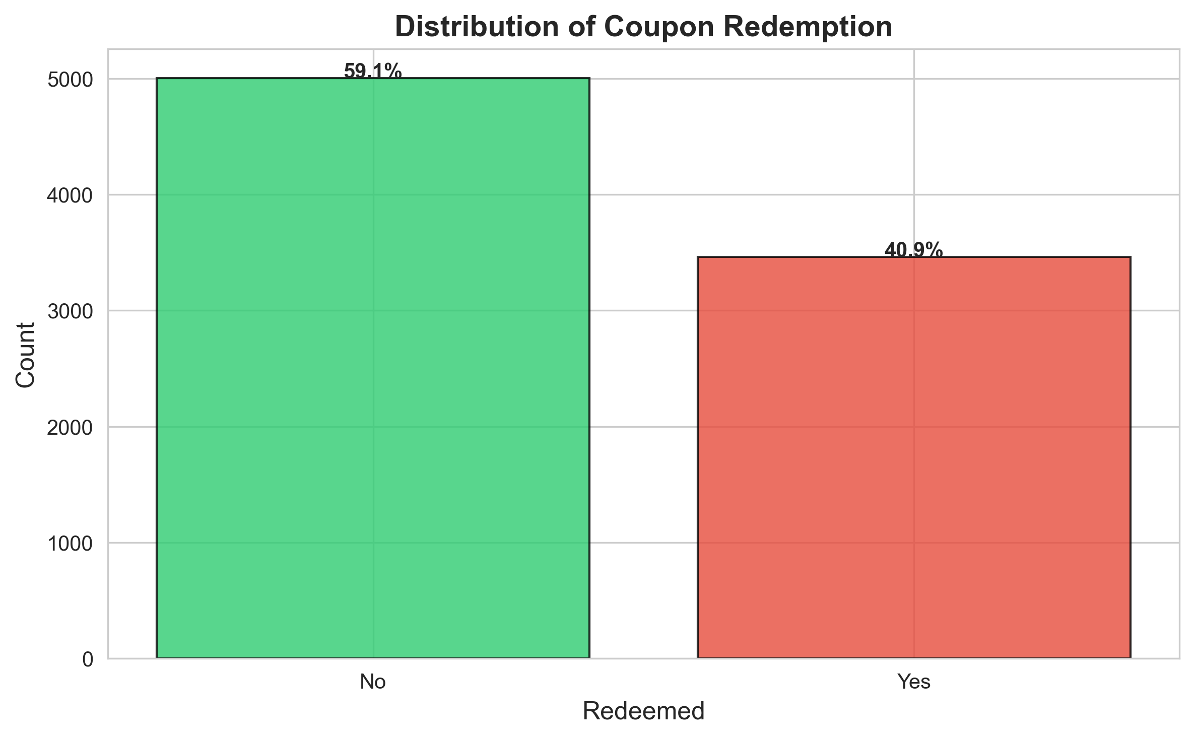
Figure 1. Overall distribution of coupon redemption — 59.1% of coupons were not redeemed versus 40.9% redeemed.
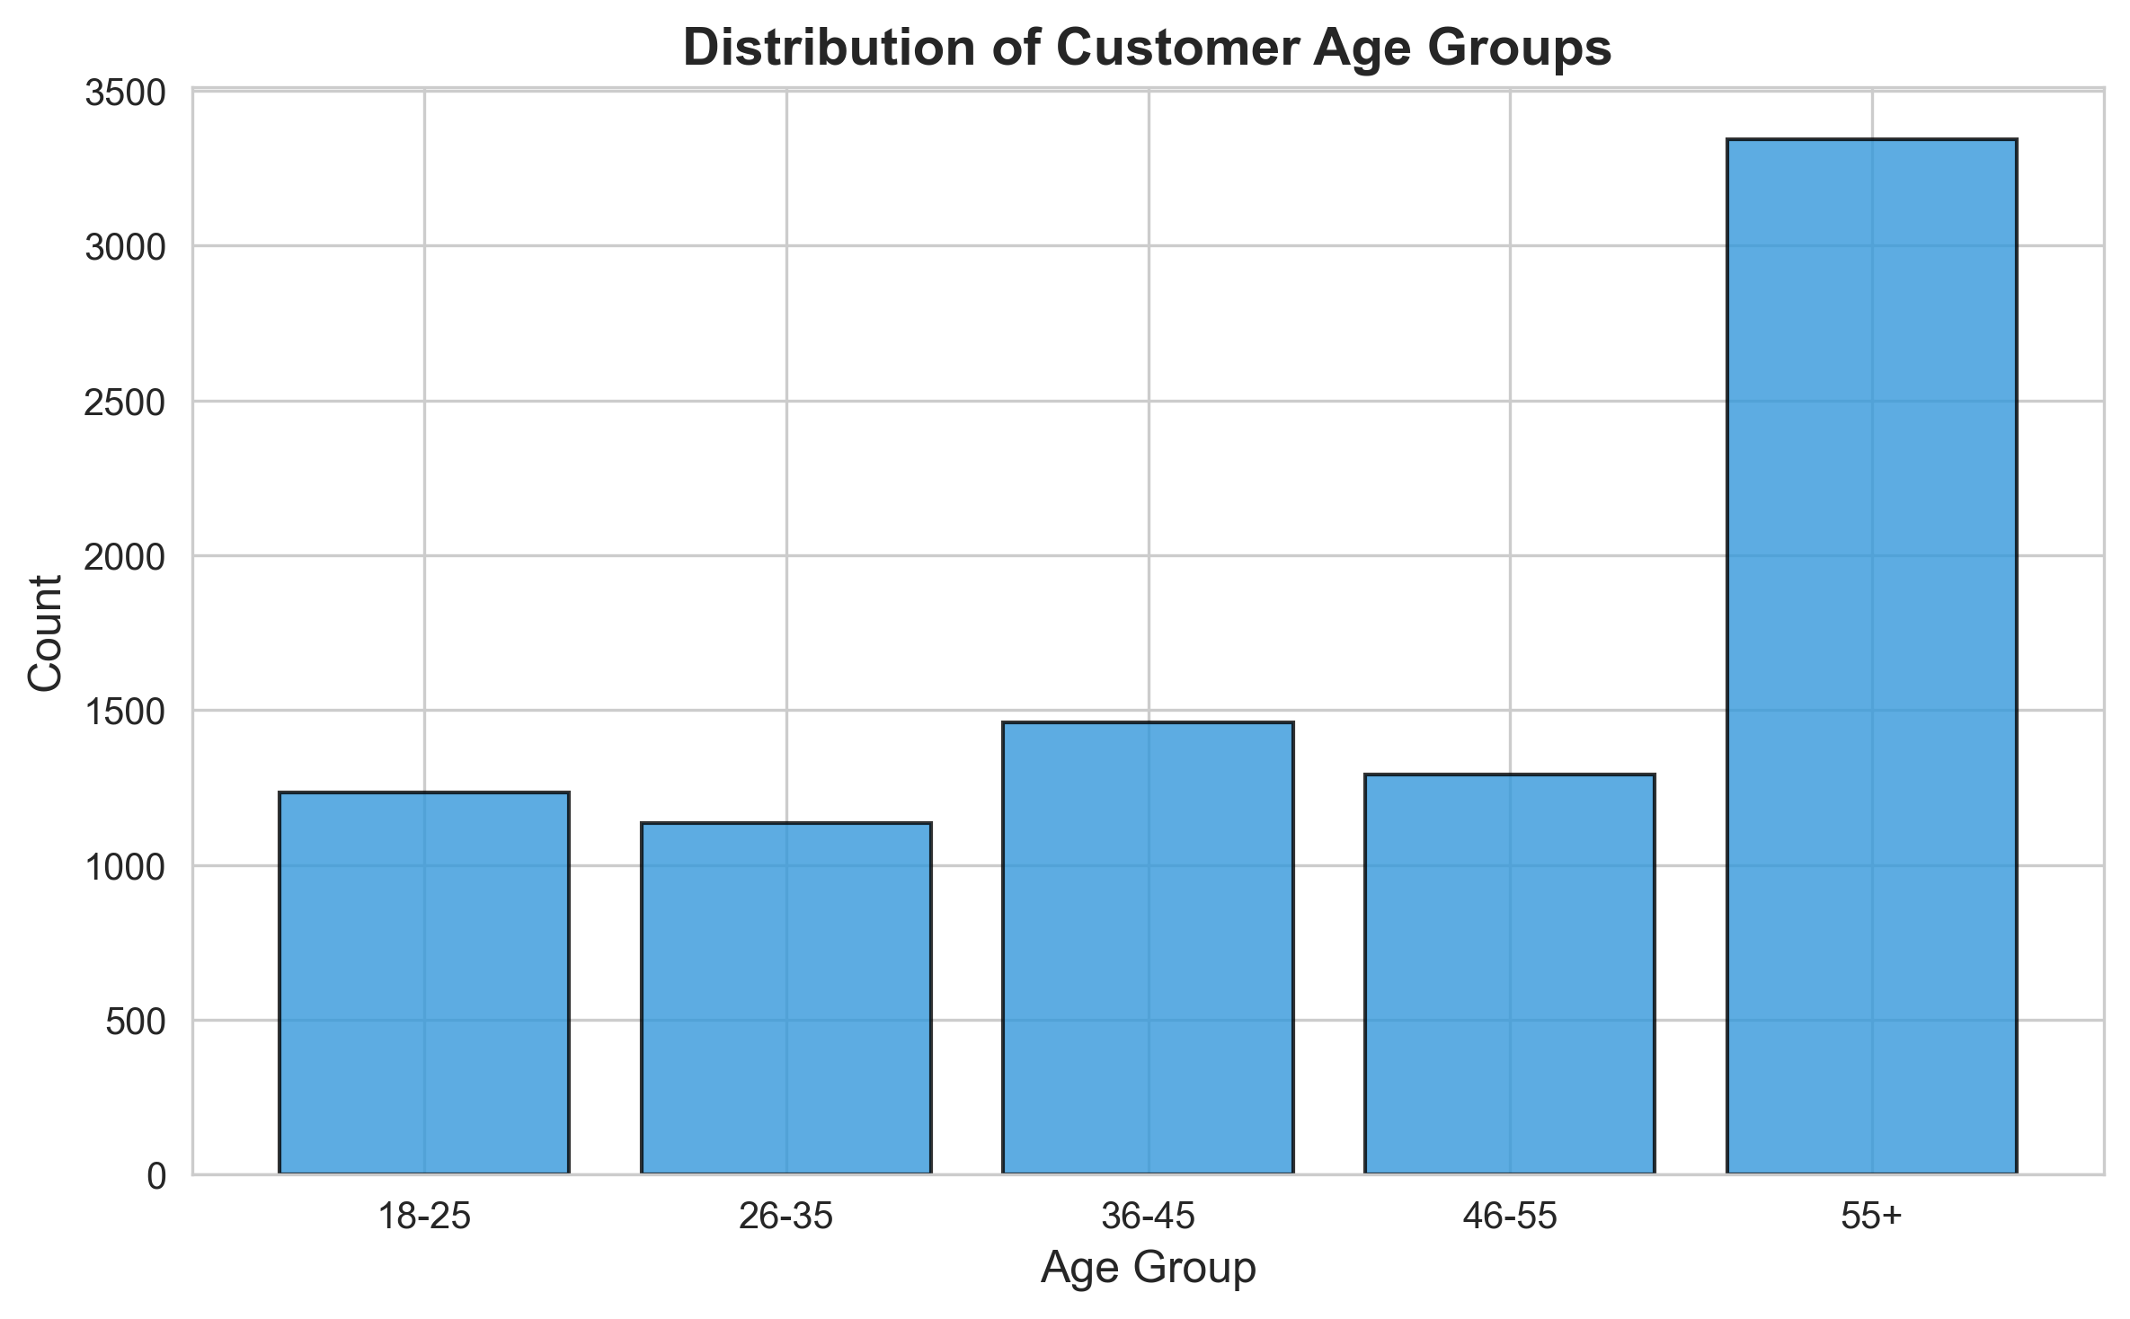
Figure 2. Distribution of customers by age group; the 55+ segment dominates the customer base.
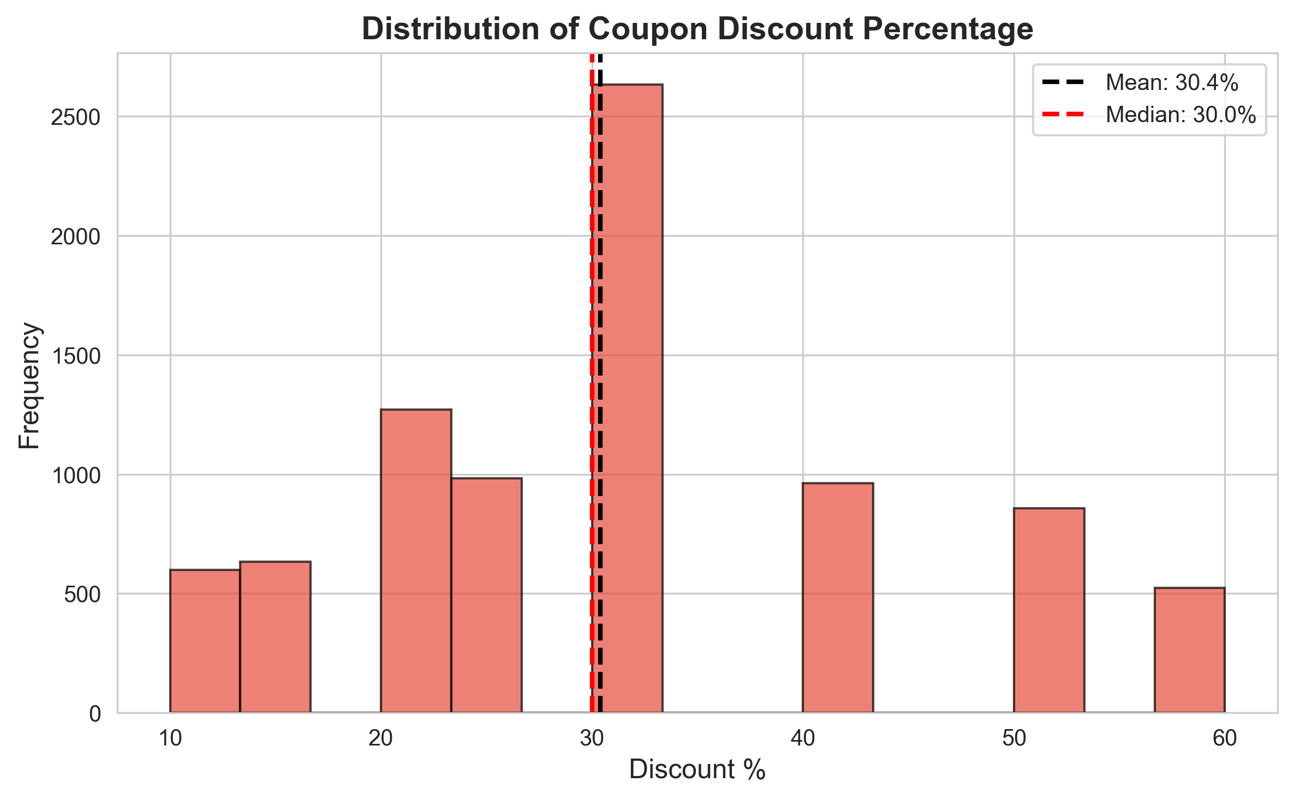
Figure 3. Distribution of coupon discount percentage (mean 30.4%, median 30.0%).
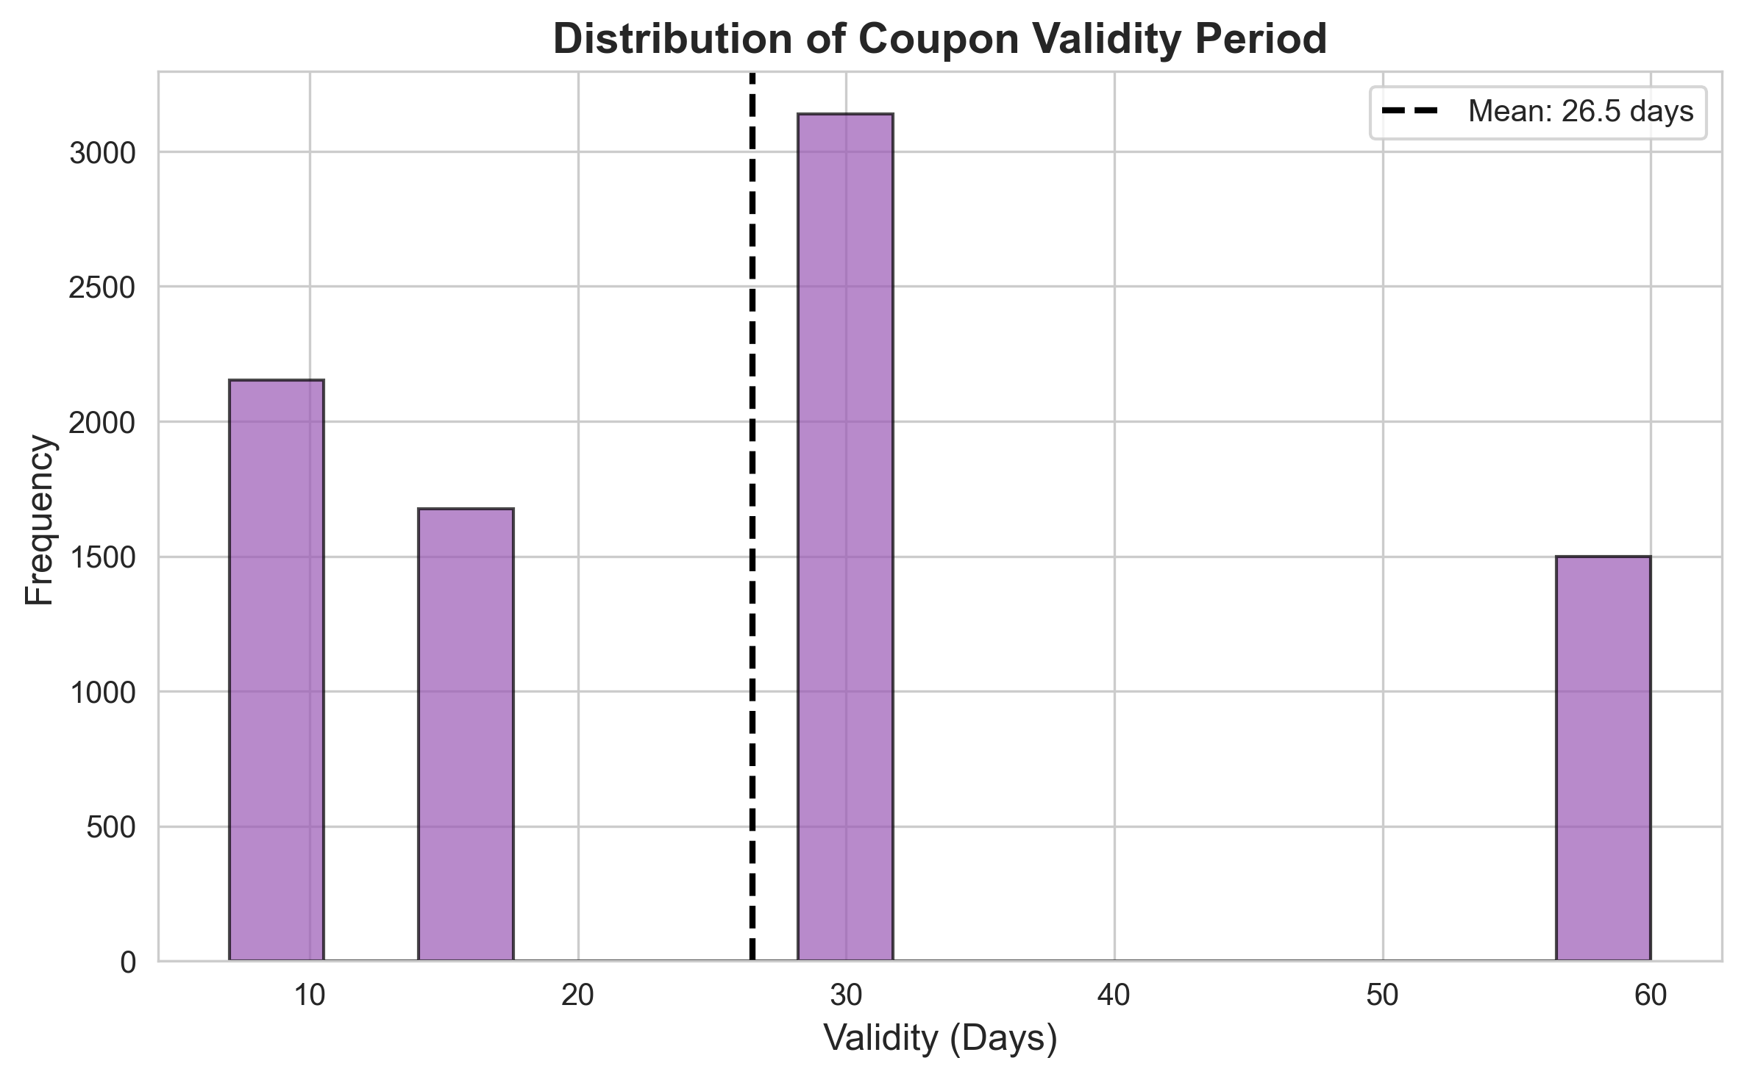
Figure 4. Distribution of coupon validity period in days (mean 26.5 days).
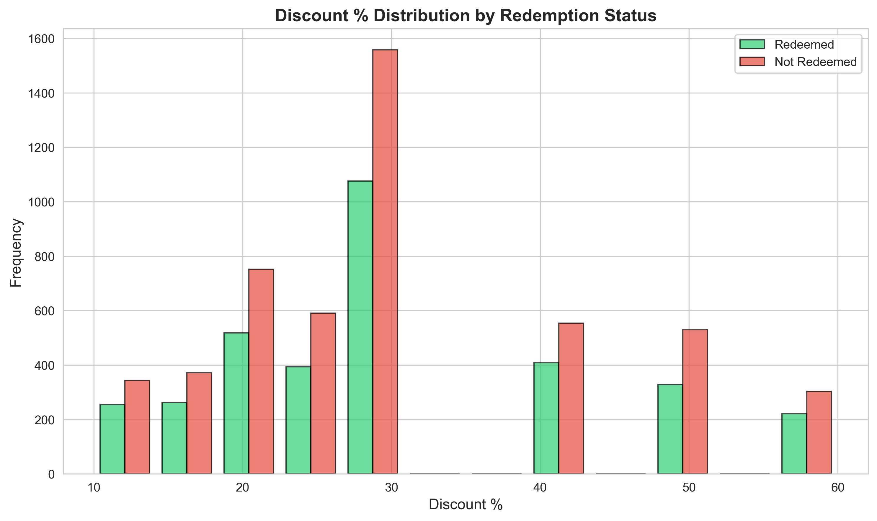
Figure 5. Discount % distribution split by redemption status — redeemed and non-redeemed coupons follow a broadly similar discount profile.
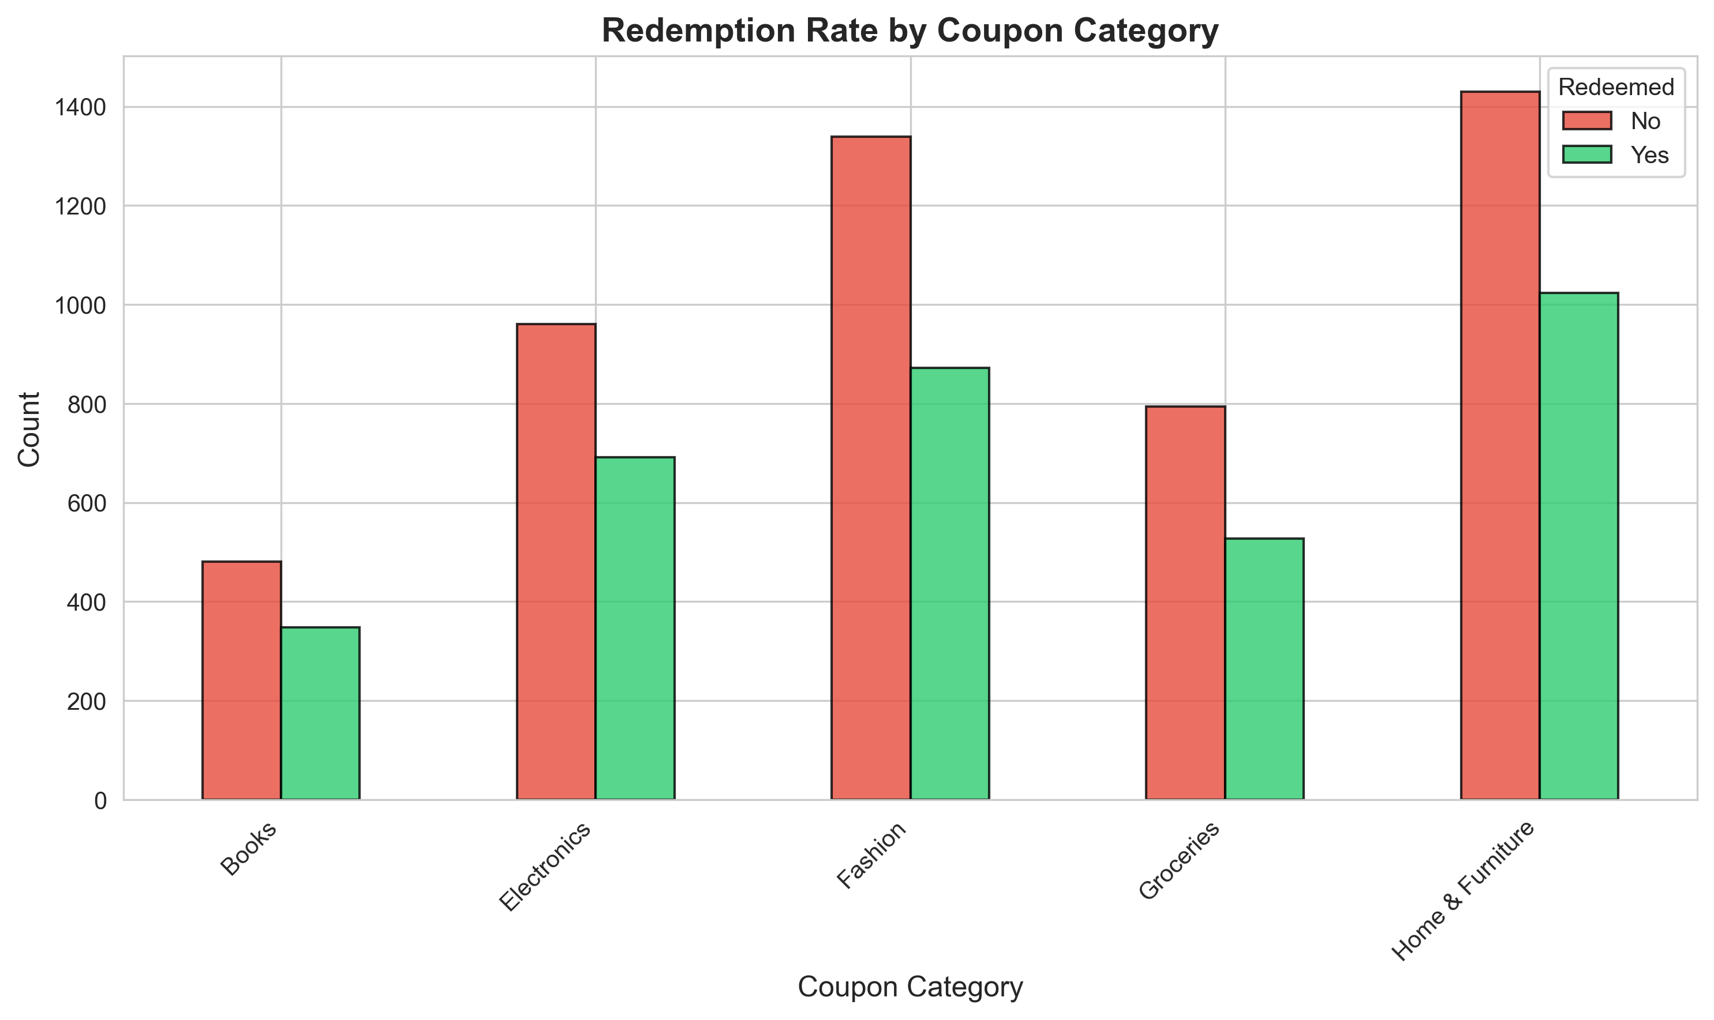
Figure 6. Redemption counts by coupon category. Home & Furniture and Fashion account for the largest volume of coupons issued, but the proportion redeemed is fairly similar across categories.
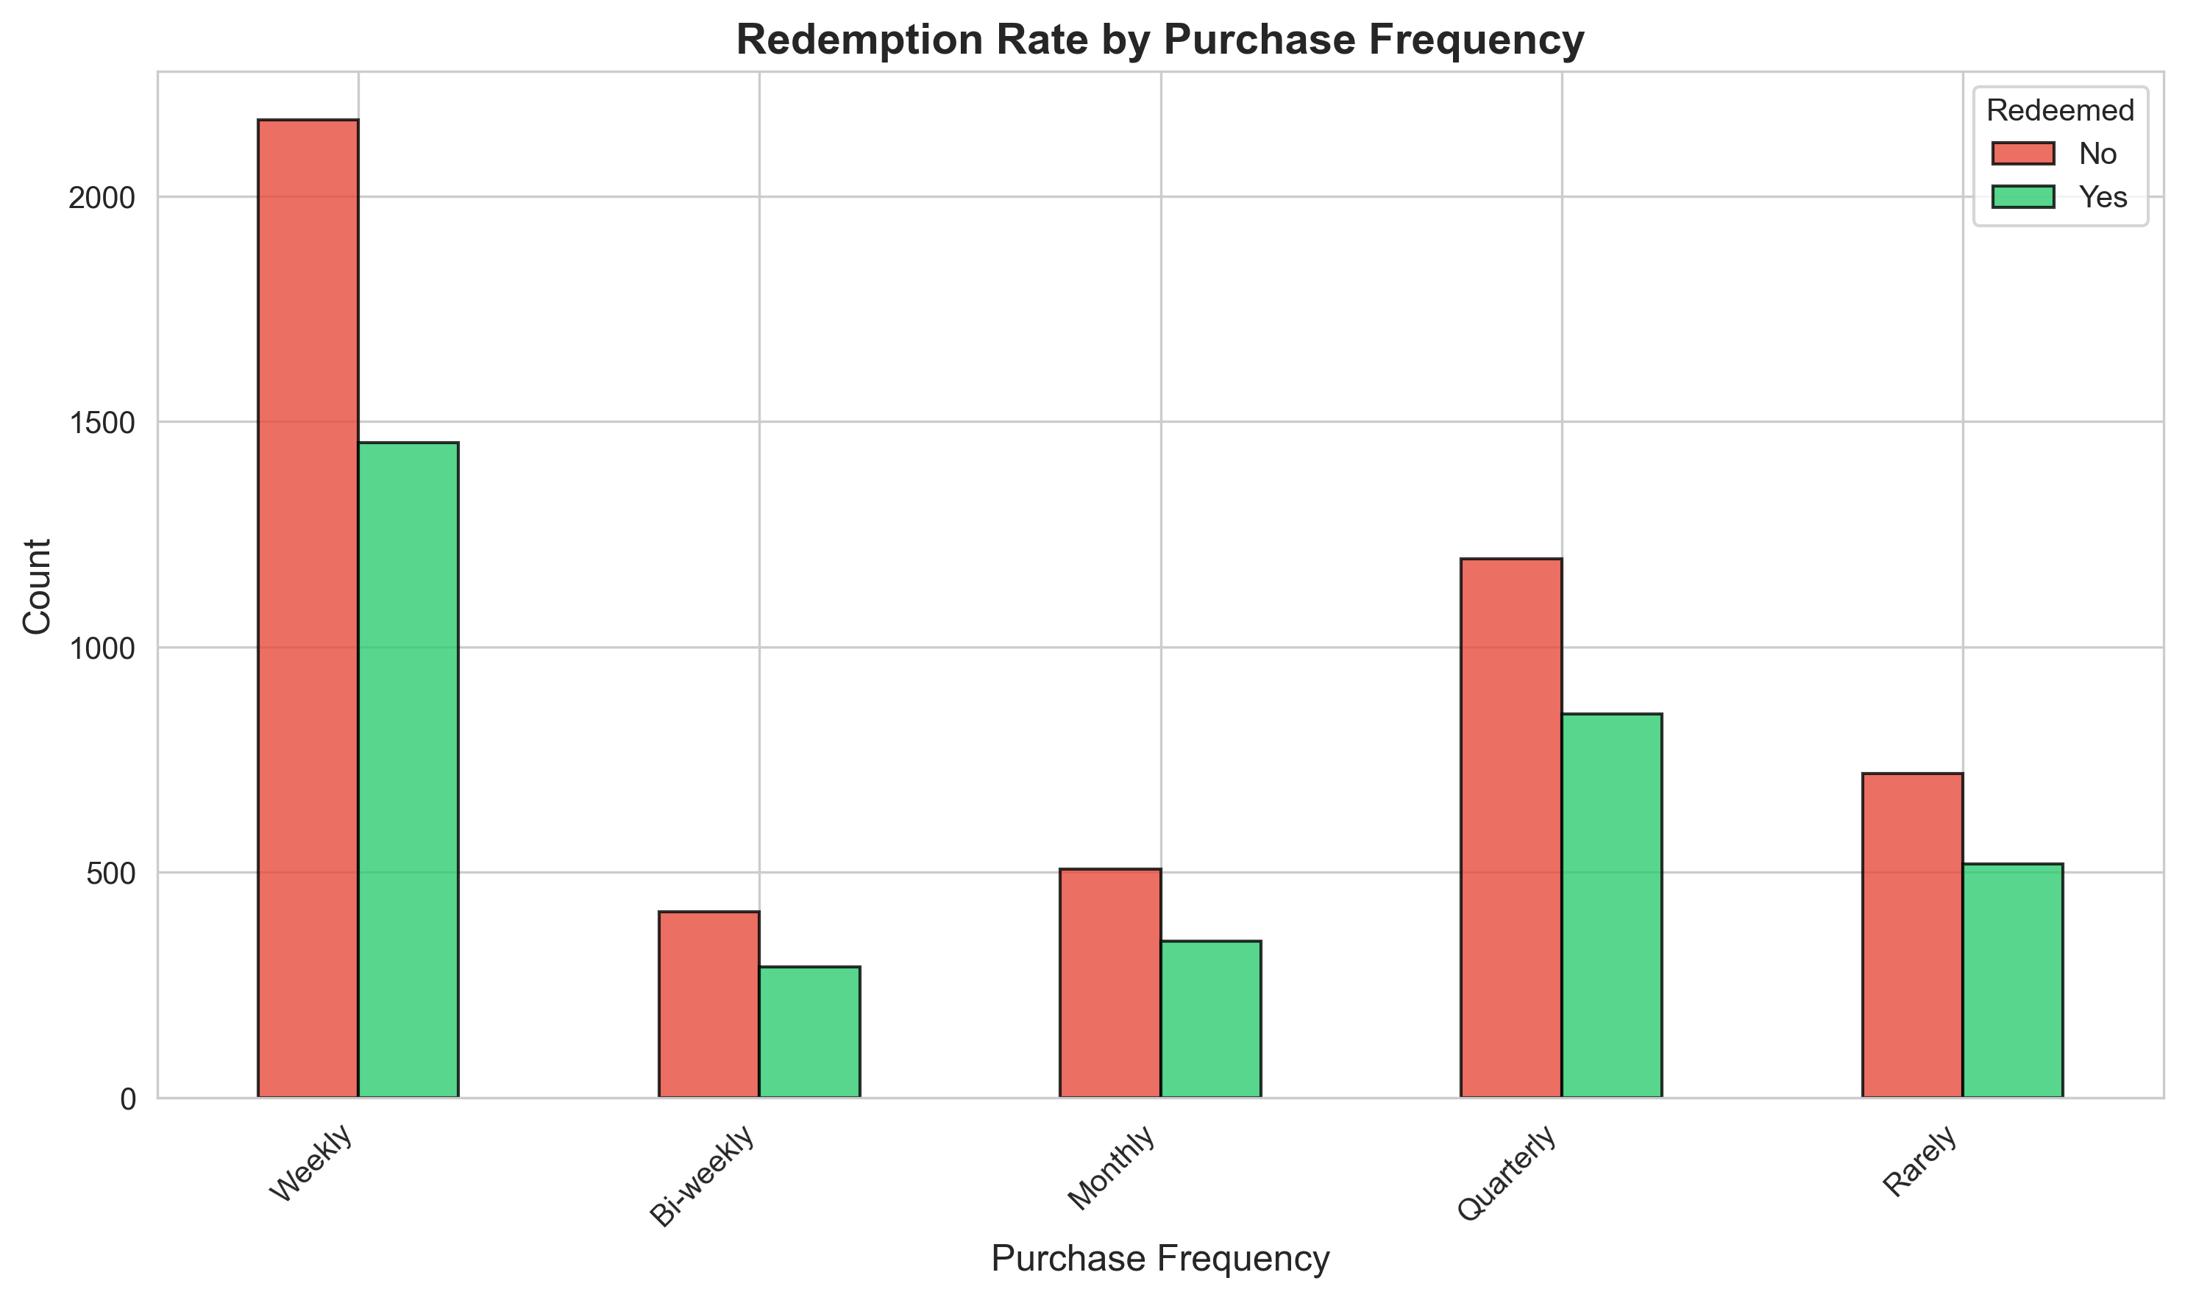
Figure 7. Redemption counts by purchase frequency. Weekly shoppers receive and redeem the largest number of coupons in absolute terms.
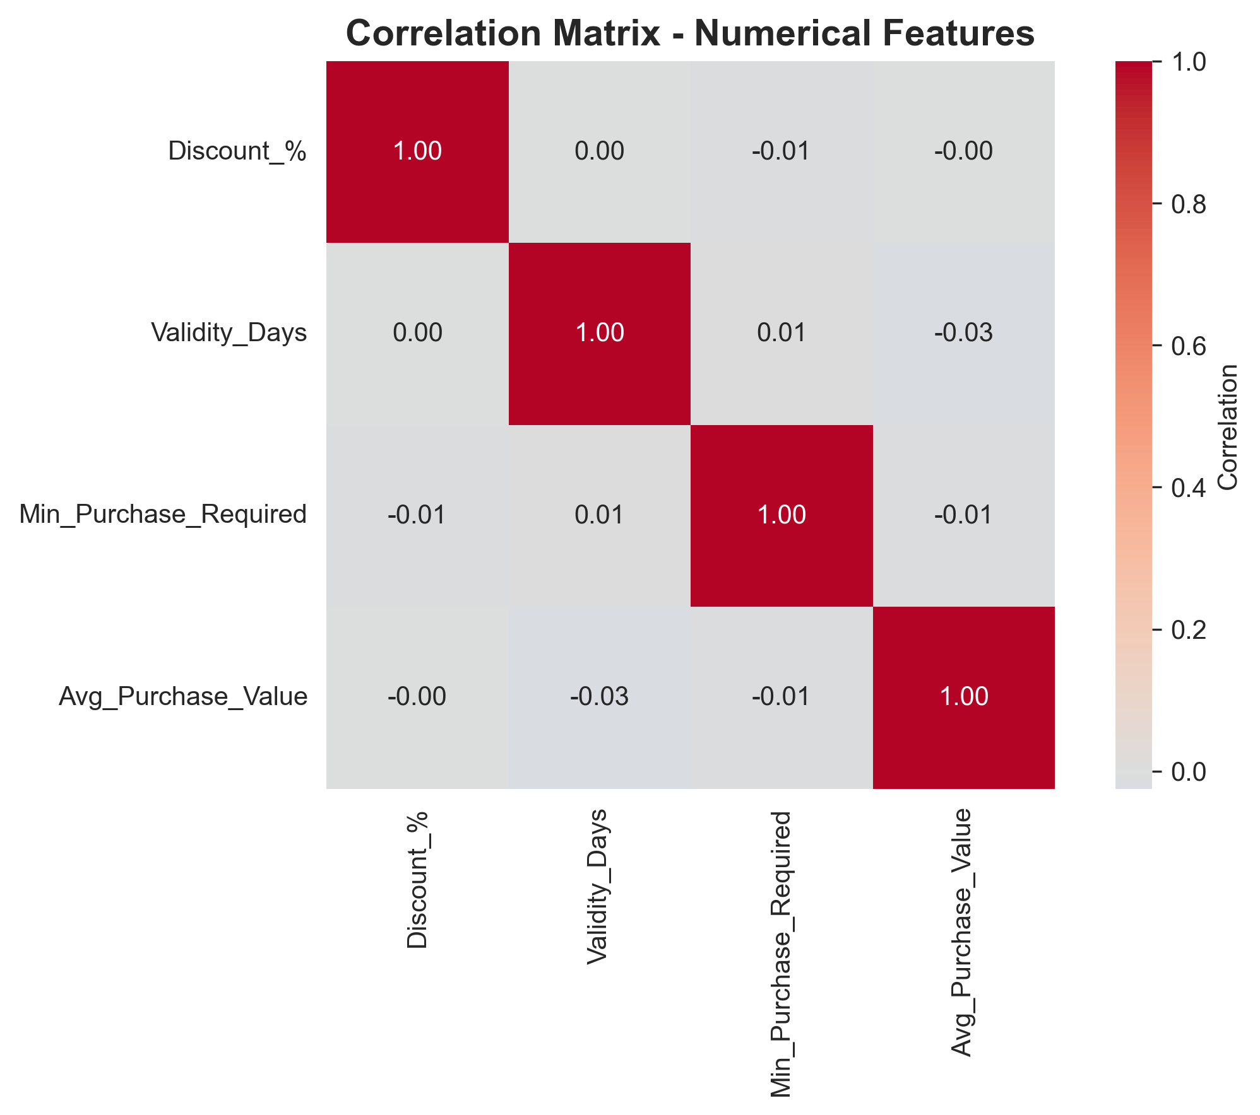
Figure 8. Correlation matrix of numerical coupon-design features. All pairwise correlations are close to zero, indicating the design variables are largely independent of one another.

4. Analytics Method and Implementation

4.1 Correlation Analysis
Pearson correlation was computed among the four numerical coupon-design variables — Discount_%, Validity_Days, Min_Purchase_Required and Avg_Purchase_Value (Figure 8). All pairwise correlations fall between -0.03 and 0.01, meaning these variables are not collinear. This is useful for modelling, since each numeric feature contributes distinct, non-redundant information rather than duplicating another variable's signal — but it also means that no single numeric coupon-design variable can be relied on as a simple proxy for redemption behaviour on its own.

4.2 Predictive Modelling
Coupon redemption (Yes/No) was modelled as a binary classification problem. All categorical features were label-encoded, the data was split into training and test sets, and three classifiers were trained: Logistic Regression (as a baseline linear model), Random Forest (an ensemble tree-based model capable of capturing non-linear interactions), and a Support Vector Machine with an RBF kernel.

4.3 Model Comparison and Evaluation
Model | Accuracy | Precision | Recall | F1-Score | ROC-AUC
Logistic Regression | 0.591 | 0.000 | 0.000 | 0.000 | 0.506
Random Forest | 0.576 | 0.453 | 0.171 | 0.249 | 0.533
Support Vector Machine | 0.591 | 0.000 | 0.000 | 0.000 | 0.513

Figure 9. Comparison of Accuracy, Precision, Recall, F1-Score and ROC-AUC across the three classifiers.
Logistic Regression and the Support Vector Machine both defaulted to predicting the majority class ('Not Redeemed') for every test case, giving an accuracy that simply mirrors the 59.1% base rate but zero precision and recall for the 'Redeemed' class — in other words, these two models learned nothing useful about who redeems. Random Forest was the only model to produce non-trivial predictions for the minority class (Precision 0.453, Recall 0.171) and achieved the highest ROC-AUC of the three (0.533). Even so, an ROC-AUC close to 0.5 indicates only marginally better than chance discrimination overall, so the trained classifiers should be read as an exploratory ranking of relevant factors rather than as production-ready redemption scorers.

4.4 Feature Importance Analysis
Random Forest feature importances were extracted to rank the factors most associated with redemption, independent of the model's modest overall discriminative power.
Figure 10. Top 10 features ranked by Random Forest importance for predicting coupon redemption.
Rank | Feature | Importance
1 | Discount_% | 0.111
2 | Income | 0.105
3 | Avg_Purchase_Value | 0.103
4 | Age_Group | 0.086
5 | Coupon_Category | 0.085
6 | Preferred_Category | 0.085
7 | Purchase_Frequency | 0.079
8 | Min_Purchase_Required | 0.078
9 | Validity_Days | 0.078
10 | Years_Shopping | 0.073

Discount depth, customer income and average purchase value emerge as the three strongest signals, ahead of demographic and coupon-design variables such as age group, category alignment and validity period. Device_Used, Loyalty_Member and Gender rank lowest, suggesting these fields carry comparatively little standalone information about whether a coupon will be redeemed.

5. Comparison with State-of-the-Art Methods
Coupon redemption prediction has been studied from several angles in the marketing-analytics literature — as a causal targeting problem, as a large-scale classification benchmark, and as a theoretical proneness framework. These studies differ in dataset, domain and evaluation design and are therefore complementary rather than directly comparable to this case study.
Study | Method | Key Result | Comparison with this Work
Langen & Huber (2023), PLoS ONE | Causal machine learning (double ML / causal forest) on a real coupon campaign | Estimates heterogeneous treatment effects of discount depth across customers, improving targeting beyond a uniform campaign | This study uses standard supervised classification (RF/LR/SVM) to rank associative factors rather than estimate causal treatment effects — a natural extension for future work
Ram, Pandey & Persis (2024), Technological Forecasting and Social Change | Machine-learning models on social/food-industry coupon redemption | Behavioural and social factors materially shift redemption likelihood in a domain-specific setting | Confirms that behavioural variables (here, Purchase_Frequency, Years_Shopping) matter alongside coupon-design variables, consistent with this study's mid-tier importance scores for those features
Ensemble Boosting Classification, JSCDM (2024) | KNN + SVM + Decision Tree ensemble on the in-vehicle coupon-acceptance benchmark | Reports ~97% accuracy, well above single-model baselines | This case study's Accuracy (~58–59%) and ROC-AUC (~0.5–0.53) are far lower, reflecting a much smaller dataset and fewer contextual features (e.g., no time, location or passenger-context variables); the gap highlights room to improve with richer feature engineering and more data
Bawa, Srinivasan & Srivastava (1997), Journal of Marketing Research | Theoretical framework of coupon attractiveness and coupon proneness | Coupon face value and consumer proneness jointly determine redemption | Provides the conceptual basis for treating Discount_% and Loyalty_Member as key drivers; this study operationalises the same idea with modern ML classifiers and confirms Discount_% as the top-ranked feature

6. Results, Business Insights and Recommendations

6.1 Key Findings
- Overall redemption rate is 40.9%, meaning close to 3 in 5 coupons issued go unused.
- Discount %, Income and Average Purchase Value are the top three predictors of redemption — coupon design and customer spending power matter more than demographic labels alone.
- The 55+ age group is the largest customer segment and is therefore the segment where redemption gains will have the biggest volume impact.
- Coupon category and purchase frequency show only moderate importance and fairly similar redemption rates across their sub-groups, suggesting category alone is not a strong lever unless paired with the customer's preferred category.
- The numerical coupon-design variables (discount, validity, minimum purchase, average purchase value) are uncorrelated with each other, so each can be tuned independently without one variable masking another's effect.
- Random Forest is the only model of the three that meaningfully distinguishes redeemers from non-redeemers, though its ROC-AUC of 0.533 shows there is substantial room for improvement with more data or additional behavioural features.

6.2 Business Recommendations
Observed Pattern | Recommended Action | Business Rationale
Discount_% is the top predictor | Test deeper discounts (30%+) for high-income, high-average-purchase customers before rolling out broadly | Concentrates discount spend where it is statistically most likely to convert
Income and Avg_Purchase_Value rank 2nd and 3rd | Segment campaigns by income band and historical spend rather than a flat offer for all customers | Aligns offer generosity with each customer's likely price sensitivity
55+ is the largest age segment | Prioritise this segment in campaign volume and A/B test category-specific offers for it | Largest addressable base — even a small redemption-rate lift has an outsized absolute effect
Coupon_Category and Preferred_Category both rank mid-tier | Route coupons to match each customer's stated preferred category instead of issuing generic category coupons | Improves relevance without needing a deeper discount
Current models show weak discrimination (ROC-AUC ~0.5) | Capture additional behavioural signals (past redemption history, channel, send time) and rebalance the training data before deploying a scoring model | The present feature set alone is not sufficient for reliable customer-level targeting

6.3 Proposed Application
A practical next step is a lightweight 'coupon-fit scoring' add-on inside the existing CRM/marketing-automation tool. Before a campaign is sent, each customer-coupon pairing would receive a relative fit score derived from Discount_%, Income, Avg_Purchase_Value, Age_Group and category alignment; marketers could then choose to route higher discounts only to pairings above a chosen score threshold. Given the current model's modest discriminative power, this should be positioned as a decision-support ranking tool that is refined over successive campaigns, not a fully automated targeting system.

7. Conclusion
This case study shows how a raw, imperfect digital-coupon dataset — with missing values, inconsistent category labels and invalid numeric entries — can be cleaned and turned into actionable business analytics. Exploratory analysis found a 40.9% overall redemption rate with discounts concentrated around 20–30% and validity periods concentrated around 10–30 days. Correlation analysis confirmed that the four numerical coupon-design variables are independent of each other, so they can be tuned separately in future campaigns.
Three classifiers were compared to predict redemption: Logistic Regression and the Support Vector Machine collapsed to the majority-class baseline, while Random Forest was the only model to produce a usable, if modest, ranking (ROC-AUC 0.533). Feature importance from the Random Forest model consistently points to Discount_%, Income and Avg_Purchase_Value as the strongest associative factors, ahead of demographic and pure coupon-design variables. The main business implication is that discount depth should be paired with customer spending power and category preference rather than applied uniformly, and that a larger, richer dataset — including behavioural history beyond what was captured here — would be needed before a redemption model could be trusted for automated, customer-level targeting.

References
1. Langen, H., & Huber, M. (2023). How causal machine learning can leverage marketing strategies: Assessing and improving the performance of a coupon campaign. PLoS ONE, 18(1), e0278937. https://doi.org/10.1371/journal.pone.0278937
2. Ram, P. K., Pandey, N., & Persis, J. (2024). Modeling social coupon redemption decisions of consumers in food industry: A machine learning perspective. Technological Forecasting and Social Change, 200.
3. Ensemble Boosting Classification for Vehicle Coupon Recommendation (2024). Journal of Soft Computing and Data Mining (JSCDM), Universiti Tun Hussein Onn Malaysia.
4. Bawa, K., Srinivasan, S., & Srivastava, R. K. (1997). Coupon attractiveness and coupon proneness: A framework for modeling coupon redemption. Journal of Marketing Research, 34(4), 517–525.

