Dataset & Exploratory Data Analysis (EDA) Note
Contextual Bandit Hybrid Bit-Semantic Transmission Selection for UAVs
Machine Learning (25SC2107E), KLH University
Likhita Sri Chakiri (2520040067) | Satwika Gunda (2520040051) | Soundarya Valli J (2520040043)

1. Why there is no external dataset
This project is a reinforcement-learning / contextual-bandit problem, not a supervised-learning problem, so it is not trained on a fixed, pre-labelled dataset of (input, correct answer) pairs. There is no such thing as a 'correct transmission mode' label for a given channel and task state - the only way to know how good a mode choice was is to attempt it and observe the resulting reward, which is exactly the online, trial-and-error setting contextual bandits and RL are designed for. Public UAV semantic-communication datasets with ground-truth optimal-mode labels do not exist, because 'optimal mode' is defined by a cost model (latency, energy, reliability trade-offs) that is specific to each deployment, not an objective property of a recorded signal.
In place of a static dataset, this project uses a parametrised simulator (uav_bandit/environment.py) that generates one channel-and-task situation per timestep. This is standard practice for bandit and RL research (the same role a labelled dataset plays in supervised learning is played here by the simulator's sampling distributions), and it is the same simulator every policy in this project - learned and non-learning alike - is evaluated against, so comparisons between policies remain fair.

2. What the simulator generates, per task
• Channel SNR - drawn from a line-of-sight / non-line-of-sight mixture (see Table 1), modelling a UAV alternating between clear and obstructed links.
• Task type - image, sensor reading, or control command, drawn uniformly, each with its own minimum semantic-quality requirement range.
• Urgency - routine, priority, or emergency, drawn uniformly, each with its own delay-budget range (emergency tasks must complete fastest).
• Delay budget and minimum quality requirement - drawn uniformly within the ranges set by urgency and task type respectively.
Table 1 below gives the exact sampling distribution for every attribute, together with the empirical mean and standard deviation measured over 6,000 sampled tasks (the same task count used for every Setting-A result in the final report), confirming the simulator behaves as specified.
Table 1: Simulated task/channel attribute distributions and their empirical statistics
Attribute | Distribution | Observed mean ± sd (N=6,000)
Channel SNR | Mixture: Uniform(15, 30) dB w.p. 0.6 (LoS), Uniform(-5, 15) dB w.p. 0.4 (NLoS) | 15.42 ± 10.00 dB
LoS share | Bernoulli(0.6) | 59.6% observed
Task urgency | Categorical, uniform over {routine, priority, emergency} | 32.3% / 33.7% / 34.0%
Task type | Categorical, uniform over {image, sensor reading, control command} | 33.6% / 34.1% / 32.3%
Delay budget | Uniform over a range set by urgency (routine 3-8s, priority 1-3s, emergency 0.2-1s) | 2.65 ± 2.24 s
Min. quality requirement | Uniform over a range set by task type (0.5-0.8 / 0.6-0.9 / 0.9-1.0) | 0.781 ± 0.144

3. Exploratory analysis of the simulated task distribution
Figure 1 is the exploratory data analysis for this project's 'dataset': six views of the same 6,000-task sample described in Table 1, generated directly from the project's own simulator with a fixed random seed for reproducibility. The SNR histogram shows the expected bimodal shape (a line-of-sight cluster around 15-30 dB and a non-line-of-sight cluster around -5-15 dB); the urgency and task-type bar charts confirm a near-uniform three-way split as configured; the delay-budget and minimum-quality histograms show the expected piecewise-uniform shape produced by mixing three different ranges; and the pie chart confirms the configured 60/40 line-of-sight split is reproduced within sampling noise (59.6% observed).
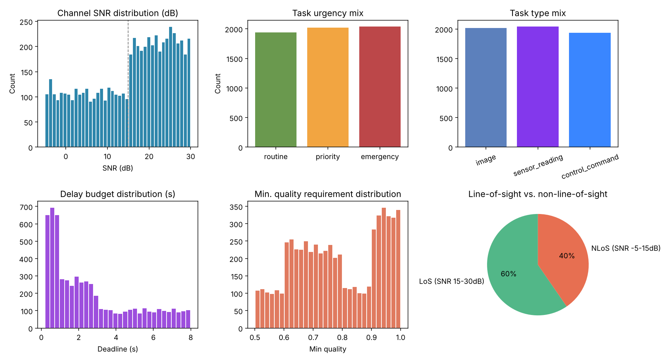
Figure 1: Exploratory analysis of the simulated task/channel distribution (N = 6,000 tasks, seed = 0).

4. How this feeds the project
This same sampling distribution is what every policy in this project is trained and evaluated against: the 6,000-task, 10-seed evaluation reported throughout the final report (Section 5) draws tasks from exactly this distribution, and the oracle policy's 0.696 average reward is the ceiling this distribution permits. Because the distribution is known and controlled, the project is also able to run the sensitivity analysis in the final report (Section 5.5), which re-generates this same EDA under different line-of-sight probabilities, energy weights, and urgency mixes to check that the project's conclusions are not an artefact of one particular sampling configuration.

