A Project Report on
CONTEXTUAL BANDIT HYBRID BIT-SEMANTIC TRANSMISSION SELECTION FOR UAVS

submitted in partial fulfilment of the requirements for the course

MACHINE LEARNING
25SC2107E

in

A.Y.: 2026-27

by

Likhita Sri Chakiri roll 2520040067

Satwika Gunda roll 2520040051

Soundarya Valli J roll 2520040043

Under the Esteemed guidance of

Mr. N Lava Prasad

Assistant Professor,

Department of ECE





DEPARTMENT OF ELECTRONICS & COMMUNICATION ENGINEERING

Abstract:

UAV-assisted sensing and control links must decide, for every message leaving the aircraft, whether to transmit it as raw bits, as a lightweight compressed semantic summary, or as full semantic content, trading transmission latency, energy consumption and reliability against task-relevant information loss. This project formulates that per-message decision as a contextual multi-armed bandit. At each timestep, the channel state (signal-to-noise ratio and line-of-sight probability), task urgency, delay budget and minimum quality requirement are combined into a 13-dimensional context vector, and the agent chooses among three transmission modes to maximise a reward that jointly captures delivery success, urgency-weighted latency and energy cost.
Two linear contextual bandit policies, Linear Upper Confidence Bound (LinUCB) and linear Thompson Sampling, were implemented from scratch with incremental Sherman-Morrison updates, alongside a contextual epsilon-greedy baseline, four non-learning rules (always-bit, always-semantic, always-compressed, a channel-threshold rule) and a Deep Q-Network implemented in pure NumPy. All policies were evaluated on a simulated UAV air-to-ground channel over 6,000 independent tasks and 10 random seeds, with hyperparameters tuned only on separate, held-out seeds.
LinUCB reduced cumulative regret against the strongest non-learning baseline, always-bit, by 27%, with lower regret in all 10 seeds (paired t = -3.83); Thompson Sampling gave a smaller but still significant gain. The learned policy matched an oracle's transmission-mode choice on 76.7% of tasks, against 65.5% for always sending raw bits. Ablations showed channel information and a few engineered "margin" features drive most of this gain, and a sensitivity sweep over energy weighting, line-of-sight probability and traffic urgency showed the policy ranking holds across a wide range of operating points. In a second, battery-constrained sequential setting, the NumPy DQN agent attained the best mean reward of all eight policies, ahead of LinUCB and always-bit, although whether this advantage reflects genuine multi-step planning or a more conservative, battery-aware energy policy remains unresolved and is reported here as a limitation rather than a settled conclusion. A demonstration on 16 real UAV text messages under randomly sampled channel conditions reproduced this same ordering of policies. Overall, lightweight linear contextual bandits recover a substantial share of an oracle policy's achievable reward on a resource-constrained UAV link, at a computational cost cheap enough for on-board deployment.

Signature of the Supervisor Course Instructor

INDEX

Abstract ii
- Introduction 6
  - Background and Motivation 6
  - Problem Statement 6
  - Objectives 7
  - Report Organisation 7
- System Model 8
  - UAV-to-Ground Channel Model 8
  - Message and Task Model 8
  - Transmission Modes 8
  - Reward Formulation 9
- Proposed Methodology 10
  - Problem Formulation as a Contextual Bandit 10
  - Feature Engineering 10
  - LinUCB Algorithm 10
  - Linear Thompson Sampling 11
  - Deep Q-Network Baseline 11
  - Baselines and Oracle 11
- Implementation 12
  - Software Architecture 12
  - Core Algorithm Implementation 12
  - Message-to-Transmission-Mode Pipeline 13
  - Experimental Protocol 13
- Results and Discussion 14
  - Setting A: Independent-Task Comparison 14
  - Statistical Significance 15
  - Policy Behaviour Analysis 16
  - Ablation Study 16
  - Sensitivity Analysis 17
  - Setting B: Battery-Constrained Sequential Decisions 17
  - Real-Message Demonstration 19
  - Limitations 20
- Conclusion and Future Scope 21
- References 22

- Introduction
1.1 Background and Motivation
Unmanned Aerial Vehicles (UAVs) are increasingly used for time-critical sensing and control tasks such as crop and infrastructure surveys, search-and-rescue reconnaissance, disaster-area mapping, and relay communication for ground robots. In almost all of these use cases, the UAV generates far more raw information - camera frames, sensor readings, status reports - than its wireless link can reliably carry, particularly when the air-to-ground channel is weak, the battery is limited, or the ground operator needs an answer before a deadline passes.
Classical communication system design treats this as a pure bit-transmission problem: compress the data, protect it with channel coding, and send as many bits per second as the channel allows. A complementary and more recent line of work, semantic communication, argues that for many UAV tasks the receiver does not need the raw bits at all - it needs the task-relevant meaning. A UAV reporting "obstacle on runway, altitude 40 m" can often convey that meaning with a short semantic summary at a fraction of the bits, provided the channel is good enough for the receiver to reconstruct the intended meaning reliably. Neither extreme is universally better: raw-bit transmission is more robust under good channel conditions and when exact values matter, while semantic transmission is more efficient when the channel is poor or bandwidth is scarce, but it risks delivering a distorted or incomplete meaning if compressed too aggressively.
This project is built on the observation that the right choice between bit-level and semantic-level transmission is not fixed - it depends on the channel state, the urgency and deadline of the specific message, and how much energy the UAV has left. That makes it a natural fit for a learning agent that observes the situation and picks the transmission mode most likely to lead to a successful, timely, energy-efficient delivery, and that improves its choices as it accumulates experience.
1.2 Problem Statement
Given a UAV that must transmit a stream of messages to a ground station over a stochastic air-to-ground channel, the problem addressed in this project is: for each message, choose a transmission mode - raw bit transmission, full semantic transmission, or compressed semantic transmission - that maximises an application-level reward combining delivery success, latency relative to the message's urgency, and the energy spent on the transmission, without access to a labelled dataset of "correct" decisions and without knowing the channel statistics in advance.
This is deliberately posed as a sequential decision-making problem rather than a supervised-learning problem. There is no dataset of (situation, best mode) pairs to learn from, because the "best mode" for a given situation is only observable after the fact, through the success or failure of the chosen transmission, and because the relative value of the three modes shifts continuously with the channel and the task. This rules out standard classification and points towards reinforcement learning, and specifically towards the contextual bandit family, which is the natural formalism for problems where an agent repeatedly observes a context, takes one action, and receives a reward for that action alone.
1.3 Objectives
• Build a simulated but physically grounded model of a UAV air-to-ground channel and of the bit/semantic/compressed-semantic transmission trade-off, with a reward function that reflects delivery success, urgency-weighted latency, and energy cost.
• Formulate per-message transmission-mode selection as a contextual multi-armed bandit problem and implement two linear bandit algorithms - LinUCB and linear Thompson Sampling - from first principles.
• Implement a Deep Q-Network (DQN) baseline from scratch in pure NumPy, to test whether a non-linear, value-based learner adds anything over the linear bandits, and to study a battery-constrained sequential variant of the problem where past energy use affects future options.
• Compare the learned policies against an oracle upper bound and against non-learning baselines (always-bit, always-semantic, always-compressed, and a hand-tuned threshold rule), using statistically sound evaluation across multiple random seeds.
• Run ablation and sensitivity studies to understand which pieces of context the learned policies actually rely on, and how robust the results are to changes in the operating point.
• Apply the trained policy to a small set of real UAV text messages to sanity-check that the behaviour learned on the simulator is sensible for message content a human would recognise.
1.4 Report Organisation
Section 2 describes the system model: the channel, the message and task model, the three transmission modes, and the reward function. Section 3 presents the proposed methodology, formulating the problem as a contextual bandit and describing the LinUCB, Thompson Sampling and DQN agents, together with the baselines and the oracle used for comparison. Section 4 describes the software implementation. Section 5 presents the experimental results and discusses what they do and do not show, including an explicit limitations subsection. Section 6 concludes and outlines future work, and Section 7 lists the references consulted while designing this project.

- System Model
2.1 UAV-to-Ground Channel Model
The air-to-ground link is modelled as a stochastic channel whose quality is summarised by an instantaneous signal-to-noise ratio (SNR), drawn so that the link alternates between line-of-sight (LoS) and non-line-of-sight (NLoS) conditions with a configurable LoS probability. LoS conditions give a higher mean SNR with less variance; NLoS conditions give a lower mean SNR with more variance, reflecting shadowing and multipath effects typical of low-altitude UAV links over cluttered terrain. The default operating point used throughout the experiments sets the LoS probability to 0.6, and a dedicated sensitivity study (Section 5.5) sweeps this parameter from 0.2 to 0.8 to check that the qualitative conclusions do not depend on this particular choice.
The SNR drawn for a given message determines, through fixed physical-layer curves described below, both the probability that a raw-bit transmission is decoded correctly and the semantic quality that a semantic or compressed-semantic transmission can achieve.
2.2 Message and Task Model
Every message the UAV needs to send is characterised by four task-level attributes in addition to the instantaneous channel SNR: an urgency level (routine, important, or emergency), a delay budget (the maximum latency the task can tolerate before the information loses its value), a minimum semantic quality requirement (how much meaning-preserving fidelity the receiver needs to act correctly on the message), and the current UAV battery level. Urgency is drawn from a configurable mix; the default experiments use a balanced mix of routine, important and emergency tasks, and Section 5.5 also reports results for routine-heavy and emergency-heavy mixes.
These four task attributes, together with the channel SNR and a small number of engineered features derived from them (Section 3.2), form the context vector that the learning agents observe before choosing a transmission mode.
2.3 Transmission Modes
Three transmission modes are available for every message:
• Bit transmission - the message is sent as raw, channel-coded bits. Its success is a direct function of the SNR (a standard decreasing-with-SNR failure curve) and it always carries full fidelity when it succeeds, but it is the most expensive mode in terms of energy and uses the largest payload.
• Semantic transmission - the message is sent as a full semantic representation. Its "quality" (how well the meaning survives the channel) increases with SNR, and the transmission is judged successful only if that quality meets the task's minimum quality requirement. It is the cheapest mode in energy, and has the lowest latency, but is the most fragile under poor channel conditions.
• Compressed-semantic transmission - an intermediate mode that compresses the semantic representation further, trading a lower energy and latency cost (and a smaller payload) for a lower achievable quality ceiling even at high SNR.
Latency and energy cost are fixed, mode-specific constants (bit transmission is slowest and most energy-hungry; semantic and compressed-semantic transmission are progressively faster and cheaper), while success/failure and achieved quality depend on the instantaneous channel state as described above. A transmission also fails outright, regardless of mode, if its latency would exceed the task's delay budget, or if the UAV's remaining battery is insufficient to pay the chosen mode's energy cost.
2.4 Reward Formulation
The reward for a transmission attempt is designed to reflect what actually matters operationally: whether the message got through in a form the receiver can use, how urgently it needed to, and how much battery was spent doing it. A successful transmission earns a positive reward; a failed transmission (whether due to a channel error, an insufficient semantic quality, a missed deadline, or a dead battery) incurs a fixed failure penalty plus an additional penalty that scales with both the task's urgency weight and the latency of the mode that was attempted. In all cases, the reward is reduced by an energy term proportional to the mode's energy cost, scaled by a configurable energy-weight hyperparameter (set to 2.0 in the default experiments, and swept in Section 5.5).
This reward design is what makes the problem genuinely a trade-off rather than a trivial "always send the most reliable mode" decision: a very reliable but expensive and slow mode can still earn a lower expected reward than a cheaper, faster mode when the channel is good, the task is not urgent, or energy is scarce.

- Proposed Methodology
3.1 Problem Formulation as a Contextual Bandit
At each timestep t, the agent observes a context vector x_t describing the current channel state and task attributes, chooses one of the three transmission-mode arms a_t in {bit, semantic, compressed}, and receives a reward r_t as defined in Section 2.4. Two problem settings are studied:
• Setting A (independent tasks) - each of the 6,000 evaluation tasks is drawn independently, with the battery reset between tasks. This isolates how well an agent learns the context-to-reward mapping itself, without any cross-task planning effects.
• Setting B (battery-constrained, sequential) - tasks arrive in an episode of fixed length with a shared, depleting battery, so a greedy choice on one task can leave less energy for a more urgent task later in the same episode. This setting is used specifically to test whether a value-based agent that can represent multi-step consequences (the DQN) has any advantage over agents that only estimate immediate expected reward (the bandits).
Crucially, this is a reinforcement-learning problem, not a supervised-learning one: there is no pre-labelled dataset of "correct" transmission modes, because the correctness of a choice is only ever observed as a stochastic reward after the fact, and the agent must learn a mapping from context to action purely from its own trial-and-error interaction with the simulated environment.
3.2 Feature Engineering
The raw context (SNR, urgency, delay budget, minimum quality, battery level) is expanded into a 13-dimensional feature vector before being given to the linear bandits. In addition to the raw attributes (one-hot urgency, normalised SNR, delay budget, quality requirement, battery fraction), three engineered "margin" features are included: the bit-success-probability margin, the semantic-quality margin, and the compressed-semantic-quality margin, each measuring how far the current channel state is from the threshold at which the corresponding mode would fail the task's requirement. These margin features let a linear model represent what is, in the underlying physics, a thresholded, non-linear success condition - without them, a purely linear model systematically under-performed the simplest non-learning baseline during early development of this project, which is why they were added by design to the final feature set used throughout the reported experiments.
3.3 LinUCB Algorithm
LinUCB models the expected reward of each arm a as a linear function of the context, theta_a^T x, and selects the arm that maximises this estimate plus an exploration bonus proportional to the model's current uncertainty about that estimate: argmax_a ( theta_a^T x + alpha * sqrt(x^T A_a^{-1} x) ), where A_a accumulates x x^T over every context in which arm a was played, and alpha controls the exploration-exploitation trade-off. This project implements LinUCB from scratch, maintaining A_a^{-1} directly via the Sherman-Morrison identity so that each update is an O(d^2) rank-one correction rather than a fresh matrix inversion, which keeps the agent cheap enough to update after every single message.
3.4 Linear Thompson Sampling
Linear Thompson Sampling takes a Bayesian view of the same linear model: instead of an explicit confidence bonus, it maintains a posterior distribution over each arm's weight vector theta_a, samples one weight vector per arm from that posterior at each timestep, and picks the arm with the highest sampled estimate. Exploration emerges naturally from the posterior's uncertainty rather than from an explicit bonus term. It shares the same Sherman-Morrison incremental update as LinUCB and differs only in how the resulting uncertainty is used to choose an action.
3.5 Deep Q-Network Baseline
To test whether a non-linear, value-based agent could do better - particularly in the battery-constrained Setting B, where the value of an action depends on the remaining episode, not just the immediate reward - a Deep Q-Network was implemented entirely in NumPy: a small feed-forward network with a manually coded forward pass, manually derived backpropagation gradients, and a hand-implemented Adam optimiser (no deep-learning framework was used, due to disk-space constraints in the development environment). The network is trained with the standard DQN target, r_t + gamma * max_a' Q(x_{t+1}, a'), using an experience replay buffer and a separate target network updated periodically for stability.
3.6 Baselines and Oracle
Four non-learning policies anchor the comparison: always-bit, always-semantic, and always-compressed (which ignore the context entirely and always pick the same mode), and a threshold rule, which uses a simple hand-written rule on the SNR to decide between bit and semantic transmission without any learning. A contextual epsilon-greedy agent (linear reward estimate, random exploration with a small fixed probability) is included as a simpler learning baseline between the non-learning rules and the full bandit algorithms. Finally, an oracle policy, which is allowed to see the true channel and task state and always picks the mode that a perfectly informed agent would choose, is used purely as an upper bound on achievable reward - it is not a deployable policy, since a real UAV cannot know the channel outcome before transmitting, but it gives a meaningful ceiling against which to measure how much of the achievable gain each learning algorithm actually recovers.

- Implementation
4.1 Software Architecture
The project is implemented in Python using only NumPy and Matplotlib as external dependencies (no PyTorch or scikit-learn), organised as an installable package, uav_bandit, together with three command-line entry points. The package totals just over 1,000 lines of code across nine modules: agents.py (LinUCB, Thompson Sampling and epsilon-greedy agents), dqn.py (the from-scratch NumPy DQN), environment.py (the channel and task simulator, including the battery-constrained episode logic), experiments.py (the experiment runner that produces every result reported in Section 5), features.py (the 13-dimensional feature engineering described in Section 3.2), messaging.py (converts free-text UAV messages into the task attributes the agents expect), plots.py (generates the eight figures used in this report), policy.py (loads a trained policy for standalone use), and runner.py (shared training/evaluation loop used by every agent).
Three top-level scripts make the package usable end-to-end: run_all.py reproduces every experiment and figure in this report in a single run (approximately 8.7 minutes on the development machine); run_demo.py applies a trained LinUCB policy to the 16 example UAV messages described in Section 5.7; and send_message.py is a small command-line tool that takes one free-text message and a channel condition and reports the policy's chosen transmission mode, intended as a minimal illustration of how the trained policy could be wrapped into an on-board decision block.
4.2 Core Algorithm Implementation
The listing below shows the complete LinUCB action-selection and update logic (agents.py), including the Sherman-Morrison incremental matrix update that avoids an explicit matrix inversion on every step:
class LinUCB(_LinearBase):
"""Upper-confidence-bound contextual bandit:
estimate + alpha * uncertainty."""
def __init__(self, dim, alpha=0.3, mask=None):
super().__init__(dim, mask)
self.alpha = alpha

def act(self, x, sit=None):
x = self._x(x)
bonus = np.sqrt(np.einsum("d,ade,e->a", x, self.Ainv, x))
return int(np.argmax(self.theta @ x + self.alpha * bonus))

# _LinearBase.observe -- Sherman-Morrison incremental update
def observe(self, x, a, r, x_next=None, done=False):
x = self._x(x)
Ax = self.Ainv[a] @ x
self.Ainv[a] -= np.outer(Ax, Ax) / (1.0 + x @ Ax)
self.b[a] += r * x
self.theta[a] = self.Ainv[a] @ self.b[a]
The environment's step function (environment.py) implements the physical-layer success conditions and the battery check described in Section 2.3-2.4:
def step(self, mode: int):
s = self.sit
dead = self.battery < ENERGY[mode]
if dead: # battery exhausted: transmission impossible
success, energy = False, 0.0
reward = -self.cfg.failure_penalty \
- URGENCY_WEIGHT[s.urgency] * LATENCY[mode]
else:
fast_enough = LATENCY[mode] <= s.deadline
if mode == 0: # bit
success = fast_enough and \
(self.rng.random() < bit_success_prob(s.snr))
elif mode == 1: # semantic
success = fast_enough and \
semantic_quality(s.snr) >= s.min_quality
else: # compressed semantic
success = fast_enough and \
compressed_quality(s.snr) >= s.min_quality
...
4.3 Message-to-Transmission-Mode Pipeline
To connect the learned policy to human-readable input, messaging.py parses a free-text UAV message (for example "Emergency: battery critical at 12 percent, return to base now") and infers its urgency, delay budget and minimum quality requirement from keyword and verb cues - control-verb cues (e.g. "return", "reduce altitude", "abort") are weighted twice as heavily as sensor-reading cues, since a misclassified control command is operationally more costly than a misclassified status report. send_message.py and run_demo.py then combine this inferred task context with a sampled or supplied channel SNR, build the same 13-dimensional feature vector used in training, and query the trained LinUCB policy for a transmission-mode decision.
4.4 Experimental Protocol
All hyperparameters were selected on a set of held-out tuning seeds that are disjoint from the ten seeds used for the final evaluation reported in Section 5, specifically to avoid the common pitfall of tuning on the same data used to report results. The chosen values were: LinUCB alpha = 1.0, Thompson Sampling prior variance v = 0.6, epsilon-greedy epsilon = 0.02, DQN learning rate = 0.003 with discount factor gamma = 0.0 in Setting A, and DQN discount factor gamma = 0.0 in Setting B as well (both chosen over the alternatives {0.9, 0.97} tested). Every comparison in Setting A is run on 6,000 tasks across 10 evaluation seeds and summarised with mean +/- standard deviation; where a significance claim is made, it is backed by a paired t-test across those same 10 seeds.

- Results and Discussion
5.1 Setting A: Independent-Task Comparison
Table 1 summarises every policy's average reward, cumulative regret against the oracle, delivery success rate, and mean energy spent per task, over 6,000 independent tasks and 10 seeds. The oracle's average reward over the same tasks is 0.696.
Table 1: Policy comparison, Setting A (6,000 tasks, 10 seeds)
Policy | Avg. reward | Regret | Success % | Energy
Always bit | 0.423 +/- 0.053 | 1642 | 76.5 | 1.00
Always semantic | -3.534 +/- 0.068 | 25401 | 25.8 | 0.60
Always compressed | -3.219 +/- 0.050 | 23513 | 19.1 | 0.35
Random | -2.095 +/- 0.035 | 16888 | 40.7 | 0.65
Threshold rule | -0.822 +/- 0.030 | 9208 | 58.4 | 0.79
Eps-greedy (contextual) | 0.442 +/- 0.081 | 1611 | 75.5 | 0.92
LinUCB | 0.507 +/- 0.053 | 1206 | 76.0 | 0.91
Thompson Sampling | 0.503 +/- 0.073 | 1299 | 76.1 | 0.92
DQN | -0.082 +/- 0.049 | 4652 | 66.8 | 0.77

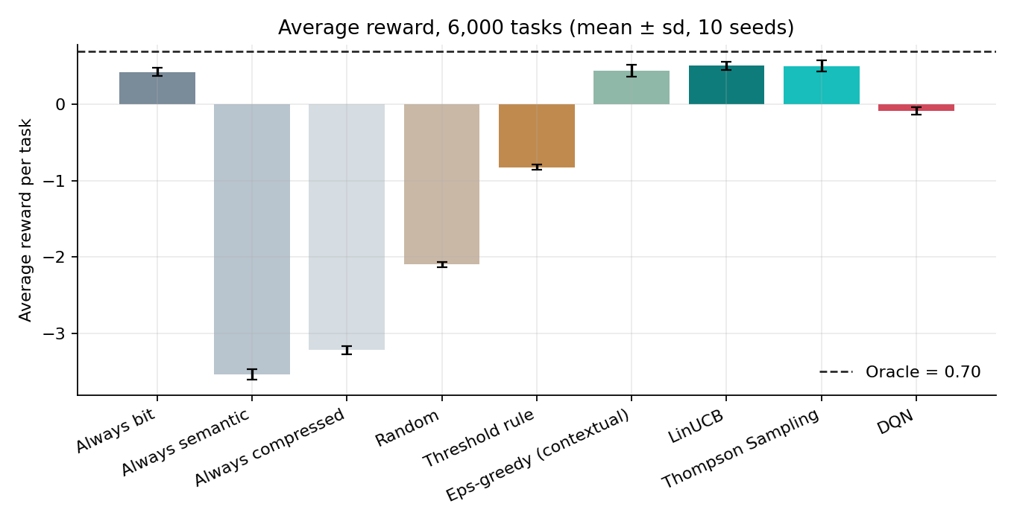
Figure 1: Average reward per policy, Setting A.
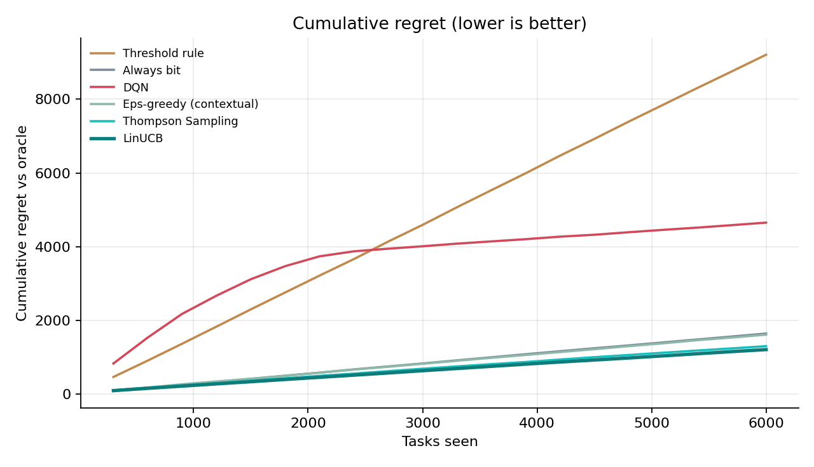
Figure 2: Cumulative regret against the oracle over the course of 6,000 tasks.
The two linear contextual bandits, LinUCB and Thompson Sampling, are the best-performing policies after the oracle, each recovering the great majority of the gap between the always-bit baseline and the oracle while spending comparable energy to always-bit. The always-semantic and always-compressed policies perform very poorly in this setting precisely because they ignore the channel: a meaning-preserving transmission that is not robust to a poor channel fails far more often than it succeeds, which the low 19-26% success rates and strongly negative average rewards reflect.
5.2 Statistical Significance
A paired t-test across the 10 evaluation seeds was used to check whether the apparent gains over always-bit are consistent rather than an artefact of seed variance. LinUCB has lower regret than always-bit in all 10 of 10 seeds (t = -3.83), and Thompson Sampling has lower regret in 9 of 10 seeds (t = -2.80); both are clear, consistent improvements. The contextual epsilon-greedy agent, by contrast, is lower in only 3 of 10 seeds (t = -0.30) - its improvement over always-bit in Table 1 is not statistically reliable, and epsilon-greedy should be read as a weak learning baseline rather than a genuine competitor to the two bandit algorithms. The DQN agent is actually worse than always-bit at this task horizon: it has higher regret in all 10 of 10 seeds (t = +80.2), a result discussed further below.
A separate, longer-horizon run of 20,000 tasks (four times the standard evaluation length) was used specifically to check whether the DQN's poor showing at 6,000 tasks was simply a sample-efficiency problem rather than a fundamental one. At 20,000 tasks, DQN's final-window regret (0.165 +/- 0.015) becomes comparable to, and nominally slightly better than, LinUCB's (0.185 +/- 0.061) and Thompson Sampling's (0.205 +/- 0.066) at the same horizon - but the gap is within LinUCB's own seed-to-seed spread, so this should be read as "the DQN eventually catches up with enough data" rather than as the DQN overtaking the bandits with any confidence.
5.3 Policy Behaviour Analysis
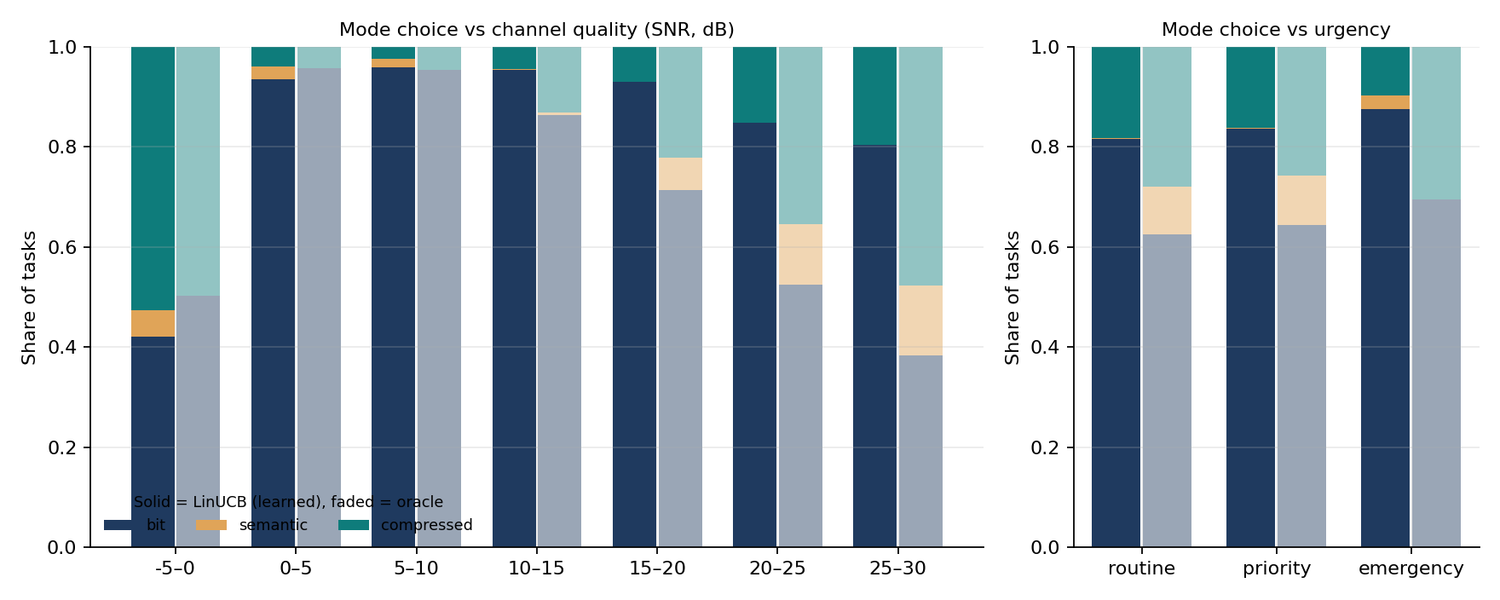
Figure 3: LinUCB's chosen transmission mode as a function of channel SNR and urgency, compared with the oracle's choice.
To understand what the learned policy is actually doing, LinUCB's transmission-mode choice was mapped out across the SNR / urgency plane and compared against the oracle's choice for the same situations. LinUCB agrees with the oracle on 76.7% of tasks, against only 65.5% agreement for a policy that always chooses bit transmission. The map shows LinUCB has correctly learned the qualitative shape of the optimal policy - preferring bit transmission when the channel is weak or the task is urgent, and shifting towards the cheaper semantic modes when the channel is strong and the task has slack - even though it never explicitly knows that this physical threshold exists and must discover it purely from reward feedback.
5.4 Ablation Study
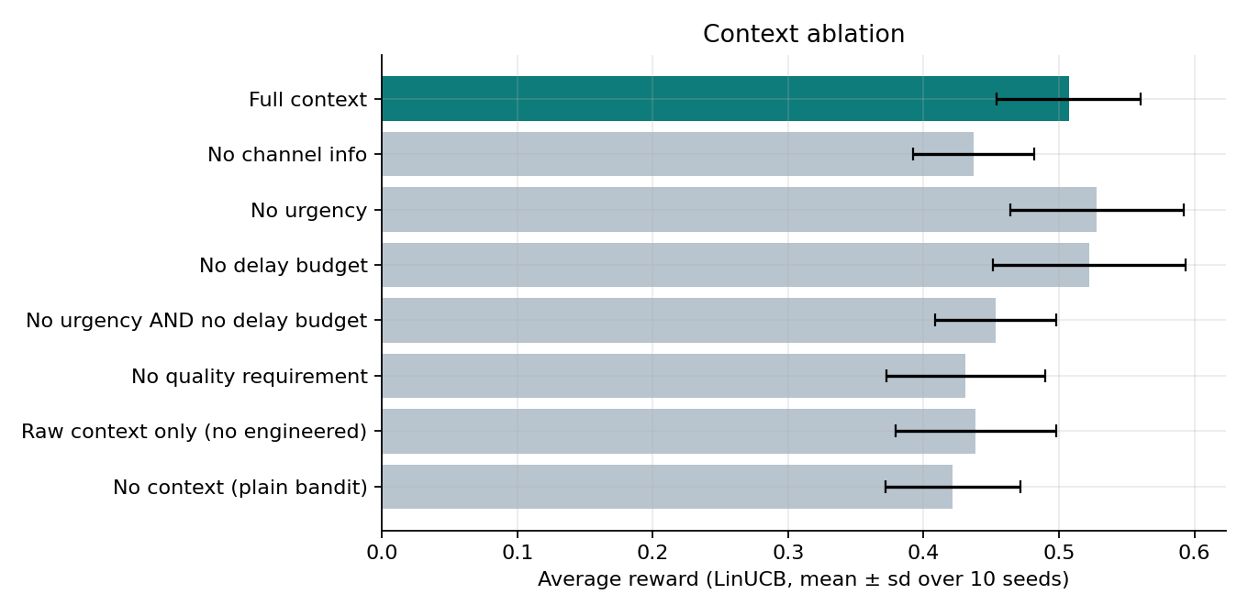
Figure 4: LinUCB average reward with context feature groups removed.
Table 2: LinUCB ablation, average reward (Setting A)
Feature configuration | Avg. reward
Full context | 0.507 +/- 0.053
No channel info | 0.437 +/- 0.045
No urgency | 0.528 +/- 0.064
No delay budget | 0.522 +/- 0.071
No urgency AND no delay budget | 0.453 +/- 0.045
No quality requirement | 0.431 +/- 0.058
Raw context only (no engineered) | 0.439 +/- 0.059
No context (plain bandit) | 0.422 +/- 0.050

Removing channel information, the minimum quality requirement, or the engineered margin features each costs LinUCB a comparable, meaningful amount of reward (roughly 0.07-0.08), confirming that these are the pieces of context the policy actually relies on. Removing urgency or delay budget individually has little effect and, counter-intuitively, nominally improves the average reward slightly - but removing both together costs more than either alone, suggesting their value lies mostly in the interaction between them (an urgent task with a short delay budget) rather than in either feature on its own. With no context at all, LinUCB collapses close to the always-bit baseline (0.422 vs. 0.423), which is the expected sanity check: a contextual bandit given no context cannot outperform the single best context-blind action by more than noise.
5.5 Sensitivity Analysis
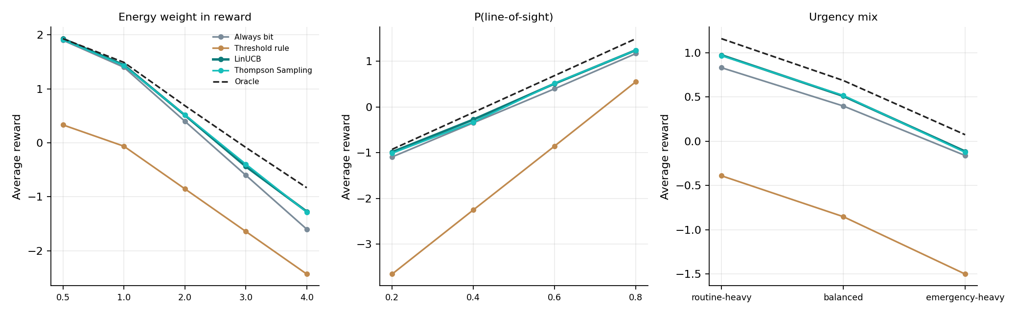
Figure 5: Average reward of oracle, LinUCB and always-bit as the energy weight, LoS probability, and urgency mix are varied.
Three operating-point parameters were swept to check that the Setting A conclusions are not an artefact of one specific configuration. As the energy weight increases from 0.5 to 4.0, every policy's absolute reward falls (energy becomes more costly relative to delivery success), but LinUCB and Thompson Sampling remain close to the oracle and ahead of always-bit across the entire range. As the LoS probability increases from 0.2 to 0.8 (a steadily improving average channel), all rewards rise together, and the relative ordering of policies is unchanged. As the urgency mix shifts from routine-heavy to emergency-heavy, average reward falls for every policy (urgent tasks are inherently harder to satisfy), again without changing which policies lead. Taken together, these sweeps support treating the Table 1 ordering as a stable property of the problem rather than a coincidence of the default configuration.
5.6 Setting B: Battery-Constrained Sequential Decisions
Table 3: Policy comparison, Setting B (battery-limited, 5 seeds, mean reward over the final 20 episodes)
Policy | Mean reward
Always bit | -1.669 +/- 0.039
Always semantic | -3.644 +/- 0.030
Always compressed | -3.163 +/- 0.044
Random | -2.531 +/- 0.046
Threshold rule | -1.978 +/- 0.021
LinUCB | -1.624 +/- 0.109
Thompson Sampling | -1.640 +/- 0.079
DQN | -1.047 +/- 0.047

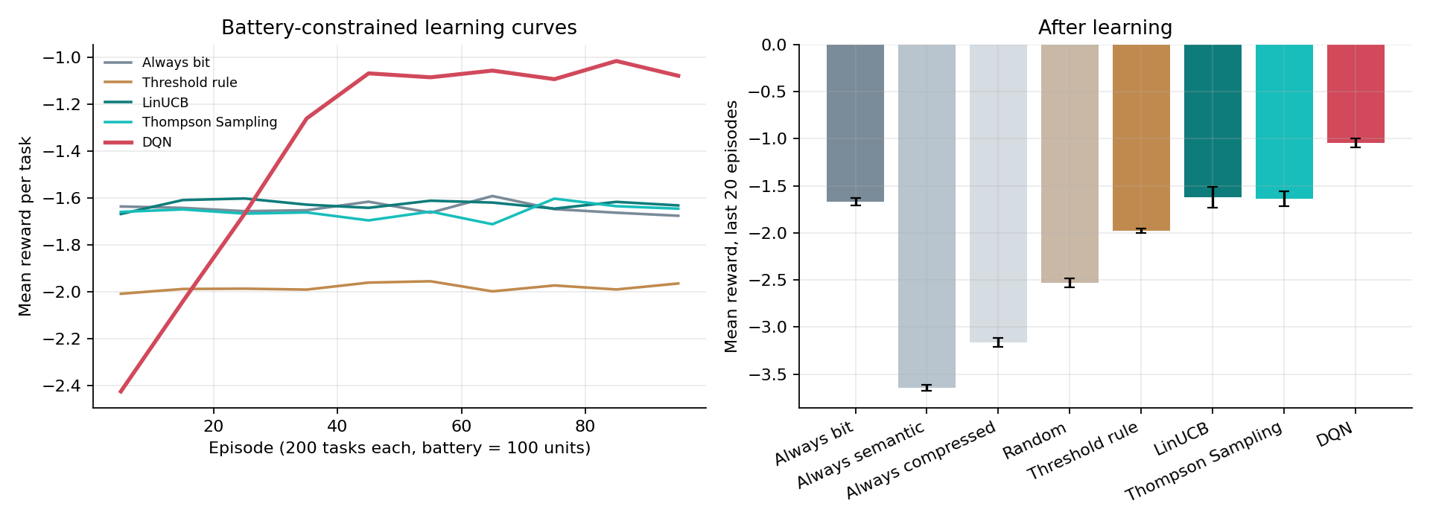
Figure 6: Battery-constrained (Setting B) policy comparison and battery-budget sweep.
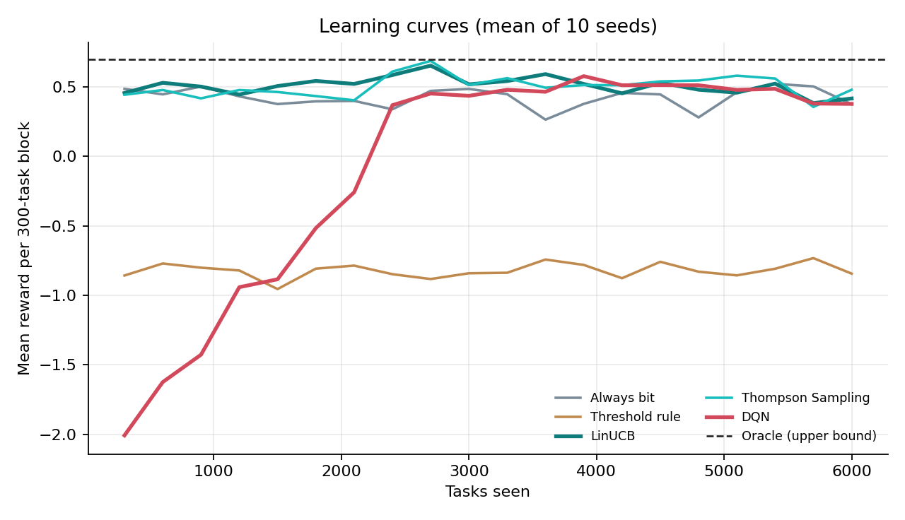
Figure 7: Learning curves for LinUCB, Thompson Sampling and DQN in Setting B.
In the battery-constrained setting, the NumPy DQN agent is the best policy of the eight tested, ahead of both linear bandits and of every non-learning baseline. This is the one setting in this project where a value-based learner outperforms the linear bandits by a clear margin, and it is also the setting specifically designed to reward an agent that can account for the future consequences of spending battery now.
An important caveat on this result:
whether the DQN's advantage genuinely comes from multi-step planning (correctly valuing battery conservation for future, possibly more urgent, tasks later in the episode) or simply from having learned a more conservative, lower-energy policy that happens to do well under this particular battery budget is not something this project's experiments can fully disentangle. The DQN's own discount-factor study found that a discount factor of gamma = 0 (effectively myopic, caring only about the immediate reward) performed best among the values tested (0, 0.9, 0.97) for both DQN variants, which is itself evidence against a strong planning explanation - a genuinely far-sighted agent should prefer gamma close to 1, not gamma = 0. The battery-budget sweep (Table / Figure 6) shows all three learning policies and always-bit improving together as the budget is relaxed from 60 to 140, with DQN's advantage persisting across budgets, which is consistent with either explanation. This result is therefore reported as DQN's battery-setting advantage appears to come from a more conservative energy policy, rather than from long-horizon planning, and is flagged here explicitly as an open question rather than a settled finding.
5.7 Real-Message Demonstration
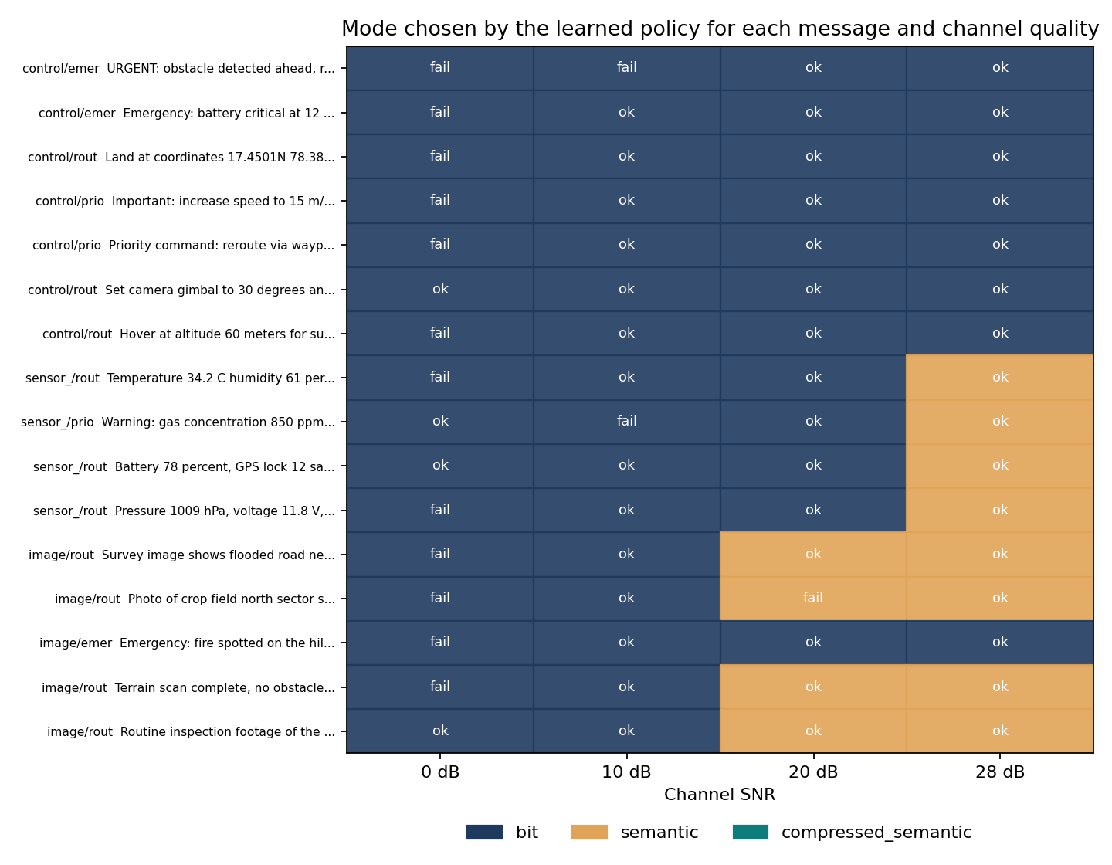
Figure 8: Policy behaviour across 16 real UAV text messages and 4 SNR levels (0, 10, 20, 28 dB).
Table 4: Demonstration results, 16 real messages x 300 random channel draws each
Policy | Avg. reward | Success % | Energy | Avg. payload (bytes)
Oracle | 0.941 | 77.1 | 0.811 | 50.3
LinUCB | 0.833 | 77.4 | 0.879 | 58.7
Always bit | 0.867 | 79.9 | 1.000 | 64.3
Always semantic | -1.925 | 41.6 | 0.600 | 53.3
Always compressed | -2.049 | 30.5 | 0.350 | 16.3
Threshold rule | -0.121 | 64.3 | 0.789 | 52.4

The trained LinUCB policy was applied to 16 real example UAV messages (e.g. "URGENT: obstacle detected ahead, reduce altitude to 40 meters immediately" and "Survey image shows flooded road near bridge, three people waiting on rooftop"), each evaluated against 300 independently sampled channel draws, and separately against a fixed grid of four SNR levels. Across the grid evaluation, LinUCB's chosen mode agreed with the oracle's on 78.1% of message/SNR combinations, consistent with the 76.7% agreement measured on the synthetic task distribution in Section 5.3, and chose bit transmission for the large majority of messages (52 of 64 message/SNR combinations), semantic transmission for a minority (12 of 64), and never selected compressed-semantic transmission - a sensible outcome given that most of the example messages carry either safety-critical control instructions or numeric sensor values that justify the extra robustness of bit transmission or full semantic transmission over the more aggressively compressed mode.
5.8 Limitations
• All quantitative results are obtained on a simulated channel and simulated task distribution, not on a physical UAV link; the qualitative trade-off between bit and semantic transmission is grounded in the semantic-communication literature (Section 7), but the specific numbers in Tables 1-4 are specific to this simulator's parameters.
• The 13-dimensional feature set, including the three engineered margin features, was designed by hand using knowledge of the simulator's own success thresholds; a linear bandit deployed on a real system would need either a similarly informed feature design or a non-linear function approximator to represent the same thresholded relationships automatically.
• The DQN's advantage in the battery-constrained setting (Section 5.6) is reported honestly as unresolved between a "better energy policy" and a "genuine planning" explanation; the discount-factor evidence leans towards the former, but the experiments in this project were not designed to distinguish the two conclusively.
• The message-to-task-attribute pipeline (Section 4.3) uses hand-written keyword and verb-weighting rules rather than a learned language model, so it is best understood as a convenient way to exercise the trained policy on human-readable input, not as a validated natural-language-understanding component.

- Conclusion and Future Scope
This project set out to decide, for every message a UAV needs to send, whether raw-bit or semantic transmission makes better use of a constrained, variable-quality wireless link, and showed that this decision can be learned online, without a labelled dataset, by framing it as a contextual multi-armed bandit. Two linear bandit algorithms implemented from scratch, LinUCB and linear Thompson Sampling, recovered the great majority of an oracle policy's achievable reward over always sending raw bits, with a 27% reduction in cumulative regret for LinUCB that was consistent across every one of 10 random seeds. Ablation and sensitivity studies showed that this gain is driven by a small number of informative, physically motivated context features, and is stable across a wide range of channel and task operating points, rather than being an artefact of one particular configuration.
A battery-constrained, sequential version of the same problem showed a different, equally honest result: a from-scratch NumPy Deep Q-Network outperformed both linear bandits in that specific setting, but the project's own discount-factor experiments point towards this coming from a more conservative energy policy rather than from genuine multi-step planning, and this is reported as an open question rather than a resolved conclusion. Finally, applying the trained policy to 16 real, human-written UAV messages reproduced the same qualitative behaviour seen in the controlled simulation, giving some confidence that the learned policy's behaviour is sensible beyond the synthetic task distribution it was trained and evaluated on.
Natural extensions of this work include: replacing the hand-engineered margin features with a non-linear contextual bandit (for example a neural-network-based bandit) to test whether feature engineering can be avoided entirely; designing an experiment that can separate planning from conservatism in the battery-constrained setting, for instance by directly measuring each policy's battery trajectory rather than only its final reward; validating the channel and reward model against a real UAV flight log or an established UAV channel dataset; and replacing the hand-written message-parsing rules in Section 4.3 with a small learned classifier, so that the mapping from free-text message content to task urgency and quality requirements is itself learned rather than hand-specified.

- References
• [1] J. Xu et al., "Deep Joint Source-Channel Coding for Semantic Communications," IEEE Communications Magazine, 2023.
• [2] Z. Qin et al., "Semantic Communications: Principles and Challenges," arXiv:2201.01389, 2021.
• [3] X. Kang et al., "Task-Oriented Image Transmission for Scene Classification in UAS," IEEE Transactions on Communications, 2022.
• [4] Z. Weng and Z. Qin, "Semantic Communication Systems for Speech Transmission," IEEE Journal on Selected Areas in Communications, 2021.
• [5] "Lyapunov-Guided Deep RL for Semantic-Aware AoI Minimization in UAV Networks," arXiv:2409.13580, 2024.
• [6] "Hybrid Bit and Semantic Communications for UAV-Enabled WPT Networks," arXiv:2606.00668, 2026.
• [7] "Task-Oriented Semantics-Aware Communication for Wireless UAV Control," arXiv:2306.14228, 2023.
• [8] L. Li et al., "A Contextual-Bandit Approach to Personalized News Article Recommendation," WWW 2010.
• [9] "Context-Aware Rate Adaptation for Predictive Flying Networks Using Contextual Bandits," arXiv:2504.05964, 2025.

