UI/UX Design Analysis of a Mobile Application
UI/UX Design Analysis Report – Snapchat mobile Application

Objective:
To evaluate the user interface (UI) and user experience (UX) of the snap chat mobile application by Analysing its navigation, layout, colour scheme, typography, user flow, and overall usability.

Introduction:
Snapchat is a popular social media app used to send photos, videos, and messages. It was created by Snap Inc in 2011. The app is known for messages and photos that disappear after being viewed. Users can also share stories, use fun filters and lenses, make voice and video calls, and chat with friends. snapchat is widely used for quick communication and entertainment.

1.Navigation structure:
The navigation system in snapchat is simple and intuitive
Features:
- Chat: Send text messages, photos, videos, and voice notes.
- Stories: Share photos or videos that stay visible for 24 hours.
- Filters and lenses: Add fun effects, stickers, and AR filters.
- Spotlight: Watch and upload short videos.
- Voice and video calls: Make a voice and video calls with friends.
- Group chats: Chat with multiple friends at the same time.

Analysis:
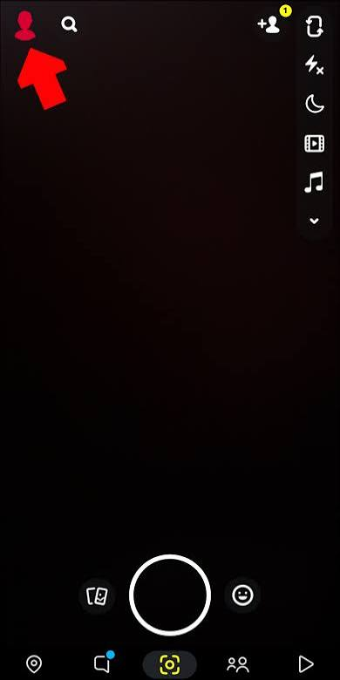

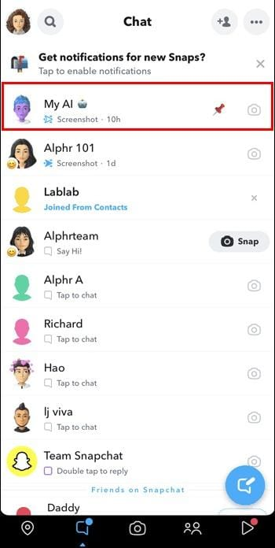
Snapchat has a simple and easy to use navigation structure that allows users to quickly access its main features.

2.Layout Organization:
Layout organization is the way items are arranged on a screen so user can easily see, understand, and use the app.
Features:
- Clear structure: The app arranges content in an organized and easy to understand way.
- Consistent design: Buttons, icons, and menus stay in the same place on every screen.
- Visual hierarchy: Important information is highlighted using size, colour, or position.
- Proper spacing: Enough space is provide between elements to improve readability.
- Easy navigation: Users can quickly find features without confusion.
Analysis:
Snapchat has a simple, camera focused layout that makes navigation quick and user friendly.
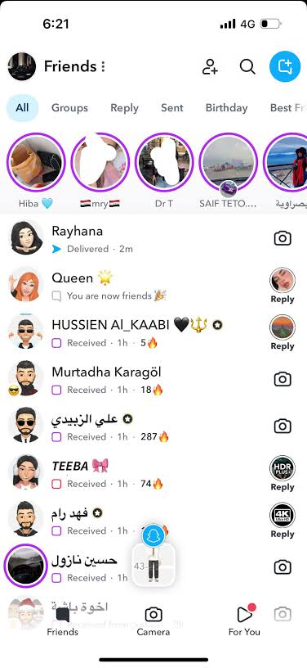
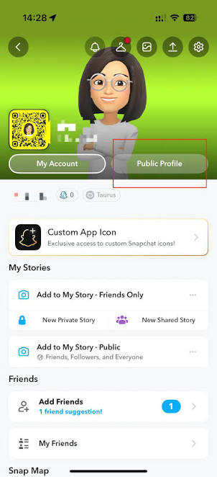
Colour theme: Snapchat uses a consistent colour palette.
Primary colour:
- Yellow: main brand.
- Black and white: icon and text .


Analysis:
Snapchat's colour theme is simple, consistent, and visually appealing, improving usability and brand recognition.
4.Typography:
Snapchat uses simple and readable fonts.
Features:
Fonts: Uses clean and easy to read fonts .
- Readable text: Font size is clear on all screen.
- Bold headings: Important titles are highlighted with bold text.
- Consistent style: The same font style is used throughout the app.
- Good contrast: Black or white text improves readability against different backgrounds.
- Custom text: Users can add, resize, and change the colour of text on Snaps.
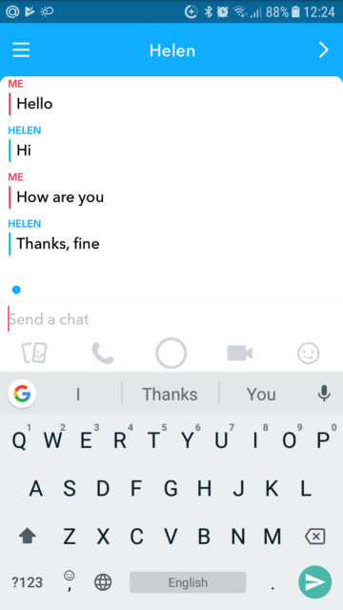

Analysis:
Snapchat's typography is simple, consistent, and readable, providing a smooth and user-friendly experience.

5.User flow:
1. Open the App: The user launches snapchat.
2. Log in/sign up: The user logs in or create a new account.
3. Capture a snap: The user takes a photo or records a videos
4.Edit the snap: Add filters, stickers, text, or drawing.
5.View content: Watch friends’ stories or spotlight videos.
6.Exit the app: Close the app after use.
Analysis:
Snapchat’s user flow is simple and fast, allowing users to capture, edit, and share content with just a few taps.
UI Identified Elements:
UI Elements Purpose
1.Camera screen Main screen to capture photos and
Videos.
2. Capture button Takes a photos or records a video.
3.Chat icon Opens chats and messages with
Friends.
4.Spotlight Shows short, entertaining videos
from the community.
5.Send button Sends snaps or messages to selected
Friends.
UX features:
- Easy navigation: Simple swipe gestures make moving between screens quick.
- Fast camera access: The camera opens immediately when the app starts.
- Personalization: Users can customize Bit Moji, filters, and settings.
- Interactive features: AR lenses, stickers, emojis, and filters improve engagement.
- Quick communication: Users can instantly send snaps, chats, and voice/video calls.

Strengths:
- Fast performance: The app opens quickly and captures photos/videos instantly.
- User friendly design: Clean interface with easy to use icons and buttons.
- Personalized Experience: Shows relevant friends, stories, and content based on user activity.
- Privacy controls: Users can choose who can view their stories and contact them.

Weakness:
- Difficult navigation: Some features are hidden, making them hard for new uses to find.
- Learning curve: New users may need time to understand gestures and icons.
- Too many features: The app can feel crowded with chat, stories, spotlight, maps, and AI
- Small icons: Some buttons and icons are small and not clearly labelled.
- Performance issues: The app may use more battery and data, especially when using the camera and AR lenses.

UI/UX observation:
UI (User Interface ) vs UX (User Experience)
- Yellow colour theme: Bright and recognizable brand identity.
- Bottom navigation icons: Easy navigation between features.
- Search bar: Quick access to friends, chats, and lenses.
- Clean, minimal layout: Fast and comfortable daily usage.
- AR filters and lenses: Fun and engaging user experience.

Suggestions for improvement:
- Improve navigation: Make important features easier to find for new users.
- Simplify the interface: Reduce screen clutter by organizing features more clearly.
- Add better icon labels: Include text labels for important icons to improve usability.
- Enhance privacy controls: Make privacy settings easier to understand and access.
- Improve search: Make it faster to find friends, chats, and content.

Learning outcomes:
Through this experiment, I learned how to evaluate a mobile application’s UI and UX based on usability principles. I understood the importance of navigation, layout, typography, colours, and user flow in creating an effective user experience. Snapchat demonstrates how a simple and consistent design can improve usability and user satisfaction.

Conclusions:
Snapchat has a simple, camera first interface that makes it easy to capture and share photos and videos. Its clean design, intuitive navigation, and interactive features like filters, stories, and spotlight provide an engaging user experience. Although some features can be difficult for users to find, snapchat remains a fast, fun, and user friendly social media application. Overall, it offers a good balance of UI(Visual design) and UX(User experience).

