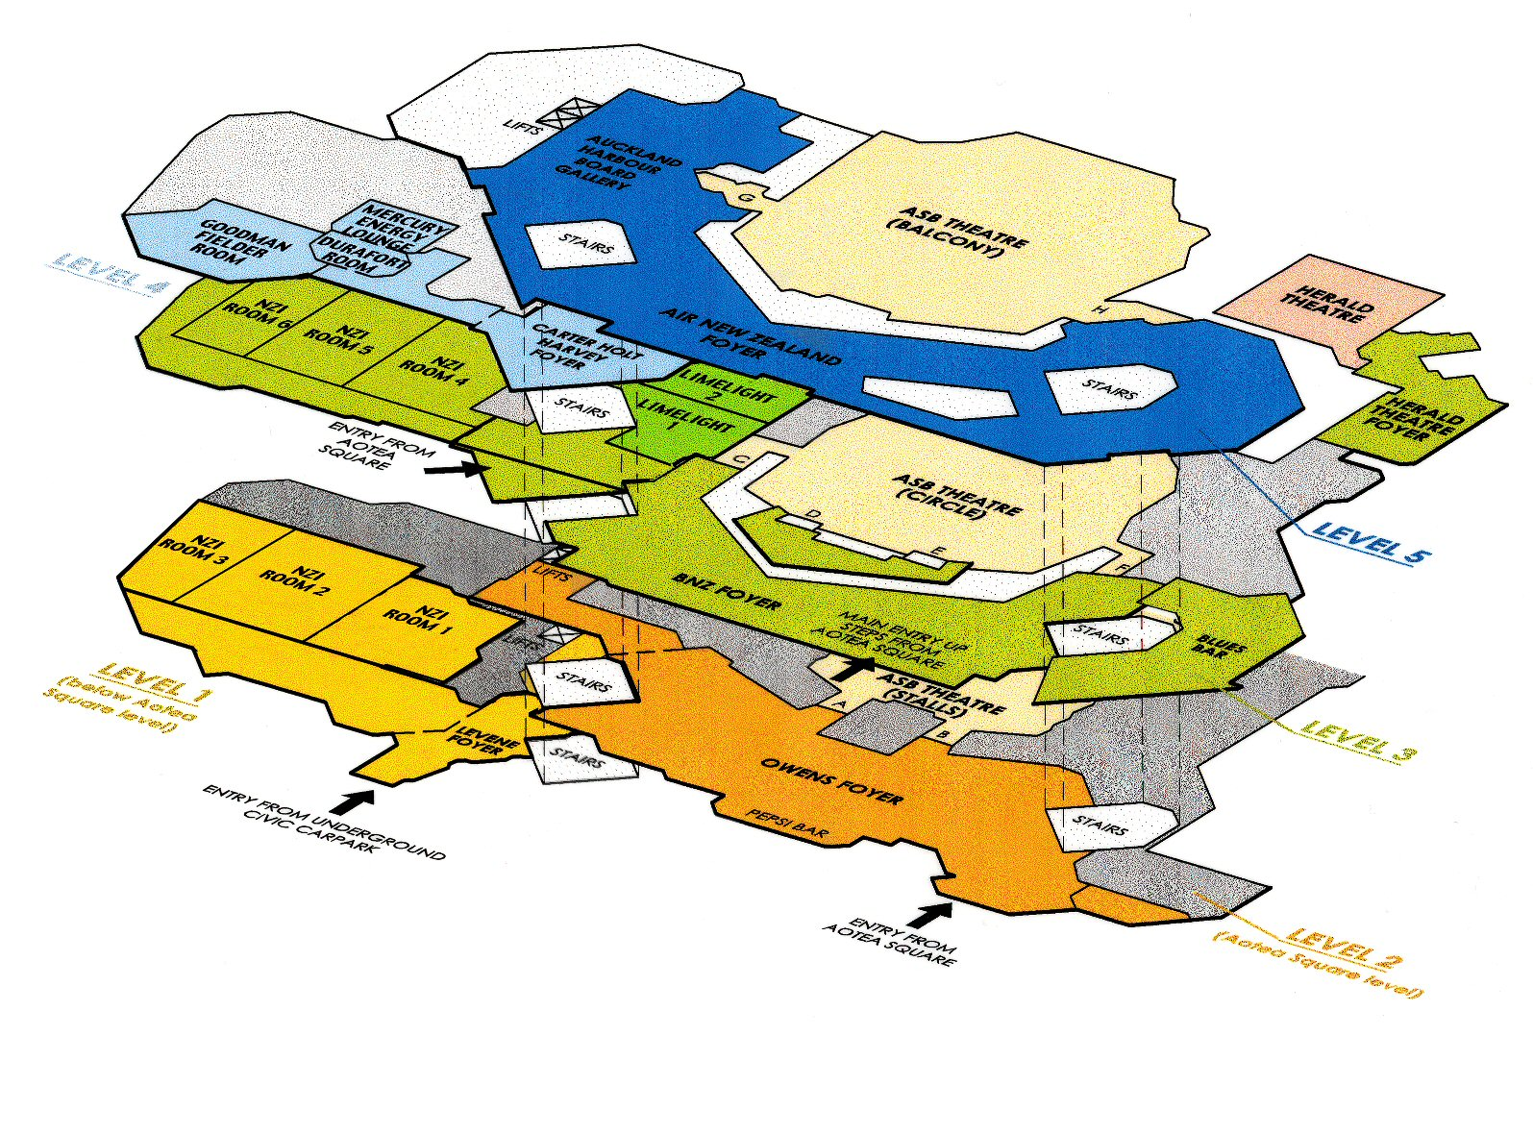
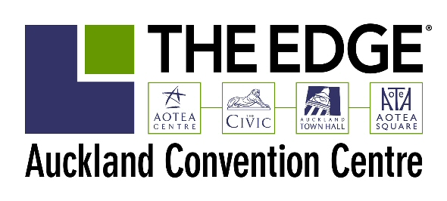
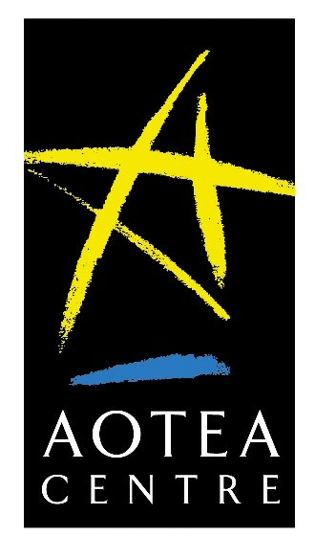
Conference to be held in this section
THE EDGE®
LEVEL 4, AOTEA CENTRE
50 MAYORAL DRIVE
AUCKLAND
NEW ZEALAND

PO BOX 5749, WELLESLEY STREET
TELEPHONE +64 9 309 2677
FAX +64 9 309 2679
WEB www.aucklandconventioncentre.co.nz

*Please note that this plan is not to scale.

