UNIVERSITY CONSTANTINE2
Address: N/A

INTERNSHIP AGREEMENT
The Host Company
Company Name: TechCorp Algeria12
Represented by:
Email: company@gmail.com
Phone: 0777384613

BETWEEN
The Student
Full Name: soundous MENZRI
Specialty: Computer science
Level: L3
Email: soundous.menzri@univ-constantine2.dz

INTERNSHIP DETAILS
Project Title: ooo
Duration: 2 months
Start Date: 21/05/2026
Location: Constantine

For the University  Admin:  (Signature & Stamp)   | For the Company  (Signature & Cachet)  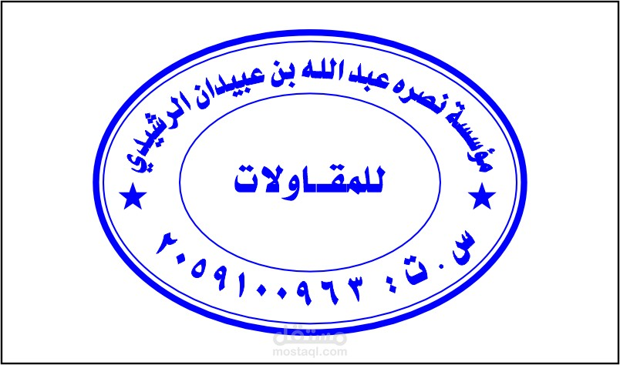

Scan to download this agreement:

