UNIVERSITY CONSTANTINE2

INTERNSHIP AGREEMENT

BETWEEN

The Host Company  Company Name: TechCorp Algeria12  Represented by:  Email: company@gmail.com  Phone: 0777384613 | The University:  University Name: University Constantine2  Represented by: soror Menzri  Email: soundous@univ-constantine2.dz  Department: NTIC3  Address: Not Provided
The Student
Full Name: soundous MENZRI
Specialty: Computer science
Level: L3
Email: soundous.menzri@univ-constantine2.dz
Phone: +213794874880

INTERNSHIP DETAILS
Project Title: jjjjjjjkkkkk
Duration: 3 months
Start Date: 22/05/2026
Location: Constantine

For the University  Admin: soror Menzri  (Signature & Stamp)   | For the Company  (Signature & Cachet)  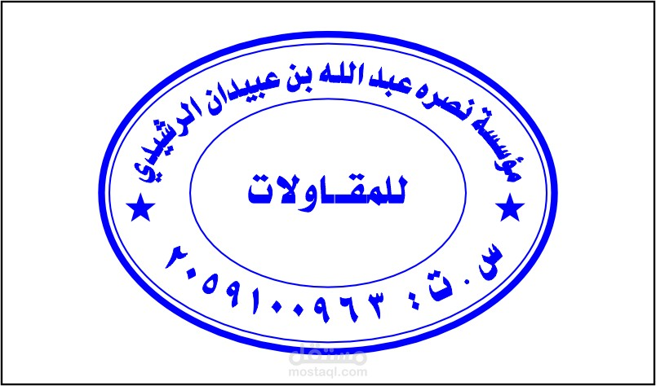

Scan to download this agreement:

