CIS37A-Lab1

Due: June-25-2017, 11:59PM

Name: Subal Pant

**Problem 1:** Write a program that reads two integer numbers from the keyboard (use scanf). Add the two numbers and display the sum.

#include <stdio.h>

#include <conio.h>

int main(void)

{

int num1, num2; //Declaring variables to store numbers

printf("Enter the First Integer: "); //1st Integer Prompt

scanf("%d", &num1); //Reading 1st Value into num1

printf("Enter the Second Integer: "); //2nd Integer Prompt

scanf("%d", &num2); //Reading 2nd Value into num2

int sum; //Declare Sum Variable

sum = num1 + num2; //Perform Addition

printf("Sum: %d", sum); //Print Sum

getch(); //Just to keep console window open after running in Visual Studio

}

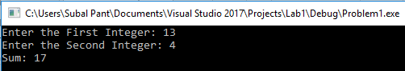

**Problem 2:** Write a program to read 4 numbers and find the average of the 4 numbers.

#include <stdio.h>

#include <conio.h>

int main(void)

{

double num1, num2, num3, num4; //Declaring variables to store numbers

printf("Enter the First Number: "); //1st Integer Prompt

scanf("%lf", &num1); //Reading 1st Value into num1

printf("Enter the Second Number: "); //2nd Integer Prompt

scanf("%lf", &num2); //Reading 2nd Value into num2

printf("Enter the Third Number: "); //3rd Integer Prompt

scanf("%lf", &num3); //Reading 3rd Value into num3

printf("Enter the Fourth Number: "); //4th Integer Prompt

scanf("%lf", &num4); //Reading 4th Value into num4

double avg; //Declare Average Variable

avg = (num1 + num2 + num3 + num4)/4; //Perform Average

printf("Average: %lf", avg); //Print Average

getch(); //Just to keep console window open after running in VS

}

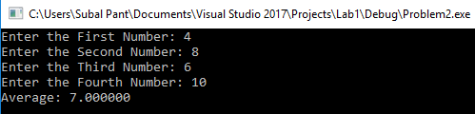

**Problem 3:** Write a program to read 2 numbers and display the largest of the two. You should use scanf to read the two numbers and use if statement to see which number is larger.

#include <stdio.h>

#include <conio.h>

int main(void)

{

double num1, num2; //Declaring variables to store numbers

printf("Enter First Number: "); //First Integer Prompt

scanf("%lf", &num1); //Reading 1st Value Into num1

printf("Enter Second Number: "); //First Integer Prompt

scanf("%lf", &num2); //Reading 1st Value Into num2

if (num1 > num2) {

printf("%lf is larger.", num1); //If num1 is larger than num2, print num1

}

else if (num1 < num2) {

printf("%lf is larger.", num2); //If num2 is larger than num1, print num2

}

else {

printf("Neither number is larger, both equal: %lf", num1); //If num1 = num, print equal and give value.

}

getch(); //Just to keep console window open after running in VS

}

3 Cases for Comparison:

