CIS37A-Lab2

Due: July-02-2017, 11:59PM

Name: Subal Pant

**Problem 1:** (Find the Largest Number) The process of finding the largest number is used frequently in computer applications. Write a pseudocode program and then a program that inputs a series of 10 non-negative numbers and determines and prints the largest of numbers.

#include <stdio.h>

#include <conio.h>

int main(void) {

/*

Initialize three variables: counter, number, largest = 0

Create "for loop" that iterates ten times:

-Needs to ask for 10 numbers

-Needs to read those numbers and store

-"if statement" to update largest variable if input number is greater

Print statement to print the largest number

*/

int counter, number, largest = 0;

for (counter = 0; counter < 10; counter++) {

printf("Enter 10 Numbers (%d): ", counter + 1);

scanf("%d", &number);

if (largest < number)

largest = number;

}

printf("\nThe largest number is: %d", largest);

getch();

}

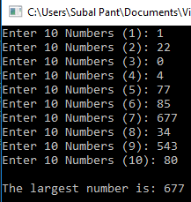

**Problem 2:** Write a program that uses looping to print the following table of values (see Lab document). Use the tab escape sequence, \t, in the printf statement to separate the column with tabs.

#include <stdio.h>

#include <conio.h>

int main(void) {

int i;

printf("N\t\t10*N\t\t100*N\t\t1000*N\n");

for (i = 0; i < 10; i++) {

printf("\n%d\t\t%d\t\t%d\t\t%d", i+1, (i+1) * 10, (i + 1) * 100, (i + 1) * 1000);

}

getch();

}

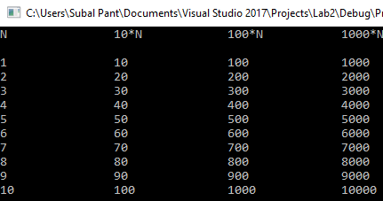

**Problem 3:** Write a program that prints 100 asterisks, one at a time. After every tenth asterisk, your program should print a newline character.

#include <stdio.h>

#include <conio.h>

int main(void) {

int i;

for (i = 0; i < 100; i++) {

printf("*");

if ((i+1) % 10 == 0) {

printf("\n");

}

}

getch();

}

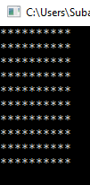

**Problem 4:** Write a program that prints the following patterns separately, one below the other (see Lab document). Use for loops to generate the patterns. All asterisks should be printed by a single printf statement of the form printf (“%s”, “*”);.

#include <stdio.h>

#include <conio.h>

int main(void) {

int i, x;

for (i = 1; i <= 10; i++) {

for (x = 1; x <= i; x++) {

printf("%s", "*");

}

printf("\n");

}

for (i = 10; i >= 1; i--) {

for (x = 1; x <= i; x++) {

printf("%s", "*");

}

printf("\n");

}

for (i = 10; i >= 1; i--) {

for (x = 9; x >= i; x--) {

printf("%s", " ");

}

for (x = 1; x <= i; x++) {

printf("%s", "*");

}

printf("\n");

}

for (i = 1; i <= 10; i++) {

for (x = 9; x >= i; x--) {

printf("%s", " ");

}

for (x = 1; x <= i; x++) {

printf("%s", "*");

}

printf("\n");

}

getch();

}

