CIS37A-Lab3

Due: July-09-2017, 11:59PM

Name: Subal Pant

**Problem 1:** Write a program to create 3 arrays of size 7. Call the arrays midterm, final and result. Read values for midterm and final. Calculate the result array by placing the average of midterm and final for each of the seven students. Print the result array. Then find the average of result array and show how far each student score differs from average score.

#include <stdio.h>

#include <conio.h>

#define SIZE 7

int main(void)

{

int midterm[SIZE];

int final[SIZE];

double result[SIZE];

double sum=0.0;

double classAverage;

printf("Midterm:\n");

for (size_t i = 0; i < SIZE; i++)

{

printf("Enter Student %d Grade (0-100) for Midterm: ", i+1);

scanf("%d", &midterm[i]);

}

printf("\nFinal:\n");

for (size_t j = 0; j < SIZE; j++)

{

printf("Enter Student %d Grade (0-100) for Final: ", j + 1);

scanf("%d", &final[j]);

}

printf("\nResults:\n");

for (size_t k = 0; k < SIZE; k++)

{

result[k] = (midterm[k] + final[k]) / 2;

sum += result[k];

printf("Student %d Resulting Grade: %lf\n", k+1, result[k]);

}

classAverage = sum / SIZE;

printf("\nClass Average = %.2lf", classAverage);

printf("\nScore Difference:\n");

for (size_t l = 0; l < SIZE; l++)

{

printf("%7.2lf\t%7.2lf\n", result[l], result[l] - classAverage);

}

getch();

}

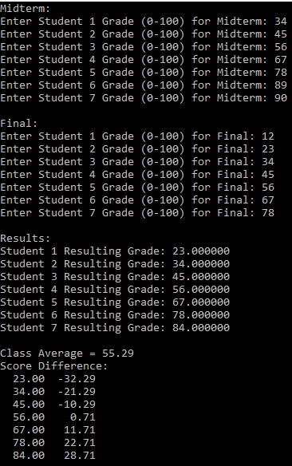

**Problem 2:** Write a program to create an array of size 10. Write a function to read values into this array. Write a function to display the values of this array. Write a function to find the max value of this array and returns that value to main. Write a function to find the minimum value of the array and return that value to main. Write a function to find the average value (in double) of this array and return that to the main. Display the difference between max and average and the difference between min and average in the main program.

#include <stdio.h>

#include <conio.h>

#include <float.h>

#define SIZE 10

void readValues(double arr[], int size)

{

for (size_t i = 0; i < size; i++)

{

printf("Enter Value %d: ", i + 1);

scanf("%lf", &arr[i]);

}

return arr;

}

void displayValues(double arr[], int size)

{

for (size_t i = 0; i < size; i++)

{

printf("%lf\n", arr[i]);

}

}

double getMaxValue(double arr[], int size)

{

double max = DBL_MIN;

for (size_t i = 0; i < size; i++)

{

if (max < arr[i])

{

max = arr[i];

}

}

return max;

}

double getMinValue(double arr[], int size)

{

double min = DBL_MAX;

for (size_t i = 0; i < size; i++)

{

if (min > arr[i])

{

min = arr[i];

}

}

return min;

}

double getAverageValue(double arr[], int size)

{

double sum = 0.0;

double average = 0.0;

double difference = 0.0;

for (size_t i = 0; i < size; i++)

{

sum += arr[i];

average = sum / size;

}

return average;

}

void main()

{

double value[SIZE];

readValues(value, SIZE);

printf("\n");

displayValues(value, SIZE);

printf("\n");

double max = getMaxValue(value, SIZE);

printf("Max Value: %lf\n", max);

double min = getMinValue(value, SIZE);

printf("Min Value: %lf\n", min);

double average = getAverageValue(value, SIZE);

printf("Average = %lf\n", average);

printf("Max - Average = %lf\n", max - average);

printf("Min - Average = %lf", min - average);

getch();

}

