**Capstone Project: Effective Behavioral Health Tools for Suicide Prevention**

Peter Buckheister

MIS581-1 – Capstone – Business Intelligence and Data Analysis

Colorado State University

Dr. Kimberly Ford

7/1/2021

Contents

Capstone Project: Effective Behavioral Health Tools for Suicide Prevention 3

Abstract 3

Introduction 3

Objectives 4

Overview of Study 4

Working Hypothesis 4

Literature Review 5

Research Design 7

Methodology 7

Methods 7

Limitations 7

Ethical Considerations 8

Organization History 8

Reasons for this Organization 9

Analysis 10

Word Cloud Analysis 10

Tool Evaluation Analysis 12

Ranking Analysis 13

Conclusion 14

Recommendations for Further Analysis and Research 15

References 17

**Capstone Project: Effective Behavioral Health Tools for Suicide Prevention**

**Abstract**

This study was conducted to show the effectiveness, in the opinions of the mental health professionals that use them, of tools available for the prevention and reduction of suicidal behaviors in community organizations. The dataset that was compiled is unique to this study and is presented in the form of a survey that was sent to mental health professionals of all levels who work in north central and northeastern Illinois. Text analysis was done on open-ended questions and ranking analysis was conducted on survey responses in order to develop a holistic picture of the opinions of the professionals who work in the field of behavioral health, especially considering the lack of empirical data that exists on the subject of suicide prevention, and the heightened difficulty the subject has presented to the world community in developing a best practice approach to how to deal with suicidal behaviors (Atkinson, et al., 2020).

**Introduction**

As the 10th leading cause of death in the United States (Underlying cause of death, 2020), and 2nd leading cause of death in the United States for ages 10-34 (Suicide, 2021) suicide is a preventable behavior, and organizations from coast to coast are employed by the communities they serve to do just that. However, this is a monumental task, and one that is usually left to organizations that have limited resources in both personnel and finances. The organizations that tackle this sensitive subject are typically organizations who survive on donations and governmental grants. Using data provided by mental health professionals on the best tools for suicide prevention, organizations with limited personnel and financial resources stand to benefit from the development of a sustainable data-driven business model that will help them focus resources on the development of the most effective tools in an effort to reduce suicide rates.

**Objectives**

The objectives of this research project are to analyze mental health professional’s responses to a questionnaire regarding the best tools for the job of suicide prevention, and to determine which tool(s) is the most effective means by which a professional in this field can have an impact in the reduction of suicides. Ultimately, the research should provide a guide to organizations providing behavioral health services to the community on which tools are the most effective and thus, should receive the bulk of funding and resource allocation.

**Overview of Study**

The overarching goal of this research project is to provide organizational focus of resources in the face of limited funding for mental health services in local communities. Even after adoption by the World Health Assembly in 2013 of the World Health Organization’s Comprehensive Mental Health Action Plan, many countries still struggle to come up with a best practice solution for how to best deal with the issue of mental health (Atkinson, et al., 2020). Although mental health disorders have been shown to be overstated as the cause of suicide in multiple studies (Jaffe, 2014) (Schmutte, et al., 2021), identifying those affected by mental health issues still play a key role in evaluating suicide risk, and since organizations in this field deal primarily with community members who are mentally ill, suicide prevention is a priority concern among many of them.

**Working Hypothesis**

The working hypothesis of this project is as follows:

*What tool available to mental health professionals is most effective at reducing the rates of suicide in the community, taking into consideration the limited financial and personnel resources of the non-profit organizations who are likely to utilize them?*

* H0 – Any given tool is no more or less effective at suicide prevention than any other tool. All things considered; all tools are equal.
* H1 – The employment of a crisis line in the community is the most effective tool that can be used in suicide prevention.
* H2 – The employment of a tool other than a crisis line in the community is the most effective way to reduce the number of suicide deaths.

**Literature Review**

The literature used in reference for this research project centers around studies done on effectiveness of tools used in the prevention of suicide, including literature regarding crisis line studies specifically. The study by Atkinson (Bringing new tools, a regional focus, resource-sensitivity, local engagement, and necessary discipline, 2020) looks at several factors of community mental health services including important points regarding funding and service distribution. The study by Cai (A scientometric analysis of suicide research, 2020) looks at the research already done on the subject, showing correlations of suicide deaths and the number of publications related to suicide by country.

For literature specifically regarding the crisis line services as a tool, the study by Hoffberg (The effectiveness of crisis line services, 2020) serves the purpose of providing knowledge of crisis line services as they exist in organizations today. The study by Hoffberg could stand on its own in support of the research hypothesis in this research project but will be used for supporting evidence. In support of this study is the article by Jaffe (Preventing suicide in all the wrong ways, 2014) which further supports the aim of this research project by its finding that funding should be directed towards the tools that actually have been proven effective in preventing suicide, and not towards ineffective tools that are being used for public relations stunts or political gain.

Another study done by Kahsay (Suicide prevention training in the child welfare workforce, 2020) points to what they refer to as “Gatekeepers” being key to the prevention of suicide, and although this study is in reference to children, the findings seem to follow initial responses gathered from this project’s research questionnaire. Many professional responses point to the presence of someone who can refer someone with suicidal ideations to professional services as a key component of suicide prevention. To complement this information, the study by Ku (Associations between mental health shortage areas, 2021) shows that suicide rates actually increase in areas where access to mental health services is lacking, supporting the notion that simply the presence of these tools is effective, and this study also explores suicide rates based upon urbanicity, a topic also explored by this project.

The article by Schmutte (Comparisons between suicide in persons with serious mental illness ,2021) provides supporting information regarding suicide among the mentally ill population, which further shows that behavioral health organizations play a key role in suicide prevention and that this research is in fact focused in the right direction as these organizations deal mainly with those in need of mental health services within local communities. Finally, the study by Zbukvic (Short report: Understanding the process of multilevel suicide prevention research trials, 2020) provides an overview of research done on the subject of suicide prevention. This study concluded that research in this field should be focused more on “mechanisms of impact” (para. 11), which is to say that most research done on suicide prevention is not shared in the professional community and thus, the recommendations cannot be followed. In other words, the study shows that suicide prevention research can be effective if it is implemented.

**Research Design**

The research design used in this project is exploratory more than any other. The objective of the research is to obtain clarification by analysis of survey responses of tool effectiveness and answering the *what* as the research hypothesis suggests.

**Methodology**

The research methodology utilized in this project will be evaluative. The objective of the project is to attempt to determine which type of professional tool, if any, is the most effective at providing a positive outcome when deployed to combat suicidal behavior. This methodology selection seems to be especially important in the field of suicide prevention, or behavioral health in general, because it is important to take away lessons from the research to use as building blocks for future research, so as not to start from zero every time research conducted in the field is attempted (Zbukvic, et al., 2020).

**Methods**

The primary method of research for this project will be driven by the collection of data from mental health professionals in the form of a questionnaire, details of which may be found under the Analysis section of this report. This survey will provide the research author with differing views of the data in order to perform competent analysis. The questions on the survey will revolve around providing responses towards the *what* that the research intends on answering: What tool is the most effective?

**Limitations**

Limitations of this research include but may not be limited to the survey itself, the lack of any empirical data surrounding the primary research hypothesis, and the authors limited knowledge in the field of behavioral health.

The survey was developed with the goal of eliciting responses of effective suicide prevention tools in mind but was established from the perspective of a data professional. The survey would have been better served by being created from the perspective of a professional in the field it is targeting (although it should be noted that this field experience could lead to research bias), along with possible focus group testing to refine the questions before they were sent out for response gathering. Additionally, there is very little data in existence that can show strong evidence of what, if anything, is effective at preventing suicide. The reasons for this should be self-explanatory. Finally, the project author has little knowledge of the field, outside of personal experience with suicidal persons, and the will to make a difference.

**Ethical Considerations**

The ethical considerations of this project are mainly limited to presenting the findings in a competent manner so that any in field that might review the research are reviewing facts and evidence that support the findings, as to not be misleading or false in any way. Secondary ethical considerations include the sensitivity of the subject manner, and should be understood as such, while also understanding that it is a subject that must be talked about if there is any progress to be made in support of a positive outcome for the research itself.

**Organization History**

AID has been in operation since 1961 as a non-profit community based organization that caters to the needs of people with “physical, developmental, intellectual, and mental health challenges” (Association for Individual Development, 2021). Reaching over 5,600 individuals, this organization seeks to empower its clients to live their best possible lives.

As a registered 501(c) non-profit, AID covers the majority of its operating expenses from the fees it charges from operating programs (AID Annual Report, 2020). Grants and personal donations make-up the remainder of income generated by the organization. AID offers services in a seven county area in northeast Illinois, mainly focused on the suburbs of the city of Chicago. The counties of Cook, DeKalb, DuPage, Kane, Kendall, McHenry, and Will all benefit from the services this organization offers.

Speaking of services, AID offers numerous services to its clients. These services include outpatient behavioral health, supportive housing, employment, crisis line, community support, nursing, health care, and psychiatric. Additionally, the organization offers services to victims of crime, and offers its services to local law enforcement. One service AID offers is the embedding of social workers in the local police departments for proactive policing when it comes to offenders with mental health issues. The crisis line service offered by AID plays a key role in providing the community with free mental health counseling in the event of a personal crisis, a service that is likely key in preventing actions such as suicide.

**Reasons for this Organization**

This organization plays a critical role in proactively addressing mental health issues faced in the communities it services. While most aspects of the services AID provides are not preventable, i.e., developmental and mental health challenges, suicide is preventable, especially considering the fact that a good proportion of suicides (over 40%) occur in people with known mental health disorders (Schmutte, et al., 2021), and behavioral health professionals are already inadequately prepared for dealing with suicidal persons (Kahsay, et al., 2020). These are the type of people that organizations such as AID are already in contact with on a daily basis, and behavioral health professionals are the ones who can benefit the most from additional research related to suicide prevention. The services provided by AID related to its crisis line and victim services, even law enforcement services could all be reinforced by analysis of data regarding suicide rates, demographics affected by suicide, etc.

**Analysis**

The data used for analysis in this project centered around a survey that was sent out to mental health professionals in the community from multiple organizations, including non-profit workers, professional counselors, and members of the board of the local NAMI chapter (National Alliance on Mental Illness, 2021). Responses from 37 recipients were captured in a Google form which can be found at the following link: https://forms.gle/fHaE9mdMKD3qxP5G8

The survey consisted of two multiple choice questions, seven rankings, one checkbox response (multiple answers), and two long answer questions. The idea was to get different views of professional opinions regarding the effectiveness of crisis tools that were available to them, and how each respondent would rate their effectiveness. It should be noted that the first question asked was to gage the respondent’s familiarity with suicidal behavior by asking whether or not the respondent had in fact had contact with persons that exhibited this type of behavior on either a personal or professional level. 78.4% of respondents revealed that they had experienced this on both levels, with 97.3% of respondents experiencing it on one level or another.

**Word Cloud Analysis**

As seen in Figures 1 and 2, word clouds were developed on Tableau Desktop using the data provided by the survey respondents for the two long answer questions. This was done to create a visual tool to convey the story that was being told through these survey responses. Disregarding the most commonly used words (crisis, tools, services, clients) that are obvious elements considering the questions asked, both word clouds reveal a set of words used by the respondents: Family, Community, and Support. Additionally, the use of the word ‘Available’ should be noted.

**Figure 1**

Word cloud analysis of survey response question regarding the effectiveness of tools available to mental health professionals.

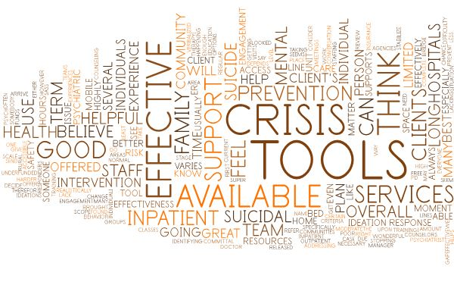

**Figure 2**

Word cloud analysis of survey response question regarding what can be improved to increase the effectiveness of crisis tools available to mental health professionals.

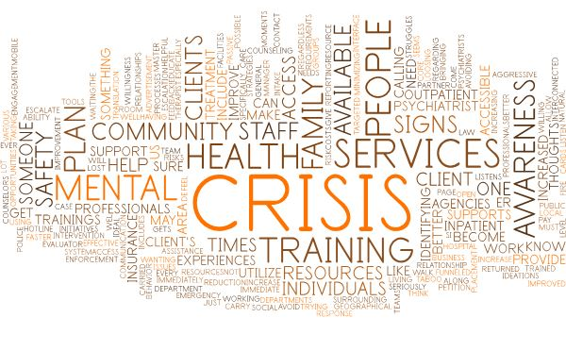

**Tool Evaluation Analysis**

The survey asked respondents directly, which tool at their disposal they felt was the most effective at preventing suicidal behavior. This question allowed for respondents to choose an ‘Other’ response and fill in their own choice. As seen in Figure 3, it was clear that Family Engagement/Support was the most popular choice, with 32.4% of respondents choosing this tool, while the Mobile Crisis Response Teams came in second at 21.6%.

**Figure 3**

Survey chart showing responses to the effectiveness of a specific crisis tool.

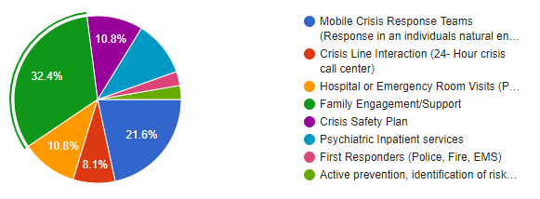

**Ranking Analysis**

The survey allowed respondents to rank their top three choices insofar as effective suicide prevention tools to further develop the initial single response question. As shown in Figure 4, the leading choice for an effective prevention tool is Family Engagement/Support (chosen by 22 respondents), followed by Psychiatric Inpatient Services (chosen by 20 respondents), and finally a tie between Crisis Line Interaction/Hospital Emergency Room Services (each chosen by 19 respondents).

**Figure 4**

Respondents ranking of effective crisis tools.

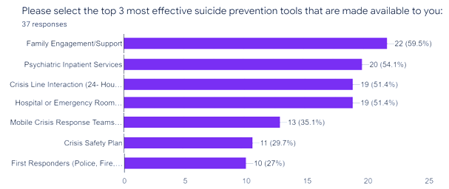

Additional ranking analysis was provided by the remaining survey questions and is aggregated below. Rankings were determined by asking respondents to rank each tool in terms of effectiveness from 1 to 5, with 5 being a very effective tool:

Crisis Safety Plan: Average ranking – 3.32

Crisis Line Interaction: Average ranking – 3.54

Hospital Emergency Room Services: Average ranking – 3.95

Family Engagement and Support: Average ranking – 4.35

Mobile Crisis Response Team: Average ranking – 4.16

Psychiatric Inpatient Services: Average ranking – 4.08

First Responders: Average ranking – 3.46

As seen in previous analysis of the survey data, Family Engagement and Support is the leading response of respondents concerning effective suicide prevention tools.

# Conclusion

Behavioral health organizations have an array of tools at their disposal for response to persons with suicidal ideations, and in the opinions of the mental health professionals who utilize them, some are more effective than others at preventing this behavior. Exploratory analysis of the data provided by the questionnaire in this project points overwhelmingly towards the engagement of family and the support provided by a family system as a key factor to the prevention of suicide. All analysis done in this project supports this conclusion. However, further analysis should be conducted to support this conclusion as family engagement is not so much a tool that can be deployed by organizations such as AID as it is a foundational cornerstone of knowledge that the presence of a family support system reduces suicidal behavior in the view of the professionals who deal with this type of behavior. This points to community education as the underlying factor concerning these findings.

The project data analysis also supports the existence of crisis response, specifically mobile response as a key tool that can be deployed by these behavioral health organizations. Again, further research should be conducted, but initial response seems to support the deployment of mobile crisis response, whether in the form of embedded social workers in a law enforcement capacity or stand-alone crisis response teams that respond to suicidal crisis instances through dispatch from crisis line workers, both of which are services already provided by organizations such as AID. The most logical conclusion supported by the evidence provided in this project is the deployment of both crisis line services and mobile response teams as the most effective tool available to organizations such as AID in their mission to reduce suicidal behavior throughout local communities. In support of this conclusion, the article by Hoffberg (The effectiveness of crisis line services, 2020) can be referenced in its conclusion that although the effectiveness of crisis lines cannot be empirically measured due to their very nature, they are without a doubt an effective measure against suicidal behavior in the short-term, and an argument can be made that suicidal behavior is the type of behavior that requires an immediate response, even if the underlying factors of the state of an individual’s mental health require longer term treatment. Therefore, the alternate working hypothesis H2 is proven to be the most accurate determination of tool effectiveness in the pursuit of suicide prevention, the availability of a combination of tools used to complement each other and the work they perform in the community. This is where the resources of non-profit organizations should be focused for maximum effectiveness.

Recommendations for Further Analysis and Research

Recommendations for further analysis include the refinement of the dataset survey and the inclusion of more respondents. This study has a possible bias regarding the respondent pool and that they all work within the same community where the thought process among professionals may be very similar, so it would benefit this research to include a more diverse set of survey participants. Additionally, behavioral health consultation could be recommended to ensure the study is true to the field it is representing. Finally, the survey questions themselves could benefit from deeper development to ensure all the right questions are being asked in the right ways.

**References**

[NCHS Data Brief, Number 362]. (2020, April). Unpublished raw data.

2010 Census Urban and Rural Classification and Urban Area Criteria. (2019, December 02). Retrieved May 26, 2021, from https://www.census.gov/programs-surveys/geography/guidance/geo-areas/urban-rural/2010-urban-rural.html

AID Annual Report 2020 (Rep.). (2020). Aurora, IL.

Association for Individual Development. (2021). Retrieved May 15, 2021, from https://www.aidcares.org/

Atkinson, J., Skinner, A., Lawson, K., Rosenberg, S., & Hickie. I. B. (2020). Bringing new tools, a regional focus, resource-sensitivity, local engagement and necessary discipline to mental health policy and planning. *BMC Public Health*, 20(1), 1–9. https://doi.org/10.1186/s12889-020-08948-3

Cai, Z., Chang, Q., & Yip, P. S. F. (2020). A scientometric analysis of suicide research: 1990–2018. *Journal of Affective Disorders*, 266, 356–365. https://doi.org/10.1016/j.jad.2020.01.121

Clinical suicide prevention workflow. (n.d.). Retrieved May 29, 2021, from https://www.oregonsuicideprevention.org/wp-content/uploads/2019/05/DRAFT-Mosaic-Diagram.pdf

Hoffberg, A. S., Stearns-Yoder, K. A., & Brenner, L. A. (2020). The effectiveness of crisis line services: A systematic review. *Frontiers in Public Health*, 7. doi:10.3389/fpubh.2019.00399

Jaffe, D. (2014, September 09). Preventing suicide in all the wrong ways. Retrieved May 26, 2021, from https://centerforhealthjournalism.org/2014/09/09/preventing-suicide-all-wrong-ways

Kahsay, E., Magness, C. S., Persky, S., Smith, P. K., & Foster, C. E. (2020). Suicide prevention training in the child welfare workforce: Knowledge, attitudes, and practice patterns prior to and following safeTALK training. *Child Welfare*, 98(1), 95–114.

Ku, B. S., Li, J., Lally, C., Compton, M. T., & Druss, B. G. (2021). Associations between mental health shortage areas and county-level suicide rates among adults aged 25 and older in the USA, 2010 to 2018. *General Hospital Psychiatry*, 70, 44-50. doi:10.1016/j.genhosppsych.2021.02.001

National Alliance on Mental Illness. (2021). Retrieved June 18, 2021, from https://www.namikdk.org/

Schmutte, T., Costa, M., Hammer, P., & Davidson, L. (2021). Comparisons between suicide in persons with serious mental illness, other mental disorders, or no known mental illness: Results from 37 U.S. states, 2003–2017. *Schizophrenia Research*, 228, 74-82. doi:10.1016/j.schres.2020.11.058

Suicide. (2021, January). Retrieved May 15, 2021, from https://www.nimh.nih.gov/health/statistics/suicide

Underlying cause of death, 1999-2019 results. (2020). Retrieved May 15, 2021, from https://wonder.cdc.gov/controller/datarequest/D76;jsessionid=1C36118A3628252984B0903BC794

Zbukvic, I. C., Mok, K., Mcgillivray, L., Chen, N. A., Shand, F. L., & Torok, M. H. (2020). Short report: Understanding the process of multilevel suicide prevention research trials. *Evaluation and Program Planning*, 82, 101850. doi:10.1016/j.evalprogplan.2020.101850