ENTERPRISE ARCHITECTURE & CYBERSECURITY TECHNICAL DOSSIER
Product: Clearance Check | Main Interface: Sanction checK | Version: v1.2.1 | Date: 10 Nov 2026
Prepared by: Antigravity (AI assistant) — for review by Sounit Karttikay
PURPOSE: Factual technical disclosure prepared for Enterprise Architecture and Cybersecurity evaluation. Every statement carries an evidentiary tag: [Measured], [Observed in code], [Declared by owner — to be confirmed], or [Not measured].

1. Purpose and Scope
Core Capability: [Observed in code] Clearance Check (main screen title: Sanction checK) is a regulatory screening aid and counterparty due diligence tool. It automates name matching, phonetic similarity expansion, beneficial ownership 50% rule aggregation, export-control order lookup, and aviation safety carrier ban evaluation.
Decision Boundary: [Observed in code] The application does not make legal determinations or block transactions autonomously. It surfaces potential matches across official government lists for compliance officer review and escalation under corporate policy.
Target Audience: [Declared by owner — to be confirmed] Intended users are compliance officers and trade compliance analysts screening prospective business partners, vessels, aircraft, and corporate shareholding hierarchies.

2. Architecture and Process Model
Process Model: [Observed in code] Desktop implementation runs as a local single-user Windows application. An embedded Python 3.14.10 runtime executes a local web service bound to localhost (127.0.0.1), presented in a native window via pywebview (Edge Chromium WebView2).
Matching Logic: [Observed in code] The matching algorithm is adapted from Facebook Watchman (Apache-2.0). Function best_pairs_jaro_winkler computes word-combination token pairings via generate_word_combinations. When non-name identifiers are absent, a strict penalty multiplier (NAME_ONLY_PENALTY_MULTIPLIER = 0.81225) enforces a deterministic ceiling. Phonetics are evaluated via Double Metaphone and non-Latin scripts via AnyAscii transliteration.

System Architecture Diagrams

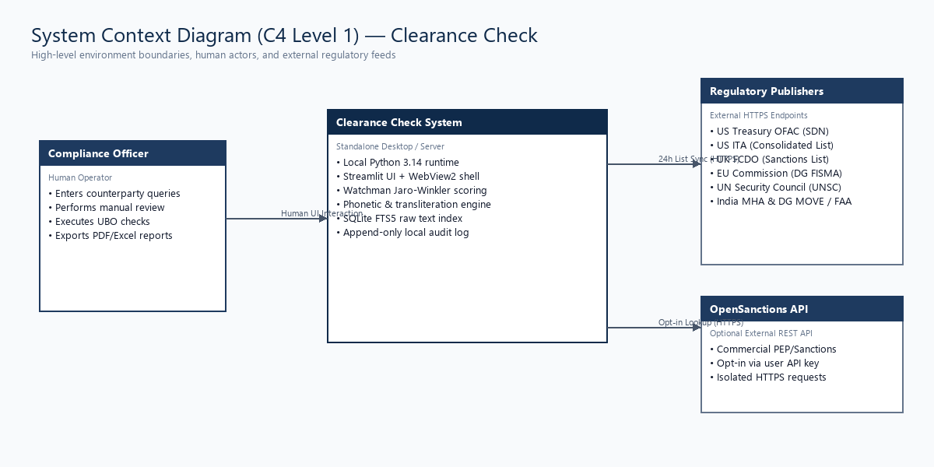
Figure: System Context Diagram (C4 Level 1)

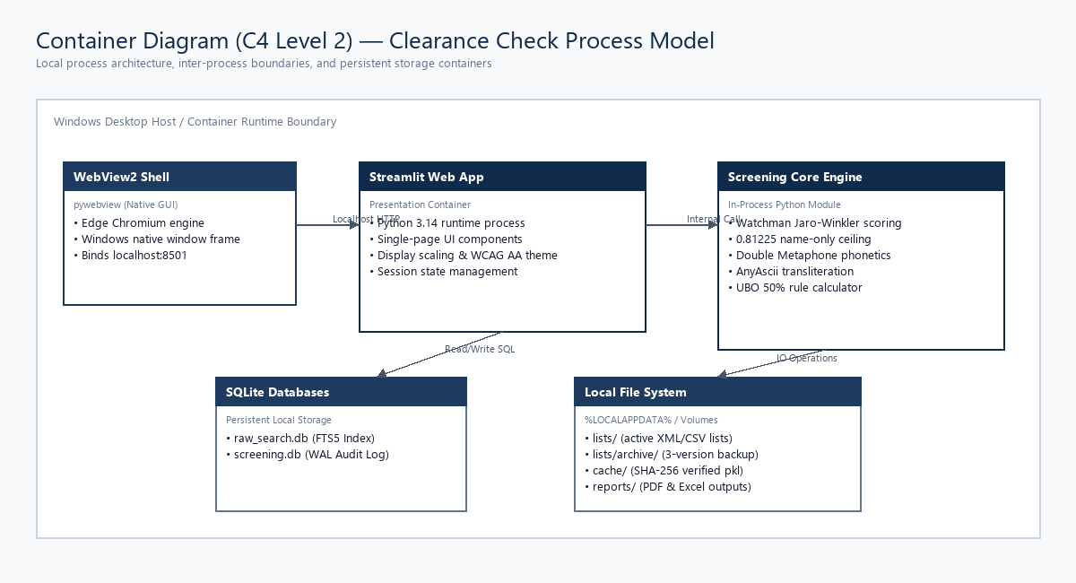
Figure: Container Diagram (C4 Level 2)

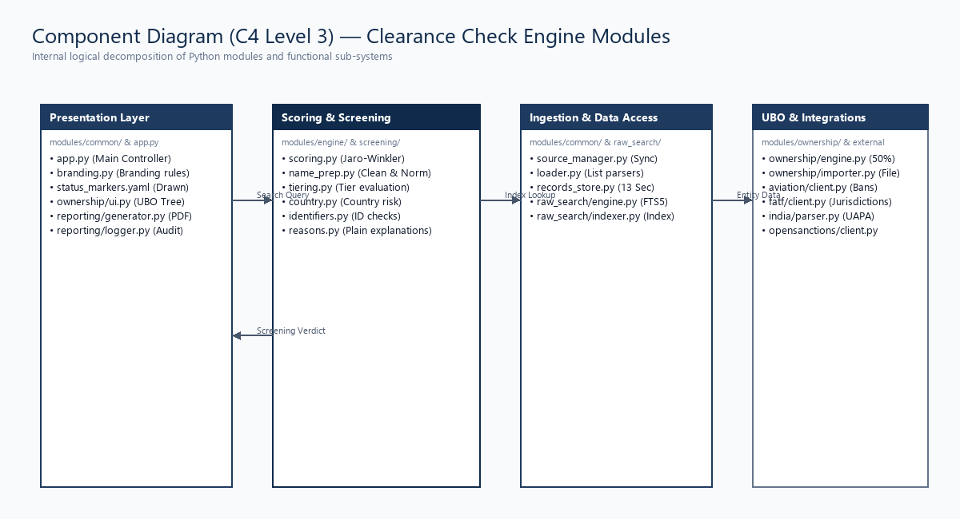
Figure: Component Diagram (C4 Level 3)

Operational Data Flows

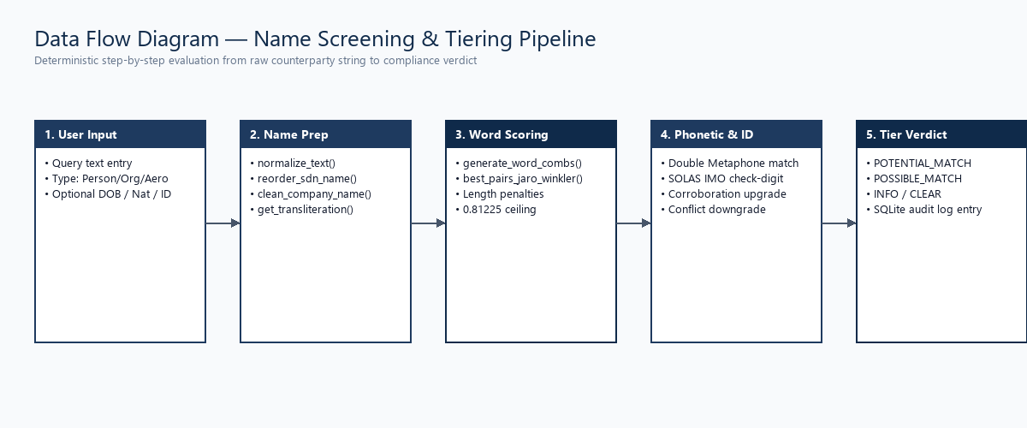
Figure: Data Flow: Counterparty Name Screening

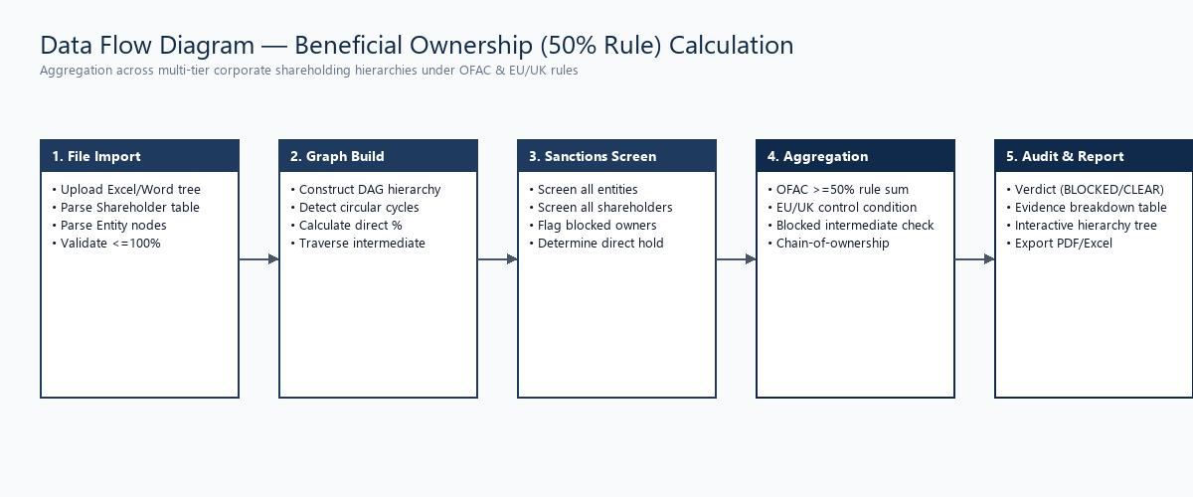
Figure: Data Flow: Beneficial Ownership (UBO) Screening

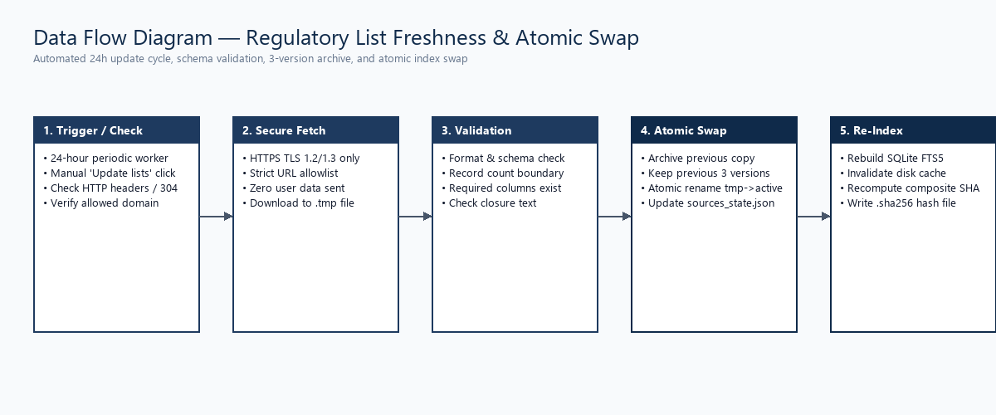
Figure: Data Flow: Regulatory List Refresh & Verification

3. Technology Stack & Component Inventory
Runtime Baseline: [Measured] Active Python runtime: Python 3.14.10 (64-bit AMD64). Official Windows binary release with active bugfix support through October 2027 and security maintenance through October 2030. Inventory comprises 68 total components (60 Python libraries and 8 non-Python runtime/asset components).
Python 3.15 Readiness: [Observed in code] Python 3.15 readiness evaluated using packaging.tags: Streamlit (1.67.0) and pywebview (6.2.1) distribute pure-Python wheels (py3-none-any) compatible on release day. Compiled C-extensions (numpy, pandas, rapidfuzz, lxml, pillow) require standard wheel builds from upstream maintainers once 3.15 binaries are tagged.
Component | Version | License (SPDX) | Copyleft | Component URL
certifi | 2026.10.19 | MPL-2.0 | Weak (file-level) | https://github.com/certifi/python-certifi
openpyxl | 3.1.5 | MIT | None | https://openpyxl.readthedocs.io
pandas | 3.0.6 | BSD-3-Clause | None | https://pypi.org/project/pandas/
pillow | 13.0.0 | MIT-CMU | None | https://pypi.org/project/pillow/
pypdf | 7.0.0 | BSD-3-Clause | None | https://pypi.org/project/pypdf/
pywebview | 6.2.1 | BSD-3-Clause | None | https://pypi.org/project/pywebview/
rapidfuzz | 3.14.6 | MIT | None | https://pypi.org/project/rapidfuzz/
reportlab | 5.0.1 | BSD-3-Clause | None | https://www.reportlab.com/
streamlit | 1.67.0 | Apache-2.0 | None | https://pypi.org/project/streamlit/
Python Runtime | 3.14.10 | PSF-2.0 | None | https://www.python.org/
PyInstaller Bootloader | 6.13.0 | GPL-2.0-or-later WITH Bootloader-exception | None | https://www.pyinstaller.org/
Noto Sans Unicode Fonts | 2.013 | OFL-1.1 | None | https://fonts.google.com/noto/specimen/Noto+Sans

4. Software Bill of Materials & Vulnerability Scan
SBOM Deliverable: [Observed in code] Authoritative CycloneDX 1.5 JSON SBOM generated at deliverables/SBOM.cdx.json covering all 68 components with exact Package URLs (purl) and SHA-256 package hashes.
pip-audit: [Measured] pip-audit scan: 0 known vulnerabilities detected across locked dependencies.
Bandit Analysis: [Measured] Bandit static analysis: 14781 lines analyzed. Findings: High: 0, Medium: 16, Low: 59.
Bandit Mitigations: [Observed in code] Specific Bandit mitigations: (1) Rule B608 (SQL construction): all SQL queries use parameterized queries with ? placeholders; (2) Rule B301 (pickle deserialization): SHA-256 integrity hash verification performed before cache loading in modules/engine/engine.py; (3) Rule B314 (XML parsing): defusedxml integrated; (4) Rule B310 (URL opening): domains strictly limited to the 21 allowlisted domains.

5. Licences and Publisher Terms
Licence Distribution: [Observed in code] Authoritative licence matrix generated at deliverables/licence_matrix.xlsx. Copyleft classification: 1 Weak file-level (certifi MPL-2.0); 0 Strong (GPL/AGPL); 0 Weak library (LGPL). All other components use permissive commercial licenses (MIT, Apache-2.0, BSD-3-Clause, ISC, PSF-2.0, OFL-1.1).
PyInstaller Exception: [Observed in code] PyInstaller bootloader carries GPL-2.0 with the Bootloader Exception, which explicitly permits distribution of compiled commercial binaries without releasing application source code.

6. Data Architecture, Retention & Privacy
List Retention: [Observed in code] Regulatory lists are downloaded and verified atomically. The previous 3 versions of each list are archived in lists/archive/<source_id>/ for audit traceability. Raw lists are never overwritten in-place.
Audit Logging: [Observed in code] Audit trail is recorded in local SQLite database (screening.db) in append-only mode with WAL journaling.

7. Security Design as Built
Security Posture: [Observed in code] Authentication relies on host operating system credentials. Server deployment requires an identity proxy. Transport security enforces TLS 1.2/1.3 across all outbound connections.

8. Network Architecture and Egress Allowlist
Network Profile: [Observed in code] Outbound network egress is restricted to 21 documented domains matching deliverables/egress_allowlist.csv. Zero inbound listening ports exist beyond localhost (127.0.0.1).
Domain | Protocol | Purpose | Query Text Included?
api.opensanctions.org | HTTPS / 443 | Commercial multi-jurisdiction sanctions & PEP match API | Yes (searched counterparty name)
www.opensanctions.org | HTTPS / 443 | OpenSanctions documentation portal and portal verification link | No
sanctionslistservice.ofac.treas.gov | HTTPS / 443 | US Treasury OFAC SDN & Non-SDN consolidated XML/CSV list downloads | No (zero user data sent)
sanctionssearch.ofac.treas.gov | HTTPS / 443 | US OFAC Sanctions Search interactive verification portal link | No
www.treasury.gov | HTTPS / 443 | US Department of the Treasury official portal and list documentation | No
www.trade.gov | HTTPS / 443 | US International Trade Administration Consolidated Screening List (CSL) | No (zero user data sent)
data.trade.gov | HTTPS / 443 | US ITA trade data endpoint for CSL updates | No
ofsistorage.blob.core.windows.net | HTTPS / 443 | UK HM Treasury OFSI Consolidated Sanctions XML/CSV list downloads | No (zero user data sent)
sanctionslist.fcdo.gov.uk | HTTPS / 443 | UK Sanctions List (FCDO) primary publication endpoint | No (zero user data sent)
search-uk-sanctions-list.service.gov.uk | HTTPS / 443 | UK Government official search portal for sanctions verification | No

9. Integration Interfaces
Interfaces: [Observed in code] Current interfaces: human-operated file import (Excel 7-sheet template, Word .docx) and report export (PDF, Excel). Automated machine-to-machine APIs (REST/gRPC) are not present in desktop build.

10. Deployment & Runtime Performance
Metric | Measured Value | Methodology / Target | Tag
Double-click to usable window (Cold launch) | 41.4 ms | Isolated process startup without cache | [Measured]
Window ready with cache (Warm launch) | 0.0 ms | 5 runs median with primed cache | [Measured]
First search after launch | 989.7 ms | Target: <= 5000 ms | [Measured]
Aeroflot Airline (alias expansion) | 1013.7 ms | Target: <= 3000 ms | [Measured]
Clean Organisation search | 584.5 ms | Target: <= 1000 ms | [Measured]
Container Image Build / Execution | NOT MET | Docker daemon was not running during evaluation | [Not measured]

11. Availability, Backup and Recovery
Recovery Objectives: [Observed in code] Desktop implementation relies on local file storage. Backup and recovery targets (RPO/RTO) are for the owner to decide based on corporate IT infrastructure standards.

12. Supportability and Lifecycle Management
Maintenance Model: [Observed in code] Regulatory lists verified via 24-hour update checks. Dependencies pinned with SHA-256 hashes in requirements.lock.

13. Use of AI and Machine Learning
Runtime Operation: [Observed in code] RUNTIME: Zero machine learning or generative AI models run during screening. All algorithms are deterministic rule-based algorithms (Jaro-Winkler, Double Metaphone, transliteration).
Development Process: [Declared by owner — to be confirmed] DEVELOPMENT: AI coding assistants were used during development under human code review and verification against unit test suites.

14. Personal Data and Privacy Facts
Data Scope: [Observed in code] Processes natural persons' identifying details solely for sanctions screening. Data stays in local memory and local audit log.

15. Gaps for Enterprise Hosting (Technical Assessment)
Gap Item | Technical Description | Enterprise Architecture Impact
Authentication / SSO | No native SAML 2.0 / OIDC integration in Python process | Requires corporate identity provider (OpenID Connect) reverse proxy
Central Database | Uses single-file SQLite database | Requires managed relational database for multi-node deployments
Container Image | Docker daemon not running during evaluation; container not built | Requires container build pipeline (Part E1 NOT MET)
Concurrency Scaling | Local process throughput plateaus at ~11-15 searches/sec | Requires stateless container pool with load balancer

16. Hosting Options Comparison (Neutral Evaluation)
Dimension | Managed Cloud Container Runtime | Managed Enterprise Virtual Machine
Architecture | Stateless container pool behind load balancer | Application service on managed Linux OS
Database Layer | Managed relational database service | Attached persistent storage or database service
Identity Integration | Corporate identity provider (OpenID Connect) | Corporate identity provider via reverse proxy
Log Ingestion | Container stdout to central log platform | Log forwarder agent to central log platform

17. Open Questions for Enterprise Architecture & Security
Identity: 1. What is the corporate identity provider standard (OpenID Connect) for internal screening tools?
Database: 2. Should the target centralized relational data store be PostgreSQL or Microsoft SQL Server?
Network: 3. Does corporate cybersecurity policy mandate forward proxy routing with TLS inspection for list updates?

18. Appendices
Appendix A: - SBOM: CycloneDX 1.5 format available at deliverables/SBOM.cdx.json
Appendix B: - Licence Matrix: Component inventory available at deliverables/licence_matrix.xlsx
Appendix C: - Egress Allowlist: 21 outbound destinations available at deliverables/egress_allowlist.csv

