FLOWTASK
Intelligent Productivity & Task Management System

Product Requirements Document (PRD)
Software Requirements Specification (IEEE Std 830 / 29148 Reference)

Version 1.0 | 2025
Classification: Internal / Personal Use

Revision History

Version | Description | Date
1.0 | Initial PRD draft — business problem analysis, full feature set, architecture, UML diagrams, agile phases, tech stack. | 2025

Table of Contents

1. Introduction

1.1 Purpose
This document constitutes the Product Requirements Document (PRD) and Software Requirements Specification (SRS) for FlowTask — an intelligent, web-based productivity and task management system. It is written with reference to IEEE Std 830-1998 and IEEE Std 29148-2018 guidelines adapted for a solo agile development workflow. The document serves as the single source of truth across all phases of design, implementation, testing, and deployment.

1.2 Document Scope
FlowTask addresses the real-world productivity challenge of managing tasks across multiple concurrent projects, meeting notes, colleague commitments, and external issue trackers (such as Jira) — all of which currently require manual collation. The system aims to:
- Automatically aggregate tasks from multiple configurable sources via polling.
- Present a unified, interactive task board with visual priority and deadline cues.
- Support two scheduling strategies: Round Robin (fair distribution across projects) and Priority Queue (deadline/priority-first ordering).
- Motivate task completion through a gamified reward system (experience points, badges, streaks).
- Deploy at zero infrastructure cost using Vercel (serverless) and SQLite/Turso (edge database).

1.3 Definitions, Acronyms, and Abbreviations
Term / Acronym | Definition
PRD | Product Requirements Document
SRS | Software Requirements Specification
MVP | Minimum Viable Product
RR | Round Robin — scheduling strategy that cycles tasks across projects
PQ | Priority Queue — scheduling strategy ordered by deadline + priority score
SSE | Server-Sent Events — real-time push from server to browser
ORM | Object Relational Mapper (Prisma)
Cron | Time-based background job scheduler (Vercel Cron Jobs)
XP | Experience Points — reward currency within the gamification system
PAT | Personal Access Token — auth method for GitHub/Jira integration

1.4 References
- IEEE Std 830-1998: Recommended Practice for Software Requirements Specifications
- IEEE Std 29148-2018: Systems and Software Engineering — Life Cycle Processes — Requirements Engineering
- Next.js 15 Documentation — https://nextjs.org/docs
- Prisma ORM Documentation — https://www.prisma.io/docs
- Turso (LibSQL) Documentation — https://docs.turso.tech
- Vercel Deployment and Cron Documentation — https://vercel.com/docs
- Jira REST API v3 — https://developer.atlassian.com/cloud/jira/platform/rest/v3/

2. Overall Description

2.1 Product Perspective
FlowTask is a standalone, single-user productivity system built as a full-stack Next.js web application. It is not a replacement for Jira, Notion, or Asana; rather, it functions as an aggregation and scheduling layer that sits atop existing tools. Users retain their external systems while FlowTask becomes their single active workspace — the place where tasks from all sources are unified, scheduled, and tracked through to completion.

Core Analogy:
FlowTask is the paper notebook and daily planner — except it auto-fills itself from all your sources, decides what to work on next, counts down your deadlines, and rewards you when you finish.

2.2 Business Problem Statement
The following pain points were identified from direct user observation and serve as the motivation for this product:
- Task fragmentation: Tasks reside in Jira, meeting notes, informal colleague requests, and personal logs — requiring manual, error-prone collation into a single notebook.
- Cognitive load from multi-project parallelism: Working across two to three concurrent projects with overlapping deadlines makes it difficult to decide what to work on without explicit scheduling logic.
- No automated awareness of urgency: Deadlines pass without proactive alerting because no tool aggregates all tasks into a unified timeline view.
- Lack of intrinsic motivation: Without visible progress or reward, sustained focus on a long backlog is psychologically draining.
- Manual scheduling overhead: Round-robin balancing between projects is a mental exercise currently done on paper, not systematically enforced.

2.3 Product Functions (High-Level)
The system provides the following primary capabilities:
- Multi-source task aggregation with configurable automatic polling
- Unified interactive task board (Kanban-style columns: Pending, In Progress, Completed, Overdue)
- Dual scheduling engine: Round Robin and Priority Queue modes, switchable per session
- Deadline alerting with user-configurable urgency thresholds (e.g., alert when < 30 minutes to deadline)
- Manual task creation, editing, tagging, and deletion
- Gamification: XP points, level progression, per-task badges, daily streaks
- Integration management UI to add/remove/configure sources
- Real-time notification delivery via Server-Sent Events (SSE)

2.4 User Classes and Characteristics
User Class | Characteristics
Primary User (Solo Developer / Knowledge Worker) | Single user; technically proficient; manages 2–3 concurrent projects; comfortable connecting OAuth-based services; desires automation over manual overhead.
Power User (Future) | May extend to small teams; identical technical profile but multi-user sessions.

2.5 Operating Environment
Environment Component | Details
Runtime Platform | Vercel (Serverless / Edge Functions)
Development Environment | macOS / Windows / Linux laptop running Node.js 20+
Framework | Next.js 15 (App Router, React Server Components)
Database (Dev) | SQLite via Prisma ORM — local file, zero setup
Database (Prod) | Turso (LibSQL) — free tier, edge-compatible, Vercel-native
Authentication | NextAuth.js v5 — JWT sessions, OAuth providers
Browser Support | Chrome 110+, Firefox 115+, Safari 16+ (PWA-ready)
Background Jobs | Vercel Cron Jobs (defined in vercel.json)

2.6 Design and Implementation Constraints
- Zero paid infrastructure: all services must have a generous free tier or be self-hosted on the developer's machine.
- No custom backend server: all server-side logic must run as Next.js API Routes or Vercel serverless functions.
- Prisma ORM enforces the schema; raw SQL queries are prohibited.
- Authentication must be handled by NextAuth.js v5; custom auth is out of scope.
- Real-time features must use SSE (or Vercel Realtime); WebSocket infrastructure is avoided to stay within serverless constraints.
- All integrations must be OAuth2 or API-Key based; no screen-scraping or undocumented APIs.

2.7 Assumptions and Dependencies
- The user has a Vercel account (free Hobby plan is sufficient).
- The user has access to Jira Cloud and can create an API token or OAuth2 application.
- Node.js 20+ and pnpm/npm are installed on the development machine.
- Internet connectivity is available for OAuth flows and external API polling.
- The Turso free tier (500 DBs, 9 GB storage, 1 billion row reads/month) is sufficient for single-user workloads.

3. Specific Requirements

3.1 Functional Requirements

FR-01: Task Board View
The system shall render a visual task board with the following swimlane columns: Pending, Scheduled, In Progress, Overdue, Completed. Each task card shall display: title, source badge (Jira / GitHub / Manual), project tag, priority indicator (1–5 stars), deadline with relative time (e.g., 'in 2h 15m'), and a completion button. The board shall support drag-and-drop reordering within columns.

FR-02: Automatic Task Polling
The system shall poll all configured integration sources at user-defined intervals (minimum 5 minutes, maximum 24 hours). Polling shall be triggered by Vercel Cron Jobs. The system shall upsert task records, avoiding duplicates by matching on externalId + sourceId. Users shall see a 'Last synced' timestamp per integration.

FR-03: Manual Task Management
The user shall be able to create new tasks manually, specifying: title, description, project tag, priority (1–5), deadline (datetime picker), alert threshold (minutes), and scheduling mode preference. Tasks shall be editable and deletable at any time.

FR-04: Scheduling Modes
The system shall support two scheduling strategies, selectable per session or per task group:
- Round Robin (RR): The scheduler cycles through distinct project tags and assigns the next slot to the first available task from the next project in rotation. This ensures proportional time allocation across all active projects.
- Priority Queue (PQ): Tasks are ordered by a composite score: score = (priority × 10) + urgency_bonus, where urgency_bonus increases as deadline approaches. The scheduler assigns slots in score-descending order.
The scheduler shall run after every poll cycle and on demand (manual trigger).

FR-05: Deadline Alerting
The system shall continuously evaluate the time remaining to each active task's deadline. When the remaining time falls below the task's alertThreshold (in minutes, user-configurable), the system shall:
- Push a real-time toast notification to the browser via SSE.
- Visually highlight the task card with a red urgency border and countdown timer.
- Log the notification in the NOTIFICATION table for history.
Default alert threshold: 30 minutes. Users may set per-task thresholds from 5 minutes to 24 hours.

FR-06: Reward and Gamification System
Upon marking a task as Completed, the reward engine shall:
- Award XP points: Base 10 XP per task + 5 XP bonus if completed before deadline + up to 15 XP streak bonus for consecutive-day completion.
- Evaluate badge eligibility: 'Speed Demon' (completed 30+ min early), 'On the Clock' (completed within threshold window), 'Project Juggler' (completed tasks from 3 different projects in one day).
- Update the user's level: every 100 XP advances the level by 1, with visual level-up animation.
- Persist the REWARD_EVENT record to the database.
- Display a celebratory modal with badge + XP summary.

FR-07: Integration Configuration
The system shall provide an Integrations settings page where the user can:
- Add a new integration source (type: Jira, Notion, GitHub Issues, Asana, Manual Webhook).
- Provide OAuth2 credentials or API key (stored encrypted in DB).
- Set per-source poll interval.
- Enable / disable a source without deleting it.
- Manually trigger a one-off sync.
- Delete a source (cascades soft-delete to associated tasks).

FR-08: Real-Time Notification Channel
The system shall implement an SSE endpoint at /api/notify that streams events to the connected browser. Event types: DEADLINE_ALERT, SYNC_COMPLETE, REWARD_GRANTED, SCHEDULER_RUN. The client shall reconnect automatically on disconnect.

FR-09: Authentication
The system shall use NextAuth.js v5 to manage user sessions. Supported providers in MVP: Email (magic link via Resend). OAuth providers (Google, GitHub) to be added in Phase 2. All API routes shall be protected by session middleware.

3.2 Non-Functional Requirements

NFR-01: Performance
Metric | Target
Task board initial load | < 1.5 seconds on LCP (Largest Contentful Paint) on desktop broadband
API response time | < 300 ms for CRUD operations (p95)
Poll execution | < 10 seconds per integration source per cycle
Scheduler run time | < 2 seconds for up to 200 tasks

NFR-02: Reliability
- The system shall handle external API failures gracefully — failed polls must log the error and retry on the next scheduled cycle without crashing.
- Database writes shall use transactions for all multi-table operations.
- Vercel's automatic retry on serverless function failures shall be the primary resilience mechanism.

NFR-03: Security
- API credentials for integrations shall be encrypted at rest using AES-256 before storage in the database.
- All API routes shall validate the NextAuth.js session token before execution.
- Input validation on all user-supplied data using Zod schema definitions.
- HTTPS enforced by Vercel on all deployed routes.

NFR-04: Usability
- The UI shall be responsive and usable on both 1080p desktop and 13-inch laptop screens.
- Colour coding: green for on-track tasks, amber for approaching deadline, red for overdue / alert-threshold breach.
- Dark mode support via Tailwind CSS dark: utility classes.

NFR-05: Maintainability
- All business logic (scheduling, reward calculation) shall be encapsulated in pure TypeScript utility functions under /lib, independently unit-testable.
- Prisma schema shall be the single source of truth for the data model; no raw SQL.
- Integration adapters shall follow a common IntegrationAdapter interface to make adding new sources a drop-in exercise.

4. UML Diagrams
This section presents the system's structural and behavioural models using UML 2.5 notation, rendered as inline diagrams throughout the document.

4.1 Use Case Diagram
Figure 1 illustrates the principal actors and use cases for FlowTask. The User actor interacts directly with all functional use cases. The External Source actor (representing Jira, GitHub, Asana, etc.) participates in data synchronisation use cases. System-internal automated behaviours (scheduling, alerting, reward engine) are shown as system-initiated use cases connected via «include» relationships.

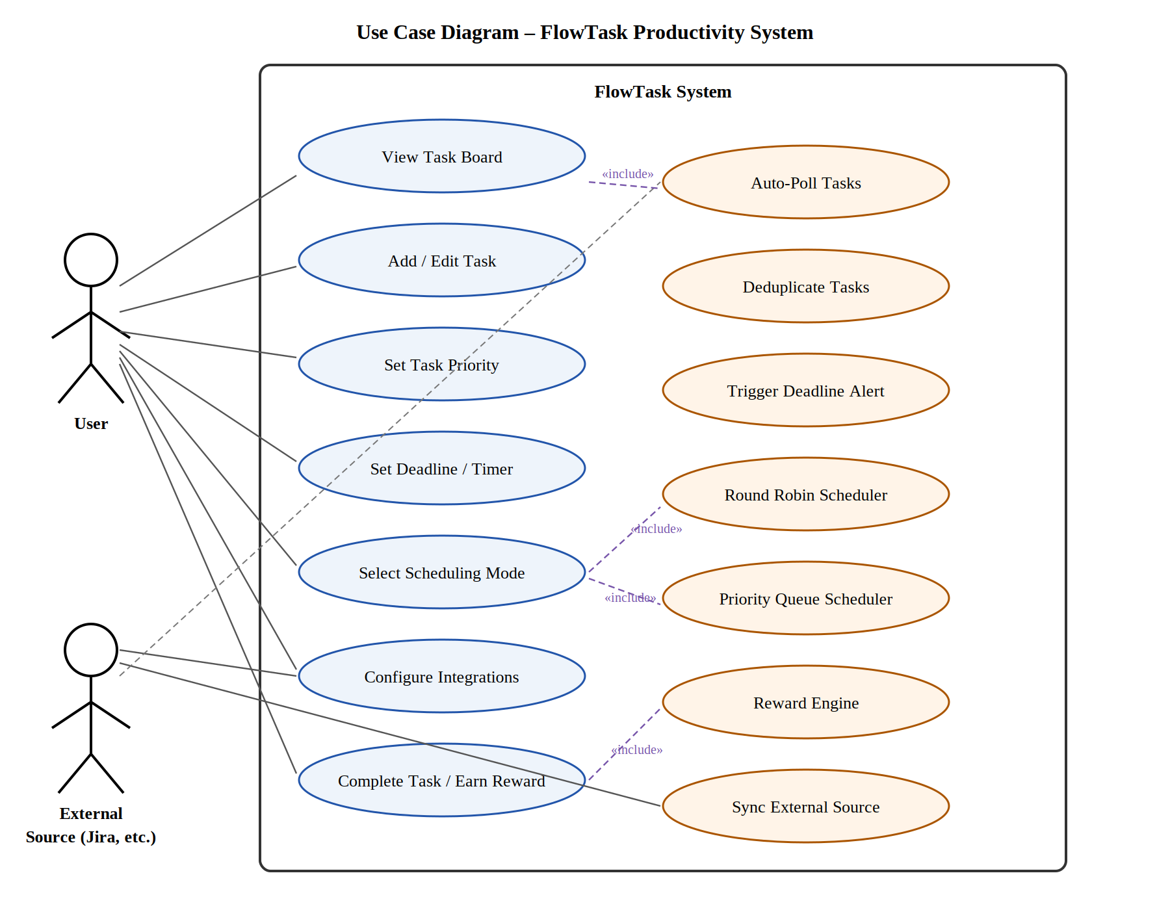
Figure 1 — Use Case Diagram: FlowTask Productivity System

4.2 Entity-Relationship (Data Model) Diagram
Figure 2 presents the complete data model for FlowTask. The USER entity is the root aggregate; all other entities reference it via foreign keys. The TASK entity is the central domain object, associated with zero or one INTEGRATION_SOURCE (for auto-imported tasks) or null (for manually created tasks). The SCHEDULE_SLOT entity records the time-boxing of tasks as generated by the scheduling engine. The REWARD_EVENT entity logs each gamification event. The NOTIFICATION entity persists alert history.

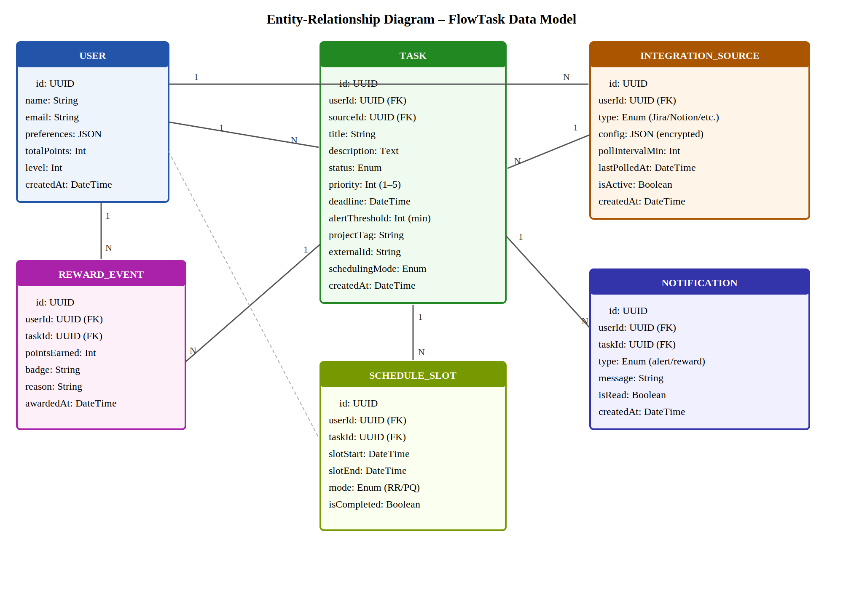
Figure 2 — Entity-Relationship Diagram: FlowTask Data Model

4.3 Sequence Diagram — Auto-Poll and Scheduling Flow
Figure 3 traces the end-to-end message flow for the core FlowTask automated cycle. The diagram covers three distinct phases, annotated with swimlane dividers: (1) the initial dashboard load and database query; (2) the background Cron-triggered poll cycle that fetches tasks from external sources, deduplicates them, and persists the results; (3) the scheduling engine run that assigns schedule slots; and (4) the deadline alert flow that pushes SSE notifications to the browser.

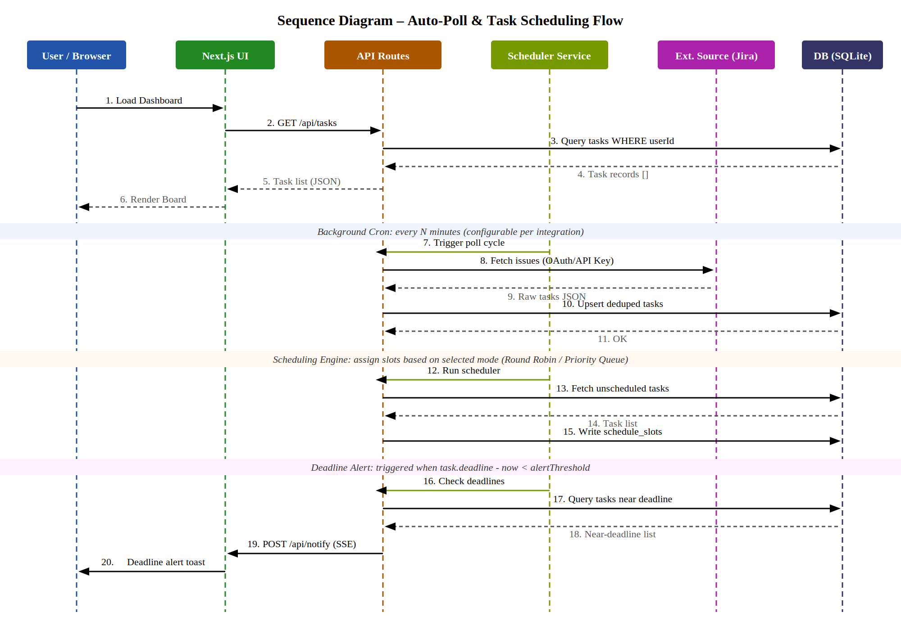
Figure 3 — Sequence Diagram: Auto-Poll, Scheduling, and Deadline Alert Flow

4.4 System Architecture / Component Diagram
Figure 4 illustrates the layered architecture of FlowTask. The Client Layer contains all React components served as Next.js pages. The API Layer consists exclusively of Next.js App Router API Routes deployed as Vercel Serverless Functions. The Data Layer encompasses the database (SQLite in development, Turso in production), the NextAuth.js session store, and the Vercel Cron Job configuration. The External Integrations layer shows the pluggable third-party sources accessed via their respective REST/GraphQL APIs.

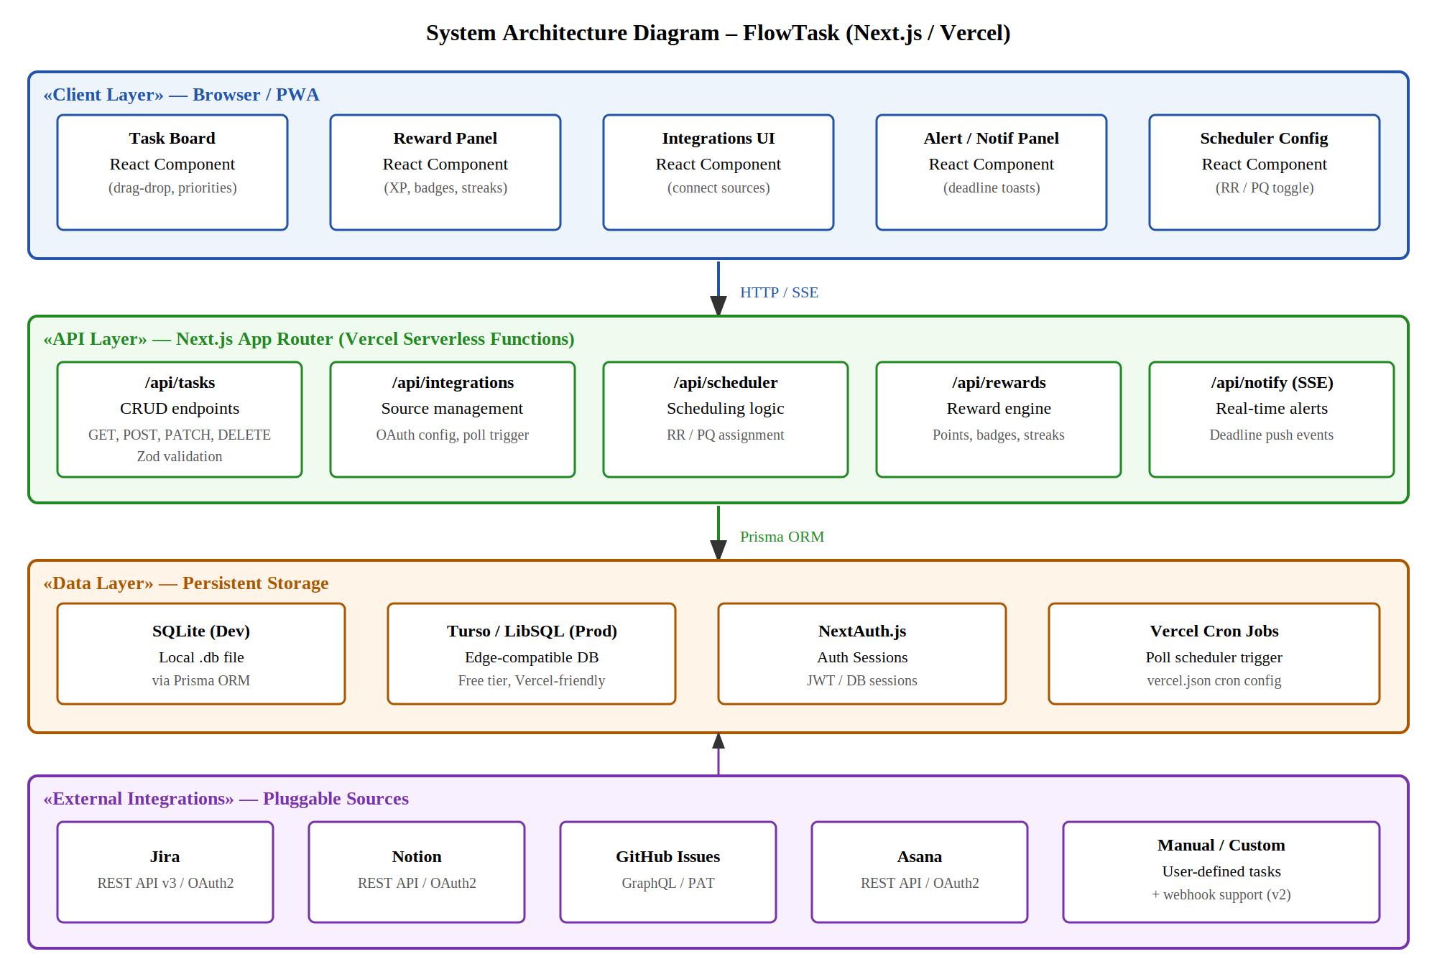
Figure 4 — Component / Architecture Diagram: FlowTask (Next.js / Vercel)

4.5 State Machine Diagram — Task Lifecycle
Figure 5 models the complete lifecycle of a Task entity within FlowTask. A task begins in the PENDING state upon creation or import, transitions to SCHEDULED once the scheduling engine assigns a time slot, and moves to IN_PROGRESS when the user begins work. From IN_PROGRESS, a task may transition to COMPLETED (triggering the reward engine), SNOOZED (temporarily deferred), or OVERDUE (deadline has passed without completion). Both COMPLETED and OVERDUE tasks eventually transition to ARCHIVED. The Alert Zone annotation marks the period within IN_PROGRESS where the deadline alert fires.

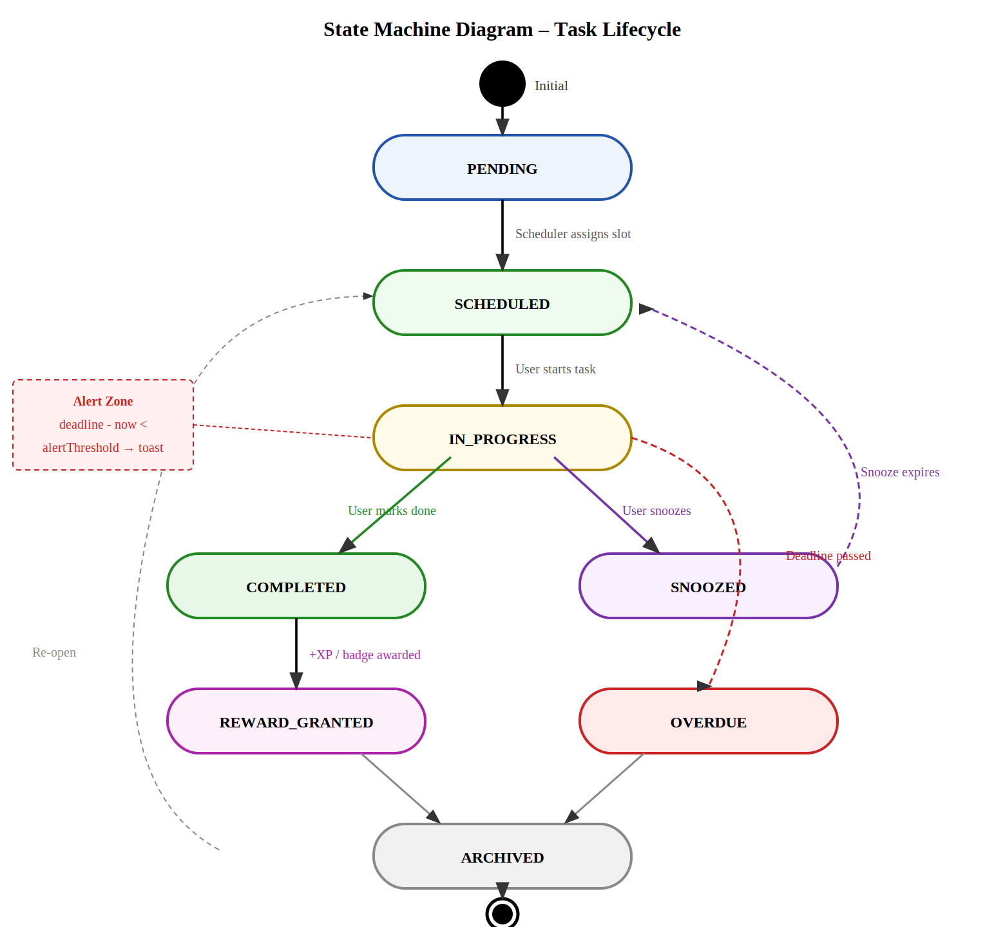
Figure 5 — State Machine Diagram: Task Lifecycle

5. Technology Stack
The following technology decisions are driven by three non-negotiable constraints: zero infrastructure cost, full local development capability, and end-to-end Vercel deployment. All selected technologies have active communities, strong TypeScript support, and generous free tiers.

5.1 Core Stack
Category | Technology | Rationale
Language | TypeScript 5.x | Type safety across full stack; eliminates runtime type errors in API and data layer.
Framework | Next.js 15 (App Router) | Server Components, API Routes as serverless functions, built-in routing, React 18 streaming.
UI Library | React 18 | Component model, hooks, Suspense boundaries for loading states.
Styling | Tailwind CSS 3.x | Utility-first CSS; dark mode via dark: classes; no runtime CSS-in-JS overhead.
Component Library | shadcn/ui | Accessible, unstyled Radix UI primitives styled with Tailwind; no vendor lock-in.
Drag & Drop | dnd-kit | Lightweight, accessible drag-and-drop for task reordering on the board.
Animation | Framer Motion | Reward animations (level-up, badge pop), task card transitions.
Icons | Lucide React | Consistent icon set; tree-shakeable.

5.2 Backend / API Layer
Category | Technology | Rationale
API Pattern | Next.js App Router (Route Handlers) | Zero-config serverless functions; auto-deployed to Vercel Edge/Serverless.
ORM | Prisma 5.x | Type-safe DB access; schema-first migrations; supports both SQLite and LibSQL.
Validation | Zod | Runtime schema validation on all API inputs; shared schemas between client and server.
Auth | NextAuth.js v5 (Auth.js) | Session management, JWT, magic link + OAuth2 providers.
Background Jobs | Vercel Cron Jobs | Defined in vercel.json; triggers polling API routes on schedule. Free on Hobby plan.
Realtime | SSE via ReadableStream | Native Web Streams API in Next.js Route Handlers; no WebSocket server needed.
Email (Auth) | Resend + React Email | Magic-link email delivery; free tier: 3,000 emails/month.
Encryption | Node.js crypto (AES-256-GCM) | Encrypt integration API keys at rest before DB write.

5.3 Data Layer
Category | Technology | Rationale
DB (Dev) | SQLite (local file) | Zero setup; Prisma supports it natively; all data in a single .db file.
DB (Prod) | Turso (LibSQL) | SQLite-compatible edge DB; free tier: 500 DBs, 9 GB storage. Vercel-native integration.
Migrations | Prisma Migrate | Version-controlled schema migrations; npx prisma migrate dev for local.
Seeding | Prisma Seed (ts-node) | Populates demo tasks, integrations, and reward data for development.

5.4 Dev Tooling & Deployment
Category | Technology | Rationale
Package Manager | pnpm | Faster installs, disk-efficient; fully compatible with Vercel builds.
Testing | Vitest + Testing Library | Unit tests for scheduling logic and reward engine; component tests for board.
Linting | ESLint + Prettier | Enforced code style; pre-commit hooks via Husky + lint-staged.
Deployment | Vercel (Hobby — Free) | Git push to main triggers CI/CD; zero config for Next.js.
CI/CD | Vercel + GitHub Actions | Vercel handles production deploy; GitHub Actions runs Vitest on PRs.
Env Management | Vercel Environment Variables | Secrets (API keys, DB URL, auth secret) stored in Vercel dashboard.
Monitoring | Vercel Analytics (free) | Core Web Vitals, function invocation counts, error tracking.

6. Agile Development Phases
The product is decomposed into four delivery phases designed for solo vibe-coding development. Each phase has a defined scope, a set of acceptance criteria, and an indicative duration. Phases are sequential but the boundaries between Phase 2 and Phase 3 may flex depending on integration complexity. Phases are structured so that at the end of each phase, the application is fully deployable and usable.

Note on Estimation:
Durations below assume evening/weekend development sessions of approximately 3–5 hours per day. If you have full-day blocks available, compress timelines by ~50%.

6.1 Phase 1 — Foundation & MVP (Weeks 1–3)
Goal: A working task board with manual task entry, local SQLite storage, authentication, and basic UI. No integrations, no scheduling engine, no gamification. This is the skeleton the rest of the product hangs on.

Deliverable | Detail | Timeline
Project Scaffold | Next.js 15 + TypeScript + Tailwind + shadcn/ui + Prisma + SQLite setup. Folder structure: /app, /lib, /prisma, /components. | Week 1
Authentication | NextAuth.js v5 with Email magic link (Resend). Protected routes middleware. | Week 1
Data Schema | Prisma schema: User, Task, IntegrationSource, ScheduleSlot, RewardEvent, Notification. First migration. | Week 1
Task CRUD API | POST /api/tasks, GET /api/tasks, PATCH /api/tasks/[id], DELETE /api/tasks/[id]. Full Zod validation. | Week 2
Task Board UI | Kanban board with 4 columns (Pending, In Progress, Overdue, Completed). Task cards with all fields. dnd-kit drag-drop. | Week 2–3
Manual Task Creation | Add Task modal: title, description, project tag, priority slider, deadline picker, alert threshold. | Week 3
MVP Deployment | Deploy to Vercel. SQLite → Turso migration. Environment variables configured. Smoke test all routes. | Week 3

MVP Acceptance Criteria:
- User can sign in via magic link.
- User can create, edit, and delete tasks manually.
- Task board renders with correct column assignment based on task status.
- Application is accessible at a live Vercel URL.

6.2 Phase 2 — Integrations & Polling Engine (Weeks 4–6)
Goal: Connect Jira as the first integration source. Implement the Vercel Cron polling engine, deduplication logic, and the integration management UI. Validate the end-to-end auto-sync flow.

Deliverable | Detail | Timeline
Integration Adapter Interface | TypeScript interface IntegrationAdapter { fetchTasks(config): Promise<RawTask[]> }. Provides the contract for all future adapters. | Week 4
Jira Adapter | Implements IntegrationAdapter. Uses Jira REST API v3 with API token auth. Fetches issues assigned to user. | Week 4
Cron Poll Handler | POST /api/cron/poll route. Iterates active integrations, calls adapter, upserts tasks. vercel.json cron entry. | Week 4–5
Deduplication Logic | Upsert by externalId + sourceId. New tasks inserted; existing tasks updated if status changed. | Week 5
Integrations Settings UI | Add/edit/delete integration sources. OAuth config form. Enable/disable toggle. 'Sync Now' button. | Week 5
Notion Adapter | Second adapter: Notion REST API, reads from a designated database. | Week 6
GitHub Issues Adapter | Third adapter: GitHub GraphQL API, reads open issues assigned to user. | Week 6
Integration Tests | Vitest tests for each adapter with mocked HTTP responses. | Week 6

Phase 2 Acceptance Criteria:
- Jira tasks appear automatically in the board after cron runs.
- Duplicate prevention: re-running sync does not create duplicate task cards.
- User can add, configure, disable, and delete integration sources from the UI.

6.3 Phase 3 — Scheduling Engine & Deadline Alerts (Weeks 7–9)
Goal: Implement the Round Robin and Priority Queue scheduling engines. Add real-time SSE deadline alerts. Add per-task visual urgency indicators.

Deliverable | Detail | Timeline
Round Robin Scheduler | Groups tasks by projectTag. Cycles through groups, assigns ScheduleSlot records in rotation. Runs post-poll and on demand. | Week 7
Priority Queue Scheduler | Computes composite score per task. Sorts descending. Assigns time slots top-down. | Week 7
Scheduler API | POST /api/scheduler/run. Accepts mode param (rr | pq). Returns assigned slot count. | Week 7
Schedule Mode Toggle | Per-session UI toggle (RR ↔ PQ) in the toolbar. Preference persisted to user.preferences JSON. | Week 8
SSE Notification Endpoint | GET /api/notify — ReadableStream that pushes JSON events to connected client. Reconnect logic on client. | Week 8
Deadline Evaluation Cron | POST /api/cron/deadlines — runs every 5 minutes, compares task deadlines to now, pushes SSE alert if within threshold. | Week 8
Task Card Urgency UI | Amber border (< 2× threshold), red border + countdown ticker (< threshold). Framer Motion pulse animation. | Week 9
Notification History Panel | Sidebar drawer listing recent NOTIFICATION records. Mark as read. Clear all. | Week 9

Phase 3 Acceptance Criteria:
- Switching to Round Robin mode distributes tasks evenly across project tags.
- Switching to Priority Queue surfaces highest-urgency tasks to the top.
- A task within its alert threshold triggers a toast notification in the browser within 30 seconds.

6.4 Phase 4 — Gamification, Polish & Production Hardening (Weeks 10–12)
Goal: Implement the complete reward engine. Polish the UI, add onboarding, improve error handling, write documentation, and harden the production deployment.

Deliverable | Detail | Timeline
XP & Levelling System | On task completion: calculate XP (base + early-completion bonus + streak bonus). Update user.totalPoints and user.level. | Week 10
Badge Engine | Evaluate badge conditions post-completion. Award and persist RewardEvent. Display badge in UI. | Week 10
Streak Tracking | Track consecutive-day completion in user.preferences. Reset on missed day. Streak displayed in header. | Week 10
Reward Celebration Modal | Framer Motion animated modal: XP gained, badge earned (if any), current level + progress bar. | Week 11
Onboarding Flow | First-login walkthrough: connect first integration → add first manual task → see scheduled slot. 3-step modal. | Week 11
Dark Mode | Full dark mode via Tailwind dark: classes. System preference detection + manual toggle. | Week 11
Error Boundaries | React error boundaries on board and modal. API error toast notifications (shadcn/ui Toast). | Week 11
End-to-End Testing | Playwright smoke tests: login → add task → complete task → receive reward. | Week 12
Documentation | README.md with setup, environment variables, Prisma migration guide, Vercel deployment steps. | Week 12
Production Hardening | Rate limiting on API routes (Vercel middleware). Review all environment variable usage. Final Vercel deployment. | Week 12

Phase 4 Acceptance Criteria:
- Completing a task triggers XP award, possible badge, and level progression.
- Streak counter increments correctly across days.
- Dark mode is fully functional with no contrast accessibility violations.
- Playwright smoke tests pass on the production Vercel URL.
- README enables a new developer to run the app locally in under 15 minutes.

7. MVP Architecture
The Minimum Viable Product (Phase 1 delivery) uses a simplified subset of the full architecture. The goal is maximum speed to a working, deployed application with no external dependencies beyond Vercel and NextAuth.js.

7.1 MVP Data Model
The MVP instantiates only the following Prisma models: User, Task. All other models (IntegrationSource, ScheduleSlot, RewardEvent, Notification) are defined in the schema at day one to avoid future breaking migrations, but are not actively used until their respective phases.

Prisma Schema Excerpt (MVP Active Models):
model User { id String @id @default(uuid()); name String?; email String @unique; totalPoints Int @default(0); level Int @default(1); tasks Task[] }
model Task { id String @id @default(uuid()); userId String; title String; status TaskStatus @default(PENDING); priority Int @default(3); deadline DateTime?; alertThreshold Int @default(30); projectTag String?; user User @relation(fields: [userId], references: [id]) }

7.2 MVP API Surface
Endpoint | Description
GET /api/tasks | Fetch all tasks for authenticated user. Query params: status, projectTag.
POST /api/tasks | Create a new task. Body: TaskCreateSchema (Zod).
PATCH /api/tasks/[id] | Update task status, priority, deadline, or any editable field.
DELETE /api/tasks/[id] | Soft-delete task (sets status = ARCHIVED).
GET /api/auth/[...nextauth] | NextAuth.js catch-all route: sign-in, sign-out, session, callback.

7.3 MVP Folder Structure
flowtask/
├── app/
│ ├── (auth)/login/page.tsx — Magic link login page
│ ├── (dashboard)/page.tsx — Task Board (Server Component)
│ └── api/tasks/route.ts — GET, POST handlers
│ └── [id]/route.ts — PATCH, DELETE handlers
├── components/
│ ├── board/TaskBoard.tsx — Main Kanban board
│ ├── board/TaskCard.tsx — Individual task card
│ └── modals/AddTaskModal.tsx — Task creation form
├── lib/
│ ├── prisma.ts — Prisma client singleton
│ └── validations/task.schema.ts — Zod schemas
├── prisma/
│ ├── schema.prisma — Full data model
│ └── seed.ts — Dev seed data
└── vercel.json — Cron job definitions (Phase 2+)

8. Integration Adapter Pattern
All external task sources are accessed through a common IntegrationAdapter interface. This ensures that adding a new source (e.g., Linear, Trello, Basecamp) requires only implementing the interface and registering the adapter — no changes to the core polling engine.

8.1 Adapter Interface
// lib/integrations/types.ts
export interface RawTask {
externalId: string; title: string; description?: string;
deadline?: Date; priority?: number; projectTag?: string;
}
export interface IntegrationAdapter {
sourceType: 'jira' | 'notion' | 'github' | 'asana' | string;
fetchTasks(config: Record<string, string>): Promise<RawTask[]>;
}

8.2 Supported Sources — Phase Roadmap
Source | Auth Method | Target Phase
Jira Cloud | REST API v3 + API Token | Phase 2 (Priority #1)
Notion | REST API + OAuth2 | Phase 2
GitHub Issues | GraphQL API v4 + PAT | Phase 2
Asana | REST API v1 + OAuth2 | Phase 3
Manual Webhook | POST /api/integrations/webhook | Phase 3
Linear | GraphQL API + OAuth2 | Phase 4 / Backlog
Trello | REST API + OAuth1 | Phase 4 / Backlog
Google Tasks | REST API v1 + OAuth2 | Phase 4 / Backlog

9. Reward System Design
The gamification system is designed to provide intrinsic motivation without becoming a distraction. The reward calculation is deterministic, transparent, and always proportional to effort and time management.

9.1 XP Calculation Formula
XP = baseXP + earlyBonus + streakBonus
Where:
baseXP = 10 (per task completion)
earlyBonus = 5 (if completed > alertThreshold before deadline)
streakBonus = min(streak_days × 3, 15) (capped at 15 XP)
Level up every = 100 XP accumulated

9.2 Badge Catalogue (MVP + Phase 4)
Badge | Award Condition | Phase
Speed Demon | Task completed 30+ minutes before deadline | Phase 4
On the Clock | Task completed within the alert threshold window | Phase 4
Project Juggler | 3 tasks from 3 different projects completed in one day | Phase 4
Streak Starter | 3-day consecutive completion streak | Phase 4
On Fire | 7-day consecutive completion streak | Phase 4
Clean Sweep | Cleared all Overdue tasks in one session | Phase 4
First Blood | First ever task completed (onboarding badge) | Phase 1 (MVP)

10. Open Issues and Future Considerations

10.1 Open Design Questions
ID | Question
OQ-01 | Should the scheduler recalculate slots every time it runs (full re-plan) or only assign slots to new/unscheduled tasks (incremental)? Full re-plan is simpler but may cause slot time to shift. Incremental is more stable but can leave orphan slots.
OQ-02 | How should tasks imported from Jira handle status synchronisation? If a Jira issue is closed externally, should FlowTask auto-complete the local task, or flag it for user confirmation?
OQ-03 | Vercel Cron Jobs on the free Hobby plan are limited to daily or every minute (no sub-minute). For < 5-minute polling, a fallback (client-side interval via SWR or React Query) may be needed. This has implications for battery life on mobile.
OQ-04 | Encryption key management for integration credentials: storing the AES key in an environment variable is acceptable for a single-user personal tool but would need a KMS (e.g., Vercel Edge Config) for multi-user scenarios.

10.2 Out of Scope (v1.0)
- Multi-user collaboration or shared task boards.
- Calendar view or Gantt chart timeline.
- Mobile native application (iOS/Android). The PWA approach provides basic mobile support.
- Bi-directional sync (writing status changes back to Jira/GitHub from FlowTask).
- AI-powered task decomposition or priority suggestion (strong candidate for v2.0).
- Offline mode beyond basic PWA caching.

10.3 Potential v2.0 Enhancements
- AI assistant: Integrate Claude via the Anthropic API to suggest which task to tackle next based on deadlines, energy level, and context switching costs.
- Bi-directional Jira sync: Write task status changes back to Jira issues in real time.
- Calendar overlay: visualise scheduled slots on a weekly calendar grid alongside external calendar events.
- Time tracking: Start/stop timer per task; report time-per-project weekly.
- Multi-user: Share a board with a team; assign tasks to members. Requires full auth overhaul and row-level security in Turso.
- Voice commands: Use the Web Speech API to create tasks by voice — useful during deep-work sessions.

11. Verification and Validation Plan
Given that this is a solo-developer project, the testing strategy is lean but must cover critical correctness constraints — especially the scheduling logic and reward calculation, which are algorithmic and must be deterministic.

11.1 Unit Tests (Vitest)
- Scheduling engine: Round Robin correctly rotates across n project groups with varying task counts.
- Scheduling engine: Priority Queue produces correct descending order for a known set of tasks with mixed priorities and deadlines.
- Reward engine: XP calculation produces correct values for all bonus combinations.
- Deduplication logic: upsert correctly updates existing task, does not create duplicate.
- Zod schemas: all boundary conditions (missing fields, invalid enums, negative priorities) rejected correctly.

11.2 Integration Tests (Vitest + MSW)
- Jira adapter: mocked HTTP responses from MSW (Mock Service Worker) produce correctly shaped RawTask arrays.
- Poll handler: end-to-end test from cron trigger to DB write using Prisma in-memory (SQLite :memory:).

11.3 End-to-End Tests (Playwright)
- Smoke test: Sign in → Create task → Task appears on board → Complete task → Reward modal appears.
- Integration test: Add Jira integration with test credentials → Trigger manual sync → Jira task appears on board.
- Alert test: Create task with deadline 2 minutes from now + threshold 5 minutes → Verify toast appears within 60 seconds.

11.4 Acceptance Criteria Summary
Each phase's acceptance criteria (detailed in Section 6) constitutes the Definition of Done for that phase. A phase is considered complete only when all acceptance criteria pass and the application is deployed to the production Vercel URL without regression.

12. Appendix

12.1 Environment Variables Reference
Variable | Description / Example
DATABASE_URL | SQLite: file:./dev.db | Prod: libsql://[db].[org].turso.io
TURSO_AUTH_TOKEN | Turso database auth token (production only)
NEXTAUTH_URL | Full public URL of the deployed app (e.g., https://flowtask.vercel.app)
NEXTAUTH_SECRET | Random 32-char secret for JWT signing (openssl rand -base64 32)
RESEND_API_KEY | Resend API key for magic-link email delivery
INTEGRATION_ENCRYPT_KEY | 32-byte hex key for AES-256-GCM encryption of integration credentials
JIRA_CLIENT_ID | Jira OAuth2 App client ID (Atlassian Developer Console)
JIRA_CLIENT_SECRET | Jira OAuth2 App client secret

12.2 Vercel Cron Configuration (vercel.json)
{
"crons": [
{ "path": "/api/cron/poll", "schedule": "*/15 * * * *" },
{ "path": "/api/cron/deadlines", "schedule": "*/5 * * * *" },
{ "path": "/api/cron/scheduler", "schedule": "*/30 * * * *" }
]
}

12.3 Glossary of Task Statuses
Status | Description
PENDING | Task has been created or imported but not yet assigned a schedule slot.
SCHEDULED | Task has been assigned a time slot by the scheduling engine.
IN_PROGRESS | User has manually started work on the task.
SNOOZED | User has temporarily deferred the task; it will return to SCHEDULED after the snooze period.
COMPLETED | Task has been marked done by the user; triggers reward engine.
OVERDUE | Task deadline has passed without reaching COMPLETED status.
ARCHIVED | Terminal state; task has been completed or dismissed and is no longer shown on the active board.

12.4 Document Control
Attribute | Value
Document Owner | Solo Developer / Product Owner
Review Cycle | Per agile phase (approximately every 3 weeks)
Version Control | Git (alongside source code in /docs/PRD.docx)
Distribution | Internal — personal use only

End of Document — FlowTask PRD v1.0

