SKILL – 01
OPERATING SYSTEMS AND SYSTEM PROGRAMMING
SKILL – 01
Title: Linux Environment Setup, Process Abstraction and System Call Analysis
Name: Souradeepta Das
Roll No.: 2520030347
Course: Operating Systems and System Programming
Skill No.: 01
1. OBJECTIVE
The objective of Skill-01 is to develop familiarity with the Linux development environment and understand fundamental operating system concepts related to processes and system calls.
The skill activities include:
- Installing/configuring a Linux environment.
- Configuring GCC.
- Setting up a Git repository.
- Creating the required project structure.
- Understanding shell architecture.
- Building an initial Makefile.
- Understanding process abstraction.
- Executing fork().
- Understanding the exec() family.
- Analyzing parent-child relationships.
- Inspecting the process tree.
- Practicing system call tracing.
2. LINUX ENVIRONMENT
Linux was configured using WSL to provide a Linux development environment on Windows.
The terminal was used to execute Linux commands and compile C programs.
Command:
gcc --version
This command verifies the GCC compiler installation.
3. GIT REPOSITORY SETUP
A Git repository was initialized for the Operating Systems and System Programming course.
The repository contains practical and skill activities in an organized structure.
SYSCORE_OSSP/
├── 2520030347_Practical/
└── 2520030347_Skill/
The repository was connected to GitHub.
4. PROJECT STRUCTURE
The repository follows a structured organization:
2520030347_Practical/
Practical-01/
Practical-02/
Practical-03/
2520030347_Skill/
Skill-01/
Skill-02/
This organization keeps each practical and skill activity independent.
5. SHELL ARCHITECTURE
The Linux shell acts as an interface between the user and the operating system.
The basic architecture is:
User
↓
Shell
↓
System Calls
↓
Linux Kernel
↓
Hardware / System Resources
The shell accepts commands from the user and invokes programs or system calls to perform the requested operation.
6. PROCESS ABSTRACTION
A process is a program in execution.
A process contains information such as:
• Process ID
• Program counter
• CPU registers
• Memory information
• Open file descriptors
• Process state
Linux manages this information using kernel data structures.
7. fork() EXPERIMENT
The fork() system call creates a new child process.
The general structure is:
pid_t pid = fork();
The return value determines the process:
Parent → child PID
Child → 0
Error → negative value
The parent and child execute independently after the fork() call.
8. exec() FAMILY
The exec() family replaces the current process image with another program.
Example:
execlp("ls", "ls", "-l", NULL);
The process that calls exec() does not create another process. Instead, its current program is replaced by the requested program.
9. PARENT-CHILD RELATIONSHIP
The parent process can obtain its PID using:
getpid()
and its parent PID using:
getppid()
The relationship can be represented as:
Parent
↓
Child
↓
Grandchild
Linux maintains these relationships in its process management structures.
10. PROCESS TREE
The Linux process tree can be inspected using:
ps --forest
or:
pstree
These commands show relationships between parent and child processes.
11. SYSTEM CALL TRACING
The strace utility can be used to trace system calls generated by a Linux program.
Example:
strace cat sample.txt
The output contains system calls such as:
openat()
read()
close()
exit_group()
System call tracing helps understand how user applications interact with the Linux kernel.
12. OBSERVATIONS
The skill activities provided practical understanding of:
• Linux command-line operation.
• GCC-based C compilation.
• Git repository management.
• Process creation.
• Parent-child relationships.
• Program replacement using exec().
• Process tree inspection.
• Kernel interaction through system calls.
13. SCREENSHOTS
Linux Environment
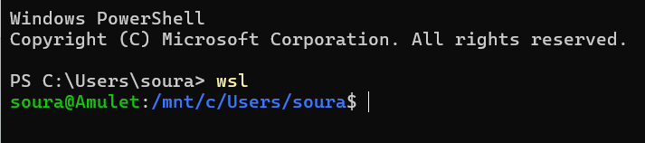GCC Configuration
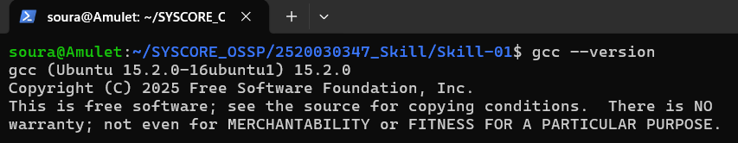

Process Tree
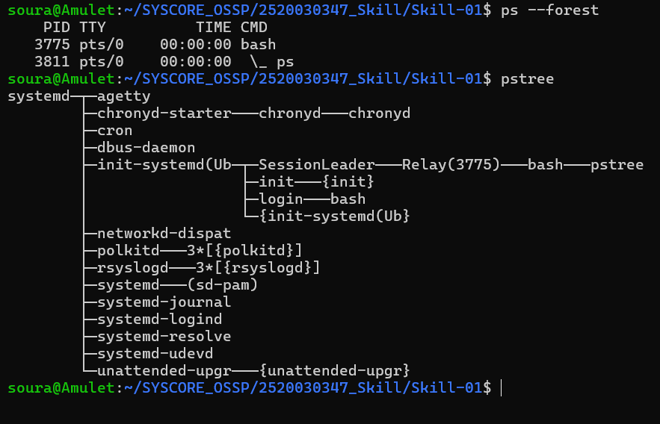System Call Tracing
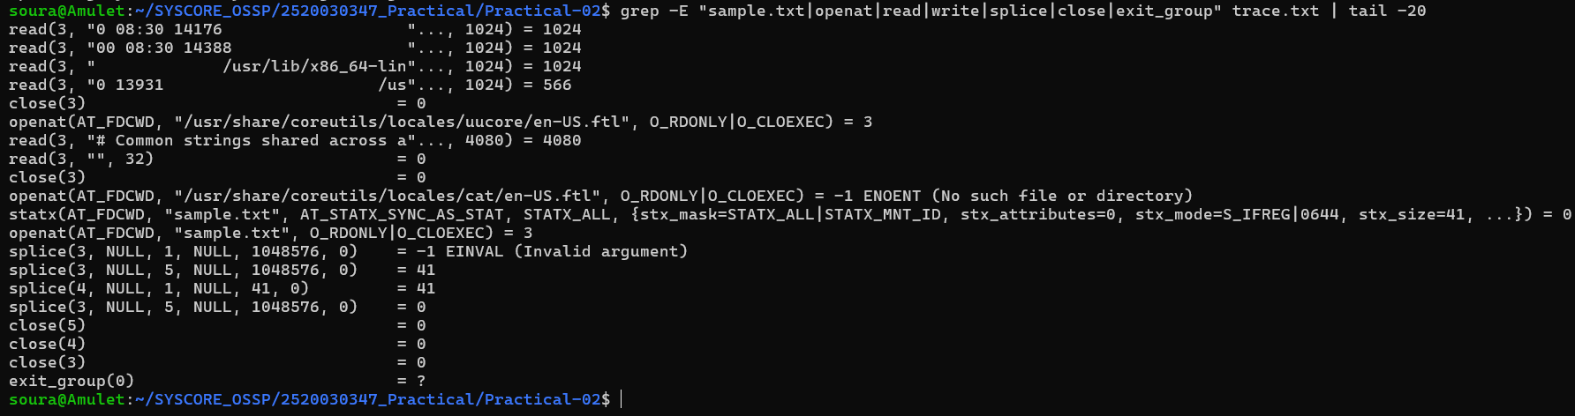14. CONCLUSION
Skill-01 provided practical exposure to Linux, GCC, Git, process management, parent-child relationships, the fork() and exec() system calls, process trees, and system call tracing. These activities established the foundation required for further Operating Systems and System Programming experiments.

