PRACTICAL – 02
OPERATING SYSTEMS AND SYSTEM PROGRAMMING
PRACTICAL – 02
Title: File Copy using System Calls and System Call Tracing using strace
Name: Souradeepta Das
Roll No.: 2520030347
Course: Operating Systems and System Programming
Practical No.: 02
1. AIM
To develop a C program using the Linux system calls open(), read(), write(), and close() to copy the contents of one file into another, and to use the strace utility to analyze the system calls generated by the cat command.
2. OBJECTIVES
- To understand Linux file-related system calls.
- To open a file using open().
- To read file contents using read().
- To write data into another file using write().
- To close files using close().
- To understand transitions between user space and kernel space.
- To trace system calls using strace.
- To identify kernel services involved during file reading.
3. THEORY
Linux provides system calls that allow user programs to interact with kernel-managed resources.
open() opens an existing file or creates a new file.
read() reads data from an open file descriptor.
write() writes data to a file descriptor.
close() releases an open file descriptor.
4. USER SPACE AND KERNEL SPACE
The C program executes initially in user space.
When it requests a system service such as open(), execution transitions from user space into kernel space.
The kernel performs the requested operation and returns the result to the user program.
The same transition occurs for read(), write(), and close().
User Application
↓
System Call
↓
Linux Kernel
↓
File System
↓
Storage / File
↓
Linux Kernel
↓
User Application
5. PROGRAM
File: file_copy.c
#include <stdio.h>
#include <fcntl.h>
#include <unistd.h>
int main()
{
int source_fd, destination_fd;
char buffer[1024];
ssize_t bytes_read;
source_fd = open("source.txt", O_RDONLY);
if (source_fd < 0)
{
perror("Error opening source file");
return 1;
}
destination_fd = open("destination.txt",
O_WRONLY | O_CREAT | O_TRUNC,
0644);
if (destination_fd < 0)
{
perror("Error opening destination file");
close(source_fd);
return 1;
}
while ((bytes_read = read(source_fd, buffer, sizeof(buffer))) > 0)
{
write(destination_fd, buffer, bytes_read);
}
close(source_fd);
close(destination_fd);
printf("File copied successfully.\n");
return 0;
}
6. FILES USED
source.txt
destination.txt
file_copy.c
file_copy
7. COMPILATION
gcc file_copy.c -o file_copy
8. EXECUTION
./file_copy
Expected message:
File copied successfully.
9. VERIFICATION
cat destination.txt
The contents of destination.txt should match the contents of source.txt.
10. OUTPUT
Screenshot 1 – Source File
Screenshot 2 – Destination File
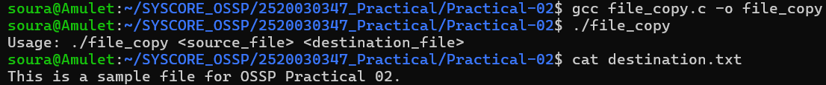
11. STRACE EXPERIMENT
The strace utility was used to observe the system calls generated by:
strace cat sample.txt
The command traces the execution of the cat program and displays the system calls made by the process.
12. IMPORTANT SYSTEM CALLS OBSERVED
The trace contained several system calls. The important file-related calls were:
openat() – Opens sample.txt in read-only mode and returns a file descriptor.
fstat() – Retrieves metadata about the file.
splice() – Transfers file data efficiently between file descriptors.
close() – Releases file descriptors.
exit_group() – Terminates the process.
13. SYSTEM CALL SEQUENCE
The important sequence near the actual file operation was:
statx()
openat()
fstat()
splice()
splice()
close()
exit_group()
14. ANALYSIS OF STRACE
The trace shows that cat performs several initialization operations before accessing sample.txt.
openat() is used to open the file.
fstat() retrieves file metadata.
The Linux version of cat used in this execution used splice() to efficiently transfer file data.
The trace showed:
splice(3, NULL, 5, NULL, 1048576, 0) = 22
followed by:
splice(4, NULL, 1, NULL, 22, 0) = 22
The file descriptors were then closed using close().
Finally, exit_group() terminated the process successfully.
15. KERNEL SERVICES INVOLVED
openat() – File opening and file descriptor allocation.
fstat() – File metadata retrieval.
read() / splice() – File data transfer.
close() – File descriptor release.
mmap() – Memory mapping.
brk() – Process heap management.
mprotect() – Memory protection.
exit_group() – Process termination.
16. OUTPUT
Screenshot 4 – strace
Screenshot 5 – Important System Calls
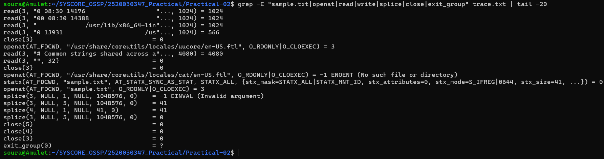17. CONCLUSION
The practical successfully demonstrated file copying using the Linux system calls open(), read(), write(), and close().
The strace experiment demonstrated how a simple command such as cat sample.txt interacts with the Linux kernel through system calls. The trace showed file opening, metadata retrieval, data transfer, descriptor closing, and process termination.

