SKILL – 02
OPERATING SYSTEMS AND SYSTEM PROGRAMMING
SKILL – 02
Title: Interactive Shell Loop and Keyboard Input Handling
Name: Souradeepta Das
Roll No.: 2520030347
Course: Operating Systems and System Programming
Skill No.: 02
1. OBJECTIVE
The objective of Skill-02 is to implement an interactive command loop and understand keyboard input processing in a Linux terminal.
The activities include:
Activity 1
• Create a main loop.
• Display a prompt.
• Read user input.
• Handle exit conditions.
• Design a control-flow diagram.
• Test an interactive loop.
Activity 2
• Capture keyboard input.
• Handle Backspace.
• Process the Enter key.
• Manage an input buffer.
• Support multi-character commands.
• Test user interaction.
2. INTERACTIVE SHELL LOOP
A basic interactive shell continuously waits for user commands.
The general flow is:
Display Prompt
↓
Read Input
↓
Check Command
↓
Is it "exit"?
YES → Exit
NO → Process Command → Display Result → Display Prompt
3. PROGRAM 1 – INTERACTIVE SHELL
File: interactive_shell.c
#include <stdio.h>
#include <string.h>
#define MAX_INPUT 100
int main()
{
char input[MAX_INPUT];
printf("=====================================\n");
printf(" Simple Interactive Shell\n");
printf("=====================================\n");
while (1)
{
printf("SimpleShell> ");
fflush(stdout);
if (fgets(input, MAX_INPUT, stdin) == NULL)
{
printf("\nInput error.\n");
break;
}
input[strcspn(input, "\n")] = '\0';
if (strcmp(input, "exit") == 0)
{
printf("Exiting shell...\n");
break;
}
if (strlen(input) == 0)
{
continue;
}
printf("You entered: %s\n", input);
}
return 0;
}
4. COMPILATION
gcc interactive_shell.c -o interactive_shell
The program can also be compiled using the Makefile:
make
5. EXECUTION
./interactive_shell
Example interaction:
SimpleShell> hello
You entered: hello
SimpleShell> operating systems
You entered: operating systems
SimpleShell> test
You entered: test
SimpleShell> exit
Exiting shell...
6. KEYBOARD INPUT HANDLING
The second program processes input at the character level.
Unlike the first program, which uses fgets() and normal terminal line buffering, the keyboard input program uses Linux terminal control through the termios interface.
Canonical mode and terminal echo are disabled so that individual characters can be processed by the program.
7. PROGRAM 2 – KEYBOARD INPUT
File: keyboard_input.c
#include <stdio.h>
#include <string.h>
#include <unistd.h>
#include <termios.h>
#define MAX_INPUT 100
void enable_raw_mode(struct termios *original)
{
struct termios raw;
tcgetattr(STDIN_FILENO, original);
raw = *original;
raw.c_lflag &= ~(ICANON | ECHO);
tcsetattr(STDIN_FILENO, TCSANOW, &raw);
}
void disable_raw_mode(struct termios *original)
{
tcsetattr(STDIN_FILENO, TCSANOW, original);
}
int main()
{
struct termios original;
char buffer[MAX_INPUT];
int index = 0;
char ch;
enable_raw_mode(&original);
printf("=====================================\n");
printf(" Keyboard Input Demonstration\n");
printf("=====================================\n");
printf("Type a command and press Enter.\n");
printf("Backspace is supported.\n");
printf("Type 'exit' to terminate.\n\n");
printf("MiniShell> ");
fflush(stdout);
while (index < MAX_INPUT - 1)
{
read(STDIN_FILENO, &ch, 1);
if (ch == '\n' || ch == '\r')
{
buffer[index] = '\0';
printf("\nYou entered: %s\n", buffer);
if (strcmp(buffer, "exit") == 0)
{
break;
}
index = 0;
printf("MiniShell> ");
fflush(stdout);
}
else if (ch == 127 || ch == 8)
{
if (index > 0)
{
index--;
printf("\b \b");
fflush(stdout);
}
}
else if (ch >= 32 && ch <= 126)
{
buffer[index++] = ch;
putchar(ch);
fflush(stdout);
}
}
disable_raw_mode(&original);
printf("\nShell terminated.\n");
return 0;
}
8. COMPILATION
gcc keyboard_input.c -o keyboard_input
Or:
make
9. EXECUTION
./keyboard_input
The program accepts individual characters and stores them in an input buffer.
10. BACKSPACE HANDLING
The program checks for Backspace using:
if (ch == 127 || ch == 8)
When Backspace is detected, the input buffer index is decreased and the previous character is removed from the terminal display.
The sequence:
\b \b
moves the cursor backward, replaces the character with a space, and moves the cursor backward again.
11. ENTER KEY HANDLING
The program checks:
if (ch == '\n' || ch == '\r')
When Enter is pressed:
- The buffer is terminated with '\0'.
- The entered command is displayed.
- The program checks whether the command is exit.
- If it is not exit, the input buffer is reset.
- A new prompt is displayed.
12. INPUT BUFFER
The program uses:
char buffer[MAX_INPUT];
to store characters entered by the user.
The index variable:
int index = 0;
keeps track of the current position in the buffer.
13. MAKEFILE
The Makefile provides a convenient way to compile both programs.
The Makefile uses GCC with -Wall -Wextra to enable compiler warnings.
Compilation:
make
Cleaning compiled programs:
make clean
14. OBSERVATIONS
The first program demonstrates a conventional interactive input loop using fgets().
The terminal's normal input processing handles line editing operations such as Backspace.
The second program provides more direct keyboard control. Canonical mode and echo are disabled using termios, allowing the program to receive individual characters.
Therefore, the second program explicitly handles:
• Characters
• Backspace
• Enter
• Input buffering
• Multi-character commands
• Exit conditions
This demonstrates the difference between terminal-managed line input and application-level character input.
15. OUTPUT SCREENSHOTS
Screenshot 1 – Interactive Shell
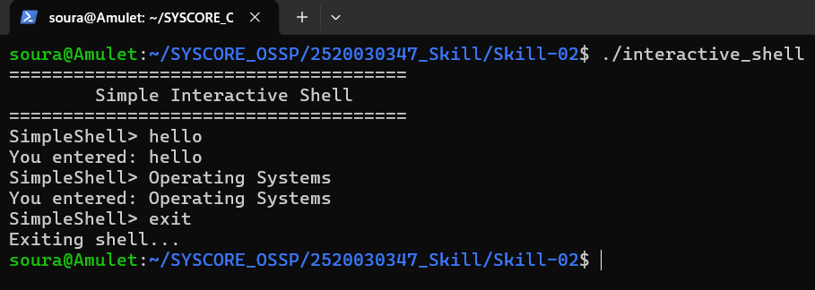Screenshot 2 – Multiple Commands(eg: Operating Systems)
Screenshot 3 – Keyboard Input
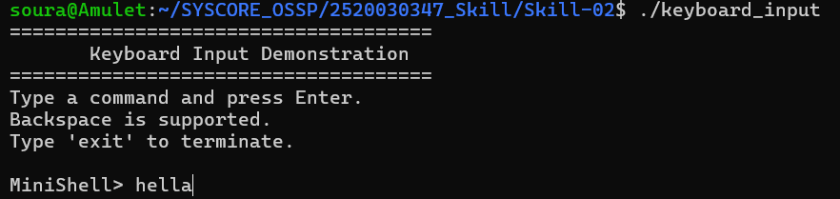
Screenshot 4 – Backspace Handling
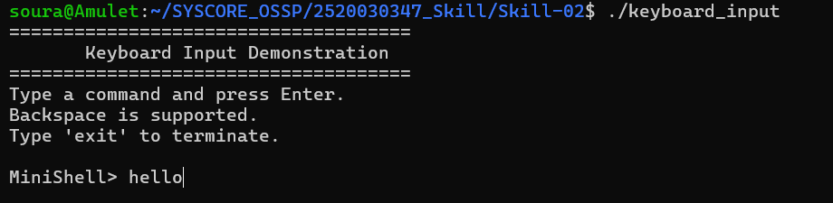
Screenshot 5 – Exit Condition
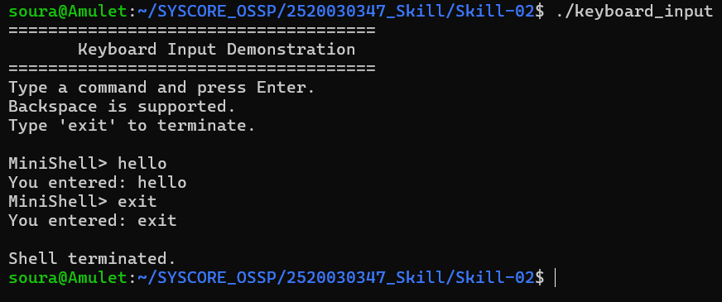Screenshot 6 – Makefile Compilation
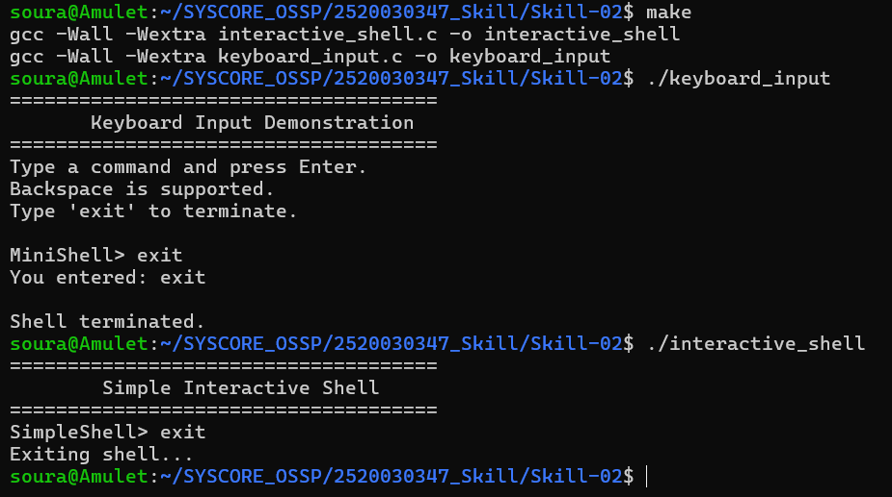
16. CONCLUSION
Skill-02 successfully demonstrated the design of an interactive shell loop and character-level keyboard input handling.
The implementation covered prompt display, user input, exit conditions, input buffering, multi-character commands, Enter-key processing, and manual Backspace handling. The use of Linux terminal control also demonstrated how applications can interact more directly with terminal input behavior.

