**Virtual Art Gallery**

**Coding Challenge SQL**

**Creating database named VirtualArtGallery :**

Screenshot 2024-04-19 154529

**Creating Artists table :**

*CREATE TABLE Artists (*

*ArtistID INT PRIMARY KEY,*

*Name VARCHAR(255) NOT NULL,*

*Biography TEXT,*

*Nationality VARCHAR(100)*

*);*



**Creating Categories table :**

*CREATE TABLE Categories (*

*CategoryID INT PRIMARY KEY,*

*Name VARCHAR(100) NOT NULL*

*);*



**Creating Artworks table :**

*CREATE TABLE Artworks (*

*ArtworkID INT PRIMARY KEY,*

*Title VARCHAR(255) NOT NULL,*

*ArtistID INT,*

*CategoryID INT,*

*Year INT,*

*Description TEXT,*

*ImageURL VARCHAR(255),*

*FOREIGN KEY (ArtistID) REFERENCES Artists (ArtistID),*

*FOREIGN KEY (CategoryID) REFERENCES Categories (CategoryID));*

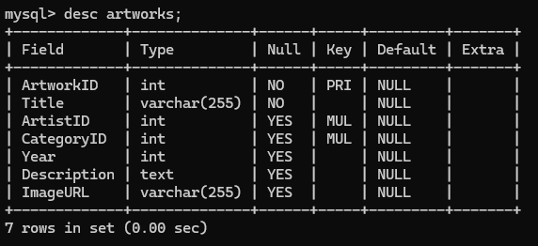

**Creating Exhibitions table :**

*CREATE TABLE Exhibitions (*

*ExhibitionID INT PRIMARY KEY,*

*Title VARCHAR(255) NOT NULL,*

*StartDate DATE,*

*EndDate DATE,*

*Description TEXT);*



**Create a table to associate artworks with exhibitions :**

*CREATE TABLE ExhibitionArtworks (*

*ExhibitionID INT,*

*ArtworkID INT,*

*PRIMARY KEY (ExhibitionID, ArtworkID),*

*FOREIGN KEY (ExhibitionID) REFERENCES Exhibitions (ExhibitionID),*

*FOREIGN KEY (ArtworkID) REFERENCES Artworks (ArtworkID));*

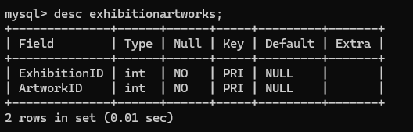

**Inserting the sample data into the Artists table :**

*INSERT INTO Artists (ArtistID, Name, Biography, Nationality)*

*VALUES (1, 'Pablo Picasso', 'Renowned Spanish painter and sculptor.', 'Spanish'),*

*(2, 'Vincent van Gogh', 'Dutch post-impressionist painter.', 'Dutch'),*

*(3, 'Leonardo da Vinci', 'Italian polymath of the Renaissance.', 'Italian');*

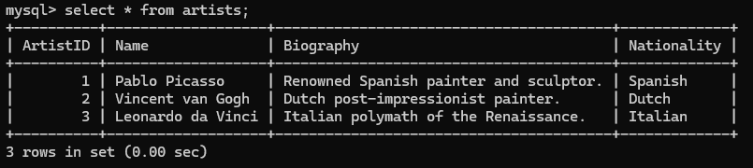

**Inserting the sample data into the Categories table :**

*INSERT INTO Categories (CategoryID, Name) VALUES (1, 'Painting'),*

*(2, 'Sculpture'),*

*(3, 'Photography');*



**Inserting the sample data into the Artworks table :**

*INSERT INTO Artworks*

*(ArtworkID, Title, ArtistID, CategoryID, Year, Description, ImageURL) VALUES*

*(1, 'Starry Night', 2, 1, 1889, 'A famous painting by Vincent van Gogh.', 'starry_night.jpg'),*

*(2, 'Mona Lisa', 3, 1, 1503, 'The iconic portrait by Leonardo da Vinci.', 'mona_lisa.jpg'),*

*(3, 'Guernica', 1, 1, 1937, 'Pablo Picasso\'s powerful anti-war mural.', 'guernica.jpg');*

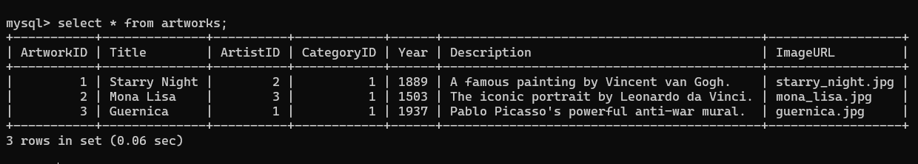

**Inserting the sample data into the Exhibitions table:**

*INSERT INTO Exhibitions (ExhibitionID, Title, StartDate, EndDate, Description)*

*VALUES (1, 'Modern Art Masterpieces','2023-01-01', '2023-03-01',*

*'A collection of modern art masterpieces.'),*

*(2, 'Renaissance Art', '2023-04-01', '2023-06-01', 'A showcase of Renaissance art treasures.');*

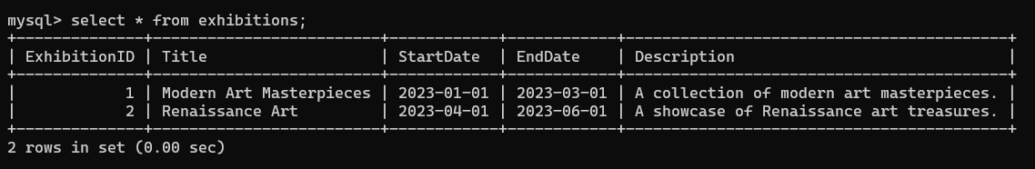

**Inserting artworks into exhibitions :**

*INSERT INTO ExhibitionArtworks (ExhibitionID, ArtworkID) VALUES (1, 1), (1, 2), (1, 3), (2, 2);*



1. **Retrieving the names of all artists along with the number of artworks they have in the gallery, and list them in descending order of the number of artworks.**

*select name,(select count(*) from artworks where artists.artistid=artworks.artistid)*

*as artwork_count from artists order by artwork_count desc;*

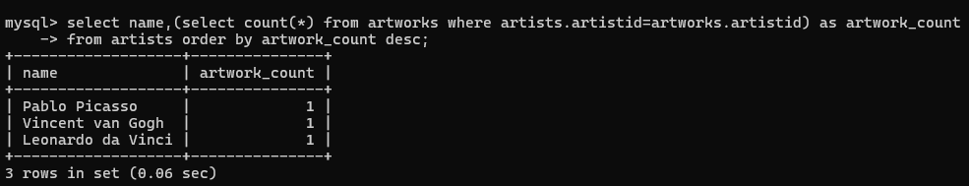

1. **Listing the titles of artworks created by artists from 'Spanish' and 'Dutch' nationalities, and order them by the year in ascending order.**

*select title from artworks where artistid in*

*(select artistid from artists where nationality in ('Spanish','Dutch')) order by year;*



1. **Finding the names of all artists who have artworks in the 'Painting' category, and the number of artworks they have in this category.**

*select name,*

*(select count(*) from artworks where artists.artistid=artworks.artistid and*

*categoryid=(select categoryid from categories where name='Painting'))*

*as painting_count from artists;*

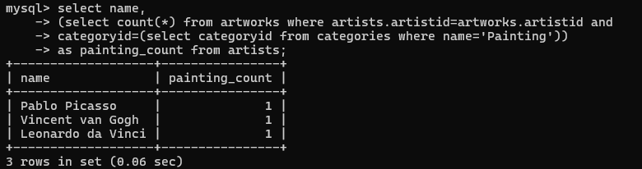

**4) Listing the names of artworks from the 'Modern Art Masterpieces' exhibition, along with their artists and categories.**



**5) Finding the artists who have more than two artworks in the gallery.**



**6) Finding the titles of artworks that were exhibited in both 'Modern Art Masterpieces' and 'Renaissance Art' exhibitions.**

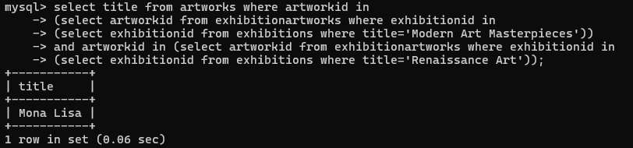

**7) Finding the total number of artworks in each category.**

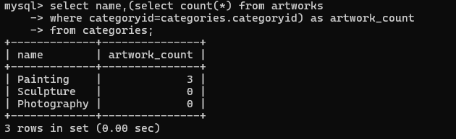

**8) Listing the artists who have more than 3 artworks in the gallery.**



**9) Finding the artworks created by artists from a specific nationality.**



**10) Listing exhibitions that feature artwork by both Vincent van Gogh and Leonardo da Vinci.**



**11) Finding all the artworks that have not been included in any exhibition.**

Screenshot 2024-04-19 215243

**12) Listing artists who have created artworks in all available categories.**



**13) Listing the total number of artworks in each category.**

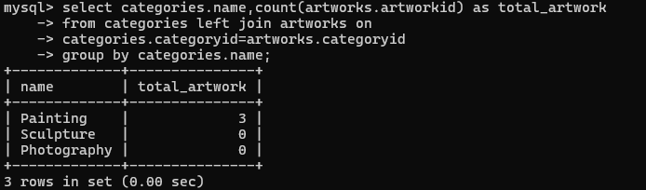

**14) Finding the artists who have more than 2 artworks in the gallery.**



**15) Listing the categories with the average year of artworks they contain, only for categories with more than 1 artwork.**

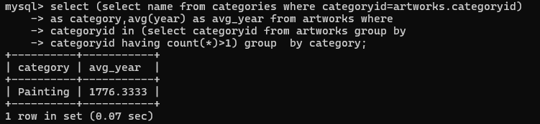

**16) Finding the artworks that were exhibited in the 'Modern Art Masterpieces' exhibition.**

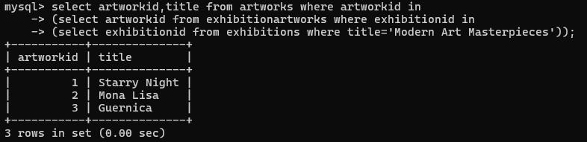

**17) Finding the categories where the average year of artworks is greater than the average year of all artworks.**

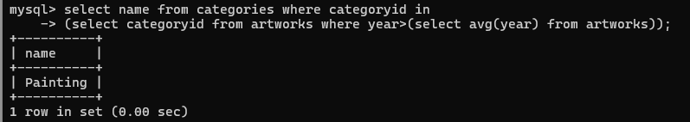

**18) Listing the artworks that were not exhibited in any exhibition.**



**19) Showing artists who have artworks in the same category as "Mona Lisa."**

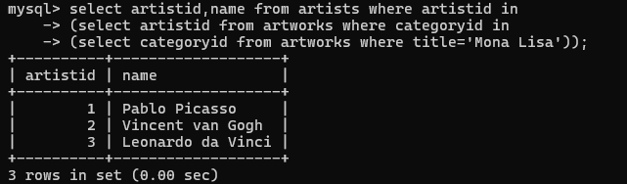

**20) Listing the names of artists and the number of artworks they have in the gallery.**

