**PAYROLL MANAGEMENT SYSTEM**

**Creation of table employee**

create table Employee(employee_id int primary key, firstname varchar(30),lastname varchar(30),dateofbirth date, gender varchar(6),email varchar(25),phonenumber varchar(15),address varchar(225),position varchar(50),joiningdate date,terminationdate date);

**Creation of table payroll**

create table payroll(payrollid int primary key, employee_id int,payperiodstartdate date,basicsalary decimal,overtimepay decimal,deductions decimal,netsalary decimal);

**Creation of table tax**

create table tax(taxid int primary key,employeeid int,taxyear int,taxableincome decimal,taxamount decimal);

**Creation of table financialrecord**

create table financialrecord(recordid int primary key,employeeid int,recorddate date, description varchar(255),amount decimal,recordtype enum('income', 'expense', 'tax payment'));

**Inserting data in employee table**

insert into Employee (Employee_id, FirstName, LastName, DateOfBirth, Gender, Email, PhoneNumber, Address, Position, JoiningDate, TerminationDate)

values

(1, 'John', 'Doe', '1990-05-15', 'Male', 'john@gmail.com', '1234567890', '123 Main St, City, Country', 'Software Engineer', '2020-01-15', NULL),

(2, 'Jane', 'Smith', '1985-09-20', 'Female', 'smith@gamilcom', '0987654321', '456 Oak Ave, Town, Country', 'Data Analyst', '2019-03-10', NULL),

(3, 'Michael', 'Johnson', '1982-07-10', 'Male', 'michael@gmail.com', '9876543210', '789 Elm St, Village, Country', 'Project Manager', '2018-07-05', '2022-02-28'),

(4, 'Emily', 'Brown', '1995-11-25', 'Female', 'brown@gmail.com', '2345678901', '101 Pine St, City, Country', 'Software Developer', '2021-02-20', NULL),

(5, 'David', 'Williams', '1988-03-12', 'Male', 'david@gmail.com', '3456789012', '202 Maple Ave, Town, Country', 'Marketing Specialist', '2017-05-10', '2023-06-30'),

(6, 'Sarah', 'Jones', '1993-08-18', 'Female', 'sarah@gmail.com', '4567890123', '303 Cedar St, Village, Country', 'Financial Analyst', '2019-11-03', NULL),

(7, 'Christopher', 'Garcia', '1980-01-30', 'Male', 'christopher@gmail.com', '5678901234', '404 Oak St, City, Country', 'HR Manager', '2016-09-15', '2024-01-15'),

(8, 'Jessica', 'Martinez', '1991-06-05', 'Female', 'jessica@gmail.com', '6789012345', '505 Elm St, Town, Country', 'Sales Representative', '2020-04-10', NULL),

(9, 'Daniel', 'Hernandez', '1987-04-08', 'Male', 'daniel12@gmail.com', '7890123456', '606 Pine St, Village, Country', 'Accountant', '2018-12-22', NULL),

(10, 'Amanda', 'Lopez', '1994-02-14', 'Female', 'amanda@gmail.com', '8901234567', '707 Maple St, City, Country', 'Customer Service Representative', '2021-09-08', NULL);

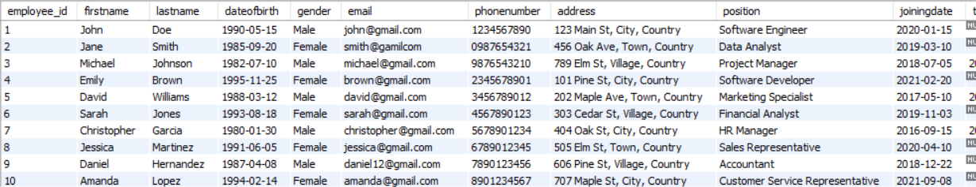

**Inserting data into payroll table**

insert into payroll (payrollid, employee_id, payperiodstartdate, basicsalary, overtimepay, deductions, netsalary) values

(101, 1, '2024-04-01', 5000.00, 200.00, 500.00, 4500.00),

(102, 2, '2024-04-01', 4500.00, 150.00, 400.00, 4150.00),

(103, 3, '2024-04-01', 6000.00, 250.00, 600.00, 5150.00),

(104, 4, '2024-04-01', 5200.00, 180.00, 450.00, 4970.00),

(105, 5, '2024-04-01', 4800.00, 200.00, 500.00, 4500.00),

(106, 6, '2024-04-01', 5500.00, 220.00, 550.00, 5170.00),

(107, 7, '2024-04-01', 5800.00, 240.00, 600.00, 5360.00),

(108, 8, '2024-04-01', 4900.00, 180.00, 400.00, 4680.00),

(109, 9, '2024-04-01', 5100.00, 200.00, 450.00, 4850.00),

(110, 10, '2024-04-01', 4700.00, 160.00, 350.00, 4510.00);

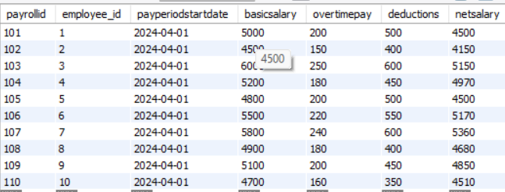

**Inserting value into tax table**

insert into tax (taxid, employeeid, taxyear, taxableincome, taxamount)values

(1001, 1, 2024, 55000.00, 8250.00),

(1002, 2, 2024, 48000.00, 7200.00),

(1003, 3, 2024, 70000.00, 10500.00),

(1004, 4, 2024, 60000.00, 9000.00),

(1005, 5, 2024, 52000.00, 7800.00),

(1006, 6, 2024, 59000.00, 8850.00),

(1007, 7, 2024, 63000.00, 9450.00),

(1008, 8, 2024, 51000.00, 7650.00),

(1009, 9, 2024, 54000.00, 8100.00),

(1010, 10, 2024, 47000.00, 7050.00);

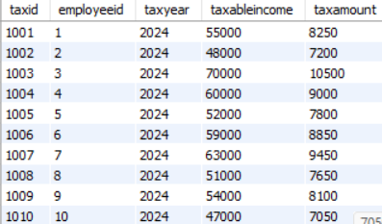

**Inserting value into financialrecord**

insert into financialrecord (recordid, employeeid, recorddate, description, amount, recordtype)values

(10001, 1, '2024-04-01', 'Salary', 5000.00, 'income'),

(10002, 2, '2024-04-02', 'Rent', 1000.00, 'expense'),

(10003, 3, '2024-04-03', 'Tax Payment', 2000.00, 'tax payment'),

(10004, 4, '2024-04-04', 'Bonus', 1500.00, 'income'),

(10005, 5, '2024-04-05', 'Internet Bill', 50.00, 'expense'),

(10006, 6, '2024-04-06', 'Salary', 5500.00, 'income'),

(10007, 7, '2024-04-07', 'Electricity Bill', 200.00, 'expense'),

(10008, 8, '2024-04-08', 'Tax Payment', 1800.00, 'tax payment'),

(10009, 9, '2024-04-09', 'Dividends', 300.00, 'income'),

(10010, 10, '2024-04-10', 'Groceries', 100.00, 'expense');

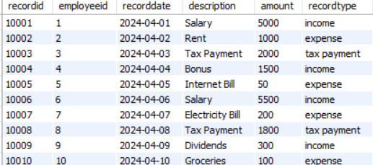

**Making column as foreign key**

alter table financialrecord add constraint financial_fk foreign key (employeeid) references Employee(employee_id);

alter table tax add constraint tax_fk foreign key (employeeid) references Employee(employee_id);

alter table payroll add constraint pay_fk foreign key (employee_id) references Employee(employee_id);