A project report on
CROSS-LINGUISTIC TRANSFER DIAGNOSTICS FOR LOW-RESOURCE FINANCIAL NLP IN INDIC LANGUAGES
Submitted in partial fulfillment for the award of the degree of
Bachelor of Technology in Computer Science and Engineering [TO FILL: specialization, if any]
by
[TO FILL: NAME OF CANDIDATE 1] ([TO FILL: Reg. No.])
[TO FILL: NAME OF CANDIDATE 2, if a team project] ([TO FILL: Reg. No.])
[TO FILL: NAME OF CANDIDATE 3, if a team project] ([TO FILL: Reg. No.])

SCHOOL OF COMPUTER SCIENCE AND ENGINEERING
[TO FILL: Month, Year]

A project report on
CROSS-LINGUISTIC TRANSFER DIAGNOSTICS FOR LOW-RESOURCE FINANCIAL NLP IN INDIC LANGUAGES
Submitted in partial fulfillment for the award of the degree of
Bachelor of Technology in Computer Science and Engineering [TO FILL: specialization, if any]
by
[TO FILL: NAME OF CANDIDATE 1] ([TO FILL: Reg. No.])
[TO FILL: NAME OF CANDIDATE 2, if a team project] ([TO FILL: Reg. No.])
[TO FILL: NAME OF CANDIDATE 3, if a team project] ([TO FILL: Reg. No.])
SCHOOL OF COMPUTER SCIENCE AND ENGINEERING
[TO FILL: Month, Year]

DECLARATION
I hereby declare that the thesis entitled “Cross-Linguistic Transfer Diagnostics for Low-Resource Financial NLP in Indic Languages” submitted by [TO FILL: NAME] ([TO FILL: REGISTER NO]), for the award of the degree of Bachelor of Technology in Computer Science and Engineering, Vellore Institute of Technology, Chennai is a record of bonafide work carried out by me under the supervision of [TO FILL: Guide Name].
I further declare that the work reported in this thesis has not been submitted and will not be submitted, either in part or in full, for the award of any other degree or diploma in this institute or any other institute or university.

Place: Chennai
Date: Signature of the Candidate

School of Computer Science and Engineering
CERTIFICATE
This is to certify that the report entitled “Cross-Linguistic Transfer Diagnostics for Low-Resource Financial NLP in Indic Languages” is prepared and submitted by [TO FILL: Name] ([TO FILL: Reg No]) to Vellore Institute of Technology, Chennai, in partial fulfillment of the requirement for the award of the degree of Bachelor of Technology in Computer Science and Engineering [TO FILL: specialization, if any] is a bonafide record carried out under my guidance. The project fulfills the requirements as per the regulations of this University and in my opinion meets the necessary standards for submission. The contents of this report have not been submitted and will not be submitted either in part or in full, for the award of any other degree or diploma and the same is certified.

Signature of the Guide: ____________________
Name: Dr./Prof. [TO FILL: Guide name]
Date: ____________________
Signature of the Examiner Signature of the Examiner
____________________ ____________________
Name: Name:
Date: Date:
Approved by the Head of Department,
B.Tech. Computer Science and Engineering [TO FILL: specialization, if any]
Name: [TO FILL: HoD name]
Date: ____________________
(Seal of the School of Computer Science and Engineering)

ABSTRACT
Multilingual language models do well on general language-understanding benchmarks, yet it is unclear whether they keep financial meaning intact when knowledge moves from one Indic language to another. The IndicFinNLP resource was designed to give single-language baselines for Hindi, Bengali and Telugu. Its language splits differ in topic, entities and difficulty, so any comparison between languages mixes the effect of language with the effect of content.
This project builds a controlled corpus in which language is the only thing that changes. Each native split is translated directly between Indic languages with IndicTrans2, without an English pivot, into Hindi, Bengali, Telugu and Malayalam. The result is 92,760 machine-translated rows whose labels are never altered. Every row is checked for numeral preservation, structural integrity and LaBSE similarity against a threshold calibrated on human translations. Rows that fail a check are flagged and kept, never deleted. A pre-translation audit shows that the sustainability and ESG-theme splits already contain the same items in every language, while the numeral split is independently sourced. Roughly one annotated financial numeral in six does not survive translation intact.
IndicBERT and multilingual BERT are fine-tuned on one language and tested zero-shot on the others with content held fixed. On sustainability classification the transfer costs 0.26 to 0.45 macro-F1 for IndicBERT and 0.11 to 0.24 for mBERT. Hindi is the worst source language for both encoders, mBERT beats IndicBERT in all twelve Hindi-source cells, and moving into a Dravidian language costs more than moving into an Indo-Aryan one. A three-stage diagnostic router assigns each failure in 72 conditions exactly one cause. Linguistic causes account for only 8.8 to 12.0 percent of failures, and two of the linguistic modules predict failure no better than chance. The report therefore states the size and shape of the transfer gap with confidence and leaves its causes as an open question.
Keywords: cross-lingual transfer, financial NLP, Indic languages, machine translation, parallel corpus, IndicBERT, mBERT, failure diagnosis

ACKNOWLEDGEMENT
It is my pleasure to express with deep sense of gratitude to [TO FILL: Guide name], [TO FILL: Designation], School of Computer Science and Engineering, Vellore Institute of Technology, Chennai, for constant guidance, continual encouragement and understanding; more than all, for teaching me patience in my endeavor. My association with the guide is not confined to academics only, but it is a great opportunity on my part to work with an intellectual and expert in the field of [TO FILL: area, for example natural language processing].
It is with gratitude that I would like to extend my thanks to the visionary leader Dr. G. Viswanathan, our Honorable Chancellor, Mr. Sankar Viswanathan, Dr. Sekar Viswanathan, Dr. G V Selvam, Vice Presidents, Dr. Sandhya Pentareddy, Executive Director, Ms. Kadhambari S. Viswanathan, Assistant Vice-President, Dr. V. S. Kanchana Bhaaskaran, Vice-Chancellor, Dr. T. Thyagarajan, Pro-Vice Chancellor, VIT Chennai and Dr. P. K. Manoharan, Additional Registrar for providing an exceptional working environment and inspiring all of us during the tenure of the course.
Special mention to Dr. Viswanathan V, Dean, Dr. Nithyanandam P, Associate Dean, Dr. Suganya G, Associate Dean, Dr. Sweetlin Hemalatha C, Associate Dean, School of Computer Science and Engineering, Vellore Institute of Technology, Chennai for spending their valuable time and efforts in sharing their knowledge and for helping us in every aspect.
In jubilant state, I express ingeniously my whole-hearted thanks to [TO FILL: HoD name], Head of the Department, B.Tech. Computer Science and Engineering [TO FILL: specialization, if any] and the Project Coordinators for their valuable support and encouragement to take up and complete the thesis.
My sincere thanks to all the faculties and staffs at Vellore Institute of Technology, Chennai who helped me acquire the requisite knowledge. I would like to thank my parents for their support. It is indeed a pleasure to thank my friends who encouraged me to take up and complete this task.
Place: Chennai
Date: [TO FILL: Name of the student]

CONTENTS
CHAPTER 1 INTRODUCTION 1
1.1 INTRODUCTION 1
1.2 OVERVIEW OF FINANCIAL NLP IN INDIC LANGUAGES 2
1.3 CHALLENGES IN CROSS-LINGUAL FINANCIAL NLP 3
1.4 PROBLEM STATEMENT 4
1.5 OBJECTIVES 4
1.6 SCOPE OF THE PROJECT 4
1.7 CONTRIBUTIONS 5
1.8 ORGANISATION OF THE REPORT 5
CHAPTER 2 BACKGROUND AND LITERATURE SURVEY 6
2.1 INTRODUCTION 6
2.2 TECHNICAL BACKGROUND 6
2.3 FINANCIAL NLP RESOURCES AND MODELS 7
2.4 INDIC NLP RESOURCES AND BENCHMARKS 8
2.5 CROSS-LINGUAL TRANSFER 8
2.6 TRANSLATION-BASED TRANSFER AND ITS VALIDITY RISKS 9
2.7 COMPARISON OF THE REVIEWED STUDIES 9
2.8 GAP ANALYSIS AND POSITIONING 11
2.9 SUMMARY 12
CHAPTER 3 PROPOSED SYSTEM AND DESIGN 13
3.1 SYSTEM OVERVIEW 13
3.2 DESIGN PRINCIPLES AND HARD RULES 14
3.3 SOURCE DATA 14
3.4 MODULE 1: INDEPENDENCE AUDIT 15
3.5 MODULE 2: ITEM ALIGNMENT 16
3.6 MODULE 3: IDENTIFIERS, LABELS AND STORAGE 17
3.7 MODULE 4: TRANSLATION 18
3.8 MODULE 5: TRANSLATION QUALITY GATES 19
3.9 MODULE 6: FREEZE AND DATASHEET 21
3.10 MODULE 7: EVALUATION-CONDITION MATRIX 21
3.11 MODULE 8: TRAINING AND ZERO-SHOT EVALUATION 22
3.12 MODULE 9: FAILURE DIAGNOSTIC ROUTER 23
3.13 MODULE 10: AGGREGATION AND FINDING RULE 25
3.14 DESIGN FOR LIMITED HARDWARE 26
CHAPTER 4 IMPLEMENTATION 27
4.1 DEVELOPMENT ENVIRONMENT 27
4.2 REPOSITORY ORGANISATION 28
4.3 CORPUS CONSTRUCTION 29
4.4 TRANSLATION CORRUPTION MODES 30
4.5 THE QUALITY GATES 31
4.6 RESUME AND DETERMINISM PROBLEMS FOUND AND FIXED 32
4.7 TRAINING IMPLEMENTATION 33
4.8 DIAGNOSTIC IMPLEMENTATION 35
4.9 USER INTERFACE: RESULTS DASHBOARD 36
4.10 REPRODUCIBILITY MEASURES 36
CHAPTER 5 RESULTS AND DISCUSSION 37
5.1 INTRODUCTION 37
5.2 TESTING STRATEGY 37
5.3 EVALUATION METRICS 38
5.4 CORPUS QUALITY 38
5.5 IN-LANGUAGE BASELINES 43
5.6 ZERO-SHOT TRANSFER 44
5.7 ENCODER COMPARISON 46
5.8 SOURCE LANGUAGE AND DIRECTION 46
5.9 FAILURE ATTRIBUTION 48
5.10 VALIDATION 50
5.11 COMPARISON WITH PUBLISHED AND PRIOR RESULTS 51
5.12 DISCUSSION 51
5.13 LIMITATIONS AND THREATS TO VALIDITY 52
CHAPTER 6 CONCLUSION AND FUTURE WORK 54
6.1 CONCLUSION 54
6.2 FUTURE WORK 55
REFERENCES 57
APPENDIX 1 SCHEMA, LABELS AND IDENTIFIERS 60
A1.1 CORPUS ROW SCHEMA FOR TASK 1 60
A1.2 LABEL SETS 60
A1.3 IDENTIFIER RULES 61
APPENDIX 2 CONFIGURATIONS 62
A2.1 TRANSLATION AND VERIFICATION SETTINGS 62
A2.2 TRAINING AND DIAGNOSTIC SETTINGS 62
APPENDIX 3 PER-DIRECTION QUALITY TABLES 64
A3.1 ENTITY PRESERVATION 64
A3.2 SIMILARITY DISTRIBUTIONS 65
APPENDIX 4 FULL TRANSFER GAP TABLES 67
A4.1 TASK 2 AND TASK 3 TRANSFER GAPS 67
APPENDIX 5 REPRODUCTION AND SCRIPT INVENTORY 69
A5.1 SETTING UP 69
A5.2 COMMANDS 69
A5.3 PHASE AND TASK INVENTORY 70

LIST OF TABLES
Table 1.1: The four languages studied 2
Table 2.1: Comparison of reviewed studies, financial and Indic resources 10
Table 2.2: Comparison of reviewed studies, transfer and translation validity 11
Table 3.1: Hard rules of the corpus and the failure each one prevents 14
Table 3.2: The three IndicFinNLP tasks and their native row counts 15
Table 3.3: Canonical row schema 17
Table 4.1: Software and hardware environment 27
Table 4.2: Principal source modules 28
Table 4.3: Machine-translated rows generated per task 30
Table 4.4: Fine-tuning configuration 34
Table 4.5: Memory budget per encoder at maximum length 128 with fp16 34
Table 5.1: Automated tests by module 37
Table 5.2: Translation quality by task 39
Table 5.3: Survival of the annotated numeral in task 1 machine-translated rows 40
Table 5.4: Median LaBSE similarity and share below τ by direction 41
Table 5.5: Calibrated similarity threshold by task 42
Table 5.6: In-language macro-F1 on held-out test folds 43
Table 5.7: Macro-F1 by encoder, Hindi source 46
Table 5.8: Mean transfer gap by source language and target family, task 2 47
Table 5.9: Composition of transfer failures, share of failures 48
Table A1.1: Additional columns for the numeral task 60
Table A1.2: Task 3 classes and counts in each language 61
Table A2.1: Frozen translation decoding configuration 62
Table A2.2: Verification settings 62
Table A2.3: Diagnostic thresholds 63
Table A3.1: Entity preservation by direction, task 1 64
Table A3.2: Entity preservation by direction, task 2 64
Table A3.3: Entity preservation by direction, task 3 65
Table A3.4: LaBSE similarity distribution by direction, task 1 (τ = 0.82) 65
Table A3.5: LaBSE similarity distribution by direction, task 2 (τ = 0.82) 65
Table A3.6: LaBSE similarity distribution by direction, task 3 (τ = 0.73) 66
Table A4.1: Transfer gap by source, target and encoder, task 2 67
Table A4.2: Transfer gap by source, target and encoder, task 3 67
Table A5.1: Principal commands by phase 69
Table A5.2: Corpus tasks and what each delivers 70

LIST OF FIGURES
Figure 3.1: Overall architecture of the seven-phase pipeline 13
Figure 3.2: The three translation blocks and nine directions of each task 18
Figure 3.3: Corpus construction sequence and quality gates 19
Figure 3.4: Classifier architecture used for every source language and encoder 22
Figure 3.5: Three-stage diagnostic router 23
Figure 5.1: Outcome of the annotated numeral in task 1 machine translation 40
Figure 5.2: Entity preservation by direction and task, with the 95 percent bar 41
Figure 5.3: Median LaBSE similarity by translation direction and task 42
Figure 5.4: In-language macro-F1 for task 2 against the published figures 44
Figure 5.5: Task 2 transfer gap, source on the vertical axis and target on the horizontal axis 45
Figure 5.6: Task 3 transfer gap, source on the vertical axis and target on the horizontal axis 45
Figure 5.7: Mean transfer gap by source language on task 2 47
Figure 5.8: Composition of transfer failures by task and encoder 48

LIST OF SYMBOLS, ABBREVIATIONS AND NOMENCLATURE
APA American Psychological Association (reference style)
AUC Area Under the (ROC) Curve
CC BY-NC-SA Creative Commons Attribution-NonCommercial-ShareAlike licence
CI Confidence Interval
CLS Classification token of a BERT-style encoder
ESG Environmental, Social and Governance
IG Integrated Gradients
IndicBERT ALBERT-based multilingual encoder pre-trained on Indian languages
IndicFinNLP Financial NLP benchmark for Hindi, Bengali and Telugu
IndicTrans2 Machine-translation models for the 22 scheduled Indian languages
LaBSE Language-agnostic BERT Sentence Embedding
mBERT Multilingual BERT (cased, base)
ML Machine Learning
MT Machine Translation
NFC Unicode Normalisation Form C
NLP Natural Language Processing
OOM Out of Memory
SHA-256 Secure Hash Algorithm, 256-bit
VRAM Video Random Access Memory
XLM-R Cross-lingual language model, RoBERTa-based
τ (tau) LaBSE cosine-similarity threshold below which a translated pair is flagged as drift
cos(a, b) Cosine similarity of two embedding vectors
F1 Harmonic mean of precision and recall
Gap(s→t) Transfer gap: source in-language score minus target score
R_frag Tokenizer fragmentation ratio (target tokens divided by source tokens)
hin, ben, tel, mal Language codes for Hindi, Bengali, Telugu and Malayalam
hin_Deva, ben_Beng, tel_Telu, mal_Mlym FLORES-style language codes used by IndicTrans2
H, B, T Translation blocks whose native source is Hindi, Bengali and Telugu respectively

CHAPTER 1
INTRODUCTION

1.1 INTRODUCTION
Language technology for finance has so far been built mostly for English. A bank, a regulator or a sustainability analyst in India, however, reads reports, news and filings in many languages, and the volume of financial text written in Indic languages is growing quickly. What is missing is labelled data. Annotating financial text is slow and needs domain knowledge, so a typical Indic language has only a few thousand labelled sentences, if any. A tempting shortcut is cross-lingual transfer: fine-tune a multilingual pre-trained encoder on the language that has labels and apply it, without further training, to a language that has none. Such zero-shot transfer works well on general benchmarks (Conneau et al., 2020; Hu et al., 2020), but it degrades in low-resource settings and between languages that are far apart (Lauscher et al., 2020).
Finance makes the problem harder in ways that general benchmarks do not show. Financial sentences are dense with numerals written in local scale conventions such as lakh and crore, with currency symbols and percentages, with named entities, and with domain terminology that may have no settled equivalent in the target language. A model that confuses ten crore with ten million is not making a small transfer error. It is giving a wrong answer about money.
This report describes a project that measures, as directly as possible, how much of a financial classifier's ability survives a change of language among Hindi, Bengali, Telugu and Malayalam, and then asks why the lost part is lost. The project is organised as seven phases. The first builds a parallel corpus in which the same content is available in all four languages. The second to fifth train classifiers and measure zero-shot transfer across languages and across two encoders. The sixth assigns each transfer failure a single cause. The seventh adds up those causes to see what the failures are made of.

1.2 OVERVIEW OF FINANCIAL NLP IN INDIC LANGUAGES

1.2.1 The four languages
The study covers four languages that differ in family, script and morphology. Hindi and Bengali are Indo-Aryan languages written in the Devanagari and Bengali scripts. Telugu and Malayalam are Dravidian languages with their own scripts, and both are strongly agglutinative: grammatical information is attached to words as long chains of suffixes rather than expressed with separate function words. Table 1.1 summarises the properties that matter for this work.
Table 1.1: The four languages studied
Language | Family | Script | Digit range (Unicode) | Native data in IndicFinNLP
Hindi (hin) | Indo-Aryan | Devanagari | U+0966 to U+096F | Yes
Bengali (ben) | Indo-Aryan | Bengali | U+09E6 to U+09EF | Yes
Telugu (tel) | Dravidian | Telugu | U+0C66 to U+0C6F | Yes
Malayalam (mal) | Dravidian | Malayalam | U+0D66 to U+0D6F | No, machine translation only

Each script also has its own set of digits, and ASCII digits are used freely alongside them. A numeral may therefore appear as a Bengali digit string in one version of a sentence and as an ASCII string in another while denoting the same number. Any automatic check of whether a number survived translation has to compare values rather than characters.

1.2.2 Financial NLP resources
IndicFinNLP (Ghosh et al., 2024) brings financial NLP to Indian languages. It provides three tasks in Hindi, Bengali and Telugu: marking numerals in financial text, classifying sentences as sustainable or unsustainable, and assigning news headlines to one of ten ESG themes. It was created to provide single-language baselines. It was not created to measure transfer, and this distinction drives much of the design that follows.

1.2.3 Why transfer needs a controlled corpus
If Hindi, Bengali and Telugu test sets contain different sentences about different companies, a score that is lower in Telugu than in Hindi can be explained by language, but equally by topic, entity or difficulty. A clean transfer measurement needs the same content in every language. Parallel test sets of this kind exist for Indic natural language inference and for general understanding tasks (Aggarwal et al., 2022; Doddapaneni et al., 2023), but none covers financial or ESG text.

1.3 CHALLENGES IN CROSS-LINGUAL FINANCIAL NLP
The project met six challenges, and each one shaped a design decision described later.
- No parallel financial data. IndicFinNLP does not claim parallelism, so the corpus has to be constructed. Machine translation is the only practical way to do so at scale, and it introduces its own errors.
- Hidden parallelism. Splits that look independent may be the same content in shuffled order. If this is not detected, a model can be evaluated on a sentence it was trained on, merely written in another script. The project therefore audits independence before translating anything.
- Translation quality is a confound. A machine-translated test set can silently measure the translator instead of the model, and low-resource languages suffer most (Agrawal et al., 2024; Artetxe et al., 2023). Translation quality has to be measured and reported, not assumed.
- Numerals are fragile. Translation can drop a number, rewrite it in another scale, change its digit system or corrupt it. Text-level similarity scores cannot see this.
- No native Malayalam. IndicFinNLP has no Malayalam data, so every Malayalam result mixes transfer difficulty with translation quality, and no human reference exists to calibrate a similarity threshold.
- Limited compute. All experiments ran on a single laptop GPU with 4 GB of memory. Every long job had to checkpoint and resume, and one of the three planned encoders could not be trained at all.
A seventh, methodological challenge runs through the whole project. A transfer failure can be explained in many ways, and a plausible explanation is not evidence. Each diagnostic module therefore had to be validated against the data before its labels could be trusted.

1.4 PROBLEM STATEMENT
Do multilingual language models preserve financial meaning when knowledge moves between Indic languages? Answering this requires, first, a parallel test set in which language is the only variable, and whose translation quality is itself measured; and second, an analysis that explains transfer failures in terms of the language and the financial content (terminology, numerals, morphology and tokenisation) and not only in terms of overall accuracy.

1.5 OBJECTIVES
- Audit the three IndicFinNLP language splits of each task to establish whether they hold independent or shared content, before any translation is generated.
- Build a four-way parallel corpus in Hindi, Bengali, Telugu and Malayalam by direct Indic-to-Indic machine translation, with every label carried through unchanged and no row ever deleted.
- Check every translated row for numeral preservation, structural integrity and semantic similarity, and calibrate the similarity threshold against human translations wherever these exist.
- Fine-tune two encoders on each native language and measure zero-shot transfer across the full grid of source and target languages on content held fixed, after validating the in-language baselines.
- Compare source languages, target language families and encoders, and report which differences exceed seed noise.
- Assign each transfer failure a single cause with an ordered diagnostic router, validate the modules, and report what the failures consist of, including the share that no module can explain.
- Release the frozen corpus with a datasheet generated from its own artefacts, so that every figure in the documentation can be traced to the data.

1.6 SCOPE OF THE PROJECT
The project covers three IndicFinNLP tasks, four languages, two encoders and nine translation directions. Corpus construction covers all three tasks. Transfer evaluation and diagnosis cover the two classification tasks, the sustainability task (task 2) and the ESG-theme task (task 3). The numeral task (task 1) is not a classification task. It is used to measure whether numerals survive translation, and it is the only task whose language splits are independently sourced.
The following are outside the scope: training on machine-translated text, few-shot or adapter-based transfer, any language outside the four named, and an English pivot. XLM-R was planned as a third encoder but could not be fine-tuned on the available GPU, and the report treats that as a limitation and not as a result. The report does not claim to explain why transfer fails. It measures the size and shape of the failure and records which candidate explanations were tested and rejected.

1.7 CONTRIBUTIONS
The work contributes the following.
- A controlled four-way parallel financial corpus of 92,760 machine-translated rows, with an independence audit, an alignment of the shared items, quality gates on every row and a released datasheet.
- A systematic zero-shot transfer study over three source languages and two encoders, with 126 planned results per task, all of which were completed.
- A three-stage diagnostic framework in which a semantic gate runs before the linguistic modules, so that noise from the project's own translations is not blamed on the model.
- A set of negative results: two of the three linguistic modules do not predict failure better than chance, tokenisation does not explain the encoder difference, and Hindi, the obvious source, is the worst source language.

1.8 ORGANISATION OF THE REPORT
Chapter 2 reviews related work and ends with a comparison of twenty studies. Chapter 3 presents the design of the system, its modules and algorithms. Chapter 4 describes how each module was implemented, including the engineering problems met on the way. Chapter 5 reports testing, metrics, results, validation and limitations. Chapter 6 concludes and lists future work. The appendices give the data schema, configurations, per-direction tables and reproduction commands.

CHAPTER 2
BACKGROUND AND LITERATURE SURVEY

2.1 INTRODUCTION
This chapter places the project in the literature. It first explains the technical building blocks the later chapters rely on, and then reviews twenty peer-reviewed works in four groups: financial NLP resources, Indic NLP resources, cross-lingual transfer, and the validity of translation-based benchmarks. A comparison table and a gap analysis close the chapter.

2.2 TECHNICAL BACKGROUND

2.2.1 Pre-trained multilingual encoders
An encoder such as BERT reads a sentence as a sequence of sub-word tokens and produces a vector for each token. A special classification token at the start of the sequence, written [CLS], is trained to summarise the whole sentence. For classification, a small linear layer is placed on top of this vector and the whole network is fine-tuned on labelled data. A multilingual encoder is pre-trained on text from many languages with a shared vocabulary, so that the same network can be fine-tuned in one language and applied in another. Multilingual BERT (mBERT) transfers across scripts but works best between languages of similar structure (Pires et al., 2019). XLM-R improved results for languages with little data by scaling up pre-training, while exposing a trade-off between transfer quality and the capacity left for each language (Conneau et al., 2020). IndicBERT, released with IndicNLPSuite, is pre-trained on Indian languages only (Kakwani et al., 2020).

2.2.2 Zero-shot transfer and the transfer gap
In zero-shot cross-lingual transfer, a model is fine-tuned on labelled data in a source language and evaluated on a target language with no further training. The XTREME benchmark defined the transfer gap as the difference between a model's score in the source language and its score in the target language (Hu et al., 2020). This project adopts that definition and computes it on identical items wherever its alignment allows.

2.2.3 Machine translation for Indian languages
IndicTrans2 provides translation models for all 22 scheduled Indian languages (Gala et al., 2023). Its Indic-to-Indic checkpoints translate directly between two Indian languages without passing through English. A pivot through English would add a second source of error, and it would make it impossible to say which translation step introduced a given error. The project uses the 1B-parameter Indic-to-Indic checkpoint.

2.2.4 Language-agnostic sentence embeddings
LaBSE maps sentences from many languages into a single vector space in which a sentence and its translation lie close together (Feng et al., 2022). The cosine similarity of two sentence vectors is therefore a cheap proxy for whether two sentences say the same thing. The project uses it for two purposes: to test whether two language splits contain the same sentences, and to score every translated sentence against its source.

2.2.5 Evaluation measures
Macro-F1 averages the F1 score of each class with equal weight. It is the primary metric here because it does not let a classifier hide behind the majority class. Numeracy-600K showed that macro-F1 and micro-F1 can differ widely when classes are unbalanced (Chen et al., 2019), which is the situation in the ESG-theme task.

2.2.6 Attribution and morphology
Two diagnostic tools appear in Chapter 3. Integrated Gradients is an attribution method that estimates how much each input token contributes to a prediction by accumulating gradients along a path from a baseline input to the real input. A morphological analyser reduces an inflected word to its stem. Telugu and Malayalam attach case markers and postpositions to the word, so a financial term can appear in a sentence only in an inflected form that a naive string match would miss. [TO FILL: add primary citations for Integrated Gradients and for the Indic NLP Library, which are not in the reference list of the existing paper.]

2.3 FINANCIAL NLP RESOURCES AND MODELS
IndicFinNLP (Ghosh et al., 2024) is the resource this work builds on. It provides nine datasets, three tasks in each of Hindi, Bengali and Telugu, with baseline results. Outside India, MultiFin focuses on headline classification across 15 languages and compares labelling by native speakers with a translate-then-label approach (Jørgensen et al., 2023). That comparison is a choice that every parallel dataset must make. Numeracy-600K treats magnitude as a distinct learnable skill (Chen et al., 2019). FinBERT shows that domain-specific pre-training beats a general BERT, especially when training data are scarce (Huang et al., 2023). The ML-ESG shared tasks cover ESG impact classification in English, Chinese, Japanese and French and include no Indic language (Chen et al., 2023). A survey of financial language models lists low-resource evaluation as an open challenge (Lee et al., 2025).

2.4 INDIC NLP RESOURCES AND BENCHMARKS
IndicNLPSuite introduced IndicCorp and the first IndicBERT (Kakwani et al., 2020). IndicXTREME extended this to nine tasks over 20 languages and introduced IndicBERT v2 (Doddapaneni et al., 2023); many of its sub-tasks are parallel across languages, which sets a precedent for the corpus built here. IndicXNLI created a parallel inference set by machine translation and compared transfer strategies, concluding that translate-train can outperform transfer from English for Indic languages (Aggarwal et al., 2022). IndoRE studied transfer among Bengali, Hindi and Telugu, the same triple that IndicFinNLP covers, for relation classification (Nag et al., [TO FILL: year]). A study of part-of-speech tagging measured how much target-language data a few-shot transfer to Indic languages needs ([TO FILL: authors], 2026). None of these resources includes ESG text.

2.5 CROSS-LINGUAL TRANSFER
Pires et al. (2019) found that mBERT transfers well among typologically similar languages and less well across dissimilar ones. XLM-R raised performance for lower-resource languages by scaling up (Conneau et al., 2020). XTREME measured the transfer gap across many languages and showed that it remains large (Hu et al., 2020). Lauscher et al. (2020) found that zero-shot transfer deteriorates for languages that are distant from the source or poorly represented in pre-training, and that a small amount of target-language data closes most of the gap. The choice of source language is a problem of its own, which depends on how related two languages are, how similar their vocabulary is and how much data exist for each (Lin et al., 2019). Adapter-based methods such as MAD-X offer a cheaper route to adaptation than full fine-tuning (Pfeiffer et al., 2020).

2.6 TRANSLATION-BASED TRANSFER AND ITS VALIDITY RISKS
Machine translation underlies most parallel Indic benchmarks, so its flaws are inherited. Artetxe et al. (2023) showed that translating the test set is more effective than earlier studies concluded, once translation quality and the mismatch between training and test text are taken into account. Agrawal et al. (2024) showed that translation errors in XNLI affect low-resource languages most, and that manual re-annotation of Hindi and Urdu did not agree well with the labels inherited from English. A systematic review of multilingual sentiment analysis concluded that creating resources for under-resourced languages from high-resource ones remains a methodologically open question (Mabokela et al., 2023).

2.7 COMPARISON OF THE REVIEWED STUDIES
Tables 2.1 and 2.2 compare the twenty studies on the property that matters for this work. The "Relation to this project" column states what the project takes from each study. The comparison draws only on what each study claims; it does not rank them.
Table 2.1: Comparison of reviewed studies, financial and Indic resources
Study | Year | Focus and contribution | Languages / domain | Relation to this project
Ghosh et al. | 2024 | IndicFinNLP: nine datasets, three financial tasks, baselines | Hindi, Bengali, Telugu; finance | Source data for all three tasks; baselines used for validation
Jørgensen et al. | 2023 | MultiFin: headline classification; native labelling versus translate-then-label | 15 languages; finance | Motivates stating how labels were obtained in a parallel set
Chen et al. | 2019 | Numeracy-600K: magnitude as a learnable skill; macro-F1 versus micro-F1 | English; finance | Supports numeral checks and macro-F1 as the primary metric
Huang et al. | 2023 | FinBERT: domain pre-training beats general BERT with limited data | English; finance | Context for domain-specific encoders
Chen et al. | 2023 | ML-ESG-2: ESG impact type identification | English, Chinese, Japanese, French | Shows no Indic ESG shared task existed
Lee et al. | 2025 | Survey of financial language models | Multiple; finance | Lists low-resource evaluation as open
Kakwani et al. | 2020 | IndicNLPSuite: IndicCorp and first IndicBERT | Indian languages; general | Source of the IndicBERT checkpoint
Doddapaneni et al. | 2023 | IndicXTREME and IndicBERT v2: nine tasks, 20 languages | Indian languages; general | Precedent for n-way parallel Indic evaluation
Aggarwal et al. | 2022 | IndicXNLI: MT-built parallel inference set; transfer strategies | Indian languages; NLI | Precedent for MT-built parallel Indic benchmarks
Nag et al. | [TO FILL] | IndoRE: transfer among Bengali, Hindi, Telugu | Same triple; relation classification | Same language triple as IndicFinNLP
[TO FILL] | 2026 | Data needed for few-shot Indic POS transfer | Indic languages; POS tagging | Few-shot budget, listed as future work

Table 2.2: Comparison of reviewed studies, transfer and translation validity
Study | Year | Focus and contribution | Languages / domain | Relation to this project
Pires et al. | 2019 | mBERT transfers across scripts, best between similar languages | Multiple; general | mBERT is one of the two encoders
Conneau et al. | 2020 | XLM-R: scale improves low-resource transfer, with a capacity trade-off | Many languages; general | Planned third encoder; capacity question left open
Hu et al. | 2020 | XTREME: transfer gap across tasks and languages | Many languages; general | Definition of the transfer gap used here
Lauscher et al. | 2020 | Zero-shot transfer worsens for distant languages; few target examples help | Multiple; general | Motivates the Dravidian-target analysis
Lin et al. | 2019 | Choosing transfer languages from relatedness and data size | Multiple; general | Motivates the source-language comparison
Pfeiffer et al. | 2020 | MAD-X: adapter-based multi-task transfer | Multiple; general | Adapters evaluated and rejected as confound
Artetxe et al. | 2023 | Translate-test revisited with quality and mismatch controls | Multiple; classification | Translation quality must be controlled
Agrawal et al. | 2024 | Translation errors in XNLI hurt low-resource languages | Hindi, Urdu and others; NLI | Warns that MT-built labels may be invalid
Mabokela et al. | 2023 | Review of multilingual sentiment analysis | Under-resourced languages | Methodological openness of resource creation
Gala et al. | 2023 | IndicTrans2: MT for 22 scheduled Indian languages | 22 Indian languages | Translation model used for the corpus
Feng et al. | 2022 | LaBSE: language-agnostic sentence embeddings | Many languages | Similarity model for audit and quality gate

2.8 GAP ANALYSIS AND POSITIONING
None of the individual methods is missing. The missing piece is their combination. Parallel Indic evaluation exists for general understanding tasks (Aggarwal et al., 2022; Doddapaneni et al., 2023) but not for finance, and multilingual ESG work has not included Indic languages (Chen et al., 2023). Transfer gaps are usually reported in aggregate (Hu et al., 2020) or explained by general language similarity (Pires et al., 2019; Lauscher et al., 2020; Lin et al., 2019). They are rarely connected, item by item, to specific properties of the content such as numerals, terminology or morphology. Few-shot budgets and source-language choice have not been studied for financial text. Finally, evidence that unverified machine-translated benchmarks may measure translation quality rather than transfer (Agrawal et al., 2024) means that any new parallel set must include explicit quality checks. This project addresses these gaps together: it builds the parallel financial corpus, measures its own translation quality, and ties each transfer failure to a recorded cause.

2.9 SUMMARY
The literature supports three working assumptions. Multilingual encoders transfer imperfectly and unevenly, so a measured gap is expected. Machine-translated benchmarks are only as trustworthy as their quality checks, so the checks must be built in. And the literature offers no Indic financial parallel benchmark, so one has to be constructed before the transfer question can be asked.

CHAPTER 3
PROPOSED SYSTEM AND DESIGN

3.1 SYSTEM OVERVIEW
The system is a pipeline that turns the three native IndicFinNLP splits into a frozen four-language corpus, trains and evaluates classifiers on that corpus, and attributes every transfer failure to a recorded cause. Figure 3.1 shows the seven phases and the artefact each hands to the next. A phase never reaches back into an earlier one except through a frozen artefact, which is what lets later results be traced to the exact data that produced them.
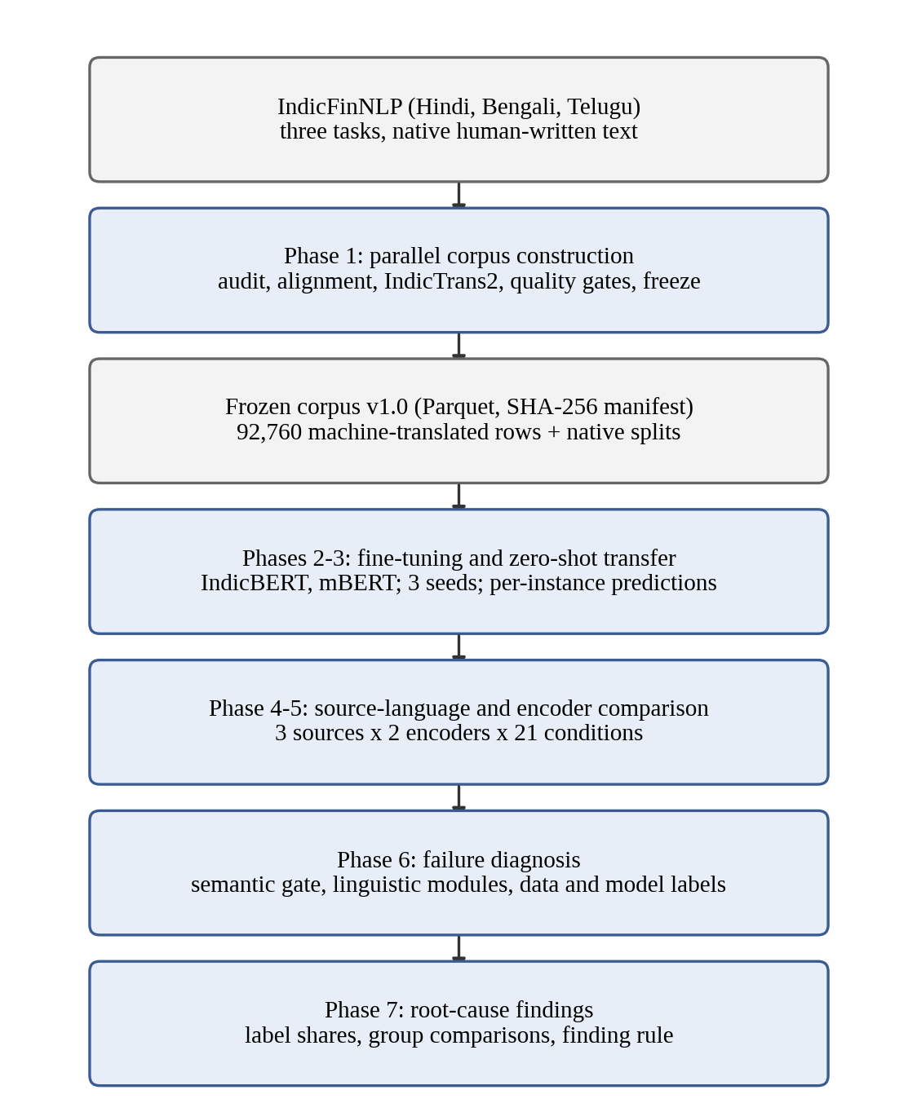
Figure 3.1: Overall architecture of the seven-phase pipeline
Three decisions apply to every phase. First, no row is ever removed from the corpus. A low similarity score, an empty output or a detected corruption is recorded as a flag on the row, so that translation failure stays a measured quantity instead of disappearing through a filter. Second, every script takes an explicit random seed, and two runs of the same configuration produce byte-identical output. Third, every artefact records a hash of the configuration that produced it.

3.2 DESIGN PRINCIPLES AND HARD RULES
The design is governed by a short list of rules fixed before implementation. Each protects a specific kind of silent error. Table 3.1 lists them with the failure they prevent.
Table 3.1: Hard rules of the corpus and the failure each one prevents
Rule | Failure it prevents
Never drop a row; flag it | Silent row loss that would corrupt every downstream result
Parquet only, never CSV for corpus data | Indic scripts and numerals breaking under CSV quoting
No pickle for corpus data | Unreadable or unsafe released artefacts
No English pivot | A second error source that makes drift attribution meaningless
No modification of the frozen release | Results that cannot be traced to fixed data
Labels come from one schema and are never remapped | Label drift between source and translated rows
Explicit seed on every script | Runs that cannot be reproduced
Configuration hash logged with every artefact | Artefacts that cannot be tied to the settings that made them
No Unicode normalisation of task 1 text without recomputing offsets | Silent corruption of character offsets

The last rule needs a word of explanation. Task 1 marks a number by character offsets into the raw string. Unicode normalisation to the NFC form decomposes precomposed nukta letters and composes Telugu vowel signs, so the text length changes while the text still looks correct. Normalising the upstream task 1 text would break 880 of its 22,786 annotated spans, and nothing visible would reveal it. For this reason normalisation is treated as corruption for task 1 and not as cleaning.

3.3 SOURCE DATA
The corpus starts from IndicFinNLP (Ghosh et al., 2024). The upstream files are kept byte for byte, with SHA-256 checksums recorded in a manifest, and are read once at the ingest boundary. Table 3.2 lists the three tasks.
Table 3.2: The three IndicFinNLP tasks and their native row counts
Task | Content | Type | Hindi | Bengali | Telugu
Task 1 | Numerals in financial text | Span annotation | 10,640 | 6,130 | 6,016
Task 2 | Sustainability sentences | Binary classification | 2,238 | 2,228 | 2,072
Task 3 | ESG news headlines | 10-class classification | 532 | 532 | 532

Task 1 has no class label. It marks a number inside a sentence with a start and an end offset, a scale marker, and the number written both in the source script and in ASCII digits. A task 1 item is therefore a sentence and span pair and not a sentence: a sentence containing three numbers appears three times. Tasks 2 and 3 are conventional classification sets. Task 2 uses the labels sustainable and unsustainable, and task 3 uses ten ESG themes.

3.4 MODULE 1: INDEPENDENCE AUDIT

3.4.1 Purpose
The comparison design assumes three independently written native splits. This module tests that assumption before anything is translated. If the splits are really the same sentences in shuffled order, then a model trained on one language and evaluated on another would be tested on its own training sentences.

3.4.2 Tests
A test that merely compares random cross-language pairs shows nothing, because random pairs from two corpora score low whether or not the corpora are parallel. The audit therefore rests on three tests, all computed with LaBSE embeddings.
- B3, structural. Row counts and class proportions are compared. Identical class shares across supposedly independent corpora indicate a shared source. Where a join key such as a URL exists, this test alone is decisive.
- B1, order-aligned. The cosine of each row pair (source row i, target row i) is compared with an index-shuffled control. It detects parallel data that kept its row order.
- B2, nearest neighbour. For each of 200 sampled source sentences, the maximum cosine similarity over the entire target split is computed. This test still fires when rows were shuffled or partially dropped, so it carries the finding.
Because a raw nearest-neighbour score is hard to read within one narrow domain, the audit also computes calibration controls. A positive control is a split known to be parallel, and negative controls are genuinely different texts from the same domain and language pair. The finding is valid only if the negative controls lie far below the threshold τ.
Algorithm 3.1: Independence test for two language splits
Input: source split S, target split R, sample size n = 200, threshold τ, seed
1. Embed every sentence of S and R with LaBSE; L2-normalise the vectors
2. Draw n sentences from S using the seed
3. For each drawn sentence s, compute m(s) = max over r in R of cos(s, r)
4. Report the median of m and the share of m(s) at or above τ
5. Repeat on the positive control and on each negative control
6. Declare the pair parallel only if the share at or above τ is far above the negative controls

3.5 MODULE 2: ITEM ALIGNMENT
The audit divides the tasks in two, and the second module handles the parallel half. Task 3 carries a URL column, so alignment is an exact join on that key and needs no model. Task 2 has no key, so alignment uses mutual nearest neighbours on LaBSE similarity above τ, and an item is kept only if the three language pairs agree. Mutual matching prevents ten source sentences from collapsing onto one target sentence, and three-way agreement means that each pair was reached by two independent routes. Algorithm 3.2 states the procedure.
Algorithm 3.2: Three-way alignment for task 2
Input: Hindi, Bengali and Telugu splits, threshold τ
1. For each language pair (a, b), compute the cosine matrix between the splits
2. Keep a pair (i, j) only if j is the nearest neighbour of i, i is the nearest neighbour of j, and cos(i, j) >= τ
3. Compose the pairwise maps: Hindi to Bengali to Telugu, and Hindi to Telugu directly
4. Keep an item only if both routes agree on every language
5. Assign a content-derived item identifier to the aligned item
6. Keep every unaligned row in its own split with an unaligned flag
7. Fail the run if any aligned item carries conflicting labels

Rows that do not align are reported and kept. A conflicting label is a hard failure, because the corpus cannot carry a single gold label for an item whose languages disagree. Task 1 is independently sourced, and the alignment module refuses to run on it: aligning it would invent a correspondence that does not exist.

3.6 MODULE 3: IDENTIFIERS, LABELS AND STORAGE
Every corpus Parquet file has the same columns, with the task carried by the file path. Table 3.3 lists them. The pair of block identifier and item identifier, together with the language, forms the primary key.
Table 3.3: Canonical row schema
Column | Type | Meaning
block_id | string | H, B or T: the block whose native split the item comes from
item_id | string | Content-derived key; the join key across languages
lang | string | hin, ben, tel or mal
origin | string | native or mt
src_lang | string | Source language of a translation; null for native rows
text | string | The sentence
label, label_id | string, integer | Gold label and its canonical index (tasks 2 and 3)
labse_sim | float | Cosine similarity with the source; null for native rows
flags | list of strings | Quality flags such as translation_drift or entity_loss

The item identifier is derived from content, never from row position. A positional identifier would silently point at a different item if the upstream files were reordered. Because a task 1 item is a sentence and span pair, its identifier includes the span. Exact duplicate rows receive an occurrence suffix, so that the four exact duplicates in task 2 stay distinct and none is dropped. Task 1 uses the same columns with the label columns replaced by the number as written, the number in ASCII digits, the start and end offsets, the scale marker and a flag that records whether the span was recovered after translation.
All reads and writes pass through one input and output module, which enforces the format, the schema and the label set. A loader raises an error on any label outside the schema and on any label identifier that disagrees with it; it never coerces or skips.

3.7 MODULE 4: TRANSLATION

3.7.1 Block design
Each task is built as three blocks, one per native language. Within a block the native split is translated into the other three languages, which gives nine translation directions and twelve splits per task (Figure 3.2). All splits within a block share item identifiers and gold labels. IndicFinNLP has no Malayalam, so Malayalam exists only as machine translation, once per block. This is a documented limitation and no attempt is made to synthesise a native version.
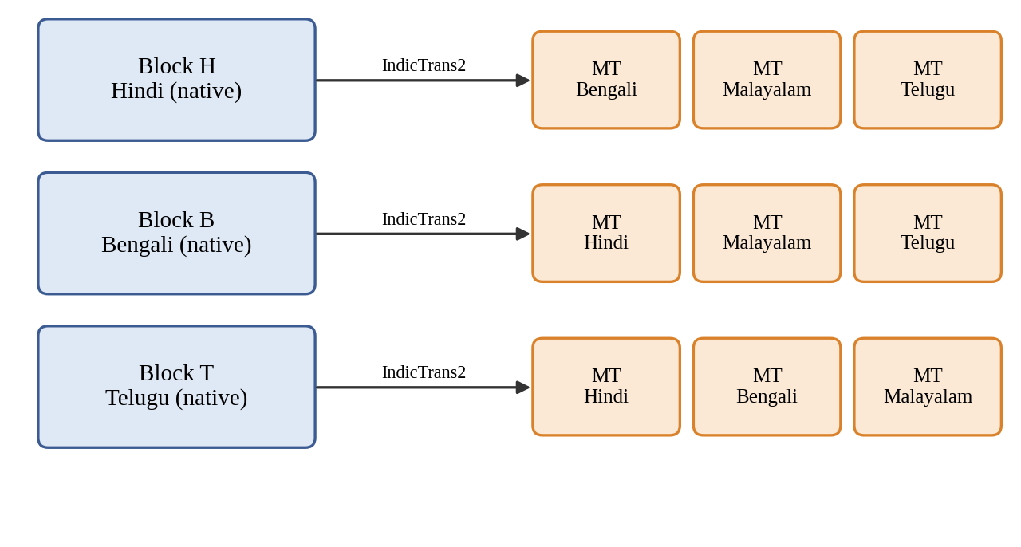
Figure 3.2: The three translation blocks and nine directions of each task

3.7.2 Translation model and decoding
Translation uses the 1B-parameter Indic-to-Indic IndicTrans2 checkpoint directly, with no English pivot. One decoding configuration is applied to all nine directions, so that drift figures are comparable: five beams, a maximum length of 256 tokens, no sampling. A decoding fingerprint, a hash of everything that can change the output text, is logged with every artefact. Batch size is deliberately left out of the fingerprint because it must not affect the output, and any dependence on it would be a defect worth catching.
The 1B model was preferred over the 320M distilled variant on measured evidence. On a 180-row sample of task 1 the smaller model was eight times faster but corrupted 10.0 percent of rows, against 4.4 percent for the larger one. A digit-preservation score had suggested the opposite, because it asks whether numbers survived and not whether the sentence came out intact.
Identical source sentences are translated once and the result is shared. In task 1 a sentence with three numbers forms three items. Translating each separately would cost up to three times as much and could yield three different translations of one sentence, differing only in which number was annotated. Sharing reduces task 1 from 68,358 translations to 40,401.

3.7.3 Recovering numeral spans
The offsets of a task 1 numeral index the source string and are meaningless after translation. The span recovery module locates the annotated numeral in the translation by value, not by digit string, and records whether it succeeded. A number rewritten as an equivalent quantity, for example one hundred million as ten crore, leaves no digit token to point at but has lost nothing; it is recorded as a scale shift, separate from a number that was genuinely dropped. A failure to recover a span is flagged and the row is kept. The failure rate is a headline result of the project, not an error to be repaired.

3.8 MODULE 5: TRANSLATION QUALITY GATES
Three automatic checks are applied to every translated row. Each detects failures that the other two cannot, and Figure 3.3 shows where they sit in the construction sequence.
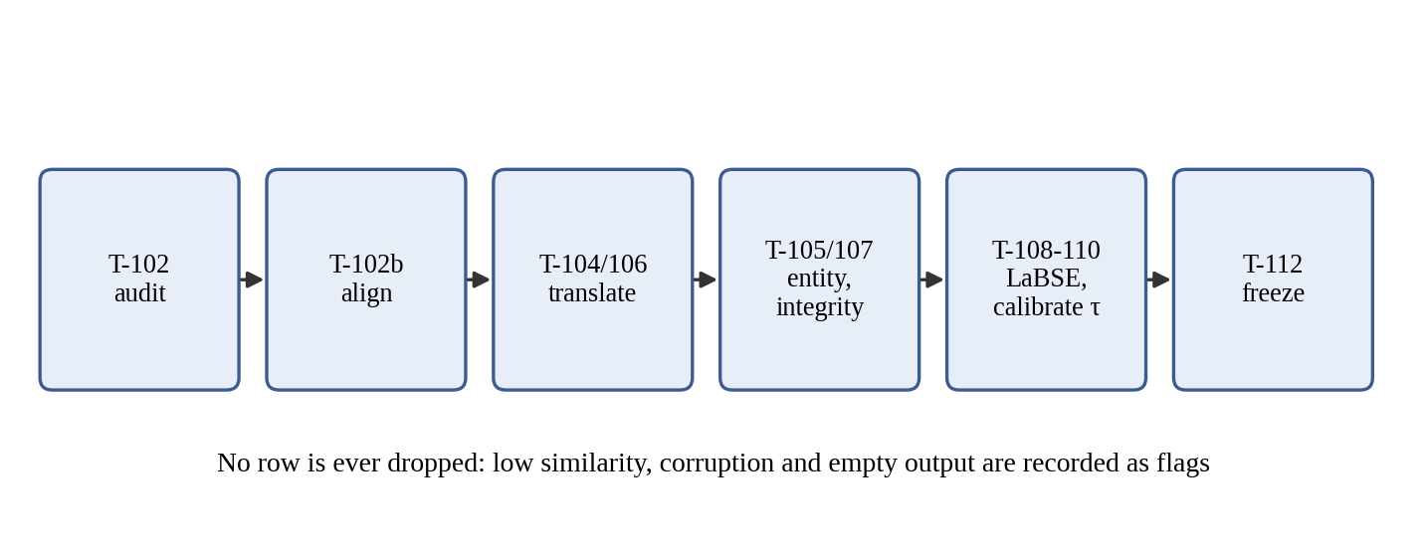
Figure 3.3: Corpus construction sequence and quality gates

3.8.1 Numeral and entity preservation
Numerals, currency symbols, percentages and lakh or crore scale terms are compared by value across digit systems. Two traps had to be handled. First, scale words: 100 million and 10 crore both equal 10 to the power 8, so both sides are normalised to a number with its scale applied before comparison. Second, thousands separators: a comma is a separator only when exactly three digits follow it, so that a date such as 22, 2019 reads as two numbers and not as 22,2019. Rows that carry a corruption of the kind described in Chapter 4 are excluded from the preservation rate, so that their loss is not attributed to numeral handling. A direction whose preservation rate falls below 95 percent is flagged.

3.8.2 Structural integrity
Blocking checks require that every block joins four ways on the item identifier, that every translated row carries its source row's label, and that native text contains no replacement characters. Any failure stops the pipeline. Non-blocking checks flag script leakage, which means characters from another Indic script, excluding the shared danda punctuation; two corruption modes observed in IndicTrans2 output, namely unrestored entity placeholders and nukta characters emitted as literal escape strings; and suspected truncation. Truncation is judged per direction, at half of that direction's own median length ratio, because Malayalam output runs about ten percent longer than its Hindi source while Bengali runs about four percent shorter, so no single global ratio can work. A leak is counted only when the source text is clean, otherwise a source that genuinely contains angle brackets would be reported as corrupted.

3.8.3 Semantic similarity
Source and translation are embedded with LaBSE and compared by cosine similarity over all 92,760 pairs, with no sampling:
sim(x, y) = (e(x) · e(y)) / (||e(x)|| ||e(y)||) (3.1)
where e(·) is the LaBSE embedding. A pair with similarity below the threshold τ receives the flag translation_drift and stays in the corpus. For tasks 2 and 3 the native split in the target language is a human translation of the same item, and a human translation is a known-good pair. The threshold can therefore be calibrated: it should accept nearly all human pairs. The calibrated values are reported in Chapter 5. For task 1, and for every Malayalam target, no human reference exists, and the report says so wherever it applies.

3.9 MODULE 6: FREEZE AND DATASHEET
When a task passes its checks, its twelve splits are copied into a release directory, hashed file by file into a manifest, and made read-only. The manifest records what produced the bytes as well as the bytes themselves: the translation model, the decoding fingerprint, the similarity model and the threshold. A verification function fails if a file is modified, deleted or added. The release datasheet is generated from the frozen manifests and the reports and is never typed by hand, so that it cannot drift from the data. A check mode fails if the committed datasheet no longer matches the artefacts.

3.10 MODULE 7: EVALUATION-CONDITION MATRIX
Which splits may act as training source, evaluation target or neither is fixed in one configuration file before any model is trained. For each of tasks 2 and 3 the matrix has 21 conditions: nine transfer cells, one for each of the three source languages paired with each of the three other languages (the other two native languages and Malayalam); the same nine cells evaluated on machine-translated target text from the source's own block; and three translationese conditions that hold the language fixed and vary only provenance. For Hindi these are native text, text translated from Bengali and text translated from Telugu. The transfer cells fall into four typological quadrants: Indo-Aryan to Indo-Aryan, Indo-Aryan to Dravidian, Dravidian to Indo-Aryan and Dravidian to Dravidian.
Two protections are enforced. At split level, no split is both a training source and an evaluation target within a condition. At item level, the training and evaluation item sets are disjoint, and the items are partitioned by a seeded hash of the item identifier and not by position. Hashing makes the partition a property of the item, so every language agrees on it without coordination. Evaluation prefers native text, so that a failure reflects transfer and not translation. Malayalam has no native text, so its evaluation data is always machine-translated, taken from a block other than the one trained on, and its provenance is recorded with each result.

3.11 MODULE 8: TRAINING AND ZERO-SHOT EVALUATION

3.11.1 Model
Each classifier is a pre-trained encoder with a single linear classification head on the [CLS] representation, trained with cross-entropy loss (Figure 3.4). The design is deliberately minimal, so that any difference between runs can be attributed to the encoder or the language and not to the head. Two encoders are compared, IndicBERT (Kakwani et al., 2020) and cased multilingual BERT (Pires et al., 2019). XLM-R (Conneau et al., 2020) was planned as a third, and it is discussed in Chapter 5.
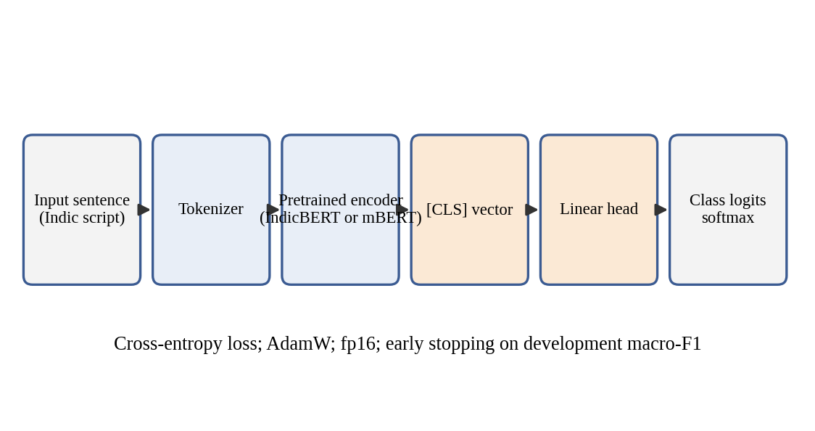
Figure 3.4: Classifier architecture used for every source language and encoder

3.11.2 Training rules
Training uses native, human-written text only, so that no transfer measurement is contaminated by the project's own translations. Every configuration is run with three seeds and reported as mean and standard deviation. Every source model is first checked against IndicFinNLP's published in-language macro-F1 with a tolerance of 0.02, and a shortfall must be diagnosed before any transfer result is read. This ensures that a large gap cannot be an artefact of a badly trained source model.

3.11.3 Zero-shot evaluation
Evaluation is strictly zero-shot. Checkpoints are loaded read-only, and the inference path asserts that no optimiser exists and no gradient step is taken. Every prediction is logged per instance with the item, the gold label, the predicted label and the class probabilities. Macro-F1 is primary, with accuracy and per-class F1 beside it, and 95 percent confidence intervals come from a 1,000-sample bootstrap over items. The transfer gap from source s to target t follows XTREME (Hu et al., 2020):
Gap(s → t) = F1(s on s items) − F1(s on t items) (3.2)
computed on the same underlying items wherever the alignment allows. A gap smaller than its own seed standard deviation is not reported as a finding.

3.12 MODULE 9: FAILURE DIAGNOSTIC ROUTER
A transfer failure is an item that the model classified correctly in the source language and incorrectly in the target language:
Fail(i) = 1[ ŷ_src(i) = y(i) ] · 1[ ŷ_tgt(i) ≠ y(i) ] (3.3)
Predictions are joined on the pair of item and seed, so a source prediction is never paired with a target prediction from a different seed. Because the model answered this exact item correctly in the source language, lack of task ability and item difficulty are ruled out by construction.
Each failure receives exactly one cause label from an ordered router, with an audit trail of every module that fired (Figure 3.5).
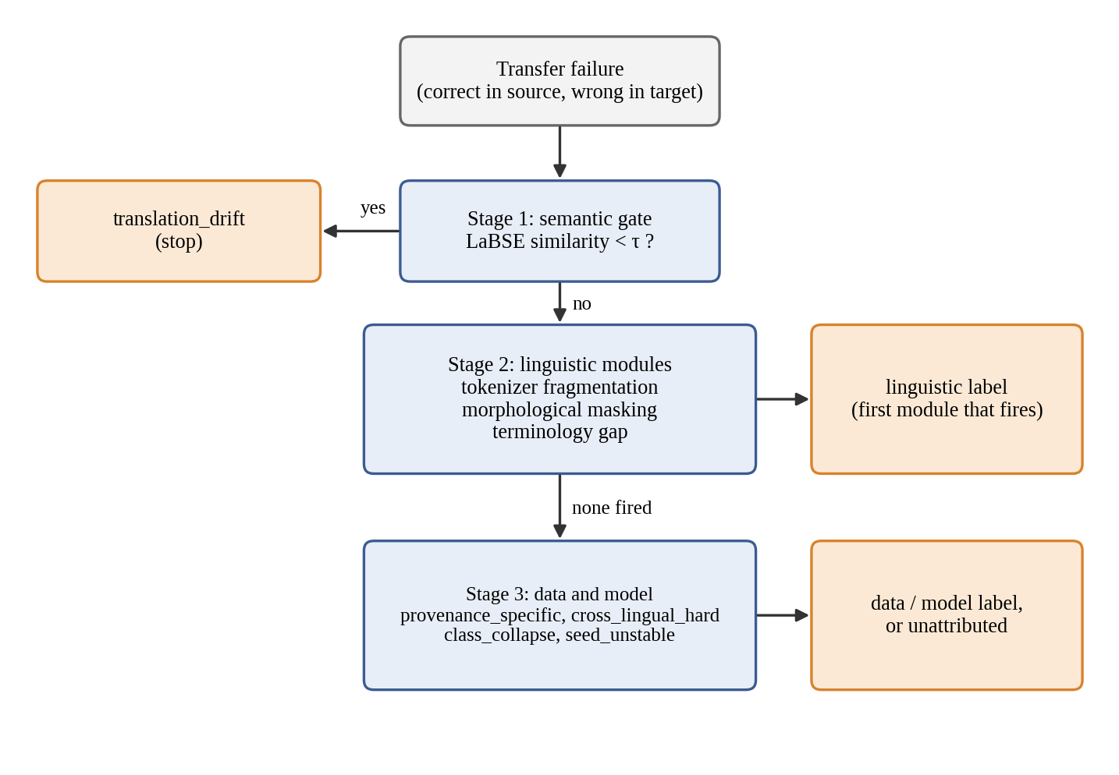
Figure 3.5: Three-stage diagnostic router

3.12.1 Stage 1: semantic gate
If the LaBSE similarity between the source text and the target text is below τ, the failure is labelled translation_drift and goes no further. The order matters. If the linguistic modules ran first, noise from the project's own translations would be blamed on tokenisation or morphology. The gate reuses the corpus similarity module without modification.

3.12.2 Stage 2: linguistic modules
The remaining failures are tested against three modules about the target text.
- Tokenizer fragmentation measures how much more finely the encoder's own tokenizer splits the target text than the source text:
R_frag = (number of target tokens) / (number of source tokens) (3.4)
and fires when R_frag is 2.0 or more.
- Morphological masking fires when a financial term from an 18-concept ESG lexicon appears in the target only inside an inflected form whose root is hidden by bound morphology. Stems come from the Indic NLP Library's morphological analyser, with rule-based suffix stripping where no analyser exists. A stem matches only exactly, with its final code point dropped, or with one added vowel sign.
- Terminology gap fires when Integrated Gradients attributions, computed against a zero-embedding baseline, diverge between the source item and its target counterpart. The threshold is set per task and encoder at the 95th percentile of divergence on pairs the model classified correctly in both languages. An attribution whose completeness error exceeds 5 percent is marked unconverged and never fires.
A fourth module, on orthographic and numeral mismatch, was planned and dropped. A digit audit showed that items whose digit system differs between native and machine-translated text fail at or below the base rate, so a label from that module would have been spurious.

3.12.3 Stage 3: data and model behaviour
Stage 3 claims only what the first two stages leave unattributed. It describes a failure by the item or the model and not by the target sentence. Four labels are used:
- provenance_specific: the same item and seed is correct on the twin target of the other provenance;
- cross_lingual_hard: the item fails in all three targets of the same source;
- class_collapse: the run predicts one class for at least 75 percent of the condition's rows, and the failure is that class;
- seed_unstable: another seed classified the item correctly.
The precedence is fixed as translation_drift, tokenizer_fragmentation, morphological_masking, terminology_gap, provenance_specific, cross_lingual_hard, class_collapse, seed_unstable and unattributed. Each label belongs to one of four groups: linguistic, data, model or unattributed. The unattributed share is reported as an outcome and is not hidden.
Algorithm 3.3: Diagnostic router for one transfer failure
Input: failed item i with seed k, source text, target text, encoder, threshold τ
1. If cos(source, target) < τ, return translation_drift
2. Compute R_frag with the encoder tokenizer; if R_frag >= 2.0, record tokenizer_fragmentation
3. Test morphological masking against the ESG lexicon and record it if it fires
4. Compute Integrated Gradients divergence; if converged and above the cell threshold, record terminology_gap
5. If any Stage 2 module fired, return the first in precedence order
6. Test provenance_specific, cross_lingual_hard, class_collapse, seed_unstable in that order
7. If none fired, return unattributed
8. Always store the audit trail of every module that fired

3.13 MODULE 10: AGGREGATION AND FINDING RULE
The unit of analysis is a failed (item, seed) row, and a group's share of a label is the fraction of that group's failures that carry it. Shares therefore describe what failures consist of. Labels are not compared against correct predictions, so a share does not show that a property makes failure more likely. Each share carries a 95 percent bootstrap interval that resamples (condition, item) clusters, so an item that fails on all three seeds counts once. Groups are compared by target direction, source language, encoder and text provenance.
A difference counts as a finding only if the two intervals do not overlap and the difference points the same way on both encoders (on both tasks, for the encoder comparison). This rule was fixed before any result table was read. Every comparison is repeated without the source runs that never trained. A difference that a known measurement limit could produce by itself is reported with that caveat attached. For example, Hindi targets can never receive the morphological label, because Hindi writes postpositions as separate words.

3.14 DESIGN FOR LIMITED HARDWARE
All experiments ran on one laptop GPU with 4 GB of memory, and the design reflects it. Every GPU job checkpoints after each batch and resumes by item key. Translation batches are halved and retried on out-of-memory errors. A batch that exceeds a time limit is treated like an out-of-memory error, so one stalled batch cannot consume a night's run. Jobs refuse to fall back silently to the CPU, because CPU arithmetic in 32-bit floats yields different translations from the GPU's 16-bit arithmetic, and a corpus generated half on each would not be comparable while looking normal.

CHAPTER 4
IMPLEMENTATION

4.1 DEVELOPMENT ENVIRONMENT
The project is written in Python 3.11, and every entry point asserts the interpreter version and fails loudly on a mismatch. It runs on Linux or WSL2, because the IndicTrans2 toolkit is not built or tested for Windows. Table 4.1 lists the main components and the reason for each choice.
Table 4.1: Software and hardware environment
Component | Choice | Reason
Language | Python 3.11 | Required by the toolkit; asserted at entry
Translation | ai4bharat/indictrans2-indic-indic-1B | Direct Indic-to-Indic, no English pivot
Similarity | sentence-transformers/LaBSE | Language-agnostic sentence embeddings
Encoders | ai4bharat/indic-bert, bert-base-multilingual-cased | The two encoders compared
Libraries | transformers 4.57.6, sentence-transformers 5.7.0 | transformers must stay below version 5
Storage | Parquet (pyarrow), JSON configs | Safe for Indic scripts and numerals
GPU | NVIDIA RTX 3050 Laptop, 4 GB | The only device available
Dashboard | Streamlit | Read-only exploration of results

4.1.1 The transformers version pin
IndicTrans2 checkpoints ship their own modelling code, loaded with remote-code trust and written against the 4.x series of the transformers library. Version 5 breaks it in three places: a removed ONNX module imported by the configuration file, a moved tokenizer base class imported by the toolkit, and a tokenizer that assigns an attribute before initialising its parent class. The first two can be shimmed, but the third cannot be fixed without patching private internals of a class loaded from remote code, which would not be reproducible. The library is therefore pinned below version 5, and the pin was checked not to change the similarity model's output: after the downgrade, the task 2 alignment reproduced bit for bit.
The checkpoint's modelling code also reads the first element of the past key values on every decoding step. Modern versions pass a cache object that is empty at the first step, so the cache must be switched off in the decoding configuration. This costs decoding speed and is a correctness requirement and not a tuning option.

4.2 REPOSITORY ORGANISATION
The corpus modules are kept flat in one source directory, with one thin command-line script per task, named by task identifier. Table 4.2 lists the modules and what each does.
Table 4.2: Principal source modules
Module | Responsibility
corpus_io | Every read and write of corpus data; format, schema and label enforcement
ids | Content-derived key construction, block mapping, join helpers
audit, align | Independence audit and item alignment
translate | IndicTrans2 wrapper with resumable, adaptive batching
spans | Re-location of task 1 numerals in translated text
entities | Scale-aware numeral, currency and percentage comparison
generate | Native split plus translations to canonical machine-translated rows
integrity | Structural, leakage and corruption checks
labse_gate | Embedding, cosine similarity, thresholding
freeze, datasheet | Hashing, manifest, immutability, generated datasheet
conditions | Evaluation-condition matrix and validator
data, config, train | Encoder registry, hashed YAML configuration, fine-tuning loop
inference, predictions, metrics | Read-only evaluation, per-instance logs, macro-F1 and bootstrap
transfer, mismatch, failures | Transfer gap, failure extraction
diagnostics, fragmentation, morphology, saliency, behaviour | The router and its modules
findings | Phase 7 aggregation and the finding rule

No module other than the input and output module reads or writes corpus Parquet files directly. This is how the format and label rules are enforced in one place and not copied into every script. Everything is run as a module from the repository root so that path resolution anchors to the root.

4.3 CORPUS CONSTRUCTION

4.3.1 Ingest and the input/output layer
The upstream spreadsheets are read once and converted to Parquet. The loader refuses an unknown label and refuses a label identifier that disagrees with the schema. A round-trip test writes and reads a fixture containing Malayalam text, Telugu digits, a currency symbol and a lakh or crore expression, and compares it byte for byte. Unaligned rows are ingested with a block-local identifier and an unaligned flag, so that they stay in the corpus while remaining visibly outside the parallel set. The native splits hold 22,786, 6,538 and 1,596 rows for the three tasks, and none was dropped.

4.3.2 Translation wrapper
The translation module wraps the model with the toolkit's pre- and post-processing. The model is loaded once and reused across directions, because loading a 4.8 GB model nine times is wasteful, and on a 4 GB card it caused an out-of-memory error on the second load. After each direction the allocator is freed, since activations are released but their blocks are not returned, so each direction would otherwise start with less memory than the last.
A fixed batch size cannot work on this card. Task 1's Telugu split has 280 rows longer than 1,000 characters against a median of 117, so a batch sized for a typical row fails on the rare long one. Beam search holds beam times batch times vocabulary logits in 32-bit floats, and that allocation fails first. The adaptive translation routine therefore halves the batch on an out-of-memory error and retries, down to a single row, and re-raises only if one row alone cannot fit. Order is preserved. The memory allocator is set to use expandable segments before the deep learning library is first imported, because otherwise beam search fails on fragmentation and not on genuine exhaustion.
Every run writes a checkpoint after each batch, keyed by item identifier, so an interrupted run resumes instead of restarting. A failed batch is flagged and the run continues; an empty output is flagged and never dropped.

4.3.3 Generation of the nine directions
The generation module turns a native split and its translations into canonical rows. It enforces row-count parity with the source, identical item identifiers and labels, and a flag on every empty translation, and it raises an error and does not merely report if any of these fails. Tasks were generated in ascending order of cost, task 3 first, so that the whole path was proven end to end in under two hours before a day of GPU time was committed to task 1. Table 4.3 gives the volumes.
Table 4.3: Machine-translated rows generated per task
Task | Rows to translate | Distinct sentences | Approx. GPU time
Task 1 | 68,358 | 40,401 | About 14 hours
Task 2 | 19,614 | 19,602 | Estimated 3 to 7 hours
Task 3 | 4,788 | 4,788 | 37 minutes

4.3.4 Span recovery and entity comparison
The span module matches a numeral by value and not by string. A Bengali digit string, an ASCII string and a grouped number such as 25,000 are all found, and 22, 2019 reads as two numbers. A list of numbers loses the spaces that separated it when translated, so 145, 146, 150 can emerge as 145,146,150. The comma is then re-read as a separator, but only when the quantity did not move: in 50 thousand rewritten as 50, 000 the digits belong to the rescaled number, and a span on the leading 50 would point at the wrong characters while claiming success. This rule recovered 255 further rows.
The entity module compares numerals, currency and percentages after normalising both sides to a value with its scale applied. It was validated against real output and not only against fixtures. The first version reported 68 to 94 percent preservation, and inspecting the flagged rows found three bugs in the checker and none in the model: a space after the comma that parsed 50, 000 as 50 and 0; a corruption mode transliterated into the target script that only two of four script forms were matched for; and currency compared as a literal symbol, so the rupee sign against its Telugu form read as a loss. After the fixes, the altered counts fell from 6 to 8 per direction to 0 to 1 on the test sample. The test fixtures include seven pairs that must compare equal, because a checker that reports loss that has not occurred is the failure to avoid.

4.4 TRANSLATION CORRUPTION MODES
Two silent corruption modes in IndicTrans2 output were found during implementation. Both destroy content while leaving fluent text, so neither is visible without an explicit check.
The first is entity placeholder leakage. The pre-processor replaces entities with placeholders such as an identifier tag and restores them after decoding. The model sometimes translates the placeholder text itself, for example into the Bengali or Malayalam rendering of the letters ID, so restoration cannot match it and the real content is lost. It can also swallow a numeric range. The second is escape leakage. A nukta character, such as the Bengali letter with code point U+09BC, can be emitted as the literal escape string u09bc, transliterated into the target script. In the first sample all eight affected rows had a nukta in the source and no row without one leaked. Over the full corpus, 607 of task 1's 734 escape leaks come from Bengali source, with 106 from Hindi source and 21 from Telugu source, so the pattern is dominated by Bengali but is not Bengali only.
The first estimate of the corruption rate, about one percent, was wrong. It used a detector covering two of the four target scripts, and a corrected detector measured 3.2 percent over the 900 rows of the translation smoke samples, with every target language affected. This episode is the reason that the checkers are validated against real output.

4.5 THE QUALITY GATES

4.5.1 Structural integrity
The integrity module splits its checks into two tiers. Blocking checks cover a block that stops joining four ways, a translated label that drifted from its source, and a replacement character in native text. These mean that the corpus makes a false claim about a row, so they fail the run. Findings cover leakage, corruption and suspected truncation. They measure the translation and not the corpus, so their rows are kept and they do not fail the run unless a strict mode is requested. The module can write its flags into the corpus idempotently: its own flags are stripped before being re-derived, so running it twice gives the same result as running it once. This was verified by running it twice and comparing every flag list.

4.5.2 Similarity scoring
Embeddings are L2-normalised at encode time, so cosine similarity is a dot product and nothing downstream needs to remember to normalise. They are cached per split, keyed by row count as well as path. A split regenerated with a different number of rows must not silently reuse vectors that belong to other sentences, which would attach every score to the wrong pair while looking healthy. A second similarity is computed for tasks 2 and 3: the translation scored against the native human translation in the same language, which is the basis of the calibration in Chapter 5.

4.5.3 Drift flags, ranking and freeze
Below-threshold rows receive the translation_drift flag and remain in the corpus; the flag is stripped and re-derived on each run so that changing τ leaves no stale flags. Directions are ranked by the mean of each measure's rank and not by a weighted sum, because a drift rate and a numeral-preservation rate share no scale, and inventing weights would manufacture precision the data cannot support. The freeze step records the per-task τ in each manifest. A bug found while generating the datasheet showed that the global τ had been written into every manifest, so that task 3's manifest recorded 0.82 while its drift flags had been derived at 0.73. This was fixed and task 3 was re-frozen.

4.6 RESUME AND DETERMINISM PROBLEMS FOUND AND FIXED
Four defects in the long-running jobs deserve record because each could have corrupted the corpus without any visible sign.
- A resume bug. Flags written to a checkpoint come back from Parquet as a numpy array and not as a list, and the translation routine treated anything that was not a list or tuple as a failed row. Every resumed row was stamped empty_output while its text sat there intact, which affected 700 of task 3's 4,788 rows. The run summary showed nothing wrong, because it counted empties from the text. A direct look at the flag column disagreed. The empty flag is now derived from the translation itself, so it holds by construction, and a regression test resumes a fully checkpointed direction and asserts that no row comes back flagged. A rebuild option re-derives the splits from existing checkpoints without loading any model, which repaired the 700 rows without touching the GPU.
- A silent CPU fallback. After a stalled run was killed, the driver entered a state in which the GPU was reported as unavailable in a new process, and the resumed direction carried on translating on the CPU. Float32 arithmetic gives different wording from float16, so a corpus generated partly on each is not comparable within one decoding fingerprint. Two of 654 sentences regenerated on the card came back different from their CPU-produced versions; the other 652 were byte-identical across processes. The translator now refuses to select the CPU automatically, and the device is recorded in the run manifest.
- A stalled batch. One batch of eight ordinary sentences stayed in the beam-search loop for 47 minutes with the GPU idle and the checkpoint untouched. Each batch now runs under a deadline, and a stall is treated like an out-of-memory error: halve, retry and isolate. A single row that still overruns is skipped, flagged and reported, and its seven neighbours keep their translations.
- A report overwrite. A run restricted to one direction used to overwrite the whole task's report with its own single row. The report now merges by direction, and only within one decoding fingerprint.

4.7 TRAINING IMPLEMENTATION

4.7.1 Configuration and registry
Every training run is described by a YAML file that is hashed, and the hash is logged with the output. A model registry maps encoder names to checkpoints and tokenizers, so adding a source language or an encoder is a configuration change and not a code change. This was tested by the source-language comparison, which added two source languages without code changes. A consistency guard compares each new configuration against the same-encoder Hindi configuration, so that a difference in the training recipe cannot be mistaken for a difference between languages. The hyperparameters are in Table 4.4.
Table 4.4: Fine-tuning configuration
Setting | Task 2 | Task 3
Maximum sequence length | 192 | 64
Batch size × accumulation | 16 × 1 (mBERT 8 × 2) | 16 × 1
Optimiser | AdamW | AdamW
Learning rate | 2 × 10^-5 | 3 × 10^-5
Weight decay | 0.01 | 0.01
Warm-up | 10% of steps | 10% of steps
Maximum epochs, early-stopping patience | 20, 5 | 40, 8
Development, test fraction | 0.10, 0.10 | 0.15, 0.15
Precision | fp16 mixed | fp16 mixed
Seeds | 3 | 3

mBERT on task 2 uses micro-batches of 8 with two-step gradient accumulation, forced by GPU memory. This keeps the effective batch at 16 and leaves the gradient unchanged, because the loss is a mean.

4.7.2 Memory budgeting
A budgeting script measured the largest batch that survives a forward pass, backward pass and optimiser step for each encoder. The fixed cost of full-precision weights, gradients and the two AdamW moment buffers is 16 bytes per parameter, independent of batch size and sequence length. Table 4.5 gives the result. XLM-R base needs 4.14 GiB for this fixed cost alone against 3.68 GiB of usable device memory, so it cannot be fine-tuned at any batch size. An adapter-based workaround was evaluated and rejected, because it would confound the pretraining-only comparison that the encoder study exists to make. XLM-R's configuration is retained for a future run on larger hardware.
Table 4.5: Memory budget per encoder at maximum length 128 with fp16
Encoder | Maximum batch | Peak (GiB) | Fixed cost (GiB) | Note
IndicBERT | 64 | 3.04 | 0.50 | Fits
mBERT | 48 | 3.32 | 2.65 | Fits
XLM-R base | 0 | not run | 4.14 | Does not fit at any batch size

4.7.3 Convergence check
Three of the nine IndicBERT runs on task 3 never fit their training data. Their test scores look like a healthy run's on a task at its data ceiling, so convergence is judged on the training fold: a run whose peak training macro-F1 stays below 0.5 is marked as not trained. Such runs stay in all all-seeds figures, and the source comparison excludes them, because a model that never moved from its initialisation scores equally badly at home and abroad, and so shows a near-zero transfer gap that ranks it as the best source.

4.7.4 Inference and logging
The inference path loads a checkpoint read-only and asserts that no optimiser is attached and no gradient step is taken. Each prediction is logged with the item identifier, seed, gold label, predicted label and class probabilities. A mismatch module flags instances that are correct in the source language and wrong in the target, and a failure module exports them as the input contract of the diagnostic phase.

4.8 DIAGNOSTIC IMPLEMENTATION
The router reuses the corpus similarity module for its gate and produces both a label file and a per-module audit trail. The fragmentation module counts tokens with the encoder's own tokenizer. The morphology module uses a documented fallback ladder because no Universal Dependencies treebank exists for Malayalam. The first fuzzy-match rule, an edit distance of two, produced 96 percent false hits, since short stems such as the one for water matched ordinary two-letter stems. It was replaced by the strict stem-match rule of Chapter 3, which reduced morphological masking labels from 10,642 to 2,484, between 2.0 and 7.8 percent of failures per cell. The saliency module calculates Integrated Gradients against a zero-embedding baseline with a completeness check. Two cells needed 800 integration steps to converge, and one cell, IndicBERT on task 3, remained at 8.2 percent unconverged, above the 5 percent limit, which is recorded as open. The divergence thresholds were set per cell at the 95th percentile on correctly handled pairs: 0.038 for task 2 IndicBERT, 0.047 for task 2 mBERT, 0.085 for task 3 IndicBERT and 0.078 for task 3 mBERT.
The behaviour module implements the four data and model labels of Stage 3. Before it was added, 88 to 91 percent of failures were unattributed. After it, unattributed fell to 9.2, 19.7, 11.8 and 14.4 percent for the four combinations of task and encoder. The aggregation phase counts the labels and changes none of them; its report is generated from the artefacts with a check mode, as the datasheet is, and a re-run is byte-identical.

4.9 USER INTERFACE: RESULTS DASHBOARD
A Streamlit dashboard lets a reader explore the results without a GPU. It has three pages, switched by task in the sidebar. The transfer page shows one heatmap of transfer gaps per model. The causes page shows what each setup's failures are made of, on native or machine-translated text, by group or by individual label. The explorer shows one failed sentence at a time, with the source and target text, every seed's prediction on both models, the cause label and the result of every check behind it. It only reads artefacts that already exist and loads no model.

4.10 REPRODUCIBILITY MEASURES
All corpus data is stored as Parquet. Two runs of one configuration produce byte-identical output, and every artefact records its configuration hash. The upstream data are committed with SHA-256 checksums, the release is read-only with a manifest, and the translation environment is pinned. Long jobs are meant to be run by a person and are built to checkpoint and resume, not to be left unattended, because each takes hours and depends on intermittent GPU access.

CHAPTER 5
RESULTS AND DISCUSSION

5.1 INTRODUCTION
This chapter reports what was tested and what was found. It begins with the testing strategy and the metrics, then presents corpus quality, the in-language baselines, zero-shot transfer, the comparisons across encoders, source languages and directions, and the attribution of failures. Validation, comparison with published figures, discussion and limitations follow. Unless stated otherwise, figures are means over three seeds with their standard deviation, and the metric is macro-F1.

5.2 TESTING STRATEGY
Every source module ships with automated tests, and a task is marked done only when its acceptance criteria pass as a check and not by inspection. Table 5.1 lists the main test groups and what each one asserts.
Table 5.1: Automated tests by module
Module | Tests | What is asserted
entities | 32 | At least five positive and five negative fixtures per check; equivalent quantities across scale words and scripts compare equal; corrupted rows are not reported as numeral loss
spans, generate | 33 | A recovered span slices the number out of the translation; 22, 2019 reads as two numbers; every source row yields one translated row with the same identifier and label; row loss, reordering and an unflagged empty translation are refused
integrity | 15 | A deliberately script-leaked fixture is caught; the danda is not leakage; a leak counts only when the source is clean; flags written twice equal flags written once
labse_gate | 7 | Known-similar and known-dissimilar pairs fall on the expected side of τ, tested on the real model
freeze | 7 | The manifest verifies; a modified, a deleted and an unexpected extra file each fail verification
conditions | 9 | No split is both training source and evaluation target; training and evaluation items are disjoint
datasheet | 11 | Figures are read back from artefacts; stated limitations stay stated; the check mode detects staleness
findings | 20 | Phase 7 shares reconcile row for row with the failure files
Phase 6 modules | 68 | Router, fragmentation, morphology and saliency (fast tests, CPU only)

The Phase 6 fast tests do not download models, and nine slow tests that need real encoders, the Indic morphology library or a GPU were not part of that run. In a scratch environment running Python 3.13 instead of the required 3.11, the whole suite gave 533 passed, 19 failed and 21 errors. All of these were traced to the scratch environment (missing packages, an offline model hub and the wrong interpreter version), none was in Phase 6 code, and the suite was not re-run in the project's own environment. [TO FILL: re-run the full suite in the Python 3.11 environment and insert the pass count.]

5.3 EVALUATION METRICS
- Macro-F1 is the primary classification metric. Accuracy and per-class F1 are reported alongside it.
- Transfer gap is the source in-language macro-F1 minus the target macro-F1, computed on the same items (Equation 3.2). Because most evaluated items are the target-language versions of sentences that the source model saw in training, the in-language term is a training-text ceiling and not a held-out estimate. The gap therefore measures what changing the language costs with sentence difficulty held constant. It is not a measure of generalisation to unseen content.
- Confidence intervals are 95 percent intervals from a 1,000-sample bootstrap over items, computed per seed.
- Corpus quality measures are the entity preservation rate, the LaBSE similarity and the share of rows below τ, the counts of each integrity finding, and for task 1 the span recovery rate.
- Failure share is the fraction of a group's failures that carry a label, with a cluster bootstrap interval.

5.4 CORPUS QUALITY

5.4.1 Structural results
All three corpora pass every blocking check. Each block joins four ways, with 10,640, 6,130 and 6,016 items for task 1, 2,238, 2,228 and 2,072 for task 2, and 532 for each block of task 3. No translated row carries a label different from its source's, and no translation came back empty. Table 5.2 summarises the non-blocking findings.
Table 5.2: Translation quality by task
Measure | Task 1 | Task 2 | Task 3
Machine-translated rows | 68,358 | 19,614 | 4,788
Placeholder leakage | 3,524 (5.2%) | 18 (0.1%) | 4 (0.1%)
Escape leakage | 734 (1.1%) | 1 (<0.1%) | 1 (<0.1%)
Script leakage | 421 (0.6%) | 3 (<0.1%) | 17 (0.4%)
Suspected truncation | 1,141 (1.7%) | 2 (<0.1%) | 0
Below τ (translation_drift) | 11,419 (16.7%) | 357 (1.8%) | 85 (1.8%)
τ | 0.82 (inherited) | 0.82 | 0.73
Median LaBSE, range over directions | 0.844 to 0.937 | 0.902 to 0.949 | 0.859 to 0.908
Entity preservation, range over directions | 49.8 to 78.7% | 89.5 to 95.7% | 77.4 to 97.0%

Task 1 is roughly an order of magnitude worse than the other two tasks on every measure. This fits its content: it is the only task dense with numerals, named entities and nukta characters, which are exactly what the two corruption modes act on. Unrestored entity placeholders are the largest mode, at 5.2 percent of task 1 rows. Script leakage is almost always a brand or domain name left untranslated in the source script, so it is a translation failure and not encoding damage.

5.4.2 Do numerals survive translation?
Task 1 measures numeral survival directly (Table 5.3, Figure 5.1). The annotated numeral is recovered in 82.8 percent of translations, and on every recovered row the recovered offsets slice out exactly the annotated number. Re-checking the unrecovered rows with the value-level entity comparison separates the kinds of loss. In 9.7 percent of rows the output keeps digits but not the annotated value. In 3.7 percent the output is corrupted, and in 3.3 percent it contains no digits at all. Only 0.4 percent are the same quantity rescaled. In 30 rows, 0.04 percent, the quantity survived and the recovery missed it, which bounds the error of the recovery procedure itself.
Table 5.3: Survival of the annotated numeral in task 1 machine-translated rows
Outcome | Rows | Share
Span recovered | 56,624 | 82.8%
Digits present, annotated value gone | 6,618 | 9.7%
Output corrupted (placeholder or escape) | 2,560 | 3.7%
No digits in the output | 2,234 | 3.3%
Same quantity, rescaled | 292 | 0.4%
Quantity preserved, span missed | 30 | 0.04%

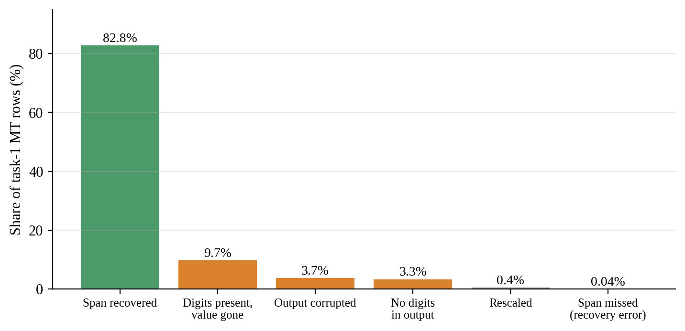
Figure 5.1: Outcome of the annotated numeral in task 1 machine translation
Roughly one financial numeral in six therefore does not survive Indic-to-Indic translation intact. Counting every numeral, currency symbol and percentage in a sentence, and not only the annotated one, is stricter. Rows with corruption, 6.2 percent of task 1, are excluded from this rate. Even so, no task 1 direction reaches the 95 percent bar: the rates run from 49.8 percent for Bengali to Malayalam to 78.7 percent for Telugu to Hindi (Figure 5.2). Task 2 directions run from 89.5 to 95.7 percent and task 3 directions from 77.4 to 97.0 percent, and in both the weakest direction is Hindi to Malayalam.
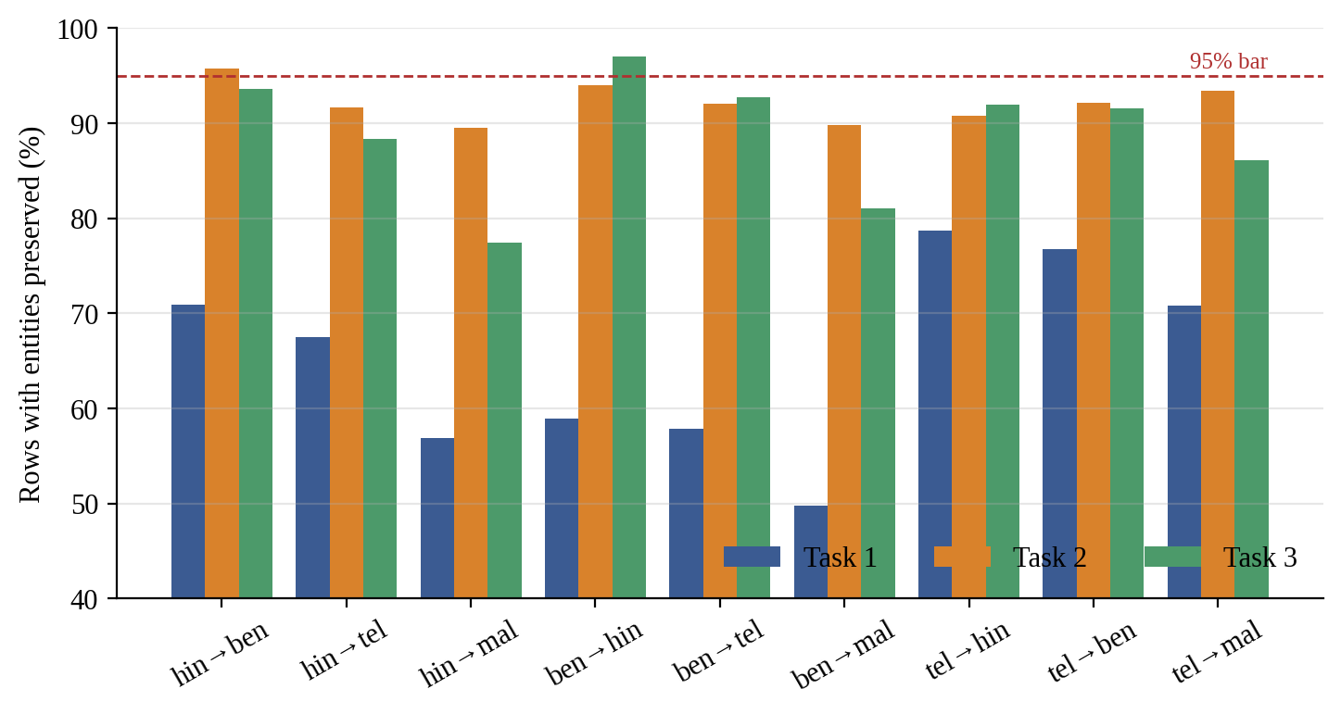
Figure 5.2: Entity preservation by direction and task, with the 95 percent bar

5.4.3 Semantic similarity by direction
On LaBSE similarity, task 1 divides by source language (Table 5.4, Figure 5.3). Hindi-source directions have median similarity from 0.906 to 0.937 and fall below τ on 5 to 11 percent of rows. Bengali-source directions have medians from 0.844 to 0.854 and fall below τ on 29 to 34 percent. This pattern appears only in task 1, the only task whose blocks hold different sentences, so it reflects the source texts as much as the translation directions.
Table 5.4: Median LaBSE similarity and share below τ by direction
Direction | T1 median | T1 below τ | T2 median | T2 below τ | T3 median | T3 below τ
hin→ben | 0.935 | 6.5% | 0.950 | 0.3% | 0.908 | 0.4%
hin→tel | 0.937 | 4.7% | 0.945 | 0.2% | 0.903 | 0.8%
hin→mal | 0.906 | 10.9% | 0.908 | 4.4% | 0.859 | 4.5%
ben→hin | 0.854 | 29.4% | 0.931 | 0.8% | 0.898 | 0.4%
ben→tel | 0.849 | 31.5% | 0.923 | 2.4% | 0.889 | 1.1%
ben→mal | 0.844 | 34.1% | 0.902 | 5.4% | 0.870 | 2.1%
tel→hin | 0.916 | 15.5% | 0.943 | 0.4% | 0.891 | 1.1%
tel→ben | 0.909 | 19.8% | 0.939 | 0.7% | 0.881 | 1.9%
tel→mal | 0.906 | 18.8% | 0.924 | 1.6% | 0.861 | 3.8%

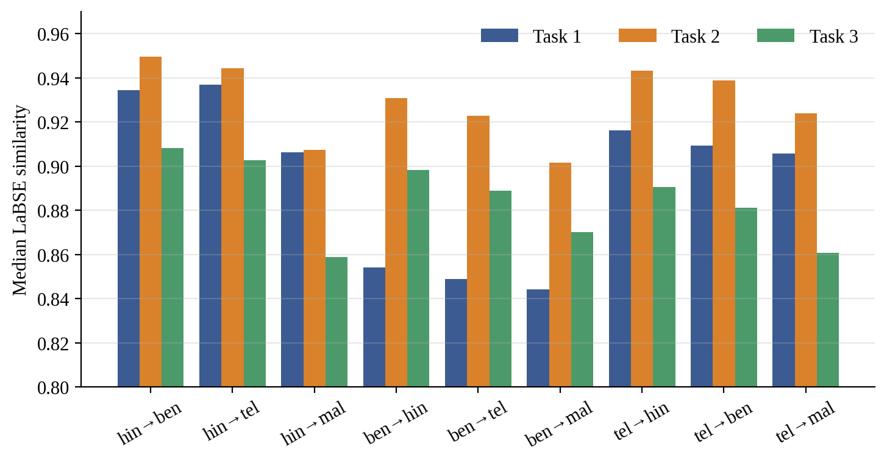
Figure 5.3: Median LaBSE similarity by translation direction and task

5.4.4 Calibrating the threshold
The human translations in tasks 2 and 3 make the threshold checkable. On task 2 the median human pair scores 0.921 with a 5th percentile of 0.846, and τ = 0.82 accepts all of them. On task 3 the median is 0.870 and the 5th percentile 0.729, so τ = 0.82 would reject 23.4 percent of human translations. The difference is text length, a median of 148 characters on task 2 against 86 on task 3, since LaBSE cosine falls as context shortens. τ is therefore set per task (Table 5.5). At the calibrated τ = 0.73, task 3's drift-flagged rows fall from 740 to 85.
Table 5.5: Calibrated similarity threshold by task
Task | τ | Basis
Task 1 | 0.82 | Inherited, not calibrated, because no human reference exists in any direction
Task 2 | 0.82 | Confirmed: rejects 0.0% of human pairs and no direction exceeds the 20% trigger
Task 3 | 0.73 | Revised: the value that accepts 95% of human pairs

A second result qualifies every similarity figure in this report. Machine translation scores higher than human translation of the same items, in both calibratable tasks and in every language pair. On task 2, for example, Hindi to Bengali machine translation scores 0.950 against 0.918 for the human Bengali and Hindi pair; on task 3 the figures are 0.908 and 0.876. LaBSE cosine rewards literal translation, so it ranks directions usefully but is a poor absolute measure of adequacy.

5.4.5 Ranking the directions
Ranking the nine directions on drift, entity preservation, corruption and truncation, by the mean of each measure's rank, yields one result that holds on every task. Translating into a Dravidian language drifts more than translating from Telugu back into an Indo-Aryan language: by about 2.6 points on task 1 (20.3 percent against 17.6 percent), 2.6 on task 2 (3.1 percent against 0.5 percent), and 0.6 on task 3 (2.1 percent against 1.5 percent at its calibrated τ). Two other comparisons reverse between tasks: whether Hindi to Malayalam is worse than Bengali to Malayalam, and whether Telugu-source directions drift more than Indo-Aryan-source ones. Neither is reported as a property of the language pair.

5.5 IN-LANGUAGE BASELINES
Table 5.6 gives the in-language macro-F1 on each held-out test fold, and Figure 5.4 shows the task 2 comparison with the published figures. Five of the six IndicBERT baselines are at or above IndicFinNLP's published figure. The exception, task 2 Hindi, is 3.7 points below. Its training behaviour is healthy: training macro-F1 of at least 0.987 on every seed and a test standard deviation of 0.004. The shortfall is attributed to a smaller test fold that is resampled per seed and to untuned hyperparameters and not to a modelling error. Tuning raised the mean by almost nothing but tightened the run-to-run spread roughly tenfold, which marks the shortfall as a stable property of this reproduction and not noise. The task 3 comparison carries little weight: the published 0.05 is the score of a model that predicts one class for every item, so exceeding it shows only that the models do better than that.
Table 5.6: In-language macro-F1 on held-out test folds
Task | Language | Published | IndicBERT | mBERT
2 | Hindi | 0.86 | 0.823 ± 0.004 | 0.874 ± 0.017
2 | Bengali | 0.80 | 0.820 ± 0.028 | 0.858 ± 0.014
2 | Telugu | 0.79 | 0.819 ± 0.015 | 0.860 ± 0.009
3 | Hindi | 0.05 | 0.153 ± 0.025 | 0.335 ± 0.042
3 | Bengali | 0.05 | 0.127 ± 0.055 | 0.292 ± 0.074
3 | Telugu | 0.05 | 0.095 ± 0.047 | 0.243 ± 0.036

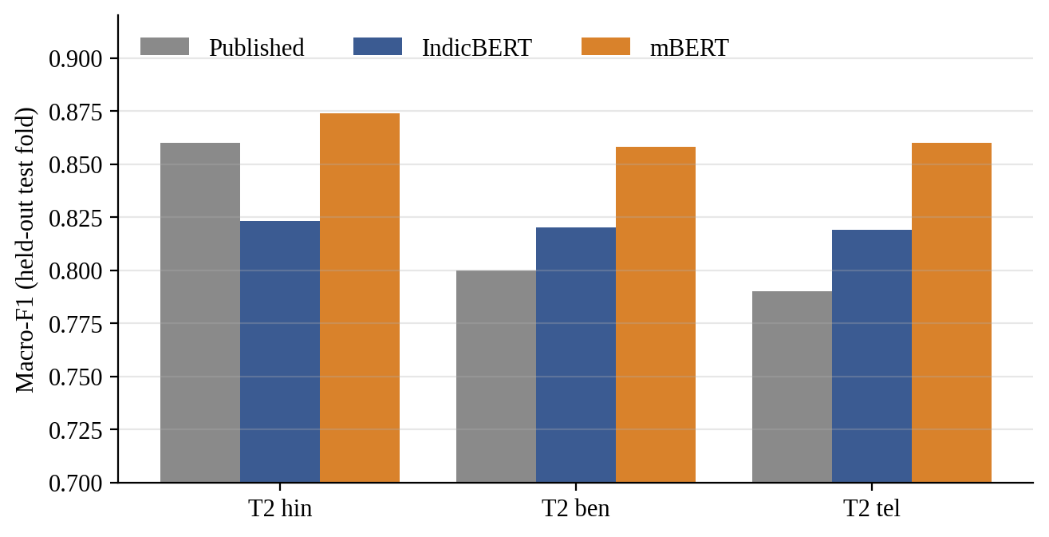
Figure 5.4: In-language macro-F1 for task 2 against the published figures
Three of the nine task 3 IndicBERT runs never fitted their training data: Bengali seed 0 and Telugu seeds 0 and 2 peaked below 0.5 training macro-F1. On a task at its data ceiling their test scores look like a healthy run's, which is why convergence is checked on the training fold. mBERT had no such failures under identical settings. These runs remain in every all-seeds figure; over converged seeds only, task 3 Bengali and Telugu score 0.159 and 0.150.

5.6 ZERO-SHOT TRANSFER
Two properties of the measurement matter when reading the transfer results. First, the in-language score that the gap subtracts from is computed on the evaluation items in the source language, and about 80 percent of them on task 2 and 70 percent on task 3 are in the source model's training fold. It is a training-text ceiling: 0.954 for task 2 Hindi with IndicBERT, against 0.823 on the held-out fold. Second, task 3 is at its data ceiling, with 532 headlines spread over ten classes.
Figures 5.5 and 5.6 show the gap for every source and target, and Appendix 4 gives the full table with seed spread. Transfer costs a large share of in-language performance in every cell. On task 2 the gaps run from 0.26 to 0.45 with IndicBERT and from 0.11 to 0.24 with mBERT. Out of Hindi, IndicBERT loses 0.39 to 0.45 on task 2 and 0.50 to 0.51 on task 3. On task 3 the gaps cluster between 0.46 and 0.56 whatever the source, target or encoder.
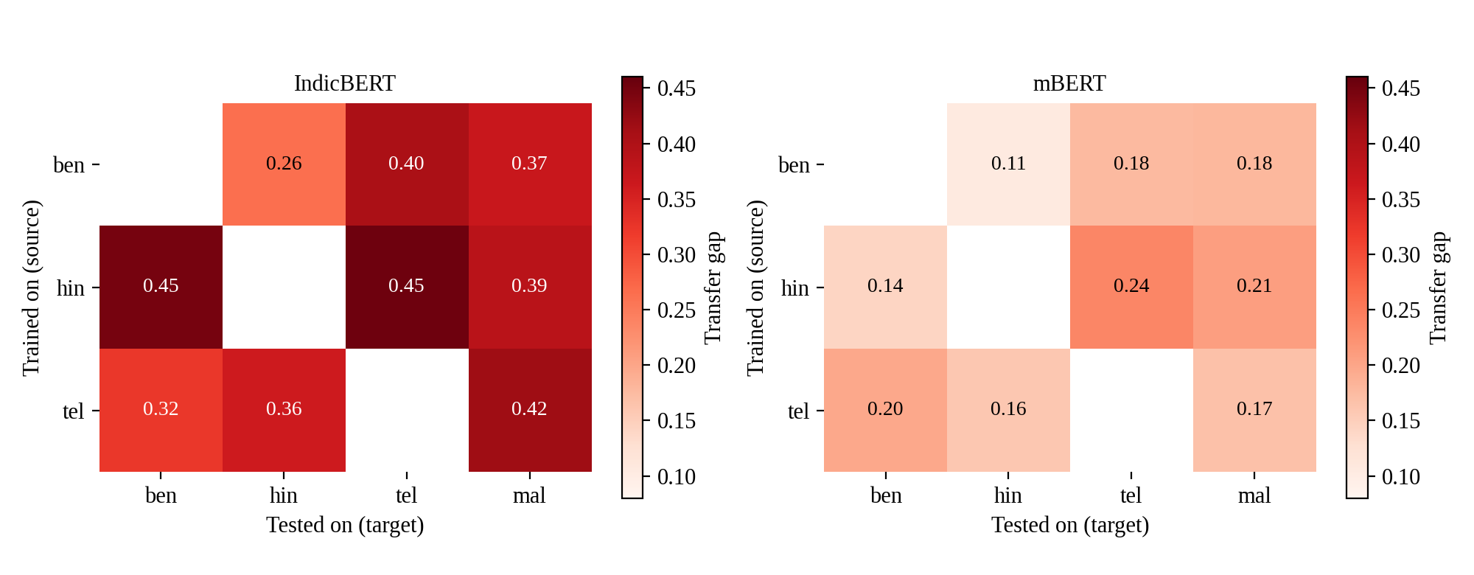
Figure 5.5: Task 2 transfer gap, source on the vertical axis and target on the horizontal axis
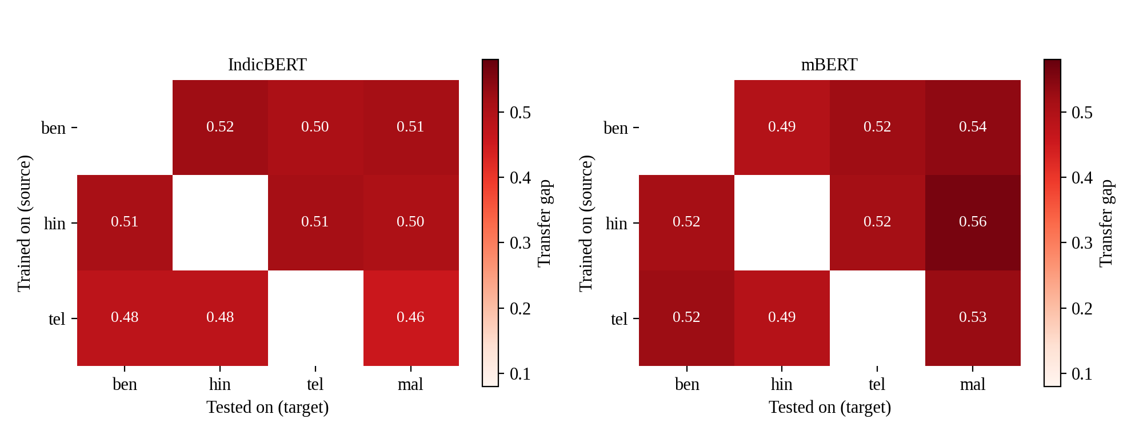
Figure 5.6: Task 3 transfer gap, source on the vertical axis and target on the horizontal axis

5.6.1 Is the loss an artefact of the translations?
Evaluating on machine-translated target text from the source's own block, instead of native text, moves these gaps by a few points at most. For the Hindi source and IndicBERT on task 2 the gaps are 0.38 to 0.47 on machine-translated targets against 0.39 to 0.45 on native ones. The loss is therefore not an artefact of this project's translations. Had translation damage been the main driver, evaluation on genuine human-written Bengali would have scored noticeably better than on machine-translated Bengali, and it did not.

5.6.2 Translationese conditions
The translationese conditions hold the language fixed and change only the text's provenance. With IndicBERT on task 2, a Hindi, Bengali or Telugu model scores 5.7 to 7.8 points lower on machine-translated text in its own language than on native text. On task 3 the drop is 8.8 to 26.6 points. The native arm is the model's own split and so largely its training text, while the translated arm is not. These differences are therefore an upper bound on the cost of translated input and not a direct measure of it.

5.7 ENCODER COMPARISON
mBERT outperforms IndicBERT on the target language in all twelve Hindi-source cells, six per task, native and translated targets (Table 5.7). The margin is 0.15 to 0.37 macro-F1, larger than the two encoders' combined seed spread in every cell, and mBERT also scores higher in-language on held-out data. The two tasks differ in how. On task 2, mBERT both starts higher and loses less in transfer, with gaps of 0.12 to 0.24 against 0.38 to 0.47. On task 3 the two lose nearly the same amount, 0.45 to 0.56 against 0.50 to 0.52. The report therefore does not claim that the better encoder transfers better in general.
Table 5.7: Macro-F1 by encoder, Hindi source
Measure | IndicBERT | mBERT
Task 2, in-language (held-out) | 0.823 ± 0.004 | 0.874 ± 0.017
Task 2, target (mean of 6 cells) | 0.519 | 0.787
Task 2, transfer gap (range) | 0.38 to 0.47 | 0.12 to 0.24
Task 3, in-language (held-out) | 0.153 ± 0.025 | 0.335 ± 0.042
Task 3, target (mean of 6 cells) | 0.087 | 0.294
Task 3, transfer gap (range) | 0.50 to 0.52 | 0.45 to 0.56

Tokenisation does not explain the result. IndicBERT needs 14 to 24 percent fewer tokens than mBERT for the same sentences, and its advantage is largest for Malayalam, yet it underperforms on every measure. Capacity might explain it. IndicBERT shares one layer's weights across all twelve layers, so its transformer body has 7.8 million parameters against mBERT's 85.6 million. Separating capacity from multilingual breadth needs a comparison of mBERT against XLM-R, which share an identically sized transformer body and differ mainly in vocabulary and pretraining breadth. That comparison could not be run on the available hardware, so the cause remains open.

5.8 SOURCE LANGUAGE AND DIRECTION
Training on Hindi gives the largest mean gap on task 2 with both encoders, and Bengali the smallest (Table 5.8, Figure 5.7). The three source models are equally good in their own language, within a quarter of a point of each other, so the ranking concerns transfer and not a stronger model.
Table 5.8: Mean transfer gap by source language and target family, task 2
Group | IndicBERT | mBERT
Source: Bengali | 0.345 | 0.153
Source: Telugu | 0.367 | 0.174
Source: Hindi | 0.429 | 0.196
Target family: Indo-Aryan | 0.349 | 0.151
Target family: Dravidian | 0.406 | 0.194

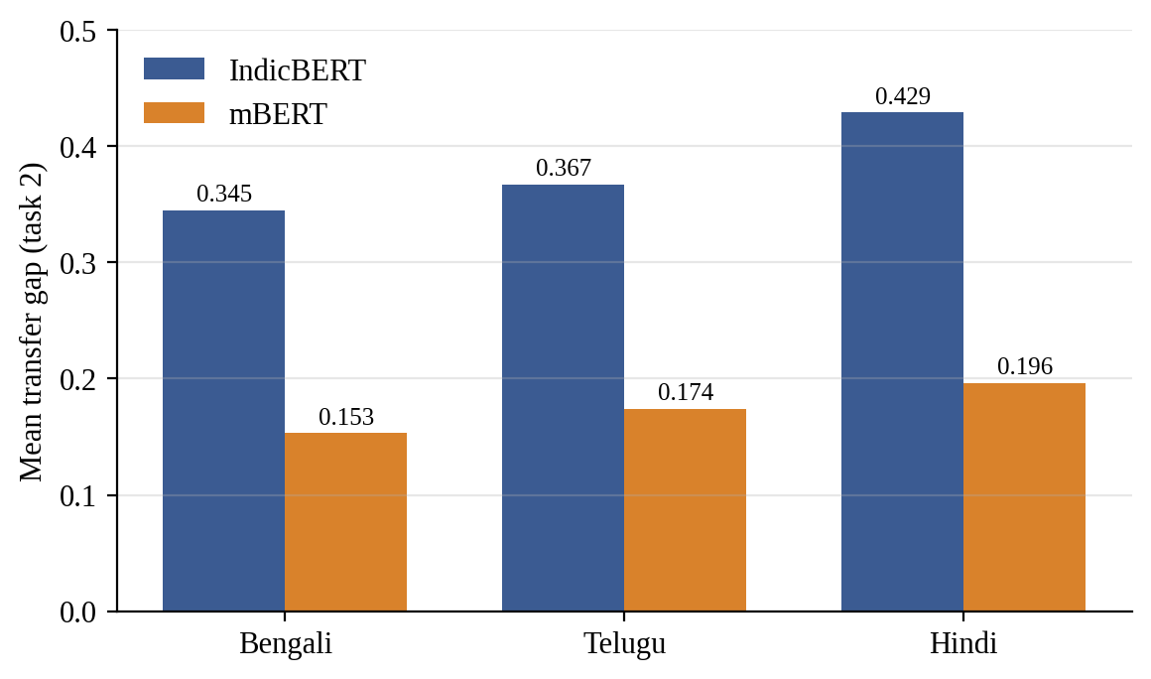
Figure 5.7: Mean transfer gap by source language on task 2
The cost sits mainly in the target language. Into a Dravidian target the mean gap is 0.406 with IndicBERT and 0.194 with mBERT, against 0.349 and 0.151 into an Indo-Aryan target. The corpus quality results in Section 5.4 found the same direction in translation quality, measured by an unrelated method; this agreement is the most solid finding of the study. Transfer is also asymmetric. Hindi to Bengali loses more than Bengali to Hindi on both encoders, beyond seed noise: 0.448 against 0.263 with IndicBERT and 0.142 against 0.105 with mBERT.
Typological proximity does not reliably pick the best source. A same-family source is best for one of three targets with IndicBERT and for all three with mBERT. The two encoders also disagree about Malayalam's best source: Bengali with IndicBERT and Telugu with mBERT. Task 3 supports no source comparison, because no difference between sources and no direction asymmetry exceeds seed noise.

5.9 FAILURE ATTRIBUTION
The router labelled every failure in all 72 cells: two tasks, two encoders and 18 transfer conditions. Table 5.9 and Figure 5.8 show what the failures consist of. Between 9.2 and 19.7 percent are unattributed. Linguistic labels account for 8.8 to 12.0 percent, and data or model labels for 69.0 to 79.4 percent. Most failures are therefore described by where they occur and not by a property of the target sentence: in every target language, in only one text provenance, on only some seeds, or under a collapsed classifier. These data and model labels describe a pattern. They do not name a mechanism.
Table 5.9: Composition of transfer failures, share of failures
Cell | Failures | Unattributed | Linguistic | Data | Model
Task 2, IndicBERT | 19,323 | 9.2% | 12.0% | 44.6% | 34.2%
Task 2, mBERT | 9,714 | 19.7% | 11.3% | 48.3% | 20.8%
Task 3, IndicBERT | 6,102 | 11.8% | 8.8% | 72.2% | 7.1%
Task 3, mBERT | 7,103 | 14.4% | 9.4% | 64.9% | 11.2%

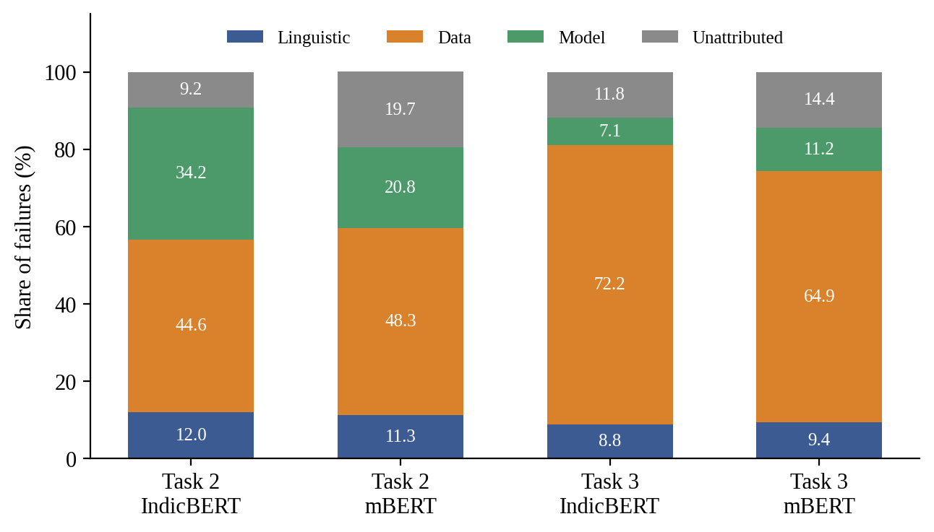
Figure 5.8: Composition of transfer failures by task and encoder
Two of the linguistic modules did not validate. Items with a masked term do not fail more often than items with the term intact: masked items fail more often in only 20 of 44 cells. Saliency divergence does not separate failures from correctly handled pairs, with an area under the curve of 0.48 to 0.52. Tokenizer fragmentation almost never fires, at most 0.5 percent of failures, because a ratio of 2.0 is rarely reached. Labels from these modules are reported, but they should not be read as established causes.
Of 228 group comparisons, 22 meet the finding rule, and 11 of those could be produced by a known measurement limit on its own. The remaining 11 fall into three groups.
- Direction (task 2). Failures out of Telugu carry more model-behaviour labels than failures into it, on both encoders (40.2 percent against 34.4 percent with IndicBERT, 24.9 percent against 14.4 percent with mBERT), mainly through seed instability.
- Source. On task 2, with Bengali and Malayalam targets, Telugu-source failures carry more model-behaviour labels than Hindi-source ones (46.8 percent against 18.4 percent, and 22.0 percent against 14.7 percent). On task 3, Hindi-source failures carry more terminology_gap labels than Telugu-source ones, but that label comes from a module that did not validate.
- Encoder. 27.3 percent of IndicBERT's task 2 failures are class collapse, which never occurs with mBERT. IndicBERT also has more cross_lingual_hard failures on both tasks (28.5 against 24.4 percent, and 60.6 against 46.6 percent), while mBERT's failures are more often seed_unstable (19.0 against 6.3 percent, and 10.5 against 5.0 percent) and provenance_specific (25.5 against 15.9 percent, and 16.6 against 8.7 percent).
Hindi-source failures are more frequent than Bengali-source ones (task 2: 32.9 against 27.7 percent of evaluated rows with IndicBERT, and 17.0 against 13.4 percent with mBERT), but no difference in their cause mix meets the rule. Hindi fails more often, not differently. On machine-translated targets, 9.5 to 25.0 percent of failures are labelled translation_drift or provenance_specific, which is the closest the pipeline comes to saying that the project's own translation caused the failure. The only native-versus-translated differences that meet the rule are in translation_drift itself, and they are an artefact of the measure: τ accepts 95 percent of human translations by construction, and LaBSE scores literal translation above human translation. Repeating every comparison without the task 3 runs that never trained changes 20 verdicts, only one of them to or from a finding.

5.10 VALIDATION
Several independent checks support the reliability of the results.
- Baseline gate. Every source model was compared with the published in-language figure before any transfer number was read. Five of the six IndicBERT baselines meet or exceed the published figure. The sixth, task 2 Hindi, fell short, and the gate passed only with a written diagnosis.
- Agreement between unrelated measures. Splitting task 1's directions by whether the annotated numeral survived separates two populations cleanly. For example, on Telugu to Bengali, 8.3 percent of rows with a recovered span fall below τ, against 68.9 percent of rows whose span was lost. A digit locator and a sentence embedder, which never see each other's output, agree on which rows went wrong. The into-Dravidian cost also appears both in translation drift and in transfer gaps.
- Hand check of the translations. The project maintainer signed off 20 sentences per translation direction on 10 September 2026, which is 180 rows per task. This covers 0.3 percent of task 1's machine-translated rows, 0.9 percent of task 2's and 3.8 percent of task 3's. Every numeral difference in the sampled translations was also classified by hand, which is what exposed the corruption modes.
- Hand check of the diagnostic labels. A spot-check of 200 task 2 IndicBERT failures, 50 per target language, agreed with the router's label on 197 (98.5 percent). Of the 200, 160 carried data or model labels, and on the 40 linguistic and unattributed rows agreement was 37 of 40. No disagreement was systematic, so no threshold was changed. The other three combinations of task and encoder were not sampled.
- Reproducibility. Two runs of the same configuration produce byte-identical output. Re-running Phase 7 reproduces the findings report, and the 72 cells reconcile row for row with the failure files. A tamper test confirms that the frozen release fails verification when a file is changed, deleted or added.

5.11 COMPARISON WITH PUBLISHED AND PRIOR RESULTS
Table 5.6 compared the in-language baselines with IndicFinNLP's published figures. The project's IndicBERT baselines on task 2 are 0.823, 0.820 and 0.819 against 0.86, 0.80 and 0.79 published. On task 3 the published figure is the score of a one-class predictor, which both encoders exceed.
The transfer findings can be compared with the literature in direction but not in magnitude. The existence of a large transfer gap agrees with XTREME (Hu et al., 2020), and the larger loss into more distant languages agrees with Lauscher et al. (2020). The finding that Hindi, the highest-resource Indic source, is the worst source on task 2 is consistent with the observation that source choice depends on more than data size (Lin et al., 2019). Finally, the warning of Agrawal et al. (2024) that machine-translated benchmarks can measure translation quality has been tested here directly: native and machine-translated targets give gaps within a few points of each other, so for these tasks the gap is not mainly a translation artefact. [TO FILL: no like-for-like numerical comparison with other Indic financial transfer studies is possible because none was found in the literature reviewed.]

5.12 DISCUSSION
Four points follow from the results.
First, the corpus audit changed the project. Treating tasks 2 and 3 as three independent splits would have led to training and evaluating on the same sentences without any visible warning. The audit, the alignment and the item-level partition exist because of that finding, and the same finding enabled the human-translation ceiling that made τ defensible.
Second, translation damage to financial numerals is large and concentrated in the task whose text is dense with numerals. One annotated numeral in six did not survive, and no task 1 direction passes a 95 percent preservation bar. A research pipeline that used machine translation of financial text without such a check would have reported a clean corpus. Because the problem is silent, the project's rule of flagging and keeping every row matters: the flagged rows are the measurement.
Third, transfer loss is real and large, and it is not mainly a translation artefact. The absolute figures are inflated in one sense and deflated in another. They are inflated because the in-language ceiling is training text; and deflated because the evaluated items are the same content in both languages, which removes difficulty differences. What the gaps measure is the cost of changing language alone.
Fourth, the diagnostic framework did not explain the gap. The causes it could name were mostly descriptions of where failures happen. The two linguistic modules that were tested against a null did not beat it. This is a negative result, and it is reported as one: size and shape of the gap are established, the mechanism is not.

5.13 LIMITATIONS AND THREATS TO VALIDITY
- No native Malayalam. Every Malayalam result mixes transfer difficulty with translation quality, and no human reference exists to calibrate τ for it.
- Limited human verification. Human verification covers a 180-row sample per task by the project maintainer, not an audit by native speakers of each target language. The automated checks establish that numerals, labels, structure and script survive, not that every sentence means the right thing.
- Similarity is not adequacy. LaBSE cosine ranks directions reliably but rewards literal wording, so τ and the drift rates are relative measures. Task 1's τ is inherited and cannot be calibrated.
- Shared content by design. Training and evaluation share content across languages, so the gaps are not measures of generalisation to unseen sentences.
- Two encoders, not three. XLM-R could not be fine-tuned on a 4 GB GPU, so the controlled test that separates capacity from multilingual breadth was not run.
- Unconverged runs. Three of nine task 3 IndicBERT runs never trained. They are kept in all-seed figures and excluded from the source comparison, and the task 3 comparison is weak in any case.
- Diagnostic limits. Shares are of failures only. Two linguistic modules do not predict failure, the data and model labels describe where failures occur and not why, one Integrated Gradients cell remains above its convergence limit, and the hand check covers one of four task and encoder combinations. Some differences are bounded by measurement limits, such as Hindi's inability to receive the morphological label.
- Single seed set and hardware. Three seeds per configuration give a rough seed spread, and a few cells have only one or two converged seeds, so no standard deviation is available for them.

CHAPTER 6
CONCLUSION AND FUTURE WORK

6.1 CONCLUSION
The project asked whether multilingual language models keep financial meaning intact when knowledge moves between Indic languages. To answer it, a four-way parallel financial corpus was built in Hindi, Bengali, Telugu and Malayalam from IndicFinNLP. It holds 92,760 machine-translated rows, each kept and flagged and none filtered, and every row is checked for numeral preservation, structural integrity and semantic similarity against a threshold calibrated on human translations wherever such translations exist. The independence audit that preceded translation changed the design: the sustainability and ESG-theme splits turned out to be the same items in every language, while the numeral split is independently sourced.
Financial numerals are fragile under translation. Roughly one annotated numeral in six does not survive Indic-to-Indic translation intact, and no direction of the numeral task reaches a 95 percent preservation rate for the numerals, currency symbols and percentages in a sentence. Cross-lingual transfer is costly as well. With content held fixed, IndicBERT loses 0.26 to 0.45 macro-F1 on sustainability classification and mBERT 0.11 to 0.24. Evaluating on the project's own translations instead of native text changes the gap by only a few points, so the loss is not an artefact of the corpus. mBERT outperforms IndicBERT in all twelve Hindi-source cells, and the evidence does not support attributing that to tokenisation. On sustainability classification, Hindi, the default choice of source, is the worst source language on both encoders. There the cost sits mainly in the target language, and moving into a Dravidian language costs more than moving into an Indo-Aryan one. The same direction appears in translation quality on all three tasks, measured by an unrelated method. The ESG-theme task, with 532 headlines over ten classes, is too small to support any comparison of sources.
The diagnostic framework labelled every failure in all 72 combinations of task, encoder and condition, and the labels describe failures without explaining them. Linguistic labels cover 8.8 to 12.0 percent of failures. Most of the rest are described by where they occur: in every target language, on only some seeds, or under a collapsed classifier. Two linguistic modules, morphological masking and terminology gap, did not predict failure better than chance. The report therefore states the size and shape of the transfer gap with confidence, and its causes as open.
Measured against the objectives of Section 1.5, the corpus was built, gated and frozen with a generated datasheet (objectives 1 to 3 and 7). The full planned transfer grid, 126 results per task, was completed (objectives 4 and 5). The router was implemented and validated, and its main outcome is that the causes of the gap remain largely unexplained (objective 6). Two limits bound all of this. Malayalam has no native text, so its results combine transfer difficulty with translation quality. And human verification covers a sample of 180 translated rows per task, not the corpus. A single 4 GB GPU also ruled out XLM-R, the comparison that would separate model capacity from multilingual breadth.

6.2 FUTURE WORK
- Encoders. Running XLM-R against mBERT on larger hardware would isolate the effect of multilingual breadth at fixed capacity and settle whether mBERT's advantage comes from capacity. IndicBERT v2 (Doddapaneni et al., 2023) would test the same question for an Indic-specific model with a full-size transformer body.
- Human verification. A native-speaker review of each target language, beyond the present maintainer sample, would establish adequacy where the automated checks establish only that numerals, labels and script survived. A small native Malayalam test set would separate Malayalam transfer from Malayalam translation.
- Diagnostics. Comparing each label's rate on failures with its rate on correct predictions would show whether a property makes failure more likely, which shares of failures cannot. The morphology and terminology modules need redesign or an intervention test, such as restoring a masked term and measuring the change in prediction. The excluded numeral module could be rebuilt on task 1's span annotations.
- Evaluation design. Task 1 is the one independently sourced task, so treating numeral detection as a transfer task would give a measurement free of shared content. Training on one item partition and evaluating on the other would add a held-out estimate beside the fixed-content gap. Few-shot target-language training (Lauscher et al., 2020) and translate-train (Aggarwal et al., 2022; Artetxe et al., 2023) would show how much of the gap a small amount of target data or translated training data recovers. For the ESG-theme task, paraphrase augmentation, as used in IndicFinNLP, could lift it off its data ceiling.
- Coverage. IndicTrans2 covers all 22 scheduled Indian languages (Gala et al., 2023), so the pipeline extends to further Dravidian and Indo-Aryan languages by configuration changes. This would test whether the into-Dravidian penalty holds beyond Telugu and Malayalam.
- Numeral robustness. Since numerals are the most fragile content, a numeral-aware translation step, for instance protecting numerals as placeholders that are verified after decoding, is a natural improvement to the corpus pipeline. The failure of the placeholder mechanism in IndicTrans2 noted in Chapter 4 shows that the protection itself must be verified.

REFERENCES
[TO FILL: the source list held surnames only, so author initials are missing from every entry below and must be added from the original publications.]
Aggarwal, Gupta, & Kunchukuttan. (2022). IndicXNLI: Evaluating multilingual inference for Indian languages. Proceedings of EMNLP (pp. 10994–11006).
Agrawal, Fazili, & Jyothi. (2024). Translation errors significantly impact low-resource languages in cross-lingual learning. Proceedings of EACL (short papers) (pp. 319–329).
Artetxe, Goswami, Bhosale, Fan, & Zettlemoyer. (2023). Revisiting machine translation for cross-lingual classification. Proceedings of EMNLP (pp. 6489–6499).
Chen, Huang, Takamura, & Chen. (2019). Numeracy-600K: Learning numeracy for detecting exaggerated information in market comments. Proceedings of ACL (pp. 6307–6313).
Chen, Tseng, Kang, Lhuissier, Seki, Day, Tu, & Chen. (2023). Multi-lingual ESG impact type identification (ML-ESG-2). Proceedings of FinNLP @ IJCNLP-AACL (pp. 46–50).
Conneau, Khandelwal, Goyal, Chaudhary, Wenzek, Guzmán, Grave, Ott, Zettlemoyer, & Stoyanov. (2020). Unsupervised cross-lingual representation learning at scale. Proceedings of ACL (pp. 8440–8451).
Doddapaneni, Aralikatte, Ramesh, Goyal, Khapra, Kunchukuttan, & Kumar. (2023). Towards leaving no Indic language behind: Building monolingual corpora, benchmark and models for Indic languages. Proceedings of ACL (pp. 12402–12426).
Feng, Yang, Cer, Arivazhagan, & Wang. (2022). Language-agnostic BERT sentence embedding. Proceedings of ACL (pp. 878–891).
Gala, et al. (2023). IndicTrans2: Towards high-quality and accessible machine translation models for all 22 scheduled Indian languages. Transactions on Machine Learning Research.
Ghosh, Maji, Narayana, & Naskar. (2024). IndicFinNLP: Financial natural language processing for Indian languages. Proceedings of LREC-COLING (pp. 9010–9018).
[TO FILL: authors]. (2026). How much data in low-resource Indian languages is "sufficient" for transfer learning: A comparative study for POS annotation. ACM Transactions on Asian and Low-Resource Language Information Processing, 25(1). [TO FILL: pages]
Hu, Ruder, Siddhant, Neubig, Firat, & Johnson. (2020). XTREME: A massively multilingual multi-task benchmark for evaluating cross-lingual generalisation. Proceedings of ICML, PMLR 119 (pp. 4411–4421).
Huang, Wang, & Yang. (2023). FinBERT: A large language model for extracting information from financial text. Contemporary Accounting Research, 40(2), 806–841.
Jørgensen, Brandt, Hartmann, Dai, Igel, & Elliott. (2023). MultiFin: A dataset for multilingual financial NLP. Findings of EACL (pp. 894–909).
Kakwani, Kunchukuttan, Golla, Gokul, Bhattacharyya, Khapra, & Kumar. (2020). IndicNLPSuite. Findings of EMNLP (pp. 4948–4961).
Lauscher, Ravishankar, Vulić, & Glavaš. (2020). From zero to hero: On the limitations of zero-shot language transfer with multilingual transformers. Proceedings of EMNLP (pp. 4483–4499).
Lee, Stevens, & Han. (2025). Large language models in finance (FinLLMs). Neural Computing and Applications, 37, 24853–24867.
Lin, Chen, Lee, Li, Zhang, Xia, Rijhwani, He, Zhang, Ma, Anastasopoulos, Littell, & Neubig. (2019). Choosing transfer languages for cross-lingual learning. Proceedings of ACL (pp. 3125–3135).
Mabokela, Çelik, & Raborife. (2023). Multilingual sentiment analysis for under-resourced languages: A systematic review of the landscape. IEEE Access, 11, 15996–16020.
Nag, Bhattacharyya, Mukherjee, Chakrabarti, et al. ([TO FILL: year]). Transfer learning for low-resource multilingual relation classification (IndoRE). ACM Transactions on Asian and Low-Resource Language Information Processing. [TO FILL: volume, pages]
Pfeiffer, Vulić, Gurevych, & Ruder. (2020). MAD-X: An adapter-based framework for multi-task cross-lingual transfer. Proceedings of EMNLP (pp. 7654–7673).
Pires, Schlinger, & Garrette. (2019). How multilingual is multilingual BERT? Proceedings of ACL (pp. 4996–5001).

APPENDIX 1
SCHEMA, LABELS AND IDENTIFIERS

A1.1 CORPUS ROW SCHEMA FOR TASK 1
Task 1 uses the canonical columns of Table 3.3 except that the label columns are replaced by the columns in Table A1.1.
Table A1.1: Additional columns for the numeral task
Column | Type | Meaning
number_indic | string | The number as written in the source script
number_english | string | The same value in ASCII digits
start_posn | integer | Character offset into the text, end-exclusive
end_posn | integer | text[start_posn:end_posn] equals number_indic
magnitude | integer | The upstream scale marker
span_recovered | boolean | Null for native rows; whether the numeral was located in the translation

Upstream offsets are exact: the slice reproduces the number on 500 of 500 sampled rows in each language, and on all 22,786 spans as shipped. On a translated row, an unrecovered span carries offsets of minus one and the flag span_not_recovered.

A1.2 LABEL SETS
Task 2 uses two labels, sustainable and unsustainable, shared identically by all three languages. Task 3 uses ten ESG themes, and every language holds the same 532 headlines with the same class counts (Table A1.2). The class sizes are uneven, with the largest class four times the size of the smallest, which is why macro-F1 is the primary metric.
Table A1.2: Task 3 classes and counts in each language
ESG theme | Count | Share
Climate change | 92 | 17.3%
Corporate governance | 91 | 17.1%
Environmental opportunities | 72 | 13.5%
Product liability | 68 | 12.8%
Natural capital | 50 | 9.4%
Pollution waste | 44 | 8.3%
Human capital | 37 | 7.0%
Corporate behavior | 30 | 5.6%
Social opportunities | 27 | 5.1%
Stake holder opposition | 21 | 3.9%

A1.3 IDENTIFIER RULES
- An identifier is derived from content, never from row position.
- A task 1 identifier includes the span, because a sentence with three numbers forms three items.
- Exact duplicate rows receive an occurrence suffix (#1, #2). Task 2 has four such rows, identical in both text and label.
- Rows that do not align across languages keep a block-local identifier and the flag unaligned.
- Malayalam has no block of its own: it appears only as a translation target within blocks H, B and T.

APPENDIX 2
CONFIGURATIONS

A2.1 TRANSLATION AND VERIFICATION SETTINGS
Table A2.1: Frozen translation decoding configuration
Setting | Value
Model | ai4bharat/indictrans2-indic-indic-1B
Beam size | 5
Maximum length | 256 tokens
Sampling | None
Key-value cache | Disabled (use_cache = False), a correctness requirement
Device | GPU only; automatic CPU fallback refused
Batch size | Adaptive, excluded from the decoding fingerprint
Language codes | hin_Deva, ben_Beng, tel_Telu, mal_Mlym

Table A2.2: Verification settings
Setting | Value
Similarity model | sentence-transformers/LaBSE, L2-normalised embeddings
Threshold τ | Task 1: 0.82; task 2: 0.82; task 3: 0.73
Audit sample size | 200 source sentences per language pair
Entity preservation bar | 95% per direction
Truncation rule | Below 0.5 of the direction's own median length ratio
Drift trigger for review | More than 20% of any direction below τ

A2.2 TRAINING AND DIAGNOSTIC SETTINGS
The fine-tuning settings are in Table 4.4. The diagnostic thresholds are in Table A2.3.
Table A2.3: Diagnostic thresholds
Setting | Value
Tokenizer fragmentation threshold | R_frag of 2.0 or more
Saliency divergence threshold | 95th percentile on pairs correct in both languages: task 2 IndicBERT 0.038, task 2 mBERT 0.047, task 3 IndicBERT 0.085, task 3 mBERT 0.078
Integrated Gradients convergence limit | Completeness error of 5%
Class collapse | One class predicted on at least 75% of the condition's rows
ESG lexicon | 18 concepts, curated in Hindi and translated with the corpus model
Seeds | Three per configuration, bootstrap of 1,000 samples

APPENDIX 3
PER-DIRECTION QUALITY TABLES

A3.1 ENTITY PRESERVATION
The tables list, for each direction, the share of rows with all entities preserved after excluding corrupted rows, and the counts of rows with dropped entities, altered entities, lost currency symbols, lost percentages and corrupted output.
Table A3.1: Entity preservation by direction, task 1
Direction | Rows | Preserved | Dropped | Altered | Currency lost | Percent lost | Corrupted
ben→mal | 5,698 | 49.8% | 6,159 | 2,469 | 265 | 538 | 432
hin→mal | 10,356 | 56.9% | 8,801 | 2,353 | 849 | 2,022 | 284
ben→tel | 5,872 | 57.8% | 4,861 | 3,116 | 191 | 249 | 258
ben→hin | 5,948 | 58.9% | 5,091 | 2,613 | 138 | 34 | 182
hin→tel | 10,442 | 67.5% | 6,564 | 2,596 | 503 | 638 | 198
tel→mal | 5,253 | 70.8% | 2,118 | 1,282 | 319 | 460 | 763
hin→ben | 10,057 | 70.9% | 6,036 | 2,358 | 373 | 122 | 583
tel→ben | 5,194 | 76.7% | 1,869 | 631 | 212 | 101 | 822
tel→hin | 5,322 | 78.7% | 1,628 | 903 | 180 | 92 | 694

Table A3.2: Entity preservation by direction, task 2
Direction | Rows | Preserved | Dropped | Altered | Currency lost | Percent lost | Corrupted
hin→mal | 2,236 | 89.5% | 130 | 28 | 103 | 80 | 2
ben→mal | 2,226 | 89.8% | 340 | 127 | 53 | 74 | 2
tel→hin | 2,072 | 90.8% | 121 | 24 | 98 | 14 | 0
hin→tel | 2,237 | 91.6% | 90 | 32 | 92 | 34 | 1
ben→tel | 2,228 | 92.0% | 289 | 127 | 42 | 39 | 0
tel→ben | 2,067 | 92.1% | 76 | 23 | 108 | 9 | 5
tel→mal | 2,070 | 93.4% | 120 | 25 | 29 | 35 | 2
ben→hin | 2,228 | 94.0% | 313 | 159 | 0 | 3 | 0
hin→ben | 2,231 | 95.7% | 64 | 29 | 51 | 5 | 7

Table A3.3: Entity preservation by direction, task 3
Direction | Rows | Preserved | Dropped | Altered | Currency lost | Percent lost | Corrupted
hin→mal | 531 | 77.4% | 65 | 52 | 78 | 7 | 1
ben→mal | 532 | 81.0% | 79 | 60 | 56 | 4 | 0
tel→mal | 531 | 86.1% | 61 | 50 | 19 | 5 | 1
hin→tel | 532 | 88.3% | 20 | 13 | 45 | 6 | 0
tel→ben | 531 | 91.5% | 34 | 24 | 16 | 4 | 1
tel→hin | 532 | 91.9% | 34 | 22 | 14 | 7 | 0
ben→tel | 532 | 92.7% | 26 | 12 | 24 | 4 | 0
hin→ben | 530 | 93.6% | 14 | 8 | 21 | 6 | 2
ben→hin | 532 | 97.0% | 23 | 10 | 1 | 5 | 0

A3.2 SIMILARITY DISTRIBUTIONS
Table A3.4: LaBSE similarity distribution by direction, task 1 (τ = 0.82)
Direction | Rows | Mean | Median | 5th pct | Below τ | Share
ben→mal | 6,130 | 0.834 | 0.844 | 0.720 | 2,090 | 34.1%
ben→tel | 6,130 | 0.842 | 0.849 | 0.743 | 1,930 | 31.5%
ben→hin | 6,130 | 0.846 | 0.854 | 0.745 | 1,801 | 29.4%
tel→ben | 6,016 | 0.874 | 0.909 | 0.631 | 1,188 | 19.8%
tel→mal | 6,016 | 0.876 | 0.906 | 0.661 | 1,133 | 18.8%
tel→hin | 6,016 | 0.870 | 0.916 | 0.540 | 934 | 15.5%
hin→mal | 10,640 | 0.892 | 0.906 | 0.783 | 1,154 | 10.9%
hin→ben | 10,640 | 0.917 | 0.935 | 0.804 | 691 | 6.5%
hin→tel | 10,640 | 0.923 | 0.937 | 0.824 | 498 | 4.7%

Table A3.5: LaBSE similarity distribution by direction, task 2 (τ = 0.82)
Direction | Rows | Mean | Median | 5th pct | Below τ | Share
ben→mal | 2,228 | 0.896 | 0.902 | 0.817 | 121 | 5.4%
hin→mal | 2,238 | 0.902 | 0.908 | 0.824 | 99 | 4.4%
ben→tel | 2,228 | 0.916 | 0.923 | 0.845 | 53 | 2.4%
tel→mal | 2,072 | 0.918 | 0.924 | 0.848 | 33 | 1.6%
ben→hin | 2,228 | 0.925 | 0.931 | 0.860 | 17 | 0.8%
tel→ben | 2,072 | 0.933 | 0.939 | 0.876 | 14 | 0.7%
tel→hin | 2,072 | 0.937 | 0.943 | 0.885 | 8 | 0.4%
hin→ben | 2,238 | 0.944 | 0.950 | 0.895 | 7 | 0.3%
hin→tel | 2,238 | 0.939 | 0.945 | 0.881 | 5 | 0.2%

Table A3.6: LaBSE similarity distribution by direction, task 3 (τ = 0.73)
Direction | Rows | Mean | Median | 5th pct | Below τ | Share
hin→mal | 532 | 0.846 | 0.859 | 0.737 | 24 | 4.5%
tel→mal | 532 | 0.851 | 0.861 | 0.746 | 20 | 3.8%
ben→mal | 532 | 0.860 | 0.870 | 0.762 | 11 | 2.1%
tel→ben | 532 | 0.871 | 0.881 | 0.775 | 10 | 1.9%
tel→hin | 532 | 0.882 | 0.891 | 0.786 | 6 | 1.1%
ben→tel | 532 | 0.879 | 0.889 | 0.777 | 6 | 1.1%
hin→tel | 532 | 0.893 | 0.903 | 0.801 | 4 | 0.8%
ben→hin | 532 | 0.891 | 0.898 | 0.798 | 2 | 0.4%
hin→ben | 532 | 0.899 | 0.908 | 0.811 | 2 | 0.4%

APPENDIX 4
FULL TRANSFER GAP TABLES

A4.1 TASK 2 AND TASK 3 TRANSFER GAPS
The tables give the mean transfer gap with its seed standard deviation, the source model's in-language score on the evaluation items (a training-text ceiling), and its score on the target. Targets other than Malayalam are evaluated on native text; Malayalam is machine-translated from a different block.
Table A4.1: Transfer gap by source, target and encoder, task 2
Encoder | Source | Target | Gap (mean ± std) | Source score | Target score
IndicBERT | ben | hin | 0.263 ± 0.053 | 0.956 | 0.693
IndicBERT | ben | mal | 0.367 ± 0.043 | 0.956 | 0.589
IndicBERT | ben | tel | 0.404 ± 0.015 | 0.956 | 0.552
IndicBERT | hin | ben | 0.448 ± 0.072 | 0.954 | 0.506
IndicBERT | hin | mal | 0.387 ± 0.057 | 0.954 | 0.567
IndicBERT | hin | tel | 0.453 ± 0.038 | 0.954 | 0.501
IndicBERT | tel | ben | 0.323 ± 0.047 | 0.957 | 0.634
IndicBERT | tel | hin | 0.361 ± 0.105 | 0.957 | 0.596
IndicBERT | tel | mal | 0.417 ± 0.005 | 0.957 | 0.541
mBERT | ben | hin | 0.105 ± 0.023 | 0.975 | 0.870
mBERT | ben | mal | 0.179 ± 0.028 | 0.975 | 0.796
mBERT | ben | tel | 0.176 ± 0.010 | 0.975 | 0.799
mBERT | hin | ben | 0.142 ± 0.010 | 0.975 | 0.833
mBERT | hin | mal | 0.209 ± 0.007 | 0.975 | 0.766
mBERT | hin | tel | 0.236 ± 0.056 | 0.975 | 0.738
mBERT | tel | ben | 0.196 ± 0.058 | 0.971 | 0.775
mBERT | tel | hin | 0.159 ± 0.060 | 0.971 | 0.812
mBERT | tel | mal | 0.167 ± 0.056 | 0.971 | 0.804

Table A4.2: Transfer gap by source, target and encoder, task 3
Encoder | Source | Target | Gap (mean ± std) | Source score | Target score
IndicBERT | ben | hin | 0.523 ± 0.163 | 0.590 | 0.067
IndicBERT | ben | mal | 0.515 ± 0.115 | 0.590 | 0.075
IndicBERT | ben | tel | 0.504 ± 0.132 | 0.590 | 0.086
IndicBERT | hin | ben | 0.510 ± 0.168 | 0.596 | 0.086
IndicBERT | hin | mal | 0.504 ± 0.184 | 0.596 | 0.092
IndicBERT | hin | tel | 0.514 ± 0.170 | 0.596 | 0.082
IndicBERT | tel | ben | 0.478 (1 seed) | 0.585 | 0.108
IndicBERT | tel | hin | 0.478 (1 seed) | 0.585 | 0.107
IndicBERT | tel | mal | 0.456 (1 seed) | 0.585 | 0.129
mBERT | ben | hin | 0.494 ± 0.004 | 0.810 | 0.316
mBERT | ben | mal | 0.538 ± 0.031 | 0.810 | 0.272
mBERT | ben | tel | 0.523 ± 0.019 | 0.810 | 0.287
mBERT | hin | ben | 0.516 ± 0.049 | 0.805 | 0.290
mBERT | hin | mal | 0.561 ± 0.050 | 0.805 | 0.244
mBERT | hin | tel | 0.516 ± 0.073 | 0.805 | 0.289
mBERT | tel | ben | 0.524 ± 0.034 | 0.784 | 0.260
mBERT | tel | hin | 0.489 ± 0.025 | 0.784 | 0.295
mBERT | tel | mal | 0.528 ± 0.054 | 0.784 | 0.256

For task 3 IndicBERT, Bengali-source cells use two converged seeds and Telugu-source cells use one, because seeds that never trained are excluded from the source comparison. A cell with one seed has no standard deviation.

APPENDIX 5
REPRODUCTION AND SCRIPT INVENTORY

A5.1 SETTING UP
The environment is a Python 3.11 virtual environment with the pinned requirements installed. The IndicTrans2 and IndicBERT repositories are gated on the model hub, so the licence must be accepted and the machine authenticated before the first download. Every command is run from the repository root as a module.

A5.2 COMMANDS
Table A5.1: Principal commands by phase
Step | Command
Fetch upstream data | python -m src.download_dataset.download
Independence audit | python -m scripts.t102_audit --task N --independence
Align parallel splits (tasks 2, 3) | python -m scripts.t102b_align --task N
Ingest native splits | python -m scripts.t103_ingest --task N
Generate translations | python -m scripts.t106_generate --task N
Rebuild splits from checkpoints | python -m scripts.t106_generate --task N --rebuild
Entity preservation | python -m scripts.t105_entities --task N
Integrity checks | python -m scripts.t107_integrity --task N --write-flags
LaBSE scoring | python -m scripts.t108_labse --task N
Drift report | python -m scripts.t109_drift --task N --write-flags
Calibrate τ | python -m scripts.t110_calibrate --task N
Direction ranking | python -m scripts.t111_ranking --task N
Freeze and verify | python -m scripts.t112_freeze --task N [--verify]
Condition matrix | python -m scripts.t113_conditions --task N
Datasheet | python -m scripts.t114_datasheet [--check]
Baselines and gate | python -m scripts.t206_baseline; python -m scripts.t207_gate
Transfer runs | python -m scripts.t305_run_conditions
Source and encoder comparison | python -m scripts.t408_source_comparison; python -m scripts.t504_comparison
Diagnostics | python -m scripts.t601_diagnostics
Findings | python -m scripts.t707_findings
Dashboard | streamlit run dashboard/app.py

A5.3 PHASE AND TASK INVENTORY
Table A5.2: Corpus tasks and what each delivers
Task | Script | Delivers
T-102 | t102_audit | Native-split audit and independence verdict per task
T-102b | t102b_align | Item correspondence for tasks 2 and 3
T-103 | t103_ingest | Identifier scheme, label schema, input/output layer
T-104 | t104_smoke | Translation pipeline, frozen decoding, model choice
T-105 | t105_entities | Numeral and entity preservation checker
T-106 | t106_generate | All nine directions for each task
T-107 | t107_integrity | Structural and corruption checks
T-108 | t108_labse | Similarity of every machine-translated pair
T-109 | t109_drift | Per-direction drift report
T-110 | t110_calibrate | Per-task threshold calibration
T-111 | t111_ranking | Direction ranking
T-112 | t112_freeze | Frozen, hashed release
T-113 | t113_conditions | Evaluation-condition matrix and validator
T-114 | t114_datasheet | Generated datasheet

The datasheet and the generated reports under the reports directory hold every figure quoted in this document. [TO FILL: repository URL or archive location to cite for the source code and the released corpus.]

