**Provisioning**

* If we want to change any identity from identityiq to the target systems. The whole accounts will be get effects .so that is the reason our provisioning concept is occurred.
* Propagating changes of identity from identityiq to the respect target system known as provisioning.
* We have the curd operations in it

1. Add
2. Update
3. Delete

Now am provisioning the HRFeedApp

* We have to on board the HRFeedApp and aggregate it.likewise oracle Application also we have to on board and aggregate it.

Oracle On boarding

Application ->Application definition->Add new Application

Form will popup give name: Oracle, owner: Administrator, Application Type: oracle database-Direct as shown below

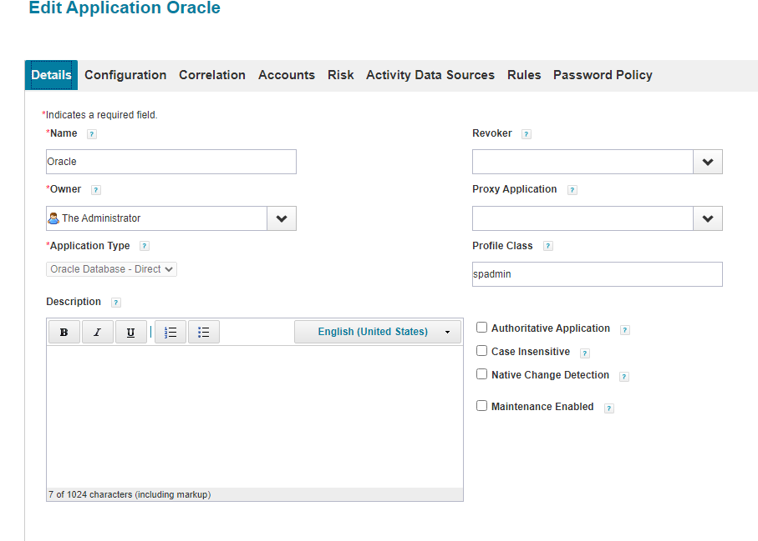

Next give the **configuration**: administrative username: system, password: our password (oracle), URL: jdbc:oracle:thin:@localhost:1521:xe,Driver class: oracle.jdbc.driver.OracleDriver as shown below.

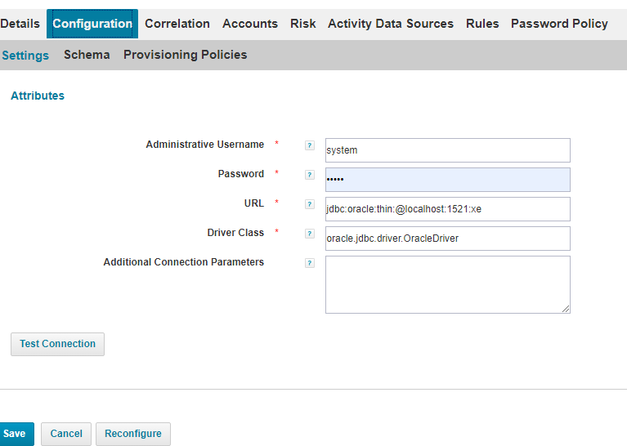

**Schema:** in this schema no need to give anything because it is a little server so it will give all attributes and group also. As shown below

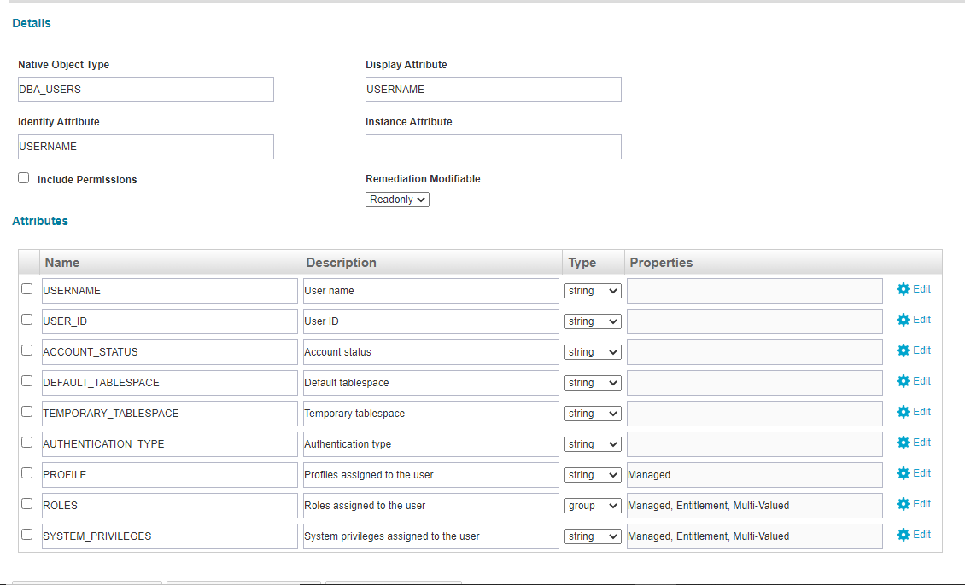

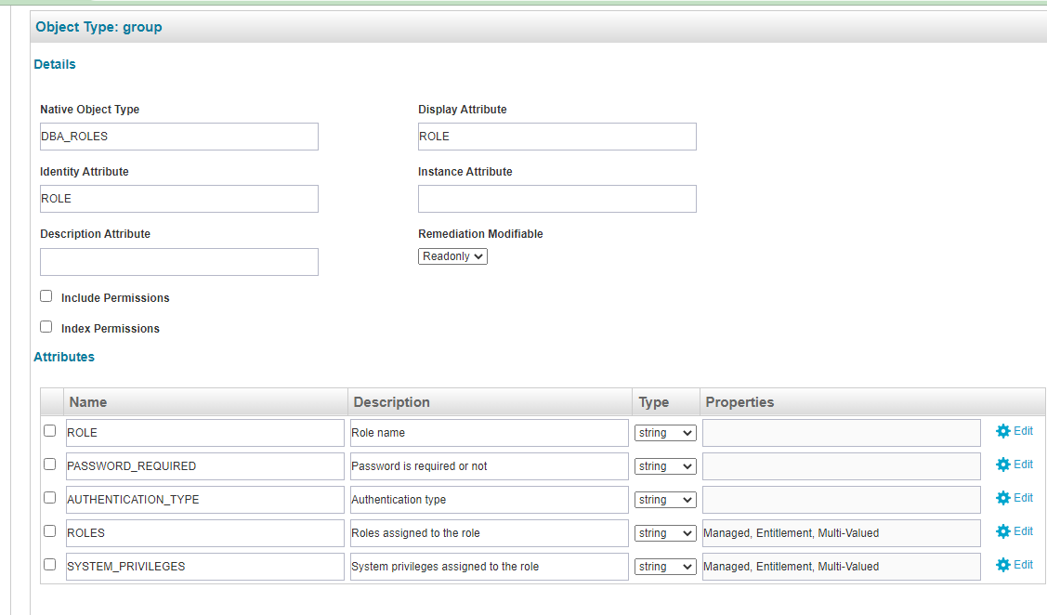

* Finally Aggregate the Application

Setup->Task->new task->Account Aggregation->give name: OracleAcc, select scanned application and save and execute.

1. Go to menu bar->my tasks->Manage Access->Manage user Access->filters->Application: HRFeedApp (which one we want to change) ->apply

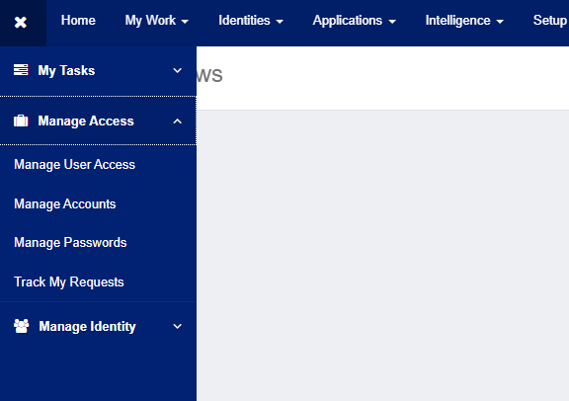

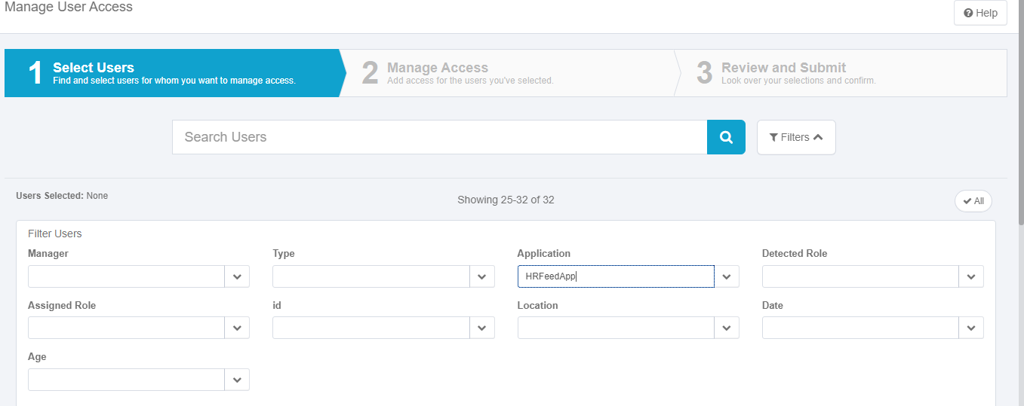

**Select user :**-> select Application: HRFeedApp ->apply->select user->next

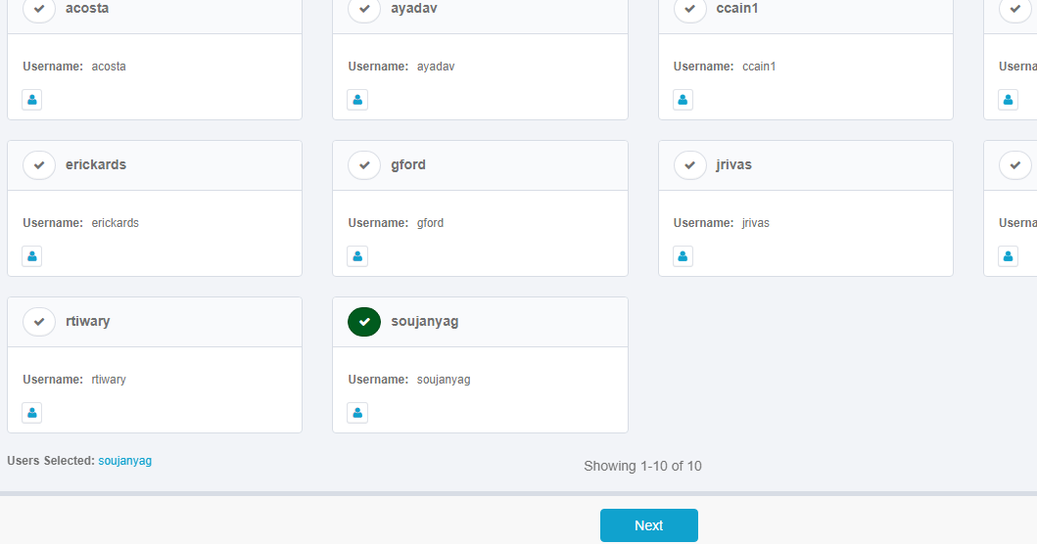

**Manage Access :**-> Filters->Entitlement Application: Oracle->Entitlement Attribute: ROLES-Oracle->Apply-> Add Access->select Accesses ->next->

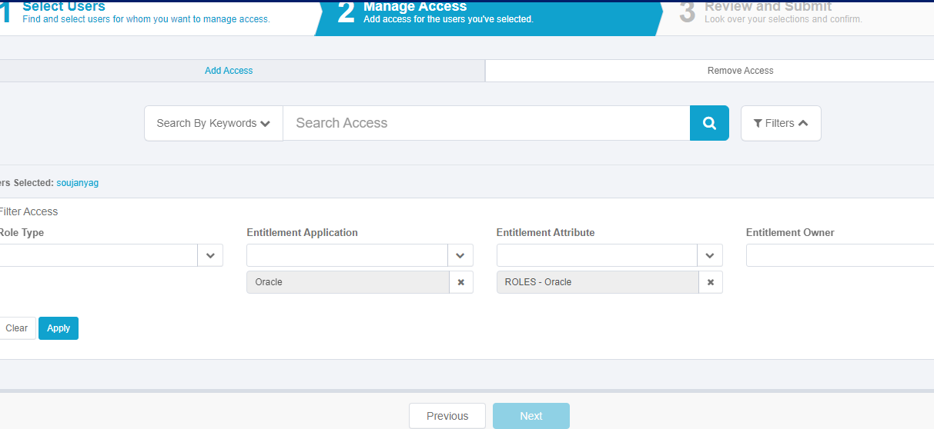

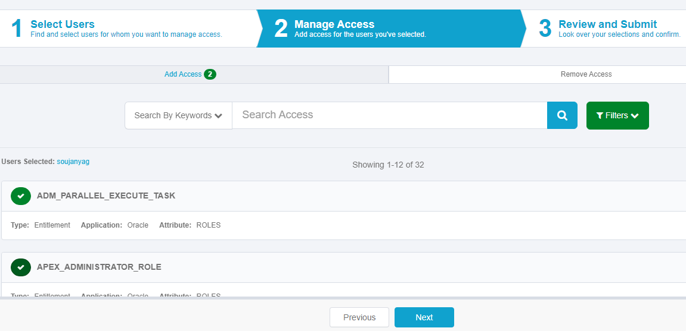

**Review and submit :->** click onsubmit-> click on complete form

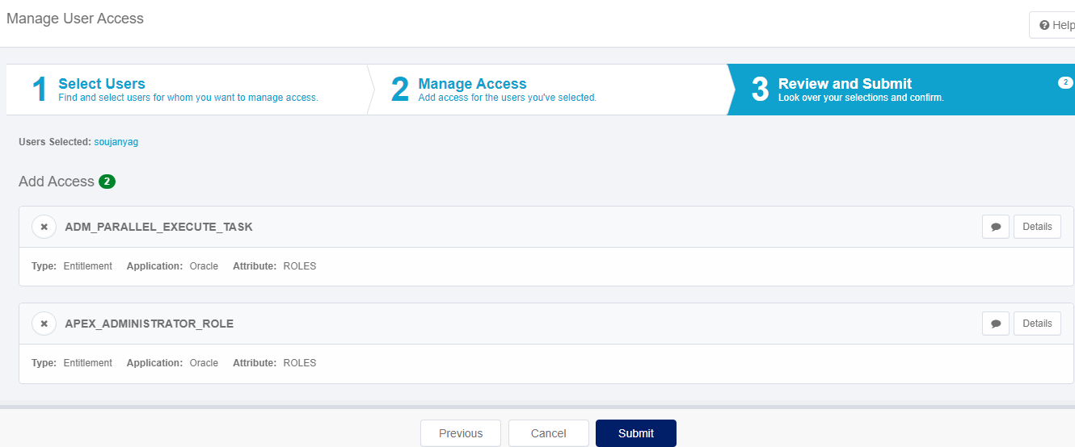

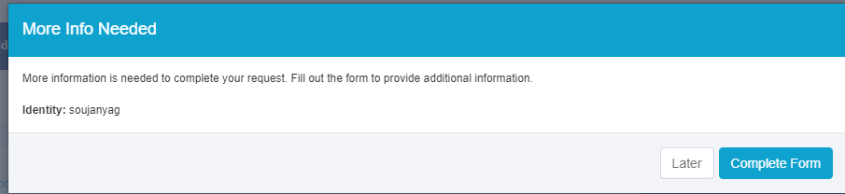

**Complete Work Item (Form) :->** username: give name (what we want to change) ->password: passwords (admin) ->click on ok

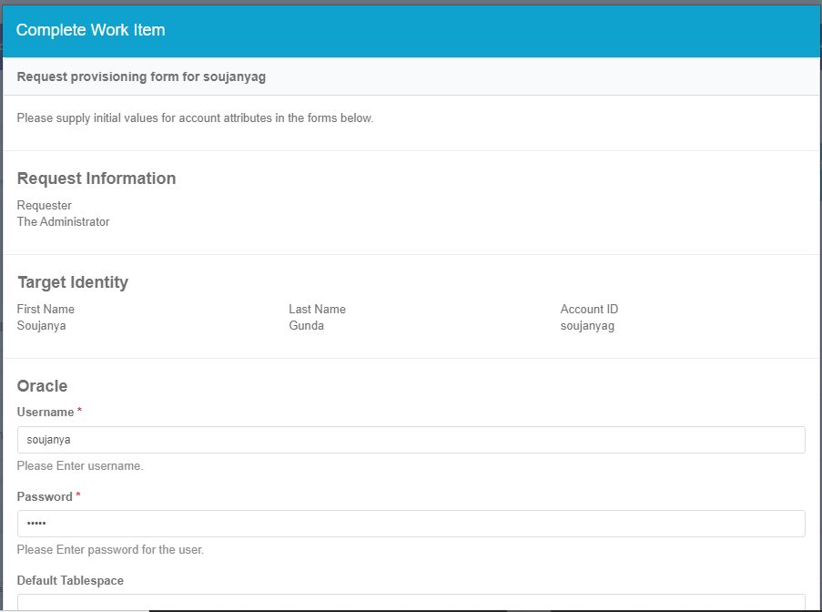



* If we want to give same access to the multiple users then we can select multiple users at a time but the complete work item form won’t come.
* So we can see in notifications (bell icon) or in work items.

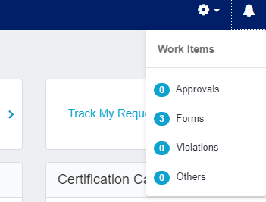 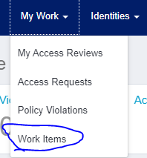

* After click on forms/work items we get one form as shown below.

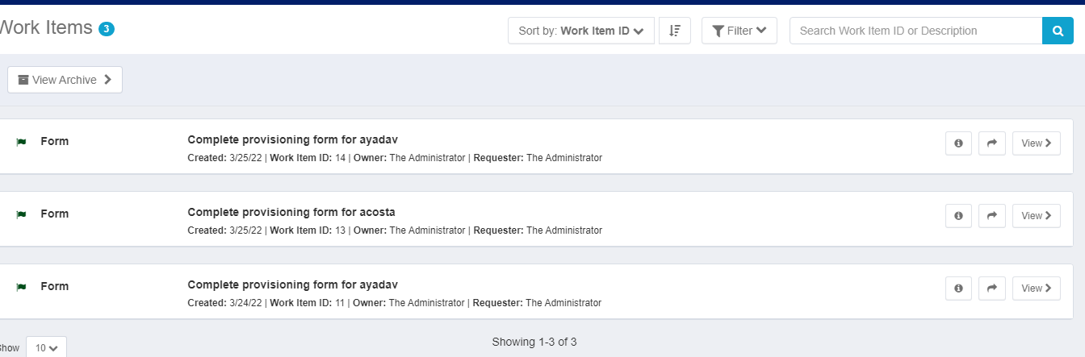

* Next go to my work->Access Request-> we can see all the request Accesses and that will be on waiting state->click on details :->
* **Completion status**: *pending*, **execution status**: *Executing*, **approval statusand provision status** both are in ***pending*** as shown below

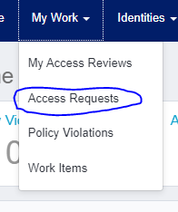

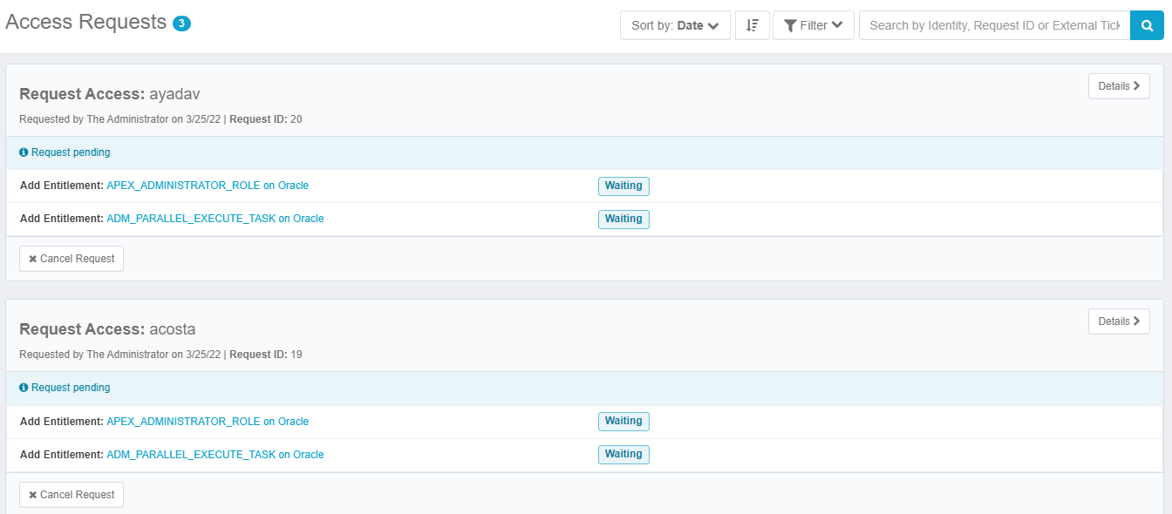

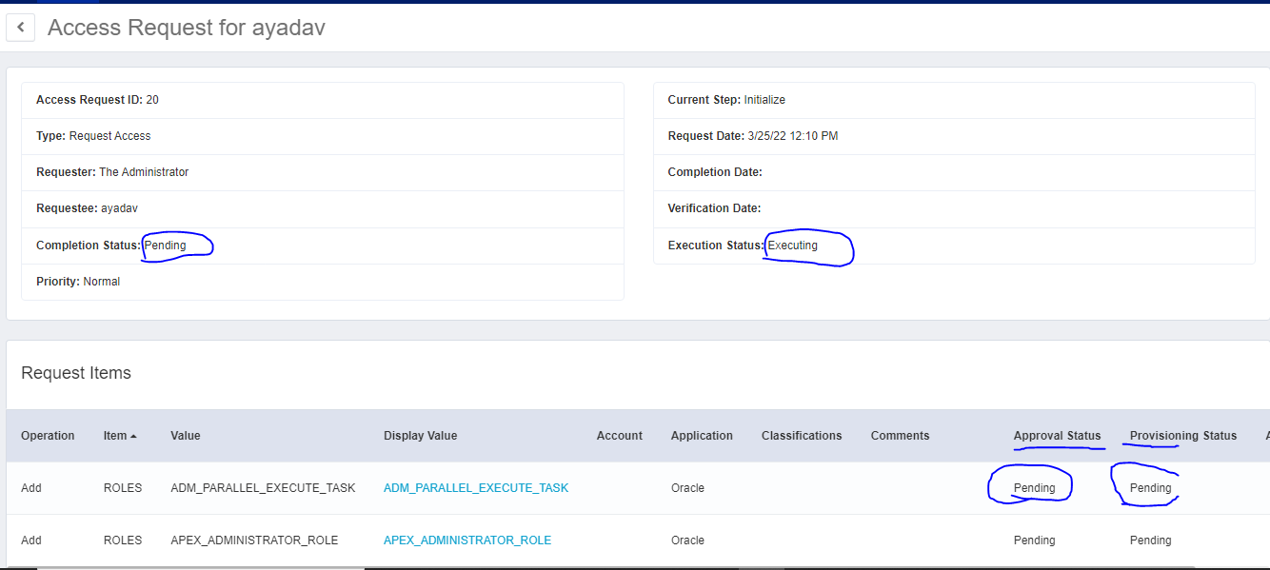

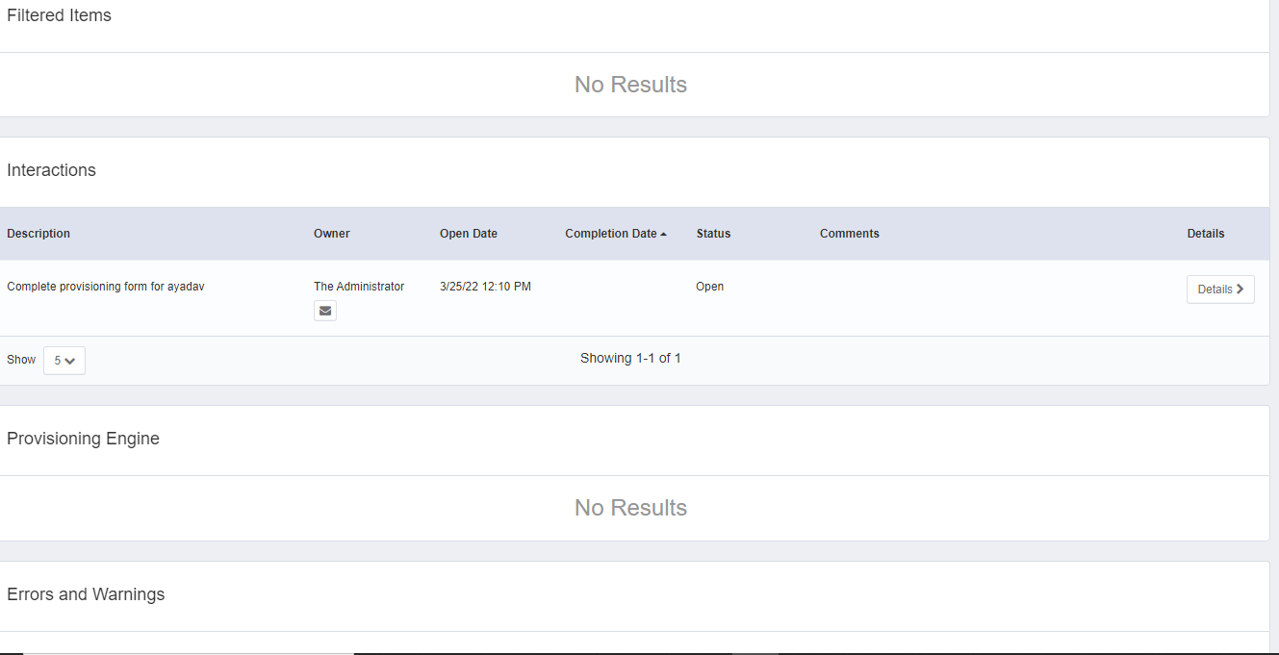

* Again go to **Work items** :-> click on **forward** and select one identity to whom you want to forward next again we get same form i.e work item finally click on **view** give **username** and **password :->** click on okay.
* Finally go to tasks->**perform maintenance** (if workflow will struck) because usually perform maintenance will execute every 5 min.
* Next go to my work->Access Request-> we can see all the request Accesses and that will be on ***provisioning state***->click on details :->
* **Completion status**: *pending*, **execution status**:*veryfying****,*** **approval status:-***pending***,provisioning status:-***committed* and **in provisioning engine status:-** *committed*  **reason:-***requested*as shown below

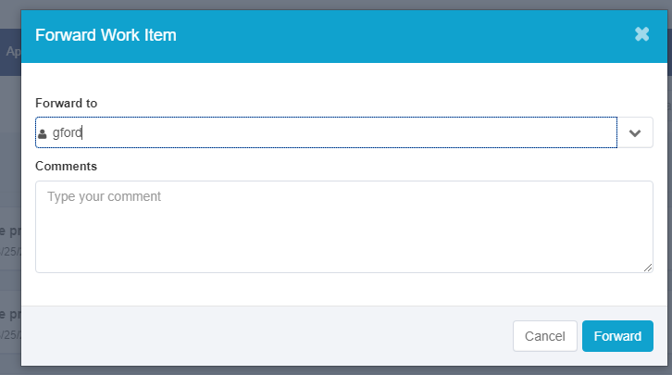

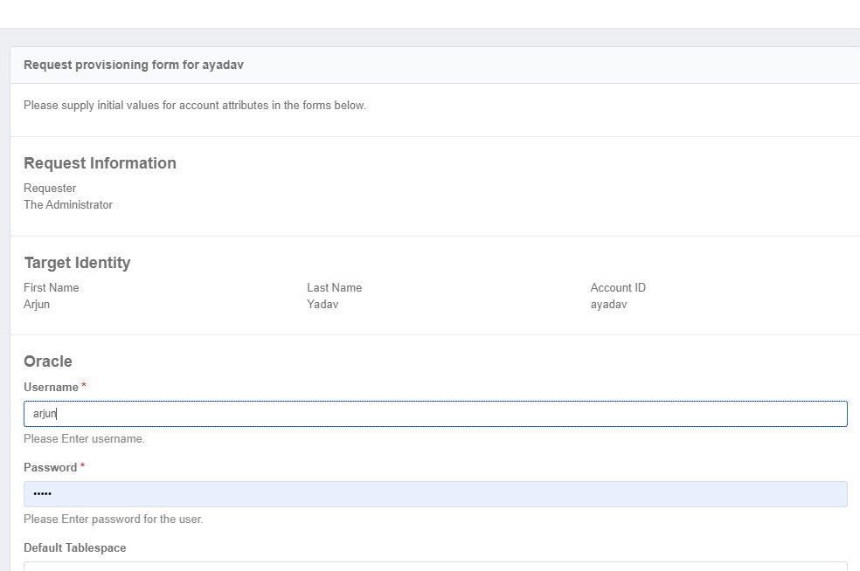

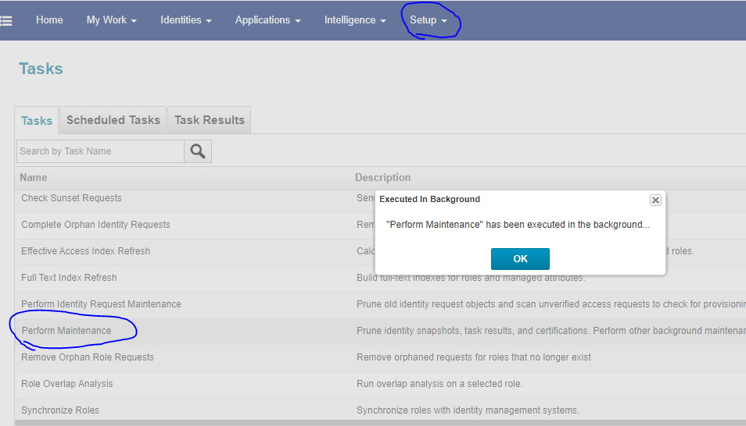

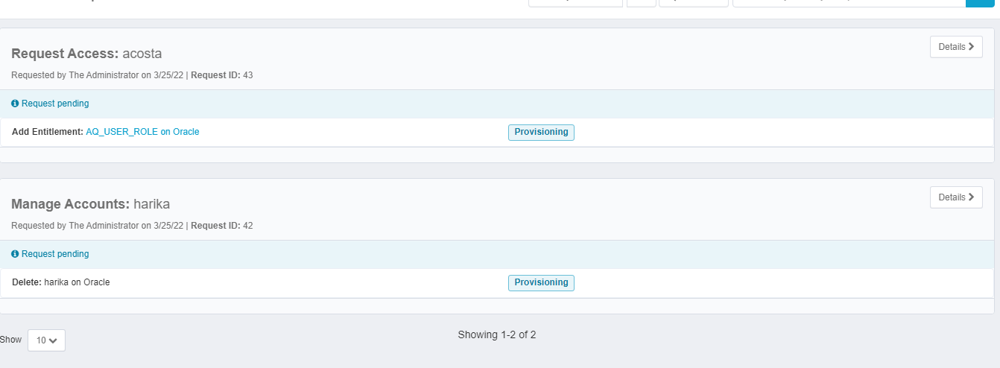

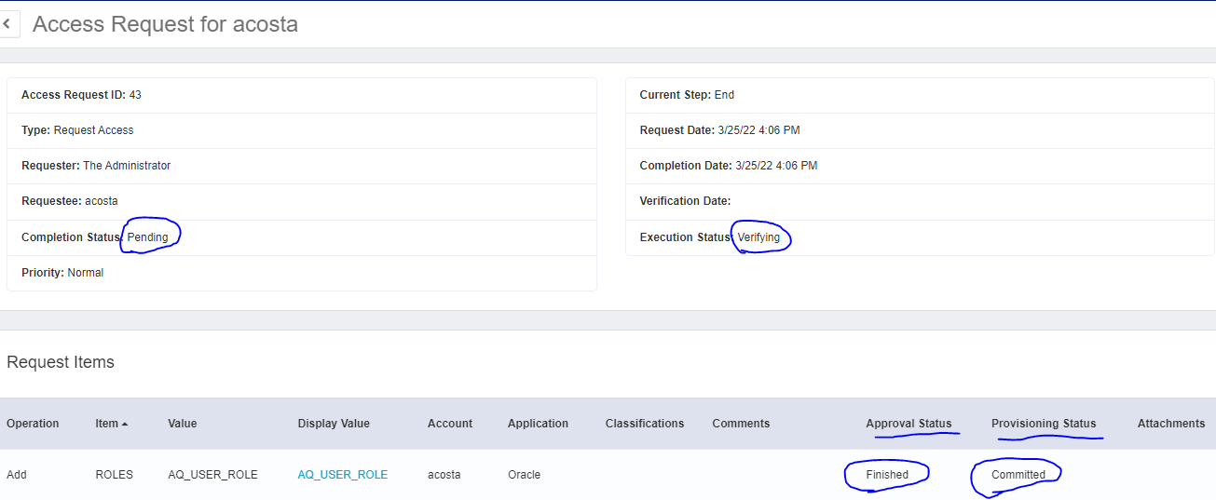

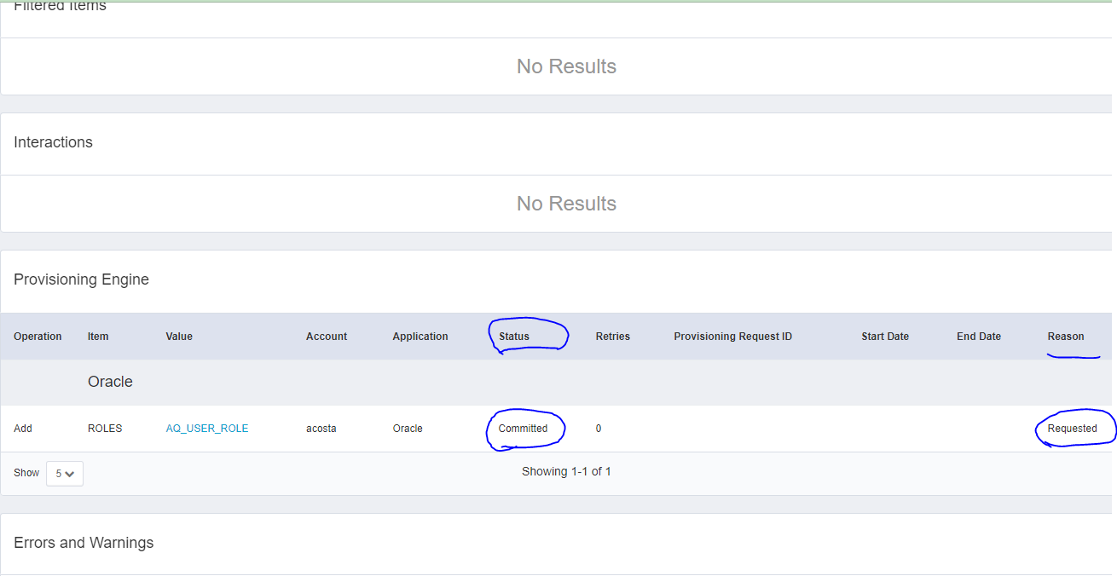

* For completion of provisioning go to set up->task-> **perform identity request maintenance ->** save and execute-> click on ok

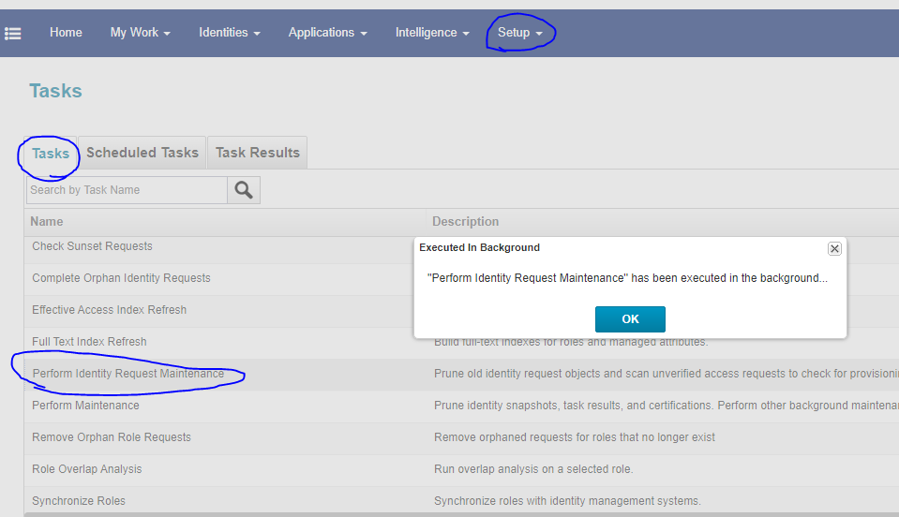

* Finally go to my work->Access Request-> we can see all the request Accesses and that will be on ***complete state***->click on details :->
* **Completion status**: *success*, **execution status**: *completed****,*** **approval status:-***finished***,provisioning status:-***finished* and **in provisioning engine status:-***finished* **reason:-***requested* as shown below

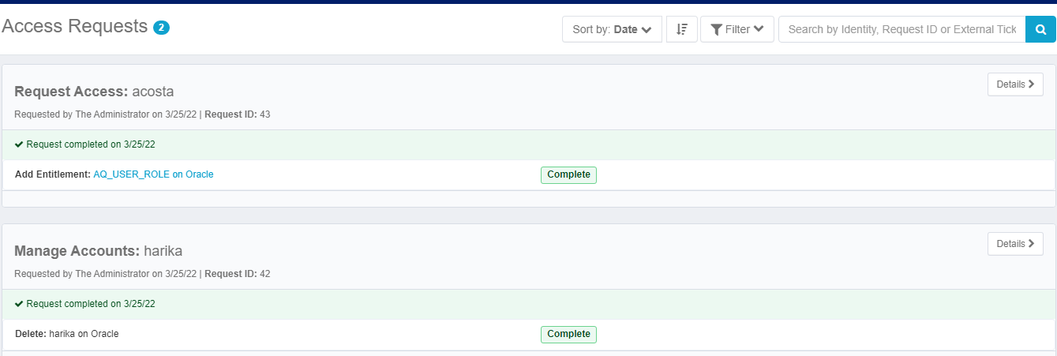

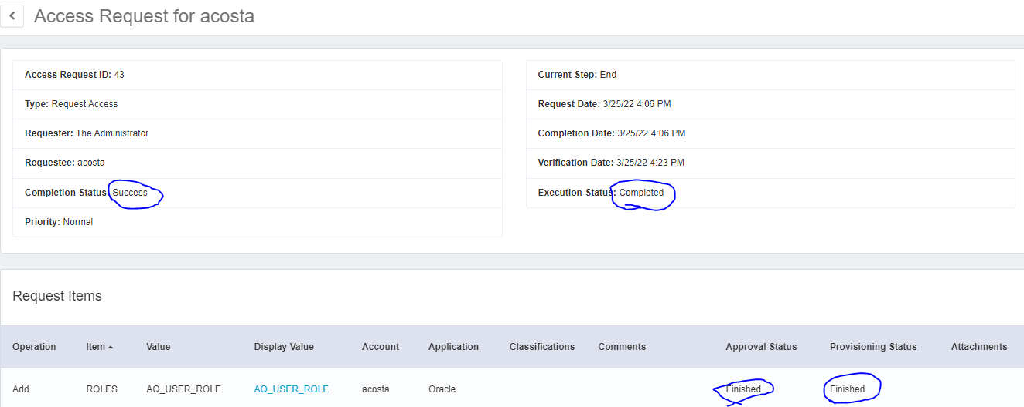

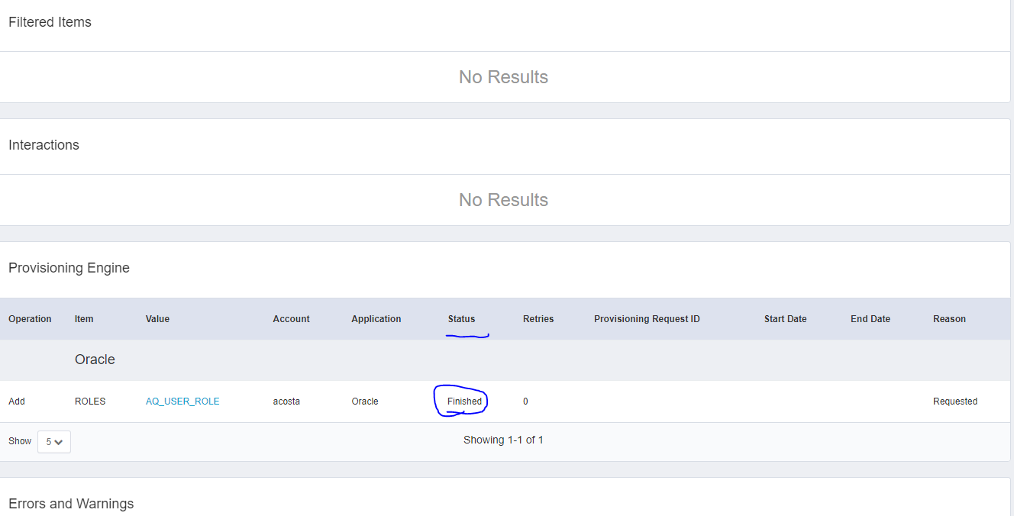

* If we change the owner (spadmin) of an application to some other identity and then we want to assign roles to identities in that case in **Access request** we get request pending and waiting on :owner name (whose name we given )

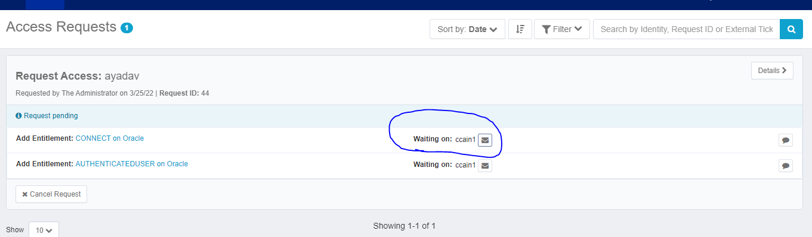

* So we have to login as the owner name which is we given, before that we have to go to identity ware house and click on identity (owner) and change password.
* After login with new user (admin) in notification we get 1 approval message.
* Open Approval and click on **approve or** if we have more approvals then click on **approve all.**

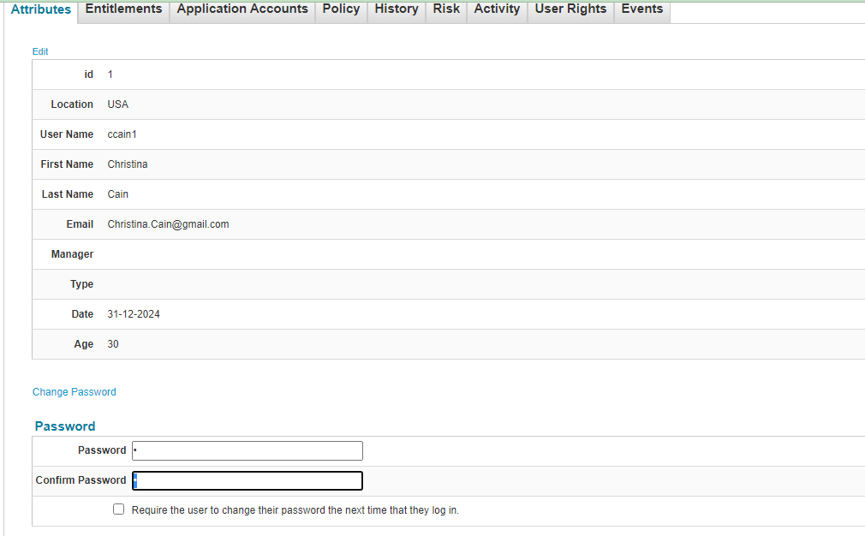

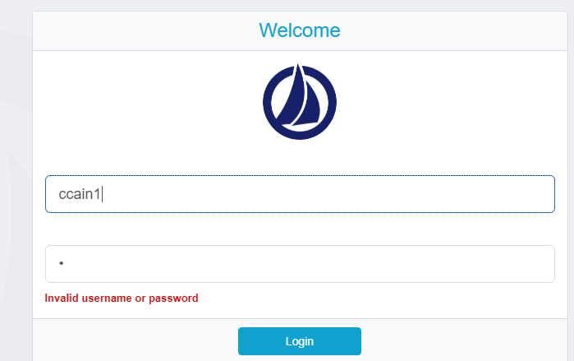

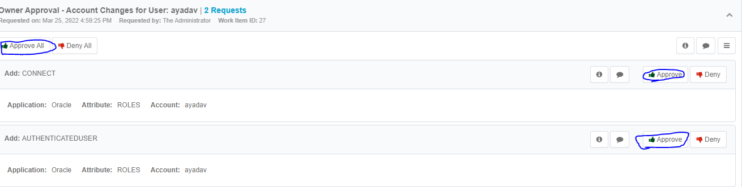

* We have to go to our default login page (admin) and we can see our request access become a provisioning state then we know already how to complete previously we did that one.