WEEK 2 TASK
DATA VISUALIZATION AND INSIGHT COMMUNICATION USING R
Exploring Netflix Content Through Data Visualization Using R
Dataset: Netflix Movies and TV Shows
Source: Kaggle

SUHANI PARMAR

1. Introduction
Data visualization is an important part of data analysis. A dataset can contain thousands of records, but tables alone can make it difficult to identify patterns. Graphs and charts help us understand information more quickly.
For this project, the Netflix Movies and TV Shows dataset from Kaggle is used. The dataset contains information about movies and TV shows available on Netflix, including title, type, country, release year, rating, duration, genre and date added.
The purpose of this project is to use R to create different visualizations and communicate simple insights from the data. The project focuses on visualization rather than machine learning or prediction.

2. Dataset Source
The dataset used is the Netflix Movies and TV Shows dataset available on Kaggle. The file is commonly provided as 'netflix_titles.csv'. It contains information about Netflix titles such as movies and TV shows, their release year, country, rating, duration, genres and date added.
The dataset is suitable for visualization because it contains both numerical and categorical variables and allows us to study trends, comparisons and distributions.
Source: Kaggle, Netflix Movies and TV Shows dataset.

3. Project Objective
- Understand the Netflix dataset using R.
- Perform basic data checking and cleaning.
- Create different types of visualizations using ggplot2.
- Study trends in Netflix content.
- Compare movies and TV shows.
- Identify countries and genres with large amounts of content.
- Understand the distribution of movie durations and ratings.
- Communicate insights in simple language.

4. Tools and Technologies Used
The project is completed using RStudio. The main R package used is tidyverse. ggplot2 is used for graphs and dplyr is used for data manipulation.
- R
- RStudio
- tidyverse
- ggplot2
- dplyr
- read.csv()
- separate_rows()
- group_by()
- summarise()
- ggplot()
- geom_bar()
- geom_col()
- geom_histogram()
- geom_point()
- geom_line()

5. Dataset Variables
Variable | Simple Meaning
show_id | Unique ID of the title
type | Movie or TV Show
title | Name of the title
director | Director name
cast | Main cast members
country | Country or countries associated with the title
date_added | Date the title was added to Netflix
release_year | Original release year
rating | Content rating
duration | Movie duration or number of TV show seasons
listed_in | Genres/categories
description | Short description of the title

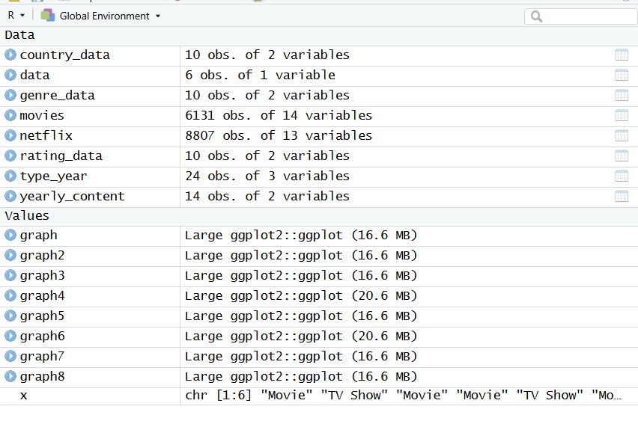

6. Data Loading
The Kaggle CSV file should be downloaded and placed in the same folder as the R script. It should be named 'netflix_titles.csv'. The data is then loaded using read.csv(). The head(), str() and summary() functions are used to understand the dataset.
library(tidyverse)
netflix <- read.csv("netflix_titles.csv",
stringsAsFactors = FALSE)
head(netflix)
str(netflix)
summary(netflix)

7. Data Cleaning and Preparation
The dataset contains missing values in some columns. For the visualization project, the main variables required for the graphs are selected and prepared. Missing values in important categorical columns are labelled as 'Unknown'. The date_added column is converted to a date where possible.
# Check missing values
colSums(is.na(netflix))
# Replace missing values in important columns
netflix$country[is.na(netflix$country)] <- "Unknown"
netflix$rating[is.na(netflix$rating)] <- "Unknown"
netflix$duration[is.na(netflix$duration)] <- "Unknown"
netflix$listed_in[is.na(netflix$listed_in)] <- "Unknown"
# Convert date added
netflix$date_added <- as.Date(
trimws(netflix$date_added),
format = "%B %d, %Y"
)
# Create year added
netflix$year_added <- as.numeric(
format(netflix$date_added, "%Y")
)

OUTPUT:
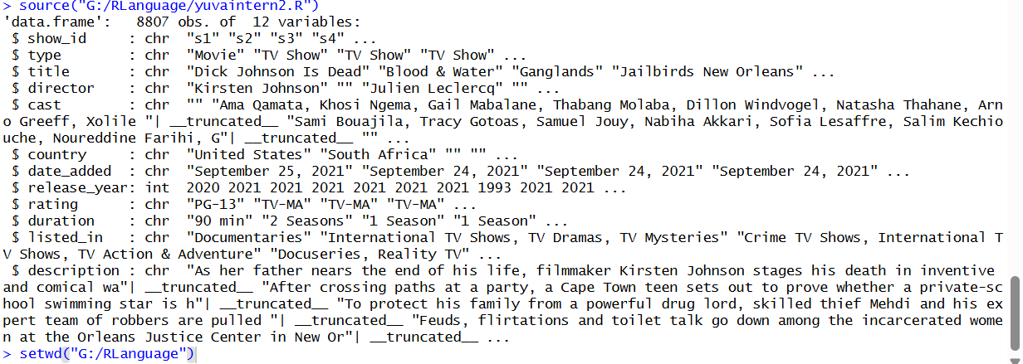

8. Visualization 1 – Movies vs TV Shows
Purpose: This graph compares the number of movies and TV shows in the dataset.
Why this graph was selected: A bar chart is suitable for comparing two categories.
Interpretation: The graph shows how the Netflix catalogue is divided between movies and TV shows. It gives a simple overview of the type of content represented in the dataset.
ggplot(netflix, aes(x = type)) +
geom_bar() +
labs(
title = "Movies vs TV Shows on Netflix",
x = "Content Type",
y = "Number of Titles"
) +
theme_minimal()
OUTPUT:
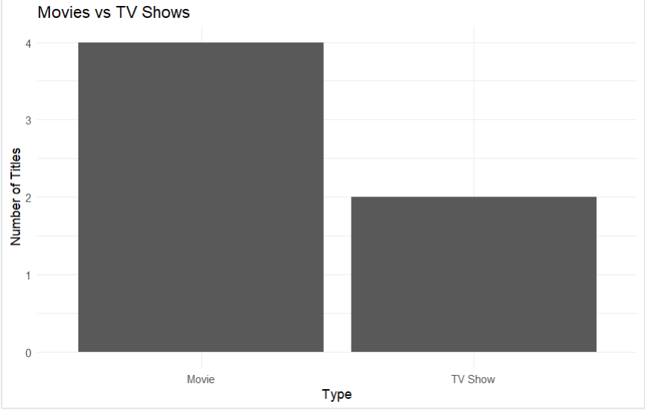

9. Visualization 2 – Content Added by Year
Purpose: This line chart shows how the number of Netflix titles added to the dataset changed over the years.
Why this graph was selected: A line chart is useful for showing changes over time.
Interpretation: The graph helps identify years when Netflix added more or fewer titles. It provides a simple view of how the Netflix catalogue expanded over time.
yearly_content <- netflix %>%
filter(!is.na(year_added)) %>%
count(year_added)
ggplot(yearly_content,
aes(x = year_added, y = n)) +
geom_line() +
geom_point() +
labs(
title = "Netflix Content Added by Year",
x = "Year",
y = "Number of Titles Added"
) +
theme_minimal()
OUTPUT:
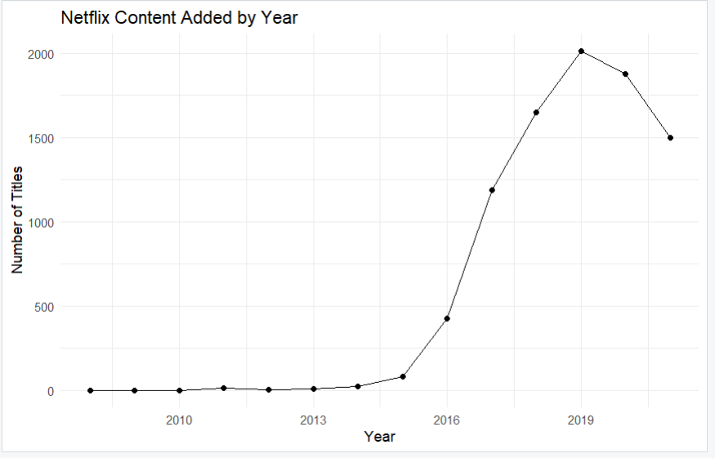

10. Visualization 3 – Top 10 Countries
Purpose: This graph identifies the countries associated with the largest number of Netflix titles.
Why this graph was selected: A horizontal bar chart makes country names easier to read and compare.
Interpretation: The graph shows which countries contribute a large amount of content to the dataset. Because a title can be associated with more than one country, the counts represent country-title associations rather than unique titles produced entirely by one country.
country_data <- netflix %>%
separate_rows(country, sep = ",\\s*") %>%
filter(country != "Unknown", country != "") %>%
count(country, sort = TRUE) %>%
slice_head(n = 10)
ggplot(country_data,
aes(x = reorder(country, n), y = n)) +
geom_col() +
coord_flip() +
labs(
title = "Top 10 Countries by Netflix Content",
x = "Country",
y = "Number of Titles"
) +
theme_minimal()
OUTPUT:
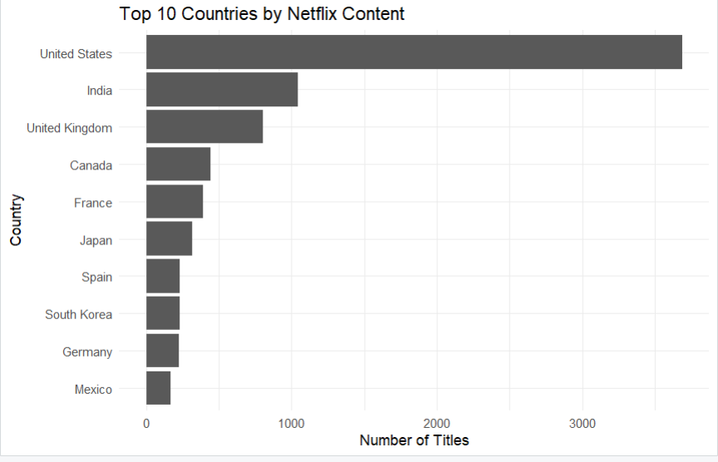

11. Visualization 4 – Movie Duration Distribution
Purpose: This histogram shows the distribution of movie durations.
Why this graph was selected: A histogram is suitable for numerical data and helps show how values are distributed.
Interpretation: Most movies are concentrated within a common duration range, while very short and very long movies are less common. The graph also helps identify unusual duration values.
movies <- netflix %>%
filter(type == "Movie")
movies$duration_min <- as.numeric(
sub(" min", "", movies$duration)
)
ggplot(movies, aes(x = duration_min)) +
geom_histogram(
bins = 30,
na.rm = TRUE
) +
labs(
title = "Distribution of Movie Durations",
x = "Duration (minutes)",
y = "Number of Movies"
) +
theme_minimal()
OUTPUT:
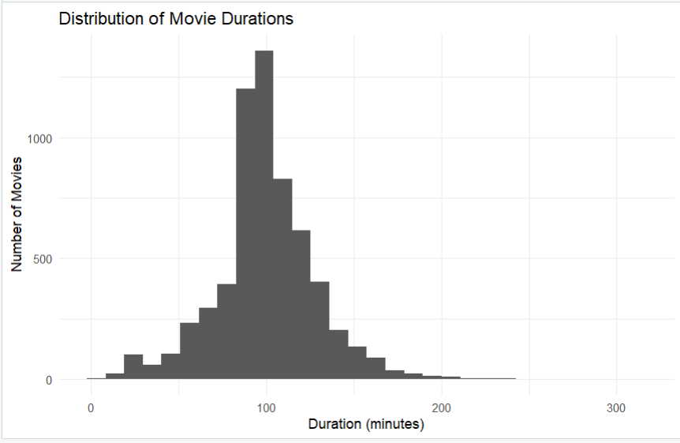

12. Visualization 5 – Content by Rating
Purpose: This graph compares the number of titles under different content ratings.
Why this graph was selected: A bar chart is appropriate because rating is a categorical variable.
Interpretation: The graph shows which ratings are most common in the Netflix dataset. It gives a simple understanding of the type of audience for which the available content is classified.
rating_data <- netflix %>%
count(rating, sort = TRUE) %>%
slice_head(n = 10)
ggplot(rating_data,
aes(x = reorder(rating, n), y = n)) +
geom_col() +
coord_flip() +
labs(
title = "Top Content Ratings on Netflix",
x = "Rating",
y = "Number of Titles"
) +
theme_minimal()
OUTPUT:
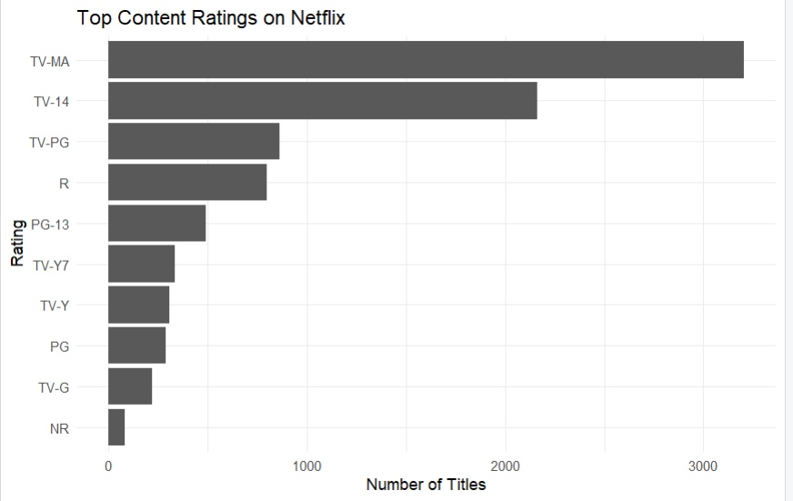

13. Visualization 6 – Release Year and Movie Duration
Purpose: This scatter plot examines the relationship between release year and movie duration.
Why this graph was selected: A scatter plot is useful when comparing two numerical variables.
Interpretation: The points show how movie durations are spread across different release years. The graph can reveal whether there is an obvious pattern or whether duration varies widely across years.
ggplot(movies,
aes(x = release_year,
y = duration_min)) +
geom_point(alpha = 0.4, na.rm = TRUE) +
labs(
title = "Movie Duration vs Release Year",
x = "Release Year",
y = "Duration (minutes)"
) +
theme_minimal()
OUTPUT:
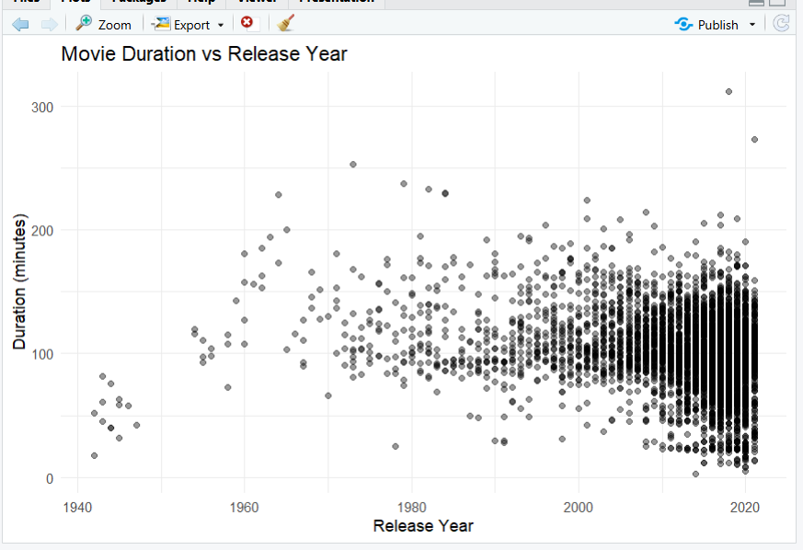

14. Visualization 7 – Movies and TV Shows Added by Year
Purpose: This graph compares the number of movies and TV shows added to Netflix over time.
Why this graph was selected: A grouped line chart makes it possible to compare two content types across the same time period.
Interpretation: The graph shows how the balance between movies and TV shows changed over time. It can help identify periods in which one type of content was added more frequently than the other.
type_year <- netflix %>%
filter(!is.na(year_added)) %>%
count(year_added, type)
ggplot(type_year,
aes(x = year_added,
y = n,
group = type,
linetype = type)) +
geom_line() +
geom_point() +
labs(
title = "Movies and TV Shows Added by Year",
x = "Year",
y = "Number of Titles",
linetype = "Type"
) +
theme_minimal()
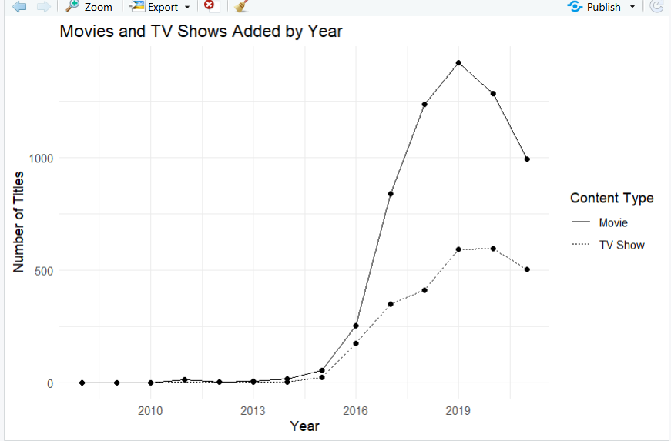

15. Visualization 8 – Top Genres
Purpose: This graph shows the most common genres or categories in the Netflix dataset.
Why this graph was selected: A horizontal bar chart makes it easy to compare many genre names.
Interpretation: The graph highlights the categories that appear most frequently in the Netflix catalogue. A title can belong to more than one genre, so the values represent genre-title associations.
genre_data <- netflix %>%
separate_rows(listed_in, sep = ",\\s*") %>%
count(listed_in, sort = TRUE) %>%
slice_head(n = 10)
ggplot(genre_data,
aes(x = reorder(listed_in, n), y = n)) +
geom_col() +
coord_flip() +
labs(
title = "Top 10 Netflix Genres",
x = "Genre",
y = "Number of Titles"
) +
theme_minimal()
OUTPUT:
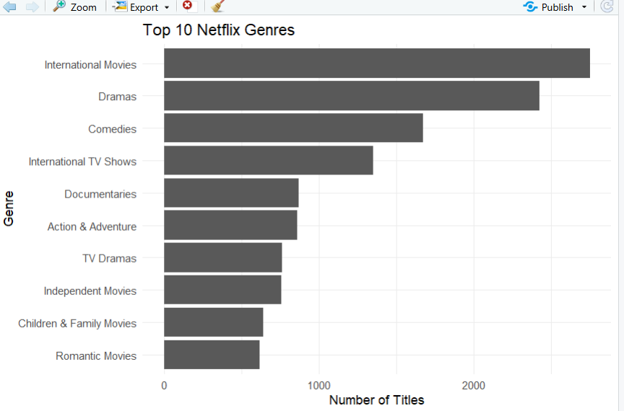

16. Major Findings
- The dataset contains both movies and TV shows, allowing a direct comparison of content types.
- The number of titles added varies across years, showing changes in Netflix's catalogue growth.
- A relatively small group of countries appears frequently in the country analysis.
- Movie durations are concentrated around common running times, while very short and very long movies are less common.
- Some content ratings appear much more frequently than others.
- Movie duration varies across release years, and the scatter plot does not need to show a simple relationship.
- Comparing movies and TV shows by year provides more information than looking only at their overall counts.
- Several genres occur frequently, showing the types of content strongly represented in the dataset.

17. Why Different Graphs Were Used
Different graphs were selected because different types of data require different visual forms. Bar charts are useful for category comparisons. Line charts are useful for showing changes over time. Histograms are useful for numerical distributions. Scatter plots are useful for studying relationships between two numerical variables. Horizontal bars are useful when category names are long.
The goal was not to use graphs only for appearance. Each visualization was selected to answer a specific question about the Netflix dataset.

18. Importance of Data Visualization
Data visualization helps convert raw data into information that people can understand quickly. For example, a table containing thousands of Netflix titles would make it difficult to identify the most common genres or countries. A graph makes these comparisons much easier.
Visualization is also useful for finding trends, unusual observations and differences between groups. It helps both technical and non-technical users communicate findings.

19. Limitations
- The dataset represents the information available in the Kaggle file and may not represent the complete current Netflix catalogue.
- Country and genre fields can contain multiple values for one title, so their counts represent associations.
- Missing values exist in some columns and were handled only for the variables required in the visualizations.
- The analysis describes patterns and does not prove that one variable causes another.
- Some titles may have unusual or missing duration information, so they are excluded from numerical duration plots.

20. Conclusion
This project used R to explore the Netflix Movies and TV Shows dataset through data visualization. Eight visualizations were designed to examine content type, content added over time, countries, movie duration, ratings, release year, content type by year and genres.
The project demonstrates that visualization can make a large dataset much easier to understand. Each graph answers a different question and presents the information in a simple form.
The analysis also demonstrates basic data cleaning, transformation and visualization using R. Overall, the project shows how R can be used to turn raw entertainment data into clear and useful insights.

21. Reproducibility
The complete R code is provided separately. To reproduce the analysis, download the Kaggle Netflix dataset, place netflix_titles.csv in the same folder as the R script, install tidyverse if required, and run the script from top to bottom in RStudio. The graphs will be generated directly from the dataset.

22. References
- Kaggle, 'Netflix Movies and TV Shows' dataset.
- R Core Team, 'R: A Language and Environment for Statistical Computing.'
- H. Wickham et al., 'ggplot2: Elegant Graphics for Data Analysis.'
- tidyverse documentation and package references.

