|  |  |  |  |
| --- | --- | --- | --- |
| **Desired positions:** | | |  |
| Full name:  /according to your travel passport/ | **Last and First Name** | |
| full_name_test | |
| Date of birth: | **date_of_birth_test** | |
| Place of Birth: | **place_of_birth_test** | |
| Marital status: | married_test | |
|
| Children: | have_any_children_test | |
| Height / Weight: | **cm** | **kg** |
| height_test | weight_test |
| City of residence: | city_of_residence_test | | |
| Current location: | current_location_test | | |
| Nationality: | ationality_test | | |
| Citizenship: | nationality_country_test | | |
| Do you have travel passport? | haveP_test | | |
| Have you received COVID vaccine?  If yes, please specify and send certificate | covid_access_test | | |
| Mobile number:  +country code /operator code/ number | phone_Number_test | | |
| Messenger:  whatsapp /viber/ telegram | messenger_test | | |
| E-mail addresses: | email_test | | |
| Facebook page: | facebook_test | | |
| Instagram page: | instagram_test | | |
| Linkedin page: | linkedIn_test | | |
| VKontakte page: | vkontakte_test | | |
| **Relative’s contact details in case of emergency:** | | | |
| Name: | name_cousen_test | | |
| Relationship: | relative_cousen_test | | |
| Mobile number  +country code /operator code/ number | phone_Number_cousen_test | | |
| Father’s name: | father_name_test | | |
| Mother’s name: | mother_name_test | | |

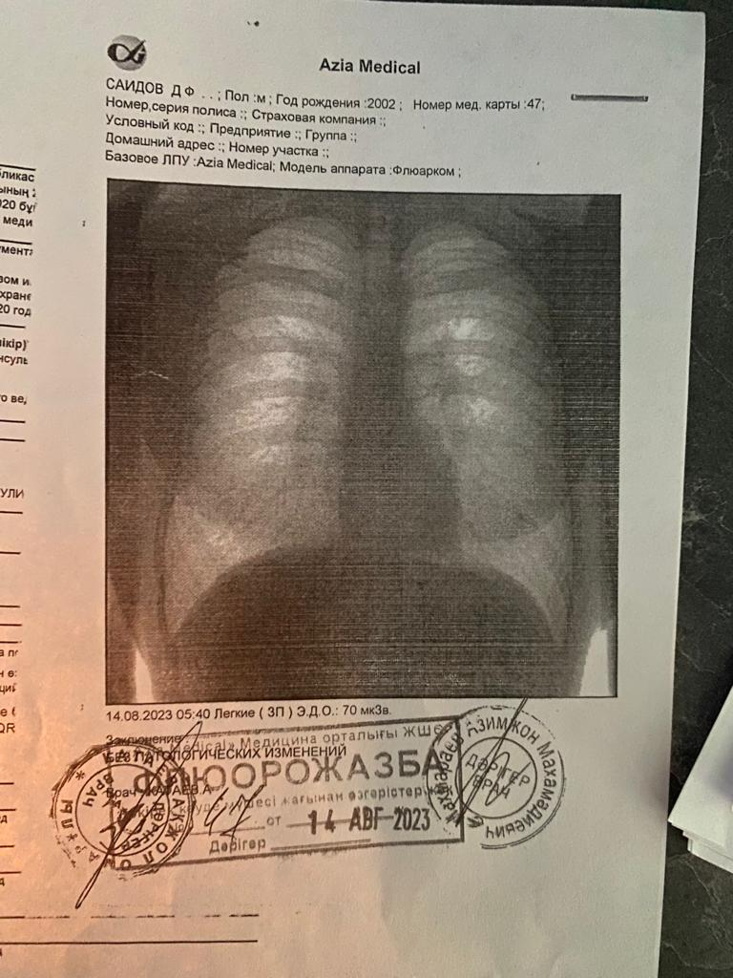

|  |  |  |  |
| --- | --- | --- | --- |
| **Preferred countries to relocate and work:** | | | |
| Qatar | UAE | Bahrain | Oman |
| gatar_test | UAE_test | Bahrain_test | Oman_test |

|  |  |  |  |
| --- | --- | --- | --- |
| **Education:** | | | |
| Certificate / Degree | College/ University | Area of  Specialization | Years  started-completed |
| education_stepen_test | university_name_test | special_degree_test | year_of_Education_test |
|  |  |  |  |

|  |  |  |
| --- | --- | --- |
| **Seminars / training attended/ Short Courses taken, and date attended:** | | |
| Year: | Name: | Period of attending: |
| course_date_test | сourse_name_test | Course_place_test |
|  |  |  |

|  |
| --- |
| **Do you have any tattoos or piercing?**  (If yes, please describe and send us photos) |
| **tattoo_discribe_test** |

|  |  |
| --- | --- |
| **Work experience**  *официальный и не официальный начиная с последнего или текущего места работы* | |
| Position: | work_position_test |
| Company’s name, location: | work_name_test, work_place_test |
| Date (started-left): | work_exp_test |
| Responsibilities: | work_responsibilities_test |

|  |  |
| --- | --- |
| Position: | other_work_position_test |
| Company’s name, location: | other_work_name_test, other_work_place_test |
| Date (started-left): | other_work_exp_test |
| Responsibilities: | other_work_responsibilities_test |

|  |  |
| --- | --- |
| Position: | now_work_position_test |
| Company’s name, location: | now_work_name_test, now_work_place_test |
| Date (started-left): | now_work_exp_test |
| Responsibilities: | now_work_responsibilities_test |

|  |  |  |  |  |
| --- | --- | --- | --- | --- |
| **Computer programs you work with:**  *Please write name of computer program you worked with* | | | | |
| Hospitality programs: | Finance programs: | Travel & booking programs: | Graphics & Design programs: | Other software: |
| hoste_program_test | finance_program_test | travel_program_test | graph_program_test |  |

|  |  |  |  |
| --- | --- | --- | --- |
| **Driver license:** | car_access_test | **Category:** | car_category_test |

|  |  |  |  |  |  |  |  |
| --- | --- | --- | --- | --- | --- | --- | --- |
| **Languages Known:** | | | | | | | |
| **Language** | **Basic** | **Elementary** | **Lower Intermediate** | **Intermediate** | **Upper- Intermediate** | **Advanced** | **Fluent** |
| **Russian** | R_b_test | R_e_test | R_l_test | R_i_test | R_u_test | R_a_test | R_f_test |
| **English** | E_b_test | E_e_test | E_l_test | E_i_test | E_u_test | E_a_test | E_f_test |
| **Type additional languages:** | | | | | | | |
| **Add_test** | A_b_test | A_e_test | A_l_test | A_i_test | A_u_test | A_a_test | A_f_test |

|  |  |  |  |  |  |
| --- | --- | --- | --- | --- | --- |
| **How did you know about us?** | | | | | |
| Google search | Facebook | Instagram | Vk.com | Friends recommendation | Other sources of  employment search |
| Mark1_test | Mark2_test | Mark3_test | Mark4_test | Mark5_test | Mark5_test |

|  |
| --- |
| **I agree to sign a contract with the employer for at least 24 months.** |

|  |  |  |  |
| --- | --- | --- | --- |
| **Important information for the candidate:** | | | |
| |  | | --- | | **RUS** |   **Отправляя данную анкету, я даю согласие на обработку моих персональных данных.**  Я понимаю и согласен с тем, что агентство вправе отказать мне в прохождении интервью с тем или иным работодателем, поскольку представляет интересы последних по подбору персонала.  Я понимаю и согласен с тем, что агентство может отказать мне в дальнейшем сотрудничестве в следующих случаях:  1. Отказ от должности и компании, в которую сначала давал (а) согласие трудоустраиваться.  2. Отказ после утверждения работодателем моей кандидатуры. | | | |
|  | | | |
| **I confirm that all information given on this resume is true.** | | | |
| **Please type first and last name** |  | Date: | Date_test |

Please insert here a full length colored picture with the smile:)