SMART ADVANCED RAILWAY SYSTEMS
by

MADHAV SHAJI
(23BCE8472)

DARSI AMIT
(23BCE8288)

SAMARANJAY SINGH (23BCE8300)

MIKHAIL ABRAHAM
(23BCE8250)
V RAJ NARAYANAN (23BEC7234)

Under the guidance of

Prof Dr. MOHAN ALLAM

VIT-AP University, Amaravati, Andhra Pradesh - 522237

ABSTRACT
Railway safety systems are essential for protecting the lives of passengers, crew, and freight, while also safeguarding railway infrastructure from accidents and disruptions. These systems include a wide array of technologies and operational strategies aimed at preventing collisions, derailments, and other incidents. Key safety features include advanced signaling systems such as Positive Train Control (PTC) and Automatic Train Protection (ATP), along with track monitoring, real-time communication, and automated response systems. The integration of sensors, machine learning, and big data analytics has improved the ability to predict and detect faults before they lead to failures. In addition to technological advancements, safety in railways relies on regulatory frameworks, safety protocols, and the proper training of personnel to address human factors. Despite these innovations, challenges such as human error, cybersecurity risks, and the need for seamless integration of new technologies with legacy systems continue to require attention. Ongoing development and international collaboration are crucial to creating more robust, efficient, and adaptive railway safety solutions for the future.

TABLE OF CONTENTS
CHAPTER NO. | TITLE
 | ABSTRACT
 | LIST OF FIGURES
1 | INTRODUCTION
2 | PROCEDURE
3 | RESULTS
2 | PROCEDURE
4 | CONCLUSION
5 | LIST OF CODES

COMPONENTS USED

Hard cardboard-2
Gear motor-4
Wheels-4
Male to Male jumper wires
Arduino UNO
Ultrasonic sensor
Male to Female Jumper wires
Dual channel relay module
Transmitter
Receiver
Rechargeable battery-2
5v Relay
Led
Small breadboard-2

Circuit Diagrams

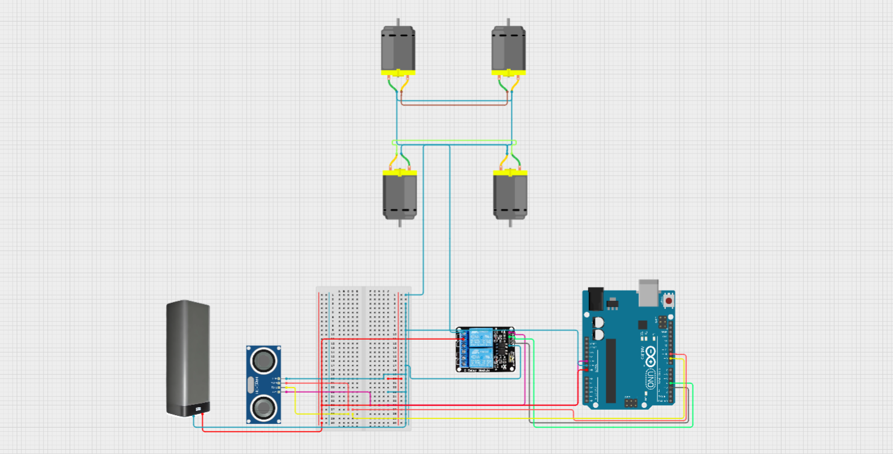

1. SNAPSHOTS OF THE PROTOTYPE

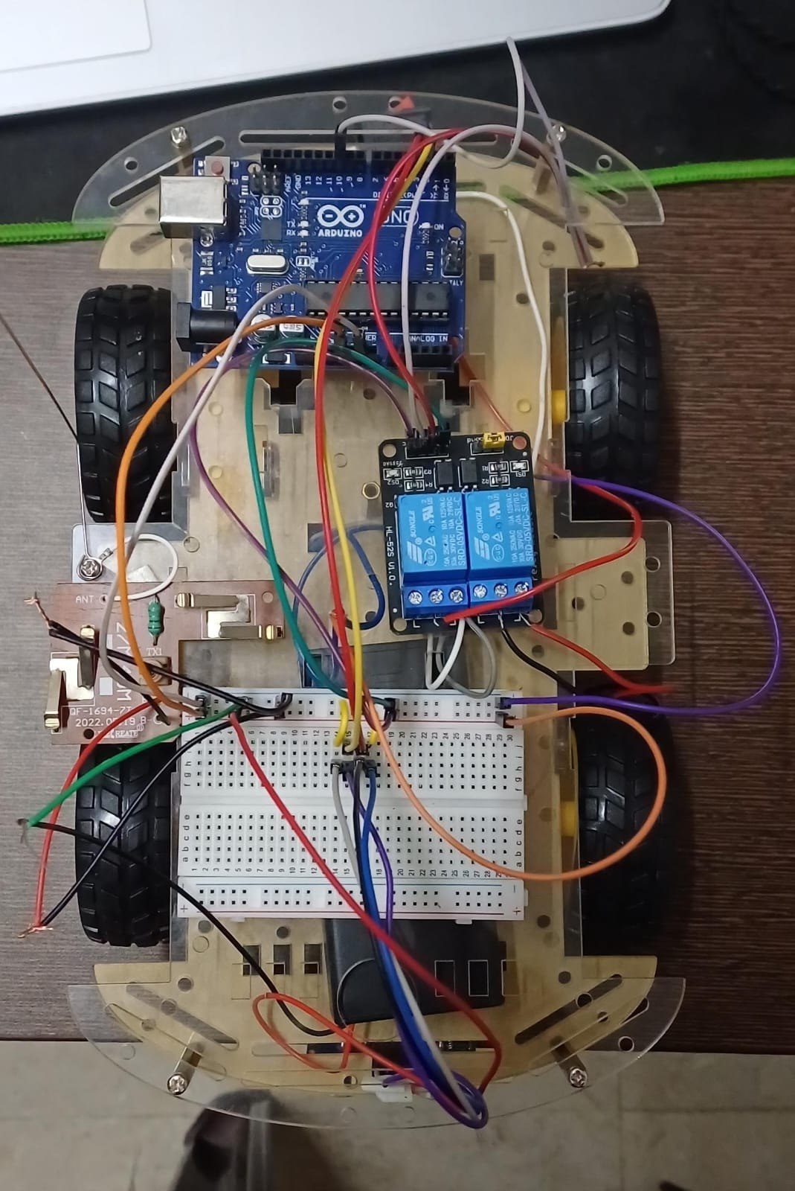

TOP VIEW

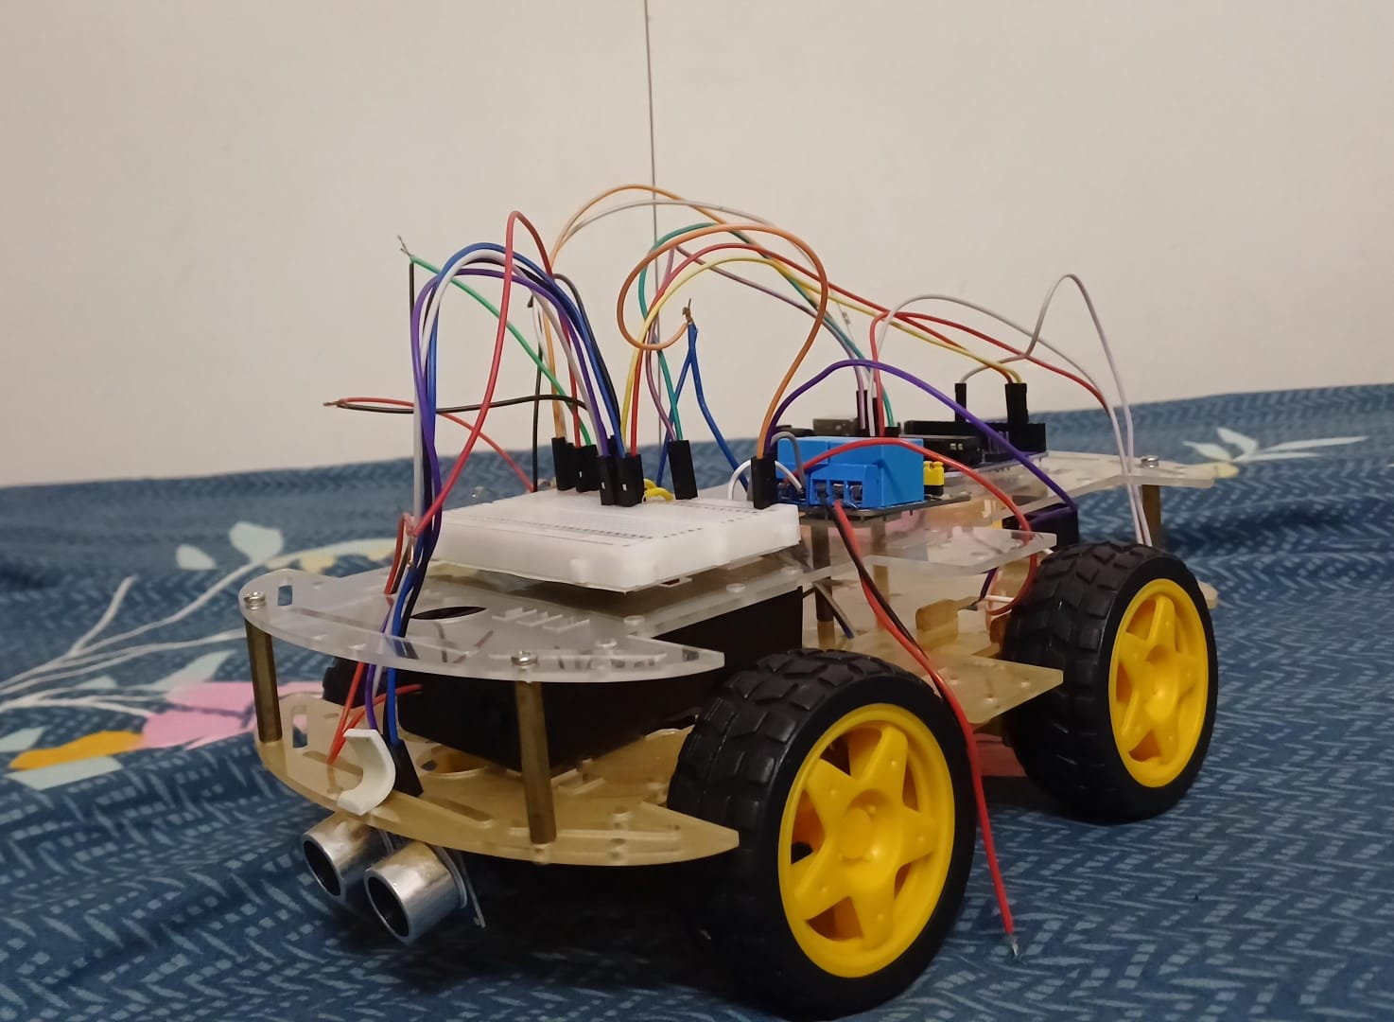

SIDE VIEW

HARDWARE ARCHITECTURE

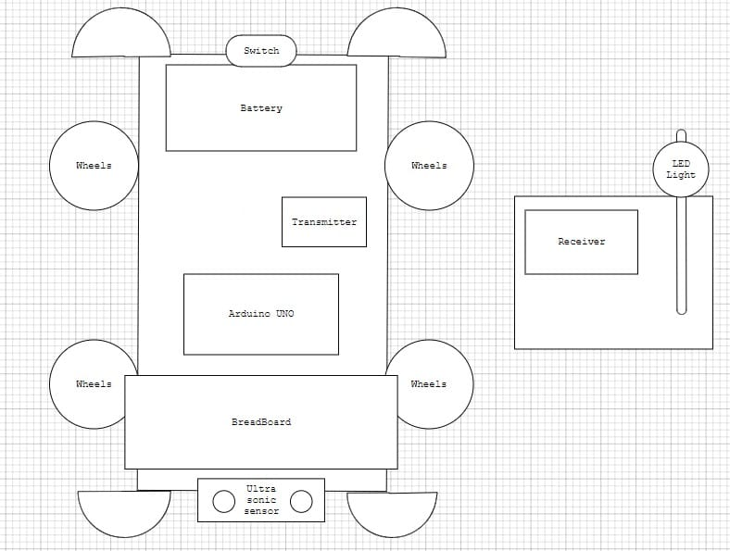

INTRODUCTION

Railway safety has always been a top priority, balancing the need for operational efficiency with the protection of passengers, freight, and infrastructure. In recent years, however, the landscape of railway safety has undergone a dramatic transformation, driven by the advent of smart, advanced technologies. These innovations are reshaping how rail networks prevent accidents, manage risks, and respond to emergencies. Today, railway safety systems leverage cutting-edge solutions such as real-time monitoring, predictive analytics, automated signaling, and advanced train control to enhance safety and operational performance. By harnessing the power of data, artificial intelligence, and the Internet of Things (IoT), these systems offer far greater accuracy in risk detection, enabling proactive responses to potential hazards and reducing human error. With the ongoing integration of these technologies, modern railways are becoming safer, more efficient, and more resilient, paving the way for a future where safety is deeply embedded into every aspect of railway operations. This shift to smart, interconnected safety systems promises not only to mitigate risks but also to redefine the standards of safety in the railway industry.

PROCEDURE

To implement the battery-powered train safety system, start by wiring an ultrasonic sensor (HC-SR04) to an Arduino UNO, connecting the Trig and Echo pins to the Arduino’s digital pins. The motor driver is used to control the train’s movement, while a red LED is incorporated to visually signal when the train stops. Program the Arduino to continuously measure the distance detected by the ultrasonic sensor; if an obstacle is detected within a defined range, the Arduino sends a signal to stop the train by controlling the motor driver. Simultaneously, the red LED lights up, and a stop signal is transmitted via a transmitter module to indicate the train has halted. After assembling the system, test the sensor’s accuracy, ensure the motor driver functions properly, and verify that the LED and transmitter respond correctly when the train stops. Once confirmed, mount the system on the train, ensuring the sensor is correctly positioned for optimal obstacle detection, and validate that the safety system reliably halts the train when needed.

RESULT

The implementation of the battery-powered train safety system was successful in meeting all objectives, demonstrating reliable performance and effective obstacle detection. The ultrasonic sensor accurately detected objects within the predefined threshold distance, typically around 10 cm, triggering an immediate response from the system. Upon detecting an obstacle in the train’s path, the Arduino sent a signal to the motor driver, halting the train’s movement without delay. Simultaneously, the red LED indicator illuminated, providing a clear visual cue that the train had stopped due to an obstacle. In addition to the local feedback from the LED, the transmitter module successfully sent a stop signal to a receiver, indicating to an external system or operator that the train had halted. Throughout testing, the system exhibited a quick response time, with the train stopping within 1-2 seconds of detecting an obstacle. There were no issues with false detections or missed objects, confirming the accuracy and reliability of the ultrasonic sensor. The battery-powered setup proved efficient, with no significant power consumption issues observed during extended testing. Overall, the system worked as intended, enhancing the safety of the train by automatically stopping it in the presence of obstacles, providing both visual and remote feedback, and ensuring operational reliability and safety.

CODE
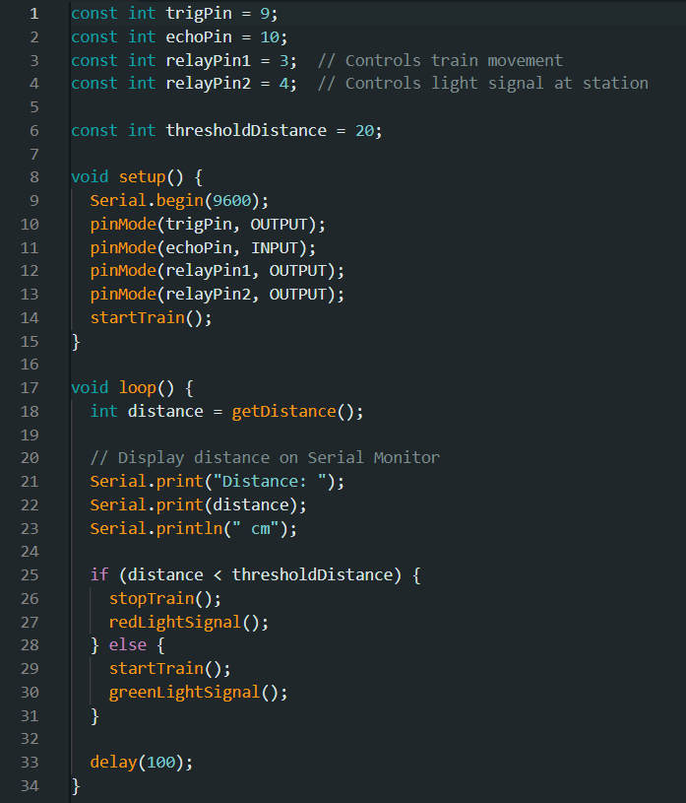

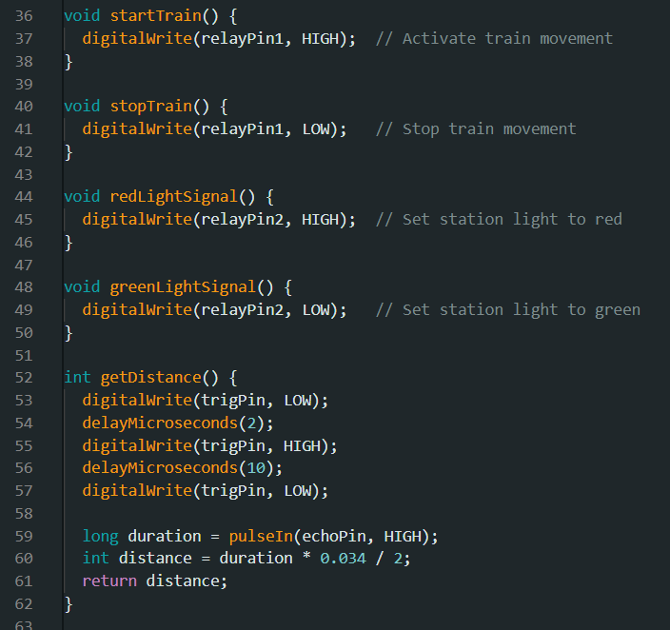

CONCLUSION

The implementation of the battery-powered train safety system, incorporating an ultrasonic sensor, Arduino UNO, motor driver, and LED indicator, proved to be an effective and reliable solution for enhancing the safety and automation of model train operations. The system demonstrated a high level of precision in detecting obstacles within the train’s path and executing an immediate stop, thereby mitigating the risk of potential collisions. The ultrasonic sensor, coupled with the Arduino, provided real-time distance measurements with remarkable accuracy, ensuring timely and reliable obstacle detection. Upon detection of an object, the motor control mechanism successfully halted the train, while the red LED indicator illuminated to provide a clear visual signal. Additionally, the transmitter module transmitted a stop signal to a remote receiver, ensuring external visibility of the stop condition. Throughout the testing phase, the system exhibited exceptional performance, characterized by swift response times and zero false positives, confirming its robustness and reliability. The battery-powered design proved efficient, supporting prolonged operation without notable power consumption concerns. This project not only demonstrated the feasibility of using smart, automated systems to enhance railway safety, but also highlighted the potential for further advancement. Future improvements could include the integration of advanced sensors, wireless communication, or predictive algorithms to elevate the system’s effectiveness, making it adaptable for broader applications in both model and full-scale railway systems.

