**Lab Final**

**Course Code:-** CSE418

**Course Title:-**   
Web Engineering Lab Final

**Submitted to:-**

Mr. Md. Mahfujur Rahman

Department Of CSE

Daffodil International University

Submitted By:-

**Name: Sourab Das**

**ID: 163-15-1140**

**Section:- PC-B**

1.Write a PHP program to insert name, id, age, and user name and password information entered by the user into a table created using MySQL and to display the current contents of this table.

CREATE TABLE `employee` (

`userid` int(8) NOT NULL,

`first_name` varchar(55) NOT NULL,

`last_name` varchar(55) NOT NULL,

`city_name` varchar(55) NOT NULL,

`email` varchar(50) NOT NULL

) ENGINE=InnoDB DEFAULT CHARSET=latin1;

database.php

<?php

$servername='localhost';

$username='root';

$password='';

$dbname = "crud";

$conn=mysqli_connect($servername,$username,$password,"$dbname");

if(!$conn){ die('Could not Connect My Sql:' .mysql_error());

}

?>

insert.php

<!DOCTYPE html>

<html>

<body>

<form method="post" action="process.php">

First name:<br>

<input type="text" name="first_name">

<br>

Last name:<br>

<input type="text" name="last_name">

<br>

City name:<br>

<input type="text" name="city_name">

<br>

Email Id:<br>

<input type="email" name="email">

<br><br>

<input type="submit" name="save" value="submit">

</form>

</body>

</html>

process.php

<?php include_once 'database.php'; if(isset($_POST['save']))

{

$first_name = $_POST['first_name'];

$last_name = $_POST['last_name']; $city_name = $_POST['city_name'];

$email = $_POST['email'];

$sql = "INSERT INTO employee (first_name,last_name,city_name,email) VALUES ('$first_name','$last_name','$city_name','$email')"; if (mysqli_query($conn, $sql)) { echo "New record created successfully !";

} else { echo "Error: " . $sql . "

" . mysqli_error($conn);

}

mysqli_close($conn);

}

?>

Alternative Code in (PDO)

<?php

$servername='localhost';

$username='root';

$password=''; $dbname = "crud";

try {

$first_name = $_POST['name'];

$last_name = $_POST['id'];

$city_name = $_POST['username'];

$email = $_POST['password']; date_default_timezone_set("Asia/Calcutta");

$insertdate = date("Y-m-d H:i:s");

$conn = new PDO("mysql:host=$servername;dbname=$dbname", $username, $password);

/* set the PDO error mode to exception */

$conn->setAttribute(PDO::ATTR_ERRMODE, PDO::ERRMODE_EXCEPTION);

$sql = "INSERT INTO employee (first_name,last_name,city_name,email,datetime)

VALUES ('$first_name', '$last_name','$city_name','$email','$insertdate')";

$conn->exec($sql); echo "New record created successfully";

}

catch(PDOException $e)

{

echo $sql . "<br>" . $e->getMessage();

}

$conn = null;

?>

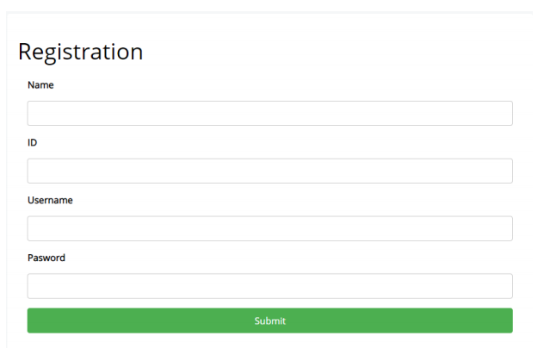

2.Write a PHP program to log in the system using session.

<!DOCTYPE html>

<html>

<head>

<title>Login Form in PHP with Session</title>

<link href="style.css" rel="stylesheet" type="text/css">

</head>

<body>

<div id="main">

<h1>PHP Login Session Example</h1>

<div id="login">

<h2>Login Form</h2>

<form action="" method="post">

<label>UserName :</label>

<input id="name" name="username" placeholder="username" type="text">

<label>Password :</label>

<input id="password" name="password" placeholder="**********" type="password">

<input name="submit" type="submit" value=" Login ">

<span><?php echo $error; ?></span>

</form>

</div>

</div>

</body>

</html>

#main {

width:960px;

margin:50px auto;

font-family:raleway

}

span {

color:red

}

h2 {

background-color:#FEFFED;

text-align:center;

border-radius:10px 10px 0 0;

margin:-10px -40px;

padding:15px

}

hr {

border:0;

border-bottom:1px solid #ccc;

margin:10px -40px;

margin-bottom:30px

}

#login {

width:300px;

float:left;

border-radius:10px;

font-family:raleway;

border:2px solid #ccc;

padding:10px 40px 25px;

margin-top:70px

}

input[type=text],input[type=password] {

width:99.5%;

padding:10px;

margin-top:8px;

border:1px solid #ccc;

padding-left:5px;

font-size:16px;

font-family:raleway

}

input[type=submit] {

width:100%;

background-color:#FFBC00;

color:#fff;

border:2px solid #FFCB00;

padding:10px;

font-size:20px;

cursor:pointer;

border-radius:5px;

margin-bottom:15px

}

#profile {

padding:50px;

border:1px dashed grey;

font-size:20px;

background-color:#DCE6F7

}

#logout {

float:right;

padding:5px;

border:dashed 1px gray

}

a {

text-decoration:none;

color:#6495ed

}

i {

color:#6495ed

}



3. Create a Home page for a college for showing some important information such as Home, About, Teacher Info, Notice board etc. using HTML and CSS (Use Bootstrap).

<!DOCTYPE html>

<html lang="en">

<head>

<meta charset="UTF-8">

<meta name="viewport" content="width=device-width, initial-scale=1.0">

<meta http-equiv="X-UA-Compatible" content="ie=edge">

<link rel="stylesheet" href="css/bootstrap.min.css">

<title>COLLEGE</title>

</head>

<body>

<!-- SIMPLE NAVBAR -->

<nav class="navbar navbar-light bg-light navbar-expand-md">

<div class="container">

<a class="navbar-brand" href="#">EDUCATION</a>

<ul class="navbar-nav">

<li class="nav-item">

<a class="nav-link" href="#">Home</a>

</li>

<li class="nav-item">

<a class="nav-link" href="#">About</a>

</li>

<li class="nav-item">

<a class="nav-link" href="#">Teacher Info</a>

</li>

<li class="nav-item">

<a class="nav-link" href="#">Notice board</a>

</li>

<li class="nav-item">

<a class="nav-link" href="#">Contact</a>

</li>

</ul>

</div>

</nav>

<script src="js/jquery-slim.min.js"></script>

<script src="js/popper.min.js"></script>

<script src="js/bootstrap.min.js"></script>

</body>

</html>



4.Write a PHP program to see user registration info from database and delete a user individually

cREATE TABLE `users` (

`id` int(11) NOT NULL AUTO_INCREMENT PRIMARY KEY,

`username` varchar(100) NOT NULL,

`email` varchar(100) NOT NULL,

`password` varchar(100) NOT NULL

) ENGINE=InnoDB DEFAULT CHARSET=latin1;

<!DOCTYPE html>

<html>

<head>

<title>Registration system PHP and MySQL</title>

<link rel="stylesheet" type="text/css" href="style.css">

</head>

<body>

<div class="header">

<h2>Register</h2>

</div>

<form method="post" action="register.php">

<?php include('errors.php'); ?>

<div class="input-group">

<label>Username</label>

<input type="text" name="username" value="<?php echo $username; ?>">

</div>

<div class="input-group">

<label>Email</label>

<input type="email" name="email" value="<?php echo $email; ?>">

</div>

<div class="input-group">

<label>Password</label>

<input type="password" name="password_1">

</div>

<div class="input-group">

<label>Confirm password</label>

<input type="password" name="password_2">

</div>

<div class="input-group">

<button type="submit" class="btn" name="reg_user">Register</button>

</div>

<p>

Already a member? <a href="login.php">Sign in</a>

</p>

</form>

</body>

</html>

* {

margin: 0px;

padding: 0px;

}

body {

font-size: 120%;

background: #F8F8FF;

}

.header {

width: 30%;

margin: 50px auto 0px;

color: white;

background: #5F9EA0;

text-align: center;

border: 1px solid #B0C4DE;

border-bottom: none;

border-radius: 10px 10px 0px 0px;

padding: 20px;

}

form, .content {

width: 30%;

margin: 0px auto;

padding: 20px;

border: 1px solid #B0C4DE;

background: white;

border-radius: 0px 0px 10px 10px;

}

.input-group {

margin: 10px 0px 10px 0px;

}

.input-group label {

display: block;

text-align: left;

margin: 3px;

}

.input-group input {

height: 30px;

width: 93%;

padding: 5px 10px;

font-size: 16px;

border-radius: 5px;

border: 1px solid gray;

}

.btn {

padding: 10px;

font-size: 15px;

color: white;

background: #5F9EA0;

border: none;

border-radius: 5px;

}

.error {

width: 92%;

margin: 0px auto;

padding: 10px;

border: 1px solid #a94442;

color: #a94442;

background: #f2dede;

border-radius: 5px;

text-align: left;

}

.success {

color: #3c763d;

background: #dff0d8;

border: 1px solid #3c763d;

margin-bottom: 20px;

}

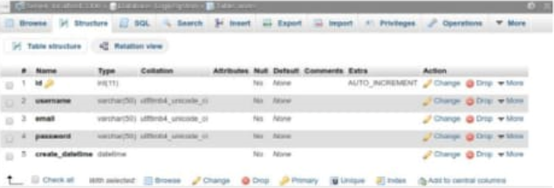

5. Write a PHP program to see user registration info from database and edit a user individually.

<!DOCTYPE html>

<html>

<head>

<title>Registration system PHP and MySQL</title>

<link rel="stylesheet" type="text/css" href="style.css">

</head>

<body>

<div class="header">

<h2>Register</h2>

</div>

<form method="post" action="register.php">

<?php include('errors.php'); ?>

<div class="input-group">

<label>Username</label>

<input type="text" name="username" value="<?php echo $username; ?>">

</div>

<div class="input-group">

<label>Email</label>

<input type="email" name="email" value="<?php echo $email; ?>">

</div>

<div class="input-group">

<label>Password</label>

<input type="password" name="password_1">

</div>

<div class="input-group">

<label>Confirm password</label>

<input type="password" name="password_2">

</div>

<div class="input-group">

<button type="submit" class="btn" name="reg_user">Register</button>

</div>

<p>

Already a member? <a href="login.php">Sign in</a>

</p>

</form>

</body>

</html>

* {

margin: 0px;

padding: 0px;

}

body {

font-size: 120%;

background: #F8F8FF;

}

.header {

width: 30%;

margin: 50px auto 0px;

color: white;

background: #5F9EA0;

text-align: center;

border: 1px solid #B0C4DE;

border-bottom: none;

border-radius: 10px 10px 0px 0px;

padding: 20px;

}

form, .content {

width: 30%;

margin: 0px auto;

padding: 20px;

border: 1px solid #B0C4DE;

background: white;

border-radius: 0px 0px 10px 10px;

}

.input-group {

margin: 10px 0px 10px 0px;

}

.input-group label {

display: block;

text-align: left;

margin: 3px;

}

.input-group input {

height: 30px;

width: 93%;

padding: 5px 10px;

font-size: 16px;

border-radius: 5px;

border: 1px solid gray;

}

.btn {

padding: 10px;

font-size: 15px;

color: white;

background: #5F9EA0;

border: none;

border-radius: 5px;

}

.error {

width: 92%;

margin: 0px auto;

padding: 10px;

border: 1px solid #a94442;

color: #a94442;

background: #f2dede;

border-radius: 5px;

text-align: left;

}

.success {

color: #3c763d;

background: #dff0d8;

border: 1px solid #3c763d;

margin-bottom: 20px;

}

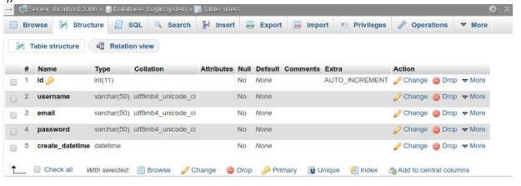

6.Write a PHP program for SIGNIN and SIGNUP using session and After Log into the system he/she will see all user registration information.

<!DOCTYPE html>

<html>

<head>

<title>Registration system PHP and MySQL</title>

</head>

<body>

<div class="header">

<h2>Register</h2>

</div>

<form method="post" action="register.php">

<div class="input-group">

<label>Username</label>

<input type="text" name="username" value="">

</div>

<div class="input-group">

<label>Email</label>

<input type="email" name="email" value="">

</div>

<div class="input-group">

<label>Password</label>

<input type="password" name="password_1">

</div>

<div class="input-group">

<label>Confirm password</label>

<input type="password" name="password_2">

</div>

<div class="input-group">

<button type="submit" class="btn" name="register_btn">Register</button>

</div>

<p>

Already a member? <a href="login.php">Sign in</a>

</p>

</form>

</body>

</html>

* { margin: 0px; padding: 0px; }

body {

font-size: 120%;

background: #F8F8FF;

}

.header {

width: 40%;

margin: 50px auto 0px;

color: white;

background: #5F9EA0;

text-align: center;

border: 1px solid #B0C4DE;

border-bottom: none;

border-radius: 10px 10px 0px 0px;

padding: 20px;

}

form, .content {

width: 40%;

margin: 0px auto;

padding: 20px;

border: 1px solid #B0C4DE;

background: white;

border-radius: 0px 0px 10px 10px;

}

.input-group {

margin: 10px 0px 10px 0px;

}

.input-group label {

display: block;

text-align: left;

margin: 3px;

}

.input-group input {

height: 30px;

width: 93%;

padding: 5px 10px;

font-size: 16px;

border-radius: 5px;

border: 1px solid gray;

}

#user_type {

height: 40px;

width: 98%;

padding: 5px 10px;

background: white;

font-size: 16px;

border-radius: 5px;

border: 1px solid gray;

}

.btn {

padding: 10px;

font-size: 15px;

color: white;

background: #5F9EA0;

border: none;

border-radius: 5px;

}

.error {

width: 92%;

margin: 0px auto;

padding: 10px;

border: 1px solid #a94442;

color: #a94442;

background: #f2dede;

border-radius: 5px;

text-align: left;

}

.success {

color: #3c763d;

background: #dff0d8;

border: 1px solid #3c763d;

margin-bottom: 20px;

}

.profile_info img {

display: inline-block;

width: 50px;

height: 50px;

margin: 5px;

float: left;

}

.profile_info div {

display: inline-block;

margin: 5px;

}

.profile_info:after {

content: "";

display: block;

clear: both;

}

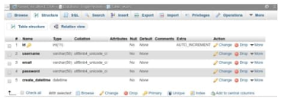

7. Write a PHP script to generate unique random numbers within a range. Sample Range : (11, 20) Sample Output : 17 16 13 20 14 19 18 15 11 12

<?php

$n=range(11,20);

shuffle($n);

for ($x=0; $x< 10; $x++)

{

echo $n[$x].' ';

}

echo "\n"

?>

8. Write a PHP script to print "second" and Red from the following array. Sample Data : $color = array ( "color" => array ( "a" => "Red", "b" => "Green", "c" => "White"), "numbers" => array ( 1, 2, 3, 4, 5, 6 ), "holes" => array ( "First", 5 => "Second", "Third"));

<?php

$color = array ( "color" => array ( "a" => "Red", "b" => "Green", "c" => "White"),

"numbers" => array ( 1, 2, 3, 4, 5, 6 ),

"holes" => array ( "First", 5 => "Second", "Third"));

echo $color["holes"][5]."\n"; // prints "second"

echo $color["color"]["a"]."\n"; // prints "Red"

?>

9. Create a script to construct the following pattern, using nested for loop.

<?php

for($x=1;$x<=5;$x++)

{

for ($y=1;$y<=$x;$y++)

{

echo "*";

if($y< $x)

{

echo " ";

}

}

echo "\n";

}

?>



10. $color = array('white', 'green', 'red'') Write a PHP script which will display the colors in the following way : Output : A. white, green, red B.

● green

● red

● white

<?php

$color = array('white', 'green', 'red');

foreach ($color as $c)

{

echo "$c, ";

}

sort($color);

echo "<ul>";

foreach ($color as $y)

{

echo "<li>$y</li>";

}

echo "</ul>";

?>

11. Create a registration form using HTML and CSS and save to the database.

<html>

<head>

<title>Registration Form</title>

</head>

<body>

<link href = "registration.css" type = "text/css" rel = "stylesheet" />

<h2>Sign Up</h2>

<form name = "form1" action="modified.php" method = "post" enctype = "multipart/form-data" >

<div class = "container">

<div class = "form_group">

<label>First Name:</label>

<input type = "text" name = "fname" value = "" required/>

</div>

<div class = "form_group">

<label>Middle Name:</label>

<input type = "text" name = "mname" value = "" required />

</div>

<div class = "form_group">

<label>Last Name:</label>

<input type = "text" name = "lname" value = "" required/>

</div>

<div class = "form_group">

<label>Password:</label>

<input type = "password" name = "pwd" value = "" required/>

</div>

</div>

</form>

</body>

</html>

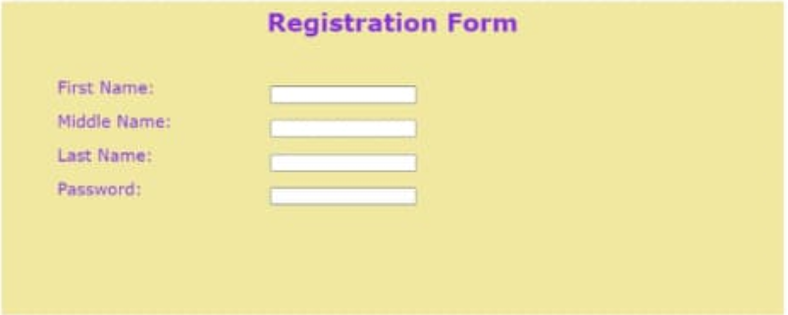

.container {

max-width: 1350px;

width: 100%;

margin: 50px;

height: auto;

display: block;

}

body {

color: #8A2BE2;

font-size: 20px;

font-family: Verdana, Arial, Helvetica, monospace;

background-color: #F0E8A0;

}

h2 {

text-align: center;

}

.form_group {

padding: 10px;

;

display: block;

}

label {

float: left;

padding-right: 50px;

line-height: 10%;

display: block;

width: 208px;

}