SCITS

FrontEnd
Url : http://mercury.promaticstechnologies.com/scits/

We have updated following in the website.

- System Management > MFC/AFC

Now a manager can add mfc records from system management.

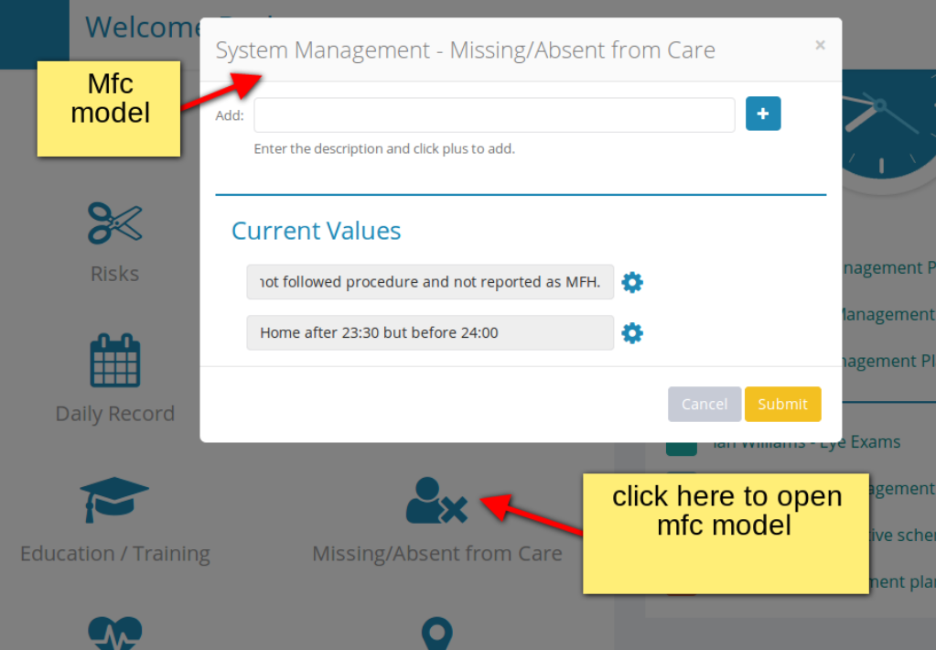

2. ServiceUserManagement > MFC/AFC

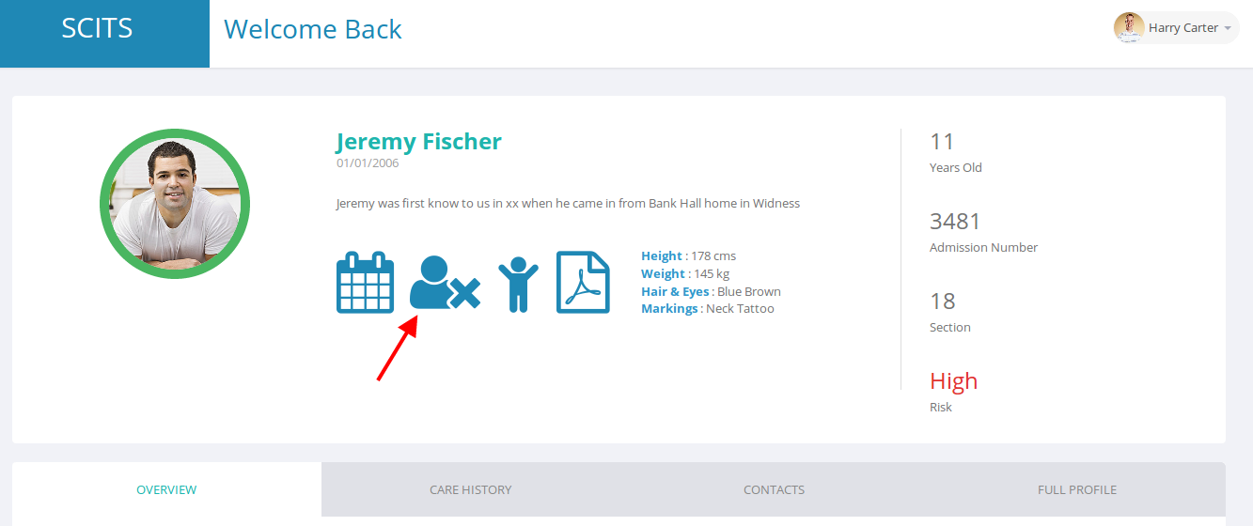

Now a manager can add mfc record for a yp by clicking on mfc icon

When we click on the mfc icon following mfc model will be shown

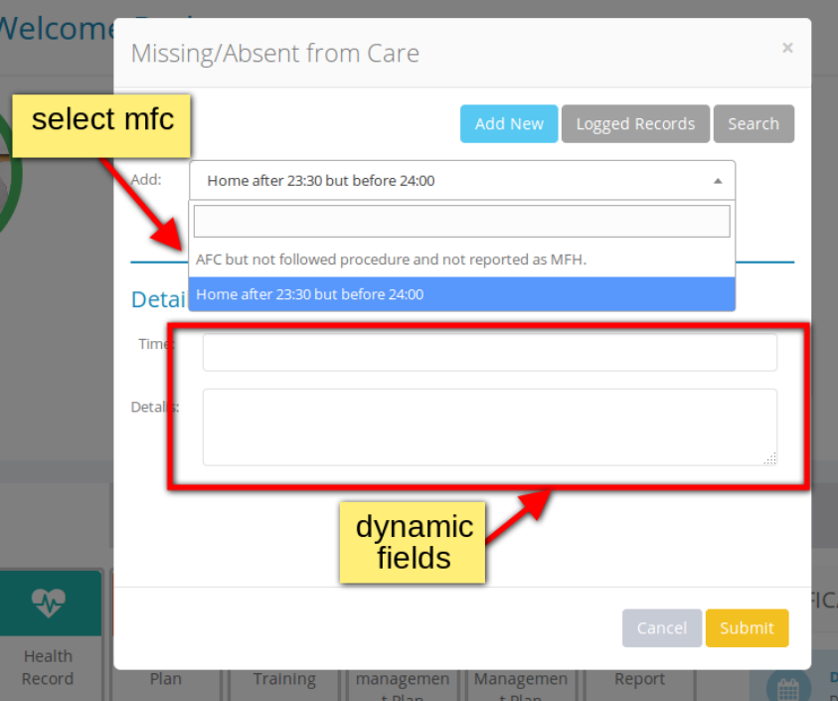

Select the mfc and then enter details below. And press submit button,
Mfc will be saved in the database.

Manager can view the logged mfc records by clicking on logged records button as shown below.
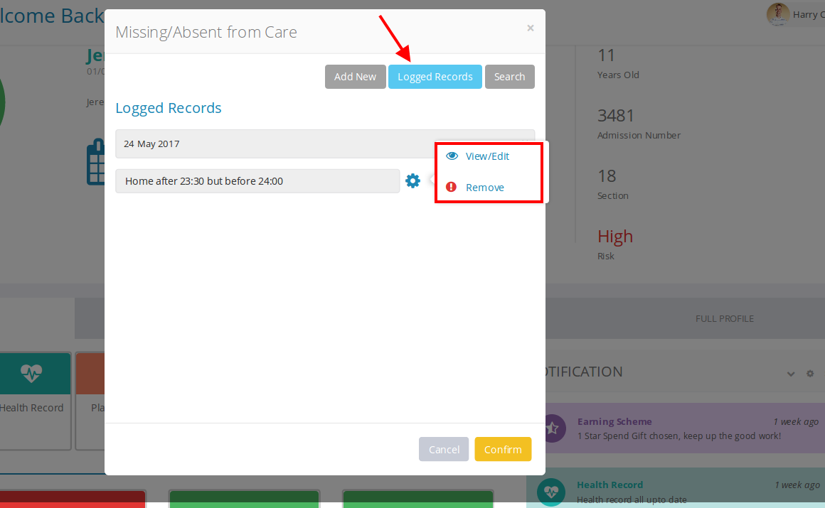
Manager can also search for mfc from search tab.
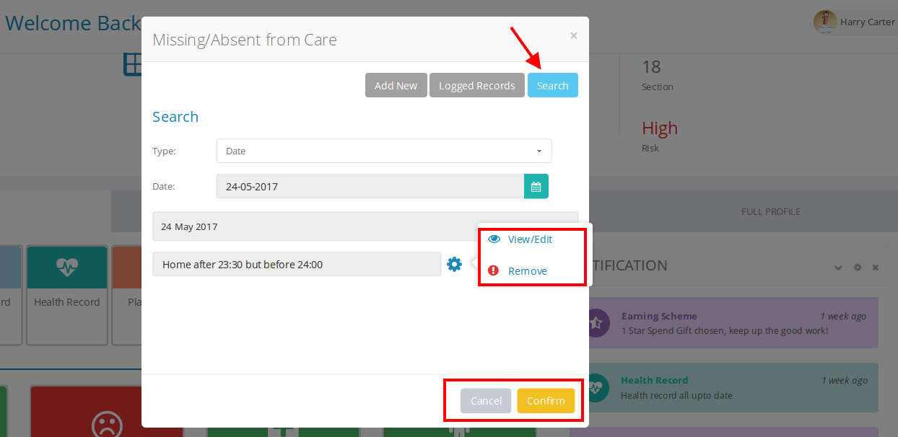

3. Earning Scheme
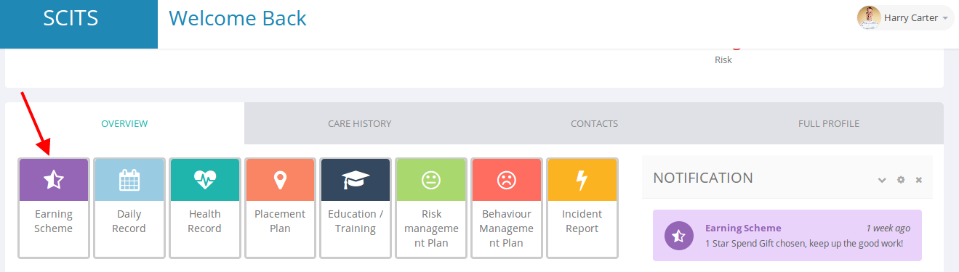
We have updated earning scheme section.
Now with the calendar in the left hand side all earning areas will be shown.
Each earning area is of 25% scores. If a yp get all 25% score in a particular area. Then it will show green tick sign at the right hand side of the area listing and if the yp has not get yet 25% on this area then red cross sign will be shown wiith area name.
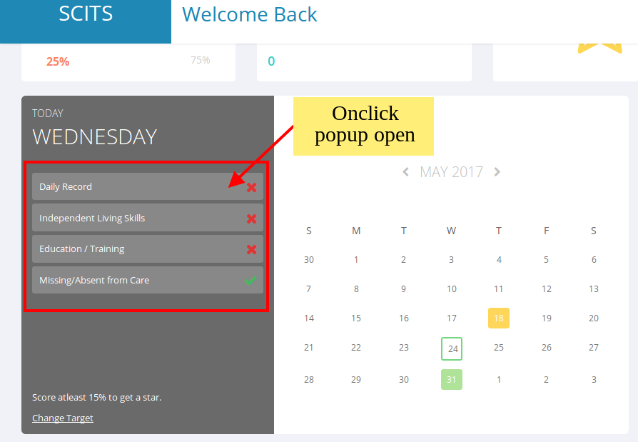
When a manager clicks on here then its details of scores will be shown as given below.

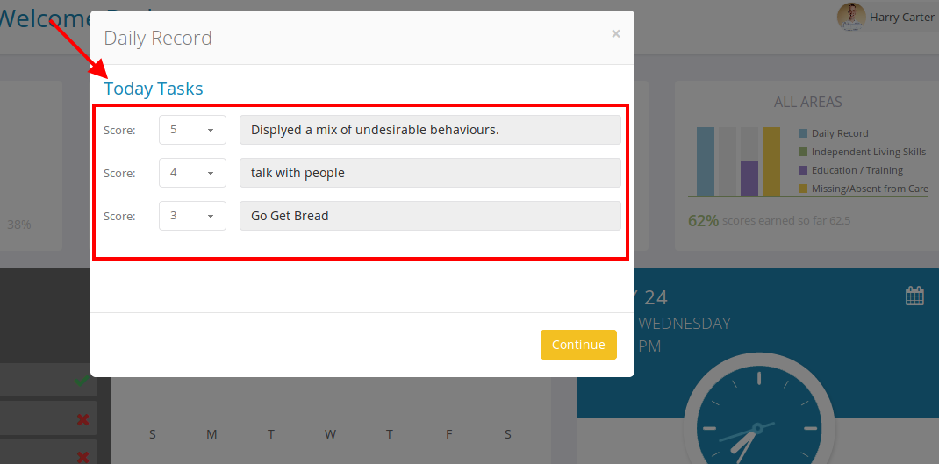
We have made functionality of earning scheme rewards as disucussed on skype chat which is given below.
“ These are parts which are going to be in the YPs profile each section will have a score behind it, for example if there is no record of missing/absent from care then that is scored as 25%, all education training is complete 25%, independent life skills is complete 25% score but on general behaviour has been bad and only 1 point out of 5 is done then this is 5% complete.”
3.1 Progress meter
Now the progress meter is set to 100% and it will show how much % scores has obtained and how much are remaining as shown below.

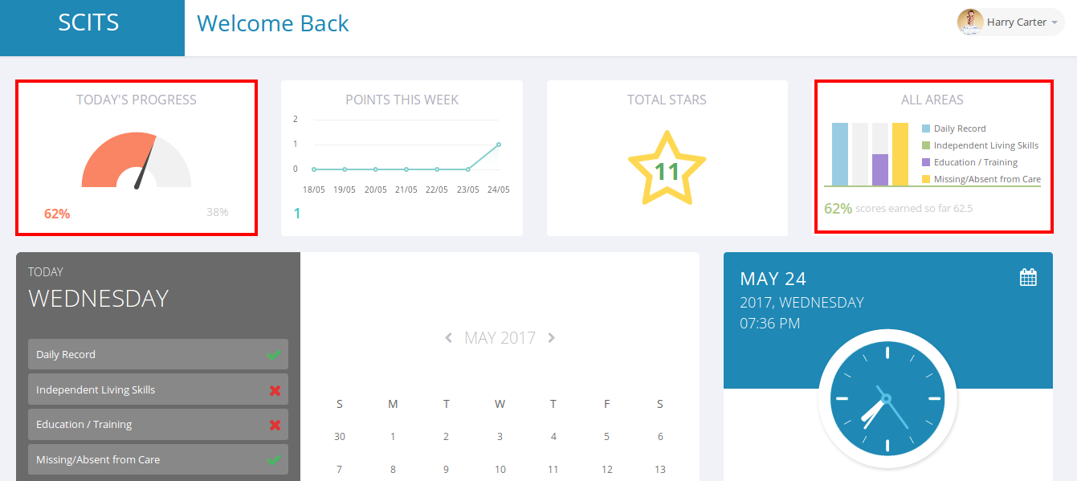
3.2 Bar graph
We have made all areas bar graph active in the earning scheme page as shown above.
4. Record Editing functionality
Now a manager can also edit the logged and searched records as discussed on skype chat.
Manager can edit all the records of the following:
1. Daily record
2. Living skills
3. MFC
4. Education record

Thanks.

