PRD

States in journey

**Journey status changes**

1. Send for approval --> Awaiting approval
2. Awaiting approval --> Reject
3. Awaiting approval --> Approve
4. Live --> Pause
5. Pause --> Resume
6. Edit --> Exit [no new version]
7. Edit --> Save [new version] --> Send for approval --> Awaiting approval --> Approve --> (Move users to new version/sunset/stop)
8. Live --> Sunset
9. Live --> Stop
10. Send for approval --> Approve --> Error in approving the journey

| Old status | New Status | Alert to |  |
| --- | --- | --- | --- |

| Old Status | New Status | Who is performing the action | Alert to |
| --- | --- | --- | --- |
| Send for Approval | Awaiting Approval | Creator | Approver |
| Awaiting Approval | Rejected | Approver | Creator |
| Awaiting Approval | Approved/Live | Approver | Creator |
| Live | Pause | Creator | ?? |
| Pause | Resume | Creator | ?? |
|  |  |  |  |
|  |  |  |  |

For all these status update, we need to send the notifications. if there is some issue in saving the journey, we need to send out a notification  
  
Client/business  
CSM/Brand POC  
Config team/IM

**Types of configuration**   
 For Approval [1,7,10]

For Status updated from live to other versions[1 to 10]

For execution failure [need to check with tech if we capture it]→ we can have a threshold if the cnt is greater than threshold we need to send alert

For low DLR for a specific engagement block [need to check with tech]→ need to think when to send this alert

Schedule Expiry reminder → Think of giving flexibility to user to set it before 3 days or 5 days

Users part of these alerts should be any users not need to have intouch access

**Alerts to be sent**

Create -Send for approval [send alert] -Journey approval request

Any state - Send for approval [send alert] -Journey approval request

Pause - resume

Edit - Save

Save - Send for approval [send alert]

Edit - save - sunset

Live to sunset [send alert]- Journey Status change

Live to stop [send alert] - Journey Status change

Expiry reminder - Journey Expiry

Input components

Journey approval request

Journey Status change   
Journey Expiry (user can give input, to start sending alerts before 3 days or 5 days )

### **Journey approval request**

For any journey that is sent for approval, the people selected below will receive a notification.

### **Journey status change alert**

If a journey changes its status (Live, Paused, Stopped, etc.), the people selected below will receive a notification.

### **Journey expiry alert**

If a journey is approaching expiry, the people selected below will receive a notification.  
 How many days before expiry date should the alert be sent? (e.g., 3 days, 5 days)

Mocks: <https://v0.app/chat/journey-alerts-setup-owPIuT2eAtx>

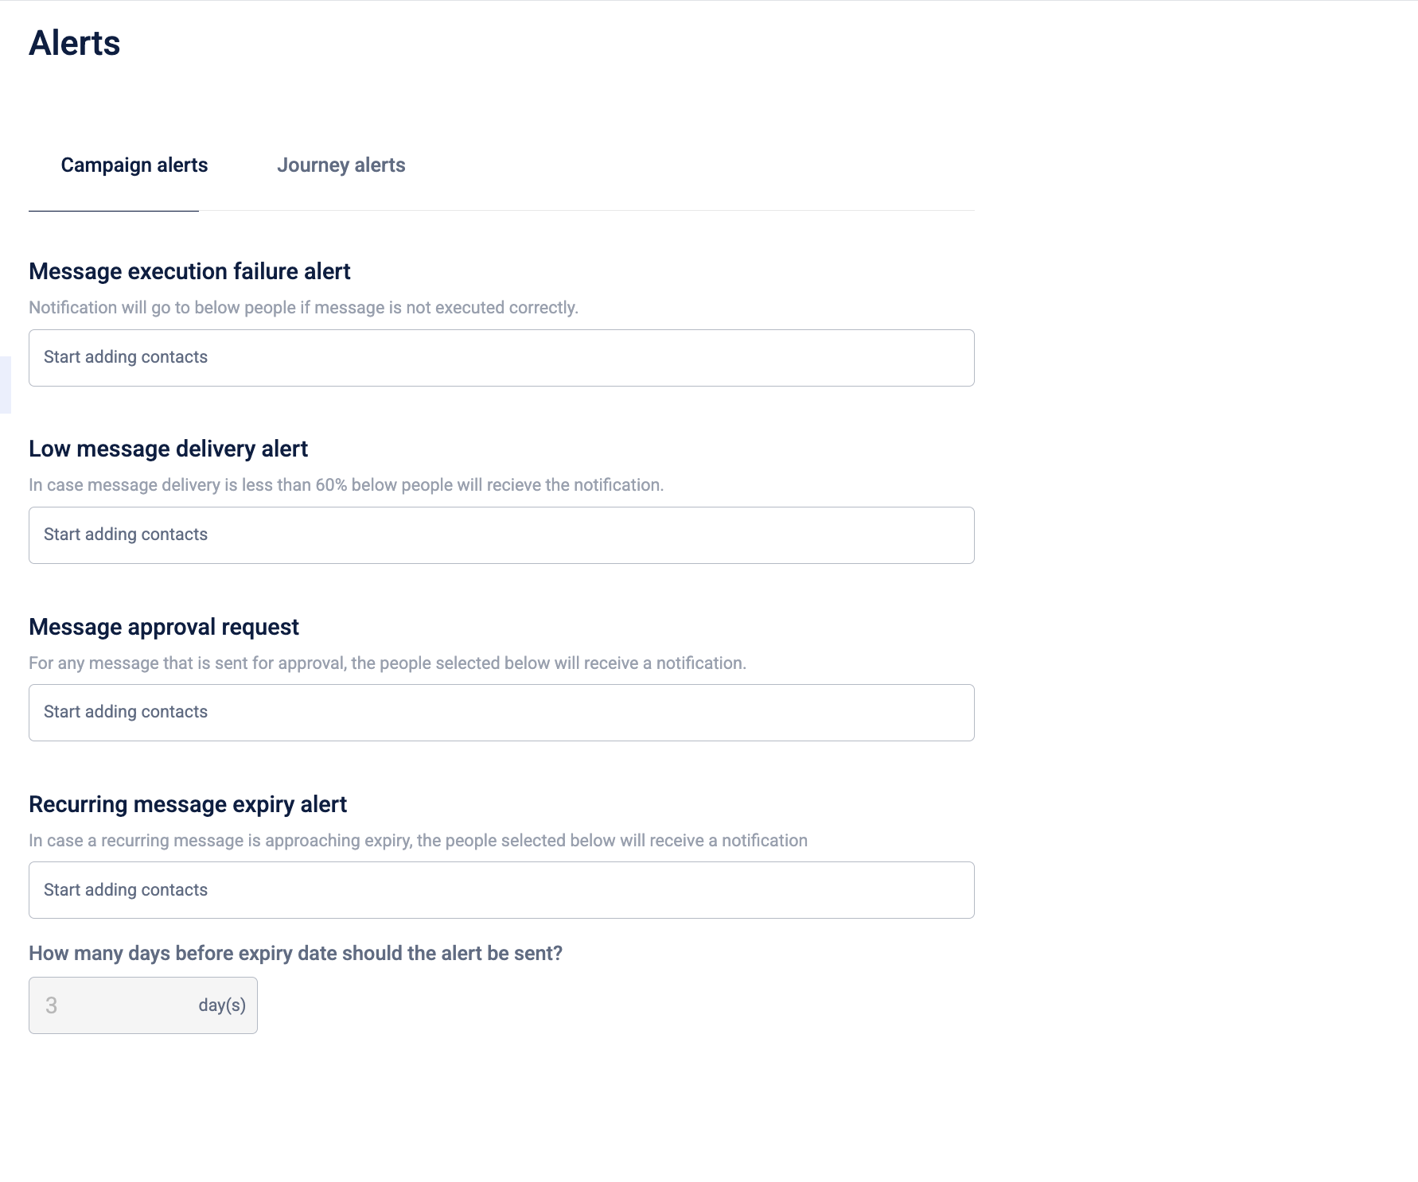

Tech Doc

Doc

# Documentation

Doc link: <https://docs.capillarytech.com/docs/configure-journey-settings#/>

## **Journey alerts**

To alert users on message approval requests, low delivery rates, or execution failures, do the following:

1. On the Engage+ home page, select the settings icon, and go to the Alerts page.
2. Go to the campaign alerts tab. The following configurations are available:

| **Configuration** | **Description** |
| --- | --- |
| A/B test alerts | Notifies the users on the status of the A/B testing. |
| Journey approval request | Notifies the users when a new journey is sent for approval |
| Journey status change alert | Notifies the users when the status of a journey is updated. |
| Journey expiry alert | Notifies the users when a journey is approaching expiry. |

1. Select the users to notify from the dropdown. The dropdown lists the points of contact (POCs) for the organisation. For more information, refer to the documentation on [Organisation POCs](https://docs.capillarytech.com/docs/org-management#/organization-point-of-contact-tab).
2. Enter the number of days before the expiry date to receive the alert.