# Use Case – Create a new event and invite all alumni from a particular program in one query

## Query – Stored Procedure based on Insert

USE segr5300;

CALL `segr5300`.`spInviteProgramAlumniToEvent`(

'MSBA Annual Gala 2019',

'2019-06-13 14:30:00',

'2019-06-13 18:30:00',

'Optimism Brewery',

5,

3,

'MSBA');

## Screenshot

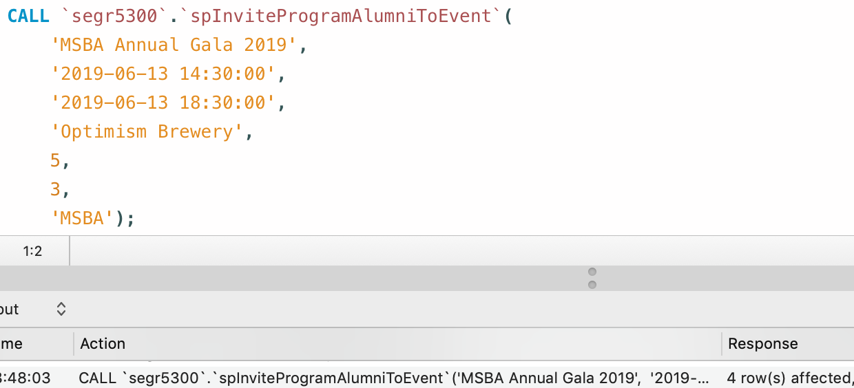

## Proof of Insertion

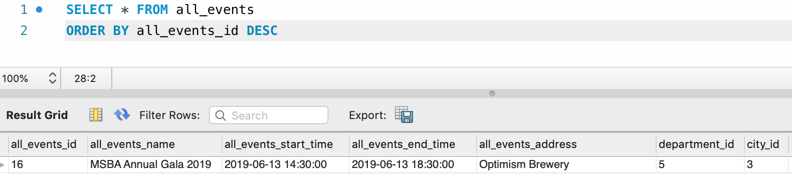

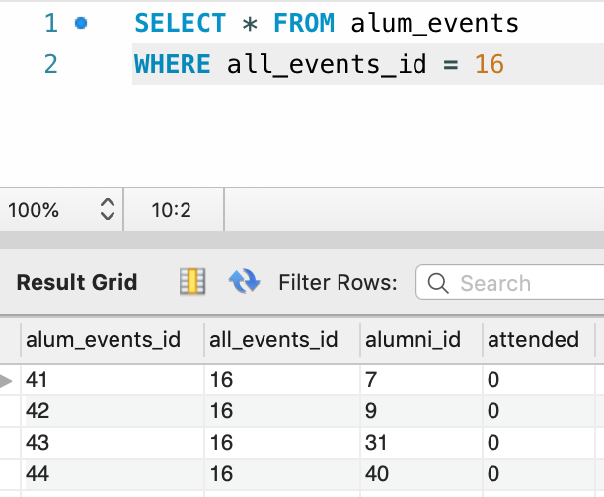

# Use Case – Find all alumni by Department – makes it easier to connect with alumni and display their basic contact information

## Query – Stored Procedure based on Select

USE segr5300;

CALL `segr5300`.`spFindAlumniByDepartment`(1);

## Screenshot

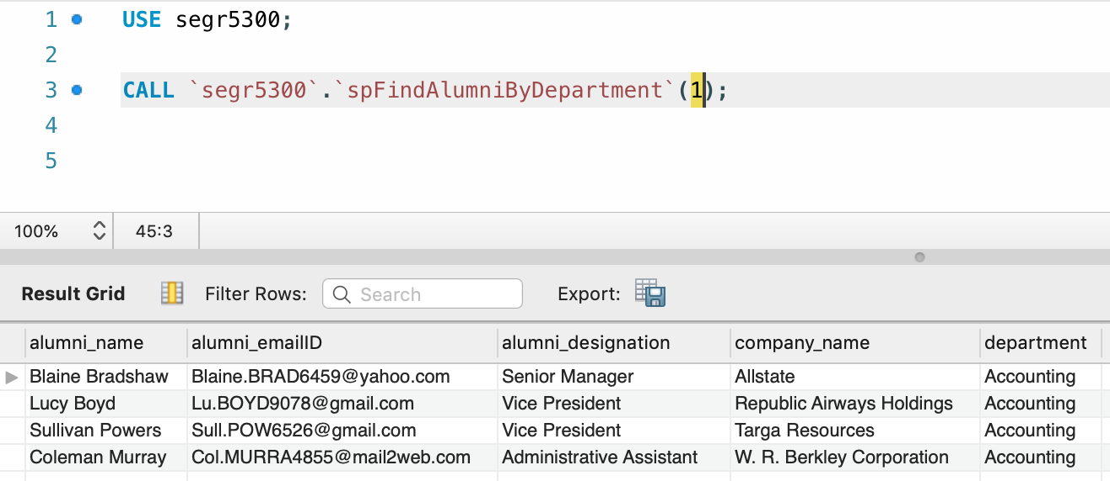

# Use Case – Get a snapshot of Alumni Profile showing contact information, donations till date, events attended, programs attended

## Query

USE segr5300;

SELECT * FROM segr5300.viewalumniprofilesnapshot;

## Screenshot

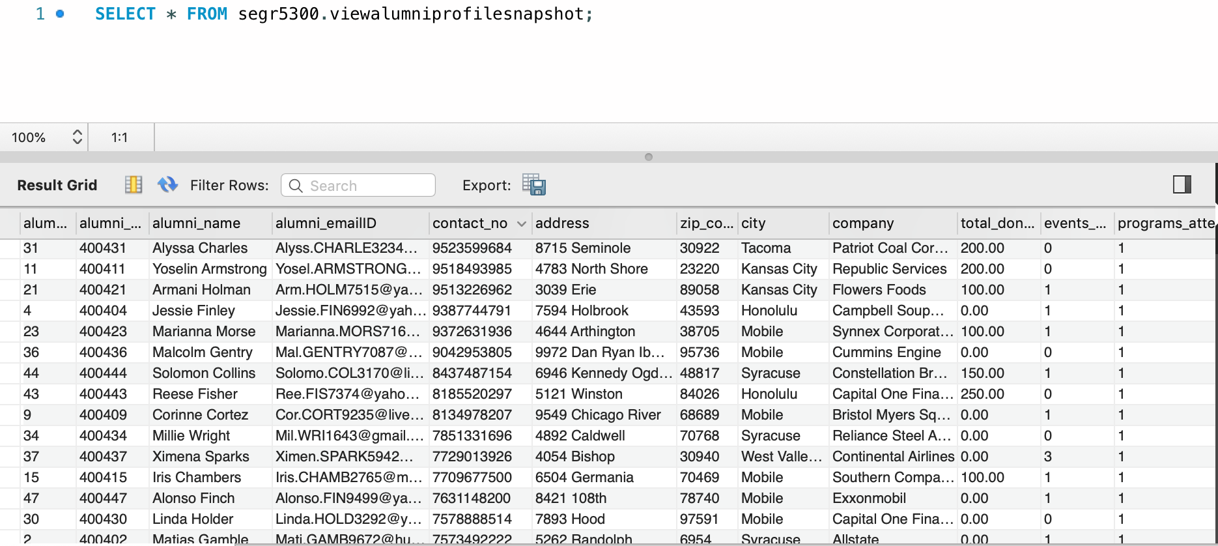

# Use Case – View all events catalogue – will be helpful in searching through relevant events or displaying the results in a calendar

## Query

USE segr5300;

SELECT `viewalleventscatalogue`.`all_events_name`,

`viewalleventscatalogue`.`event_date`,

`viewalleventscatalogue`.`event_start_time`,

`viewalleventscatalogue`.`event_end_time`,

`viewalleventscatalogue`.`host_department`,

`viewalleventscatalogue`.`location`,

`viewalleventscatalogue`.`city_name`,

`viewalleventscatalogue`.`country_name`

FROM `segr5300`.`viewalleventscatalogue`;

## Screenshot

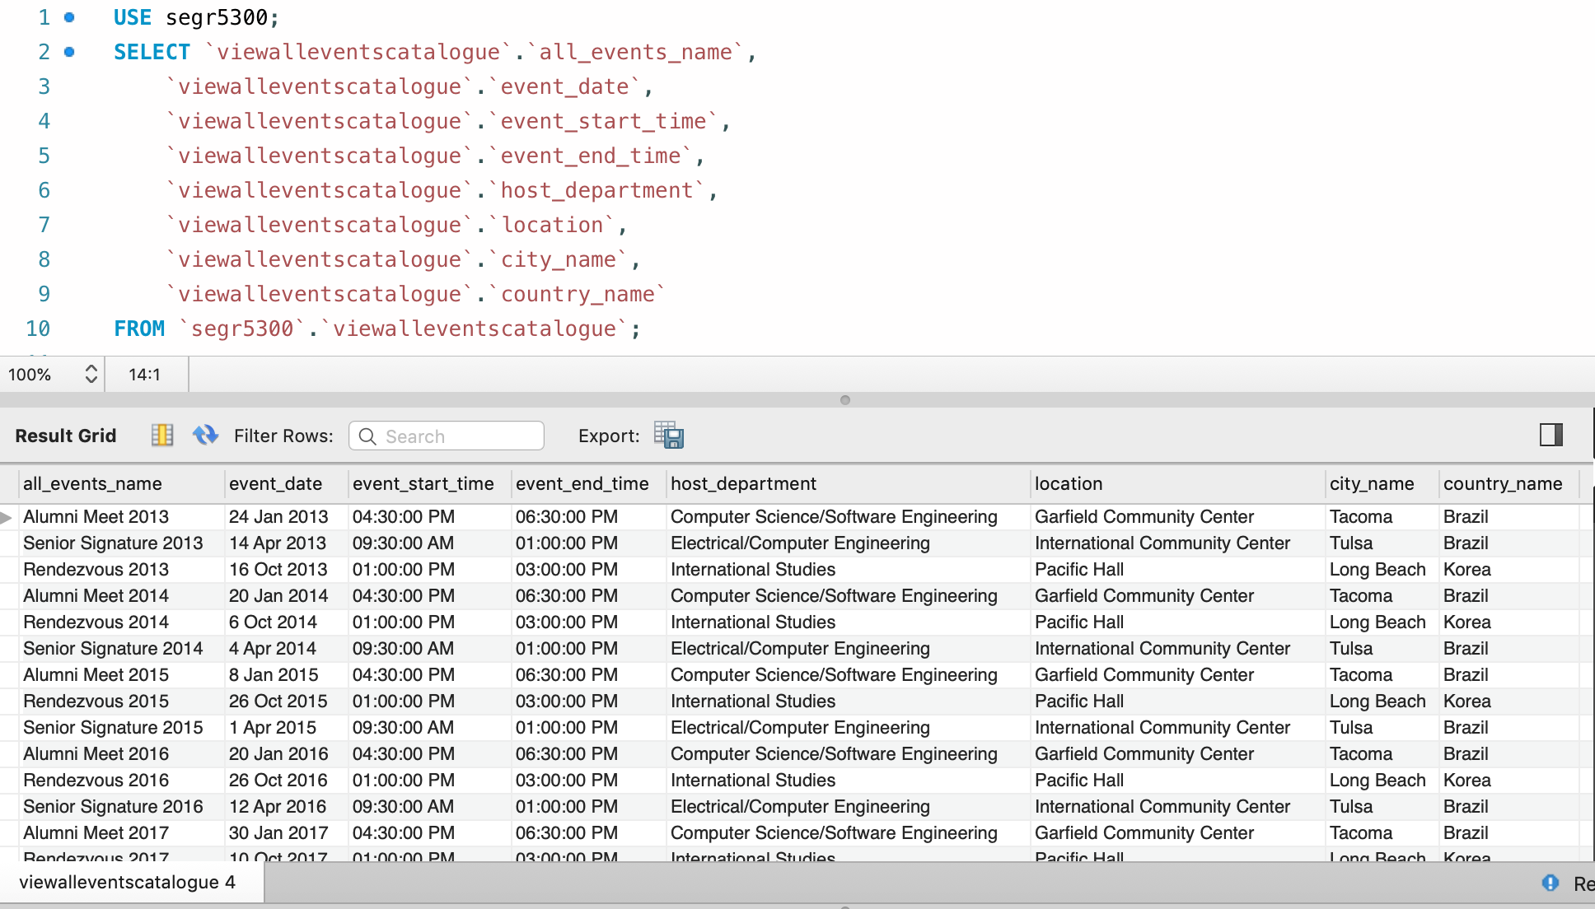

# Use Case – Get the top 5 alumni based on donations to send them appreciation notes. This will build a continuous relationship.

## Query

USE segr5300;

SELECT `viewtop5donation`.`alumni_name`,

`viewtop5donation`.`Total_Donation`

FROM `segr5300`.`viewtop5donation`;

## Screenshot

