**GROUP PROJECT – MILESTONE 2**  
SEGR 5300

# Group 9: Sanyukta Ghai, Sourabh Gupta, Huy Le

# Exercise 4:  ANALYTIC QUERIES and Integration into TABLEAU or EXCEL

## Analytical query 1:

## Returning the event information and number of attendance

**Tableau**

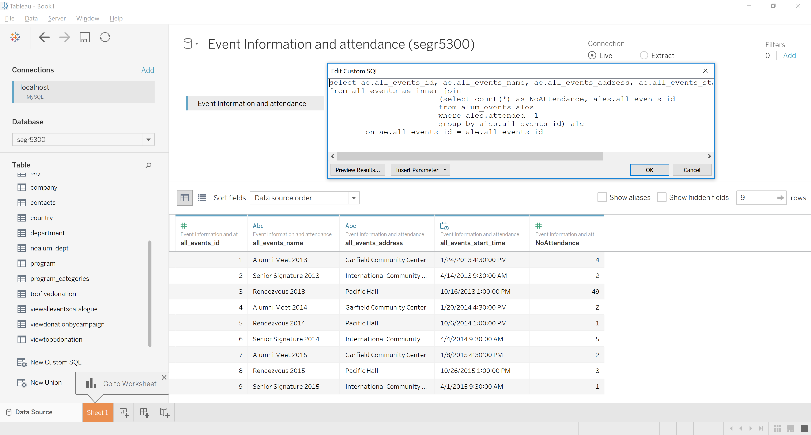

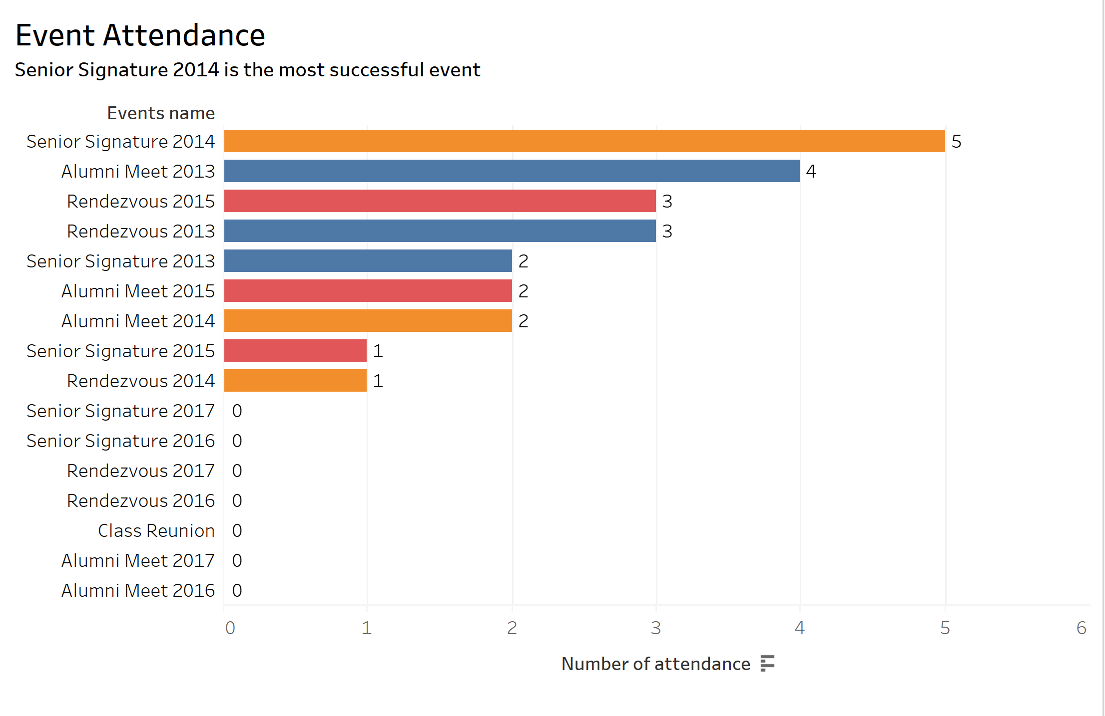

**Excel**

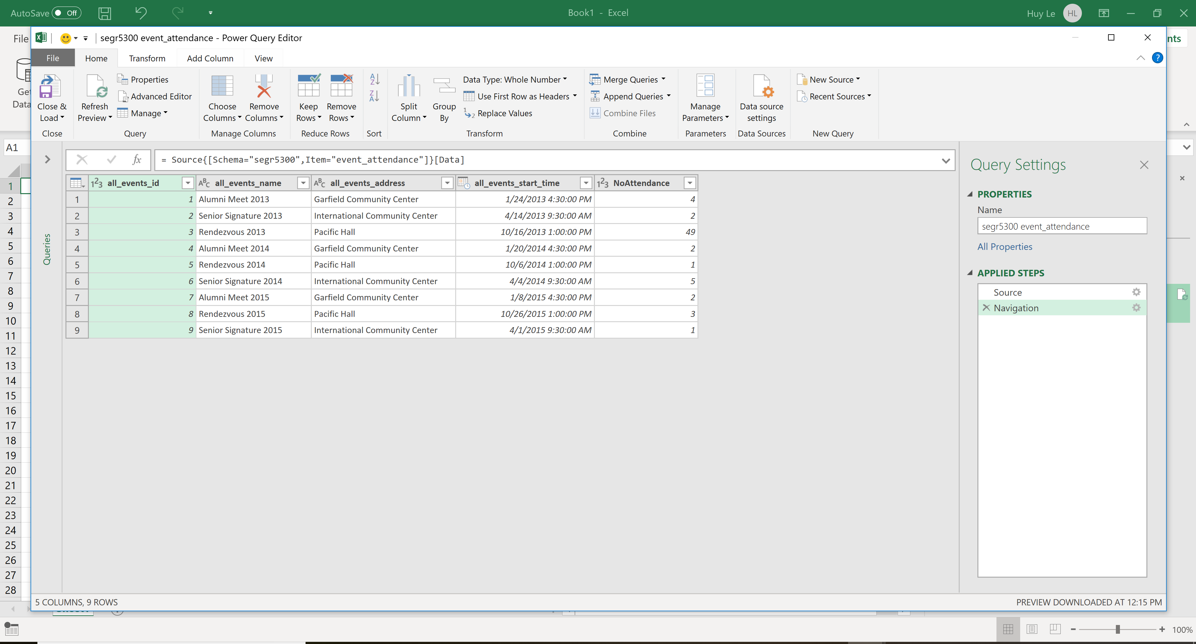

## Analytical query 2:

## This query returns the number of alumni and their donation of each department in school. With the result, customers can have an overview of alumni and their participation with school’s events.

**Tableau**

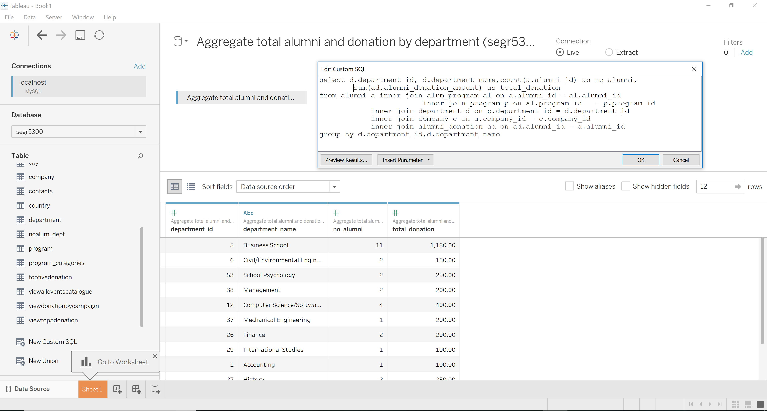

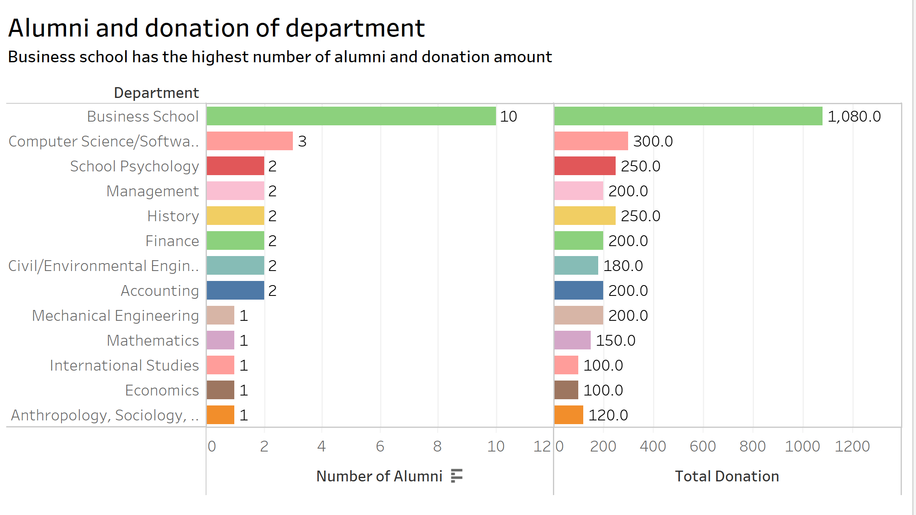

**Excel**

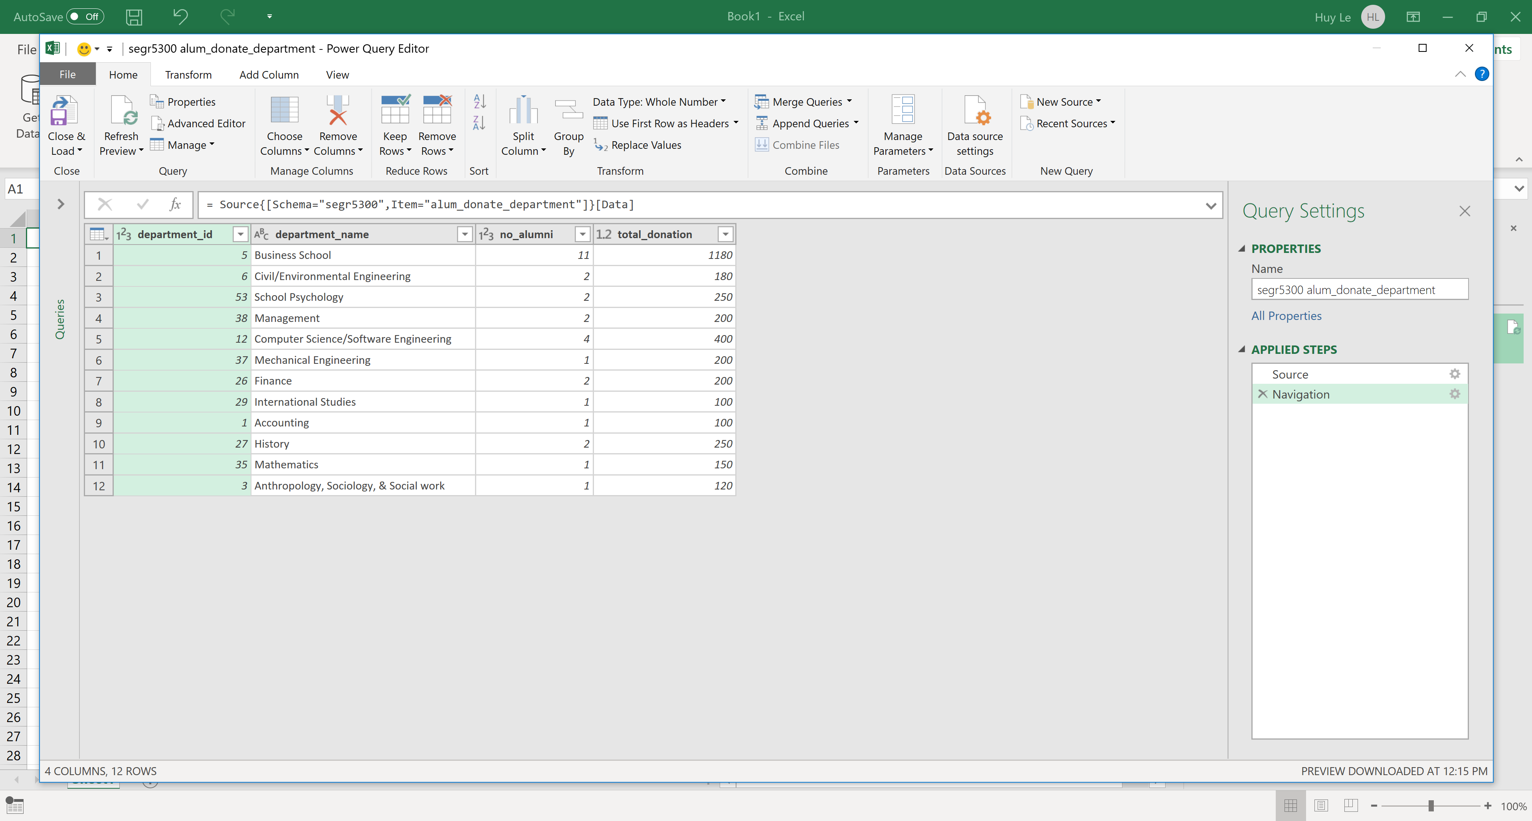

## Analytical query 3: top 3 cities where donation, number of alumni and number of companies are maximum

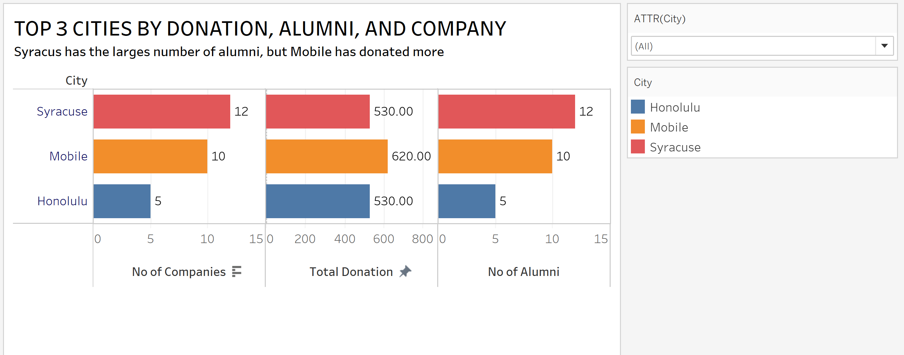

## Analytical Query 4:

## The detail information of the Cities with number of alumni, total amount of donation which are divided by Company

