# Screenshot showing AWS RDS MySQL connection

1. AWS Console

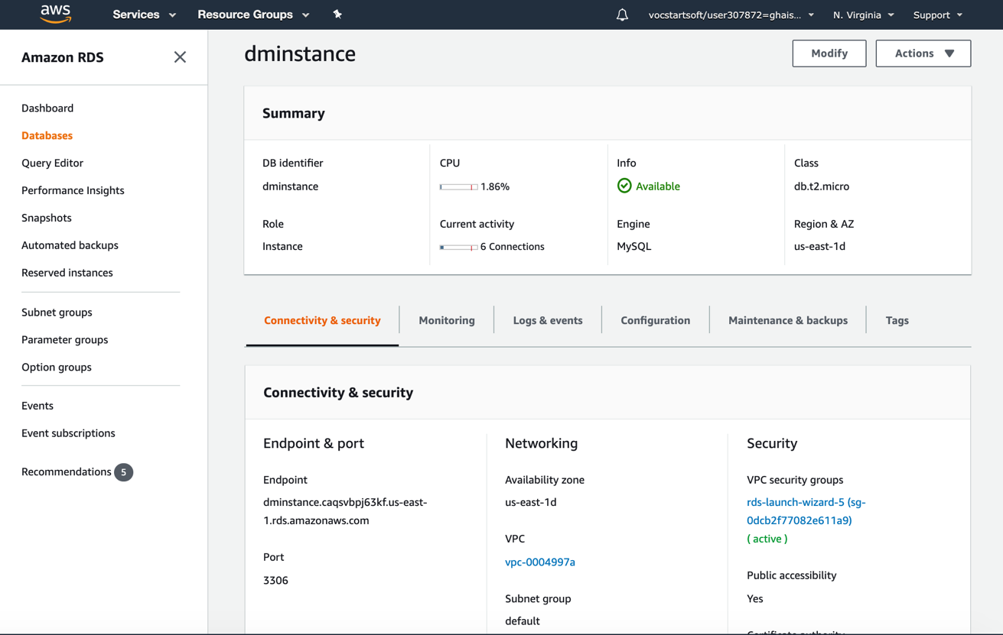

1. Connecting from MySQL Workbench

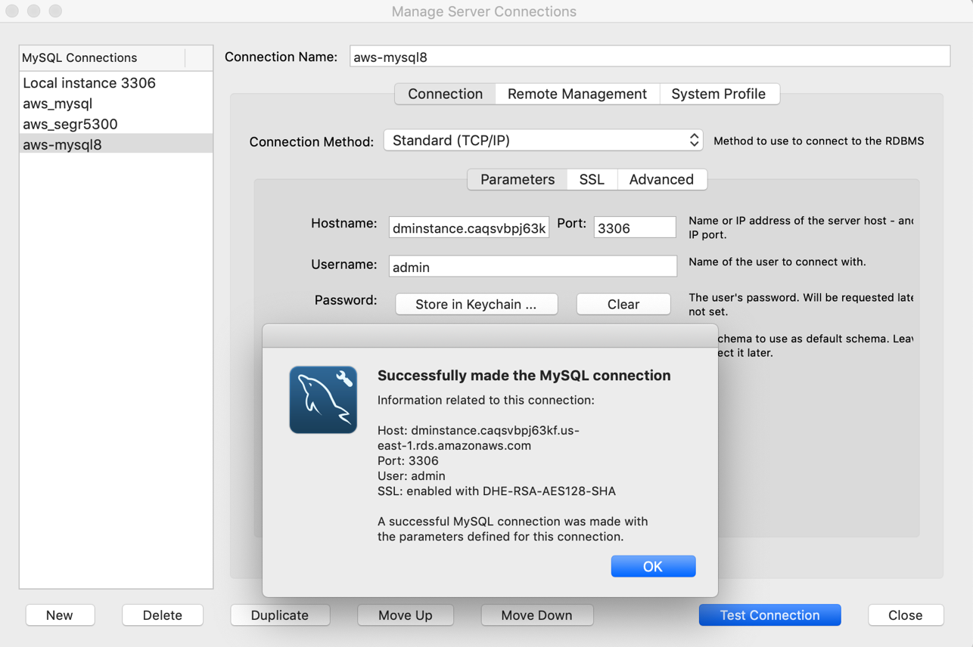

1. Connection Information
   1. Hostname: dminstance.caqsvbpj63kf.us-east-1.rds.amazonaws.com
   2. User Name: admin
   3. Password: datamarvels