Sr. No. | TATA OBSERVATION | PESPL RESPONSE | Remark
1 | Cable tray will be from inside the building. | Noted & updated in 3D model 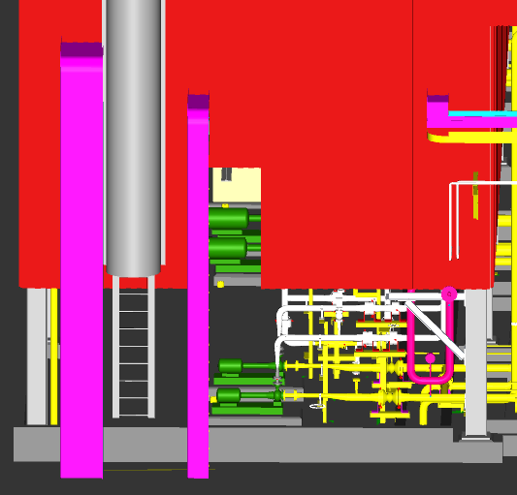 | Closed.
2 | Cable tray will be from inside the building with cutout on sheet. | Noted & tray updated in 3D model | Closed.
3 | Cable tray layout connectivity to individual motors are missing in the 3 D model to be shown for every motors. | Conduit provided in model for motor cable 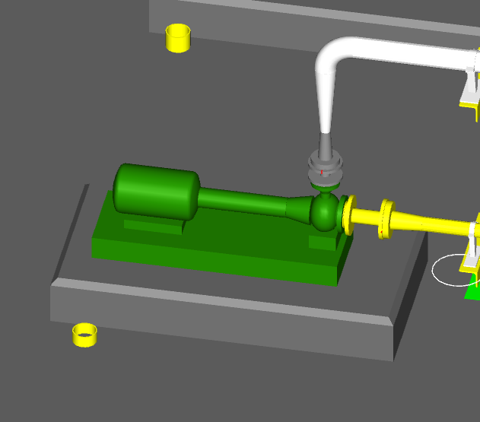 | Closed.
4 | JB & LPBS mounting arrangement to be shown in the 3 D model | Aquatech give response
5 | Instrument to be shown in the model | Aquatech give response
6 | Instrument location & access to be shown. | Aquatech give response
7 | If equipment mounting is not in access level. Through tubing It has to be shown. | Aquatech give response
8 | Cable tray height to match with height of the pipe cable tray can be installed side by side. This will avoid fouling of man movement in the platform | Aquatech give response
9 | Cable tray height to match with height of the pipe cable tray can be installed side by side. This will avoid fouling of man movement in the platform | Aquatech give response
10 | Cable tray height to match with height of the pipe cable tray can be installed side by side. This will avoid fouling of man movement in the platform | Aquatech give response
11 | Fouling of walkbay to be check | Noted & updated in 3D model 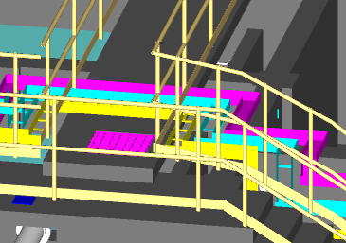 | Closed.
12 | Fouling of walkway to be check & rectify. | Noted & updated in 3D model 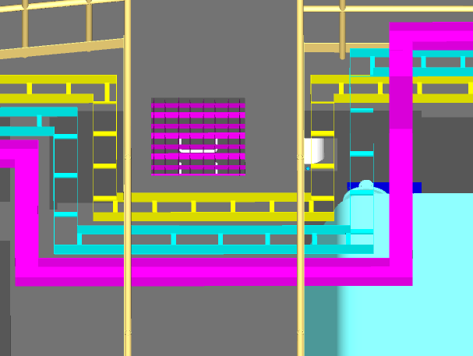 | Closed.
13 | Incoming and outgoing Cable tray layout is not shown in 3 D model. | Aquatech give response
14 | ARP ECR 5mtr & 11mtr cable tray routing not shown. | Aquatech give response
15 | ARP ECR equipment arrangement layout not shown 5mtr & 11mtr level in 3D model. | Aquatech give response
16 | PJB, CJB & LPBS not shown. | Aquatech give response
17 | Instruments are not shown in 3 D model. | Aquatech give response
18 | Cable tray support upto JB to be shown | Aquatech give response
19 | Fouling with the walk bay & tray to be shown along the railing | Noted & updated in 3D model
20 | Cable tray support upto JB to be shown | Aquatech give response
21 | Cable tray routing to be check and modify | Noted & updated in 3D model 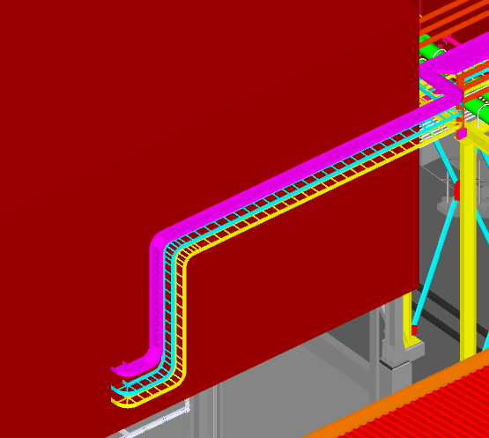 | Closed.
22 | Cable tray routing and dropdown to be taken from wall side & tray supporting arrangement to be shown | Noted & updated in 3D model | Only tray routing updeted
23 | Cable tray supporting structure to be shown | Aquatech give response
24 | Cable tray routing and dropdown to be taken from wall side & tray supporting arrangement to be shown | Noted & updated in 3D model | Only tray routing updeted
25 | Incoming / outgoing cable tray routing to be shown with in ECR. | ECR room 3D model require for tray modelling, after received 3 model cable tray will be updated
26 | Equipment arrangement layout to be shown of ECR | ECR room 3D model require for tray modelling, after received 3 model cable tray will be updated
27 | Incoming cable tray routing from PL ECR to WWTP ECR to shown in 3D model. | ECR room 3D model require for tray modelling, after received 3 model cable tray will be updated
28 | Lighting layout to be shown. | Aquatech give response

