CHAPTER 1
INTRODUCTION
This chapter includes the discussion on why this project is needed. It explains the problem statement and objectives of the project. It also gives the overview of organization of report.

1.1 PREAMBLE
The aim of this project report is to describe the network mapping tool, for surveillance and monitoring of network infrastructure using active probing technique.

This project proposal is addressed to the network monitoring system and the people associated with it. It is intended to enhance the current network monitoring System, which has umpteen flaws and currently used in various organization. Our network monitoring software which is going to surrogate the current but obsolete system addresses all the problem associated with it.

The rapid growth in size and complexity of networking systems makes performance management tasks such as problem determination – detecting system problems and isolating their root causes – an increasingly important but also extremely difficult task. For example, in IP network management, we would like to quickly identify which router or link has a problem when a failure or performance degradation occurs in the network. In the e-Commerce context, our objective could be to trace the root-cause of unsuccessful or slow user transactions (e.g. purchase requests sent through a web server) in order to identify whether it is a network problem, a web or back-end database server problem, etc.

1.2 NEED OF THE PROJECT
Network mapper is a dynamic discovery and mapping tool that helps network administrators/ Data centre administrators to visualize their complete network infrastructure with a live network map. There's no facility available for the network administrator for getting a notification when a link goes down. This network mapper will generate an automatic notification when a link goes down.
There are other tools which are present to perform network mapping. But they are generally based on SNMP (Simple Network Management Protocol). The disadvantages associated with SNMP based approach are:
- It is not compatible with all the devices.
- It has a long header size.
- It has security issues in SNMP v1 and v2 i.e there's no encryption of data.
- In SNMP v3 cryptographic calculations is present but it can increase CPU load approx. By 20 %.

1.3 PROBLEM STATEMENT
In a large network setup it is hard to visualize the network topology. The network administrator faces several problems, related to failure detection. The network administrator is not aware of these problems instantly. Even when he detects that something is going wrong, it becomes an uphill task to trace those broken links on the network. Also, he doesn't know the uptime and downtime of that link, and no records are stored. There is a requirement for a tool to dynamically generate and monitor network graph and to notify the administrator when a broken link is detected with its location and downtime.

1.4 OBJECTIVE
- To create a network mapping tool.
- To use tool for surveillance and monitoring of network infrastructure using active probing technique.
- To add and delete node dynamically.
- To generate notification message to network administrator when a link goes down.

1.5 SOLUTION APPROACH
The network mapper provides a tool to visually monitor the entire LAN network. Whenever a device is added in our network (manually), then it will be shown automatically. A message will be generated whenever a link is down. An entry of every device will be maintained in a log file for network administrator.
We are using active probing technique because it is compatible with all the devices, no such security is needed.

Active probing technique relies on traceroute-like probing on the IP address space. These probes report back IP forwarding paths to the destination address. By combining these paths one can infer router level topology for a given POP. Active probing is advantageous in that the paths returned by probes constitute the actual forwarding path that data takes through networks. It is also more likely to find peering links between ISP's.

Active probing selects and sends probes as needed in response to problems that actually occur. It therefore avoids both the difficulty of constructing probes for all possible problems as well as the waste inherent in using probes for problems that in fact never occur. Furthermore, because probes are selected on-line to obtain further information about particular problems that have occurred, they need not circulate regularly throughout the entire network; instead they can be targeted quickly and directly to the points of interest. Active probing may be a powerful and effective technique for problem determination. Probing Technology In the context of network systems management, a probe is a program that executes on a particular machine (called a probe station) by sending a command or transaction to a server or network element and measuring the response. The PING PROGRAM is probably the most popular probing tool that can be used to detect network availability.

Active probing is an active network monitoring technique that has potential for developing effective solutions for fault localization. In this paper we use active probing to present an approach to develop tools for performing fault localization. We discuss various design issues involved and propose architecture for building such a tool. We describe an algorithm for probe set selection for problem detection and present simulation results to show its effectiveness.

We propose an active probing scheme for the task of problem determination. The key idea is to divide problem determination into two steps: detecting occurrence of a problem and then actively probing in order to localize the problem. The first step is to detect whether there is a problem; once occurrence of a problem is detected, the second step, we have developed it such a way that we are pinging all the systems and then we receive ICMP reply. Now, we analyse the ICMP reply and then we identify the code of ICMP packet and if the ICMP code type is 3, then the destination node is down and if it is type 8, It is then destination node is active.

CHAPTER 2
BACKGROUND
This chapter contains the summary of the tools which are available for mapping and monitoring of the network. This chapter also contains the summary of previous work done in the field of network monitoring. This chapter also contains a study of research paper published by IBM research.

2.1 RELATED TOOLS
2.1.1 ICINGA
Icinga is an offshoot of Nagios that is currently being rebuilt anew. It offers a thorough monitoring and alerting framework that’s designed to be as open and extensible as Nagios is, but with several different Web UI options. Icinga 1 is closely related to Nagios, while Icinga 2 is the rewrite. Both versions are currently supported, and Nagios users can migrate to Icinga 1 very easily [1].
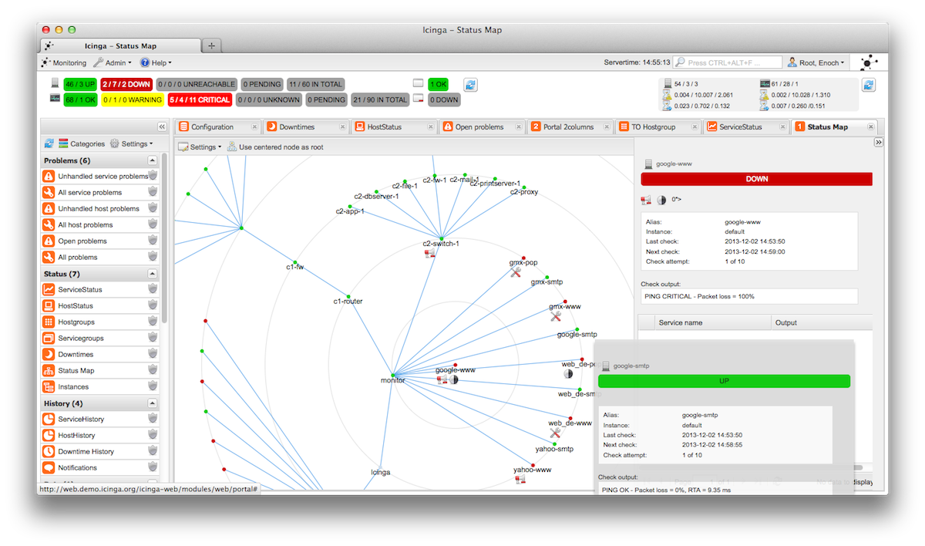
Fig 2.1 This figure is showing the status map of Icinga, all the nodes are plotted on the screen.

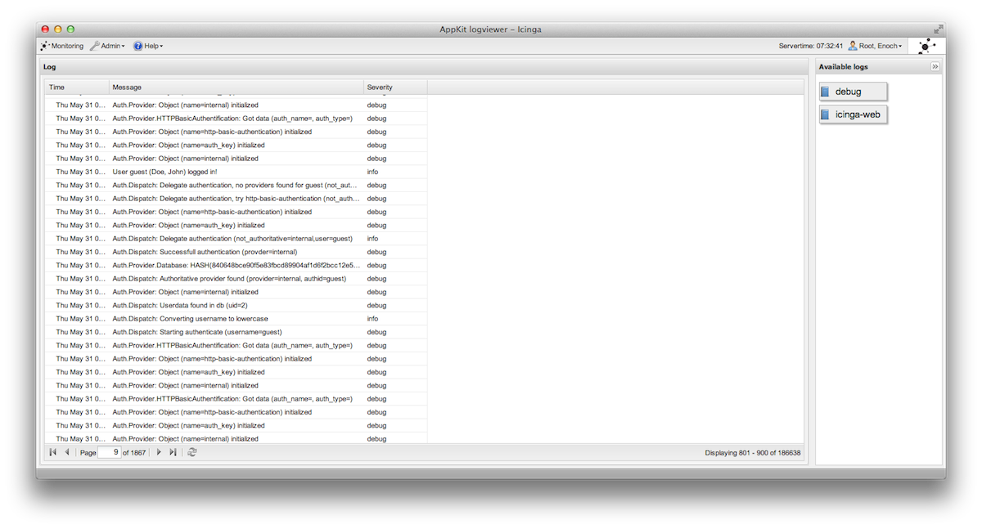
Fig 2.2 This figure is showing the Network Log of Icinga. All the status of nodes is shown here.
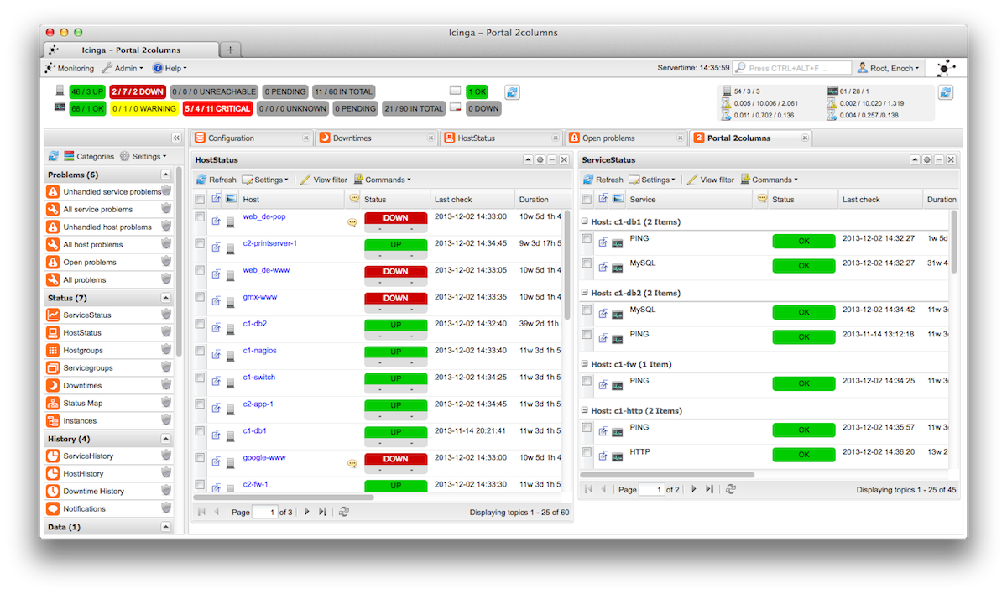
Fig 2.3 This figure is showing the portal of Icinga. All the portal columns are shown here.

2.1.2 NEDI
NeDi may not be as well known as some of the others, but it’s a great solution for tracking devices across a network. It continuously walks through a network infrastructure and catalogs devices, keeping track of everything it discovers. It can provide the current location of any device, as well as a history.
NeDi can be used to locate stolen or lost devices by alerting you if they reappear on the network. It can even display all known and discovered connections on a map, showing how every network interconnect is laid out, down to the physical port level [1].
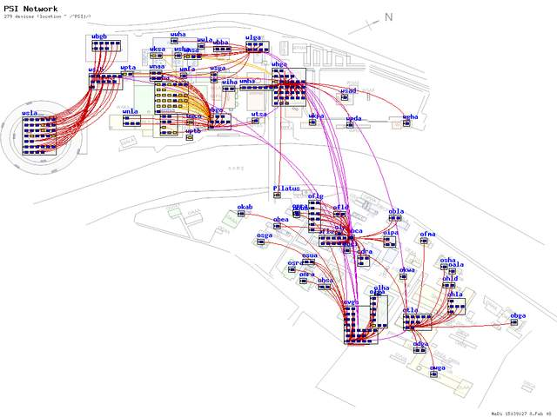

Fig 2.4 This figure is showing the Sample Network diagram of Nedi. The GUI of Nedi looks like this.
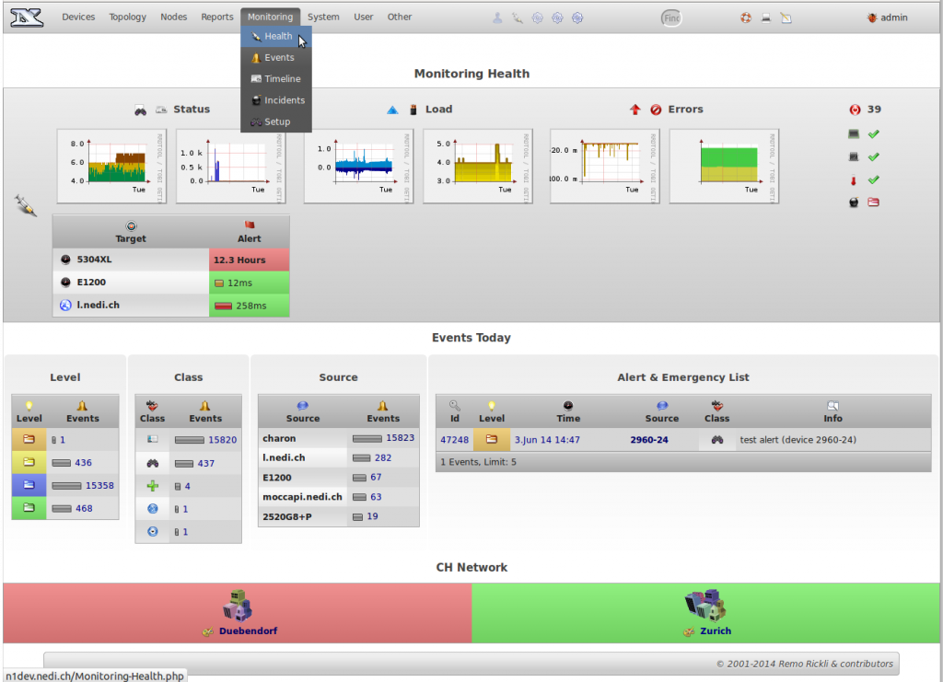

Fig 2.5 This figure is showing the Sample Network Status of Nedi all the options present.

2.1.3 ZABBIX
Zabbix monitors servers and networks with an extensive array of tools. There are Zabbix agents for most operating systems, or you can use passive or external checks, including SNMP to monitor hosts and network devices. You'll also find extensive alerting and notification facilities, and a highly customizable Web UI that can be adapted to a variety of heads-up displays. In addition, Zabbix has specific tools that monitor Web application stacks and virtualization hypervisors.
Zabbix can also produce logical interconnection diagrams detailing how certain monitored objects are interconnected. These maps are customizable, and maps can be created for groups of monitored devices and hosts [1].
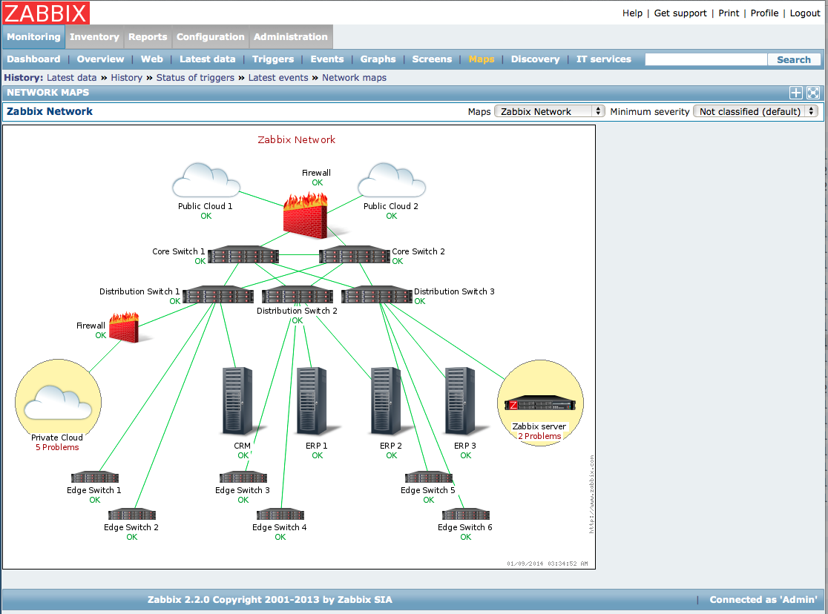
Fig 2.6 This figure is showing Sample Network diagram of Zabbix. All the nodes are represented by respective images.
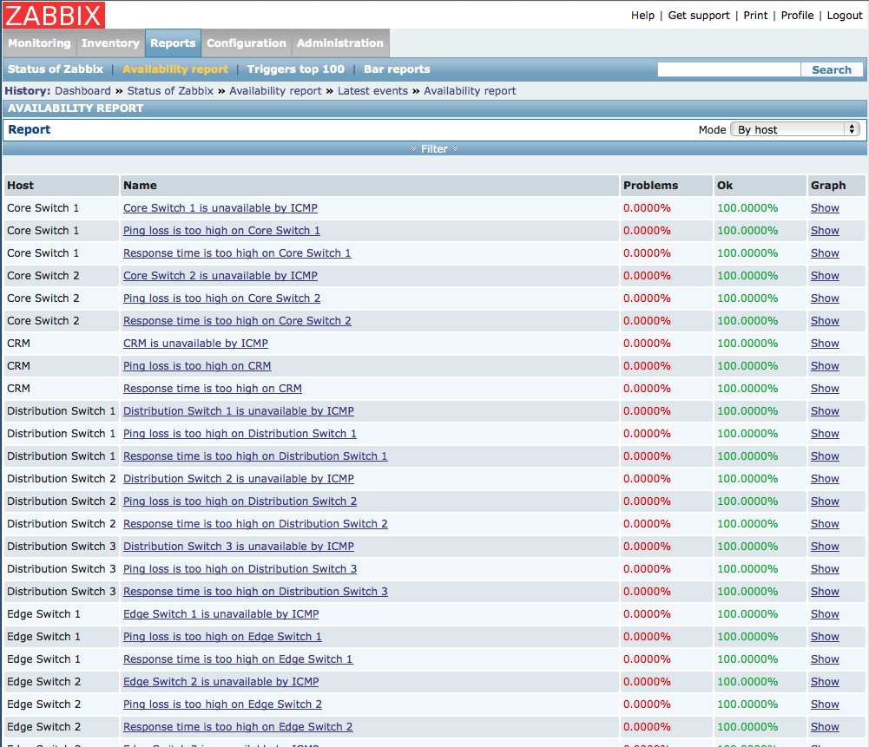

Fig 2.7 This figure depicts logs showing the availability report in Zabbix.
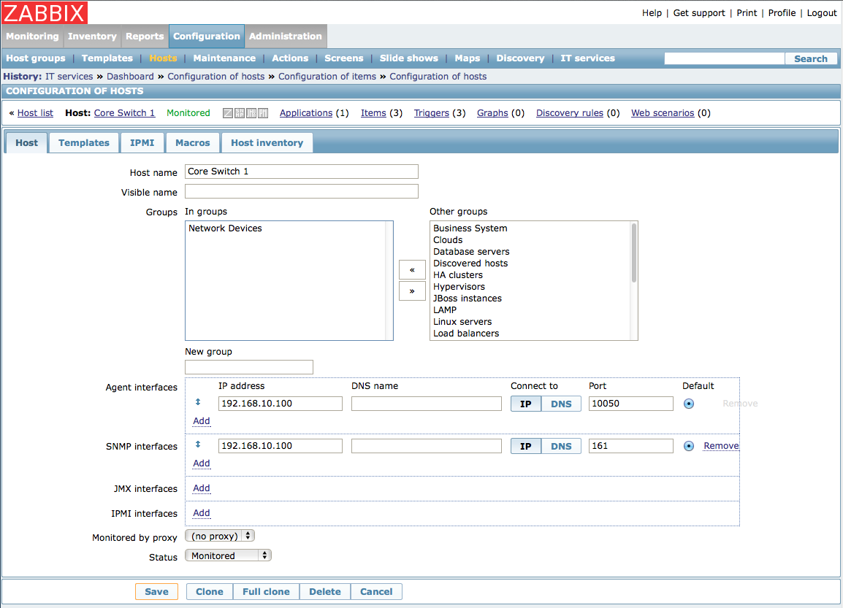
Fig 2.8 This figure is showing the Configuration of host is done in Zabbix with options.
2.1.4 CHEOPS
Cheops-ng is a Network management tool for mapping and monitoring your network. It has host/network discovery functionality as well as OS detection of hosts. Cheops-ng has the ability to probe hosts to see what services they are running. On some services, cheops-ng is actually able to see what program is running for a service and the version number of that program [1].
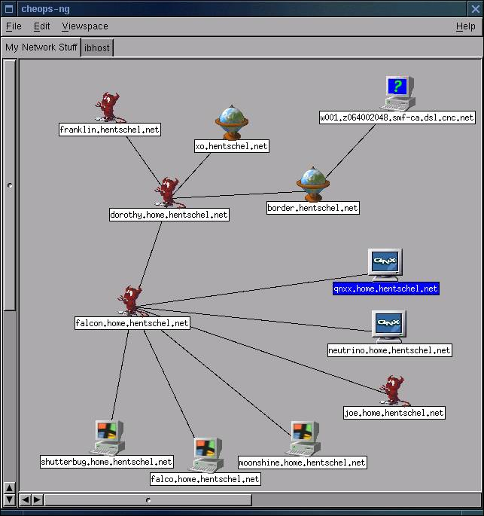

Fig 2.9 This figure is showing the sample network diagram with nodes.
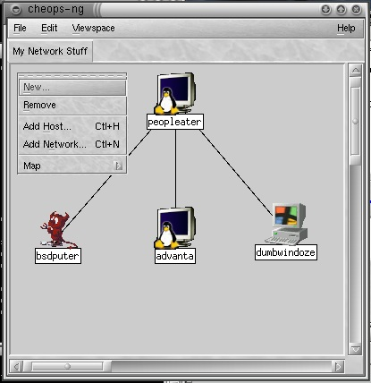

Fig. 2.10 This figure is showing how to Edit network in Cheops-ng with all options.

2.2 LITERATURE REVIEW
Problem determination is one of the most important tasks in managing networking systems. Probing (both at the transaction and network levels) has been widely used for assessing compliance with Service Level Agreements and locating problems in networking systems. However a probing scheme which uses a fixed setoff regularly scheduled probes can be expensive in terms of the number of synthetic transactions needed, especially for the task of problem determination. This paper introduces an active probing scheme to reduce the number of probes needed. Our key idea is to divide the problem determination task into two steps. We first use relatively small number of fixed, regularly scheduled, probes for detecting that problem has occurred. In the second phase, once occurrence of a problem is detected, additional probes are issued on-the-fly to acquire additional information until the problem is localized. We develop algorithms for selecting an optimal setoff probes for problem detection and choosing which probes to send next based on what is currently known. We demonstrate through both analysis and simulation that the active probing scheme can greatly reduce the time needed for localizing the problem and it is compatible with all hardwares when compared with a non-active probing scheme like SNMP [2].
The rapid growth in size and complexity of networking systems makes performance management tasks such as problem determination – detecting system problems and isolating their root causes – an increasingly important but also extremely difficult task. For example, in IP network management, we would like to quickly identify which router or link has a problem when a failure or performance degradation occurs in the network. Ianthe e-Commerce context, our objective could be to trace the root-cause of unsuccessful or slow user transactions (e.g. purchase requests sent through a web server) in order to identify whether it is a network problem, a web or back-end database server problem, etc. Another example is real-time monitoring, diagnosis and prediction of the “health” of a large cluster system containing hundreds or thousands of workstations performing distributed computations (e.g., Linux clusters or GRID-computing systems).Two general approaches are commonly used for problem determination. The first is event correlation, in which every managed device is instrumented to emit an alarm when its status changes. By correlating the received alarms a centralized manager is able to identify the problem. However, this approach usually requires heavy instrumentation, since each device needs to have the ability to send out the appropriate alarms [2].
Also it may be difficult to ensure that alarms are sent out, e.g. by advice that is down. To avoid these problems, which arise from using a fixed, “passive “data-gathering approach, a more active probing technology has been developed, which allows one to test network and system components in order to provide more accurate and cost efficient problem determination. Aerobe is a test transaction whose outcome depends on some of the system’s components; accurate diagnosis can be achieved by appropriately selecting the probes and analyzing the probe outcomes. Previous work has focused on selecting probes in an off-line, pre-planned fashion. Prior information about network and system dependencies, which problems need to be detected most urgently (perhaps because they are more important or more likely to occur), and other forms of prior knowledge are used to construct set of probes that is small (thereby reducing probing costs such as data storage requirements and network load) yet provides extensive coverage so that problems can be diagnosed. These probes are scheduled to run periodically to provide information about what problems may be occurring [2].
Active Probing Technique implementation and effectiveness over various problems:
Pre-planned probes v/s Active probing:
Using pre-planned probe sets suffers from considerable limitations. Because the probe set is computed off-line, it needs to be able to diagnose all possible problems which might occur. However in practice constructing such a probe set can be quite difficult, because one must envisage all problems one would like to be able to diagnose and construct probes for them. A pre-planned probe set may also be very wasteful, because many problems that might occur do not in fact ever happen. Probes to detect such problems enlarge the probe set unnecessarily, but knowing which probes can safely omitted can usually only be determined on-line by monitoring which problems in fact occur.
Another disadvantage of pre-planned probe sets is that because the probes run periodically at regularly scheduled intervals, there may be a considerable delay in obtaining information when a problem occurs. It is clearly desirable to detect the occurrence of problem as quickly as possible. Furthermore, once the occurrence of a problem has been detected, additional information may be needed to diagnose the problem precisely. This information may not be obtainable from the results of the pre-planned probes - additional probes may need to be sent to obtain it. These probes should be appropriately selected “on-demand”, based on the results of the previous probes. Our works develops a methodology called active probing that addresses these limitations. This involves probing in an interactive mode, where probe results are analyzed to determine the most likely diagnosis, and then additional probes are selected and sent in order to gain further information. This process may repeat - once additional probe results are obtained, the diagnosis is refined, and, if necessary, more probes are selected, and so on, until the problem is completely determined. The idea of this approach is to “ask the right questions at the right time” [2].
Active probing selects and sends probes as needed in response to problems that actually occur. It therefore avoids both the difficulty of constructing probes for all possible problems as well as the waste inherent in using probes for problems that infect never occur. Furthermore, because probes are selected on-line to obtain further information about particular problems that have occurred, they need not circulate regularly throughout the entire network; instead they can be targeted quickly and directly to the points of interest. Thus fewer probes are needed than in a pre-planned approach, allowing for a considerable reduction in probing costs.
Implementing active probing requires developing solutions for the following issues:
1. A small probe set must be pre-selected, so that when a problem occurs we can detect that something has gone wrong.
2. The probe results must be integrated and analyzed, to determine the most-likely network state.
3. The “most-informative” probes to send next must be selected, based on the analysisof previous probe results.
4. This process must be repeated until the problem diagnosis task is complete.
Active probing provides efficient solutions for each of these issues and integrate them into a practical system for active probing. Active probing substantially reduces the number of probes needed to diagnose problems when compared with pre-planned probing. Our preliminary results suggest that active probing may be a powerful and effective technique for problem determination and will surpass the limitations of the prevailing tools based on SNMP [2].

2.2.1 ACTIVE PROBING EFFECTIVENESS IN DIFFERENT EXISTING DISCOVERY SYSTEMS
Initial topology discovery systems, such as Mercator, based on hop-limited probing methods sent probes out from a single location. Probing in such a way is likely to result in a tree-like topology and will tend to miss out “cross-links”, i.e. traversal branches. Subsequent work therefore adopted multiple source approaches, in which multiple probing sources are used. Quite like looking glasses, a large number of public traceroute servers have been made available and can be found at. Initially their use was mainly intended for debugging purposes but they can also be used by topology discovery tools, although their web interfaces sometimes lack convenience [2].
An example of such a platform is Planet Lab which has currently 694 machines hosted on 335 different sites which provides a network testbed for many active research projects of all kinds, covering file sharing, content distribution networks, QoS overlays, anomaly detection mechanisms, and network measurement tools. An implementation making use of Planet Lab is script route aimed at providing traceroute servers’ accessibility but with the flexibility of running a variety of measurement tools. Other approaches have deployed their own measurement infrastructure, like the well-known Skitter project of CAIDA which has between 20 and 30 available monitors’ world-wide providing traffic measurements services for researchers. The Active Measurement Project (AMP) of the National Laboratory for Applied Network Research (NLANR), although recently terminated in July 2006, took a slightly different approach by letting 150 monitors, mainly deployed in the United States, probe each other in a full mesh in order to obtain dense coverage of the underlying network. Another project, Rocket fuel, concentrates on discovering the internal topologies of ISPs. A more recent trend has been to move towards a more distributed system as demonstrated by a project like DIMES from the Tel-Aviv University. DIMES relies on the distribution of small portable agents to the community, in a similar spirit to ones such as SETI@home, which perform typical traceroute and ping probes around the globe [2].

CHAPTER 3
ANALYSIS

This section consists of details of details of functional and non-functional requirements of the system but it describes in detail the functionality of the system. It also discuss how the different components interact.

3.1 FUNCTIONAL REQUIREMENTS
In a large network setup it is hard to visualize the network topology. The network administrator faces several problems, such as broken link. The network administrator is not aware of these problems instantly.
The network administrator should know about anomalies present in his network instantly and should be able to solve them in quick succession of time. Also the administrator should know the status of a link whether it is up or down but without a proper tool it is very tedious job for the network administrator.
What he requires is a tool which can generate a graph for the given network so that he can visualize his network easily and can find the anomalies present in it instantly.
Functional Requirement-
- Visually monitor entire LAN network.
Every device in a network will be shown as an icon, the live link connecting two nodes in a green connector and the dead link in red connector. For every type of device we have a defined icon, such as for routers, desktops and servers.
- Dynamic identification.
If a device is added in our network (manually), then it will be shown automatically. The system will refresh itself after defined time period.
- Automatic message generation
Whenever any link is down, (which will be shown in red on map) an automatic message/SMS will be generated to the network administrator.
- Maintain log
The system will maintain a log of links, indicating the uptime and down time of the network device. It will also show the current status of link.
Additional functionalities (for CCTV monitoring)
Identify if the CCTV camera is blocked or not using image processing in matlab.

3.2 NON- FUNCTIONAL REQUIREMENTS
The non functional requirements discuses the issues like performance, security and reliability of the system. It describes how the system will respond to any abnormal conditions. It also discusses the key attributes that affects the quality of software.
3.2.1 PERFORMANCE REQUIREMENTS:
To measure the performance of the network mapping system, various parameters re checked on the basis of which performance is better. These parameters are:
Performance: The ping module implementation involves ping process in which the reply of the ICMP echo messages should return in at most five seconds.
Reliability: In case of server and power failure, the entire will collapse. Therefore, a proper back up facility should be available. Also, the backup of database should be maintained separately to ensure data safety even in some cases of data loss.
3.2.2 SOFTWARE QUALITY ATTRIBUTES:
The software quality attributes of the system measures the effectiveness of the factors which measures the quality of software used. These factors are:
Availability: If the probe message gets disrupted, then information or the probe must be sent again for verification.
Usability: The system is easy to operate and navigates in the most expected ways with no delays.
Security: The main security concerns is for the user verification. Hence, proper verification mechanisms that is user ID and password should be used to avoid corruption or unauthorized access.

3.3 DIAGRAMS
3.3.1 USE CASE DIAGRAM
The use case diagram is shown on figure shows the set of possible sequences of interactions between systems and users in a particular enviroment. It shows the activities that the administrator at network mapper perform.
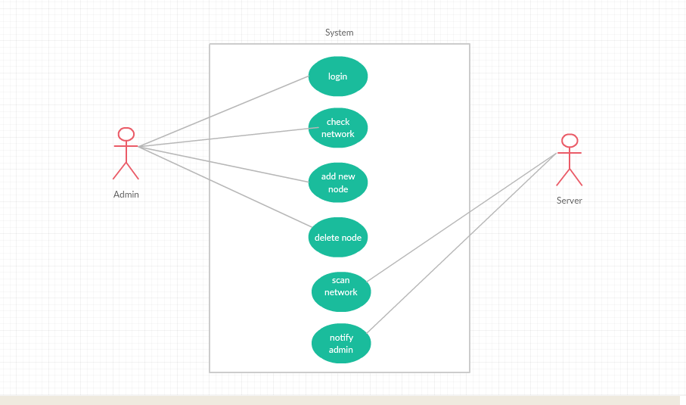

Fig 3.1 Use case diagram showing the actors and usecases in the given figure above.
3.3.1.1 USE CASE DIAGRAM DESCRIPTION
The use case comprises of actors, actions and scenarios. For every scenario, there is a basic flow and an alternative flow. The status of the system before and after an action is performed is also explained in this section.
A) ACTORS :
administrator : An administrator is the only user who will monitor the whole and keep the records of the whole topology. He has to authenticate himself each time he comes to access the application

B) ACTIONS :
1) LOGIN :- This module is for the authentication of administrator . In this module the customer enters his/her login credentials and the system verifies that it is the correct or not.
ACTOR : administrator
BASIC FLOW : The user will simply enter the login credentials and the system will check the entered login id and password in the existing file and grant the access if it is correct.
2) CHECK NETWORK :- This module will check the network by pinging the nodes present in the network. administrator will trigger this operation.
ACTOR : administrator
BASIC FLOW : The administrator will click the generate graph button and the whole network will be pinged one by one and corresponding information will be stored in the corresponding file.
3) ADD NODE :- This module will add nodes in the the topology . The user will simply add the ip address the parent id and the name of the node and the node will get entered in the system.
ACTOR: administrator
BASIC FLOW: The user will enter the ip address, parent id, node name and id and after clicking the submit button the node will get added.
4) DELETE NODE :- This module will delete nodes from the topology. The user will enter the ip address to delete and the node will get deleted.
ACTOR: administrator
BASIC FLOW: The user will simply enter the ip address to be deleted and the node will get deleted from the topology.
5) SCAN NETWORK :- This module will scan the whole network using the BFS algorithm and will generate the status of the nodes level by level.
ACTOR: administrator
BASIC FLOW: On pressing the generate button the graph will get generated automatically using the BFS algorithm.
6) NOTIFY administrator :- This module will generate sms for the down IPs and will send it to the administrator. The sms will cotain the information about the down Ips.
ACTOR: administrator
BASIC FLOW: The system will generate the message automatically every time it is been refreshed.

3.3.2 ACTIVITY DIAGRAMS:
3.3.2.1 USER AUTHENTICATION:
Firstly, we have taken user ID and password and accordingly verified whether a user exist or not. If the provided user ID and password are correct, then redirect user to the home page.

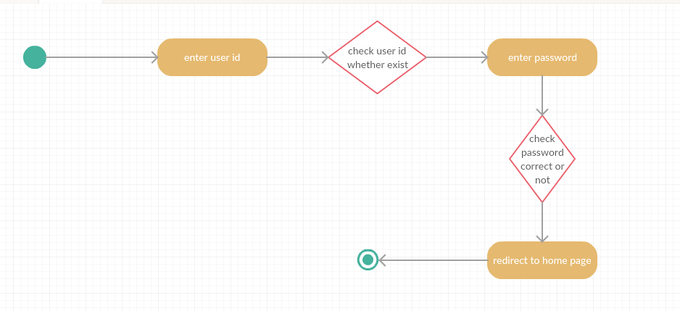

Fig 3.2 Activity diagram – login

3.3.2.2 NETWORK LOG:
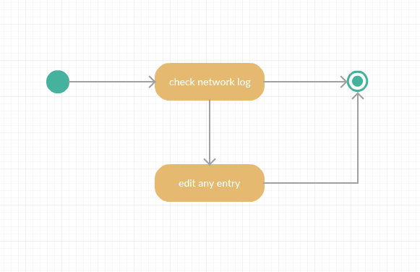
Here user can click on a network log button and can edit any entry.

Fig 3.3 Activity diagram – check network

3.3.2.3 ADDITION OF NODE :
Firstly, the user will click on the new node button to add any new device to the network. He has to provide the IP of the device, its parent ID, device ID and device name.
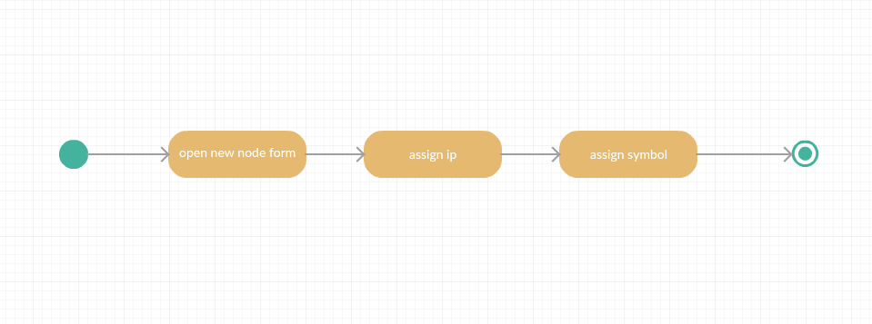
Fig 3.4 Activity diagram – addition of nodes

3.3.2.4 DELETION OF NODE :
Firstly, the user will click on delete node button so as to delete the device from the network. He has to provide IP and ID of the device to be deleted.
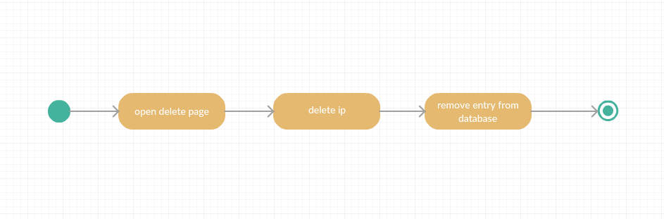

Fig 3.5 Activity diagram – deletion of nodes

3.3.2.5 SCAN NETWORK :
Firstly, the user have to click on the scan network button. After this our ping module will get executed and sends ICMP messages to all the devices within the network. Then it check for the ICMP replies coming from the different network devices if the reply type is 3, then the device is down otherwise it is active and will be shown by the green line.
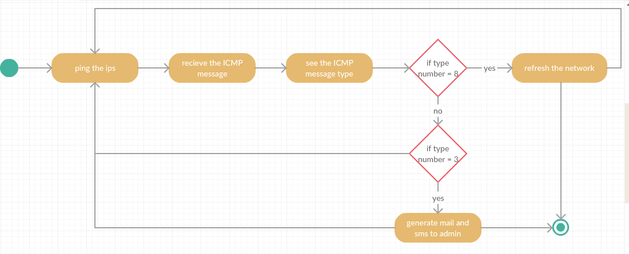

Fig 3.6 Activity diagram – Scan network
3.3.2.6 NOTIFY administrator :
Here, after receiving the ICMP reply message, if the message type is 3, then it means the device is down and the system will generate a notification to the administrator about the down link or device.
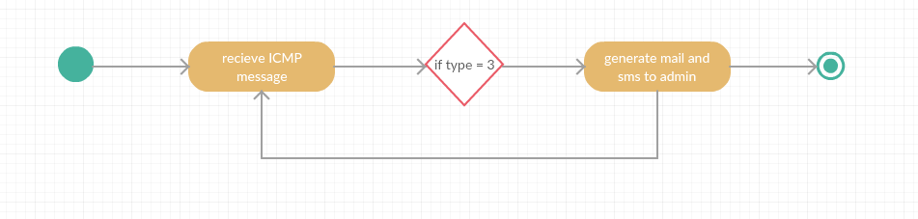
Fig 3.7 Activity diagram – Notify administrator

3.4 ALGORITHM DESCRIPTION
GRAPH TRAVERSAL ALGORITHM (BREADTH FIRST SEARCH):
We have implemented BFS algorithm for graph traversal. The adjacency list which we have created in GraphConnection.JSON is used in BFS Traversal. It checks the status of the devices using Ping utility. The output of PING command shows destination unreachable when the ICMP packet reply from the device is of type 3 or else if it shows destination reachable when the ICMP packet reply from the device is of type 8. The output of PING command is analyzed and based on this output we change the value or status of the link ‘0’as link is down, ‘1’ as link is up and ‘2’ as link is unreachable.

3.5 FEASIBILITY ANALYSIS
3.5.1 TECHNICAL FEASIBILITY
Technical feasibility access the current resources and technology, which are required to accomplish user requirements in the software within the allocation time and for this, the software development team ascertains whether the current resources and technology can be upgraded or added in the software to accomplish specified user requirements.
Technical feasibility of the product has been studied under following heads :
Hardware availability:- The application needs a server, camera and computer system(PC).
Software availability: - Brackets, gedit.
3.5.2 ECONOMIC FEASIBILITY :
This system requires server, camera for surveillance and computer system.
(I) Hardware cost: - As such no separate hardware is required. We need a server and cameras.
(II) Software cost :- Software needed for development of this system are open source software( Front end : Html ,Java script and CSS ; Back end : C++ ) hence, there is no cost associated with them.
3.5.3 OPERATIONAL FEASIBILITY :
Operational feasibility is an measure of how well a proposed system solves the problem. The existing systems have a problem that they are based on SNMP protocol which is not quite secured and also their header size is too large. So the proposed system removes these problem as:-
Here we are using Active Probing to solve the issues involved in previous systems. This proposal is secured such that It does not require any data fetching from the tables. It has nothing to do with Header size problem because it uses ping command, so it will not create any data congestion.
In current system, there is no provision for detect to notify the administrator about the down links. But in our proposed system, if any link is down so it will notify the administrator about down links.
3.5.4 SCHEDULE FEASIBILITY :
A project will fail if it takes too long to be completed before it is useful. Typically this means estimating how long the system will take to develop and if it can be completed in a given time period. Schedule feasibility is a measure of how reasonable the project timetable is.
The system is scheduled accordingly to the needs of the project. It is being divided into two phase I and II.
(i) Phase I - This phase needs completion till design phase as per the predefined schedule, Phase- I is completed as per the expected schedule.
(ii) Phase II - This system has independent front end and back end modules. All identified modules have been clearly defined, divided to team members and the construction has been completed successfully.

CHAPTER 4
DESIGN

This chapter focuses on the over all design og the project. It describes the design of the project through various diagrams. The architecture of the project is shown through the architecture diagram. This chapter discusses all the description of the components which are present in the tool.
4.1. DESIGN STRATEGY
Active probing technique is used for implementing our proposed Network Mapper tool. We propose an active probing scheme for the task of problem determination. We have developed it in such a way that firstly all the systems are pinged and then we receive ICMP reply. Now these replies are examined and we grep the destination unreachable .
A graph data structure used to store the network topology in the software. The nodes are added to the graph by the network administrator. The non-leaf nodes are either routers or servers. Breadth first search technique is used to traverse the whole tree. We are using BFS technique because it has lower algorithmic constant factor, than DFS technique.
According to the actual graph data stored, the software will detect the active and broken links by using active probing. The software will send probes to detect these links and show them as either green or red line. We have used grey colour lines for undiscovered links.

4.2. REQUIREMENTS
The objective of this tool is not just to create a network topology. Most importantly, we want to create and maintain a user friendly tool and compatible for all layer three devices. It should have a GUI through which the administrator can execute each task. The interface should be simple, systematic and clear. It should allow the administrator to actually make easier to work such as generating the graph dynamically, implementing coloured nodes for links for easy recognition and we have assigned different IPs for respective nodes for easy understanding. Each program should be straightforward and should not contain functions that overlap. It should display a clear and systematic nodes with connected links with green colour and broken links with red colour which makes easy for administrator to recognize easily. It should display the front end process such as login, etc. It should display recognition results so that we are able to evaluate and analyse. Internally, Network Mapper have the following processes.

1) Log in process
2) Addition of Nodes
3) Generation of graph.
4) Automatic Alert generation.
5) Dynamic status of graph.

4.4. ARCHITECTURE DIAGRAM
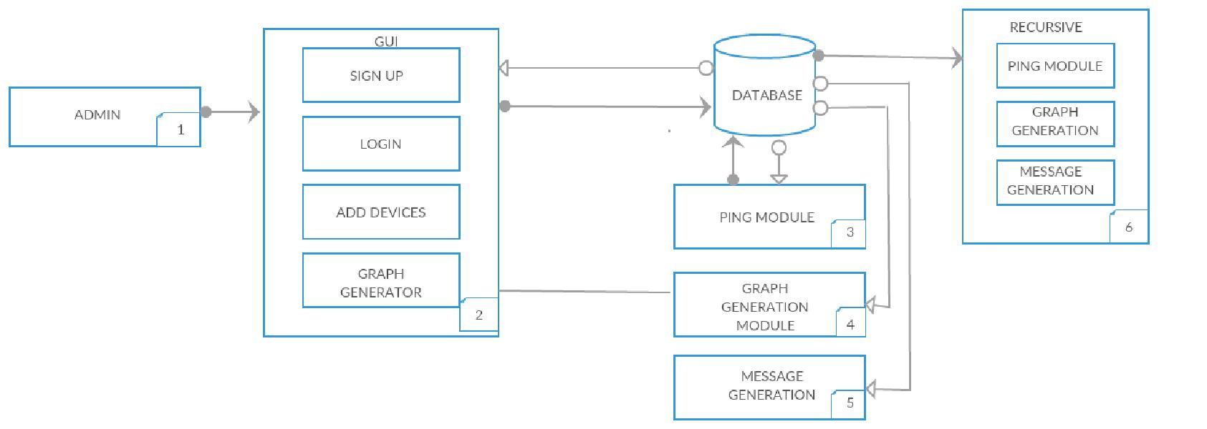
Fig. 4.1
Architecture Diagram with various modules.

4.4.1 GUI ENVIRONMENT
Our GUI Environment is highly-integrated and professional GUI environment in which a user can easily create GUI for any type of projects or dissertations work. It is a high-level programming language that includes two main functions:
1) JSON function.
2) TICK function.

4.4.2 PING MODULE
In this module we have taken input from graph connections.json file and done parsing of JSON file into JSON objects. The value from these JSON objects in C++ code are used to fill the array of IP Addresses and the adjacency list. There is the “isAlive” function which returns the Boolean value 0/1 depending on the link status.
4.4.3 SMS MODULE
We have used a SMS gateway “ViaNetSMS” which takes Username, password, message sender, destination address and the message. It takes input from linkstate.json and decodes into Jason objects
It observes all the links of json objects and whose value is 0 or any of the down links and the target of that downed link is appended to the message and the SMS is send to the administrator.
4.4.4 FRONT-END MODULE
For the purpose of LOG in, we have created a PHP session. After log in, it directs to the Home page. Our home page has three options ADD node, Generate graph and Send SMS.
4.4.5 BACK END MODULE
The output from PING goes to grep command such that it scans the destination unreachable keyword. The output is fed to wc utility which counts the number of lines. If the number of lines is 0 then it returns 1 that indicates that the link is up, otherwise it returns 0 that indicates the link is down. Initially all link state values are 2 in GraphConnection.json.

CHAPTER 5
IMPLEMENTATION
This chapter describes how the design has been understood and properly translated into desired system. Implementation phase consists of the coding of the project. Firstly, the information is gathered from the various initial phase of our project. Then this information is used to develop the actual system in the implementation phase. Active Probing is used for the implementation of our project. We created three main module in our project which are Front-End Module, PING Module and SMS Module. In Front End Module we write a program in which it contains options for Add Node, Generate graph, etc. In PING Module we write a program in which it contains C++ code that pings the corresponding IP Address and records its status. In SMS Module we write a program in which all the down links are checked and sends the SMS to network administrator about the broken links.

5.1 MODEL DESCRIPTION
We have used Active Probing technique for the Network Mapper.Active probing is an active network monitoring technique that has potential for developing effective solutions for fault localization. In this paper we use active probing to present an approach to develop tools for performing fault localization. We discuss various design issues involved and propose architecture for building such a tool. We describe an algorithm for probe set selection for problem detection and present simulation results to show its effectiveness.

An Algorithm for Network Mapper using Active Probing is as follows:
- Initially, the links are added using GUI, given that the details such as IP Address, ID, Parent ID, device name.
- Using these graph connections, the nodes are traversed using BSF and the link states are detected by analyzing the output of PING utility.
- The link states are then used to plot the NETWORK GRAPH.
- Finally, the SMS is send to the Network administrator regarding the information about the down links.

5.2 WORKING DIAGRAM
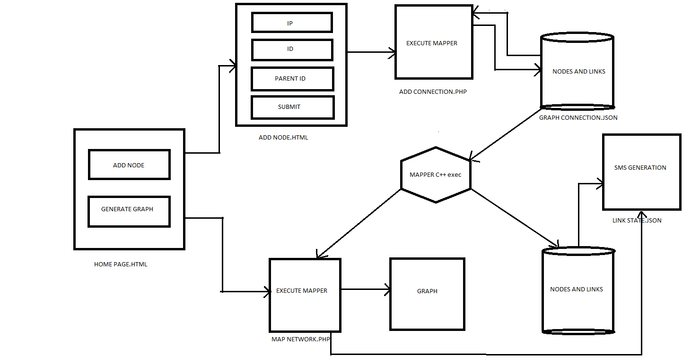
Fig. 5.1 Working diagram

ADD NODE: Firstly, user will click on Addnode button present in Homepage.html. This will redirect the user to AddNode.html. In addnode.html , user will provide information about the device to be added like its ip address , its id , parent id , and device name. This information will be stored in a Json file after executing addconnection.php .

GENERATE GRAPH : Firstly, user will click on generated graph button. After this the mapper will execute which will fetch date from the Json file and generate a graph of the network.

SMS GENERATION : This module will take data from linkstate.json file. If the value corresponding to a link is 0, then it means the link is down and the module will generate sms to network administrator which contain the ip of the device which is down . and this device will be shown by red link in the graph.
CHAPTER 6
TESTING AND RESULTS

This chapter comprises of various tests performed on system to test its accuracy and reliability. It contains the process of validating and verifying user. It is done so as to ensure that the system meets the technical as well as business requirements that guided its design and development as expected. It contains sample tests with correct deployments and outputs.

6.1. UNIT TESTING:
Initially, we have performed unit testing in which single components are tested.
6.1.1 USER AUTHENTICATION TESTING:
Every authenticated user is provided with a user id and password. The user is authenticated using these details.
- Correct values – User Id: administrator, Password : test
- Entered values – User Id: random Password: random
- Result – Incorrect Login
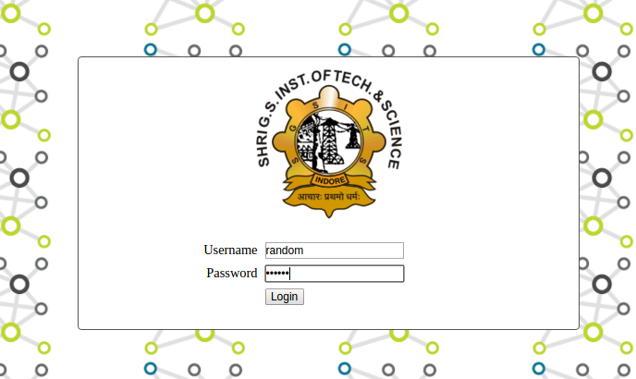

Fig 6.1 Login page input

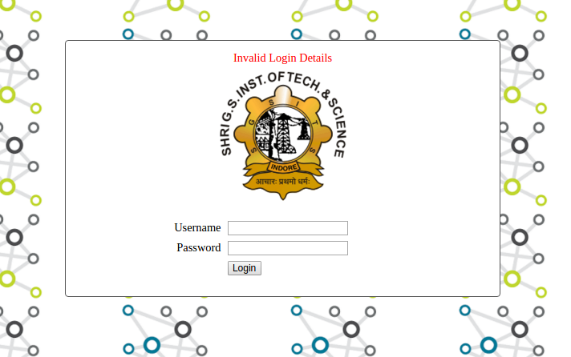

Fig 6.2 User id and password authentication

6.1.2 ADD/DELETE NODE TESTING:
Under this testing, we have assigned an IP of the devices and stored this IP to a file. We have created a HTML page for taking the inputs from the administrator. We took IP and ID of the device, Parent ID and name of the device. These inputs are then directed to a JSON file such that we randomly take IP of the devices through our HTML page and then we finally check that the particular entered IPs are stored within the proposed JSON file.
Similarly, in the case of deleting a node, we have created a HTML page for the entry of the ID to be deleted. All the entries related to this ID will be deleted from the JSON file. Now, the test was complete when we found the particular ID was removed from the file.

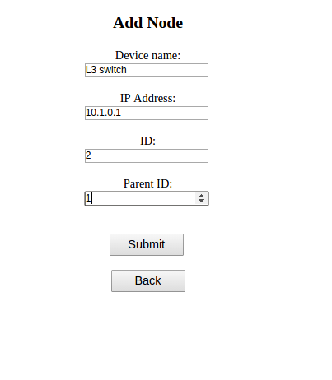

Fig 6.3 Add node form
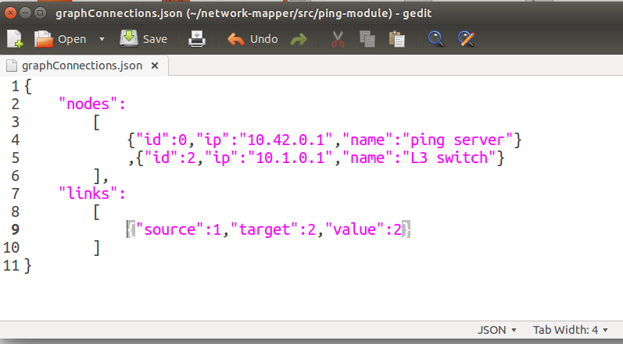
Fig 6.4 graphConnections.json file for add node

6.1.3 PING MODULE TESTING:
In this testing, we have assigned static IPs to a file, then our program in take these IPs and the program pings all the defined static IPs. Now, we receive PING reply coming from that IPs. Now, we store these reply’s status in another file.
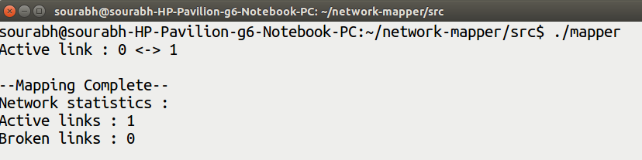
Fig 6.5 Checking connection status using ping reply
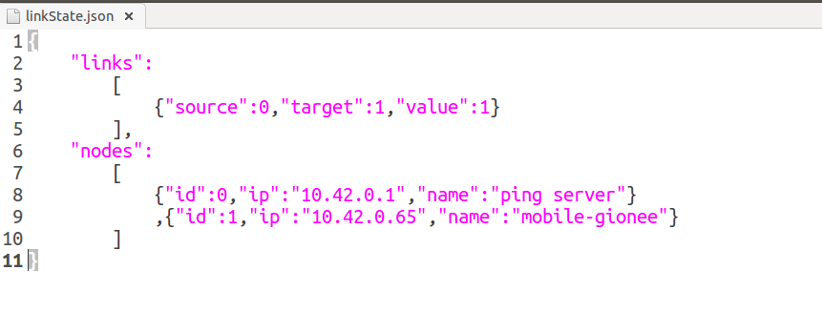
Fig 6.6 linkState.json file depicting link status

6.1.4 FRONT END TESTING:
The file consisting of the PING reply’s status is reviewed. This status is then used by The d3.js to determine the broken and up links. Our d3.js determines such that if the link to the particular IP is down then it shows that link to that node by a red line. Similarly, it determines the up-link as of green line. Our main objective is to make the interface so user friendly and easy to understand for the administrator and for this purpose d3.js fulfills our requirements.
The Log-in page of our GUI implementation, the URL is not accessible directly. We have tested this as for maintaining security.

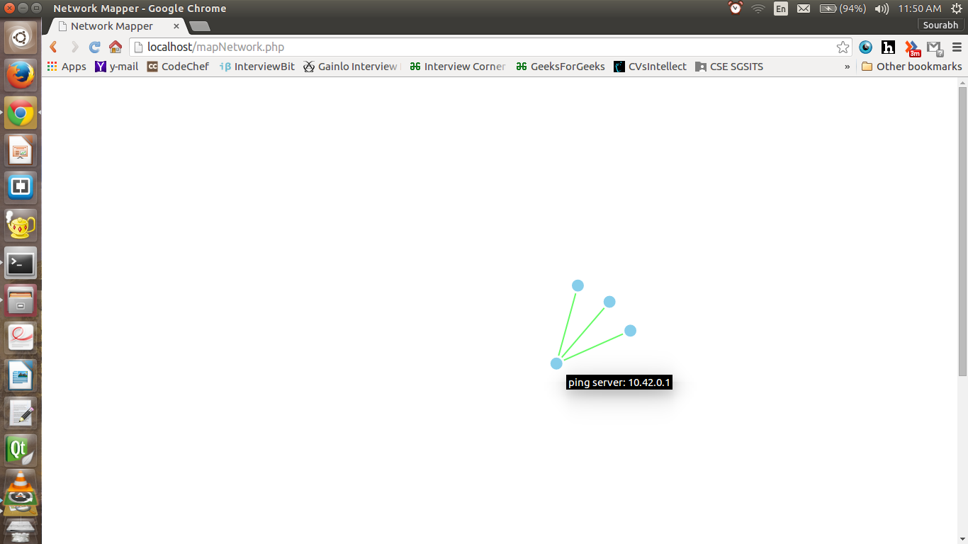
Fig. 6.7. The three IPs connected with three green/active links.
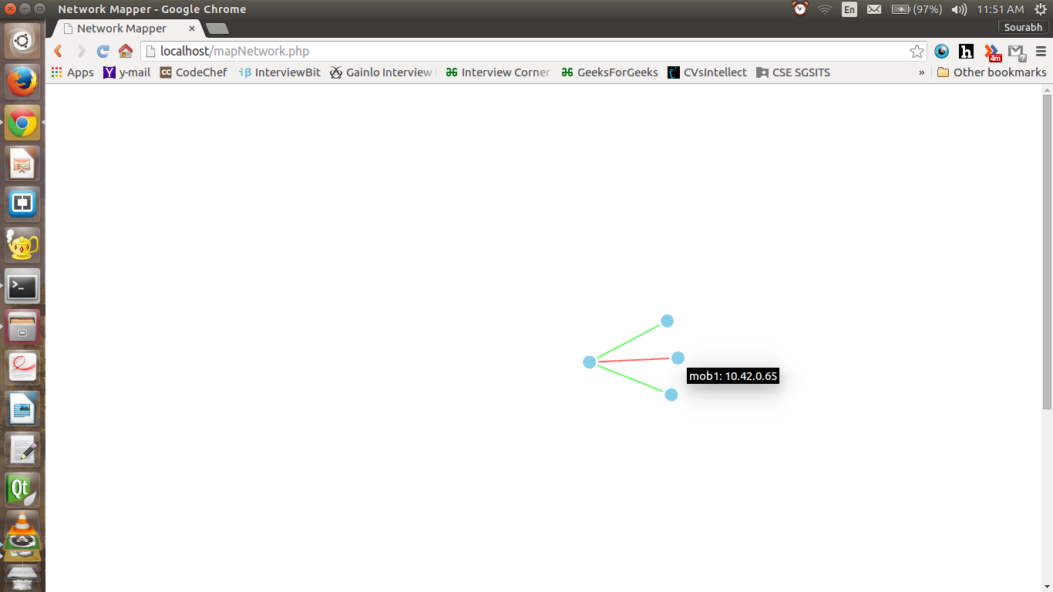
Fig. 6.8. The red link of IP 10.42.0.28 showing disconnection

6.2. INTEGRATION TESTING:
We have implemented this testing on a small scale and large scale.
6.2.1 SMALL SCALE:
At smaller scale, we have implemented this testing in such a way that the respective IPs of four to five mobile cell phones as well as laptops are analyzed under our testing. Firstly the IPs assigned to these devices are recorded. The graph is generated accordingly with all the links active and live, showing green colored links to respective nodes (Devices and IPs). The main objective was accomplished with the graph generation, showing all the connected devices with their IPs. Now, the testing was done to determine what happens when a particular link to a device is disconnected. So, accordingly we have disconnected a device and we found that the respective disconnected device is displayed as a Red colored link to that particular node. This small scale testing gave us the required confidentiality into our proposed testing and cleared all paths for our large scale testing.
6.2.2 LARGE SCALE:
At larger scale, we have implemented this testing in such a way that the respective IPs of switches and cameras are connected to our main server that is “10.0.1.9”.
L3 Switch: 10.0.200.1
GH New: 10.0.11.1 ; GH Old: 10.0.10.1
L2 Comp. Engg. 1: 10.0.1.2 ; L2 Comp. Engg. 2: 10.1.0.5
GCL Switch: 10.0.1.6
L2 Instrumentation: 10.0.4.1
Camera 1: 10.99.0.11 ; Camera 2: 10.99.0.12 ; Camera Comp. Engg.: 10.99.0.31
The respective IPs of switches and cameras are analyzed under our large scale testing. The test gave us a graph generated. The green and red lines indicates whether the switch or camera is connected or disconnected respectively.
Camera Comp. Engg.: 10.99.0.31 (Red – Disconnected)
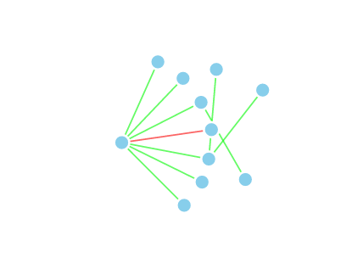
Fig 6.9 Large scale testing on mapping network
6.3. RESULTS:
After testing stage, the outcome of our proposed Network Mapper tool and its working has been accomplished on a small scale working model. We have connected three different IPs: 10.42.0.65, 10.42.0.83 and 10.42.0.28. The proposed approach to make these IPs visible as connected by green line was achieved. Similarly, to identify the broken link or down link, we have disconnected IP 10.42.0.28 to determine this broken link. Therefore, the link to node of IP 10.42.0.28 is shown by a red line which determines the broken link and SMS is send to administrator regarding the broken link.
STEP 1: 10.42.0.65, 10.42.0.83, 10.42.0.28 - Green links (Connected)
STEP 2: 10.42.0.65, 10.42.0.83 – Green links (Connected) and 10.42.0.28 – Red link (Disconnected)

CHAPTER 7
CONCLUSION

In Phase 1 we have done the study of need of network mapping in the industry. In this study we have gone through current development done in the field of network mapping and what basic technologies used in there.
We studied tools various open source tools like ICINGA, ZABBIX, NEDI,CHEOPS. These all tools are based on SNMP based approach. All these tools are deployed in various industries. But the major disadvantage with the SNMP based approach is that all the hardware doesn’t support SNMP. Various security issues have been listed with SNMP based approach. Also the header size of the probe packet is very large which causes congestion in network and takes time to resolve these large headers at receivers end.
We have done the feasibility study of this project and reached to a conclusion that this project can be implemented. We have designed Use-Case, Activity and Architecture diagram for the project.
In Phase 2 our main focus is on development of project using various technologies and methods. We will be working with HTML, CSS, JAVA SCRIPT, C++ and PHP to develop our project. Our back end will be entirely based on C++. All the ping process packet capture will be done by script written in C++ and tcp dump. After analysing the packet code type the entries in the database will be automatically updated and based on that automatic tree generation will be done. A form will be filled by the administrator to add a new node in the network and the corresponding entry will be done in the database. And that node will be automatically included in the network tree. Also the whole system will automatically refresh in every 5 Seconds. This proposed approach is successfully achieved. Thus, concluding that our Active probing technology based Network Mapper Tool have surpassed the current prevailing drawbacks of SNMP and its current prevailing tools.

ANNEXURE A
INSTALLATION

Step 1: To download XAMPP
1) Go to https://www.apachefriends.org/index.html
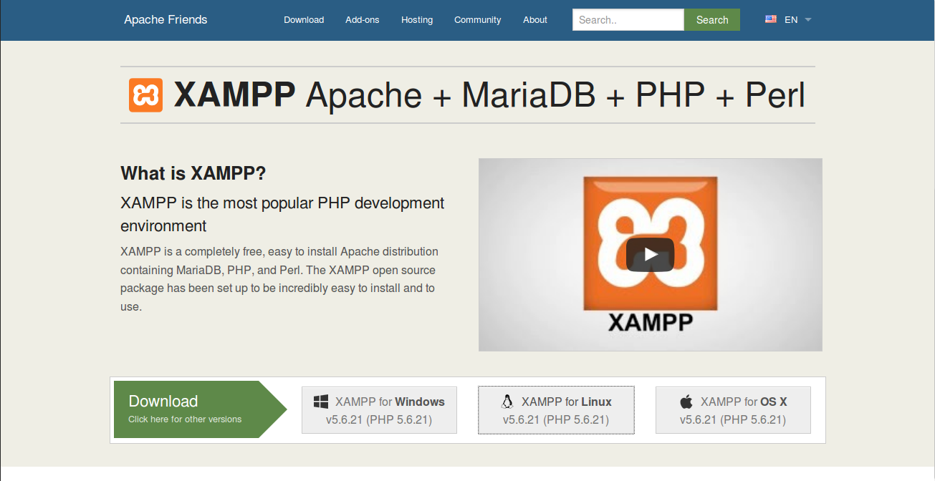
Fig 1 XAMPP home page

2) Click on XAMPP for Linux v5.6.21 (PHP 5.6.21).
3) Click on "Save File" radio button and click "OK".
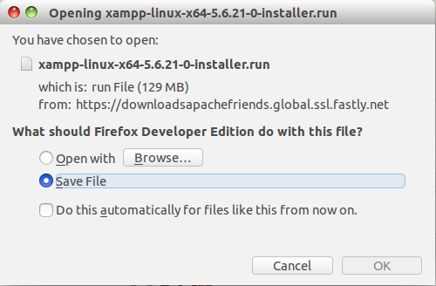

Fig 2 Download package

Step 2: Install XAMPP
1) After downlaoding the package change it to executable then run to install it with following command:
sudo chmod +x xampp-linux-x04-1.8.3.2-installer.run
sudo ./xampp-linux-x04-1.8.3.2-installer.run
2) Then click continuosly on Next and the Finish.
3) Then goto the Terminal and type following command:
sudo /opt/lampp/manager-linux.run
Fig 3 run manager-linux.run
4) Then the XAMPP control panel will open.
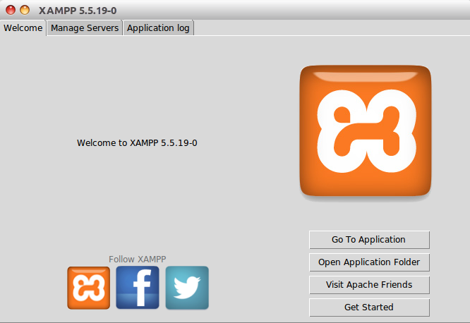
Fig 4 Control panel

5) Goto “Manage Servers” and click on “Start All”.
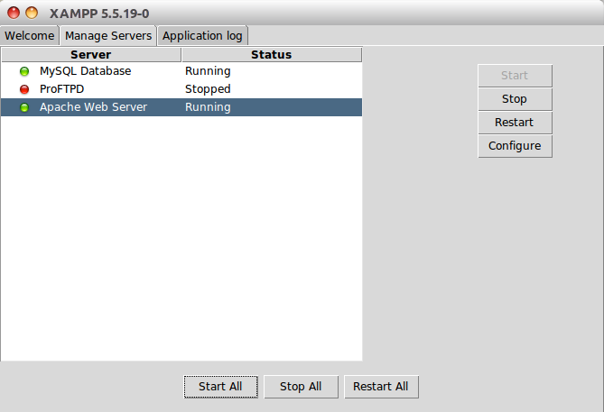
Fig 5 XAMPP manage servers
6) Open Browser and type “localhost” the xampp homepage will open.
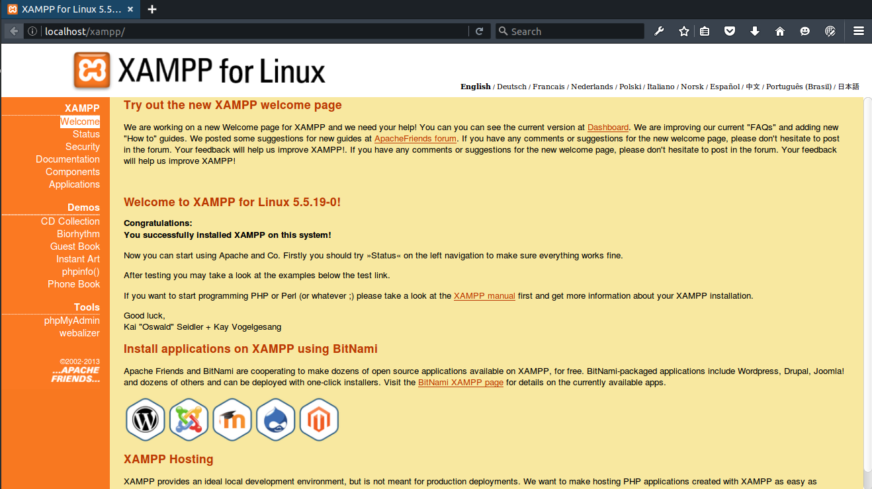
Fig 6 Open xampp homepage

Step 3: Download and Extract repository.
1) Goto https://github.com/sourabh14/network-mapper and download the repository.
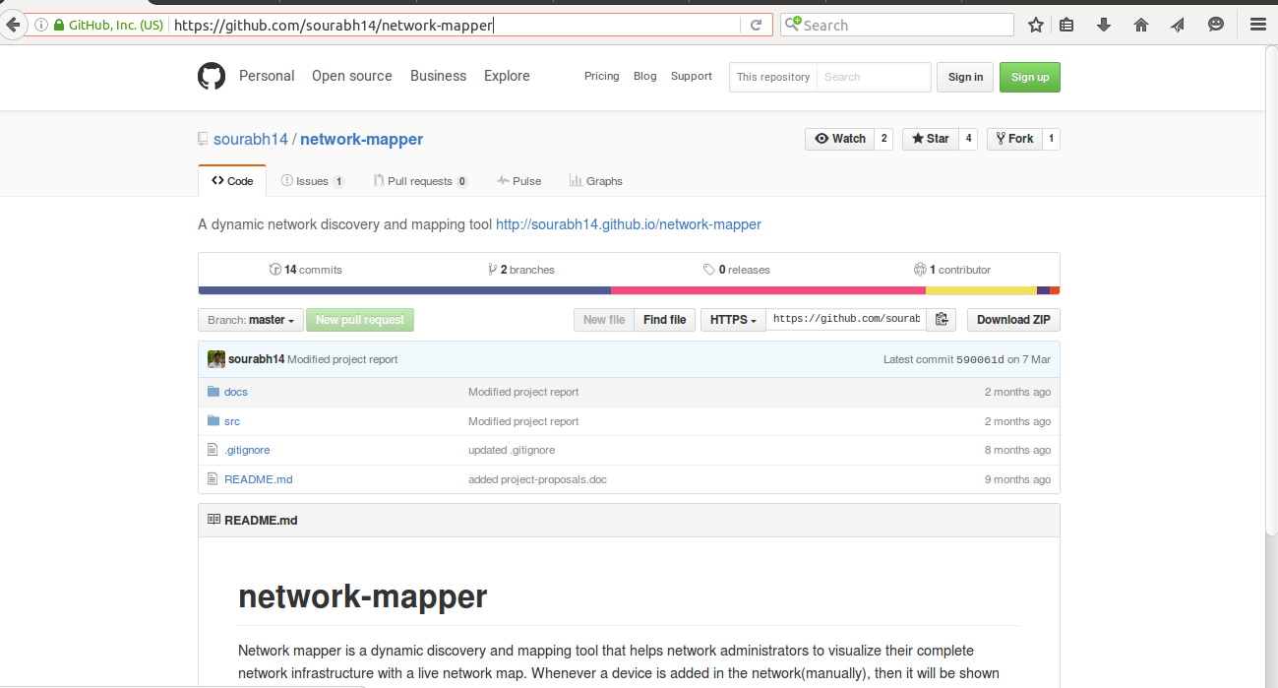
Fig 7 Github repository page
2) Then extract the zip file and move repository to /opt/lampp/htdocs
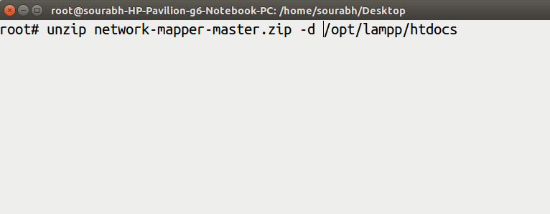

Fig 8 Extract repository and move to root folder

ANNEXURE - B
USER MANUAL
This section contains steps to use network-mapper software:
- Start Apache server server.
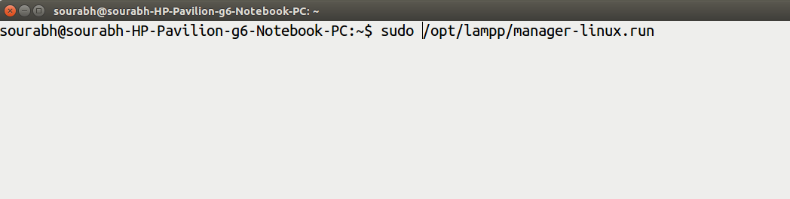
Fig 9 Run manager-linux.run
- In localhost open /network-mapper/src/homePage.html in a web browser
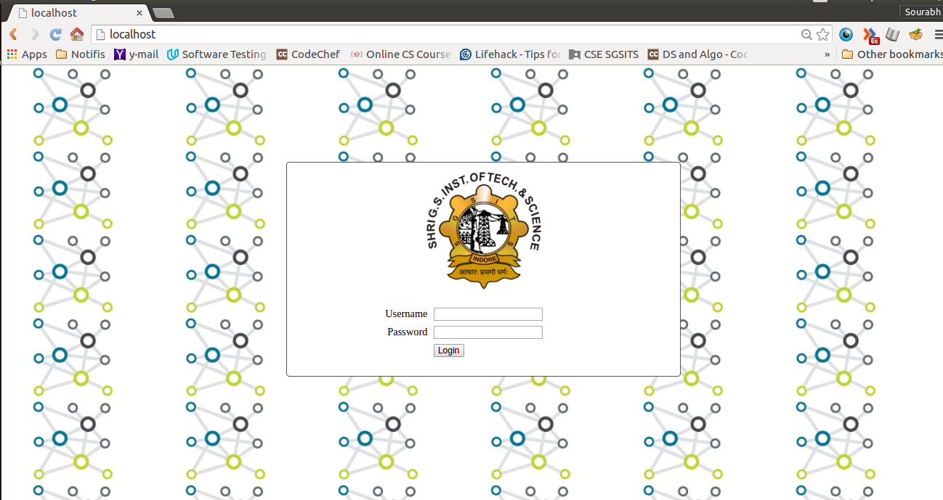
Fig 10 Network mapper homepage
- Enter username and password.

- Add node : To add a node fill details and click submit button.
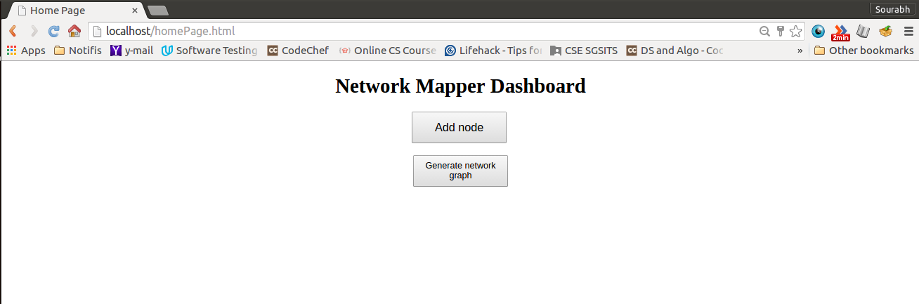
Fig 11 Network mapper Dashboard
- Generate graph: Click on Generate network graph to view the network.
Fig 12 Network mapper graph

REFERENCES
[1] Existing tools Network Mapper based on SNMP. [Online]. Available:
http://www.networkworld.com/article/2825879/network-management/7-free-open
[2] Active Probing, Mark Brodie, Irina Rish, Sheng Ma, Genady Grabarnik, Natalia Odintsova, I.B.M. T.J. Watson Research
[3] Andrew S. Tanenbaum, “Computer Networks” Prentice Hall, Hardcover, 3rd edition, March 1996.
[4] Douglas E. Comer, “Internetworking with TCP/IP Volume 1: Principles protocols and Architecture”, 6th Edition, 2013.
[5] Behrouz A. Forouzan, “Data Communication and Networking”, Published by The McGraw-Hill, 4th Edition, 2007.
[6] Larry L. Peterson and Bruce S. Davie, “Computer Networks: A system approach”, Published by Morgan Kaufmann, 5th Edition, 2012.
[7] James F. Kurose and Keith W. Ross, “Computer Networking: A top down approach”, Pearson Edition, 6th Edition, 2013.
[8] Douglas E. Comer, “Probing TCP implementation”, Department of Computer Sciences, Purdue University, 2002.

