Shri G. S. Inst. of Technology and Science


Proposals for Major Project

Aug 2015

Project Guide:-
Mr. Rajesh Dhakad

Submitted by:-
Sarvagya Soni (0801CS121070) AB44063
Shivam Joshi (0801CS121074) AB44069
Shubham Kumawat (0801CS121081) AB44073
Sourabh Shrivastava (0801CS121084) AB44075
Yashil Jijhotiya (0801CS121095) AB44086

NETWORK MAPPER

INTRODUCTION

Objective
To create a network mapping tool, for surveillance and monitoring of network infrastructure using active probing technique.

Background Study
Network mapping is the study of the physical connectivity of networks. A network mapper is a software that maps the entire LAN network, and provides tools to visually configure and moniter it. Network mapping discovers the devices on the network and their connectivity.

Many organizations create network maps of their network system. These maps can be made manually using simple tools or the mapping process can be simplified by using tools that integrate auto network discovery with Network mapping.

Many of the vendors from the Notable network mappers list enable you to customize the maps and include your own labels, add un-discoverable items and background images. Sophisticated mapping is used to help visualize the network and understand relationships between end devices and the transport layers that provide service. Items such as bottlenecks and root cause analysis can be easier to spot using these tools.

Need of project
Network mapper is a dynamic discovery and mapping tool that helps network administrators/ Data center admins to visualize their complete network infrastructure with a live network map.

Problem statement
In a network infrastructure, we face several problems, such as broken link. The network administrator is not aware of these problems instantly. Even when he detects that something is going wrong, it becomes an uphill task to trace those broken links on the network. Also, he doesn't know the uptime and downtime of that link, and no records are stored.

Proposed solution
The network mapper provides a tool to visually monitor the entire LAN network. Whenever a device is added in our network(manually), then it will be shown automatically. A message will be generated whenever a link is down. An entry of every device will be maintained in a log file for network administrator.

BACKGROUND STUDY

Theory
There are three main techniques used for network mapping: SNMP based approaches, active probing and route analytics.

- SNMP based approach
Simple Network Management Protocol (SNMP) is an "Internet-standard protocol for managing devices on IP networks". Devices that typically support SNMP include routers, switches, servers, workstations, printers, modem racks and more. SNMP is widely used in network management systems to monitor network-attached devices for conditions that warrant administrative attention.
The SNMP based approach retrieves data from Router and Switch MIBs in order to build the network map.

- Active probing based approach
This technique relies on traceroute-like probing on the IP address space. These probes report back IP forwarding paths to the destination address. By combining these paths one can infer router level topology for a given POP. Active probing is advantageous in that the paths returned by probes constitute the actual forwarding path that data takes through networks.

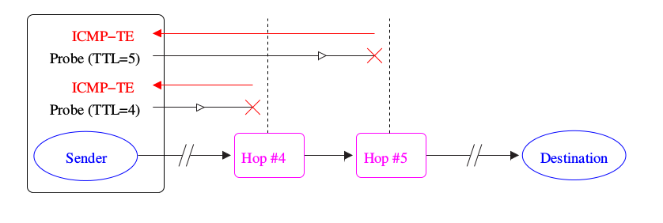
It is also more likely to find peering links between ISP's. However, active probing requires massive amounts of probes to map the entire Internet. It is more likely to infer false topologies due to load balancing routers and routers with multiple IP address aliases. Decreased global support for enhanced probing mechanisms such as source-route probing,
ICMP Echo Broadcasting, and IP Address Resolution techniques leaves this type of probing in the realm of network diagnosis.
The active probing approach relies on a series of traceroute-like probe packets in order to build the network map.

- Route analytics based approach
Route analytics is an emerging network monitoring technology specifically developed to analyze the routing protocols and structures in meshed IP Networks. Their main mode of operation is to passively listen to the Layer 3 routing protocol exchanges between routers for the purposes of network discovery, mapping, real-time monitoring and routing diagnostics.
The route analytics approach relies on information from the routing protocols to build the network map.

ANALYSIS

Functionalities
Some of the functionalities of network mapper will be :
- Visually moniter entire LAN network.
Every device in a network will be shown as an icon, the live link connecting two nodes in a green connector and the dead link in red connector. For every type of device we have a defined icon, such as for routers, desktops and servers.
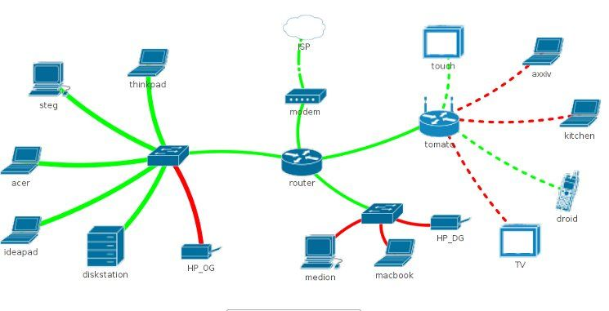

- Dynamic identification.
If a device is added in our network(manually), then it will be shown automatically. The system will refresh itself after defined time period.

- Automatic message generation
Whenever any link is down, (which will be shown in red on map) an automatic message/SMS will be generated to the network administrator.

- Maintain log
The system will maintain a log of links, indicating the uptime and down time of the network device. It will also show the current status of link.

Additional functionalities (for CCTV monitoring)
Identify if the CCTV camera is blocked or not using image processing in matlab.

Proposed Working
Our proposed system will work on Active probing method of network mapping. There are many tools which work on SNMP based mapping.

Steps of operation :
- Admin Login
- Drag and drop new devices
- Create new entry in log
- Automatic refresh
- Show new entries
- Create network map
- Generate message for broken link
- Log out

Present tools

Icinga
Icinga is an offshoot of Nagios that is currently being rebuilt anew. It offers a thorough monitoring and alerting framework that’s designed to be as open and extensible as Nagios is, but with several different Web UI options. Icinga 1 is closely related to Nagios, while Icinga 2 is the rewrite. Both versions are currently supported, and Nagios users can migrate to Icinga 1 very easily.

NeDi
NeDi may not be as well known as some of the others, but it’s a great solution for tracking devices across a network. It continuously walks through a network infrastructure and catalogs devices, keeping track of everything it discovers. It can provide the current location of any device, as well as a history.

NeDi can be used to locate stolen or lost devices by alerting you if they reappear on the network. It can even display all known and discovered connections on a map, showing how every network interconnect is laid out, down to the physical port level.

Zabbix
Zabbix monitors servers and networks with an extensive array of tools. There are Zabbix agents for most operating systems, or you can use passive or external checks, including SNMP to monitor hosts and network devices. You'll also find extensive alerting and notification facilities, and a highly customizable Web UI that can be adapted to a variety of heads-up displays. In addition, Zabbix has specific tools that monitor Web application stacks and virtualization hypervisors.

Zabbix can also produce logical interconnection diagrams detailing how certain monitored objects are interconnected. These maps are customizable, and maps can be created for groups of monitored devices and hosts.

Advantages
- It can become a viable and convenient tool for network administrators and network engineers to visualize their complete network infrastructure with a live network map.
- It provides clear understanding of relationships between devices.
- Automates network discovery and map creation and hence saves manual time and effort.

SPAM CLASIFIERS

INTRODUCTION

Objective :

Spammers recognize these attempts to prevent their messages and have developed tactics to circumvent these filters, but these evasive tactics are themselves patterns that human readers can often identify quickly. This work had the objectives of developing an alternative approach using a neural network (NN) classifier brained on a corpus of e-mail messages from several users.

Need of project :
Email is the effective way of communicating with each other. Spam mails are unwanted emails or bad emails or unsolicited email which user receives. Spam mails are used for spreading virus or malicious code, for fraud in banking, for phishing, and for advertising. So it can cause serious problem for internet users such as loading traffic on the network, wasting searching time of user and energy of the user, and wastage of network bandwidth etc. According to investigation today user receives more spam emails then non spam emails. To avoid spam/irrelevant mails we need effective spam filtering methods. At the same time, a large part of email traffic consists of nonperson, non time critical information that should be filtered. Spam/Irrelevant emails greatly affect the efficiency and accuracy of the aimed processing work. As a result, there has recently been a growing interest in creating automated systems to help users filter the emails.

Problem statement :

To categorize spam and non spam emails using machine learning algorithms and to isolate them into different two groups.

Proposed solution :

1) Here we are using MAT-LAB/octave and C++ programming language.

2) Spam filtering methods fall into the following machine based learning:
Machine based learning :
Unlike traditional technique, machine learning based methods automatically analyze the content of received messages and build more robust models accordingly. Therefore, they can be more effective and dynamically updated to cope with spammers’ tactics.

BACKGROUND STUDY

What is spam?

Spam, in computing terms, means something unwanted. It has normally been used to refer to unwanted email or Usenet messages, and it is now also being used to refer to unwanted Instant Messenger (IM) and telephone Short Message Service (SMS) messages. Spam email is unwanted, uninvited, and inevitably promotes something for sale. Often the terms junk email, Unsolicited Bulk Email (UBE), or Unsolicited Commercial Email (UCE) are used to refer to spam email. Spam generally promotes Internet – based sales, but it also occasionally promotes telephone- based or other methods of sales too.

Fundamental Concepts :
It involves an algorithm naming simultaneous covering algorithms.
Simultaneous covering algorithms like ID3 and C4.5 generate the entire rule set at once, while the sequential covering algorithms like AQ15 and CN2 learn the rule set in an incremental fashion. C4.5 is a well known algorithm used for classifying datasets. It induces decision trees and rules from datasets, which could contain categorical and numerical attributes. The rules could be used to predict categorical values of attributes from new records. We discusses an overview of data classification and its techniques, the basic methods of C4.5 algorithm, the process and analysis of the results of an experiment, which utilizes C4.5 for classifying spam base dataset C4.5 performs well in classifying the dataset, but more data needs to be collected in order to gain useful rules.

Tools used :

Here we use MAT-LAB/ACOTAVE and C++ programming languages.

Process :
Particular words have particular probabilities of occurring in spam email and in legitimate email. The filter doesn't know these probabilities in advance, and must first be trained so it can build them up. To train the filter, the user must manually indicate whether a new email is spam or not. For all words in each training email, the filter will adjust the probabilities that each word will appear in spam or legitimate email in its database.

After training, the word probabilities (also known as likelihood functions) are used to compute the probability that an email with a particular set of words in it belongs to either category.

Advantages :

1) One of the main advantages of Bayesian spam filtering is that it can be trained on a per-user basis.
2) The word probabilities are unique to each user and can evolve over time with corrective training whenever the filter incorrectly classifies an email. As a result, Bayesian spam filtering accuracy after training is often superior to pre-defined rules.
3)It can perform particularly well in avoiding false positives, where legitimate email is incorrectly classified as spam.

Disadvantages :

Words that normally appear in large quantities in spam may also be transformed by spammers. Another technique used to try to defeat Bayesian spam filters is to replace text with pictures, either directly included or linked.

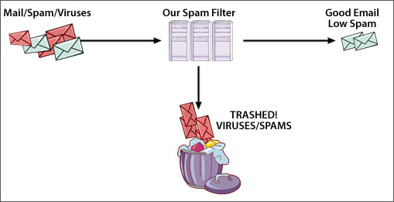
Diagram :

DATA COMPRESSION ENGINE

Background

Data Compression shrinks down a file so that it takes up less space. This is desirable for data storage and data communication. Storage space on disks is expensive so a file which occupies less disk space is "cheaper" than an uncompressed file. Smaller files are also desirable for data communication, because the smaller a file the faster it can be transferred. A compressed file appears to increase the speed of data transfer over an uncompressed file.

As the Data is increasing day by day, the need of storage is also increasing. Data storage units are costly and grab a large space. By compressing the data we can utilise the same unit for more data. But even compression causes loss of data and quality. Our main focus in this project will be reducing losses during the compression and designing an almost lossless Data Compression Engine.

Need of data compression

The two most important points are:
1-Data storage
-Modern data processing applications require storage of large volumes
of data.
-Compressing a file to half of its original size is equivalent to doubling
the capacity of the storage medium.
2-Data transmission
-Modern communication networks require massive transfer of data
over communication channels.
-Compressing the amount of data to be transmitted is equivalent to
increasing the capacity of the communication channel.
-Smaller a file the faster it can be transferred over the channel.

Problem Statement

To compress more than 40% of any given data file with proper encoding and decoding.

Project proposal

In this project, we have developed a wavelet-based image compressor and decompressor. The building blocks of this codec, e.g. wavelet module could be used in other applications too. For the demo, we apply the forward 2-D integer-to-integer wavelet on a gray scale bitmap file. The arithmetic coding is used on the transformed matrix to generate the compressed file.

Proposed solution proposed

We will use C++ for our compressor and de-compressor. The input to the compressor
systems is a 256 gray scale bitmap file. In compressor, first, we read the bitmap matrix and pass it to wavelet module. The integer to integer wavelet is applied to the matrix in two dimensions both horizontally and vertically. The arithmetic encoder, code the transformed 2-D wavelet and generates the compressed file.

Technologies and tools

1) We will be using Huffman codes for making this engine.

2) C and C++ will be used to increase the robustness ad speed of the engine.

3) MYSQL used for RDBMS operations and handling.

Advantages
1) As Data is compressed we will be needing less space to store our data on the storage unit.
2) Quality of the data is the major concern. So data after the compression will be almost of the same quality as before the compression.

