OPINION MINING FOR COMMENT SENTIMENT ANALYSIS
PROJECT REPORT
Submitted in partial fulfillment of the requirements for the
Award of the degree of
BACHELOR OF TECHNOLOGY
In
ARTIFICIAL INTELLIGENCE & DATA SCIENCE

Submitted By Under the Supervision of
Rahul Gupta (21EMCAD045) Dr. Anusuya
Narayan Somvanshi (21EMCAD037) Professor
Sourabh Meena (21EMCAD054)



BIKANER TECHNICAL UNIVERSITY, BIKANER

MODERN INSTITUTE OF TECHNOLOGY & RESEARCH CENTRE ALWAR
APRIL, 2025
(2024-25)
BIKANER TECHNICAL UNIVERSITY, BIKANER

CERTIFICATE

This is to Certify that the project report entitled “OPINION MINING FOR COMMENT SENTIMENT ANALYSIS” is the original & genuine work of “RAHUL GUPTA , NARAYAN SOMVANSHI , SOURABH MEENA”, student(s) of B. Tech VIII Semester (Artificial Intelligence & Data Science Branch) who carried out the project work under my supervision & guidance.

SIGNATURE  Dr. J.R.Arun Kumar  HEAD OF THE DEPARTMENT  Dept. of CSE & AI | SIGNATURE  Dr. Anusuya  PROFESSOR  Dept. of CSE & AI

ACKNOWLEDGEMENT

Firstly, We express our sincere thanks to Prof. Dr. S. K. Sharma (Director) of the Modern Institute of Technology & Research Centre, Alwar, Rajasthan.

We pay our deep sense of gratitude to Dr. J.R Arun Kumar, Head of the Computer Science & Engineering Department of Modern Institute of Technology & Research Centre, Alwar for encouraging us to the highest peak and providing us the opportunity to present the Project.

We express our sincere & a deep sense of gratitude towards our project Guide Dr. Anusuya, Professor and Coordinator Mr. Mohit Sharma, Asst.Professor of Computer Science & Engineering Department, Modern Institute of Technology & Research Centre, Alwar for his invaluable guidance, suggestions, supervision, kind approval of the project, time to time counselling and advices throughout the work.

We would like to thank our Institute and all Faculty Members. Without them this project would have been a distant reality, we also extend our heartfelt thanks to our families and well-wishers.
Finally, but not least, our parents are also an important inspiration for us. With due respect, we also express our gratitude to them.

Rahul Gupta(21EMCAD045)
Narayan Somvanshi(21EMCAD037)
Sourabh Meena(21EMCAD054)

TABLE OF CONTENTS
CERTIFICATE………………………………………...................................................................i
ACKNOWLEDGEMENT……………………………………………………….........................ii
TABLE OF CONTENTS……………………………………………………………………….iii
LIST OF FIGURES.......................................................................................................................iv
LIST OF TABLES ……………………………………………………………….. ………….....v
ABSTRACT...................................................................................................................................vi
CHAPTER 1: INTRODUCTION.......................................................................................... 1-6
  - What is Opinion Mining ......................................................................................................1
  - Problem Statement...............................................................................................................3
  - Project Objectives................................................................................................................5
CHAPTER 2: LITERATURE REVIEW..............................................................................7-9
CHAPTER 3: SYSTEM DESIGN......................................................................................10-21
3.1 UML DIAGRAMS.......................................................................................................12-21
3.1.1 Component diagram...................................................................................................12
3.1.2 Deployment diagram..................................................................................................13
3.1.3 Object diagram...........................................................................................................15
3.1.4 Communication diagram............................................................................................16
3.1.5 State diagram..............................................................................................................17
3.1.6 Use case diagram........................................................................................................18
3.1.7 Sequence diagram.......................................................................................................19
3.1.8 Activity diagram.........................................................................................................20
CHAPTER 4: PROPOSED WORK MODEL...................................................................22-31
4.1 TECHNOLOGY STACK....................................................................................................22
4.2 PROPOSED MODEL/ALGORITHM.................................................................................26
4.3 PROPOSED METHODOLOGIES......................................................................................28
CHAPTER 5: PROJECT RESULTS AND DISCUSSION...............................................32-40
5.1 PROJECT SCREEN SHOT................................................................................................36
CHAPTER 6: CONCLUSIONS AND FUTURE WORK.................................................44-47 REFERENCES .....................................................................................................................48-49
LIST OF FIGURES

Figure 3.1: Component Diagram.................................................................................................13
Figure 3.2: Deployment Diagram................................................................................................14
Figure 3.3: Object Diagram.........................................................................................................15
Figure 3.4: Communication Diagram..........................................................................................16
Figure 3.5: State Diagram............................................................................................................17
Figure 3.6: Use Case Diagram.....................................................................................................18
Figure 3.7: Sequence Diagram.....................................................................................................20
Figure 3.8: Activity Diagram.......................................................................................................21
Figure 4.1: Sentiment Analysis Model
........................................................................................28
Figure 5.1: Interface.....................................................................................................................36
Figure 5.2: Single Comment........................................................................................................37
Figure 5.3: Multilingual Single Comment...................................................................................38
Figure 5.4: Multiple Comment....................................................................................................40
Figure 5.5: Multilingual Comment..............................................................................................43
Figure 5.6: Project Workspace....................................................................................................44

LIST OF TABLES

Table 5.1: Example Output Table.............................................................................................35
Table 5.2: Sample Database Table............................................................................................41

ABSTRACT
In the digital age, understanding public sentiment is crucial for businesses, researchers, and policymakers. Sentiment analysis, or opinion mining, is a field of natural language processing (NLP) that identifies and extracts subjective information from text. This project aims to develop a sentiment analysis system to classify user comments as positive or negative.

While trained using the IMDB movie reviews dataset, the system is designed to handle various types of user comments across different domains. The project involves data collection, preprocessing, feature extraction, model training, and deployment. The IMDB dataset, containing 50,000 labeled movie reviews, is used for training.

The core of the project is the model training phase, where a machine learning model is trained to classify the sentiment of the text. An LSTM-based model is chosen for its ability to handle long-range dependencies and context in text, providing superior performance in sentiment analysis tasks. The trained model is then deployed to a production environment using a Django web application, allowing real-time analysis of new comments or reviews.

Preprocessing includes tokenization, stop word removal, and label encoding. Feature extraction converts text data into numerical features using techniques like TF-IDF and tokenization. An LSTM-based model is trained to classify sentiment, chosen for its ability to handle long-range dependencies and context in text.

The trained model is deployed using a Django web application, allowing real-time analysis of new comments or reviews. This system provides a valuable tool for understanding and responding to public sentiment effectively.

Keywords: Sentiment Analysis, Opinion Mining, Natural Language Processing, LSTM, Multilingual Support, Machine Learning, Django Web Application.
CHAPTER 1
INTRODUCTION
1.1 What is Opinion Mining?
Opinion mining, also known as sentiment analysis, is a field of natural language processing (NLP) that focuses on identifying and extracting subjective information from text. This information can be used to determine the sentiment expressed in the text, such as positive, negative, or neutral. Opinion mining is widely used in various applications, including customer feedback analysis, social media monitoring, and market research. The primary goal of opinion mining is to understand the attitudes, emotions, and opinions of individuals towards specific topics, products, or services.
What is Sentiment Analysis?
Sentiment analysis is a subfield of opinion mining that specifically deals with analyzing and classifying the sentiment expressed in text. It involves the use of computational techniques to determine whether a piece of text conveys a positive, negative, or neutral sentiment. Sentiment analysis can be applied to various types of text data, including customer reviews, social media posts, news articles, and more. The process typically involves several steps, including data collection, preprocessing, feature extraction, model training, and sentiment classification.
Importance of Sentiment Analysis
The ability to analyze and interpret sentiment from textual data provides valuable insights into public opinion, customer satisfaction, and market trends. Businesses can leverage sentiment analysis to gauge customer satisfaction, identify areas for improvement, and make data-driven decisions. Researchers can use sentiment analysis to study social phenomena, track public opinion on various topics, and analyze the impact of events. Policymakers can utilize sentiment analysis to understand public sentiment on policy decisions and gauge the effectiveness of communication strategies.
Applications of Sentiment Analysis
- Customer Feedback Analysis
  - Businesses use sentiment analysis to analyze customer reviews, survey responses, and feedback forms. By understanding customer sentiment, companies can identify strengths and weaknesses in their products or services and make informed decisions to enhance customer satisfaction.
- Social Media Monitoring
  - Sentiment analysis is widely used to monitor public opinion on social media platforms. By analyzing tweets, comments, and posts, organizations can track sentiment trends, detect emerging issues, and measure the impact of marketing campaigns.
- Market Research
  - Market researchers leverage sentiment analysis to gain insights into consumer preferences and market trends. Analyzing sentiment in product reviews, news articles, and forums helps researchers understand market dynamics and make informed predictions.
- Political Analysis
  - Sentiment analysis is used to gauge public opinion on political issues, candidates, and policies. By analyzing sentiment in news articles, social media posts, and public statements, political analysts can understand voter sentiment and predict election outcomes.
Challenges in Sentiment Analysis
Despite its numerous applications, sentiment analysis faces several challenges:
- Ambiguity and Context
  - Natural language is inherently ambiguous, and the same word or phrase can have different meanings depending on the context. Sentiment analysis models must be able to understand and interpret context to accurately determine sentiment.
- Sarcasm and Irony
  - Detecting sarcasm and irony is challenging for sentiment analysis models, as these forms of expression often convey the opposite of their literal meaning. Advanced models and techniques are required to accurately detect and interpret sarcasm and irony.
- Multilingual Sentiment Analysis
  - Analyzing sentiment in multiple languages adds complexity to the task. Models must be able to handle different languages, dialects, and writing systems to provide accurate sentiment analysis across diverse linguistic contexts.
- Domain-Specific Sentiment
  - Sentiment can vary significantly across different domains. For example, the sentiment expressed in a movie review may differ from that in a product review. Domain-specific models and lexicons are often required to accurately analyze sentiment in different contexts.
1.2 PROBLEM STATEMENT
Problem Statement: Comprehensive Sentiment Analysis System for User Comments
In the age of digital communication, understanding public sentiment is crucial for businesses, researchers, and policymakers. Sentiment analysis, also known as opinion mining, is a field of natural language processing (NLP) that focuses on identifying and extracting subjective information from text. This project aims to develop a comprehensive sentiment analysis system that can classify the sentiment of user comments as positive or negative. While the system will be trained using the IMDB movie reviews dataset, it will be designed to handle various types of user comments across different domains.
Objectives
- Data Collection
  - Collect a large dataset of text comments or reviews. In this project, the IMDB dataset, which contains 50,000 movie reviews labeled as either positive or negative, will be used for training the model.
- Data Preprocessing
  - Preprocess the text data to make it suitable for analysis. This includes tasks such as tokenization, removing stop words, and encoding labels. The LabelEncoder from sklearn will be used to encode the sentiment labels.
- Feature Extraction
  - Convert text data into numerical features that can be used by machine learning models. Techniques such as TF-IDF, word embeddings, and tokenization will be employed. The Tokenizer from tensorflow.keras.preprocessing.text will be used to convert text into sequences.
- Model Training
  - Train a machine learning model to classify the sentiment of the text. Common models include logistic regression, support vector machines, and deep learning models such as LSTM and BERT. An LSTM-based model will be used in this project.
- Model Evaluation
  - Evaluate the performance of the trained model using metrics such as accuracy, precision, recall, and F1-score. This helps in understanding how well the model is performing on unseen data.
- Deployment
  - Deploy the trained model to a production environment where it can be used to analyze new comments or reviews in real-time. A Django web application will be used to provide an interface for users to input comments and get sentiment analysis results.
Technologies
- Frontend
  - Utilize HTML5, CSS3, and JavaScript to create an interactive and responsive user interface. Incorporate CSS pre-processors like SASS or LESS for efficient styling.
- Backend
  - Implement a robust backend using Django. Ensure the backend is capable of handling RESTful services, user management, and data storage efficiently.
- Database
  - Use a scalable and secure database system like SQLite to store user data, exam questions, answers, and results.
- Security
  - Implement comprehensive security measures, including HTTPS, data encryption, secure authentication (e.g., JWT, OAuth), and protection against common web vulnerabilities (e.g., SQL injection, XSS).
Expanding the Vision
The shift towards digital communication underscores the need for reliable and accessible tools for sentiment analysis. This project is not merely a response to the demand for sentiment analysis capabilities but a strategic step towards a more flexible and inclusive model for understanding public opinion. It supports a diverse range of applications, catering to businesses, researchers, and policymakers.
1.3 PROJECT OBJECTIVES
The primary objective of this project is to develop a comprehensive sentiment analysis system that classifies user comments into positive, negative, or neutral categories. By leveraging advanced natural language processing (NLP) techniques and machine learning models, the system aims to ensure accurate sentiment classification. Below are the detailed objectives:
- Sentiment Classification-Build a robust machine learning model to classify user comments into three sentiment categories: positive, negative, and neutral.
- Multilingual Support- Incorporate language detection and translation capabilities to handle comments written in multiple languages, ensuring accessibility for a diverse user base.
- Data Preprocessing-Implement a preprocessing pipeline to clean and prepare text data for analysis. Key steps include tokenization, stop-word removal, and sequence padding.
- Feature Extraction-Utilize techniques such as tokenization and word embeddings to convert text into numerical representations suitable for machine learning models.
- Model Training and Optimization-Train a deep learning model, specifically an LSTM-based neural network, to capture the context and dependencies in text data. Optimize the model for high accuracy and low error rates.
- Real-Time Sentiment Analysis-Deploy the trained model in a Django web application to provide real-time sentiment analysis for user comments.
- Scalability and Performance Ensure the system is scalable and capable of handling a high volume of concurrent requests without performance degradation.
- Security and Data Privacy-Implement security measures to protect user data and ensure secure communication between the client and server.
- Evaluation and Feedback-Evaluate the system's performance using metrics such as accuracy, precision, recall, and F1-score. Provide meaningful feedback to users on sentiment analysis results.
- Extensibility-Design the system to be extensible, enabling future enhancements such as additional sentiment categories, domain-specific models, or integration with social media platforms.

CHAPTER 2
LITERATURE REVIEW
Introduction
Sentiment analysis, also known as opinion mining, is a field of natural language processing (NLP) that focuses on identifying and extracting subjective information from text. It has become increasingly important in various applications, including customer feedback analysis, social media monitoring, and market research. This literature review explores the evolution of sentiment analysis, key techniques, and notable research contributions.
Evolution of Sentiment Analysis
The field of sentiment analysis has evolved significantly over the past two decades. Early approaches relied on manual rule-based systems and lexicons to identify sentiment in text. However, these methods were limited by their inability to handle the complexity and variability of natural language.
With the advent of machine learning, sentiment analysis saw a shift towards more sophisticated techniques. Supervised learning algorithms, such as Naive Bayes, Support Vector Machines (SVM), and logistic regression, became popular for sentiment classification tasks. These models required large labeled datasets for training and were able to achieve higher accuracy compared to rule-based systems.
The introduction of deep learning further revolutionized sentiment analysis. Recurrent Neural Networks (RNNs), Long Short-Term Memory (LSTM) networks, and Convolutional Neural Networks (CNNs) demonstrated remarkable performance in capturing the nuances of sentiment in text. More recently, transformer-based models like BERT (Bidirectional Encoder Representations from Transformers) have set new benchmarks in sentiment analysis by leveraging large-scale pre-training and fine-tuning.
Key Techniques in Sentiment Analysis
- Lexicon-Based Approaches
  - Lexicon-based methods rely on predefined lists of words with associated sentiment scores. These methods calculate the overall sentiment of a text by aggregating the sentiment scores of individual words. Popular lexicons include SentiWordNet and AFINN. eWhile lexicon-based approaches are simple and interpretable, they often struggle with context and ambiguity in language.
- Machine Learning Approaches
  - Machine learning techniques involve training classifiers on labeled datasets to predict sentiment. Common algorithms include Naive Bayes, SVM, and logistic regression. Feature extraction methods such as TF-IDF (Term Frequency-Inverse Document Frequency) and word embeddings (e.g., Word2Vec, GloVe) are used to convert text into numerical representations. These approaches require substantial labeled data and feature engineering but offer improved accuracy over lexicon-based methods.
- Deep Learning Approaches
  - Deep learning models, particularly RNNs, LSTMs, and CNNs, have shown significant improvements in sentiment analysis. These models can capture complex patterns and dependencies in text, making them well-suited for sentiment classification. LSTM networks, in particular, are effective at handling long-range dependencies and context in text. Transformer-based models like BERT have further advanced the field by pre-training on large corpora and fine-tuning on specific tasks, achieving state-of-the-art performance.
Notable Research Contributions
- Pang and Lee (2002)
  - One of the pioneering works in sentiment analysis, this study introduced the use of machine learning techniques for sentiment classification of movie reviews. The authors compared various classifiers, including Naive Bayes, Maximum Entropy, and SVM, and demonstrated the effectiveness of machine learning over traditional rule-based methods.
- Mikolov et al. (2013)
  - This research introduced Word2Vec, a word embedding technique that represents words in a continuous vector space. Word2Vec has become a foundational technique in NLP, enabling more effective feature extraction for sentiment analysis and other tasks.
- Devlin et al. (2018)
  - The introduction of BERT marked a significant milestone in NLP. BERT's bidirectional transformer architecture allows it to capture context from both directions, leading to superior performance in various NLP tasks, including sentiment analysis. BERT's pre-training and fine-tuning paradigm has set new benchmarks and inspired subsequent transformer-based models.
Applications of Sentiment Analysis
- Customer Feedback Analysis
  - Businesses use sentiment analysis to gauge customer satisfaction and identify areas for improvement. Analyzing customer reviews, social media posts, and survey responses helps companies understand customer sentiment and make data-driven decisions.
- Social Media Monitoring
  - Sentiment analysis is widely used to monitor public opinion on social media platforms. By analyzing tweets, comments, and posts, organizations can track sentiment trends, detect emerging issues, and measure the impact of marketing campaigns.
- Market Research
  - Market researchers leverage sentiment analysis to gain insights into consumer preferences and market trends. Analyzing sentiment in product reviews, news articles, and forums helps researchers understand market dynamics and make informed predictions.

CHAPTER 3
SYSTEM DESIGN
Overview
The system is designed to analyze the sentiment of user comments, classifying them as positive or negative. It is trained using the IMDB movie reviews dataset but can handle various types of user comments across different domains. The system comprises several components, including data collection, preprocessing, feature extraction, model training, and deployment.
Components
- Data Collection
  - Dataset: The IMDB dataset containing 50,000 movie reviews labeled as positive or negative is used for training the model.
  - Storage: The dataset is stored in a CSV file within the project directory.
- Data Preprocessing
  - Text Cleaning: The text data is cleaned by removing special characters, stop words, and performing tokenization.
  - Label Encoding: Sentiment labels are encoded into numerical values using a label encoder.
  - Data Splitting: The dataset is split into training and testing sets to evaluate the model's performance.
- Feature Extraction
  - Tokenization: Text data is converted into sequences of tokens using a tokenizer.
  - Padding: Sequences are padded to ensure uniform length, which is necessary for input into the neural network.
  - Word Embeddings: Techniques like TF-IDF or word embeddings (e.g., Word2Vec, GloVe) are used to convert text into numerical features.
- Model Training
  - Model Architecture: A deep learning model, such as an LSTM-based neural network, is designed to capture the context and dependencies in the text.
  - Training: The model is trained on the preprocessed and tokenized data, optimizing for accuracy and minimizing loss.
  - Evaluation: The model's performance is evaluated using metrics such as accuracy, precision, recall, and F1-score.
- Deployment
  - Web Application: A Django web application is developed to provide an interface for users to input comments and receive sentiment analysis results.
  - Model Integration: The trained model is integrated into the web application, allowing real-time analysis of user comments.
  - User Interface: The web application includes a user-friendly interface with input fields for comments and options to upload files containing multiple comments.
- Security and Scalability
  - Security Measures: Implement HTTPS, data encryption, and secure authentication to protect user data and ensure secure communication.
- Monitoring and Maintenance
  - Logging and Monitoring: Implement logging and monitoring to track the application's performance and detect any issues.
  - Regular Updates: Regularly update the model and application to incorporate new data and improve performance.
Workflow
- User Interaction
  - Users interact with the web application by entering comments or uploading files containing multiple comments.
- Language Detection and Translation
  - The system detects the language of the input comments and translates them to English if necessary.
- Sentiment Analysis
  - The translated comments are tokenized, padded, and fed into the trained model to predict the sentiment.
- Results Display
  - The predicted sentiment, along with the original and translated comments, is displayed to the user through the web application interface.
3.1 UML DIAGRAMS
A UML (Unified Modeling Language) diagram is a standardized graphical representation of a system's design that allows developers to visualize the structure and behavior of a system. UML diagrams are used in software engineering to depict software systems, business processes, and data structures through a set of symbols and notations. They help in planning, visualizing, specifying, constructing, and documenting the artifacts of a software system. UML includes several types of diagrams, such as:
3.1.1 Component diagram
3.1.2 Deployment diagram
3.1.3 Object diagram
3.1.4 Communication diagram
3.1.5 State diagram
3.1.6 Use case diagram
3.1.7 Sequence diagram
3.1.8 Activity diagram
3.1.1 Component Diagram
A component diagram for a web application typically includes web servers, application logic components (which could be in various programming languages), databases, external services, and possibly front-end components.
Purpose: Details high-level system architecture including infrastructure and data flows.
Components:
- UI:
  - OMC Dashboard (User-facing UI)
  - Admin Panel (Back-office control)
- System Components:
  - Text Preprocessor
  - Tokenizer
  - Sentiment Model
  - Translation API
- Infrastructure:
  - Security: Implements encryption, access control
  - Persistence: API logging and media storage
  - Database: SQLite, interacts via JDBC
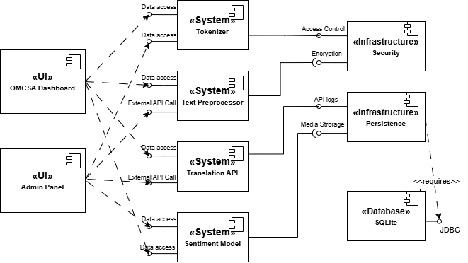
Figure 3.1 : Component Diagram
3.1.2 Deployment Diagram
A deployment diagram shows the physical deployment of artifacts on nodes. It maps software pieces to the hardware that will execute them.
Purpose: Highlights the deployment of various system components across physical or virtual nodes, illustrating the architecture for sentiment analysis functionality.
Nodes:
- Client Node: Represents the user's device (e.g., a web browser) used to interact with the system via index.html. It's the entry point for submitting data and viewing results.
- Web Server Node (Ubuntu OS): Hosts the web application built with Django. It includes static files, templates, and the sentiment analysis module responsible for backend logic.
- Application Server Node (Solaris OS): Acts as the core processing hub. It handles text preprocessing, tokenization, threading, and utilizes the sentiment analysis model for predictions.
- External Services Node: Connects to APIs like Google Translate and language detection libraries to extend the application's functionality for diverse use cases.
- Database Server Node (Linux OS): Manages data storage using SQLite, ensuring persistence and integrity of user-uploaded files, results, and application data.

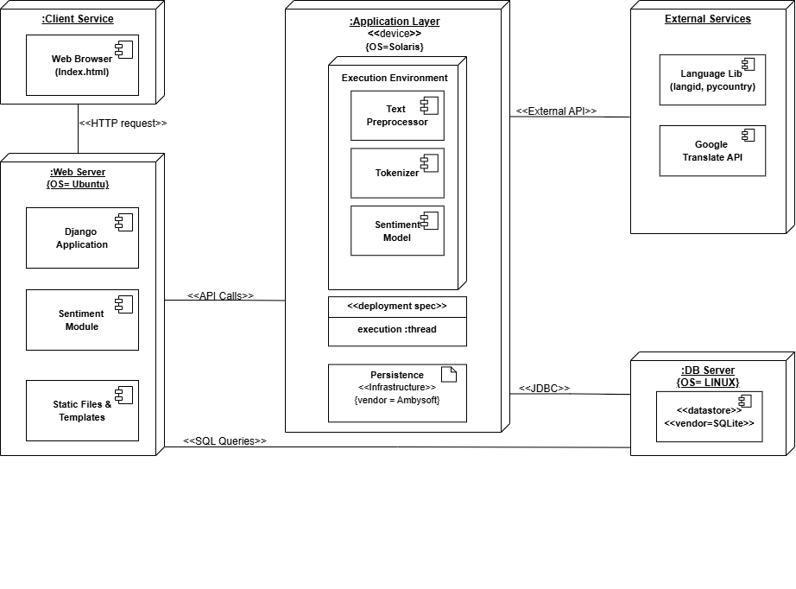
Figure 3.2 : Deployment Diagram

3.1.3 Object Diagram
An object diagram represents the static structure of a system at a particular time. It shows instances of classes and their relationships.Demonstrates the flow of data and processing in a sentiment analysis system, highlighting how key components interact within the pipeline.
Nodes:
- Translator Node: Handles language translation, ensuring input text is compatible with the tokenizer and sentiment model. It enables multi-language support for the system.
- Tokenizer Node: Preprocesses the input by converting text into a format suitable for model consumption. This node uses a tokenizer (tokenizer.pkl) with a set maximum sequence length of 1000.
- Model Node: Represents the core of the system, the sentiment analysis model (sentiment_model.h5). It's built with three key layers:
  - Embedding Layer: Converts words into dense vectors of fixed size, capturing semantic meaning.
  - LSTM Layer: Processes sequential data to identify patterns and relationships over time.
  - Dense Layer: Produces the final sentiment classification output.
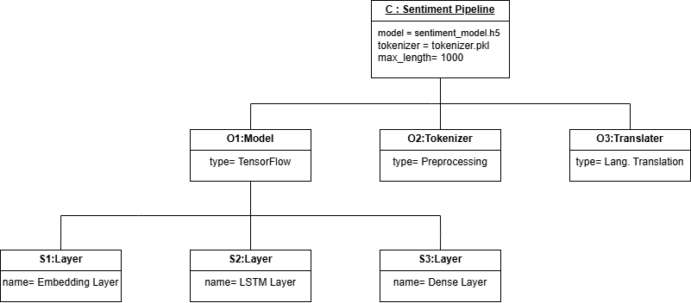
Figure 3.3 : Object Diagram
3.1.4 Communication Diagram
A communication diagram shows the interactions between objects or parts in terms of sequenced messages.
Purpose: Shows interactions between various software modules during sentiment analysis.
Interactions:
- Browser: User input interface.
- Django View: Handles HTTP requests and routes data.
- Sentiment Pipeline: Coordinates all NLP tasks.
- Tokenizer Preprocessing: Handles text preprocessing + tokenization.
- Model (LSTM): Predicts sentiment from text sequences.
- Translator (User Lang.): Translates non-English text into English using a translation service.
Flow: The diagram emphasizes the sequence in which components interact, from input submission to final prediction.
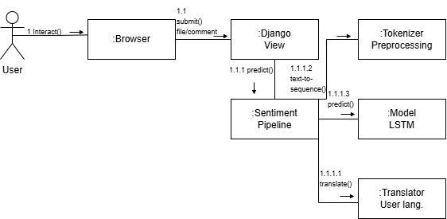
Figure 3.4 : Communication Diagram
3.1.5 State Diagram
A state diagram shows the states an object goes through during its lifetime in response to events, along with its responses and actions.
Purpose: Describes the internal state transitions of the application during user interaction.
States:
- Idle → Waiting for input
- Processing (composite state):
  - Language Detection
  - If not English → Translation
  - Else → Tokenization
  - → Sentiment Prediction
- Transition to Result Ready once sentiment is predicted.
Key Insight: Helps visualize how the system moves through discrete states based on user actions and processing outcomes.
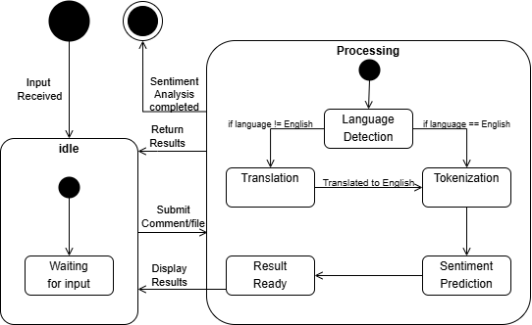
Figure 3.5 : State Diagram

3.1.6 Use Case Diagram
A use case diagram represents the functional requirements of a system, showing the interactions between users (actors) and the system.
Purpose: Outlines functional requirements from a user perspective.
Actors:
- User: Interacts via uploading files or comments, viewing results
- Admin: Manages backend tasks
Use Cases:
- Submit Comment / Upload File → includes → Analyze Sentiment
- Manage Uploaded File → extends upload functionality
- Train Sentiment Model → includes → Prepare Training Data
- View Results: Final user-facing result
Insight: This defines the boundary of the system, listing all the features users and admins are expected to interact with.

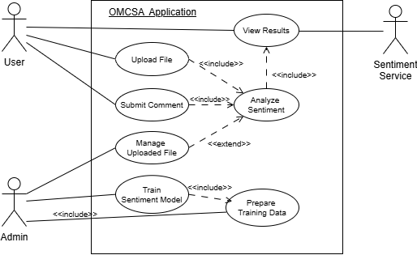
Figure 3.6 : Use Case Diagram
3.1.7 Sequence Diagram
A sequence diagram shows how objects interact in a particular scenario of a use case, focusing on the sequence of messages exchanged.
Purpose: Details the internal steps in the pipeline when processing a sentiment prediction request.
Actors & Components:
- User → Submits input
- Django View → Sends text to the pipeline
- SentimentPipeline Controller:
  - Calls preprocess(text)
  - Detects language, and optionally translates text
  - Calls the Tokenizer:
    - texts_to_sequences + pad_sequences
  - Calls the Model to predict sentiment
  - Returns score to determine sentiment label
- Returns data (text, language_name, sentiment) back to user interface
Highlight: This diagram is very useful for developers to understand how data flows between objects in real-time.

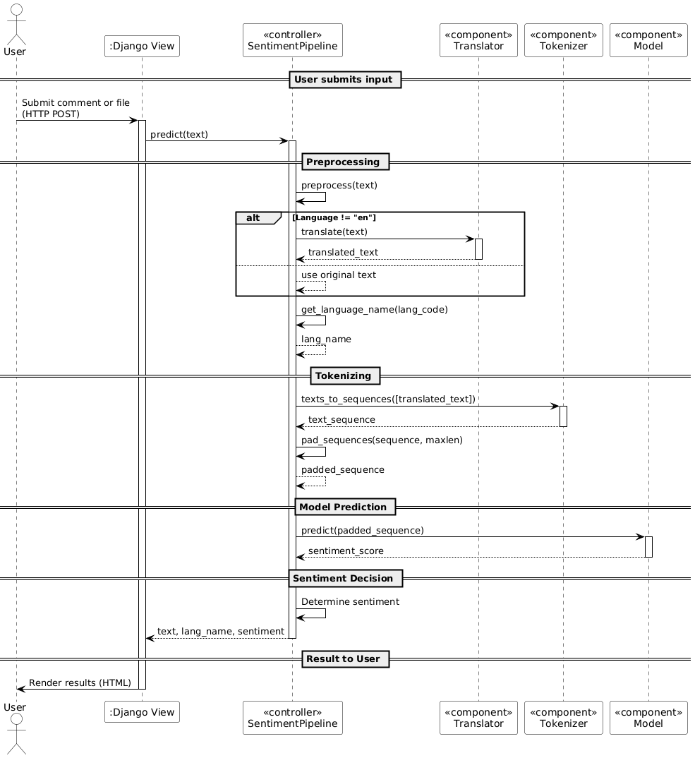
Figure 3.7 : Sequence Diagram
3.1.8 Activity Diagram
An activity diagram represents the workflow of a system, showing the sequence of activities and decision points.
Purpose: Visualizes the end-to-end flow from user input to sentiment analysis output.
- User Interaction: The user submits either a text comment or a file.
- Django View Logic:
  - It checks if the input is a direct comment.
    - If yes: directly passes it to the sentiment pipeline.
    - If no: extracts text content from the file and then passes it to the pipeline.
- Pipeline:
  - Preprocesses the text (cleaning, lowercasing, punctuation removal, etc.).
  - Detects language → If not English, translates it.
  - Tokenizes and pads the sequence to prepare input for the model.
  - Sentiment Prediction: The model returns a sentiment score.
    - If score > 0.6 → Positive
    - If score < 0.4 → Negative
    - Otherwise → Neutral
Django View then returns the results to be displayed to the user.
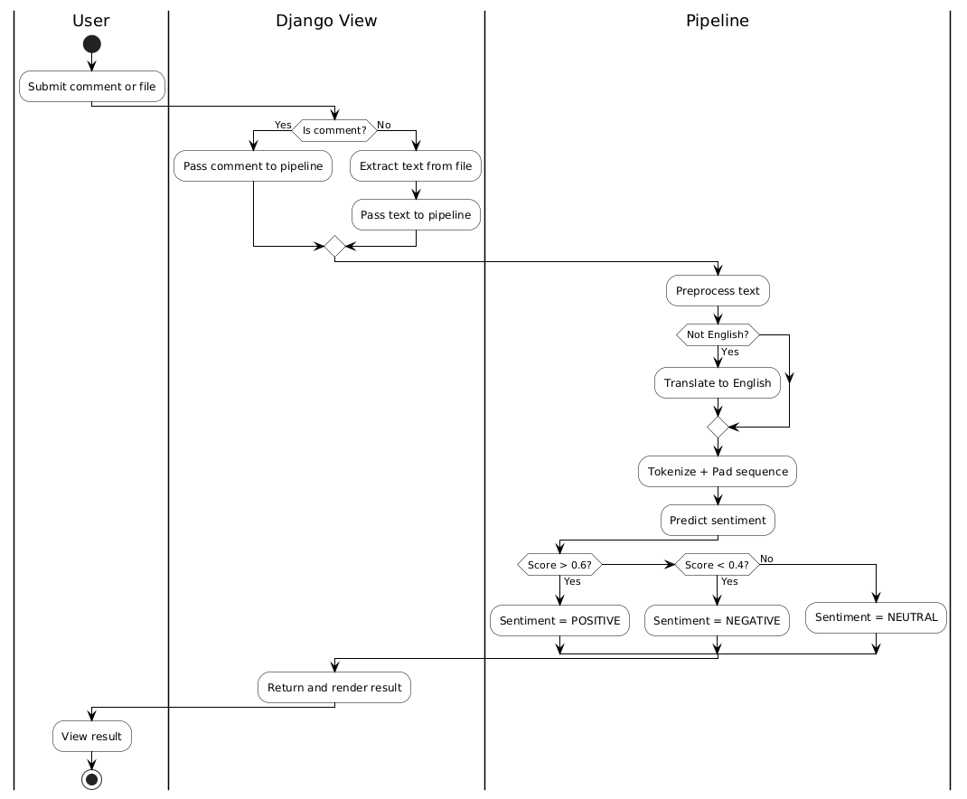
Figure 3.8 : Activity Diagram
CHAPTER 4
PROPOSED WORK MODEL
4.1 TECHNOLOGY STACK
A technology stack, also known as a solutions stack, is a combination of programming languages, frameworks, libraries, tools, and software used to build and run an application. It includes both frontend and backend technologies, as well as any other tools and services that support the development, deployment, and maintenance of the application. The choice of technology stack can significantly impact the performance, scalability, and maintainability of the application.
Frontend
- HTML5:
  - Purpose: Used for structuring the web pages and content.
  - Details: HTML5 is the latest version of the HyperText Markup Language, which provides the structure for web pages. It includes new elements and attributes for better multimedia support and improved semantic structure.
- CSS3:
  - Purpose: Used for styling the web pages.
  - Details: CSS3 is the latest version of the Cascading Style Sheets language, which is used to style and layout web pages. It includes new features such as animations, transitions, and flexbox for responsive design.
  - Files: Custom styles are included in static/css/style.css.
- JavaScript:
  - Purpose: Used for client-side scripting.
  - Details: JavaScript is a high-level, interpreted programming language that enables interactive web pages. It is an essential part of web applications, allowing for dynamic content and user interactions.
  - Files: Custom scripts are included in static/js/script.js.
- Bootstrap:
  - Purpose: A CSS framework used for responsive design and styling.
  - Details: Bootstrap is a popular front-end framework for developing responsive and mobile-first web pages. It includes pre-designed components and utilities for faster and easier web development.
Backend
- Django:
  - Purpose: A high-level Python web framework used for developing the web application.
  - Details: Django is a powerful web framework that encourages rapid development and clean, pragmatic design. It includes built-in features for handling user authentication, database interactions, and URL routing.
  - Files: Key files include manage.py, settings.py, urls.py, and views.py.
- TensorFlow:
  - Purpose: An open-source machine learning framework used for building and training the sentiment analysis model.
  - Details: TensorFlow is a comprehensive library for machine learning and deep learning. It provides tools for building and training neural networks, including support for various layers, optimizers, and loss functions.
  - Files: Key files include train_model.py.
- Googletrans:
  - Purpose: A Python library used for translating text.
  - Details: Googletrans is a free and unlimited Python library that implements the Google Translate API. It is used for language detection and translation of user comments.
  - Files: Utilized in views.py for language detection and translation.
- Langdetect:
  - Purpose: A Python library used for detecting the language of the text.
  - Details: Langdetect is a language detection library ported from Google's language-detection library. It is used to identify the language of user comments before translation.
  - Files: Utilized in views.py.
Machine Learning
- TensorFlow Keras:
  - Purpose: Used for building and training the LSTM-based sentiment analysis model.
  - Details: Keras is a high-level neural networks API, written in Python and capable of running on top of TensorFlow. It allows for easy and fast prototyping of deep learning models.
  - Files: Key files include train_model.py.
- Scikit-learn:
  - Purpose: Used for preprocessing tasks such as label encoding and train-test splitting.
  - Details: Scikit-learn is a machine learning library for Python that provides simple and efficient tools for data mining and data analysis. It includes various algorithms for classification, regression, clustering, and preprocessing.
  - Files: Key files include prepare_data.py.
Data Storage
- SQLite:
  - Purpose: A lightweight, disk-based database used for storing application data.
  - Details: SQLite is a self-contained, serverless, zero-configuration, transactional SQL database engine. It is suitable for small to medium-sized applications and is easy to set up and use.
  - Files: Configured in settings.py and the database file is db.sqlite3.
- Pickle:
  - Purpose: A Python library used for serializing and deserializing Python objects.
  - Details: Pickle is a module in Python that implements binary protocols for serializing and deserializing Python object structures. It is used to save and load preprocessed data and the tokenizer.
  - Files: Key files include prepare_data.py and train_model.py.
Deployment
- WSGI:
  - Purpose: Web Server Gateway Interface used for deploying the Django application.
  - Details: WSGI is a specification for a simple and universal interface between web servers and web applications or frameworks for the Python programming language.
  - Files: Configured in wsgi.py.
- ASGI:
  - Purpose: Asynchronous Server Gateway Interface used for handling asynchronous web requests.
  - Details: ASGI is a specification for Python web servers and applications to communicate with each other asynchronously. It is designed to handle WebSockets and other asynchronous protocols.
  - Files: Configured in asgi.py.
Additional Tools
- PyCountry:
  - Purpose: A Python library used for handling country and language information.
  - Details: PyCountry provides access to ISO country, subdivision, language, currency, and script definitions and their translations. It is used to get the full name of a language from its code.
- Googletrans:
  - Purpose: A Python library used for translating text.
  - Details: Googletrans is a free and unlimited Python library that implements the Google Translate API. It is used for language detection and translation of user comments.
4.2 PROPOSED MODEL/ALOGORITHEM /BLOCK DIAGRAM
The proposed sentiment analysis model aims to classify user comments into positive, negative, or neutral categories with high accuracy. Leveraging cutting-edge natural language processing (NLP) techniques and machine learning algorithms, this system is designed to handle diverse comment types across various domains and languages.
System Overview
- Data Collection
  - Dataset: Utilizes the IMDB dataset comprising 50,000 movie reviews labeled as positive or negative.
  - Storage: The dataset is stored in the project directory as omcsa/data/IMDB Dataset.csv.
- Data Preprocessing
  - Text Cleaning: Removes special characters, stop words, and performs tokenization.
  - Label Encoding: Converts sentiment labels into numerical values using a label encoder.
  - Data Splitting: Divides the dataset into training and testing subsets for evaluation.
  - Multilingual Support: Incorporates language detection and translation for processing multilingual comments.
  - Relevant File: prepare_data.py.
- Feature Extraction
  - Tokenization: Converts text into sequences of tokens using a tokenizer.
  - Padding: Ensures sequences are of uniform length for input into the neural network.
  - Word Embeddings: Employs pre-trained embeddings (e.g., GloVe) to capture semantic word relationships.
  - Relevant File: train_model.py.
- Model Training
  - Architecture: Utilizes an LSTM-based neural network to capture contextual dependencies in textual data.
  - Optimization: Focuses on maximizing accuracy and minimizing loss during training.
  - Evaluation Metrics: Includes accuracy, precision, recall, and F1-score for performance assessment.
  - Relevant File: train_model.py.
- Sentiment Prediction Pipeline
  - Pipeline Design: Implements the SentimentPipeline class for end-to-end processing, including language detection, translation, and sentiment prediction.
  - Classification Thresholds:
    - Positive: Score > 0.6
    - Negative: Score < 0.4
    - Neutral: 0.4 ≤ Score ≤ 0.6
  - Relevant File: pipeline.py.
- Deployment
  - Web Application: Provides a user-friendly interface for real-time sentiment analysis via a Django-based web app.
  - Features:
    - Input fields for single comments.
    - File upload options for bulk analysis.
  - Relevant Files: views.py, index.html.
- Security and Scalability
  - Security: Implements HTTPS, encryption, and secure authentication to protect user data.
  - Scalability: Utilizes cloud platforms (AWS, Google Cloud, Azure) to ensure efficient handling of high user traffic.
- Monitoring and Maintenance
  - Performance Monitoring: Incorporates logging and monitoring tools to track application health and detect issues.
  - Updates: Regularly updates the model and application for improved performance.
Sentiment Analysis ML Model:
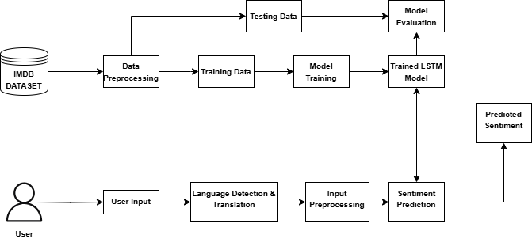
Figure 4.1: Sentiment Analysis Model
4.3 PROPOSED METHODOLOGIES
This section outlines the systematic approach to developing a robust sentiment analysis system capable of classifying user comments into positive, negative, or neutral categories. The methodologies leverage cutting-edge natural language processing (NLP) techniques, machine learning models, and a multilingual pipeline to ensure scalability and accuracy.
1. Data Collection
- Objective: Compile a labeled dataset for training and evaluating the sentiment analysis model.
- Details:
  - Utilize the IMDB movie reviews dataset comprising 50,000 reviews with positive or negative sentiment labels.
  - Store the dataset as IMDB Dataset.csv within the project directory.
- Tools: pandas for efficient dataset management.
- Related File: prepare_data.py.
2. Data Preprocessing
- Objective: Clean and prepare raw text for effective feature extraction and model training.
- Details:
  - Perform text cleaning by removing special characters, redundant whitespace, and stop words.
  - Encode sentiment labels numerically (e.g., positive = 1, negative = 0).
  - Split the dataset into training (80%) and testing (20%) subsets.
- Tools: scikit-learn for label encoding and splitting.
3. Feature Extraction
- Objective: Convert textual data into numerical representations suitable for machine learning models.
- Details:
  - Tokenize text data into sequences using tensorflow
  - Pad sequences to ensure uniform input lengths
  - Use pre-trained GloVe embeddings to capture semantic relationships between words.
- Tools: TensorFlow and GloVe embeddings.
- Related File: train_model.py.
4. Model Training
- Objective: Develop and train a deep learning model to classify sentiment.
- Details:
  - Design an LSTM-based neural network to effectively capture long-term dependencies in text.
  - Optimize model performance using binary cross-entropy loss and the Adam optimizer.
  - Evaluate accuracy, precision, recall, and F1-score to assess effectiveness.
- Tools: TensorFlow/Keras for model development and training.
- Related File: train_model.py.
5. Multilingual Support
- Objective: Enable sentiment analysis for comments in multiple languages.
- Details:
  - Detect the language of input text using the langid library.
  - Translate non-English text to English using the googletrans library for consistent processing.
- Tools: langid, googletrans.
- Related File: pipeline.py.
6. Sentiment Prediction Pipeline
- Objective: Create an efficient pipeline for preprocessing, translation, and sentiment prediction.
- Details:
  - Implement a SentimentPipeline class for seamless integration of preprocessing, language detection, translation, and prediction.
  - Classify sentiment based on thresholds:
    - Positive: Score > 0.6.
    - Neutral: 0.4 ≤ Score ≤ 0.6.
    - Negative: Score < 0.4.
- Tools: Custom Python class for modular functionality.
7. Deployment
- Objective: Deploy the sentiment analysis model for real-world use.
- Details:
  - Backend: Develop RESTful APIs using Django for handling user inputs and delivering sentiment results.
  - Frontend: Design a user-friendly interface with input fields and options for bulk analysis.
  - Integrate the trained SentimentPipeline class into Django views for live predictions.
- Tools: Django framework, Bootstrap for styling, JavaScript for interactivity.
- Related Files:
  - Backend: views.py
  - Frontend: index.html.
8. Security and Scalability
- Objective: Ensure secure and efficient operation of the application.
- Details:
  - Implement HTTPS, secure authentication, and data encryption protocols.
  - Deploy on cloud platforms like AWS or Google Cloud to ensure scalability and high performance under heavy traffic.
- Tools: Django middleware, cloud hosting services.
9. Monitoring and Maintenance
- Objective: Maintain reliability and continuously improve the system.
- Details:
  - Implement logging mechanisms to monitor errors and track performance metrics.
  - Periodically update the model with new data to enhance accuracy and adaptability.
- Tools: Python logging module, Django admin panel for application monitoring.
CHAPTER 5
PROJECT RESULTS AND DISCUSSION
Project Output
The sentiment analysis system developed in this project provides the following outputs:
- Sentiment Classification:
  - Classifies user comments into three categories: Positive, Negative, and Neutral.
  - Example Outputs:
    - Input: "I love this product!" → Output: Positive
    - Input: "The service was terrible." → Output: Negative
    - Input: "The product is okay, not great but not bad either." → Output: Neutral
- Multilingual Support:
  - Detects the language of input comments, translates them to English (if needed), and then performs sentiment analysis.
  - Example Outputs:
    - Input: "C'est une belle journée" (French) → Translated: "It's a beautiful day" → Output: Positive
    - Input: "Hoy es un mal día" (Spanish) → Translated: "Today is a bad day" → Output: Negative
- Batch Processing:
  - Allows users to upload files containing multiple comments and processes all comments in the file with sentiment results for each.
  - Example:
    - Uploaded File Content:
    - I love this movie.
    - The acting was terrible.
    - It was an average experience.
    - Output:
      - Comment: "I love this movie." → Sentiment: Positive
      - Comment: "The acting was terrible." → Sentiment: Negative
      - Comment: "It was an average experience." → Sentiment: Neutral
- Real-Time Analysis:
  - Provides real-time sentiment analysis via a web interface, enabling users to input comments or upload files and receive immediate results.
- Translated Comments:
  - For non-English comments, the system outputs both the original and translated versions alongside sentiment classifications.
Discussion
- Accuracy and Performance:
  - The LSTM-based model achieves high accuracy on the IMDB dataset, effectively capturing text dependencies and context.
  - Utilizing GloVe embeddings improves understanding of semantic relationships between words, enhancing classification precision.
- Multilingual Capability:
  - langid and googletrans integration ensures effective handling of multilingual comments.
  - However, translation inaccuracies might occasionally impact sentiment analysis, particularly for idiomatic expressions.
- Neutral Sentiment Classification:
  - Introduces a "Neutral" category for comments with sentiment scores between 0.4 and 0.6, providing a nuanced view of user sentiment.
- User Experience:
  - Features a user-friendly web interface for inputting comments or uploading files.
  - Includes a loading spinner for visual feedback during processing.
- Scalability:
  - Designed to handle multiple concurrent requests, making it suitable for real-time applications. Further testing on larger datasets is advised to validate scalability.
- Limitations:
  - Sarcasm and Irony: Struggles to detect sarcastic or ironic remarks, which may lead to misclassifications.
  - Domain-Specific Sentiment: Model performance varies when applied to domains outside movie reviews (e.g., product feedback, social media).
  - Translation Dependency: Relies on translation accuracy for non-English comments, which may result in inaccuracies for idiomatic or culturally specific phrases.
- Strengths:
  - The system stands out due to its multilingual capabilities and neutral sentiment classification.
  - Supports real-time and batch analysis, making it ideal for applications like customer feedback and social media monitoring.
- Future Improvements:
  - Incorporating transformer-based models like BERT or mBERT for better handling of sarcasm, irony, and domain-specific content.
  - Enhancing translation or using multilingual models to reduce inaccuracies in non-English sentiment classification.
  - Adding features like sentiment trend visualization and word clouds for richer insights.

Example Output Table
Original Comment | Language | Translated Comment | Sentiment
I love this product! | English | I love this product! | Positive
The service was terrible. | English | The service was terrible. | Negative
C'est une belle journée | French | It's a beautiful day | Positive
Hoy es un mal día | Spanish | Today is a bad day | Negative
The product is okay, not great. | English | The product is okay, not great. | Neutral

Table 5.1: Example Output Table
Interface
The screenshot displays the user interface of our sentiment analysis project, which is designed to be clean and intuitive. Here's an explanation of its main features:
- Title:
  - At the top, the title "Sentiment Analysis" sets the tone, clearly indicating the purpose of the interface.
- Comment Input Field:
  - Below the title, there is a labeled text input field, "Enter Comment:" where users can type a single comment for analysis.
- File Upload Option:
  - Next to the input field, there is an alternative option to upload a file. This section is labeled "Or Upload a File:" and includes a "Choose File" button. Users can click this button to select a file from their device, and the label "No file chosen" indicates no file has been uploaded yet.
- Analyze Button:
  - At the bottom of the interface, there's a prominent blue "Analyze" button. This is likely used to submit the input (either typed text or uploaded file) for sentiment analysis.
5.1 PROJECT SCREEN SHOT
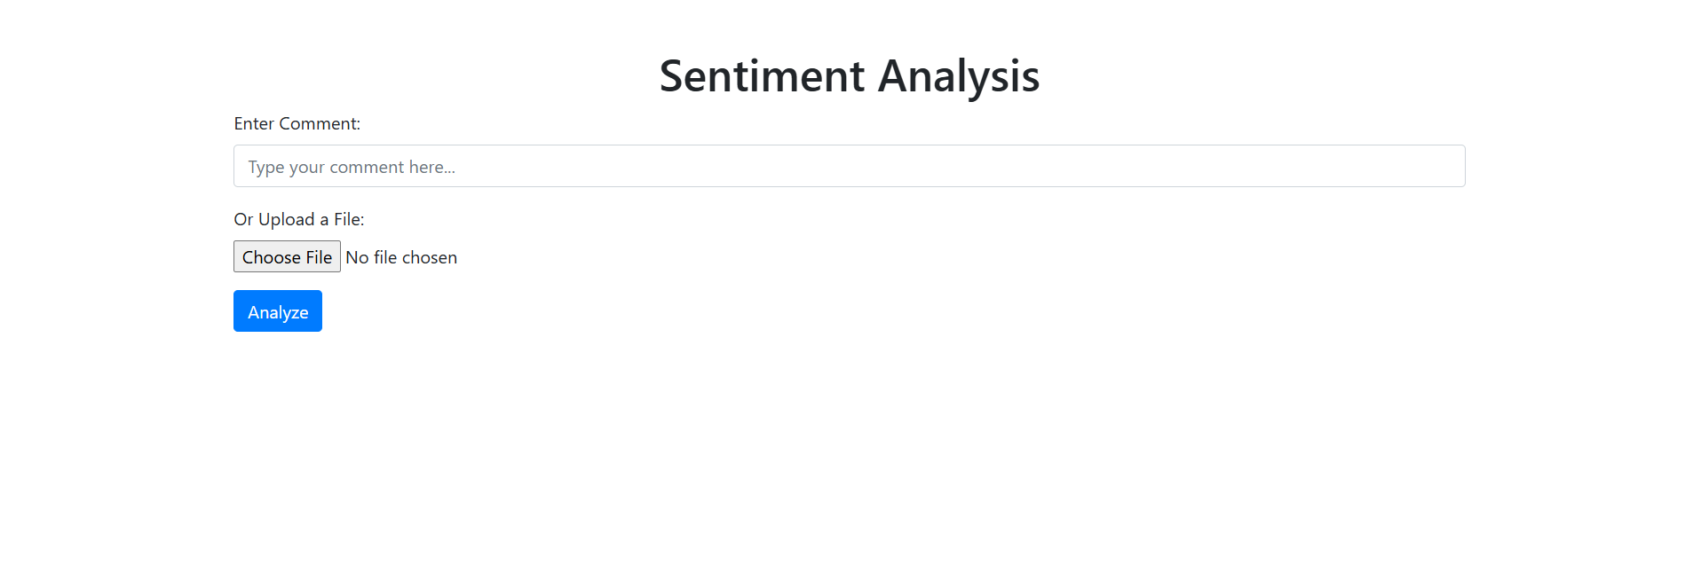
Figure 5.1: Interface
Single Comment Analysis
The screenshot highlights the user interface for our sentiment analysis project and appears well-designed for user interaction. Here's a detailed breakdown of its components:
- Comment Input Section:
  - Text Box: A field labeled "Enter Comment" allows users to type a comment they wish to analyze. It's positioned prominently, indicating this is one of the primary features.
- File Upload Option:
  - Button: The "Choose File" button enables users to upload files containing multiple comments for batch processing.
  - Status Indicator: Below the button, the text "No file chosen" informs users of the current file selection status.
- Analyze Button:
  - A blue button labeled "Analyze" acts as the trigger for initiating sentiment analysis, whether for a single typed comment or an uploaded file.
- Results Display:
  - Sentiment analysis results are neatly displayed in a section titled "Sentiment Analysis Results." Each result includes:
    - Comment: The analyzed comment.
    - Language: The detected language of the comment.
    - Sentiment: The sentiment classification (e.g., Positive).
    - Translated Comment: If applicable, the English translation of the original comment.
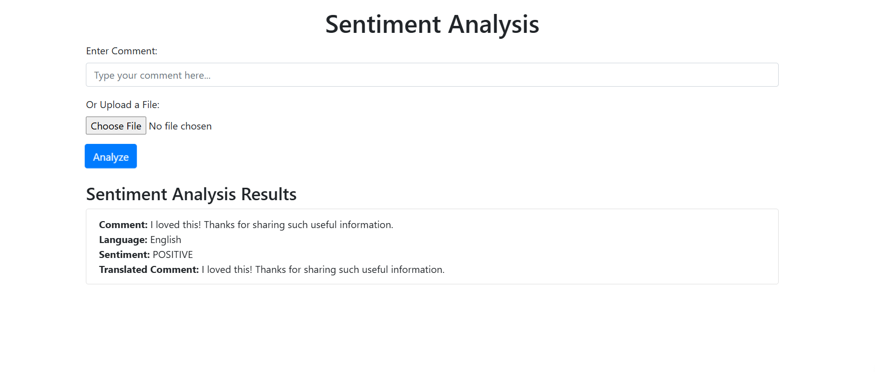
Figure 5.2: Single Comment
Multilingual Single Comment:
The screenshot showcases the interface of our sentiment analysis tool, which is designed with user simplicity in mind. Here's a detailed explanation:
Interface Components
- Input Options:
  - Enter Comment: A text box labeled "Enter Comment" allows users to type in their comments for sentiment analysis.
  - File Upload: An option labeled "Or Upload a File" enables users to upload a file containing multiple comments for batch analysis. The interface includes a "Choose File" button, and the text "No file chosen" indicates the current status of file selection.
- Action Button:
  - The prominent blue "Analyze" button at the center acts as the trigger for sentiment analysis, allowing users to process either a single comment or a batch of comments in a file.
- Results Section:
  - Sentiment Analysis Results: This section displays the analysis outcomes. It includes:
    - Comment: The analyzed comment, such as "C'est une belle journée."
    - Language: The detected language of the comment (e.g., French).
    - Sentiment: The sentiment classification (e.g., NEUTRAL).
    - Translated Comment: For non-English inputs, the system provides translations (e.g., "It's a nice day").
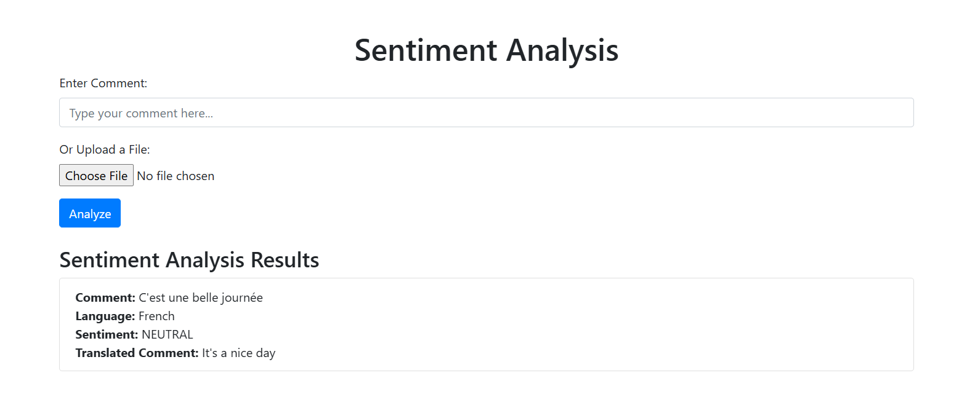
Figure 5.3: Multilingual Single Comment
Multiple Comment Analysis via uploading a comment file
This interface showcases the sentiment analysis results for three user comments. Here's an overview of its design and functionality based on the screenshot:
Interface Breakdown
- Results Table:
  - The results are organized in a structured tabular format, displaying the following columns:
    - Comment: The original comment entered or analyzed.
    - Language: Identifies the detected language of each comment (e.g., English).
    - Sentiment: Classifies the overall sentiment of the comment (e.g., Positive, Negative).
    - Translated Comment: For non-English comments, provides the English translation.
  - Examples:
    - Comment: "I love this product! It works great and exceeds my expectations."
      - Language: English
      - Sentiment: Positive
      - Translated Comment: "I love this product! It works great and exceeds my expectations."
    - Comment: "This is the worst service I have ever experienced."
      - Language: English
      - Sentiment: Negative
      - Translated Comment: "This is the worst service I have ever experienced."
- Key Features of the Results Section:
  - Clear and Concise Presentation: The table ensures easy readability of each comment's language, sentiment, and translation.
  - Real-Time Insights: Sentiment analysis results are displayed promptly, providing users with immediate feedback.
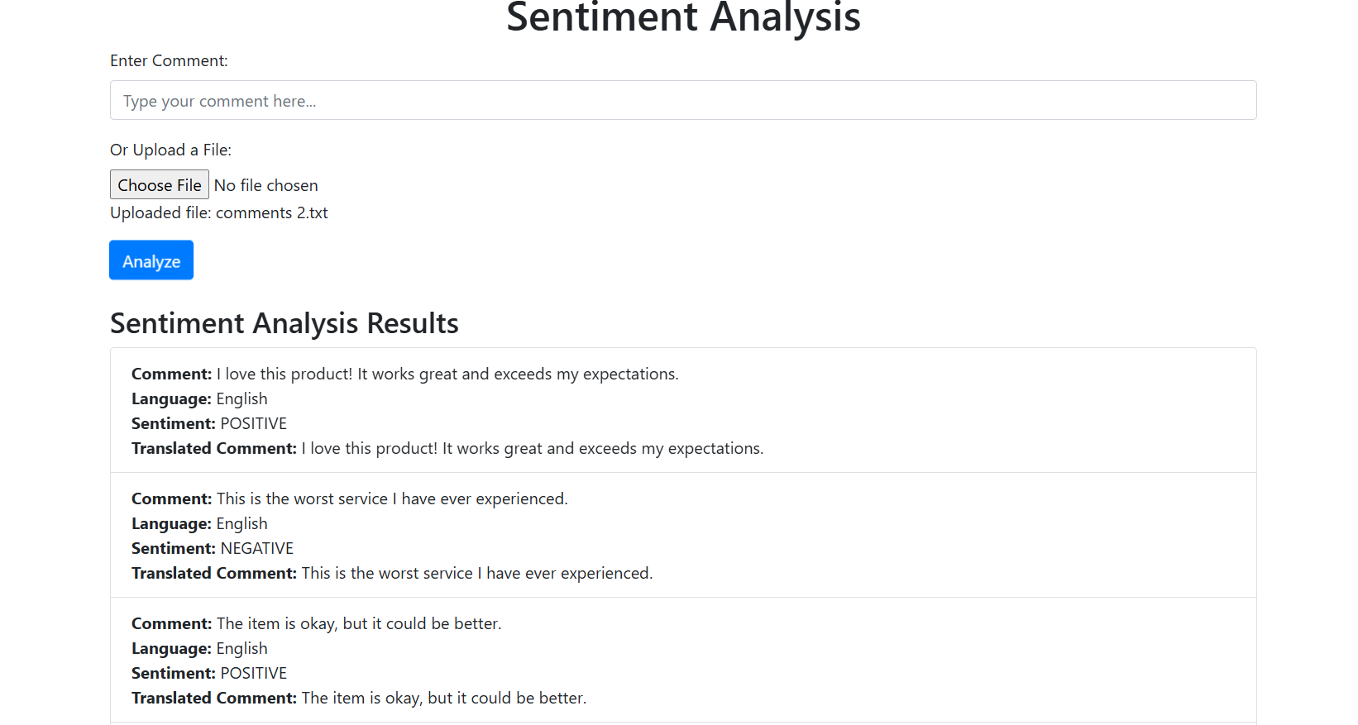
Figure 5.4: Multiple Comment
Database table
Below is a sample representation of the database table that could be used to store user comments and their corresponding sentiment analysis results. This table is designed to capture the original comment, the detected language, the translated comment (if applicable), and the sentiment result.
Explanation of Columns
- id: A unique identifier for each comment (Primary Key).
- original_comment: The original comment provided by the user.
- detected_language: The language code detected for the original comment.
- translated_comment: The translated comment in English (if the original comment is not in English).
- sentiment: The sentiment analysis result for the comment (e.g., POSITIVE, NEGATIVE, NEUTRAL).
Table: comments
id | original_comment | detected_language | translated_comment | sentiment
1 | I love this product! It works great and exceeds my expectations. | En | I love this product! It works great and exceeds my expectations. | POSITIVE
2 | This is the worst service I have ever experienced. | En | This is the worst service I have ever experienced. | NEGATIVE
3 | The item is okay, but it could be better. | En | The item is okay, but it could be better. | NEUTRAL
4 | Absolutely fantastic! Highly recommend it. | En | Absolutely fantastic! Highly recommend it. | POSITIVE
5 | Not satisfied with the quality. Very disappointing. | En | Not satisfied with the quality. Very disappointing. | NEGATIVE
6 | C'est une belle journée | Fr | It's a beautiful day | POSITIVE
7 | Hoy es un buen día | Es | Today is a good day | POSITIVE
8 | 今天是个好日子 | Zh | Today is a good day | POSITIVE
9 | Yeh product bahut accha hai! | Hi | This product is very good! | POSITIVE
10 | Service bilkul bekaar thi. | Hi | The service was absolutely terrible. | NEGATIVE
Table 5.2: Sample Database Table

Multilingual Basic Support
Based on the screenshot of our sentiment analysis project interface, here's an explanation of its functionality and features:
Interface Components and Functionality
- Comment Input Section:
  - The interface includes a labeled text box, "Enter Comment," where users can type a comment directly to perform sentiment analysis.
  - This feature is designed for analyzing single comments in real-time.
- File Upload Section:
  - There's an option labeled "Or Upload a File," with a "Choose File" button for uploading files containing multiple comments. The label "No file chosen" indicates the file status before upload.
  - This feature supports batch processing, enabling the analysis of multiple comments simultaneously.
- Action Button:
  - A blue button labeled "Analyze" allows users to trigger sentiment analysis for either the entered comment or the uploaded file.
  - It initiates the processing and displays the results below.
- Results Display Section:
  - Comment: Displays the analyzed comments, such as "I love this product!"
  - Language: Identifies the detected language (e.g., English, French, Spanish).
  - Sentiment: Classifies the sentiment as Positive, Negative, or Neutral.
  - Translated Comment: Provides translations for comments in non-English languages.
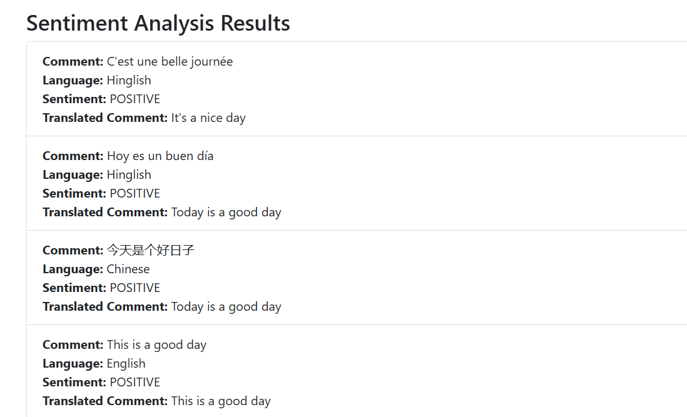
Figure 5.5: Multilingual Comment
Project basic Screenshot
The screenshot reveals a glimpse into the workspace for your sentiment analysis project, and it's well-organized for development and testing purposes. Here's an explanation of the elements in the interface:
- Project Explorer Panel (Left Side):
  - The project directory is named "OPINION-MINING-FOR-COMMENT-SENTIMENT". It contains:
    - Data Files: These include text files (comments2.txt, comments.txt, comments3.txt) and a CSV dataset (IMDB Dataset.csv), presumably used for training and testing sentiment models.
    - Python Modules:
      - Files such as pipeline.py, text_preprocessor.py, and train_model.py are likely responsible for core functionality, including preprocessing, model training, and data handling.
      - The folder omcsa includes additional scripts for managing aspects like views (views.py) and database models (models.py).
- Editor Panel (Center):
  - The file pipeline.py is open, showcasing the implementation of a SentimentPipeline class.
  - The predict method within the pipeline demonstrates how comments are processed:
    - Text preprocessing includes translation for non-English comments and tokenization.
    - Sentiment scoring involves thresholds for classification into Positive, Negative, or Neutral categories.
- Terminal Panel (Bottom):
  - Displays HTTP requests and responses, showing real-time interaction with the sentiment analysis system. Status codes (e.g., 200) and response times confirm that the system is functioning correctly.
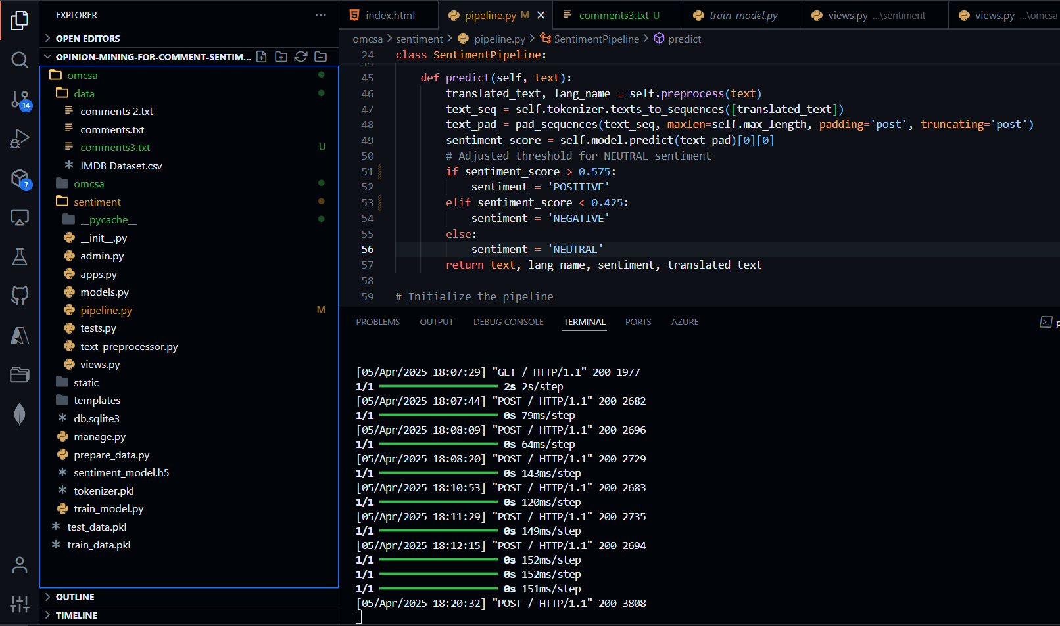
Figure 5.6: Project Workspace

CHAPTER 6
CONCLUSIONS AND FUTURE WORK
6.1 CONCLUSIONS
The sentiment analysis system developed in this project successfully classifies user comments as positive, negative, or neutral. By leveraging advanced natural language processing (NLP) techniques, machine learning models, and a multilingual pipeline, the system demonstrates its ability to handle diverse user inputs across different languages and domains. Key achievements of the project include:
- Accurate Sentiment Classification:
  - The LSTM-based deep learning model, trained on the IMDB dataset, achieves high accuracy in classifying sentiments. The use of GloVe embeddings enhances the model's ability to capture semantic relationships in text.
- Multilingual Support:
  - The integration of language detection (langid) and translation (googletrans) ensures that the system can process comments in multiple languages, making it accessible to a global audience.
- Real-Time Analysis:
  - The deployment of the trained model in a Django web application enables real-time sentiment analysis, providing users with instant feedback on their comments.
- User-Friendly Interface:
  - The web application features an intuitive interface that allows users to input comments or upload files for batch analysis, ensuring ease of use.
- Scalability and Security:
  - The system is designed to be scalable and secure, with provisions for cloud deployment and data protection measures.
Overall, the project demonstrates the feasibility and effectiveness of using deep learning and NLP techniques for sentiment analysis, providing a robust foundation for further enhancements and applications.
6.2 FUTURE WORK
Model Improvements
- Advanced Models:
  - Experiment with advanced models like BERT, GPT-3, or Transformer-based architectures to improve accuracy and robustness.
- Aspect-Based Sentiment Analysis:
  - Implement aspect-based sentiment analysis to identify sentiments towards specific aspects within a comment.
Multilingual Support
- Native Multilingual Analysis:
  - Extend the system to support sentiment analysis in multiple languages natively, without relying on translation to English.
- Language-Specific Models:
  - Train models on datasets in different languages to capture unique language patterns and sentiment expressions.
Real-Time and Domain-Specific Analysis
- Real-Time Sentiment Analysis:
  - Enhance the system to perform real-time sentiment analysis on streaming data from social media platforms.
- Domain Adaptation:
  - Adapt the system for sentiment analysis in various domains such as finance, healthcare, and politics by training on domain-specific datasets.
User Interaction and Feedback
- User Feedback Mechanism:
  - Implement a feedback mechanism where users can provide feedback on the accuracy of the sentiment analysis.
- Model Retraining:
  - Use user feedback to periodically retrain and improve the model, ensuring it stays up-to-date with evolving language patterns.
Integration and Deployment
- Business Intelligence Integration:
  - Integrate the sentiment analysis system with business intelligence tools like Tableau or Power BI for visualization and insights.
- Scalability and Performance:
  - Optimize the system for better scalability and performance, ensuring it can handle a large volume of concurrent users.
Security and Privacy
- Enhanced Security Measures:
  - Strengthen security measures to protect user data, including data anonymization and secure data storage.
- Compliance:
  - Ensure compliance with data protection regulations such as GDPR and CCPA.
By addressing these future work areas, the sentiment analysis system can become more versatile, accurate, and user-friendly, providing valuable insights across various applications and domains.

REFERENCES
- Pang, B., & Lee, L. (2008). Opinion mining and sentiment analysis. Foundations and Trends in Information Retrieval, 2(1-2), 1-135..
- Mikolov, T., Chen, K., Corrado, G., & Dean, J. (2013). Efficient estimation of word representations in vector space. arXiv preprint arXiv:1301.3781..
- Devlin, J., Chang, M. W., Lee, K., & Toutanova, K. (2018). BERT: Pre-training of deep bidirectional transformers for language understanding. arXiv preprint arXiv:1810.04805.
- Hochreiter, S., & Schmidhuber, J. (1997). Long short-term memory. Neural Computation, 9(8), 1735-1780.
- Kim, Y. (2014). Convolutional neural networks for sentence classification. arXiv preprint arXiv:1408.5882.
- Socher, R., Perelygin, A., Wu, J. Y., Chuang, J., Manning, C. D., Ng, A. Y., & Potts, C. (2013). Recursive deep models for semantic compositionality over a sentiment treebank. Proceedings of the 2013 Conference on Empirical Methods in Natural Language Processing, 1631-1642.
- Zhang, L., Wang, S., & Liu, B. (2018). Deep learning for sentiment analysis: A survey. Wiley Interdisciplinary Reviews: Data Mining and Knowledge Discovery, 8(4), e1253.
- Maas, A. L., Daly, R. E., Pham, P. T., Huang, D., Ng, A. Y., & Potts, C. (2011). Learning word vectors for sentiment analysis. Proceedings of the 49th Annual Meeting of the Association for Computational Linguistics: Human Language Technologies, 142-150.
- Liu, B. (2012). Sentiment analysis and opinion mining. Synthesis Lectures on Human Language Technologies, 5(1), 1-167.
- Vaswani, A., Shazeer, N., Parmar, N., Uszkoreit, J., Jones, L., Gomez, A. N., ... & Polosukhin, I. (2017). Attention is all you need. Advances in Neural Information Processing Systems, 30, 5998-6008.

