**4.Statement**

**Bug ReportTitle:** No error message displayed when the "Message" field is empty**Bug ID:** 001**Severity**: High**Priority:** High**Description**: When submitting the contact form with the "Message" field left empty, no error message is displayed. According to the expected behaviour, an error message should be shown to prompt the user to fill in the required field.

**Steps to Reproduce:**

**Step1-**Navigate to the application by Url “.

**Step2-** Click on the "Contact Us" link.

**Step3-** Fill in the "Full Name," "Id", "Phone No" and “Email” fields

**Step4-** Select "Management" from the “Job Role” dropdown.

**Step5-** Leave the “Message” textbox field as blank.

**Step6-**Select “I Agree” radio button.

**Step7-**Click on “Submit” button.

**Step8-**Verify that error message should be display.

**Expected Result:** An error message should be displayed indicating that the "Message" field is required.

**Actual Result:** Error message is displayed.

**Environment:** Test**Browser:** Google Chrome

**Attachment:**

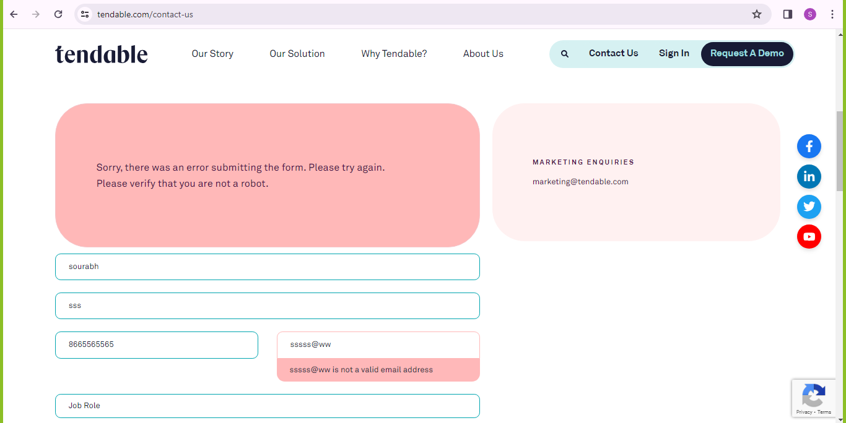

**5 .Statement**

* Strategy Employed For this challenge, I employed a systematic approach to test automation using Selenium WebDriver and Java.
* The strategy included:
* Identifying the test scenarios based on the requirements. –
* Writing test scripts using Selenium WebDriver to automate the identified scenarios.
* Using XPath expressions to locate and interact with elements on the web pages.
* Implementing assertions to verify expected outcomes. - Incorporating TestNG to manage test execution and assertions.
* Bug Report In case of failure, a bug report should be draftedfollowing the provided template and uploaded to GitHub alongside the code.