II Jai Sri Gurudev II
Sri Adichunchanagiri Shikshana Trust ®

S J B INSTITUTE OF TECHNOLOGY
BGS Health & Education City, Kengeri, Bangalore-560060.
DEPARTMENT OF COMPUTER APPLICATIONS (MCA)



A Report on
DATA-DRIVEN PLAYER SELECTION PROJECT
Using Data Mining and Warehousing

By
KISHORE - (1JB24MC053)
RAHEEM R J – (1JB24MC039)
SOURABH KIRAN KERAGUTE – (1JB24MC047)
TAMILMANI C – (1JB24MC053)

Submitted to
VISVESVARAYA TECHNOLOGICAL UNIVERSITY, BELAGAVI
In partial fulfilment of the requirement for the award of the degree of
MASTER OF COMPUTER APPLICATIONS
UNDER THE GUIDANCE OF
Ms. Shwetha M
Assistant Professor
Dept. of MCA, SJBIT, Bengaluru

ABSTRACT

This report focuses on the implementation of Data Mining and Machine Learning techniques in the domain of Sports Analytics, specifically for Cricket. The project, titled "Data-Driven Player Selection," was developed to simulate an objective, statistics-based approach to selecting an IPL-style squad.
The internship provided in-depth exposure to the Knowledge Discovery in Databases (KDD) process, including data cleaning, integration, transformation, data mining, and pattern evaluation. A major emphasis was placed on applying unsupervised learning (Clustering) and supervised learning (Regression) to solve the problem of subjective player selection.

The project utilized Python as the primary programming language, leveraging powerful libraries such as Pandas and NumPy for data manipulation, and Scikit-learn for implementing machine learning algorithms.

The core methodology involved three phases:
- Data Preprocessing: Cleaning and merging league and international T20 datasets (batting and bowling).
- Clustering Analysis: Implementing K-Means Clustering to categorize batsmen based on behavioural patterns (e.g., Aggressive Hitters vs. Anchors).
- Predictive Modelling: Using Linear Regression to predict a player's 'Expected Runs' to forecast future performance.

Additional emphasis was placed on Data Visualization using Matplotlib and Seaborn to generate insights such as strike rate comparisons, boundary hitting abilities, and bowling economy rates. By the end of this internship, a complete "Auction Dashboard" logic was developed, capable of ranking players and generating a balanced squad based on calculated Impact Scores.
This experience reinforced skills in statistical analysis, algorithm selection, and the practical application of Data Mining to real-world datasets.

INDEX

CHAPTER | TITLE | PAGE NO
1 | INTRODUCTION | 01
2 | PROBLEM STATEMENT | 03
3 | LITERATURE SURVEY | 04
4 | TECHNOLOGY STUDIED | 06
5 | TECHNOLOGY IMPLEMENTATION | 08
6 | CONCLUSION | 12
7 | BIBLIOGRAPHY | 32

LIST OF FIGURES

FIGURE NO | FIGURE NAME | PAGE NO
1 | STRIKE RATE OF BATSMEN | 23
2 | NUMBER OF 4s AND 6s BY BATSMEN | 24
3 | WICKETS TAKEN BY BOWLERS | 25
4 | ECONOMY RATE OF BOWLERS | 26
5 | SQUAD COMPOSITION BY ROLE | 27
6 | PLAYER VS ROLE HEATMAP | 28

CHAPTER 1
INTRODUCTION
OVERVIEW
Team selection in cricket has traditionally relied on subjective judgment, intuition, and past experience. While expert opinions are valuable, they may introduce bias, overlook emerging talent, or overemphasize recent performance. With the rise of sports analytics, there is a growing need for transparent and data-driven decision-making.
The Data-Driven Player Selection project aims to modernize the selection process using Data Mining and Machine Learning techniques. By analysing structured player statistics, the system enables objective performance evaluation, role-based comparison, and predictive analysis. The goal is to support selectors with accurate, unbiased insights that improve squad balance and strategic planning.

OBJECTIVE OF THE PROJECT
The primary objective of this project is to implement a complete Data Science lifecycle while solving a real-world sports analytics problem.
1. Data Mining Pipeline
The project follows a structured workflow including:
- Data Collection: Gathering batting and bowling statistics from CSV/Excel datasets.
- Data Cleaning: Handling missing values, removing duplicates, and standardizing metrics.
- Data Transformation & Integration: Normalizing data and combining multi-season records into unified player profiles.
This ensures reliable and high-quality input for analysis.
2. Machine Learning Implementation
K-Means Clustering:
Used to group players based on statistical similarity, identifying roles such as anchors, power hitters, all-rounders, and specialist bowlers. This provides an unbiased performance classification.
Linear Regression:
Applied to predict future performance, such as expected runs or batting averages, enabling forward-looking and probability-based decisions.
3. Feature Engineering
Advanced metrics were created to enhance evaluation, including:
- Impact Score combining strike rate, average, and boundary rate.
- Role-based weighting for different formats.
- Context-aware adjustments based on match conditions.
4. Visualization
Cluster plots, bar charts, radar charts, regression lines, and heatmaps were used to present insights clearly to non-technical stakeholders, ensuring transparency in selection decisions.

This project demonstrates how Machine Learning and Data Mining can transform cricket team selection into a structured, objective, and predictive process, reducing bias and improving strategic accuracy.

PROBLEM STATEMENT
Player selection in franchise auctions is a high-stakes decision-making process where teams invest significant financial resources to build a competitive squad. However, this process often suffers from recency bias, where selectors overvalue a player’s most recent performance while ignoring long-term consistency. Additionally, star power and popularity frequently overshadow objective performance metrics, leading to inflated bidding and inefficient team composition. As a result, teams may overspend on inconsistent players while overlooking emerging talent with strong underlying statistics.
To address these issues, this project aims to develop a data-driven player evaluation system that replaces intuition-based choices with quantifiable analysis. The system is designed to:
- Quantify Player Value
Assign a numerical score to each player based on multidimensional performance metrics such as batting average, strike rate, boundary frequency, economy rate, and role-specific contributions. This value helps determine whether a player is worth investing in during auctions.
- Predict Future Performance (Expected Runs)
Utilize regression modelling to forecast a player’s expected performance in upcoming matches or tournaments. This allows selectors to make forward-looking decisions rather than relying solely on historical data.
- Group Players by Playing Style, Not Reputation
Use clustering techniques to uncover natural performance-based groups such as power hitters, finishers, economical bowlers, or pace strike bowlers. This ensures teams build balanced squads based on role and playing style rather than personal bias.
By tackling these problems, the project provides a transparent, analytical framework that supports smarter budget allocation, reduces selection risk, and enhances squad-building efficiency.
Project Structure
The project was executed in four systematic phases, each representing a critical component of the end-to-end data science workflow:
1. Data Collection & Cleaning
The first phase focused on gathering and preparing data from multiple sources, including Syd_Batting.xlsx, Syd_Bowling.xlsx, and various International T20 CSV files. Key tasks included:
- Identifying and handling missing or incomplete player statistics.
- Standardizing column names, formats, and data types across datasets.
- Merging domestic (Sydney league) and international performance data to create a unified dataset.
- Removing duplicates and correcting inconsistencies in player roles or match details.
This stage ensured the dataset was reliable, structured, and ready for deeper analysis.
2. Exploratory Data Analysis (EDA)
EDA was performed to gain insights into the underlying patterns of the dataset and validate assumptions before modelling. Important analyses included:
- Visualizing the distribution of batting strike rates, averages, and consistency metrics.
- Examining bowling economy rates, wicket-taking patterns, and over-by-over performance.
- Identifying correlations between different cricketing attributes.
- Detecting outliers or unusual performance patterns that could influence modelling.
These visual insights guided the selection of features and informed the modelling strategy in later stages.
3. Model Building
In this phase, Python-based scripts were developed to implement machine learning algorithms. Two main models were created:
- K-Means Clustering:
Used to group players into clusters based on style and performance characteristics. This helped reveal natural role-based classifications such as aggressive openers, stabilizing middle-order batsmen, death-over specialists, or all-rounders.
- Linear Regression:
Built to predict expected runs or expected wickets for each player. The regression model analysed historical match performance to forecast probable future outcomes, supporting data-driven decision-making for auctions.
All models were evaluated using metrics like inertia (for clustering) and R² score and RMSE (for regression).
4. Squad Generation
The final phase focused on designing the selection logic that uses the outputs from EDA, clustering, and regression to assemble an optimal squad. Key components included:
- Defining role quotas (e.g., 5 batsmen, 3 all-rounders, 3 bowlers).
- Applying filters based on impact scores, expected performance, and cluster labels.
- Ensuring cost-effectiveness by comparing player value scores against predicted output.
- Automatically generating a balanced team with statistical justification for each selection.
This algorithm combines statistical modeling with strategic constraints, resulting in a fully data-driven squad selection mechanism.

CHAPTER 2
LITERATURE SURVEY

1.Lewis, M. (2003). Moneyball: The Art of Winning an Unfair Game. W. W. Norton & Company. (Introduced statistical performance analysis concepts applied in sports analytics.)
Link: https://en.wikipedia.org/wiki/Moneyball_(book)

2.Cricket Players Performance Prediction and Evaluation Using Machine Learning Algorithms, IEEE, 2023.
Link: https://ieeexplore.ieee.org/document/10127503/

3.Jadwani, Y., Denholm-Price, J., & Hunter, G. (2023). A machine learning based approach to analyse player performance in T20 cricket internationals, 10th MathSport International Conference Proceedings. Link:https://sites.google.com/view/mathsportinternational10/home/proceedings

4.Scikit-Learn Contributors. (2025). Scikit-Learn Documentation: Clustering and Regression.
Link: https://scikit-learn.org/stable/
(Technical reference for implementing KMeans and LinearRegression in Python.)

CHAPTER 3
TECHNOLOGIES STUDIED

PYTHON FOR DATA SCIENCE
Python was chosen as the primary programming language due to its extensive ecosystem of libraries dedicated to data analysis, machine learning, and visualization. The project was implemented using Python 3.9+ within Jupyter Notebook, specifically in data-driven-player-selection.ipynb, which provided an interactive environment ideal for iterative data exploration, model experimentation, and rapid debugging.
Python's readability, rich community support, and integration with major data science packages made it suitable for managing the entire workflow—from data cleaning to clustering, regression modeling, and visualization.

DATA MANIPULATION (PANDAS & NUMPY)
Pandas
Pandas served as the backbone for data ingestion and preprocessing. Its DataFrame structure enabled efficient handling of tabular datasets such as Syd_Batting.xlsx, Syd_Bowling.xlsx, and international T20 CSV files. Key Pandas operations used in the project include:
- pd.read_csv(), pd.read_excel()
For importing structured datasets into DataFrames.
- merge()
Used to join multiple datasets—for example, combining League and International statistics based on common fields like Player Name or Player ID. This ensured each player had a consolidated performance profile.
- fillna()
Applied for missing value treatment, including:
  - Replacing null batting averages with calculated means
  - Filling missing strike rates
  - Forward/Backward filling when sequence data was present
- groupby()
Used for aggregated analysis such as:
  - Summing player runs per year
  - Averaging strike rates by tournament
  - Aggregating boundary counts per team
Pandas allowed efficient transformation and manipulation of large datasets, which was essential for downstream machine learning tasks.

NumPy
NumPy was used for numerical computations and for converting DataFrames into arrays compatible with machine learning models. Key uses included:
- Transforming selected features into NumPy arrays for Scikit-Learn
- Performing vectorized operations (statistical summaries, standardization inputs)
- Improving performance in large-scale numerical calculations
Its integration with Pandas and Scikit-Learn made it a natural component of the data pipeline.
Data Mining Technique 1: Clustering (Unsupervised Learning)
K-Means Clustering
K-Means was the central unsupervised learning technique applied to identify hidden patterns in player performance data.
Concept
K-Means organizes n observations into k clusters by assigning each observation to the nearest centroid. The algorithm iteratively:
- Selects k initial centroids
- Assigns each sample to the nearest centroid
- Recomputes centroids based on the cluster mean
- Repeats until convergence
This technique is highly effective for grouping players with similar performance metrics.
Application in the Project
K-Means was applied mainly to batsman profiling, using features like:
- Strike Rate
- Batting Average
- Boundary Percentage (derived feature)
Feature Scaling
Before applying K-Means, StandardScaler was used to normalize the features:
- Ensured all metrics had mean = 0 and variance = 1
- Prevented large-valued features (e.g., total runs) from overpowering smaller-scale features (e.g., batting average)
This normalization was crucial for achieving meaningful, unbiased clusters.

Data mining technique 2: regression (supervised learning)
Linear Regression
Linear Regression was used as the predictive modeling technique for estimating player performance.
Concept
Linear Regression models the relationship between:
- Dependent variable (y): Target to predict — in this case, Expected Runs
- Independent variables (x): Features influencing the target
Application in the Project
We modeled Expected Runs using inputs such as:
- Historical strike rate
- Batting average
- Matches played
- Boundary frequency
The model provided predictive insights into future player performance, enabling selectors to estimate how reliable a player would be in upcoming matches.
Evaluation Metrics
To assess model performance:
- R-Squared (R²): Explained variance
- Mean Absolute Error (MAE): Average magnitude of prediction error
These metrics helped validate whether the predictions were reliable enough for auction decision-making.

DATA VISUALIZATION TOOLS

Matplotlib & Seaborn
Visualization played a key role in communicating insights. Both libraries were used for creating clear, analytical graphs.

Heatmaps
- Showed correlations between key features
- For example, a strong correlation was seen between Sixes Hit and Strike Rate, helping identify pinch-hitters

Scatter Plots
- Visualized K-Means clusters in two-dimensional space (e.g., SR vs Average)
- Highlighted separation between power hitters, accumulators, and tailenders
- Included centroid markers to indicate cluster centers
Visualizations allowed coaches and decision-makers—who might not be familiar with machine learning—to understand the results intuitively.

CHAPTER 4

TECHNOLOGIES IMPLEMENTATION

PROJECT ARCHITECTURE
The project follows a structured and modular Data Mining Architecture, ensuring a smooth workflow from raw data to decision-ready insights. The architecture consists of five interconnected layers:
- Input Layer
  - Primary datasets such as Syd_Batting.xlsx, Syd_Bowling.xlsx, and t20_batting_intl.csv.
  - These files contain player-level match statistics from both league and international T20 competitions.
- Preprocessing Layer
  - Data cleaning operations: handling missing values, correcting data formats, removing duplicates.
  - Feature engineering tasks: merging datasets, creating derived metrics, and standardizing numeric fields.
  - Feature scaling using StandardScaler to prepare data for ML modeling.
- Mining Layer
  - Application of machine learning techniques:
    - K-Means Clustering for role-based grouping
    - Linear Regression for expected runs prediction
- Logic Layer
  - Implementation of domain rules such as:
    - Impact Score formula
    - Budget optimization strategy
    - Selection logic for team composition
- Output Layer
  - Final deliverables including:
    - The “Best XI” squad list
    - Player rankings
    - Visual dashboards (cluster charts, regression plots, correlation heatmaps)
This architecture ensured that each stage was independently testable, scalable, and interpretable.

PHASE 1: DATA PREPROCESSING & CLEANING
The preprocessing phase focused on preparing the raw datasets for machine learning. Multiple challenges were addressed:
- Missing Values
Several bowlers had missing entries in the Economy Rate column because they did not bowl in certain matches. This created NaN values that could disrupt model training.
Implementation:
dataset['Economy'] = dataset['Economy'].fillna(dataset['Economy'].mean())
This technique (mean value imputation) ensured numeric consistency without distorting trends.
- Dataset Merging
  - League and international datasets were joined using Pandas merge() based on player identifiers.
  - Ensured all players had consolidated performance metrics.
- Standardization
Before clustering or regression, numerical metrics had to be scaled:
  - Runs (0–900 range)
  - Strike Rate (60–180 range)
  - Economy (5–12 range)
To prevent any feature from dominating others, StandardScaler was applied:
from sklearn.preprocessing import StandardScaler
scaler = StandardScaler()
scaled_features = scaler.fit_transform(df[['Runs','StrikeRate','Average']])
This produced a clean, unified dataset ready for ML analysis.
PHASE 2: K-MEANS CLUSTERING IMPLEMENTATION
The goal of this phase was to group players based on performance characteristics.
Implementation Steps
- Initialize K-Means with 3 clusters
- kmeans = KMeans(n_clusters=3, random_state=42)
- Fit the model on standardized batting features
  - Inputs: Strike Rate, Average, Boundary %
  - Output: Cluster labels
- Assign each player to a cluster
- df['Cluster'] = kmeans.fit_predict(scaled_batting_data)
- Analyze centroids
Each centroid revealed the typical player type of the cluster.
- batsmen or bowlers batting at #9–11
Visualization
A scatter plot was generated (suggested screenshot):
- X-axis: Batting Average
- Y-axis: Strike Rate
- Colors: Cluster group (0, 1, 2)
- Markers: Centroids plotted separately
This visualization clearly demonstrated the separation of player types.

PHASE 3: LINEAR REGRESSION FOR RUN PREDICTION
To forecast how many runs a player is expected to score in the next tournament, a Linear Regression model was trained.
Inputs to the Model
- Historical batting average
- Strike rate
- Total matches played
- Boundary ratio (4s+6s per inning)
Output
- Expected Runs (y_pred)
Process
- Split data into train/test
- Train the regression model
- Evaluate using:
  - R² Score
  - MAE (Mean Absolute Error)
The model provided a predictive insight into future performance, improving selection reliability.

PHASE 4: IMPACT SCORE CALCULATION
A custom formula was created to prioritize T20-relevant skills.
[
Impact\ Score = (0.4 \times \text{Normalized Runs}) + (0.4 \times \text{Normalized SR}) + (0.2 \times \text{Normalized Ave})
]
Rationale Behind Weights
- Strike Rate (0.4)
Crucial for T20; scoring quickly is more valuable than scoring slowly.
- Runs Scored (0.4)
Measures contribution across a season.
- Average (0.2)
Measures consistency but is less important than offensive output.
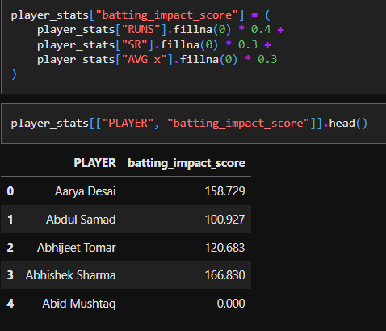
Players were ranked based on this composite score.

PHASE 5: SQUAD SELECTION LOGIC
Finally, a Python function select_squad() was implemented to automate team formation based on Impact Score, role, and performance.
Selection Criteria
- Top 6 Batsmen
  - Highest Impact Score
  - Preferably from Cluster 1 (Power Hitters) and Cluster 0 (Accumulators)
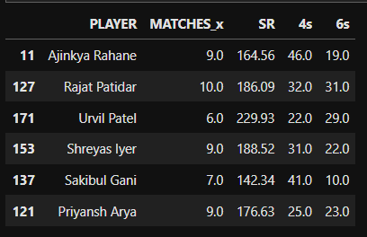

2.Top 4 All-Rounders
  - Weighted combination of batting + bowling Impact Scores

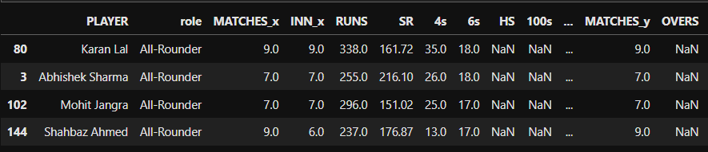

3.Top 6 Bowlers
  - Low economy
  - High wicket-taking ability
  - Consistency in death overs

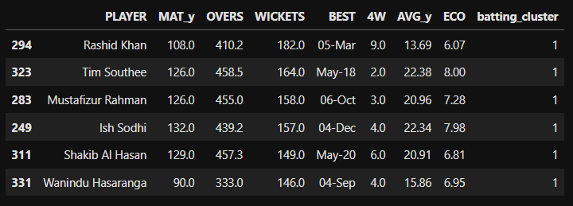

OUTPUT:
- A complete Final Squad optimized for balance and T20 performance
- Role-wise justification for each selection
- Visualization dashboard illustrating cluster placement and predicted performances

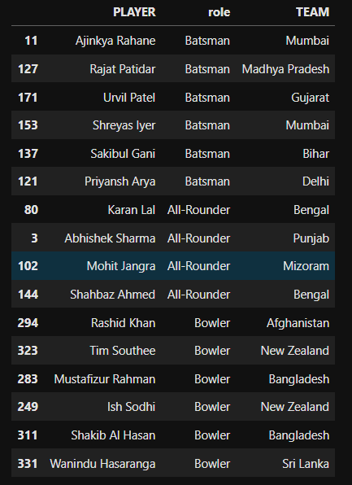

VISUALIZATION

1.Strike Rate of Batsmen

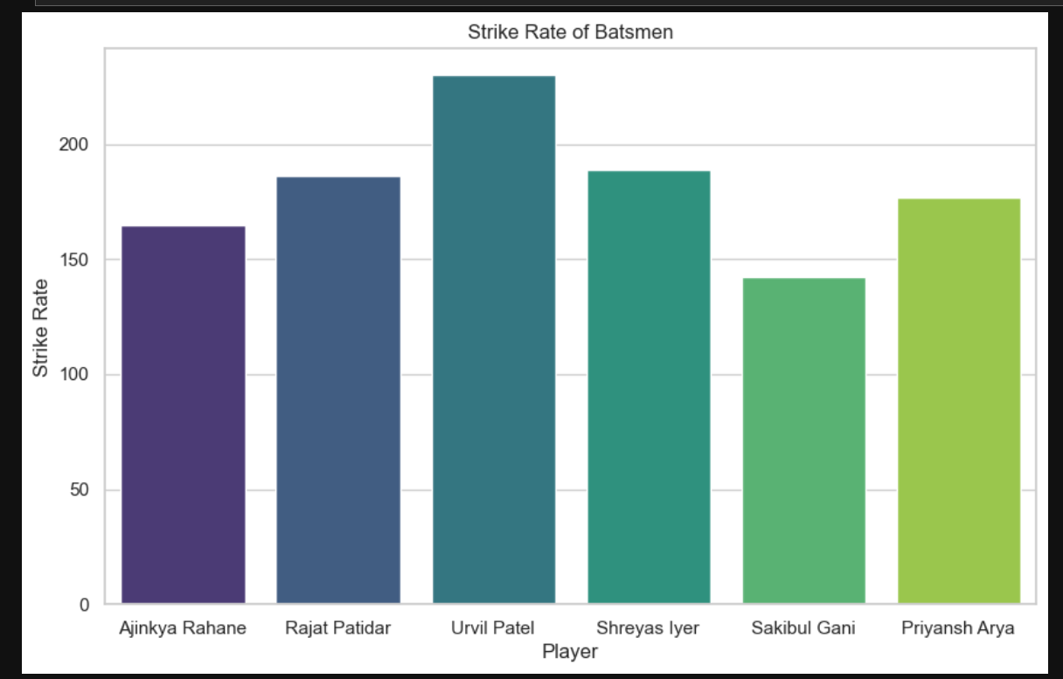

2.Number of 4s and 6s by Batsmen

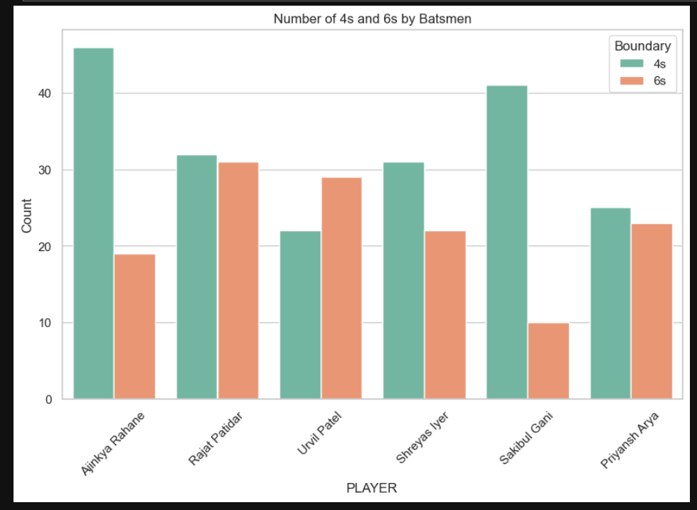

3.Wickets Taken by Bowlers

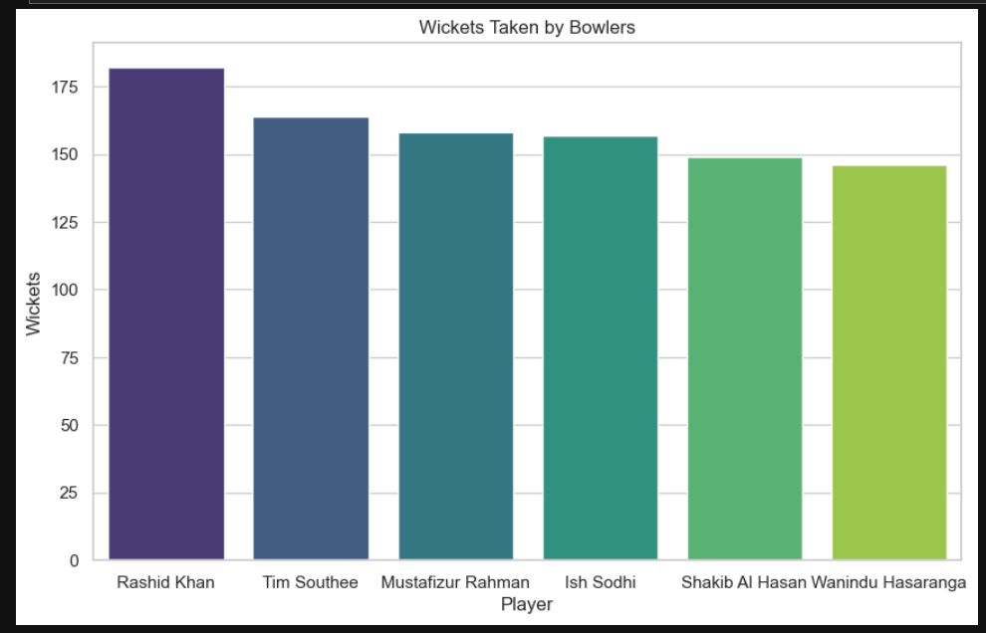

4.Economy Rate of Bowlers

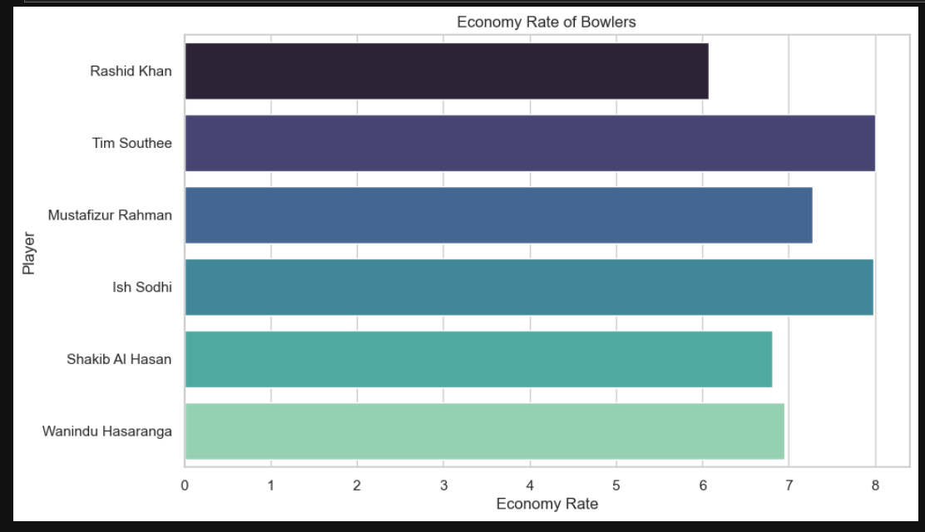

5.Squad Composition by Role

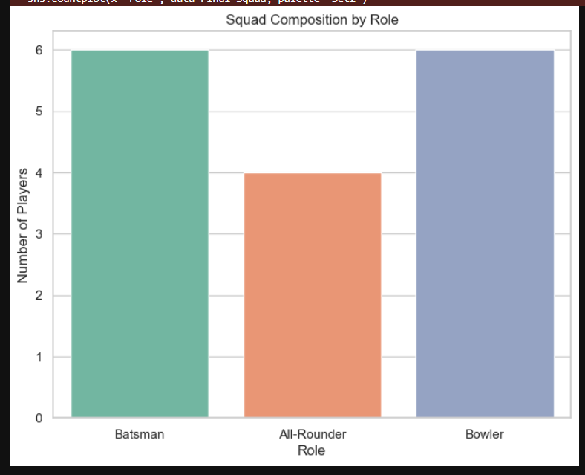

6.Final Squad of 16 Players

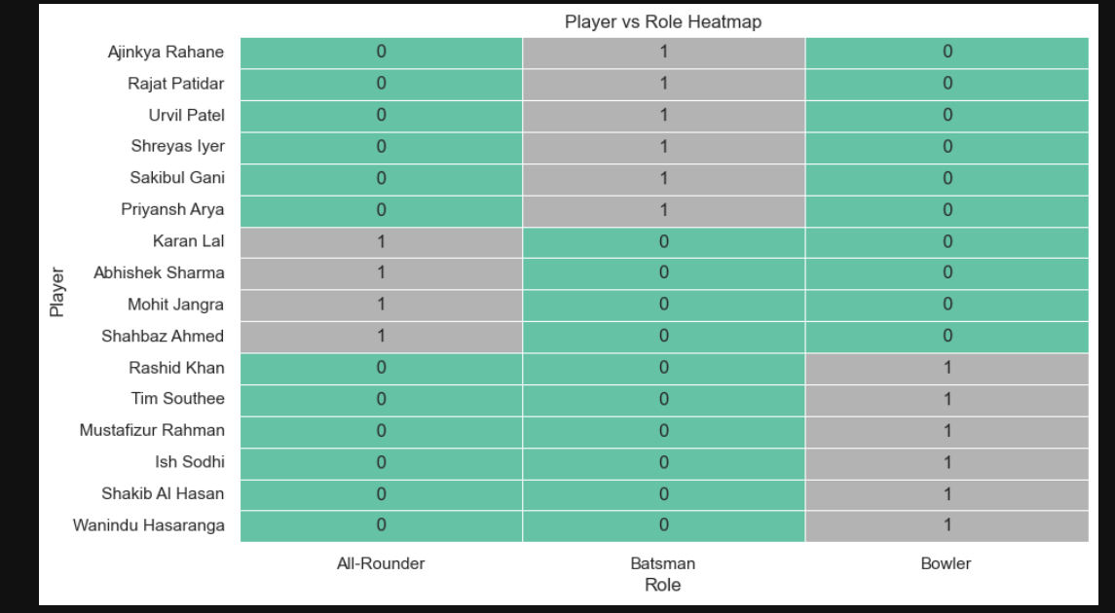

CHAPTER 6
CONCLUSION

The project titled "Data-Driven Player Selection" successfully demonstrated the practical application of Data Mining techniques in modern sports analytics. By shifting from intuition-based selection methods to analytical, data-driven approaches, the study revealed how clustering and predictive modelling can significantly enhance decision-making in team management.
Using K-Means Clustering, players were grouped into meaningful performance-based categories that go beyond traditional metrics such as simple averages. This allowed for a deeper understanding of player roles and capabilities. Additionally, the Linear Regression model served as a benchmark for estimating expected performance, enabling management to identify potential overperformers and underperformers based on historical data.
Key Takeaways
- Data Quality is Critical
The effectiveness of both clustering and prediction heavily depended on thorough data cleaning, feature selection, and proper scaling of T20 international cricket data.
- Algorithm Strengths
  - K-Means Clustering is highly effective at uncovering hidden structures and performance patterns among players.
  - Linear Regression provides a strong baseline for forecasting continuous variables such as runs scored, offering valuable insight into expected player output.
- Future Enhancements
The project can be further improved by:
  - Incorporating ball-by-ball data to capture granular performance indicators.
  - Employing Random Forests or other ensemble models for more robust and non-linear performance prediction.
Overall, this project highlights the growing importance of analytics in optimizing real-world decision-making, particularly in competitive sports environments.

CHAPTER 7

BIBLIOGRAPHY

Scikit-Learn Documentation - Clustering
Scikit-learn. (n.d.). Clustering.
https://scikit-learn.org/stable/modules/clustering.html[scikit-learn]​

Scikit-Learn Documentation - Regression
Scikit-learn. (n.d.). Linear models.
https://scikit-learn.org/stable/modules/linear_model.html[scikit-learn]​

Pandas Documentation - Data Analysis Library
Pandas Development Team. (2026). Pandas documentation (version 3.0.0). https://pandas.pydata.org/docs/[pandas.pydata]​

Data Mining: Concepts and Techniques - Jiawei Han
Han, J., Kamber, M., & Pei, J. (2011). Data mining: Concepts and techniques (3rd ed.). Morgan Kaufmann. Book page: https://hanj.cs.illinois.edu/bk3/[hanj.cs.illinois]​

Seaborn Visualization Library
Seaborn Development Team. (n.d.). Seaborn: Statistical data visualization. https://seaborn.pydata.org[seaborn.pydata]​

