* **Create a time-based application to wish the end user.**
* **For example, if the time is 6 a.m., display 'Good morning.'**
  + - **If the time is 6:45 p.m., show 'Good Evening.'**
* **Create project:**

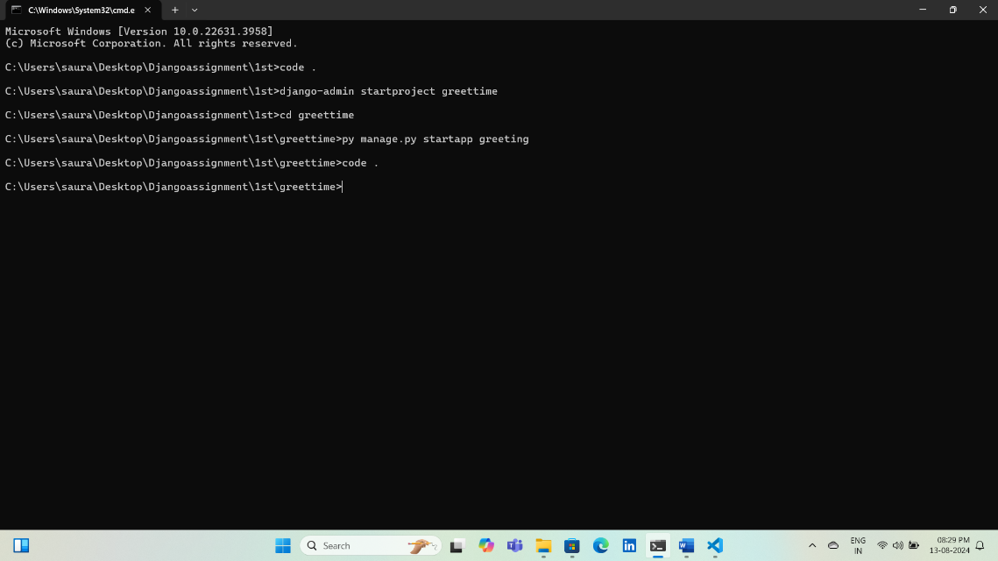

* **Register app:**

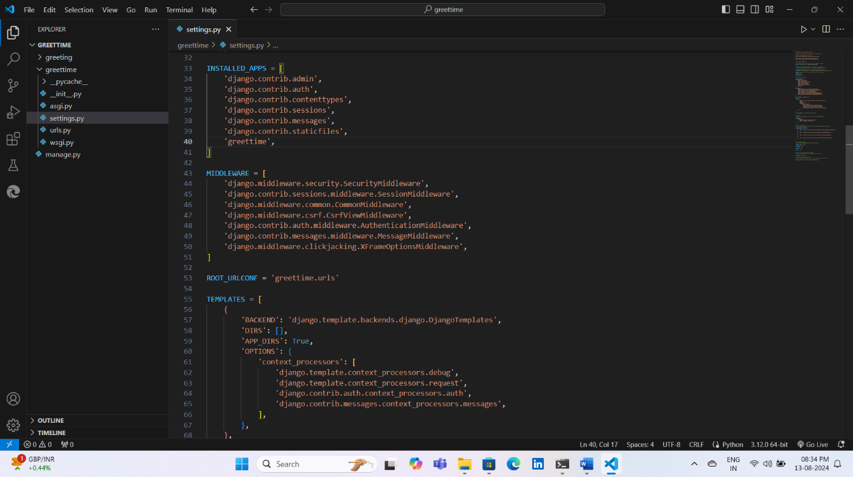

* **Create template folder inside create index.html:**

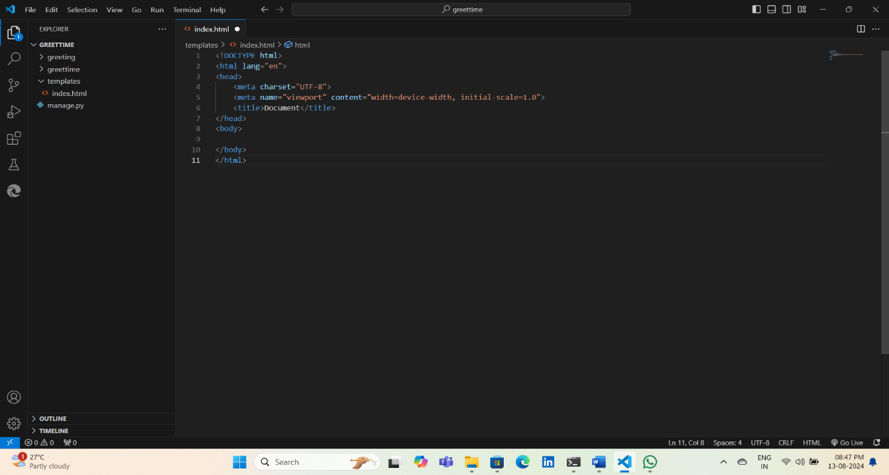

* **Register template folder:**

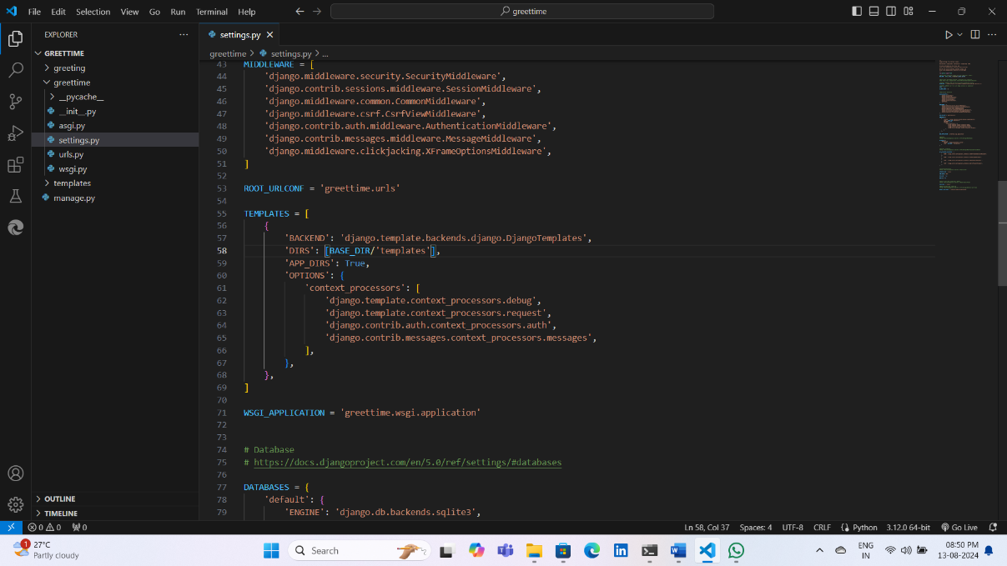

* **Views.py:**

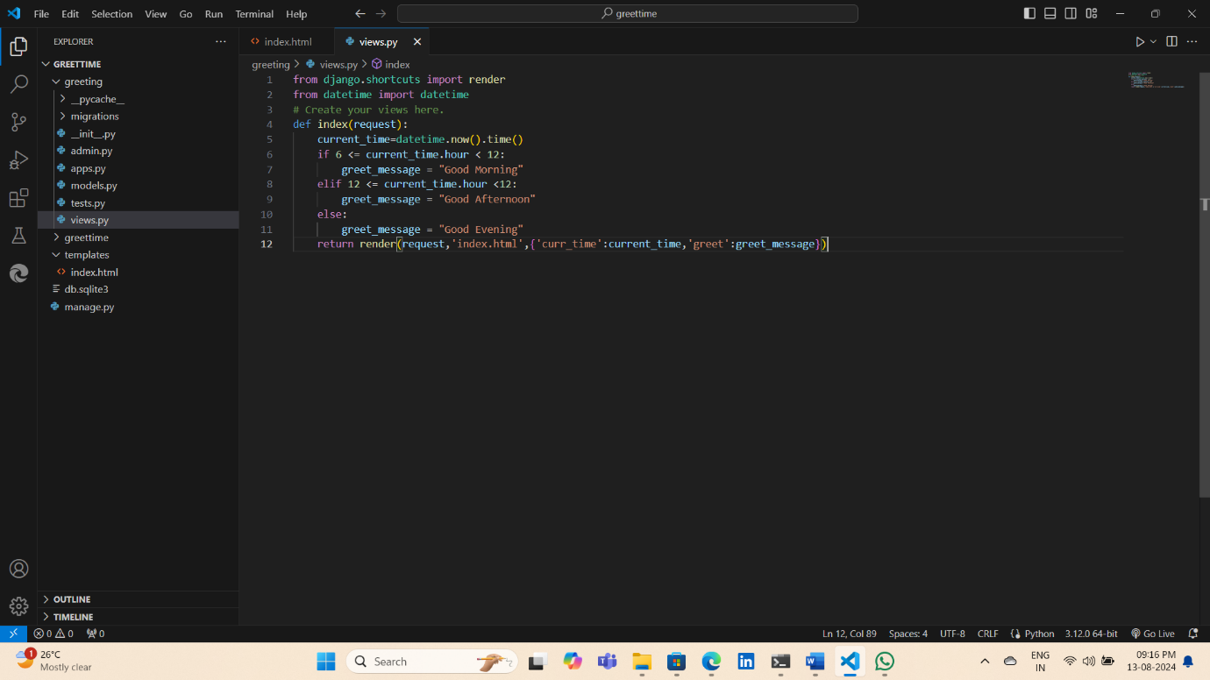

* **Code inside index.html:**

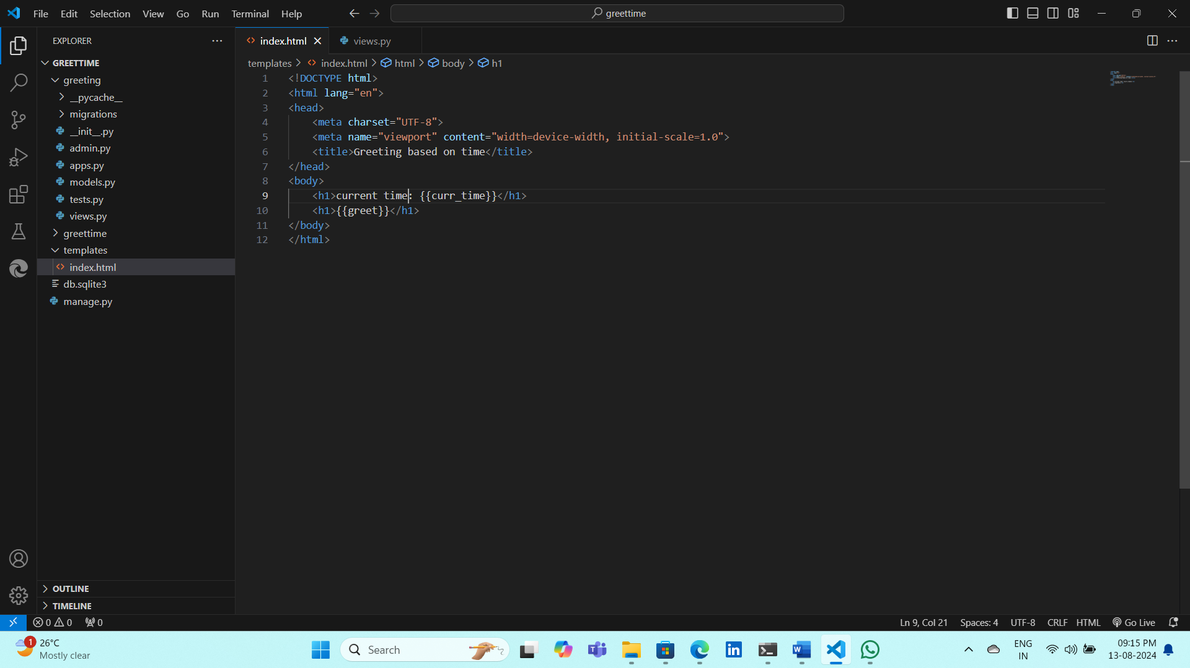

* **Configure project url:**

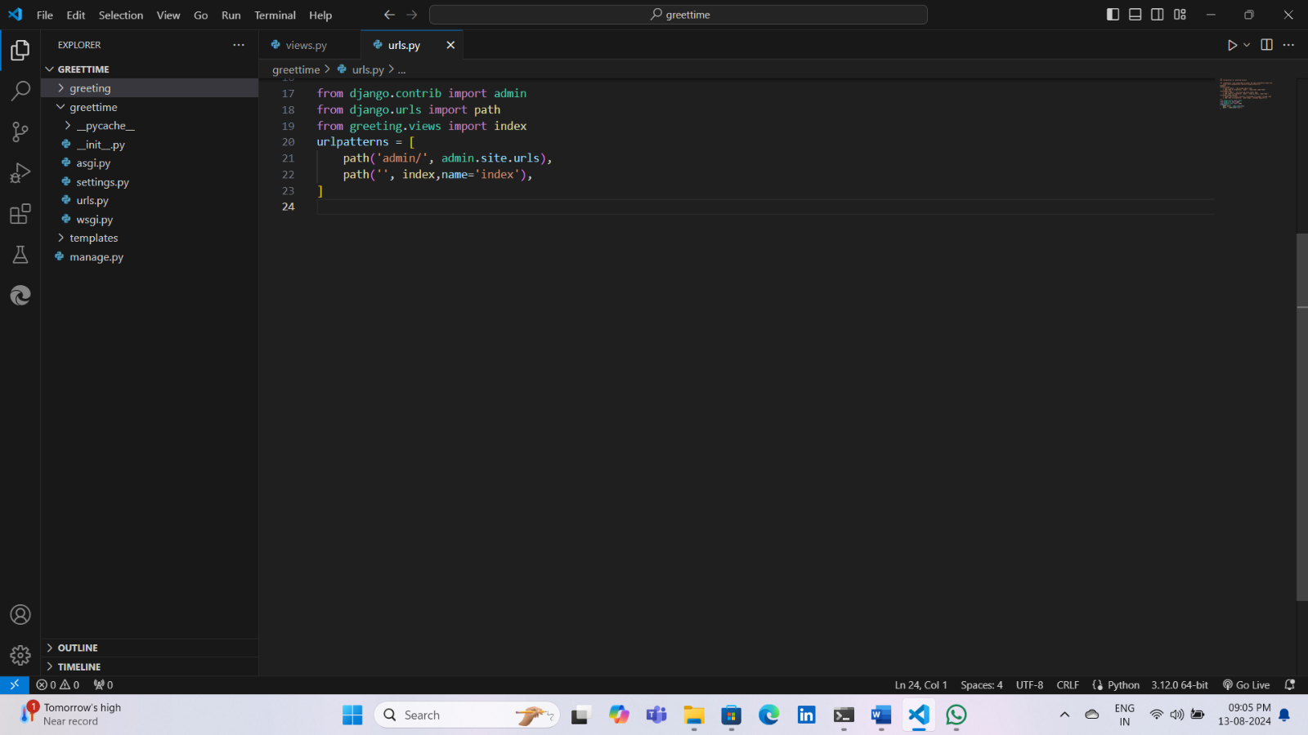

* **Output: py manage.py runserver**

