- Create a time-based application to wish the end user.
- For example, if the time is 6 a.m., display 'Good morning.'
    - If the time is 6:45 p.m., show 'Good Evening.'

- Create project:
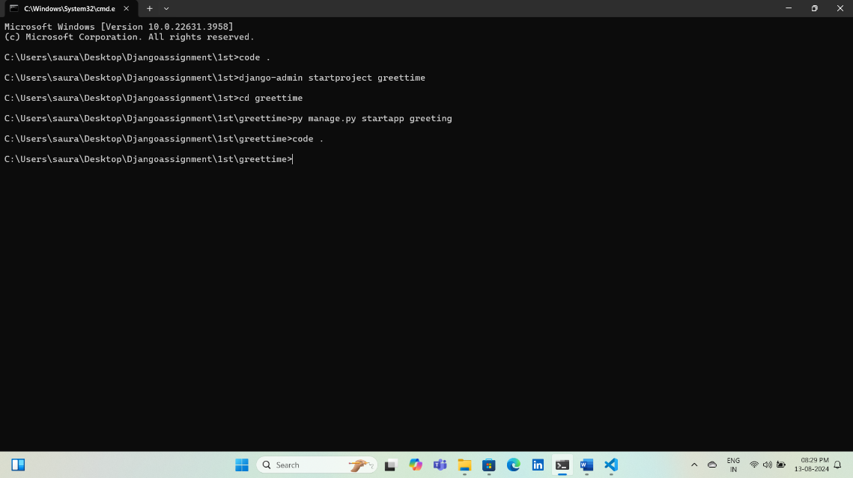
- Register app:
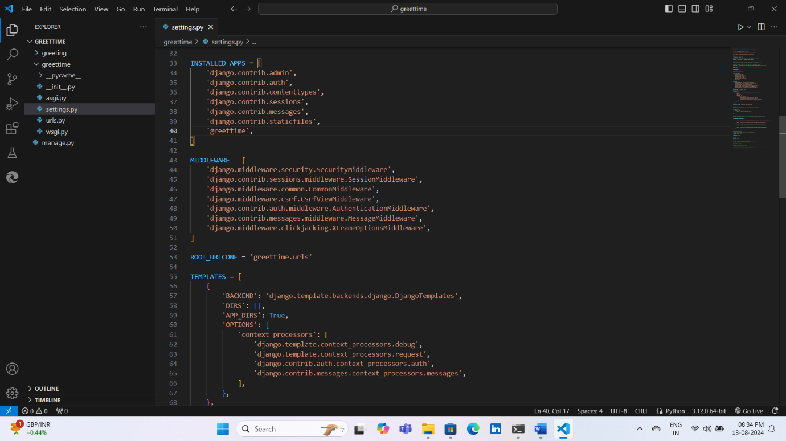
- Create template folder inside create index.html:
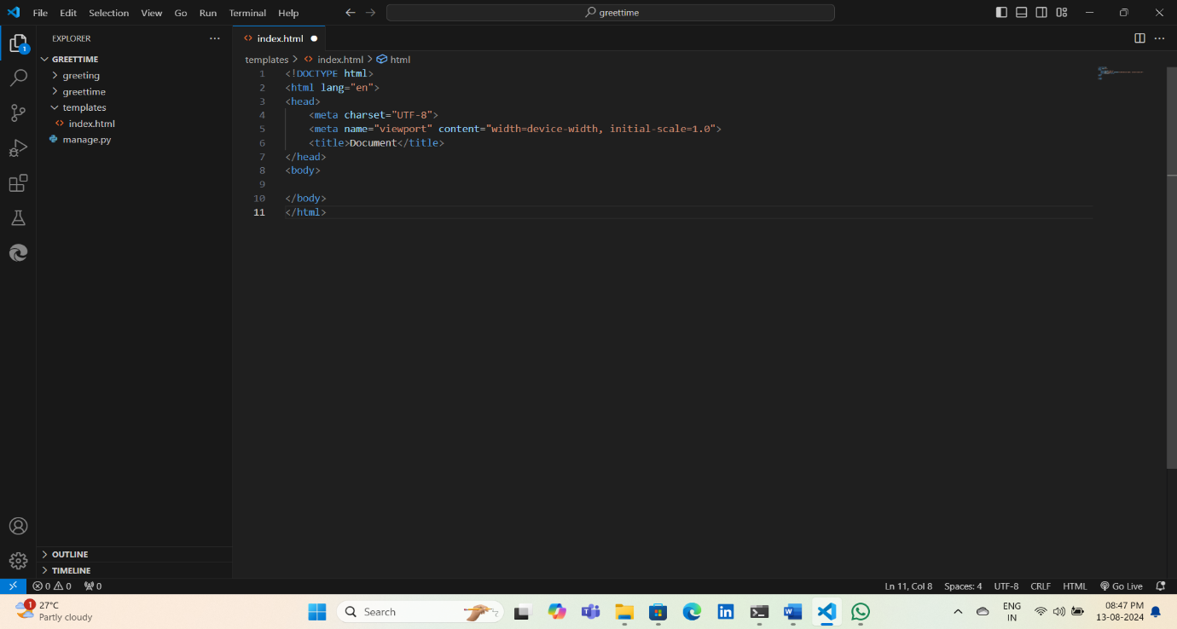

- Register template folder:
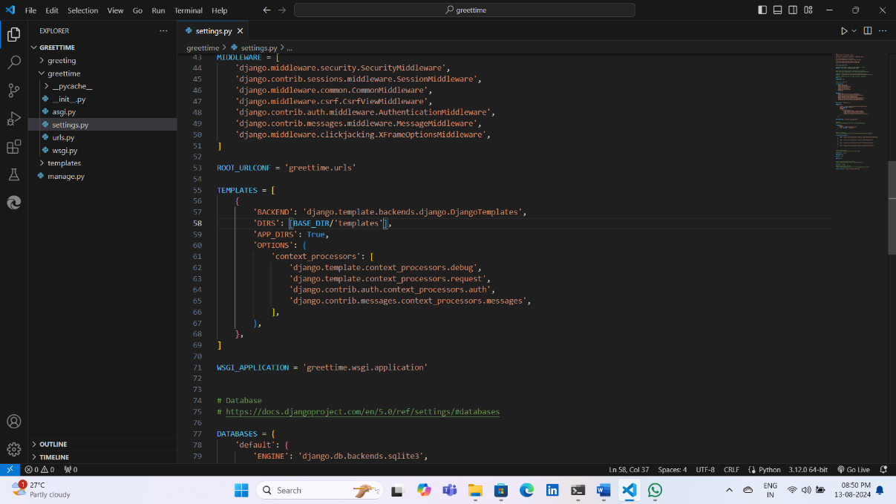
- Views.py:
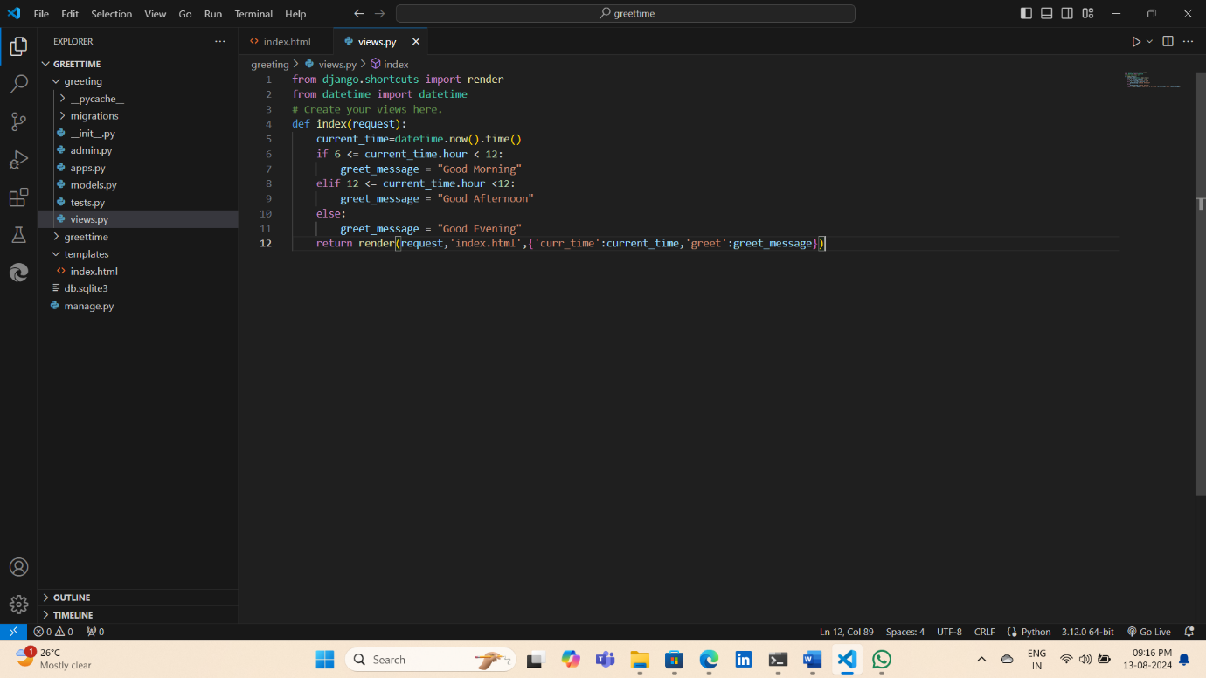
- Code inside index.html:
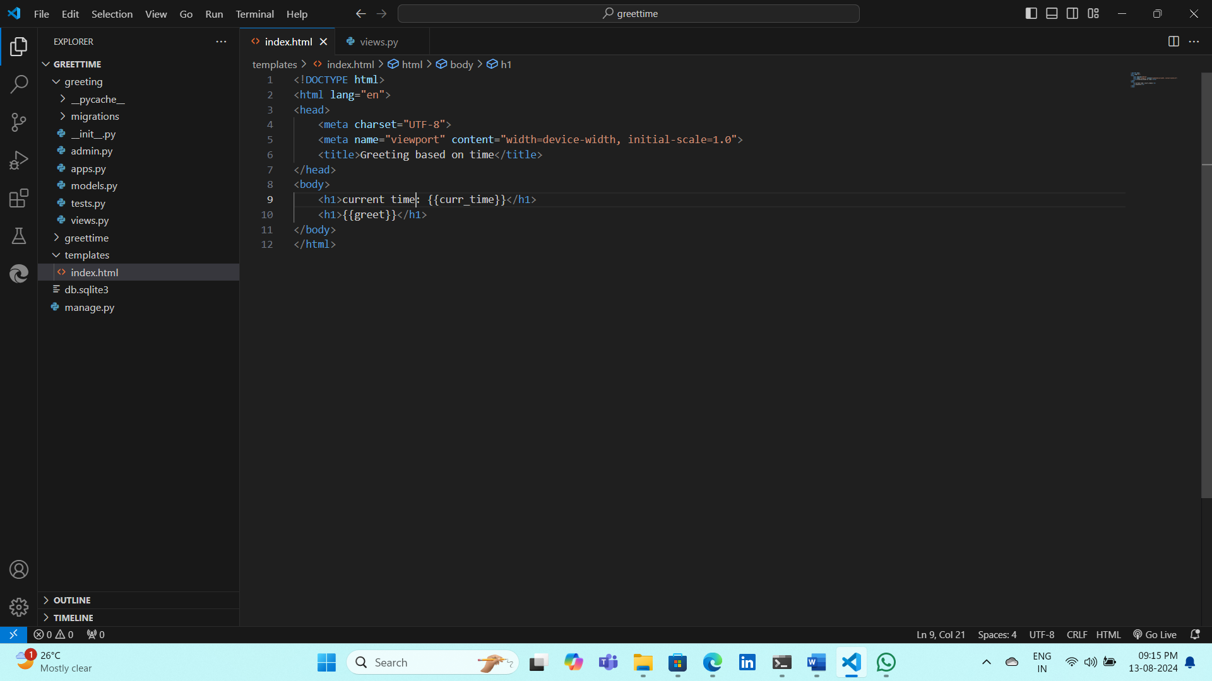
- Configure project url:
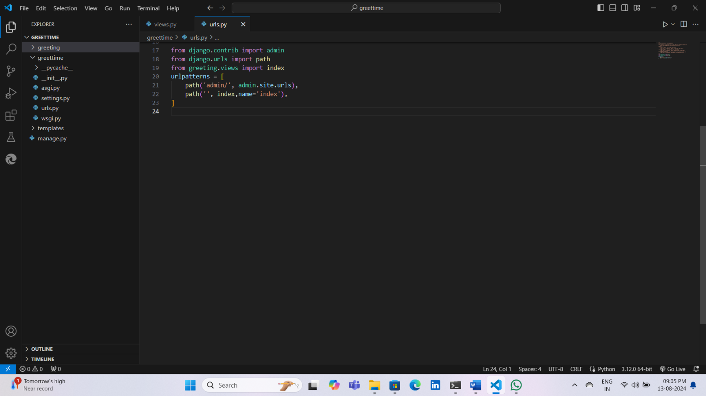
- Output: py manage.py runserver
