Customer Churn Analysis Project

1.Introduction
Customer churn refers to the situation when customers stop using a company's services. In the telecom industry, understanding churn is important to retain customers and increase profit.
In this project, we analyzed customer churn data using Excel, SQL, and Python.

2.Dataset Description
The dataset contains 7043 customer records. The important columns used in this analysis are:
- Customer ID
- Gender
- Tenure
- Contract Type
- Monthly Charges
- Churn
The goal is to identify patterns and reasons why customers leave the service.

3.Excel Analysis
In Excel, pivot tables were created to analyze churn based on different factors.
- Tenure was grouped into categories (0–9, 10–19, >20)
- Contract type vs churn was analyzed
- Churn distribution was visualized
Excel helped in quick data summarization and initial analysis.
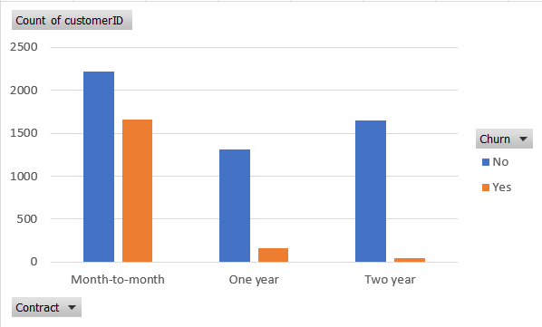
Figure 1: Contract Type vs Churn (Excel Analysis)
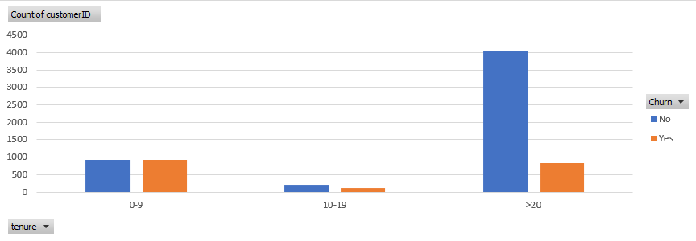
Figure 2: Tenure Group vs Churn (Excel Analysis)
4.SQL Analysis
SQL was used to perform data querying and aggregation.
Example queries:
- Total number of customers
- Count of churned vs non-churned customers
- Contract type vs churn analysis
- Tenure group vs churn analysis
SQL helped in structured data analysis and extracting meaningful insights.
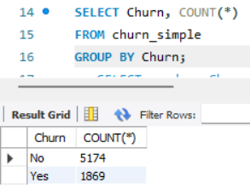
Figure 3: SQL Query for Churn Distribution
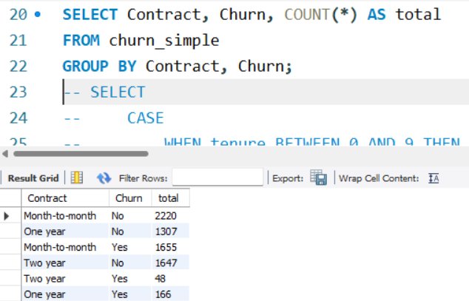
Figure 4: SQL Query for Contract vs Churn Analysis
5.Python Analysis
Python was used for data visualization using pandas and matplotlib.
The following charts were created:
- Churn Distribution
- Gender vs Churn
- Contract vs Churn
- Tenure Group vs Churn
- Monthly Charges vs Churn
These visualizations helped in better understanding of customer behavior.
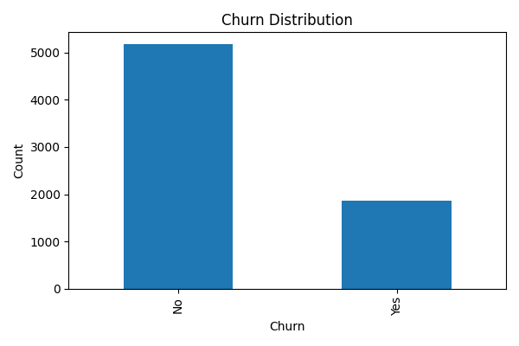 Figure 5: Churn Distribution (Python)
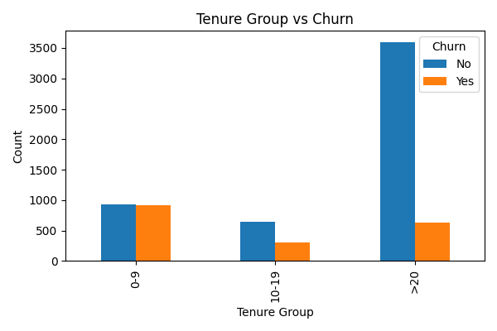 Figure 7: Tenure Group vs Churn (Python)
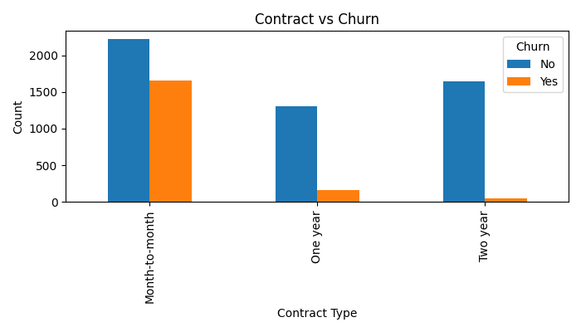 Figure 6: Contract Type vs Churn (Python)
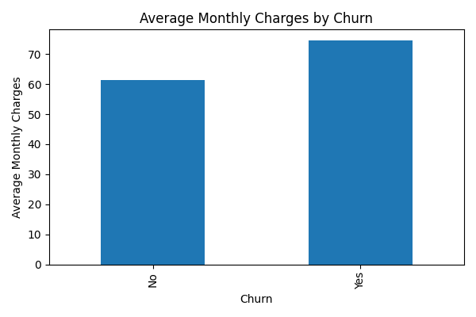 Figure 8: Monthly Charges vs Churn (Python)

6.Key Insights
- Customers with month-to-month contracts have higher churn.
- Customers with longer tenure are less likely to churn.
- Higher monthly charges are associated with higher churn.
- Gender has minimal impact on churn.

7.Conclusion
From the analysis, it is observed that contract type, tenure, and monthly charges play a major role in customer churn. Companies should focus on retaining customers with short-term contracts and high monthly charges.

