Task 2: Exploratory Data Analysis (EDA)
Analysis of the Books to Scrape dataset collected in Task 1

1. Introduction
Exploratory Data Analysis (EDA) is the process of examining a dataset using summary statistics and visualizations before further analysis. This project analyzes the book dataset produced by the Task 1 web-scraping exercise.

2. Objectives
- Ask useful questions before analyzing the dataset.
- Inspect dataset dimensions, variables, and data types.
- Summarize numerical variables using descriptive statistics.
- Visualize price and rating patterns.
- Check missing values, duplicate records, and potential anomalies.
- Document limitations and assumptions for future analysis.

3. Questions explored
- How many records and variables are present?
- What are the mean and median book prices?
- How many books appear in each star-rating category?
- Does the sample suggest a relationship between price and rating?
- Are there missing values or duplicate rows?

4. Dataset structure
The bundled input contains 5 rows and 7 columns after preparing numeric fields.
Variables include book title, displayed price, rating, numeric rating, availability, product URL, and derived numeric price where available.
- title: object
- price: object
- rating: object
- rating_numeric: int64
- availability: object
- product_url: object
- price_numeric: float64

5. Descriptive analysis
Duplicate rows found: 0.
Missing cells found: 0.
Mean price in the bundled sample: £51.53.
Median price in the bundled sample: £51.77.
Mean rating in the bundled sample: 2.80 out of 5.
Sample Pearson correlation between price and rating: 0.007.

6. Visualizations
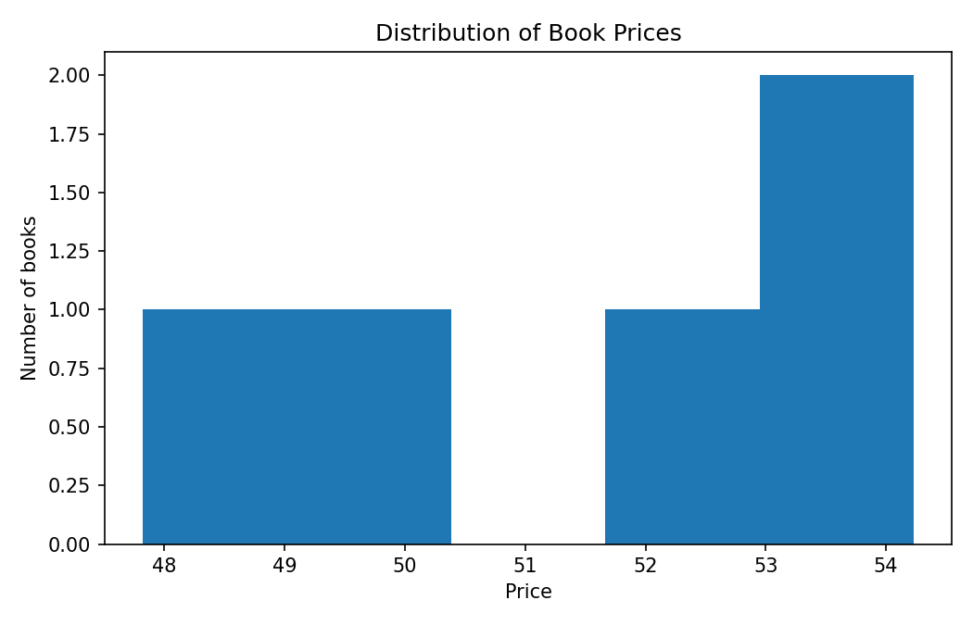
Figure 1. Distribution of book prices.
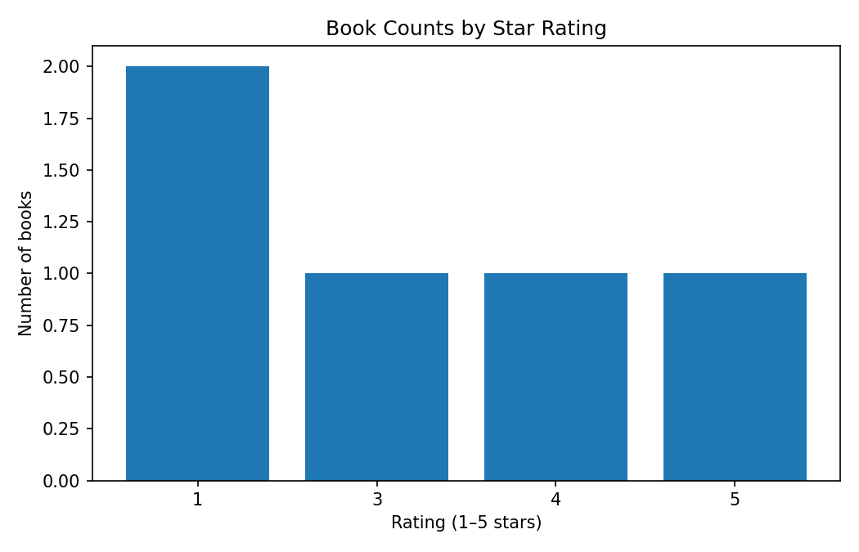
Figure 2. Number of books by star rating.
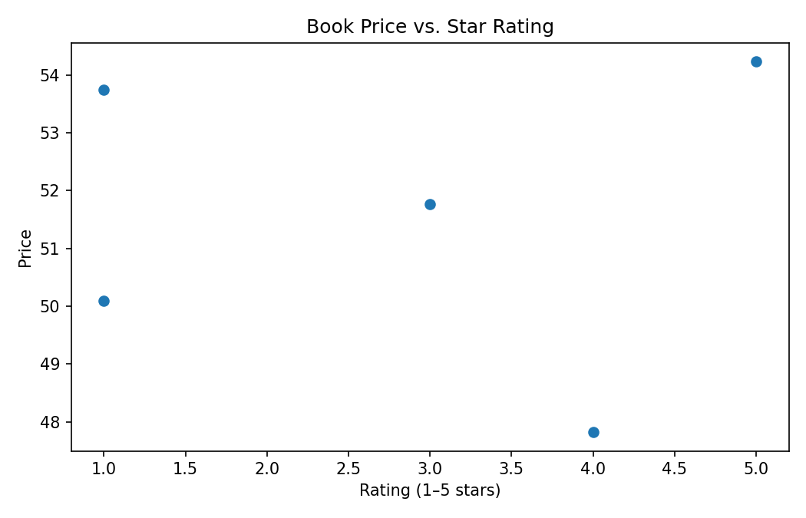
Figure 3. Book price compared with star rating.

7. Data quality checks
The analysis checks missing values and exact duplicate rows. It also converts displayed prices into numeric values and maps word ratings to numbers from 1 to 5. The script flags negative prices and ratings outside the expected range.

8. Hypothesis and interpretation
Exploratory hypothesis: books with higher star ratings may have different prices from books with lower ratings. The price-versus-rating scatter plot and correlation can be used to inspect this possibility. This is an exploratory hypothesis only; a small sample cannot validate it, and correlation does not imply causation.

9. Limitations and next steps
Important: the included dataset is only a small preview (five records in the bundled sample). The figures and statistics demonstrate the EDA workflow, not population-level conclusions. Run the Task 1 scraper to obtain the full catalogue, then rerun eda.py against the newly collected CSV. Recheck missing values, duplicates, outliers, and all summaries on the full dataset.

10. Conclusion
This project demonstrates a repeatable EDA workflow using Pandas and Matplotlib. It inspects the dataset, calculates descriptive statistics, visualizes distributions and relationships, and records data-quality issues to guide further analysis.

