**A PROJECT REPORT ON**

“REGESRATION AND TRACKING SYSTEM USING PYTHON AND DJANGO”

**A Dissertation submitted in partial fulfillment of the requirements for the award of degree of**

# MASTER OF COMPUTER APPLICATIONS

**Of**

# VISVESVARAYA TECHNOLOGICAL UNIVERSITY

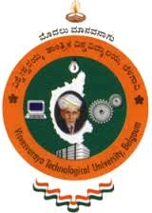

**By**

**SOURABH.C.S**

**(4BD19MCA23)**

**Under the Guidance of**

### Internal Guide: External Guide:

### Mr. MOHAMMAD SADIQ.B Mr. ANIL.K



**DEPARTMENT OF MASTER OF COMPUTER APPLICATIONS**

**BAPUJI INSTITUTE OF ENGINEERING AND TECHNOLOGY**

**DAVANGERE-57704 KARNATAKA**

**2021-2022**

**A PROJECT REPORT ON**

### “REGISTRATION AND TRACKING SYSTEM USING PYTHON AND DJANGO”

**A Dissertation submitted in partial fulfillment of the requirements for the award of degree of**

# MASTER OF COMPUTER APPLICATIONS OF

**VISVEVARAYA TECHNOLOGICAL UNIVERSITY**

### By SOURABH.C.S (4BD19MCA23)

**Under the Guidance of**

### MR.MOHAMMAD SADIQ .B MR.ANIL.K

MCA,MISTE BE, MTech

Internal Project Guide, External Project Guide,

Associate Professor, Global Designs

Department of MCA, DHARWAD

BIET, Davanagere



**DEPARTMENT OF MASTER OF COMPUTER APPLICATIONS BAPUJI INSTITUTE OF ENGINEERING AND TECHNOLOGY**

**DAVANGERE-57704 KARNATAKA**

**2021-2022**

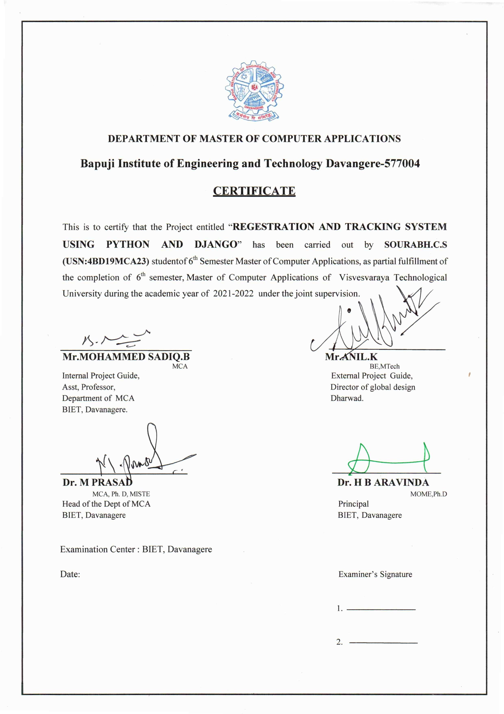

# 

**1.2 COMPANY PROFILE**

**GLOBAL DESIGNS**

A well-known name in technical education and IT is Global Design. We have a large student base from all over India and are located in Dharwad, Hubli, Belgaum, Banglore, Shimoga, and Manglore. Global Design is a firm believer in delivering substantial hands-on technological practises to developers and students alike in order to strengthen their core IT competency. We are committed to imparting our knowledge to our students and have over 26 years of training experience in the information technology, mechanical, electronics, and mechatronics industries. To prepare our students for the workplace, our curriculum complies with industry standards. We have the knowledge necessary for Web technologies, systems programming, network applications, enterprise solutions, mechatronics, and CAD/CAM/CAE. Global Design is a leading institute for higher technical training in Dharwad, Karnataka since 1996 for courses in the area of Information Technology, Mechanical and Civil industry are offered. The courses are taken by engineering students to enhance their skills and credentials to get prime jobs. Global Design has partnered with Autodesk as Autodesk Authorized Training Center. Autodesk is a global leader known for software’s such as AutoCAD, Revit, 3ds Max, Fusion 360, Inventor, Navisworks, etc. These software’s are used extensively in the industry worldwide and there is a great demand for certified candidates of Civil, Mechanical, Electrical and Automobile students in addition to their academic curriculum. The training staffs of Global Design are approved instructors of Autodesk. On course completion, an Autodesk certificate is issued to the student which is globally recognized and will give the students an edge over other students during placement. Global Design is also Autodesk Academic Partner and is imparting training in various engineering and technical colleges across eight states i.e. Karnataka, Goa, Maharashtra, Tamilnadu, Kerala, Andhra Pradesh, Jharkhand and Orissa.

**DECLARATION**

I, **SOURABH.C.S** student of 6th MCA, Bapuji Institute of Engineering and Technology, bearing **USN 4BD19MCA23** hereby declare that the project entitled **"REGISTRATION AND TRACKING SYSTEM USING PYTHON AND DJANGO"** has been carried out by me under the supervision of Internal Guide **Mr.MOHAMMED SADIQ.B ,** Assistant Professor, Dept of MCA and External Guide **Mr.ANIL.K**, Director of Global Design Dharwad and submitted in partial fulfilment of the requirements for the award of degree of **Master of Computer Applications** by the Visvesvaraya Technological University during the academic year 2021­2022. This report has not been submitted to any Organization/University for any award of degree or certificate.

**Name: SOURABH.C.S**

|  |  |
| --- | --- |
| **Signature:** |  |

# ACKNOWLEDGMENT

Salutation to our beloved and highly esteemed institute of **“BAPUJI INSTITUTE OF ENGINEERING AND TECHNOLOGY, DAVANAGERE”** for having well qualified staff and labs furnished with necessary equipment and computers for growing up to become true post graduates.

I would like to thank our beloved principal **DR. H. B. ARAVIND**, **Principal**, BIET, as I consider myself very lucky to have such excellent computing facilitates and their inspiration throughout my professional encouragement.

I express wholehearted gratitude to **DR. M. PRASAD, HOD**, Department of Master of Computer Applications. I wish to acknowledges the help who made my task easy by providing his valuable help and encouragement.

I express my sincere thanks to my guide **MOHAMMAD SADIQ .B,** Associate Professor, Department of Master of Computer Applications , for giving me constant encouragement, support and valuable guidance throughout the course of the project without whose stable guidance this project would not have been achieved.

I express my sincere thanks to **Mr. ANIL.K** for their valuable guidance and expert advice rendered by them in completing the project successfully.

I would like to express my heartily gratitude to **GLOBAL DESIGNS**, where I got an opportunity to do the project in their company as an intern with all the require facilities.

Finally I thank all those who are involved directly and indirectly in completion of my project.

**SOURABH.C.S**

**4BD19MCA23**

**ABSTARCT**

The project is on “Registration and Tracking System Using Python And Django”

It is used by the educational institute which provides the information about the institute on an organization. The registration and tracking system has been developed to the particular institute has problem prevailing in the practicing manual system. They also have the problem of keeping the record of the trainer and students even though different collages. In the existing system, staring of the data and records keeping is difficult. Which takes more man power , and its time consuming and there is less security for the data, here needs manual calculations and no direct role for the higher officials.as earlier taking a student attendance is difficult which needs a manual work and it can be challenging to track who has actually attended class room-based sessions. Using track8ing system can be much easier way to mark student attendance. That why we are building this project to register and keep track the particular trainer ,collages and students

TABLE OF CONTENTS

|  |  |  |
| --- | --- | --- |
| SL NO | CONTENTS | PAGE NO |
| 1 | Introduction   * 1. Project Description   2. Company Profile | 1 |
| 2 | Literature Survey  2.1 Existing  2.2 Proposed System  2.3 Feasibility study  2.4 Tools And Technologies Used  2.5 Hardware And Software Requirements | 4 |
| 3 | Software Requirements Specifications  3.1 Users  3.2 functional Requirements  3.3 Non-Functional Requirements | 12 |
| 4 | System Design  4.1 System Perspective  4.2 Context Diagram | 15 |
| 5 | Detailed Design  5.1 Use Case Diagram  5.2 Sequence Diagram  5.3 Collaboration Diagram  5.4 Activity Diagram  5.5 Database Design | 19 |
| 6 | Implementation  6.1 Screen Shots | 31 |
| 7 | Software Testing  7.1 Test cases | 34 |
| 8 | Conclusion | 36 |
| 9 | Future Enhancements | 37 |
| 10 | Appendix A: Bibliography | 38 |
| 11 | Appendix B: User Manual | 39 |