v
c
URRICULUM
ITAE

With The Help of Almighty and the Most Bounteous “ALLAH”
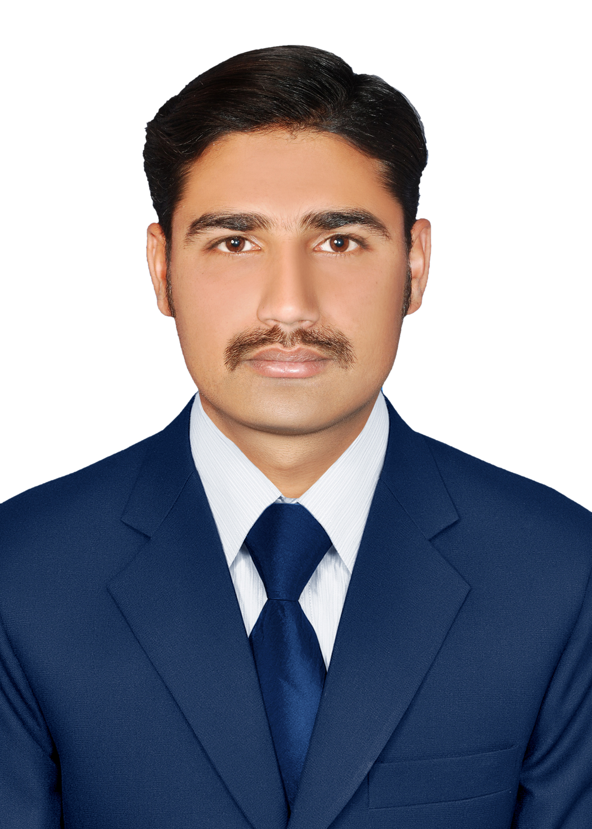

Address:
HOME ADDRESS :- 30/4, AL-HAMRA PARK, QANCHI MORH
LAHORE ROAD SARGODHA, PAKISTAN
E-mail :- rehman.255515@gmail.com

ABDUL REHMAN

PHONE NO: + 92305-3223088
+92345-5108787
PROFESSIONAL CAREER OBJECTIVE

PROFESSIONAL CAREER OBJECTIVE

Seeking a challenging project, I want to make it up to the mark. I hope you will, soon, find this truth that how much I mould myself in my words.

PERSONAL DETAILS

- Father’s Name Rashid Ahmad
- Gender Male
- Date of Birth Nov 15, 1992
- Nationality Pakistani
- CNIC No 384031-932903-7
- Religion Islam
- Marital Status Married

QUALIFICATION

Description | Obt.Marks & Division | Year | Subject | Board/University
M.A / M.Sc | 1st (625) | 2021 | Health & Phy Science | University of Faslabad
B.A | ₁st ₍₆₇₅₎ | 2018 | Arts | Alama Iqbal Open University
I.com | ₁st (800) | 2013 | Account | Alama Iqbal Open University
Metric | 1st (824) | 2009 | Science | BISE Sargodha

Diploma  COM | 91 % | 2010 | Computer | Sanatzaar Computer College
Diploma  Quantiti Servaior | 90 % | 2011 | Civil Enginnering | Govt. Tevta College
Diploma  AUTO CAD | 90% | 2011 | Civil | Sanatzar Computer College
Diploma  DAE 3 Year | 67% | 2023 | Civil | Hira College Sargodha

OPERATING SYSTEM & SOFTWEAR IN COMMAND

- Typing 35 Wpm
- MS Office (All Versions)
- MS_ Word
- MS-Excel
- MS-PowerPoint
- Windows-XP/Vista/2000/98/7
- Auto CAD (2004/2006)
- Internet Searching And Downloading
- Drivers Installation
- Protection Softwares (Anti viruses)
- System Restore & Backup
- Installing of Operating System

EXPERIENCE IN FIELD

- As a Computer Operator at Saibaan Marketing Sargodha
(1 Year)

- As a Teacher in different School & Colleges in Sargodha
(2 Year)

- As a Quantiti Servaior Enginnior in Riaz Textile Mills (Faroz Wattwon) under Guarantee Engineers (1.3 Year)

- As a Site incharge & Q.S in Ellcott spinning Mills Under Guarantee Engineers (Lahore) (1.6 Year)

- As a Construction Manager Civil in M/S M.T AWAN Constrution Company (Govt. Contrectureship) in NDL Mills (Lahore)
(2 Year)

- As a Project Manager Civil in M/S M.T AWAN Constrution Company (Govt. Contrectureship) in NDL Mills (Lahore) (Working from Dec, 2019 To 2022.)

- I made my Own Construction Company with the name of (U.G/M.Z REHMAN Construction Company) in 2022 and now my Construction Company is Working together with DESCON Engineering Pvt. Ltd, at interloop HD-5 khurryawala, Faisalabad (Still Working from Dec,2022 to so on.)

LANGUAGES

- National Urdu Excellent
- International English Good
- Regional Punjabi Good

HOBBIES AND INTERSTS

1- Recites Holy Quran 2- Reading books
3- Update from Internet 4- Gardening.
5- Cricket & Snooker 6- Business and News updates.
7- Reading Newspaper

PERSONAL SKILLS

- Excellent oral and written communication skills.
- Have Creative business skills.
- Ability to work independently and in team oriented envoirment.
- Good customer service attitude.

REFERANCE

Will be furnished upon request

